ASSIGNMENT 9 Exercise 16: Clustering

Abhijit Mandal

2020-11-01

## Assignment

**In this problem, you will use the k-means clustering algorithm to look for patterns in an unlabeled dataset. The dataset for this problem is found at data/clustering-data.csv.**

## Question A:

**Plot the dataset using a scatter plot.**

## Answer for A:

## Set the working directory to the root of your DSC 520 directory  
  
setwd("~/Documents/GitHub/dsc520")  
  
#Load the `clustering-data.csv`  
  
clustering_data <- read.csv("data/clustering-data.csv")  
head(clustering_data)

## x y  
## 1 46 236  
## 2 69 236  
## 3 144 236  
## 4 171 236  
## 5 194 236  
## 6 195 236

summary(clustering_data)

## x y   
## Min. : 0.0 Min. :134.0   
## 1st Qu.: 56.0 1st Qu.:141.0   
## Median : 82.0 Median :154.0   
## Mean :109.6 Mean :175.7   
## 3rd Qu.:180.0 3rd Qu.:218.0   
## Max. :249.0 Max. :236.0

#plot the data point  
library(ggplot2)  
ggplot(data = clustering_data, aes(y = y, x = x)) + geom_point() + ggtitle("Clustering Data")

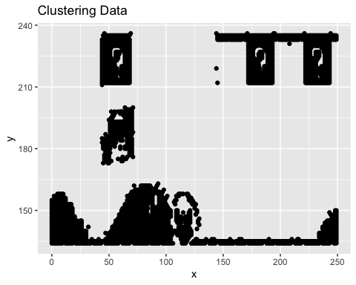

## Question B.

**Fit the dataset using the k-means algorithm from k=2 to k=12. Create a scatter plot of the resultant clusters for each value of k.**

## Answer for B:

cluster_matrix <- data.matrix(clustering_data)  
wss <- (nrow(cluster_matrix) -1) * sum(apply(cluster_matrix,2,var))  
total.withinss_values <- NULL  
average_distance <- NULL  
kmean_values<- NULL  
  
for(i in 2:12){  
 wss[i] <- sum(kmeans(cluster_matrix,centers=i)$tot.withinss)  
   
 cdata <- clustering_data  
 cdata.kmeanscluster <- kmeans(cdata, i)  
 cdata$cluster <- as.factor(cdata.kmeanscluster$cluster)  
   
 p <- ggplot(data = cdata, aes(x = x, y = y, color = cluster)) + geom_point(size = 0.5) + geom_point(data = as.data.frame(cdata.kmeanscluster$centers),   
color = "blue", shape = 10, size = 2) + ggtitle(paste("K Means Cluster for K = ", i, sep ="")) + theme_bw()  
  
 #display graph  
 print(p)  
   
 kmean_values<- c(kmean_values, i)  
 x.distance <- cdata.kmeanscluster$centers[cdata$cluster] - cdata$x  
 y.distance <- cdata.kmeanscluster$centers[cdata$cluster] - cdata$y  
 total.distance <- sqrt((x.distance ** 2) + (y.distance ** 2))  
 average_distance <- c(average_distance, mean(total.distance))  
 total.withinss_values <- c(total.withinss_values, cdata.kmeanscluster$tot.withinss)  
   
}

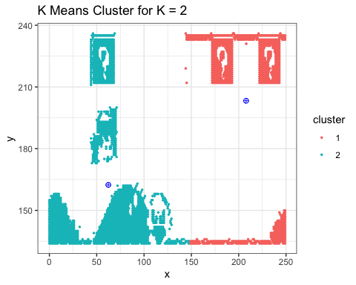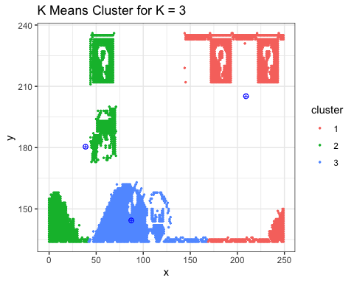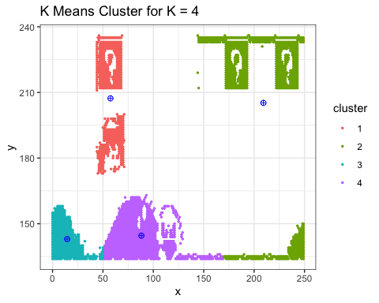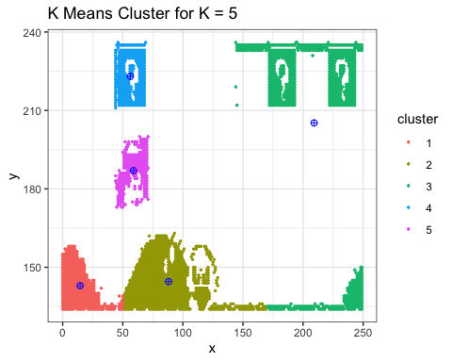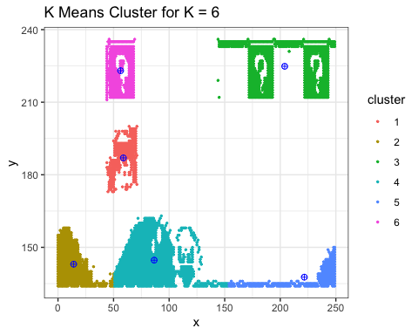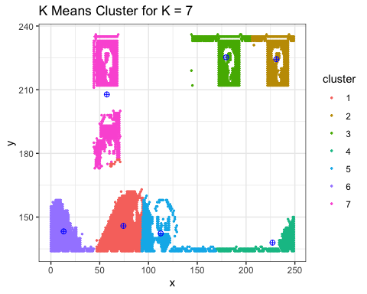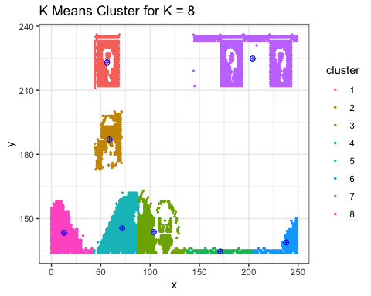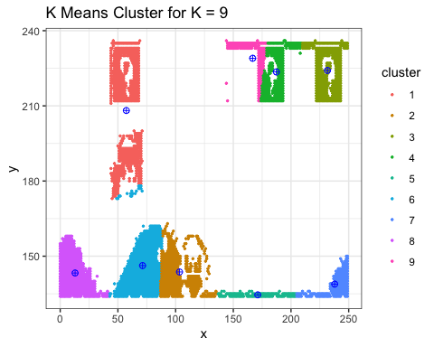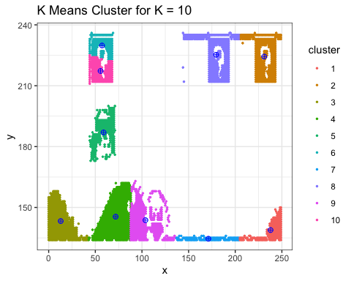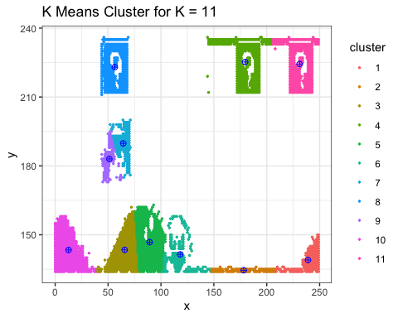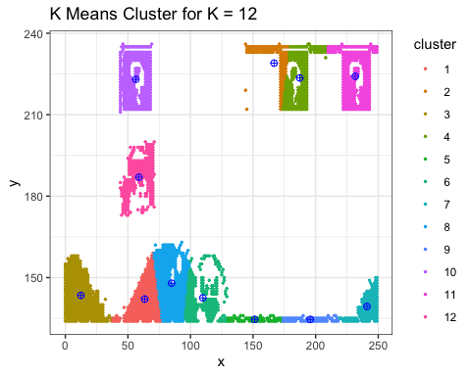

## Question C.1:

**As k-means is an unsupervised algorithm, you cannot compute the accuracy as there are no correct values to compare the output to. Instead, you will use the average distance from the center of each cluster as a measure of how well the model fits the data. To calculate this metric, simply compute the distance of each data point to the center of the cluster it is assigned to and take the average value of all of those distances.Calculate this average distance from the center of each cluster for each value of k and plot it as a line chart where k is the x-axis and the average distance is the y-axis.**

## Answer For C.1

avg_distdata <- data.frame(kmean_values, average_distance)  
avg_distdata

## kmean_values average_distance  
## 1 2 85.59601  
## 2 3 82.90632  
## 3 4 82.20270  
## 4 5 82.20191  
## 5 6 84.12965  
## 6 7 82.32686  
## 7 8 83.26995  
## 8 9 82.33173  
## 9 10 82.38236  
## 10 11 82.12749  
## 11 12 82.07278

ggplot(data = avg_distdata, aes(x=kmean_values, y=average_distance)) + xlab("Clusters") + ylab("Average Distance") + theme_bw() + geom_point() + geom_line(color = "blue")

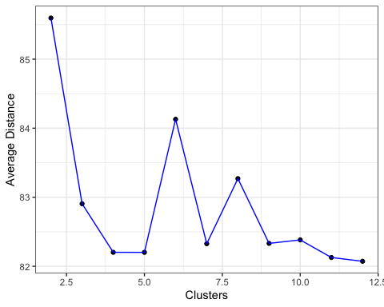

## Question C.2:

**One way of determining the “right” number of clusters is to look at the graph of k versus average distance and finding the “elbow point”. Looking at the graph you generated in the previous example, what is the elbow point for this dataset?**

## Answer For C.2

Looking the graph generated from average and within sum of squares, the elbow point seems to lie between 7 and 9.

#Plot SS  
plot(1:12, wss, type="b",xlab="Number of clusters",ylab="within sum of squares")

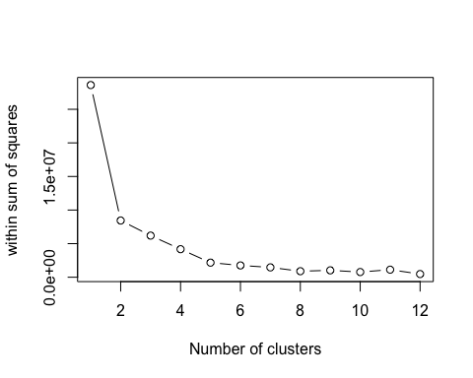

totalWithinSS <- data.frame(kmean_values, total.withinss_values)  
totalWithinSS

## kmean_values total.withinss_values  
## 1 2 8443681.1  
## 2 3 6014377.9  
## 3 4 4009678.4  
## 4 5 3758773.6  
## 5 6 1920708.1  
## 6 7 1102869.9  
## 7 8 1299901.3  
## 8 9 843884.4  
## 9 10 629825.8  
## 10 11 536642.8  
## 11 12 463576.6

ggplot(data = totalWithinSS, aes(x=kmean_values, y=total.withinss_values)) + xlab("Clusters") + ylab("Within SS") + theme_bw() + geom_point() + geom_line(color = "blue")

