Competitive analysis

A competitor for the application Pocket Pantry is an app called Mealime. This is an app designed to create a meal plan for your grocery shopping with several added functions to with a focus on healthy alternatives.

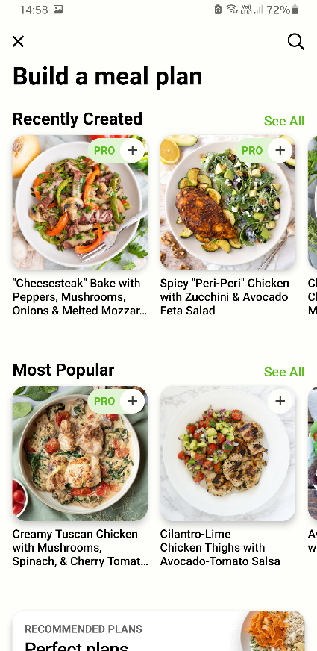 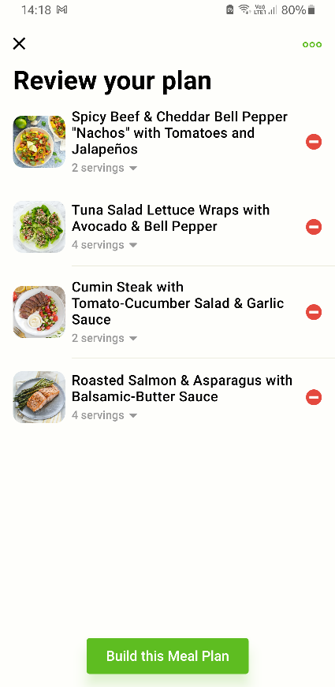  
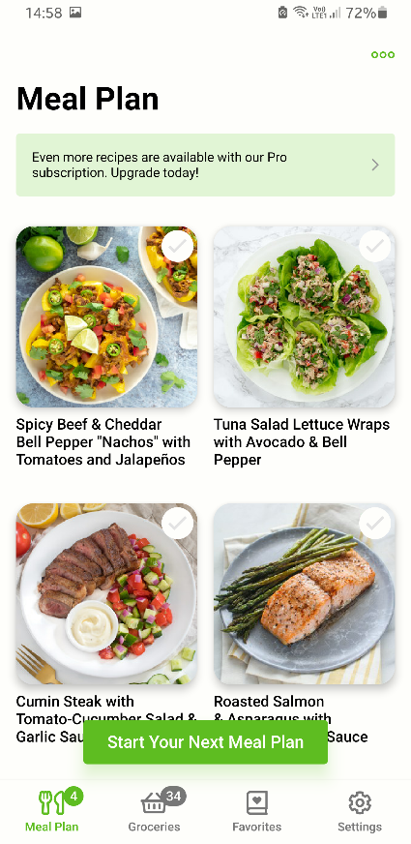

# 10 requirements

The following requirements are categorized in two categories. Must have – requirements and nice to have requirements.

Must have – requirements

A mother can plan a meal plan with a set number of portions from recipes to collect their groceries to a shopping list.

A student can create a plan to get a schedule of his/her meals for a week.

A student can uncheck certain groceries that they already have at home.

A father can save his favorite recipes to be used for his next meal plan.

A student can pick a set of portions to calculate how many eggs he/her needs to make pancakes.

Nice to have – requirements

An athlete can easily read a recipe to see the nutritional information for each meal that he/she cooks.

A student can create an account to save their recipes and previous planned meals over several devices.

A mother can put on a notification to remind her of making the next meal plan for the upcoming week.

A student can save their favorite recipes by importing them from a specific URL.

A student can create their own recipe from scratch by typing it in manually in the application.