OOP-Project
Team Topaz – Organizer

Team name: Topaz

Team members:
- Penka Kamenova (username: pepakam)
- Georgi Neykov (username: georgi.neykov)
- Ivan Zdravkov (username: IvanZdravkovBG)
- Kolio Kolev (username: Quasar)
- Gabriela Angelova (username: kalbo_17)

Project purpose:
Our project represents our notion of a good organizer. The following application provides options like adding events with start time and end time to the timeline, editing already existing events, adding and removing notes without time limit and saving the whole information in an improvised database (.txt files). Our program has the ability to load all the existing events and notes every single time we run it. You can also see the current date and time and the remaining part of the day with only one look at the organizer grid. As a deeper description of our project we append Scheme 1.
EDIT: By opening the program, you are asked to enter a username and a password. Both of them are 123.

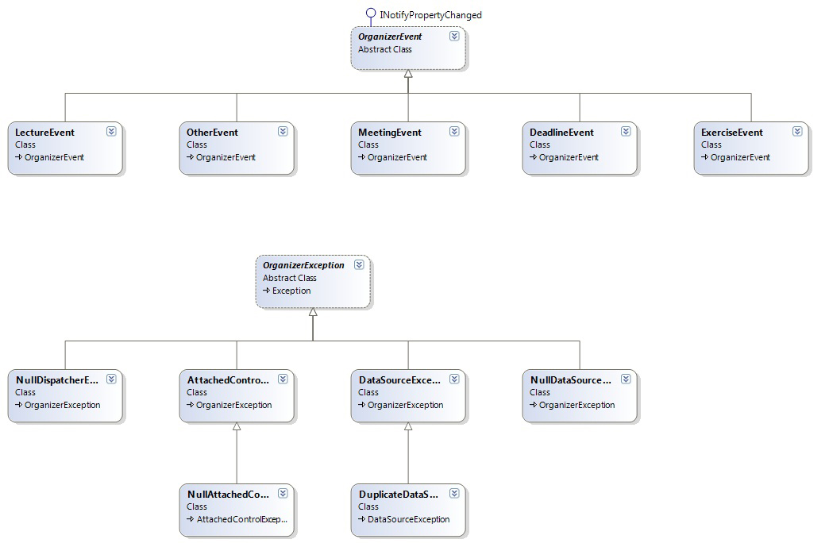
Class diagram:

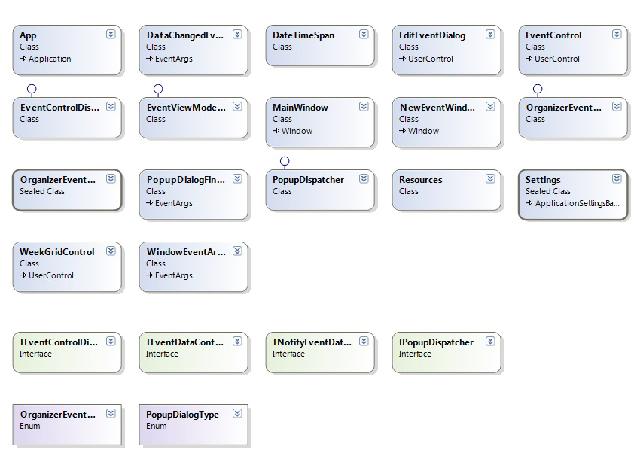

SVN repository: https://code.google.com/p/team-topaz/

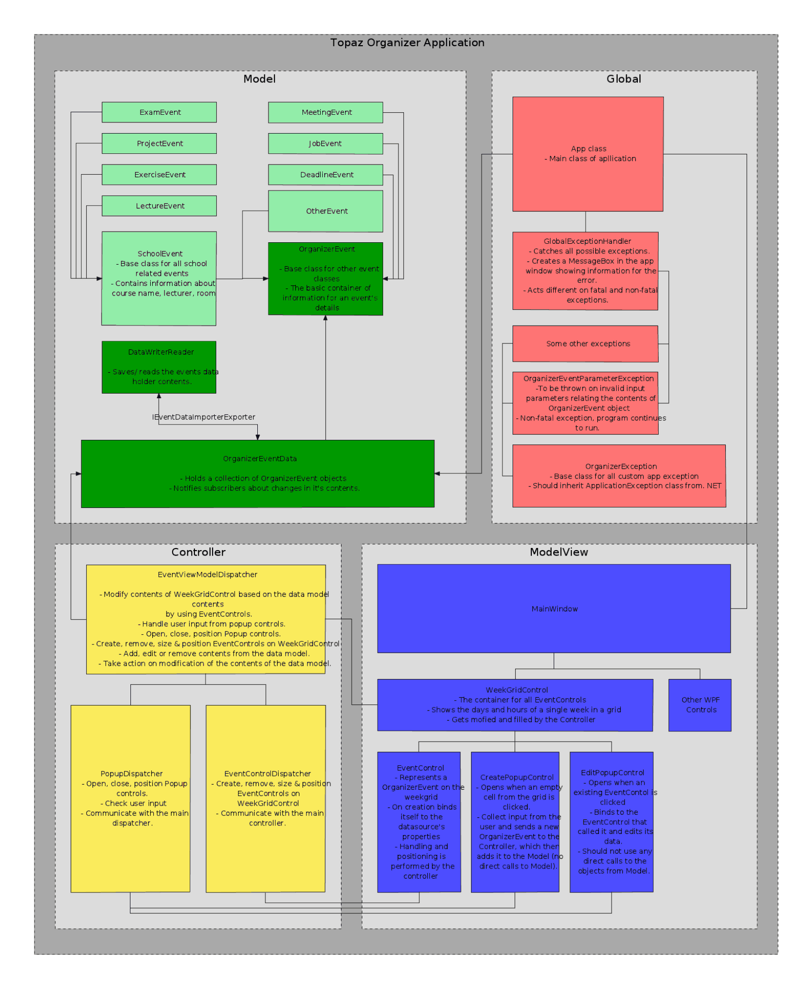
Scheme 1:

