Homework 8

4.18

a) 7

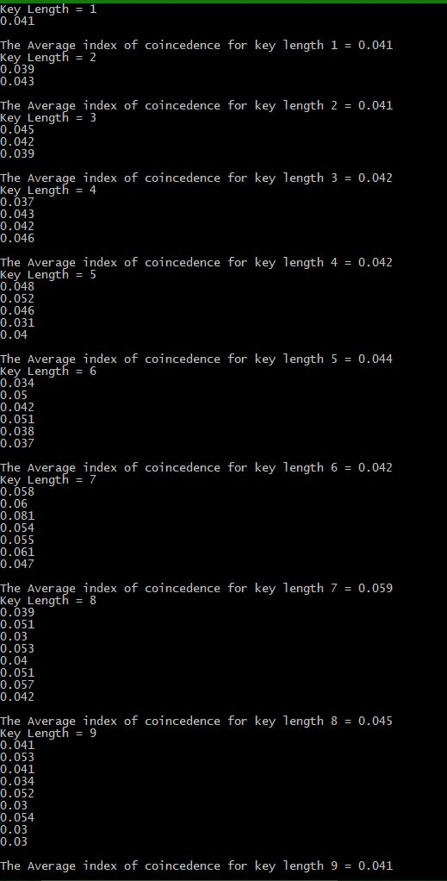b)

We chose 7 as the key length.

c) The Relative rotations are:

0

9

2

7

11

9

25

d) ajchljz

bkdimka

clejnlb

dmfkomc

**englpnd**

fohmqoe

gpinrpf

hqjosqg

irkptrh

jslqusi

ktmrvtj

lunswuk

mvotxvl

nwpuywm

oxqvzxn

pyrwayo

qzsxbzp

ratycaq

sbuzdbr

tcvaecs

udwbfdt

vexcgeu

wfydhfv

xgzeigw

yhafjhx

zibgkiy

We chose englpnd and changed the p to an a. We got the following:

It is to be questioned whether in the whole length and breadth of the world there is a more admirable spot for a man in love to pass a day or two than the typical english village it combines the comforts of civilization with the restfulness of solitude in a manner equal led by no other spot except the new york public library