**(I) Preparing to fit the model**

(a) Directory Structure

The first step to running the Hierarchical Bayesian Soliwat (HBSoilwat; Appendix 1) to ensure the proper directory structure as the code assumes a certain structure. Everything is contained within a common directory (in this case E:/Soilwat). Within this directory, we will have the five files containing the relevant R code to start to fitting process (1_SOILWAT.Fit.Start.R), introduce special functions (2_SOILWAT.Fit.Functions.R; also, see Appendix 2), initialize relevant objects in R (3_SOILWAT.Fit.Initialize.R), run the Gibbs sampler (4_SOILWAT.Fit.Gibbs.R), and use some post processing and analysis tools (5_SOILWAT.Fit.PostProc.R).

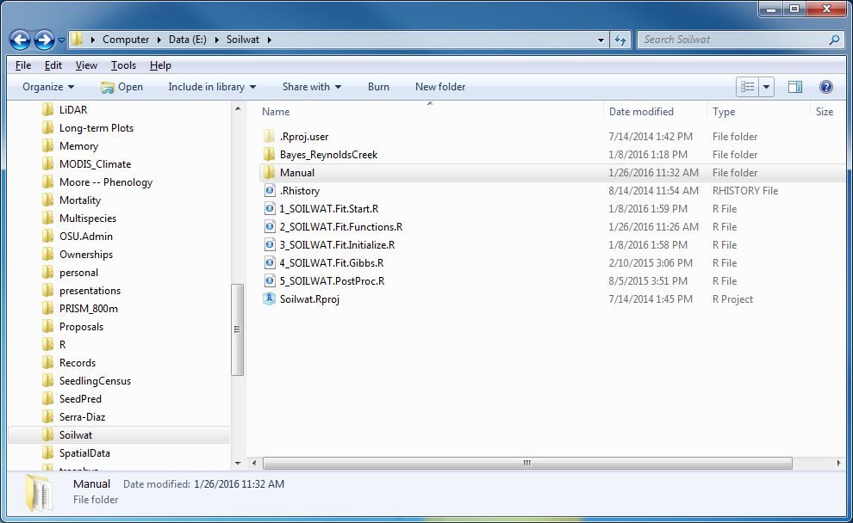

The filepath for this directory needs to be used to define the dir.model object in 1_SOILWAT.Fir.Start.R. In addition, there will need to be a project folder whose name matches the runname object in 1_SOILWAT.Fir.Start.R. In this example, it is Bayes_ReynoldsCreek. I named it this because we are fitting the Bayesian model to data at Reynolds Creek.

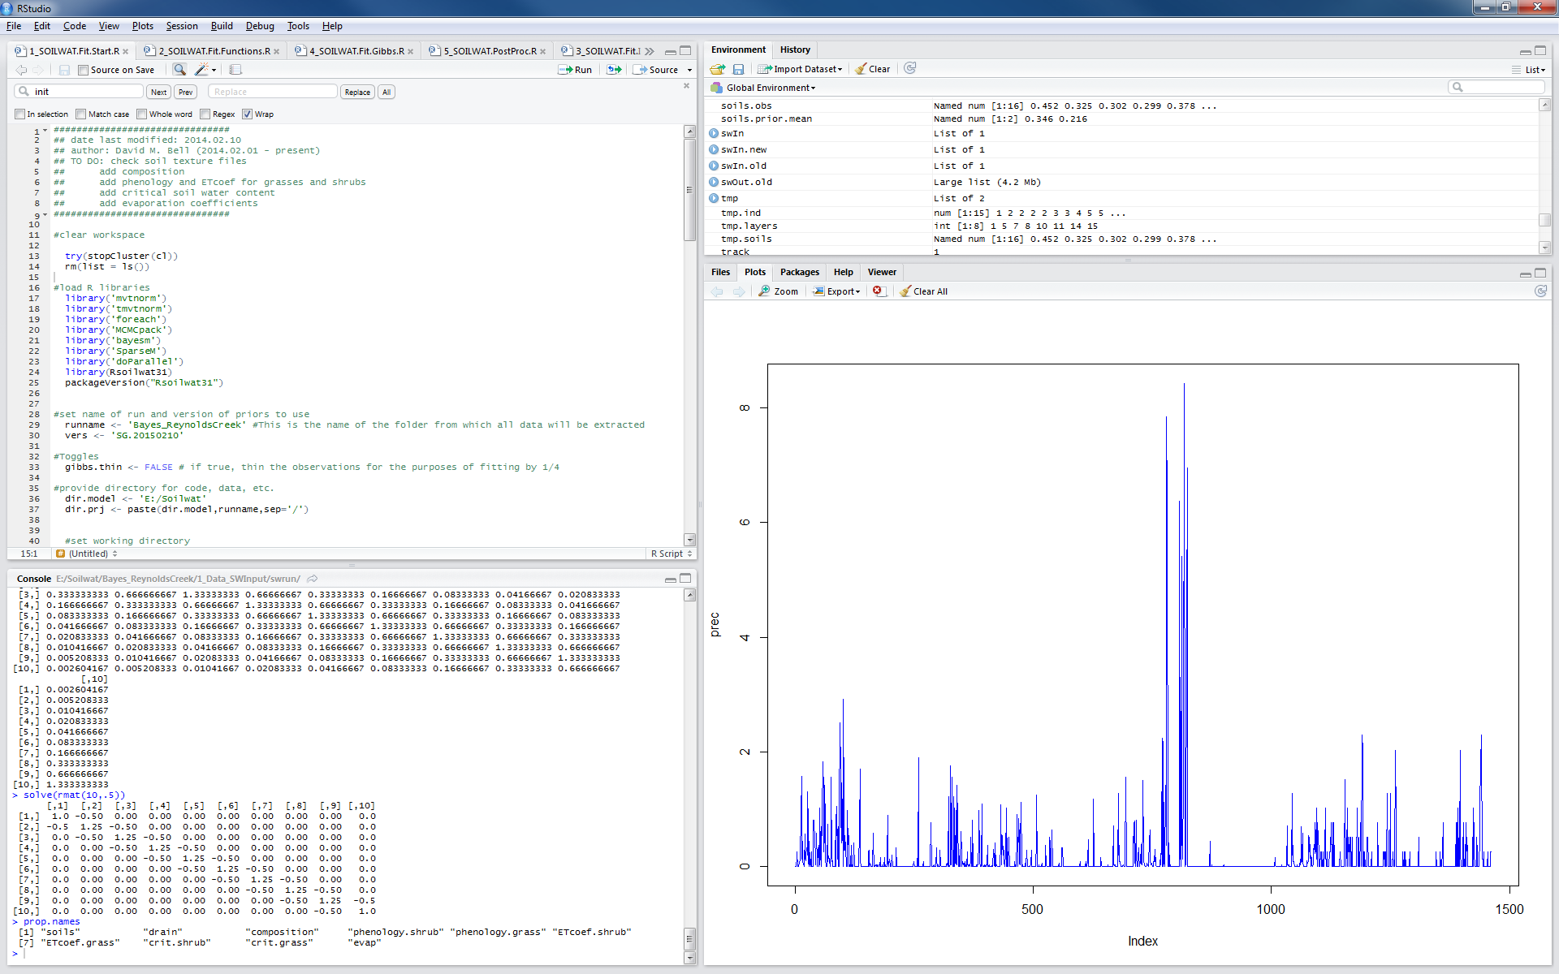

Within E:/Soilwat/Bayes_ReynoldsCreek, there will be at least two folders and one comma-delimited table (.csv): a folder with all the Soilwat data structure (1_Data_SWInput), a folder where post processing of Bayesian Output will occur (3_Runs), and a file with all the prior information, including which parameters to fit (priors.csv). There may also be a number of .RData files (R workspaces) as this is where raw model fitting is saved.

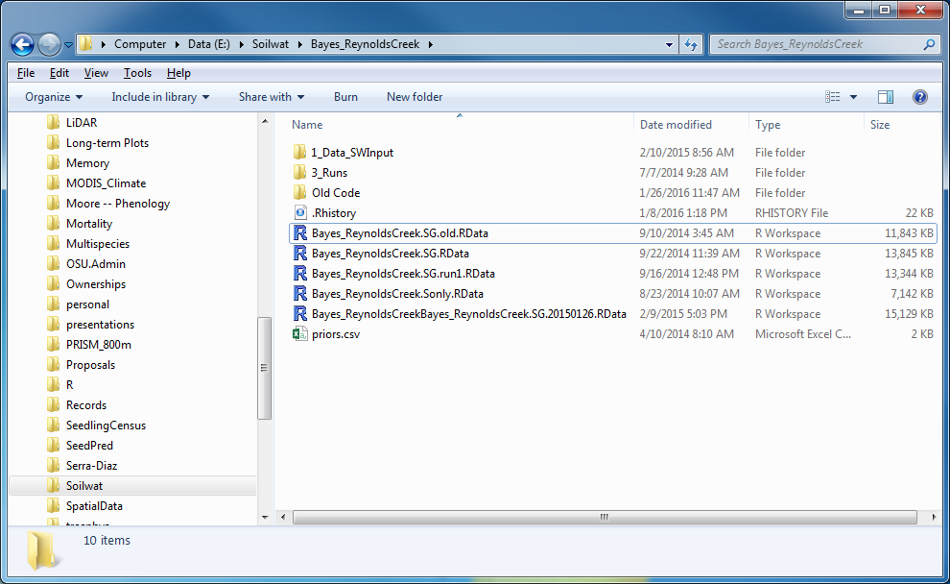

(b) Soilwat Files

Any Soilwat file that defines initial conditions can be modified and values will be carried over into the R workspace. In addition, we need observations, especially soil moisture. These data are located in E:/Soilwat/1_Data_SWInput/fielddata/[sitename]/3_Field_Output

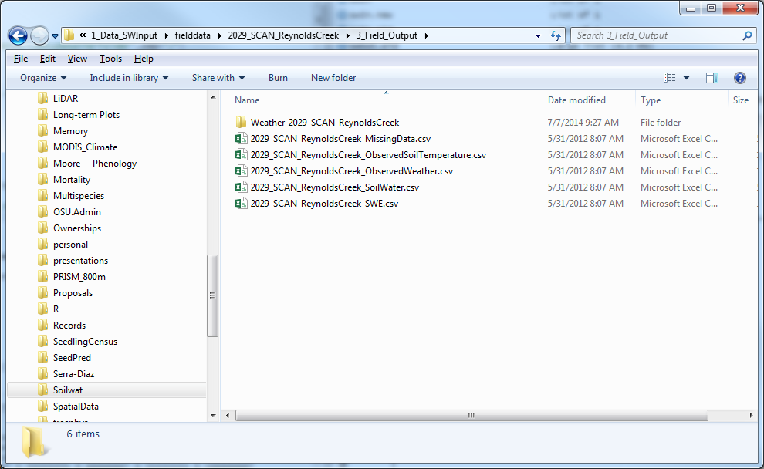

Take a look at these files for the appropriate file formats (I think I took the formats from Daniel). Also, we need to make sure we have information on the appropriate soil layers under consideration and how they relate to individual soil moisture sensors (see E:/Soilwat/1_Data_SWInput/fielddata/ FieldSensors_MappedTo_SoilWatLayers.csv).

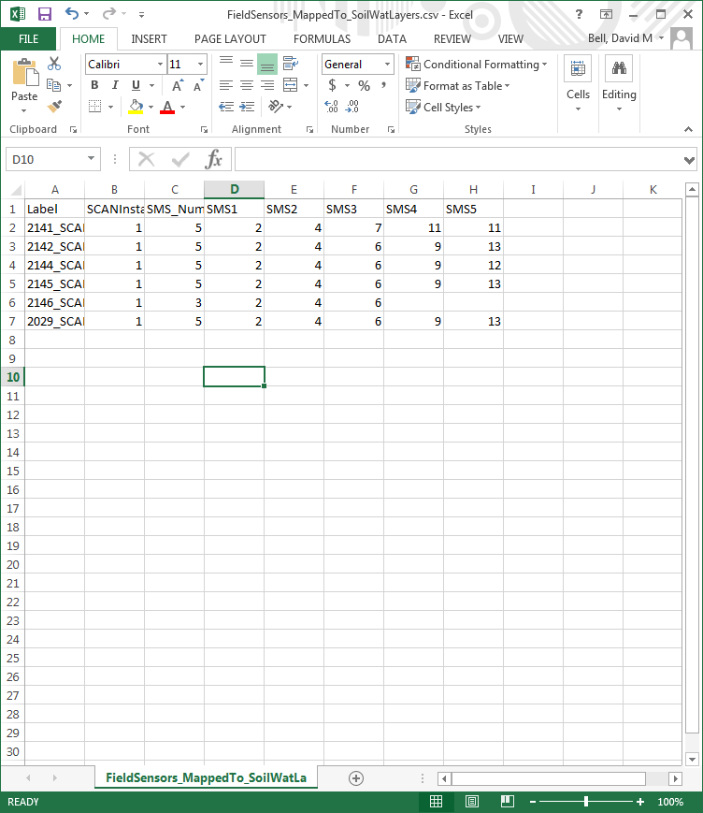

(c) Prior parameter values

Modification of the priors.csv file is quite important as it controls several things. First, the column “include” determines whether the parameter is allowed to vary (1) or not (0). Given it is allowed to vary, this file also determines the strength of prior information and the range of acceptable values. The priors are split into two columns. The first, titled “order”, gives the names and order of the components of the prior being specified. For normally distributed variables, this will be mean, variance, lower bound, and upper bound. For composition, it is a list of the functional types and the priors will be for a Dirichlet. Basically, the prior value divided by the sum is the average proportion and the larger the numbers, the stronger the prior. The second column, titled “pars”, are the actual prior values.

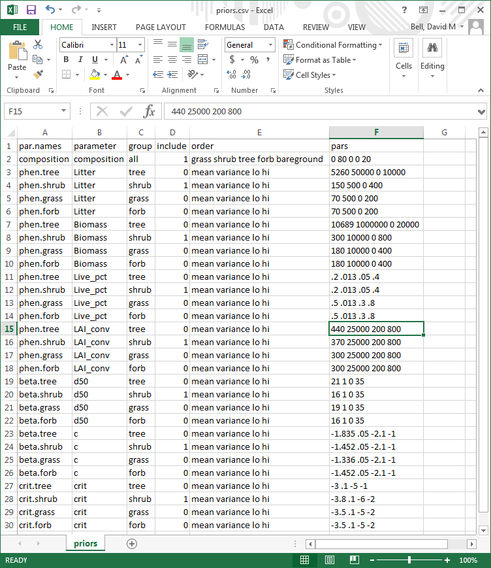

*Definition of priors for process errors.* In “3_SOILWAT.Fir.Initialize.R”, lines 262-273 deal with priors for the variance components. These are rather important. sig is the initial value of the variance while s1 and s2 are the used in the inverse gamma prior on the variance, so small values constitute a less informative prior. rho is the initial autocorrelation, rhoV is the initial proposal variance for the metropolis algorithm, rho.lo and rho.hi are the range of values allowed for rho, rho.prior.mean and rho.prior.variance are the mean and variance for the prior on the autocorrelation.

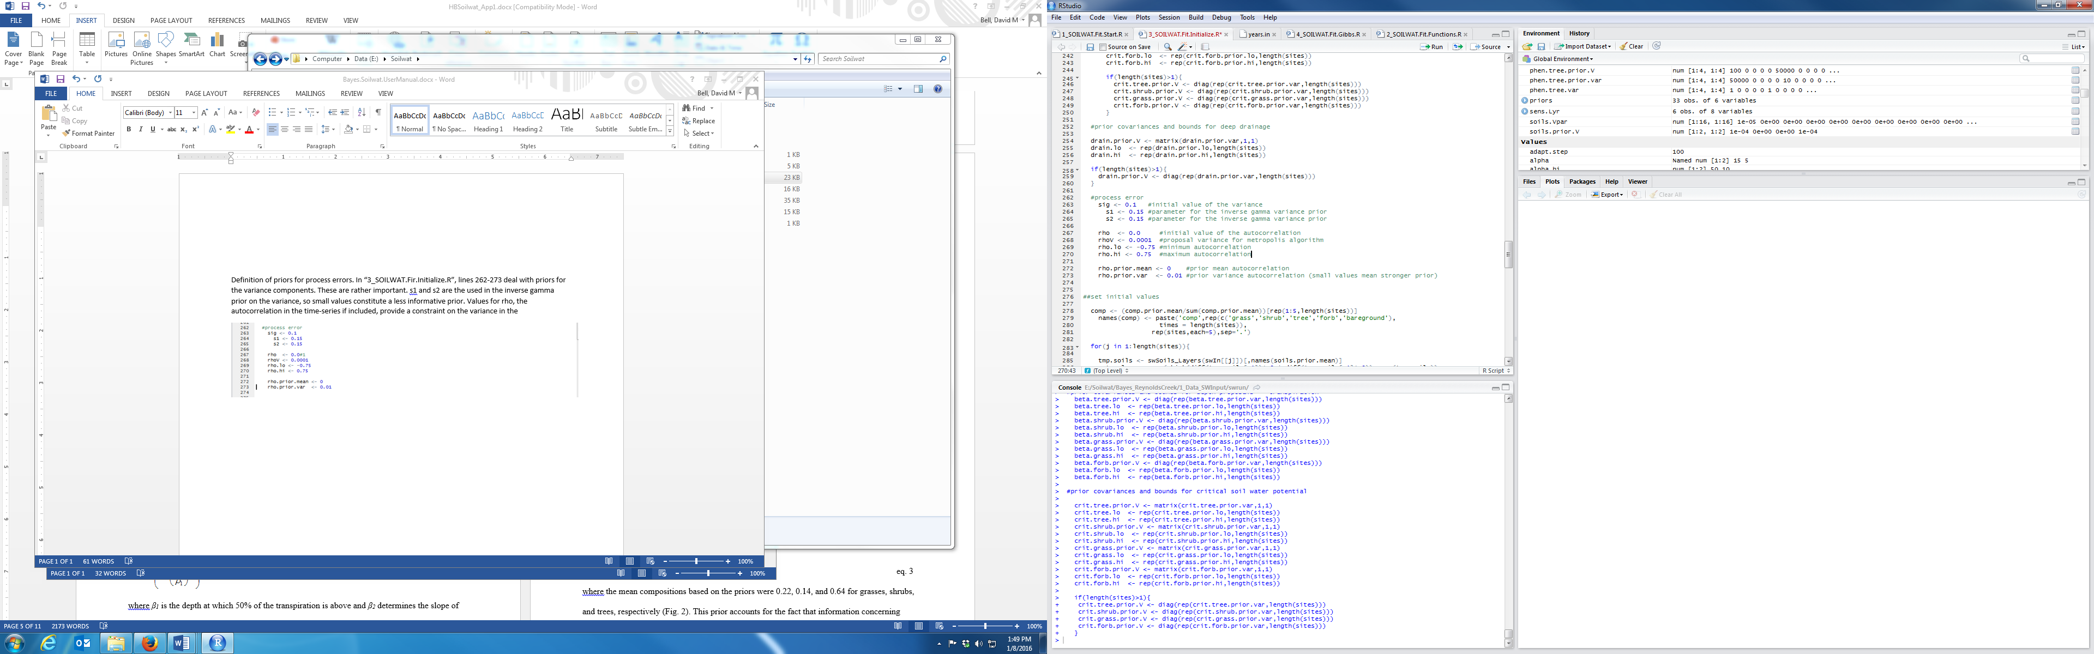

**(II) Running the model**

To fit the data, really one just needs to run 1_SOILWAT_Fit.Start.R as it calls all the relevant additional code. Note that you will need to have the packages loaded early in the code installed (including Rsoilwat31) and be using 32-bit R. If there are newer versions of RSoilwat, the present modeling procedure may need to be updated to reflect changes in the R implementation of Soilwat. The following objects need to be defined by the user: runname, vers, dir.model, sites, and ng. There are also a lot on proposal covariance matrices that can be tuned, but the current set seems to work fine, provided a long-enough Gibbs Sampler is run (>10000 steps).

Once the code is running, the R console will interatively update the user regarding step, estimates of the variance (sigma) and acceptance proportions for each set of parameters.

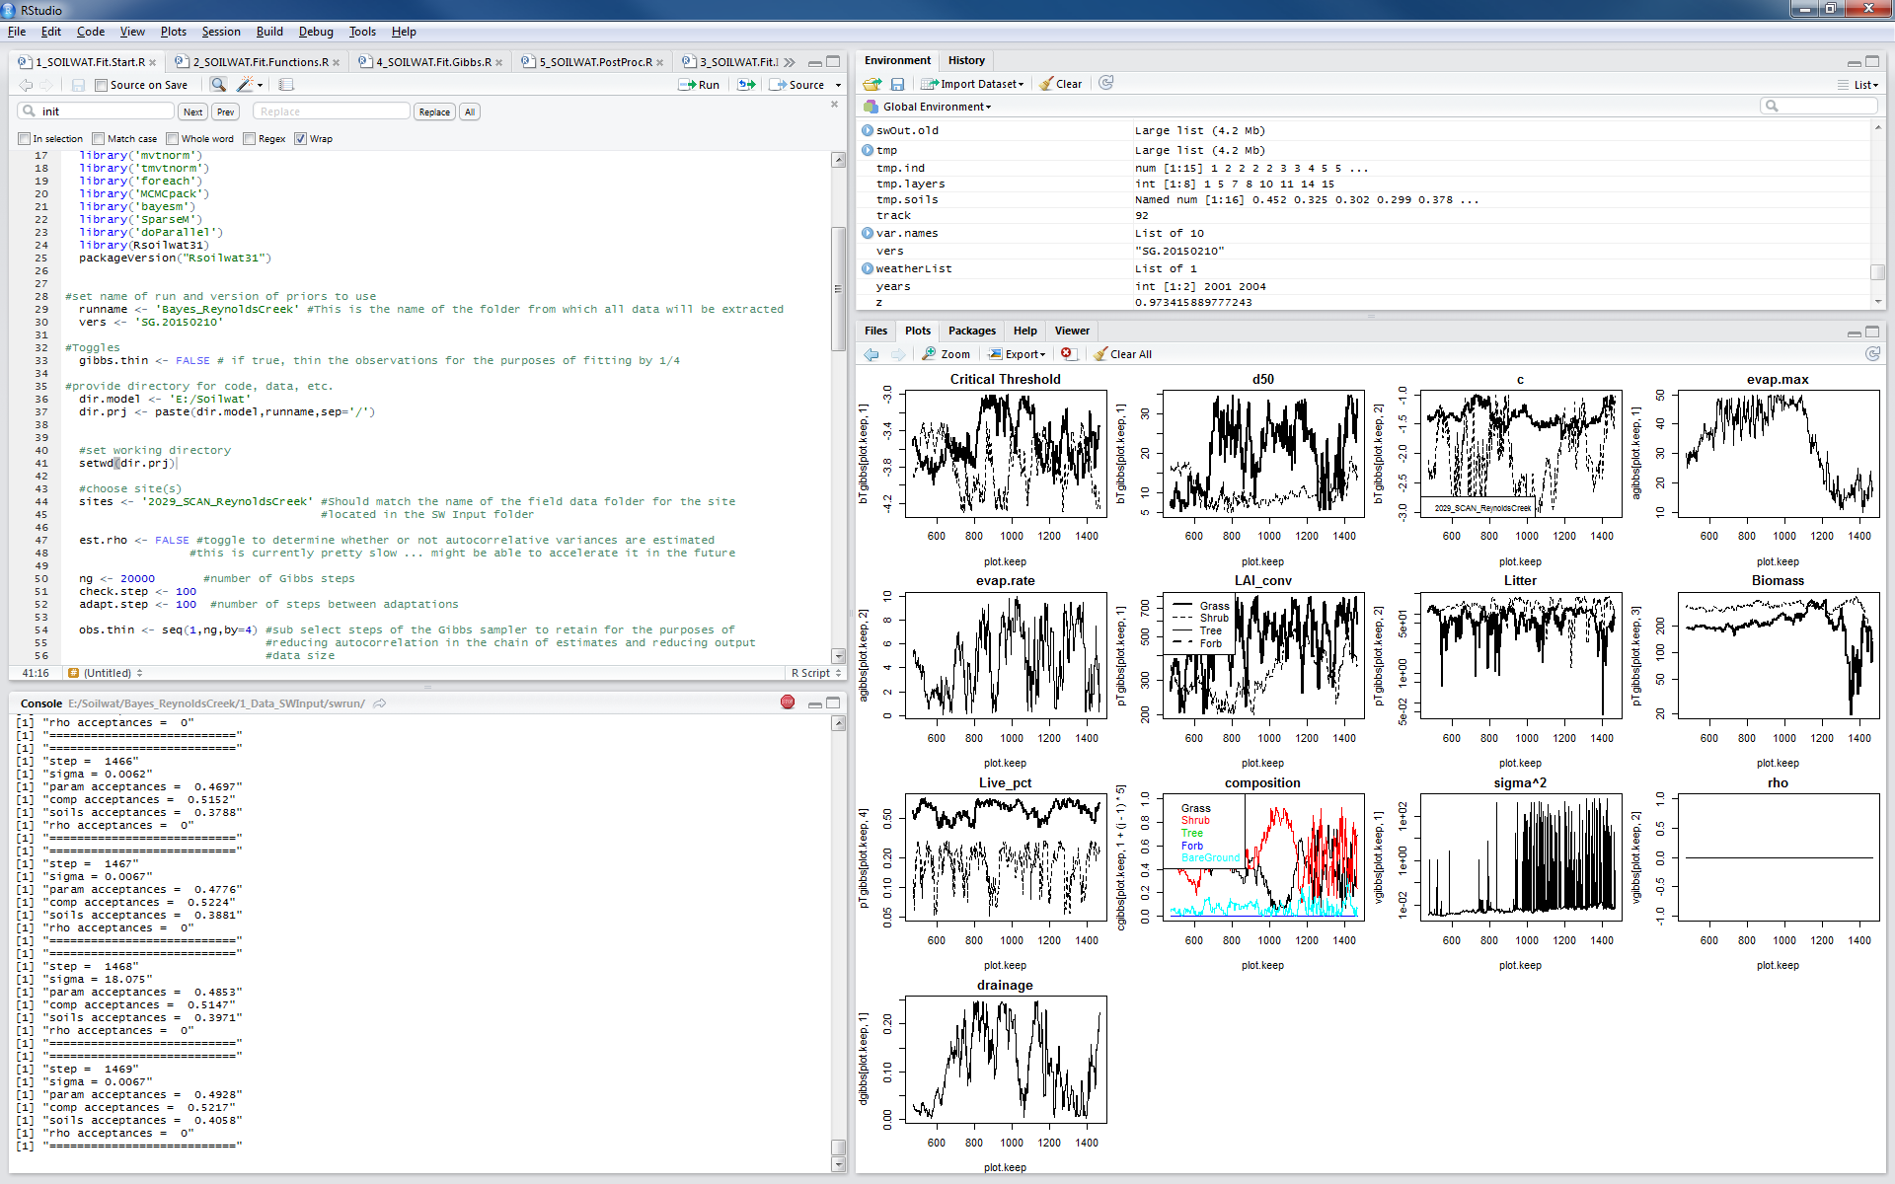

For acceptance rates, we want between 0.2 and 0.4, if possible. The adaptation algorithm, which modifies proposal covariances, should help to achieve this One can also look at traces of parameter estimates which will give you a visual representation of model behavior and convergence



**(III) Looking at output**