**HBSoilwat Appendix 1. Bayesian Calibration Model Specification and Description**

**Modeling Justification**

Ecosystems are fundamentally complex and mechanistic simulation models offer vital tools for understanding processes shaping ecosystem dynamics (Uriarte and Yackulic 2009). The structure of these models represent a simplification of our understanding of ecosystem dynamics and are parameterized in a variety of ways. Initial parameterization generally begins with a review of the literature to either identify the most likely value for each parameter and model tuning to produce reasonable dynamics (Rykiel 1996). Increasingly powerful computation, the development of advanced statistical methods, and the growing availability of long-term, time-series data of ecosystem processes have facilitated model parameterization via optimization techniques and the exploration of ecological sensitivity and uncertainty (Luo et al. 2009; Clark et al. 2011). In particular, integrating mechanistic models with hierarchical Bayesian modeling provides opportunities for ecologists to examine variation in ecological processes, characterize ecosystem dynamics between different systems, and forecast change (Clark et al. 2001; Luo et al. 2011; Weng and Luo 2011)

Uncertainties in model predictions arise from various sources, including parameter uncertainty and simplification of the physical and ecological processes in the model (i.e., model misspecification). We developed a Hierarchical Bayesian Soil Water (HBSoilwat) modeling framework that incorporates uncertainties in observations and parameters in parameterizing biological and physical processes impacting soil water dynamics. The soil water model used in this study, known as Soilwat, is a one-dimensional ecohydrological simulation model representing climatic, edaphic, and biotic influences on vertical variation in soil water dynamics (Parton 1978, Lauenroth and Bradford 2006, Schlaepfer et al. 2012). The model takes abiotic and biotic variation in environment (e.g., daily weather conditions and aboveground vegetation structure) and processes (e.g., bare-soil evaporation and transpiration) as inputs. The model represents idealized site ecohydrology by characterizing soil water movement and dynamics, producing predictions of soil water content, inputs through infiltration, and losses through deep drainage, evaporation, and transpiration.

**Model Development**

SCAN and SNOTEL sites provide observations of environmental drivers *xij,t*, specifically as daily climate and soil texture profile, and soil water content at several depths (*yij,t*) for sensor *i* at depth *dij* on site *j* at time *t* (Fig. 1). For the purposes of this study, we assume that environmental drivers were observed without error. In contrast, we assume that volumetric soil water contents *yij,t* are an imperfect measure of the true volumetric soil water content characterized by the predictions from the Soilwat model *Mij,t*(*xij,t*) for probe *i* and site *j* for time *t*.

eq. 1



where Σ*ij* is the *Tij* by *Tij* covariance matrix and *Tij* is the number of time steps being modeled for spoil moisture sensor *ij*. Given that ignoring temporal autocorrelation in time-series models can cause substantial errors (e.g., Hoeting 2009; Evin et al. 2014), we incorporate an AR(1) process, such that the covariance matrix is

eq. 2



eq. 3



where *σ*2 is the error variance, and *ρ*2is the first-order autocorrelation coefficient. The prior for *σ*2 is assumed to be an inverse gamma distribution *Gamma*-1(0.1, 0.1), so that the prior distribution as support for *σ*2 > 0, but is otherwise weak. Because the correlation coefficient could range from near zero (best case scenario of no autocorrelation) to near unity (residuals are highly correlated in time), the prior for *ρ*2 is a uniform distribution *Uniform*(-0.1, 0.95). This representation assumes that the residuals are independent in space, but not in time.

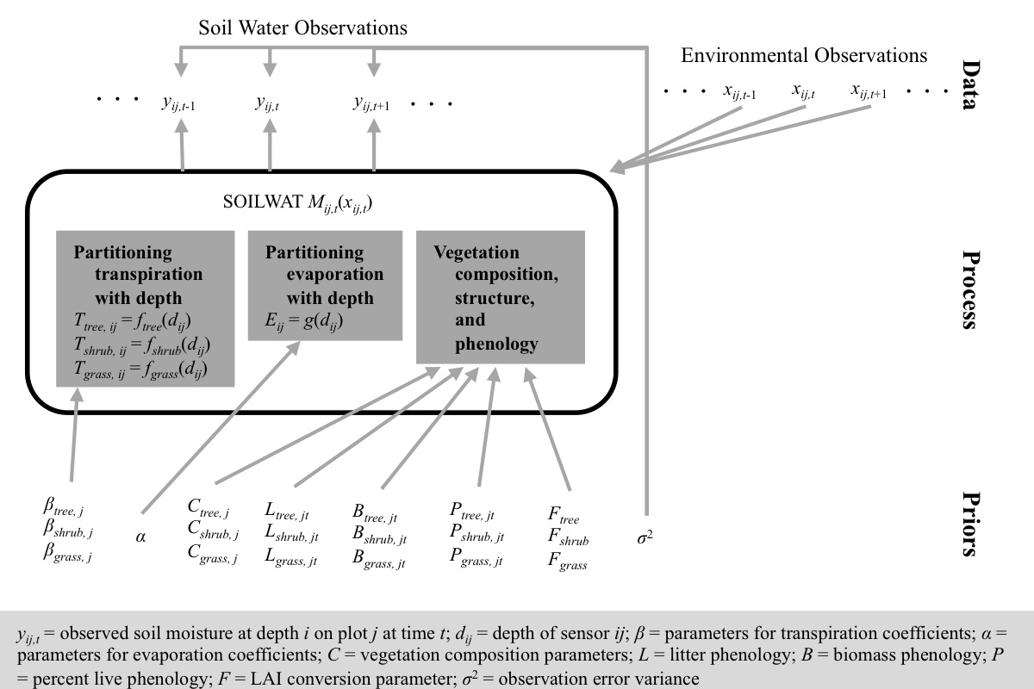

Figure 1. Directed acyclic graph for Hierarchical Bayesian Soil Water (HBSoilwat) modeling framework. Gray arrows represent dependencies. The HBSoilwat modeling framework predicts posterior parameter distributions in three components of the Soilwat simulation model *Mij,t*(*xij,t*), the **partitioning of transpiration with depth**, the **partitioning of evaporation with depth**, and characteristics of **vegetation composition, structure, and phenology**, as well as observation error variance.

In addition to the uncertainty associated with the volumetric soil water observations, parameter values characterizing vegetation structure as well as abiotic and biotic processes may be poorly known. To maintain photosynthesis, plants extract water from soils and transpire this water to the atmosphere through stomata, contributing to soil water losses. In terrestrial ecosystems with relatively continuous canopy cover, from grasslands to shrublands to woodlands to forests, the global average of water losses through transpiration range from 185% to 466% of evaporative water losses (Jasechko et al. 2013, 2014; Coenders-Gerrits et al. 2014). While it is clear that vegetation has a large impact on terrestrial ecohydrology, both (1) partitioning of water removal with depth through transpiration and evaporation across the root profile and (2) the vegetation composition, structure, and phenology, which may be poorly observed.

***Partitioning evaporation and transpiration by depth***

Water losses to evaporation and transpiration arise from surface soils and soil layers accessed by vegetation roots, respectively. For evaporation, which is assumed to be a strictly physical process, soil water losses occur in the surface soils, with the depth to which evaporation can remove water from soil depending on soil texture. For transpiration, the distribution and activity of roots determine the ability of vegetation to extract water with depth.

Evaporation Profile *α*

We assume that bare-soil evaporation is strongest at the soil surface and declines exponentially to a maximum depth that depends on the soil texture of the upper soil layers. The maximum depth *Dj* (cm) to which evaporation can extract soil water *Dj* = min(*Dmax*, *xjδ*), where the maximum depth regardless of soil texture was assumed to 15 cm (Torres and Calera 2010), *xj* = [1 *sandj*2 *clayj*2], *sandj* and *clayj* were the mean proportions of surface soil volume comprised of sand and clay, respectively, *δ* = [*δ*0 *δ*1 *δ*2], and *Dmax* is the maximum depth independent of soil texture (Wythers et al. 1999). We assume a multivariate normal prior for *δ* with mean [4.1984 0.6695 168.7603] and covariance matrix  and a normal prior for *Dmax* with mean 15 and variance 5. Evaporation coefficients *Eij* are drawn from an exponential function defined from the soil surface to *Dj*. Thus, for deep soils (*dij* > *Dj*) *Eij* = 0 and for shallow soils (*dij* ≤ *Dj*)

 eq. 5

where 

*STATUS: Completed, based on Soilwat wrapper provided by D. Schlaepfer*

Transpiration Profile *βj*

The ability of plants top access soil water with depth depends on the depth profile of roots and the activity of those roots. For example, while root biomass declines exponentially with depth (Jackson et al. 1996; Zeng et al. 2001; Schenk and Jackson 2002), most root water uptake occurs through fine, not coarse, roots, which may or may not be highly correlated with root biomass profile (**). Based on Schenk and Jackson (2002). Cumulative transpiration *T*(*d*) down to depth *d* (cm) is taken to be



where *β1* is the depth at which 50% of the transpiration is above and *β2* determines the slope of the decline in transpiration with depth. Thus, for a given portion of the soil profile (*d*1 to *d*2), the proportion of the water used for transpiration drawn from that volume of soil is *T*(*d*2) – *T*(*d*1)

*STATUS: Completed*

***Vegetation composition, structure, and phenology***

Because sensors were placed in a single vertical soil profile for each site, vegetation characterization in the model represent an idealized representation of the vegetation accessing the soil profile in question. Even if vegetation composition, structure, and phenology were measured precisely, spatial heterogeneity in aboveground and belowground characteristics of vegetation may result in a divergent idealized representation in the model. In addition, limitations of the sampling design for SCAN and SNOTEL sites make vegetation composition, structure, and phenology uncertain because no measurements of vegetation characteristics were recorded, though qualitative descriptions (i.e., dominant plant species) and photos of the site were available. Given both the representation of vegetation in the Soilwat model and lack of a quantitative description of the vegetation, we modeled vegetation parameters at two levels: vegetation composition in terms of functional group (i.e., grasses, shrubs, and trees) and vegetation structure and phenology within functional groups.

Vegetation Composition *Cj*

Vegetation composition was taken as the proportion of canopy cover associated with each functional group: proportion of cover in grasses *Cgrass,j*, proportion of cover in shrubs *Cshrub,j*, and proportion of cover in trees *Ctree,j*, where *Cgrass,j* + *Cshrub,j* + *Ctree,j* = 1. Therefore, we assume that vegetation composition *Cj* = [*Cgrass,j*, *Cshrub,j*, *Ctree,j*] was distributed as a Dirichlet distribution with a prior distribution

*Cj* ~ *Dir*([1.5, 1, 4.5]) eq. 3

where the mean compositions based on the priors were 0.22, 0.14, and 0.64 for grasses, shrubs, and trees, respectively (Fig. 2). This prior accounts for the fact that information concerning composition is based on site photographs, but not direct measurement (i.e., uncertainty), and that while woodlands are dominated by tree species, they do not generally develop continuous forest canopies.

*STATUS: composition assumed to be trees only Cj = [0, 0, 1]*

Critical Soil Water Potential and Drainage

The critical soil water potential for a vegetation type and site are modeled as a normally distributed random variable. Deep soil drained for a site is modeled as a normally distributed random variable

Vegetation Structure and Phenology *Ljt*, *Bjt*, *Pjt*, and *F*

The amount of vegetation, both live and dead, varies by site (i.e., structure) and season (i.e., phenology), resulting spatio-temporal variation in vegetation structure. We need to have a conversion factor for relating live biomass to leaf area (*Fgrass*, *Fshrub*, and *Ftree*) to be able calculate both evaporation of intercepted water and transpiration from the leaves. In contrast, litter, biomass, and percent live all vary seasonally, representing vegetation phenology. To characterize within functional group vegetation phenology by:

**(1) Get monthly maximum vegetation parameters.** The maximum monthly litter (*Lj,grass*, *Lj, shrub*, and *Lj,tree*; g m-2), biomass (*Bj,grass*, *Bj, shrub*, and *Bj,tree*; g m-2), and the proportion of biomass that is living (*Pj,grass*, *Pj, shrub*, and *Pj,tree*) for a given site *j* and period of time *t* for each functional group are parameters to be estimated. Therefore, these values can vary between iterations of the Gibbs sampler.

**(2) Define seasonal patterns.** Monthly variation of litter, biomass, and percent live by month as the proportion of the maximum monthly values for each functional group are based on literature values for growing season patterns scaled to the site-specific growing season length. The simplest solution is just to assume that the seasonal pattern remains constant, so we can divide the initial values for each month by the maximum monthly value to get the seasonal pattern.

**(3) Calculate vegetation phenology.** We took the product of maximum monthly vegetation parameters and the seasonal pattern used as the vegetation phenology input in Soilwat.

*STATUS: within-functional group, no phenology yet, but site-specific parameters for Ljt*, *Bjt*, *Pjt*, *and* *F*

**Literature Cited**

Clark, J. S., Carpenter, S. R., Barber, M., Collins, S., Dobson, A., Foley, J. A., Lodge, D> M., Pascual, M., Pielke, R., Jr., Pizer, W., Pringle, C., Reid, W. V., Rose, K. A., Sala, O. E., Schlesinger, W. H., Wall, D. H., and Wear, D. 2001. Ecological forecasts: an emerging imperative. *Science* 293: 657-660.

Clark, J. S., Agarwal, P., Bell, D. M., Flikkema, P. G., Gelfand, A., Nsuyen, X., Ward, E., and Yang, J. 2011. Inferential ecosystem models, from network data to prediction. *Ecological Applications* 21: 1523-1536.

Coenders-Gerrits, A. M. J., can der Ent, R. J., Bogaard, T. A., Wang-Erlandsson, L., Hrachowitz, M., and Savenije, H. H. G. 2014. Uncertainties in transpiration estimates. *Nature* 506: E1-E2.

Evin, G., Thyer, M., Kavetski, D., McInerney, D., and Kuczera, G. 2014. Comparison of joint versus postprocessor approaches for hydrological uncertainty estimation accounting for error autocorrelation and heteroscedasticity. *Water Resources Research* DOI: 10.1002/2013.WR014185.

Hoeting, J. A. 2009. The importance of accounting for spatial and temporal correlation in analyses of ecological data. *Ecological Applications* 19: 574-577.

Jackson, R. B., Canadell, J., Ehleringer, J. R., Mooney, H. A., Sala, O. E., and Schulze, E. D. 1996. A global analysis of root distributions for terrestrial biomes. *Oecologia* 108: 389-411.

Jasechko, S., Sharp, Z. D., Gibson, J. J., Birks, S. J., Yi, Y., and Fawcett, P. J. 2013. Terrestrial water fluxes dominated by transpiration. *Nature* 496: 347-350.

Jasechko, S., Sharp, Z. D., Gibson, J. J., Birks, S. J., Yi, Y., and Fawcett, P. J. 2014. Jasechko et al. reply. *Nature* 506: E2-E3.

Lauenroth, W. K., and Bradford, J. B. 2006. Ecohydrology and the partitioning AET between transpiration and evaporation in a semiarid steppe. *Ecosystems* 9: 756-767.

Luo, Y., Weng, E., Wu, X., Gao, C., Zhou, X., and Zhang, L. 2009. Parameter identifiability, constraint, and equifinality in data assimilation with ecosystem models. *Ecological Applications* 19: 571-574.

Parton, W. J. 1978. Abiotic section of ELM. In: Innis, G. S., Ed. pp 31-54, Grassland simulation model. Ecological Studies 26, New York: Springer, 298 p.

Rykiel, E. J, Jr. 1996. Testing ecological models: the meaning of validation. *Ecological Modelling* 90: 229-244.

Schenk, H. J., and R. B. Jackson. 2002. The global biogeography of roots. *Ecological Monographs* 72: 311-328.

Schlaepfer, D. R., W. K. Lauenroth, and Bradford, J. B. Consequences of declining snow accumulation for water balance of mid-latitude dry regions. *Global Change Biology* 18: 1988-1997.

Torres, E. A., and Calera, A. 2010. Bare soil evaporation under high evaporation demand: a proposed modification to the FAO-56 model. Hydrological Sciences Journal-Journal Des Sciences Hydrologiques, 55, 303-315.

Uriarte, M., and Yackulic, C. B. 2009. Preaching to the unconverted. *Ecological Applications* 19: 592-596.

Zeng, X. 2001. Global vegetation root distribution for land modeling. *Journal of Hydrometeorology* 2: 525-530.