Appendix 2: Important Objects in HBSoilwat

sens.Lyr = a matrix of the soil layers individual sensors are associated with

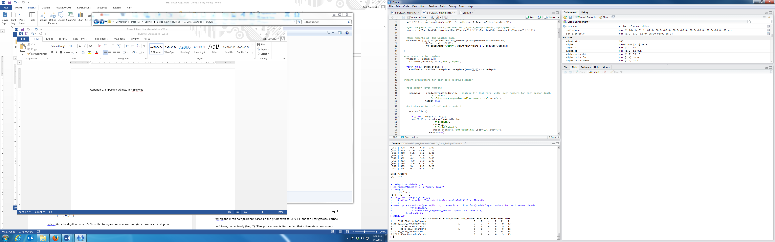

obs = list of matrices of volumetric water content measurements for each site

