# 财务-云服务收入每月分摊确认

* 分摊总表

|  |  |  |  |  |  |  |  |  |  |  |  |  |  |  |
| --- | --- | --- | --- | --- | --- | --- | --- | --- | --- | --- | --- | --- | --- | --- |
| 统计时间：2019-04-04 | |  |  |  |  |  |  |  |  |  |  |  |  |  |
| 包年包月所有云服务收入确认 | | |  |  |  |  |  |  |  |  |  |  |  |  |
| 计算思路： | |  |  |  |  |  |  |  |  |  |  |  |  |  |
| 按财务要求，对于已入账的收入，分阶段确认； | | |  |  |  |  |  |  |  |  |  |  |  |  |
| 启用日在统计期间起始日之前，且到期日大于期间截止日，计入当期收入确认 | | | | | | |  |  |  |  |  |  |  |  |
| 月份 | 起始日 | 截止日 | 起始条件 | 起始表达式 | 截止条件 | 截止表达式 | 月收入确认（总计） | 云会议方数 | 硬件端口云服务 | 延保服务 | 云存储 | H.323方数 | 直播包年 | 固定方数云会议室 |
| Nov-17 | 2017-11-1 | 2017-11-30 | <= | <=43069 | > | >43069 | 25055.00 | ¥20,473.33 | ¥0.00 | ¥1,833.33 | ¥479.17 | ¥962.50 | ¥0.00 | ¥1,306.67 |
| Dec-17 | 2017-12-1 | 2017-12-31 | <= | <=43100 | > | >43100 | 47898.25 | ¥36,819.50 | ¥2,326.25 | ¥2,262.50 | ¥758.33 | ¥1,925.00 | ¥0.00 | ¥3,806.67 |
| Jan-18 | 2018-1-1 | 2018-1-31 | <= | <=43131 | > | >43131 | 69458.75 | ¥50,370.00 | ¥5,880.42 | ¥3,050.00 | ¥1,133.33 | ¥3,525.00 | ¥0.00 | ¥5,500.00 |
| Feb-18 | 2018-2-1 | 2018-2-28 | <= | <=43159 | > | >43159 | 82397.83 | ¥58,077.00 | ¥6,671.67 | ¥4,604.17 | ¥1,379.17 | ¥4,387.50 | ¥705.00 | ¥6,573.33 |
| Mar-18 | 2018-3-1 | 2018-3-31 | <= | <=43190 | > | >43190 | 104421.25 | ¥69,070.83 | ¥8,443.75 | ¥6,441.67 | ¥1,850.00 | ¥5,350.00 | ¥705.00 | ¥12,560.00 |
| Apr-18 | 2018-4-1 | 2018-4-30 | <= | <=43220 | > | >43220 | 139145.33 | ¥91,100.33 | ¥14,766.67 | ¥7,314.17 | ¥2,116.67 | ¥7,362.50 | ¥705.00 | ¥15,780.00 |
| May-18 | 2018-5-1 | 2018-5-31 | <= | <=43251 | > | >43251 | 184096.08 | ¥125,398.17 | ¥18,222.92 | ¥9,068.33 | ¥2,291.67 | ¥8,325.00 | ¥1,410.00 | ¥19,380.00 |
| Jun-18 | 2018-6-1 | 2018-6-30 | <= | <=43281 | > | >43281 | 223202.42 | ¥141,142.83 | ¥29,257.08 | ¥12,735.00 | ¥2,966.67 | ¥9,287.50 | ¥2,820.00 | ¥24,993.33 |
| Jul-18 | 2018-7-1 | 2018-7-31 | <= | <=43312 | > | >43312 | 302238.33 | ¥157,195.83 | ¥52,614.17 | ¥14,801.67 | ¥3,379.17 | ¥11,912.50 | ¥30,315.00 | ¥32,020.00 |
| Aug-18 | 2018-8-1 | 2018-8-31 | <= | <=43343 | > | >43343 | 325770.17 | ¥173,728.50 | ¥67,600.83 | ¥19,135.00 | ¥4,095.83 | ¥13,875.00 | ¥7,755.00 | ¥39,580.00 |
| Sep-18 | 2018-9-1 | 2018-9-30 | <= | <=43373 | > | >43373 | 374206.50 | ¥193,069.83 | ¥82,079.17 | ¥23,485.00 | ¥4,358.33 | ¥17,112.50 | ¥7,755.00 | ¥46,346.67 |
| Oct-18 | 2018-10-1 | 2018-10-31 | <= | <=43404 | > | >43404 | 426060.50 | ¥219,944.67 | ¥95,858.33 | ¥27,480.83 | ¥5,650.00 | ¥18,200.00 | ¥9,400.00 | ¥49,526.67 |
| Nov-18 | 2018-11-1 | 2018-11-30 | <= | <=43434 | > | >43434 | 490536.42 | ¥243,010.83 | ¥113,223.75 | ¥28,401.67 | ¥5,550.00 | ¥22,387.50 | ¥12,220.00 | ¥65,742.67 |
| Dec-18 | 2018-12-1 | 2018-12-31 | <= | <=43465 | > | >43465 | 581303.67 | ¥260,322.83 | ¥166,791.67 | ¥36,101.67 | ¥5,795.83 | ¥24,575.00 | ¥15,296.67 | ¥72,420.00 |
| Jan-19 | 2019-1-1 | 2019-1-31 | <= | <=43496 | > | >43496 | 622488.25 | ¥262,673.67 | ¥183,602.08 | ¥37,685.00 | ¥6,475.00 | ¥25,662.50 | ¥16,001.67 | ¥90,388.33 |
| Feb-19 | 2019-2-1 | 2019-2-28 | <= | <=43524 | > | >43524 | 651794.08 | ¥270,979.50 | ¥193,336.25 | ¥36,964.17 | ¥7,083.33 | ¥25,862.50 | ¥15,296.67 | ¥102,271.67 |
| Mar-19 | 2019-3-1 | 2019-3-31 | <= | <=43555 | > | >43555 | 724771.75 | ¥291,824.67 | ¥223,223.75 | ¥36,235.00 | ¥7,558.33 | ¥30,337.50 | ¥16,863.33 | ¥118,729.17 |
| Apr-19 | 2019-4-1 | 2019-4-30 | <= | <=43585 | > | >43585 | 701664.50 | ¥271,442.83 | ¥221,160.00 | ¥35,695.83 | ¥7,708.33 | ¥28,325.00 | ¥16,863.33 | ¥120,469.17 |
| May-19 | 2019-5-1 | 2019-5-31 | <= | <=43616 | > | >43616 | 652395.42 | ¥237,068.33 | ¥215,453.75 | ¥33,566.67 | ¥7,504.17 | ¥27,275.00 | ¥16,158.33 | ¥115,369.17 |
| Jun-19 | 2019-6-1 | 2019-6-30 | <= | <=43646 | > | >43646 | 615910.83 | ¥223,026.67 | ¥204,846.67 | ¥30,275.00 | ¥6,858.33 | ¥26,400.00 | ¥14,748.33 | ¥109,755.83 |
| Jul-19 | 2019-7-1 | 2019-7-31 | <= | <=43677 | > | >43677 | 566788.75 | ¥202,597.50 | ¥190,545.42 | ¥28,062.50 | ¥6,445.83 | ¥23,775.00 | ¥12,633.33 | ¥102,729.17 |
| Aug-19 | 2019-8-1 | 2019-8-31 | <= | <=43708 | > | >43708 | 520661.67 | ¥188,343.33 | ¥176,444.17 | ¥23,554.17 | ¥5,758.33 | ¥21,812.50 | ¥9,813.33 | ¥94,935.83 |
| Sep-19 | 2019-9-1 | 2019-9-30 | <= | <=43738 | > | >43738 | 478408.75 | ¥170,625.83 | ¥164,961.25 | ¥19,087.50 | ¥5,554.17 | ¥18,837.50 | ¥9,813.33 | ¥89,529.17 |
| Oct-19 | 2019-10-1 | 2019-10-31 | <= | <=43769 | > | >43769 | 416874.17 | ¥133,892.50 | ¥152,509.17 | ¥14,800.00 | ¥4,204.17 | ¥17,137.50 | ¥8,168.33 | ¥86,162.50 |
| Nov-19 | 2019-11-1 | 2019-11-30 | <= | <=43799 | > | >43799 | 340762.08 | ¥100,944.17 | ¥137,774.58 | ¥9,725.00 | ¥3,941.67 | ¥13,212.50 | ¥5,348.33 | ¥69,815.83 |
| Dec-19 | 2019-12-1 | 2019-12-31 | <= | <=43830 | > | >43830 | 246664.17 | ¥78,461.67 | ¥85,285.00 | ¥4,645.83 | ¥3,445.83 | ¥10,325.00 | ¥3,938.33 | ¥60,562.50 |

* 月度分摊明细

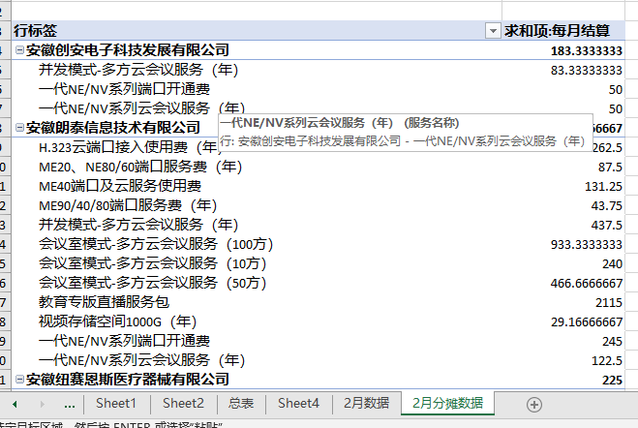

# 财务-伙伴订单销货情况

对照crm，补齐开机绑定判定

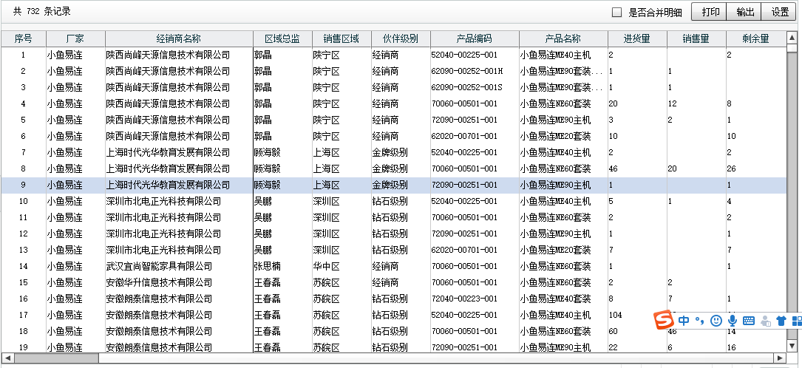

首次绑定开机

select de.device_sn,de.device_category,device_display_name,(case when bind.first_bind_timestamp is null then de.bind_timestamp else bind.first_bind_timestamp end ) as first_bindtime from ainemo.libra_user_device de

left join ainemo.libra_nemo_first_bindtime bind

on de.device_sn = bind.nemo_sn

where de.device_type in ('2','8') and in_use ='1' and device_expire_time != '-1';

select de.device_sn,de.device_category,device_display_name,de.bind_timestamp from ainemo.libra_user_device de where de.device_type = '7' and in_use ='1' and device_expire_time != '-1';

# 产品部-每周端口到期提醒，定时邮件送达

|  |  |  |  |  |  |  |
| --- | --- | --- | --- | --- | --- | --- |
| 终端号 | 终端名称 | 端口到期日 | 客户 | 渠道负责人 | 区总 | 大区总 |
| 326428 | 智能视频（青岛） | 2019-4-10 | 山东祥云世纪电子有限公司 | 景杰 | 栾凤平 | 王硕 |
| 971208 | 智能视频终端 | 2019-4-11 | 莱西环亚电脑科技有限公司 | 景杰 | 栾凤平 | 王硕 |
| 962474 | 智能视频终端 | 2019-4-11 | 青岛四通天运商务有限公司 | 景杰 | 栾凤平 | 王硕 |
| 20318176 | 视频会议终端 | 2019-4-12 | 深圳市思玥科技有限公司 | 李灿 | 吴鹏 | 李军 |
| 20671048 | 深圳总部-206会议室 | 2019-4-13 | 电连技术股份有限公司 | 李灿 | 吴鹏 | 李军 |

# 产品部-App增长数据（done）