ClearCase Task Development Procedure
Chicago Board Options Exchange

July 20, 2000

Table of Contents
Introduction 1
Goals 1
Required Skills 1
Developers 1
Configuration Manager 1
Integration Manager 1
Project Manager 1
Process Flow 1
Normal Flow 2
Alternative Flow 4
Dependent Tasks 4
Embedded Tasks 5
Multiple Dependencies 6
Synchronizing to a Baseline 6
Description 6
Integration Merge Process 7
Description 7
Steps for Creating a New Task 8
Description 8
Process Example 9
SBT Process Example 10
SBT Infrastructure Process Example 16
Definitions 18

Introduction

This document addresses the ClearCase task development procedure for the Screen Based Trading (SBT) system. It describes the process flow and includes examples that depict the process from the development stage through the new baseline integration.

Goals
There are two main goals for this process.
- Create an environment in which developers can write code without being disrupted by untimely changes to the code base upon which they are dependent.
- Be able to release the minimum set of functionality requested by either system test or production users.

Required Skills
The Developers, Configuration Managers (CM), Integration Managers (IM) and Project Managers require certain skills to perform their assignments. This section lists the necessary skills for each individual involved in the process.

Developers
- check-in
- check-out
- create elements
- setting a config spec

Configuration Manager
- all developer skills
- creation of config specs
- creation of branch types
- creation of label types
- creation of labels

Integration Manager
- Requires all CM skills, however finding needed merges and file merges are frequent.

Project Manager
- Ability to reasonably divide system functionality into a set of independent functions. This may of course be the result of collaboration from many people including developers, users and architect.

Process Flow
This section details the ClearCase task development process flow. It describes a normal flow scenario and an alternative flow scenario.

Normal Flow
- The Project Managers define tasks so that no incomplete dependencies exist between the tasks. This is not absolutely necessary but is highly desirable. The better the independence between tasks the more cleanly the process will work. The process does however support an imperfect planning stage.
- At the Project Managers request, the CM creates a branch type in all applicable vobs for each task. The branch type is created after work for that task is to be performed.
- Branches identify the work being performed through the name, of the branch type.
- Build time problems that occur during integration are corrected directly on the branch representing the integration.
- The following are examples of the different kinds of task branches used and their naming conventions.
Branch Naming Conventions | Description | Example
dev_XYZ | A SBT task development branch. | /dev_busttrade
integration | System test integration branch. | /integration
sbt_X.XX | SBT development integration branch type.  Development integration branches are used to combine multiple streams of development to a single place prior to promoting to the ‘integration’ branch. | /sbt_5.01  - The number 5 represents the increment number.  - .01 represents the first baseline version.
if_X.XX | IF development integration branch type. | /if_5.05  - Same meaning as the sbt_X.XX just for the IF layer
cf_X.XX | CF development integration branch type. | /cf_6.05  - Same meaning as the sbt_X.XX just for the CF layer

- An IM is officially assigned to the development task. The IM will be responsible for that tasks ClearCase needs from this point forward.
- At the Project Managers request, the CM creates and publishes a config spec for each task.
- The IM validates the config spec to make sure that the baseline and the config spec are correct for the task. This includes validating that the baseline makes sense for the task.

- Each Developer creates a view for each task they will work on. It is possible that more than one person may work on a task but each person works in a separate view. Never use the same view for multiple CONCURRENT OR SERIAL tasks. Each task should be done in a new, separate view to ensure the integrity of each task.
- Once the view, branch type and config specs are created, it is business as usual. Developers check-in and check-out files as needed to complete their work. When multiple developers are working on a single task, it is advisable that the developers working on the branch coordinate changes to minimize the instability of the branch.
- When a task is complete, the Developer notifies the appropriate managers (CM, IM, Project Managers, etc.).

For the Developer to consider the task complete the following must be true.
- No checkouts can exist on that task branch (in any view).
- All code must compile error and preferably warning free.
- The system’s runtime behavior should be at a level that if this were the only task completed, it could be submitted to system test as is.

- The Project Managers and Architect decide which completed tasks should get merged to the development integration branch. Other factors besides just the task’s completed status may determine whether that task should be integrated.

- The Project Manager notifies the IM to merge the completed development branch to the development integration branch.

- The IM performs the integration merge as described in the section “Integration Merge Process.”

- The IMs, at the discretion of the development teams and Project Managers, synch the outstanding development branches to the latest baseline. This process is described in “Synchronizing to a Baseline.”

Alternative Flow
The normal flow is the perfect world case and the alternative flows are only needed when a planning error occurs or a bug is found that is needed to continue work on the new functionality. Since bugs and planning errors do occur in the real world, the alternative flows address how to deal with them. All of these cases have to do with dependencies that were not known, detected, or ignored prior to the start of a task. All of these flows then deal with what happens after development begins and before it is complete. This is all within step 7 from the main flow.

Dependent Tasks
This situation arises in several cases. First, when two tasks start with the intention of being independent but it turns out that one task needs the other task to complete the work. Second, this occurs when bugs are found after a task is started. And finally, this could occur when two tasks are started intentionally in parallel when it is known that there is a dependency. This is useful to keep stable the work on each independent branch and allow otherwise dependent tasks to occur in parallel. The process described works the same independent of the reason for the dependency.
- The developer determines that he needs the work located on another branch.
- The developer should complete as much work as possible without having the needed dependency.
- Once the other work on the other branch is completed and merged into the development integration branch, the integration manager can synchronize with the new baseline (see the section below on Synchronizing to a Baseline).
- Once the development branch is synchronized to the new baseline, work continues as usual.

Embedded Tasks
The next situations arises when a task started with the intention of being a single task turns out to be two tasks and the embedded task is needed by another task. There are multiple possibilities.
- Break out the embedded task and move it to its own task branch.
- Complete the work
- Merge the change back to the development integration branch as described in the section “Integration Merge Process.”
- The Project Manager will ask developers in need of that functionality to synchronize to the new baseline as described in the section “Synchronizing to a Baseline.”
or
- Complete all the work on the branch with the embedded task.
- Merge the branch back to the development integration branch as described in the section “Integration Merge Process.”
- The Project Manager will ask developers in need of that functionality to synchronize to the new baseline as described in the section “Synchronizing to a Baseline.”
This second alternative does not work when the embedded task is a bugfix that needs to be released independently of the new functionality being developed on the branch.

Multiple Dependencies
In this case, a third task needs the functionality in two tasks that are complete but not able to be merged to the increment branch. This involves the creation of an independent integration branch to satisfy the dependency. New development will then occur relative to this auxiliary integration branch. Pre_sbt500 is the first naming example used in this type of scenario, but a good naming standard will need to be established since there may be many of these intermediate development/merge areas.

Once all the tasks have been merged and problems solved in the "pre-merge" branch, the tasks will be ready for synchronization to a baseline.

Synchronizing to a Baseline

Description

The following are the steps the IM must perform in order to synchronize to a new baseline.

- The IM creates a new view to perform the synchronization.

- The IM updates the config specs in vobs\dte\dte_admin\config_specs\. For example, the task “update_order” is using SBT_5.01 as the baseline. There is a bugfix in SBT_5.01.01 that is needed to complete the update_order task. The following config spec will allow the update_order task to change from using the SBT_5.01 baseline to the SBT_5.01.01baseline.

element *…/sbt_5.01/SBT_5.01.01
element * …/sbt_5.01/0

mkbranch /sbt_5.01
element * …/integration/SBT_5.01
element * …/integration/0
end mkbranch /sbt_5.01

- The IM uses the new config spec for the synchronization.

- The IM locks the branch that needs to be synchronized. (ideal, but we are not doing this)

- The IM runs the "findmerge" command or uses the "Merge Manager" tool to determine which files need to be merged.

- The IM merges each file indicated. (Checked-out files on the branch will not be able to be merge, see the following step)

- For each file that is already checked-out by a developer on that branch, the IM asks that developer to either checkin the file or unreserve the checkout. The IM will need to unlock the branch prior to the developers being able to unreserve, checkin or uncheckout files.

- If step 7 was necessary, go back to step 4 otherwise continue to the next step.

- The IM works with the developers as necessary to resolve merge problems.

- The IM performs a full build after the merges are complete.

- The IM works with the developers as necessary to resolve build problems.

- Once all the build/merge problems are resolved, the merged files are checked-in.

- The IM unlocks the branch.

- The IM informs the team (via email) that a new config spec is available in /vobs/dte/dte_admin/config_specs/

- The IM deletes the view that was created for synchronization.

- For each developer that may have unreserved checkouts during this process, the IM should help them perform merges from the LATEST on the branch to their unreserved checkouts and .

Integration Merge Process

Description

This section describes the integration merge process. The following details the IM's responsibilities throughout the process.

- The Project Manager notifies the entire "IM Team" via e-mail that a particular branch is about to merge back to the development integration branch.
- The IM performs the merge using the “findmerge” command or the “Merge Manager” tool. All merges during an integration merge should be trivial merges. If not, a synchronization merge was probably missed. Although uncommon, there are some cases where ClearCase will indicate that a merge is non-trivial when in fact it is trivial. When non-trivial merges occur the IM must validate that each merge is actually trivial. If any merge is not trivial the synchronization process should be followed before the integration merge occurs. See the section “Definitions” for an explanation of trivial and non-trivial merges.
- The IM compiles the LATEST on the development integration branch.

- The IM installs the new jars.

- The IM checkpoints the development integration branch using the /vobs/dte/dte_amdin/config_specs/tools/createCheckpoint.ksh script.

Layer | VOBs
IF | infrastructure (only those files that are NOT labeld CF )
CF | FoundationFramework  infrastructure (For the specifics see the createCheckpoint.ksh script. In general, it is all source code and the jars created from that source except for idl).  SessionManagementService  CommonFacilities
SBT | domain  server  client  sysAdminClient  simulator  gui

- The IM updates the baselines spreadsheet with the new label information. The spreadsheet is located in the documents vob under "/vobs/dte/documents/dte/development_process/baselines.xls".
- The IM distributes an e-mail to the entire "IM Team" and Odalys notifying them that the baseline is stable and checked in.

Steps for Creating a New Task

Description
This process will setup the environment so each developer can begin editing configuration items. It is performed once at the beginning of a task and is necessary to perform before beginning that task.

- The Project Manager defines the new task.
- The Project Manager notifies the CM of the new task and provides the following information:
- Task name (or identifier of some sort)
- The identifier for bugfix could be the DDTS tracking ID
- The identifier for new development could be some project plan identifier
- Baseline
- Task Type, “bugfix” or “new development”

- The CM creates the branch type and config spec.
- The CM creates the branch type in all development vobs.
- If the task type is “New Development,” the branch type is:
- Format:
dev_<task name>
- Examples:
dev_12345
OR
dev_maintain_users
- The CM creates NT and UNIX versions of the config spec.
- The CM checks-in the config specs in the dte_admin vob in the config_specs directory.
- The CM notifies the Project Manager that the task is ready to be started.

- The Project Manager notifies the team that development work may begin.

- Each Developer working on the task creates a view and sets the config spec on either NT or UNIX

NT
- Create the view
- Run the program> Start-> Programs -> Clearcase -> Create View
- Press the Dynamic button
- Enter the view name
- Format:
<login name>_<task name>_nt
- Example:
samuels_update_user_nt
- Enter the view storage location (this must be in UNC format.)
- Press Next
- Press Finish
- Choose the drive letter to which this view will be connected
- Press OK
- Set the config spec
- Open the Clearcase properties dialog for the view
- Open the config spec located m:\<view name>\dte_admin\config_specs\. Choose the config spec with your task name.
- Format:
<task name>.nt.cs
- Example:
update_user.nt.cs

UNIX
- Create the view
- Run the program Start -> Run
- Enter: telnet dte_dev
- Enter unix login name
- Enter unix password
- Enter the command:
- Format:
/usr/atria/bin/cleartool mkview –tag <view name> /net/dte_dev/tools/views/<view name>.vws
- Example:
/usr/atria/bin/cleartool mkview –tag samuels_update_user_unix /net/dte_dev/tools/views/samuels_update_user_unix.vws
- Set the view
- cleartool setview <view name>
- Set the config spec
- Change to the directory /vobs/dte/dte_admin/config_specs.
- Enter the command
- Format:
/usr/atria/bin/cleartool setcs –tag <view name> <task name>.unix.cs
- Example:
/usr/atria/bin/cleartool setcs –tag samuels_update_user_unix update_user.unix.cs
- Synchronize the UNIX view for use under NT
- Run the program> Start -> Programs -> Clearcase Administration -> Region Synchronizer
- Choose the view name from the list of view names presented.
- Press the import button
- A dialog appears, choose “OK”

Process Example
This section describes the process flow using a generic example. For ease of understandability, the process is illustrated using three examples. Each example builds on the previous example until the entire process is depicted.

SBT Process Example

Example 1

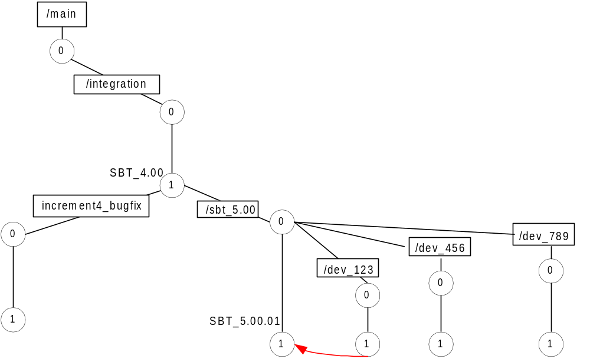
- In this scenario, to the left of the integration branch the Developers work on increment 4 bug fixes that did not make the integration cutoff date, system test date or production date. The increment 4 bug fix branch is named increment4_bugfix reflecting the bug fix branch naming convention. One version of bug fix changes has occurred in this illustration.

- Increment 5 development is depicted to the right of the integration branch. The branch named /sbt_5.00 represents the baseline branch.

- Three development branches have been created from /sbt_5.00: /dev_123, /dev_456 and /dev_789. These development branches correspond to development tasks (e.g. /dev_bust_trade).

- A development team is assigned to each task.

- The CM creates config specs for the development branches.

- The development team retrieves the new config spec from ClearCase.

- The team working on /dev_123 creates a view for the task and begins working on the branch. In this example, one version of the task has been created.

- The team must make sure that all development problems have been fixed before performing a merge to the baseline branch, /sbt_5.00.

- The IM performs the merge. The merge occurs from the latest version of the /dev_123 branch to the baseline branch, /sbt_5.00, thus creating a new version of /sbt_5.00. A new version is created in order to identify the differences from the previous version.

- The IMlabels the new version, SBT_5.00.01reflecting the SBT labeling convention.

- At this point, the /dev_123 task is complete.

- Each development team that needs to incorporate the changes in SBT_5.00.01 into their code must first edit their config specs to include the new label name. The CM is responsible for this task. The developer only needs to be concerned with retrieving the config spec from ClearCase.

- Simultaneously, two other teams are working on /dev_456 and /dev_789. Both development branches have created one version of the task. In this setting, neither task is ready to be merged into the baseline branch.

Example 2
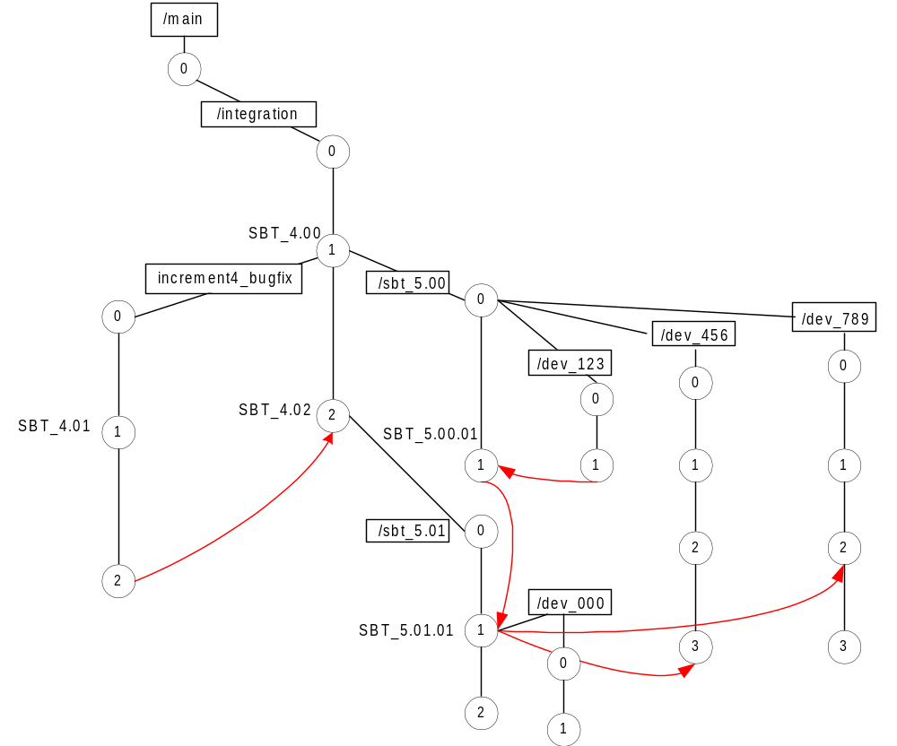
- In this example, the CM created a release label, SBT_4.01, for version 1of the increment4_bugfix branch.

- Developers requiring the use of this new release will need to retrieve the config spec from ClearCase.

- A second version is created on the increment4_bugfix branch to continue work on bug fixes.

- Version 2 is thoroughly tested by the developer before merging into the integration branch.

- The integration manager performs the merge from the bug fix branch into the integration branch.

- A new version (version 2) is created on the integration branch. Again, a new version is created in order to differentiate between the previous version (version 1) and the new version (version 2).

- The new version is labeled SBT_4.02.

- At this state, all increment4_bugfixes are complete.

- On the baseline side, a new version is created to incorporate the bug fix changes.

- The new version is labeled /sbt_5.01 by the integration manager.

- The previous development integration branch (version 1), labeled SBT_5.00.01, must be merged into /sbt_5.01 in order to combine the baseline functionality with the increment 4 bug fixes.

- The IM creates a new version in order to differentiate between the previous version and the new version.

- The new version is labeled SBT_5.01.01 representing the first change on the development integration branch named /sbt_5.01.

- At this point a new development branch is created, /dev_000, from SBT_5.01.01.

- Version 1is created on development branch /dev_000 to enable differentiation between the previous version and the current version.

- Development branch /dev_456 requires the functionality from SBT_5.01.01. Therefore, it must be synchronized to the new baseline.

- SBT_5.01.01 is merged out to version 3 of the /dev_456 branch to ensure that everything works properly before merging it back to the baseline branch.

- Development branch /dev_789 is ready to be merge into the baseline branch. Before this can be accomplished, /dev_789 must test with the functionality in SBT_5.01.01 to ensure a stable environment.

- SBT_5.01.01 is merged out to version 2 of the /dev_789 branch. In this scenario, the merge was unsuccessful. Therefore, /dev_789 must stabilize the environment before merging back to the baseline branch.

- Version 3 on /dev_789 is created to work on stabilizing the environment.

Example 3

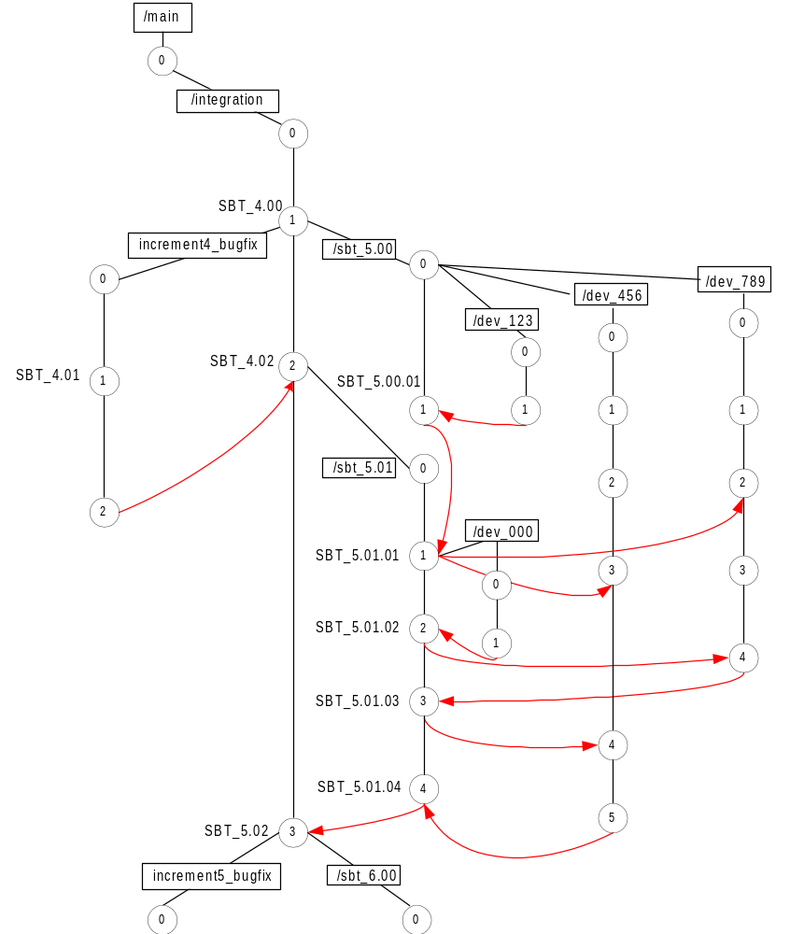

- /dev_000 is merged into the baseline branch, thus creating a new version.

- The new version is labeled SBT_5.01.02 representing the second change in the baseline branch named /sbt_5.01.

- Development branch /dev_000 is now complete.

- Development branch, /dev_789 is ready to be merge into the baseline branch. Before this event takes place, SBT_5.01.02 is merged out to the development branch to ensure a stable environment.

- The merge is successful and /dev_789 is merged back into the baseline branch.

- A new version is created on the branch and it is labeled SBT_5.01.03, representing the third change in the /sbt_5.01 branch.

- Development branch /dev_789 is now complete.

- Development branch /dev_456 is ready to be merged into the baseline branch.

- SBT_5.01.03 is merged out to /dev_456 to ensure a stable environment.

- The merge is unsuccessful, therefore, version 5 is created on /dev_456 to work on stabilizing the environment.

- After the environment is stabilized, /dev_456 is merged back into the baseline branch, thus creating version 4 on the branch.

- Version 4 is labeled SBT_5.01.04 by the IM.

- Development branch /dev_456 is now complete.

- SBT_5.01.04 on the baseline branch must now be merged into the integration branch.

- The IM performs the merge and labels the integration branch SBT_5.02.

- The increment 6 development process is now ready to begin.

- Increment 6 begins with a bug fix branch labeled increment5_bugfix, an integration branch labeled SBT_5.02 and a development branch labeled /sbt_6.00. The development branch is labeled following the SBT development branch labeling convention of x + 1, x representing the previous increment number.

- At this point, the ClearCase task development process starts again with modifying confic specs, assigning tasks, etc.

SBT Infrastructure Process Example
This section describes the SBT infrastructure process. The process is the same as the previous example, except for differences in the naming conventions.

Example Infra_1

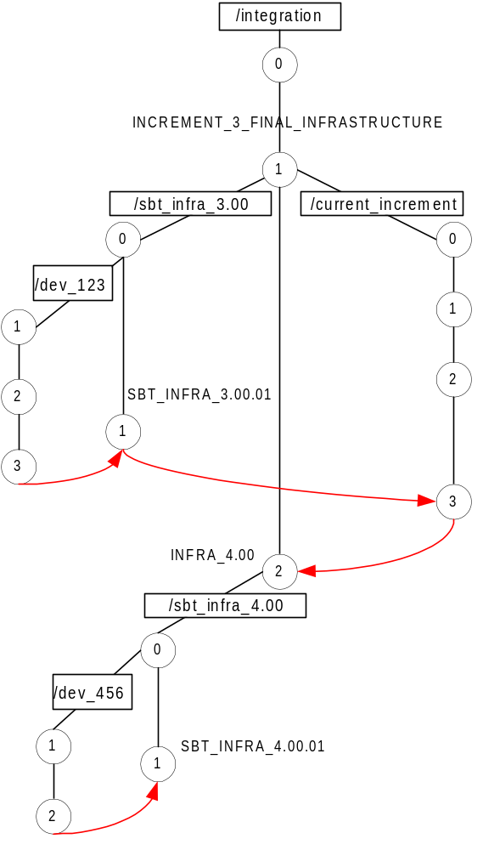
- In this example the integration branch is labeled INCREMENT_3_FINAL_INFRASTRUCTURE representing the SBT Infrastructure labeling convention.

- From the integration branch, a development branch is created and named, /sbt_infra_3.00 by the integration manager.

- A new development task is created on this branch and labeled /dev_123. Work continues on this branch until version 3.

- Once, version 3 of /dev_123 is ready to be merged with the SBT infrastructure baseline, a new version is created by the integration manager to incorporate the changes.

- The new version is labeled SBT_INFRA_3.00.01 representing the first change in increment 3 infrastructure.

- On the /current_increment branch, three versions have been created.

- SBT_INFRA_3.00.01 on the baseline side is merged into version 3 on the /current_increment branch.

- /current_increment is merged into the integration branch and is labeled, INFA_4.00 following the SBT infrastructure naming convention.

- At this point, the process starts again. The CM creates labels and config specs for new development.

Definitions
Task
The minimal and sufficient amount of work required to add or fix a piece of system functionality and still leave the system in a consistent, usable state.
Trivial Merge
Trivial merges are merges that are guaranteed to work. No human intervention is ever needed and ClearCase completes the merge automatically.
Automatic Merge
Automatic merges are merges that ClearCase was able to perform without conflict, but there is a possibility that the end result is undesirable. When using a typed language such as Java, it is rare that an automatic merge will produce a result that is ill-formed yet still compiles; therefore, it is excessive to check every automatic merge for correctness.
Failed Merge

Failed merges require manual intervention to resolve. These are cases where two files are changed in the same place and ClearCase cannot determine the proper result of the merge. The developers implementing the changes will be required to fix failed merges.

