Monitoring Coppelia With FIXometer
FIXometer is a GUI tool that you can use to monitor and perform administrative tasks for one or more Coppelia servers. Like all Javelin products, FIXometer is a 100% pure Java application. It runs on all Java-supported platforms.

Features
FIXometer has the following features:
- Runs on all Java-supported platforms - FIXometer is a Java application that can run on UNIX and Windows operating systems.
- Monitors sessions statistics - You can configure FIXometer to display session statistics for all monitored Coppelia servers such as connection status and number of orders sent and received, etc. FIXometer updates the statistics in real time. See the sections below for a complete list of monitored fields.
- Controls Coppelia servers - From the FIXometer command console, authorized users can execute all Coppelia commands, such as connecting and disconnecting counterparties, altering inbound and outbound message sequence numbers, and running End-of-Day processing.
- Recognizes High Availability clusters - FIXometer actively monitors each Coppelia server's role in a High Availability cluster. It displays cluster members under a node in FIXometer's server topology tree, using distinct icons to indicate server state (primary/backup).
- Triggers event and alarms - You can configure FIXometer to provide visual and audio alarms when a server comes up or goes down, when a connection is broken, or when a server exceeds its threshold for queued messages.
- Provides multiple access levels - A security feature can be enabled to allow only authorized users to issue manipulative commands against monitored Coppelia servers.
- Monitors API connections - FIXometer can monitor client middleware connections (client applications). Using FIXometer, you can monitor messages queues between client applications and Coppelia.
- Monitors Coppelia internals - You can view Coppelia’s internal queues and threads. You can monitor both blocking and sequence queues. You can also see how many threads are running and what their priorities are.

Terms Used
It is essential to understand the difference between Server Groups and Servers in order to properly configure FIXometer.
- Server Group – A logical group of servers that function together in a High Availability (HA) cluster. If your servers are not part of an HA cluster, your Server Groups will contain only one Server.
- Server – A Server represents one instance of Coppelia. For HA installations, a Server is not the HA cluster, but rather an individual member of the cluster.
Note: For more information on HA, please refer to the chapter on High Availability.

Starting FIXometer
Your installation comes with startup scripts to run FIXometer for either UNIX or Windows operating systems. FIXometer requires a configuration (.ini) file. This file, which is described in detail later in the chapter, contains various configuration settings. The most important of these settings informs FIXometer how to find the Coppelia servers on the network. Your installation comes with a default configuration file called fixometer.ini, which is set to monitor the default Coppelia Buy and Sell side server configurations that ship with the product.
Note: To monitor the Coppelia servers in your production environment, you must tailor the default configuration file. You will learn how to do this later in the chapter, but first, we will show you FIXometer’s many features.

Windows NT/2000
To start FIXometer in a Windows environment, use the fixometer.bat file, included with the installation. You will find the script in the ...\utils\FIXometer folder, relative to where Coppelia is installed. The script uses the classes and Java libraries supplied with Coppelia.

Sample Windows Script
set PATH=.;c:\tools\jdk1.3\bin
set APPIA=c:\Javelin\Coppelia\lib
set CLASSPATH=%CLASSPATH%;%APPIA%\coppelia.jar;%APPIA%\fixometer.jar
set CLASSPATH=%CLASSPATH%;%APPIA%\jmf.jar;%APPIA%\javtech.jar;.
set CLASSPATH=%CLASSPATH%;%MY_DATABASE_CLASSES%
java -classpath %CLASSPATH% com.javtech.fixometer.FIXometer fixometer.ini

UNIX
To start FIXometer in a UNIX environment, use the FIXometer.sh script, included with the installation. You will find the script in the .../utils/FIXometer directory, relative to where Coppelia is installed. The default script makes use of the classes and Java libraries supplied with Coppelia.

Sample UNIX Script
#!/bin/sh
export PATH=.:$PATH:/usr/local/bin/JRE1.3/
export APPIA=/usr/Javelin/Coppelia/lib
CLASSPATH=$CLASSPATH:$APPIA/coppelia.jar:$APPIA/fixometer.jar
CLASSPATH=$CLASSPATH:$APPIA/jmf.jar:$APPIA/javtech.jar:.
export CLASSPATH=$CLASSPATH:$MY_DATABASE_CLASSES
java –classpath $CLASSPATH com.javtech.fixometer.FIXometer fixometer.ini

Writing Your Own Startup Script
If you need to create your own start up script or modify the ones provided by Javelin, the script must follow the same basic steps:
- Set the Path to the Java JRE executable that you are using.
- Set the classpath to include all required libraries: fixometer.jar, coppelia.jar, javtech.jar, and jmf.jar, plus any libraries that contain needed JDBC database drivers.
- Execute the class com.javtech.fixometer.FIXometer with the Java JRE and pass the path to the FIXometer configuration (.ini) file as the one and only command line argument.

The FIXometer Screen
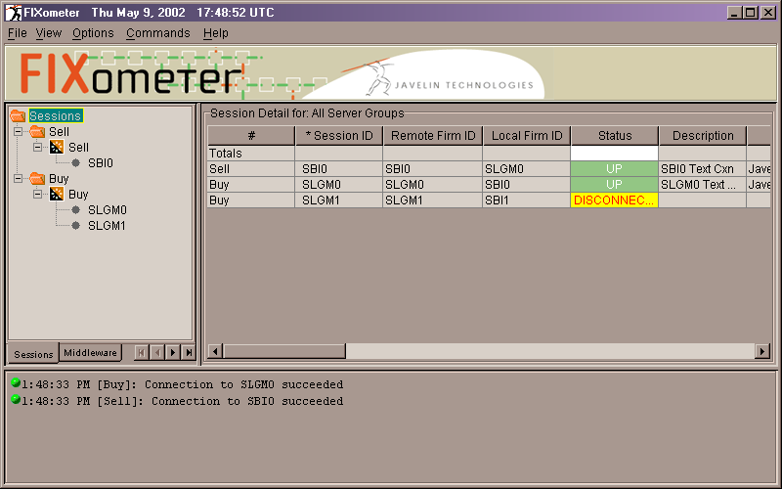
Let us examine the parts of the FIXometer screen. At the top, is a menu bar. The components of the menu bar are discussed later in the chapter. Just below the FIXometer banner on the left, you can see the server topology displayed as a tree. The root of the tree (Sessions) tells you that the leaves of the tree are the configured sessions of the monitored Coppelia servers. The first level of the tree shows the Server Groups. Below each Server Group are the member Servers of that Server Group. Under each Server are the Coppelia Sessions (Connection blocks in Coppelia’s configuration file). Although not shown here, if there are Sessions that are part of a group, FIXometer displays member Sessions under a special group node. For more information on Grouping Sessions, please refer to the chapter on Session Concepts.
To the right of the tree, is the Detail Grid, which gives the details of the Servers that are in the topology tree. FIXometer only displays the detail of those servers that you highlight in the tree view. At startup, the root of the tree is highlighted causing the details of all Sessions details to be displayed.
At the bottom of the FIXometer screen is an audit trail of FIXometer activity and monitored Coppelia server events.
In addition to monitoring and administering Coppelia Sessions, FIXometer simultaneously monitors the following information:
- Middleware connections (client application program connections).
- Coppelia’s internal Blocking and Sequence Queues.
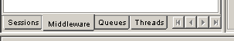
- Coppelia’s internal threads.
You can view this information by navigating the tabs under the tree topology view. If you cannot see all the tabs, use the arrows to navigate between them.

Available Statistical Information
These four tabs provide four distinct sets of statistical views, namely:
- Session view.
- Middleware view
- Queue view.
- Thread view.
For those views for which it is appropriate, FIXometer reserves the first row of the Detail Grid for column totals.
The following sections describe the various statistics that are available under each view.

Session View
The following table lists the statistics that are displayed under the Session view. Many of the statistics simply report on the Session’s configuration attribute settings in the monitored Coppelia’s .ini file. For more information on these attributes, please refer to the chapters on Session Concepts and FIX Session Concepts.
Session View Statistics
Field | Description
# | The Server Group to which the Session belongs
Session ID | The Session ID of the Session. This corresponds to the name of the Connection block in the monitored Coppelia configuration file.
Remote Firm ID | The name of the session counterparty. For FIX sessions, this is controlled by the remote_firm_id Connection block configuration attribute.
SenderCompID | The name by which the session counterparty knows the Coppelia side of the connection. For FIX sessions, this is controlled by the local_firm_id Connection block configuration attribute.
Status | Connection Status, indicated both with color and text. A series of question marks (???) indicates that no information is available about this connection. This is caused by the Coppelia instance not running at the time.
Description | Session Description. This information comes from the description configuration attribute.
Contact | Session Contact name and phone number. This information comes from the contact configuration attribute.
Net Addresses | Counterparty’s machine IP addresses. This information comes from the net_address configuration attribute.
Port | Counterparty’s machine Port number. The information comes from the remote_port configuration attribute.
Version | Protocol version being used over this Session.
Num Queued In | Number of messages queued in Coppelia (for this Session) that have not yet been handed to the client application. When there are multiple client applications connected to Coppelia, Coppelia maintains a separate queue for each. In that case, this statistic reports on the maximum inbound queue size for this particular Session. Alternatively stated, this statistics tells you that for Session x, over all applications connected to Coppelia, there are at most y messages that have not been delivered to the applications.
Num Queued Out | Number of messages for this Session that have been posted to Coppelia but have not yet been sent to the counterparty. A build-up here can be caused by a connection being down or a true backlog in Coppelia due to heavy message traffic.
Seq Num In | The next expected inbound message sequence number for this Session.
Seq Num Out | The next outbound message sequence number for this Session.
Msgs In | Number of messages received on this Session.
Msgs Out | Number of messages sent on this Session.
Bytes In | Number of bytes received on this Session.
Bytes Out | Number of bytes sent on this Session.
Last In | Time the last message was received on this Session.
Last Out | Time the last message was sent on this Session.
Rejects | Number of FIX Reject messages sent or received on this Session.
Orders | Number of FIX Orders sent or received on this Session.
Exec Acks | Number of FIX Execution Acknowledgements sent or received on this Session.
Executions | Number of FIX Executions sent or received on this Session (excluding Acknowledgement Executions).
Cancels | Number of FIX Order Cancel Requests sent or received on this Session.
Indications | Number of FIX Indications of Interest sent or received on this Session.
Allocations | Number of FIX Allocations sent or received on this Session.

Executing Commands From the Session View
You can execute Coppelia Operator Commands related to individual Sessions directly from the Detail Grid. Moving the mouse cursor over a Session and clicking the right mouse button brings up the following menu:
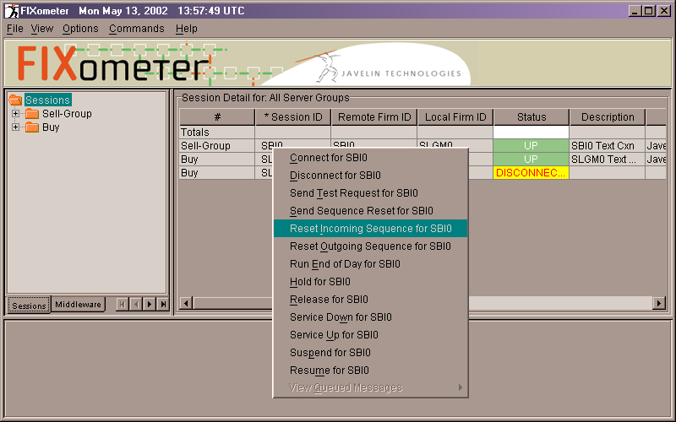

The commands available through this menu are the same as those available under the Commands menu in the main FIXometer menu. This popup is customized for the Session over which you clicked. The meanings of these commands is described below in the section on FIXometer menu Options.

Middleware View
The figure below shows what a typical Middleware view might look like. Like the Session view, the tree hierarchy on the left shows the hierarchy of Server Groups and their constituent Servers. Under each server is a list of all Middleware IDs (defined in the table below).
Under each Middleware ID is the list of inbound queues broken down by Session. An inbound queue is defined as the queue of those messages for a particular Session that are queued within the Coppelia engine that have not yet been delivered to a particular Middleware ID. A special queue, GLOBAL, holds global messages that do not pertain to a particular Session.
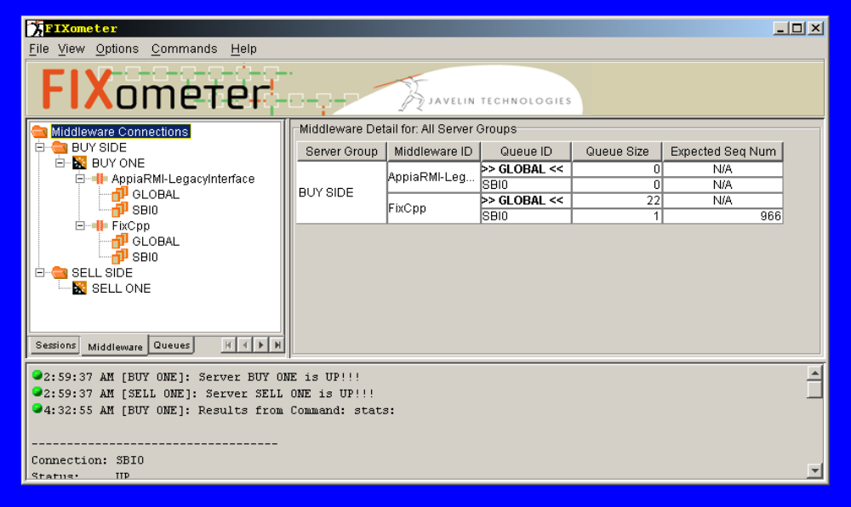The following table lists the statistics that are displayed under the Middleware view.
Middleware View Statistics
Field | Description
Server Group | The name of the Server Group as listed in the FIXometer configuration as and shown in the server hierarchy.
Middleware ID | The unique ID of a Middleware connection. In the Point-to-Point Middleware APIs (In-Process, RMI, CORBA, Socket, etc.), client applications supply this ID when they connect to Coppelia. This enables Coppelia to maintain queues for each connected application. For Message Oriented Middleware technologies (Tibco, Talarian, etc.), Middleware IDs are handled differently. Coppelia sets up the ID based on the Middleware block name in its .ini file. This is because client application does not directly connect to Coppelia.
Queue ID | The ID of each inbound queue. The queues correspond to the Session IDs. A special queue, denoted as >> GLOBAL <<, is for messages that are global to the server and do not pertain to any particular Session.
Queue Size | The number of messages currently in the inbound queue.
Expected Sequence Num | This field only contains data when Reliable Messaging is enabled for this Middleware ID. This field contains the next sequence number that Coppelia will deliver to the Middleware. If, for example, it is 100, and a message with sequence number 89 arrives, Coppelia will not deliver it to the application. For more information on Reliable Messaging, please refer to the appropriate Middleware API chapter.

Viewing Middleware Properties
In the Middleware view, right clicking over a middleware brings up a popup menu with one selection: Properties. Selecting Properties brings a dialog containing the Middleware’s configuration. Please refer to the appropriate Middleware API chapter for your installation for more information on the meaning of these configurable settings.
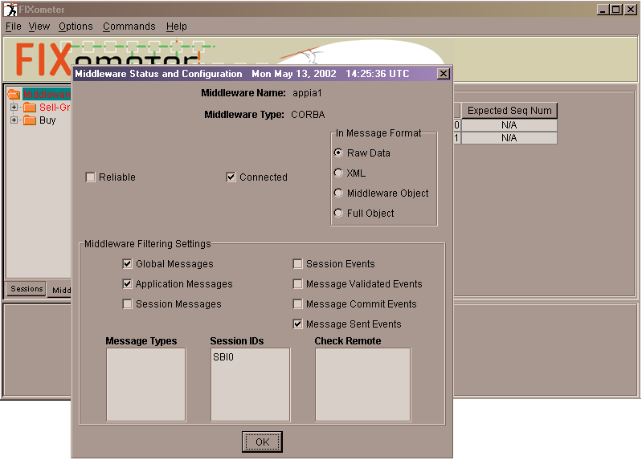

Queue View
Note: The Queue view provides information that may prove useful in diagnosing a server problem. This information is best interpreted with the help of Javelin support staff.
The figure below shows what a typical Queues view might look like. Like the views discussed in the previous sections, the tree hierarchy on the left shows the hierarchy of Server Groups and their constituent Servers. Under each server are two groupings: one for Blocking Queues and one for Sequence Queues (two different types of queues that Coppelia uses internally).
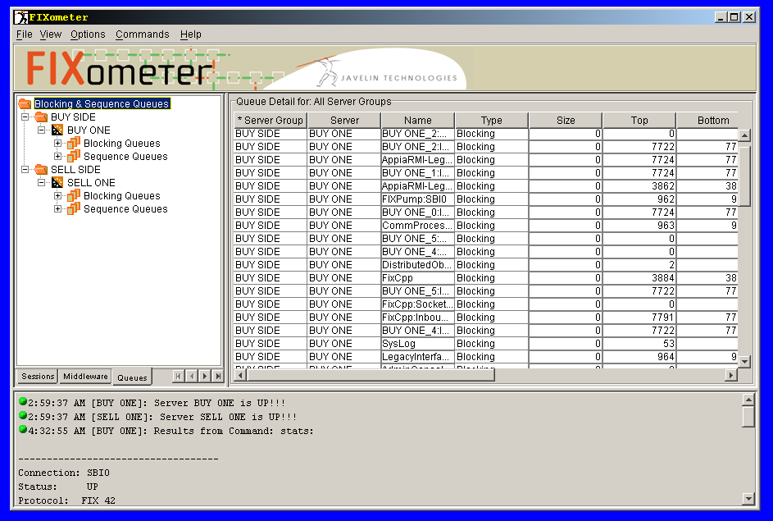

The following table lists the statistics that are displayed under the Queue view.
Queue View Statistics
Field | Description
Server Group | Name of the Server Group as listed in the FIXometer configuration as and shown in the server hierarchy.
Server | ID of the individual Server within the Server Group
Name | Internal name of the queue
Type | Queue type. Either Blocking or Sequence.
Size | Number of items currently in the queue
Top | Top used slot in the queue.
Bottom | Bottom used slot in the queue.
Sleep Count | Number of times an attempt to put to the queue was forced to sleep.
Put Fail Count | Number of times Coppelia failed when trying to add something to the queue because queue was full.
Get Fail Count | Number of times Coppelia failed when trying to get something from the queue because queue was empty.
Inbound TPS | Inbound transactions per second.
Outbound TPS | Outbound transactions per second.
Get Count | Number of retrievals from the queue.

Thread View
Note: The Thread view provides information that may prove useful in diagnosing a server problem. This information is best interpreted with the help of Javelin support staff.
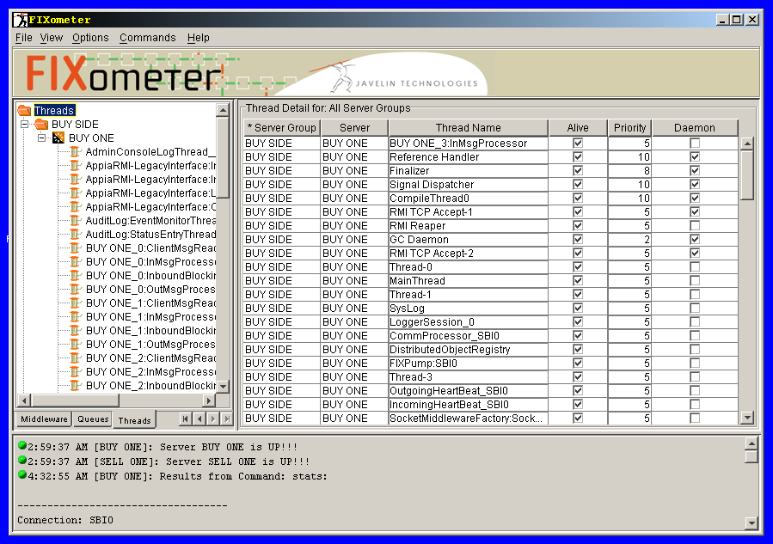
The figure below shows what a typical Thread view might look like. Like the views discussed in the previous sections, the tree hierarchy on the left shows the hierarchy of Server Groups and their constituent Servers. Under each server are listed all of Coppelia’s internal threads.
The following table lists the statistics that are displayed under the Thread view.
Thread View Statistics
Field | Description
Server Group | Name of the Server Group as listed in the FIXometer configuration as and shown in the server hierarchy.
Server | ID of the individual server within the Server Group.
Thread Name | Name of the thread.
Alive | Boolean value indicating whether the thread is alive.
Priority | Thread priority. Higher number means higher priority.
Daemon | Boolean value indicating whether the thread is a daemon thread. Daemon threads are threads whose existence does not prevent the program from terminating. A Java program terminates when all non-daemon threads finish running.

FIXometer Layout and GUI Configuration
FIXometer’s views display a lot of detailed statistics in its Detail Grid (as shown in the tables in the previous sections). You may not be interested in some of this information. Or, perhaps instead of having to horizontally scroll the grid all the way to the end to find a statistic you are looking for, you would rather see that statistic in the first column. FIXometer allows you to customize the grid’s layout in two ways.
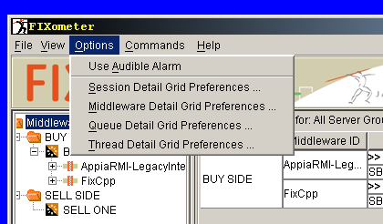
The first is through the Grid Preferences. From the Options menu, choose the view whose grid you would like to modify. The listed grids correspond to the view tabs: Session, Middleware, Queues, and Threads.
After choosing a grid, the corresponding Grid Preferences Dialog appears. It lists the columns that are available for each particular view. You can add and remove columns of data from a view by checking or un-checking the column names that are presented in the dialog.
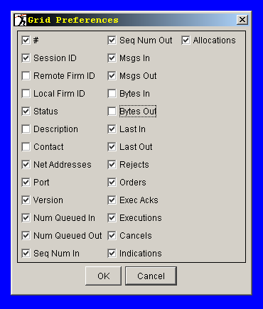
In addition to adding and removing columns, you can also reorder the columns. To do this, simply drag the column header to a new position. You will find that the whole column has moved along with the header.
Your customized layout is saved when you exit FIXometer and is restored when you restart it. The information is saved in a file named fixometer.cfg. It is created automatically for you by FIXometer, and saved in the path specified by the file_path configuration attribute (described later in the chapter). If this file is moved or erased, your FIXometer layout is lost and FIXometer, when restarted, reverts to the default layout.

Downloading Coppelia Configuration, Log, and Reject Files
With FIXometer, you can:
- Download a monitored Coppelia server’s configuration (.ini) file. Once downloaded you can:
- Launch Configurator to edit it.
- Save it to disk.
- Upload to a monitored Coppelia server its configuration file that you previously downloaded (and possibly edited) and optionally instruct Coppelia to reset its configuration based on changes made.
- Download a monitored Coppelia server’s .log file.
- Download a monitored Coppelia server’s .rej file.
Note: For more information on .log and .rej files, please refer to the chapter on Coppelia’s Log Files.
All of these features are available from the FIXometer menu bar and are described below in the section on Menu Options.

Setup and Security Concerns
Certain installations may not want to allow FIXometer users to download these files due to their sensitive nature. Allowing a FIXometer user to upload to Coppelia a modified (and possibly quite different) configuration file and direct it to reload its configuration can be very risky. For these reasons, these features are not available by default.

xfer_port
FIXometer uses a separate port for the downloading and uploading of these files. It is called the XFer port. You set this port with the xfer_port configuration attribute. You place the xfer_port attribute in the Server block (described in the section on Configuring FIXometer).
You also must set the xfer_port in Coppelia’s configuration file. In the Coppelia configuration file, you place the xfer_port configuration attribute in Coppelia’s Main block (in non-HA configurations) or in the Coppelia’s Server blocks (in HA configurations).
If the xfer_port attribute is not properly configured in both the FIXometer and Coppelia configuration files, the downloading and uploading of files will result in an error message.

XFer Permissions and Relevant Coppelia Configuration Attributes
Setting up the xfer_port attributes both in the Coppelia and FIXometer configuration files is only the first step in enabling the downloading and uploading of files. Coppelia listens on the xfer_port for download/upload requests but denies these requests unless you configure Coppelia’s XFer Permissions configuration attributes.
You configure XFer Permissions by adding an XFer Permission block to the Main block. You can do this easily with Configurator.
Note: For more information on Configurator, please refer to the chapter on Configurator.
Using the Configurator, you create the XFer Permission block as follows:
- Start Configurator for Coppelia and open the Coppelia .ini file you wish to modify.
- Select the Main block in the Configurator Block Navigator.
- Ensure that the XFer Permissions check box is checked.
- If you are checking this box for the first time, Configurator will create an XFer Permissions block and place its details in the Detail Pane.
- If the box has already been checked, use the Block Navigator to navigate to the xfer_permissions node. This brings the XFer Permission block configuration attributes into the Detail Pane.
- Fill in the details of the XFer Permissions block making sure to complete the following settings:
- INI Download Permitted – Controls whether Coppelia permits download of its configuration file.
- INI Upload Permitted – Controls whether Coppelia permits FIXometer to upload a modified configuration file.
- Log Download Permitted – Controls whether Coppelia permits download of its .log and .rej files.
- Save the configuration file.
The resulting changes to the Coppelia .ini file look like this:
[MAIN]
...
...
xfer_permissions = [XFER_PERMISSIONS0]
...
...
[XFER_PERMISSIONS0]
log_download_permitted = OFF
ini_download_permitted = ON
ini_upload_permitted = ON

FIXometer Menu Options
The following tables describe the various commands available from FIXometer’s menu bar.
File Menu Selections
Selection | Description
Server Configuration →  Download from Server | Retrieves an Coppelia configuration file from a monitored Coppelia server for editing. FIXometer gives you the option to launch configurator to edit the downloaded configuration file.
Server Configuration →  Open Config. File | Opens a previously downloaded Coppelia configuration file for editing, saving, or upload to a monitored Coppelia server.
Download Log File | Retrieves the Log file or reject file from a monitored Coppelia server.
Security Logons | Manages Server Group security logon status. Please refer to the section on Using Security.
Exit | Exits FIXometer.
View Menu Selections
Selection | Description
Message Inspector | Launches the Message Inspector. Message Inspector is a separate product. For information about Message Inspector, please contact Javelin support.
Find Connection | Finds Sessions in the monitored Coppelia Servers. This is useful when FIXometer is monitoring a large numbers of Sessions. If the session is found, the tree view display expands to that Session and highlights it.
Options Menu Selections
Selection | Description
Use Audible Alarm | Indicates whether to sound an audible alarm. The sound clips are played under certain alarm conditions:  - Server goes down  - Connection is broker, or  - Queue threshold limit is exceeded.
Session Detail Grid Preferences | Opens the grid preferences configuration for the Session view. Allows for the adding / removing of columns from the Session view.
Middleware Detail Grid Preferences | Opens the grid preferences configuration for the Middleware view. Allows for the adding / removing of columns from the Middleware view.
Queue Detail Grid Preferences | Opens the grid preferences configuration for the Queue view. Allows for the adding / removing of columns from the Queue view.
Thread Detail Grid Preferences | Opens the grid preferences configuration for the Thread view. Allows for the adding / removing of columns from the Thread view.
Commands Menu Selections
Selection | Description
Connect | Allows you to issue a Logon request and initiate a session with a counterparty
Disconnect | Allows you to issue a Logout message and disconnect from a counterparty
Send Test Request | Allows you to send a FIX Test Request message to a counterparty.
Send Sequence Reset | Allows you to send a FIX Sequence Reset message. FIXometer prompts you for a new sequence number for the Sequence Reset message.
Reset Incoming Sequence | Allows you to manually set the incoming sequence number. FIXometer prompts you for a new sequence number. The Incoming Sequence number is the next expected incoming sequence number for that session.
Reset Outgoing Sequence | Allows you to manually set the outgoing sequence number. FIXometer prompts you for a new sequence number. The Outgoing Sequence number is the next expected outgoing sequence number for that session.
Run End-of-Day | Allows you to run End-of-Day processing for a particular session.
Hold | Allows you to put a session in Hold state. In Hold state, Coppelia rejects all inbound application-level messages on that Session if the counterparty is connected at the time the Hold is initiated. If initiated from a disconnected state, Coppelia refuses connection attempts from that counterparty.
Release | Takes a Session out of Hold state
Service Down | Allows you to put a Session into Service Down state. Service Down is identical to the Hold state, except that it causes an immediate disconnect of a logged-in Session.
Service Up | Takes a Session out of Service Down state
Suspend | Allows you to put a Session into Suspend mode. Suspend is identical to Service Down with the exception that the suspended state is persisted. This means that the suspended state is maintained even if the Coppelia server is brought down and subsequently restarted.
Resume | Takes a Session out of Suspend state.
View Queued Messages | Available only with Message Inspector. Message Inspector is a separate product. For more information on Message Inspector, please contact Javelin support.
Recover from Log File | Allows you to run the recover_from_log_file Operator Command for a particular server. This rebuilds the persistence database from the server’s log file.
Execute Command | Allows you to execute an Operator Command for the specified server. You can enter any command permitted on the Coppelia server command line. For more information on Operator Commands, please refer to the chapter on Operator Commands.
Help Menu Selections
Selection | Description
About FIXometer | Displays FIXometer version information. Additionally, this also displays the versions of all monitored and currently running Coppelia servers.

Using Security
FIXometer’s security mechanism prevents unauthorized users from issuing commands against one or more monitored Coppelia servers. Authorization is granted on a Server Group basis.
To obtain authorization to execute a command against a particular member Server of a Server Group, you must first “logon” by entering a username and password.

How It Works
The Security mechanism is entirely independent of Coppelia and is based on an RDBMS entitlement table. Your Database Administrator (DBA) must create this entitlement table and grant write access to selected users. You define the location of this table with a Security DB block (defined in the Server Group block) in the FIXometer configuration file. The users who have been granted write access to the table are the ones that have the authorization to issue commands to that Server Group.
Note: The user is not really logging on to the Coppelia server and FIXometer does not store usernames and passwords in the fixometer.ini file.

Security Setup

Entitlement Table
To set up FIXometer security, a DBA must create an entitlement table in an RDBMS. The table must be called FIXometerAudit. The FIXometerAudit table must have the following schema:
FIXometerAudit Schema
Field | Type
TimeStamp | Timestamp/date
Username | varchar (50)
ServerGroup | varchar (50)
Connection | varchar (50)
Message | long varchar / text
The DBA must grant write privileges to those users who will be accessing this table (through) FIXometer in order to gain access to a particular Server Group.

The Security DB Block
After creating the FIXometerAudit entitlement table, FIXometer must be told where to locate it. You do this by adding a reference to a Security DB block to your FIXometer configuration (.ini) file. The Security DB block is listed in the Server Group block.
A Security DB block contains only two configuration attributes: security_sql_url and security_sql_driver. These attribute provide the URL and driver information for the JDBC connection to the database engine that you are using.
Note: As of this release, FIXometer only supports Sybase and Oracle JDBC for Security.
You can use Configurator to create the Security DB block or you can add it to your FIXometer configuration file with a text editor.
Note: For more information on Configurator, please refer to the section on Configuring FIXometer.
The following FIXometer configuration file fragment shows you a Server Group configured for Security.
[MAIN]
server_group = [SELL]
...
[SELL]
server = [SELL_SERVER]
security_db = [SECURITY_DB0]
...
[SELL_SERVER]
monitor_port = 8500
ip_address = 127.0.0.1
...
[SECURITY_DB0]
security_sql_url = jdbc:sybase:Tds:localhost:2638?ServiceName=Security
security_sql_driver = com.sybase.jdbc2.jdbc.SybDriver
Each server group block can point to its own security_db block. Additionally, there can be more than one security_db block reference. In the event that FIXometer cannot connect to the database specified in the first security_db, it attempts to connect to the second, and so on.
There are some other aspects of Security that should be mentioned:
- You may have more than one Security DB block for your Server Group, each pointing to a different RDBMS. If access to one is unsuccessful, FIXometer attempts to contact the second, and so on.
- Although each Server Group must point to its own Security DB block. The Security DB blocks can be set to point to the same database. This provides a uniform set of usernames and passwords for all Server Groups for which Security is being used.
- The FIXometerAudit table records commands executed for the Coppelia server and serves as an audit trail of FIXometer activity.

Security Enforcement
Before allowing Operator Commands to be run against a particular Server Group, FIXometer checks if one or more Security DB block are defined for a that Server Group. If there is at least one Security DB blocks defined, FIXometer prompts you for a username and password and attempts to gain write access to the entitlement table. If this fails, the request is denied. If successful, FIXometer registers that that user is “logged on” to that Server Group and further Operator Command requests go unchallenged.

Logging Off and Proactively Logging On
You can log off from your entitlement to access a Server Group by selecting the Security Logons Menu item (described above). The Security Logons Dialog shows the Server Group and the current logon status. Through this dialog, you can log off.
As was previously mentioned, FIXometer prompts you for username and password, when you attempt to execute a command against a Server Group. If you do not want to be preempted by this prompt at the time you wish to execute an Operator Command, you can use the Security Logons Dialog to proactively log on to a Server Group. Simply select the Server Group and click the Change Status button.

Passive Logon
By setting the passive_logon configuration attribute (Main block – defaults: ON) to ON, FIXometer silently uses a previously entered username and password to log on to additional Server Groups. In this way, logging on to one Server Group, in effect, logs you on to all of them.

Configuring FIXometer
FIXometer installs with the appropriate startup and configuration files to monitor the default sessions that ship with Coppelia. To configure FIXometer to monitor the Coppelia servers within your production environment, you must modify the default configuration file or create a new FIXometer configuration (.ini) file. You can use Configurator for this purpose or you can use any text editor to do so.
Note: Configurator, a graphical .ini file editor, is described in more detail in the chapter on Configuration. Although that chapter is devoted to the configuration of Coppelia, we suggest that you consult that chapter to familiarize yourself with general Configurator concepts as well as general .ini file concepts discussed towards the end of that chapter.

Launching Configurator
Your installation comes with a script called ConfigureFixometer.bat that launches Configurator to configure a FIXometer .ini file. It is located in the ...\utils\Configurator directory of your installation. Before launching Configurator for FIXometer, you must be familiar with the structure of the configuration file that you will be constructing.
Note: The following section assumes you have read the section entitled The .ini File Structure in the chapter on Configurator.

FIXometer .ini File Structure
FIXometer’s configuration file is block based, starting with a Main block ([MAIN]). The Main block, while containing its own attributes (attribute = value), also points to sub-blocks as in attribute = [SUB_BLOCK]. By having blocks point to sub-blocks a hierarchical effect is created.
A FIXometer .ini file can be thought of a hierarchy with three levels.
- The Main block.
- Server Group block(s).
- Server block(s).
The following diagram illustrates these levels. The grayed out boxes indicate optional features. 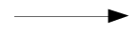 indicates that more than one block can exist on that level. All levels of the tree are discussed below.
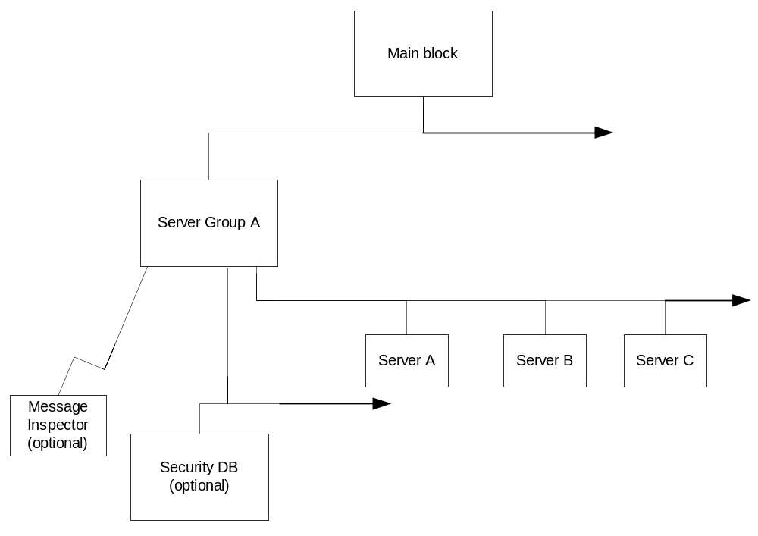

- Main – The Main block is where you define global attributes.
- Server Group – You define a Server Group block for each server cluster that you are monitoring. A cluster is a group of servers in a High Availability (HA) configuration. If yours is not an HA installation, you still need the abstraction of a Server Group; only your Server Group will have only one constituent Server (see next item). For more information on HA, please refer to the chapter on High Availability. The Server Group blocks are referenced from the Main block. It is in the Server Group blocks that you set configuration attributes that affect the entire Server Group.
- Server – Each Server Group references one or more Servers. If the Coppelia engines you are monitoring are not part of HA clusters, your Server Groups will reference only one Server. The Server block contains configuration attributes that correspond to one server. It is in the Server block that you set the attributes that instruct FIXometer how to connect to the particular Coppelia instance that you are monitoring. It is therefore critical that there be a direct correspondence between attributes set in the Server block(s) to attributes set in the Coppelia .ini files Server block(s) (Main block for non HA installations). This is discussed below in more detail.
Note: It is critical that each Server Group contain only those Servers that are members of the same HA cluster. For more information on HA, please refer to the chapter on High Availability.
- Security DB – You define one or more Security DB blocks if you want to impose security restrictions on a particular Server Group. This enables you to prevent unauthorized users of FIXometer from issuing commands to the Coppelia server. You set up security for the Server Group as a whole (and not for individual Servers). For more information, see the section below on Setting Security.
- Message Inspector – you define a Message Inspector block for a Server Group to enable FIXometer to browse Message Inspector database tables. Message Inspector is a separate product. For more information on Message Inspector, please contact Javelin support.

monitor_port and ip_address
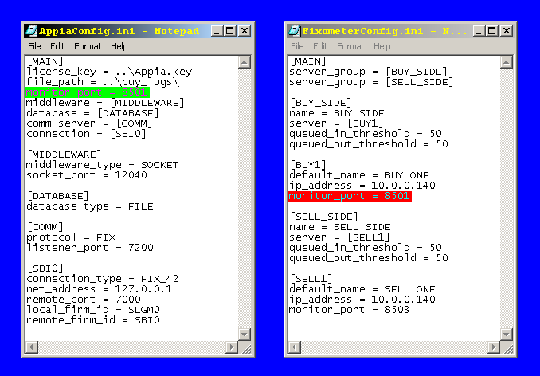
The most important part of the FIXometer configuration file is making sure that the settings in the Server blocks match the setting in the .ini files of the various Coppelia servers being monitored. FIXometer communicates with Coppelia over a socket connection. The port on which FIXometer connects to Coppelia is specified by the Coppelia configuration attribute: monitor_port. The ip_address attribute in the FIXometer Server block must be set to the IP address of the machine that Coppelia is running on.
This diagram shows the relationship between an Coppelia configuration file and a FIXometer configuration file. Notice that the value of the monitor_port attribute in the Main block in the Coppelia configuration file matches the value of the monitor_port attribute in the [BUY1] block in the FIXometer configuration file.

For High Availability (HA) Configurations
When monitoring servers that are in an HA cluster, the following rules apply:
- The FIXometer .ini file must have a separate Server block for each member of the cluster.
- You set the Server block configuration attribute ip_address to the actual address of each cluster member’s machine (not the virtual IP address provided by the HA clustering software).
- Because all members of an HA cluster use the same Coppelia .ini file (where each cluster member’s attributes are defined in separate Server blocks), there are multiple monitor_port attributes in the Coppelia configuration file – one per Server block. The monitor_port attributes in the FIXometer Server blocks must match these values.
Note: For more information on HA, please refer to the chapter on High Availability.

Configuration File Options
The following lists the available FIXometer configuration file attributes. They are arranged by block type.

Main Block Attributes

Sound File Attributes
The sound file attributes listed below specify sound clips that FIXometer will play when certain alarm conditions occur.
Note: These values of these attributes are not interpreted relative to your file system. They denote Java resources and are relative to FIXometer’s classpath. For example, a value of /foo.wav refers to a file called foo.wav that is found in the top directory of any directory listed in the classpath.
server_down_alarm_sound_file
Default: /audio/rosemary_server_down.wav
# Instances: 1
Allowed values: any sound file, specified as a resource.
This attribute specifies the path to a sound file that FIXometer plays when a server goes down.
connection_down_alarm_sound_file
Default: /audio/rosemary_connection_down.wav
# Instances: 1
Allowed values: any sound file, specified as a resource.
This attribute specifies the path to a sound file that FIXometer plays when a connection goes down.
connection_over_threshold_alarm_sound_file
Default: /audio/rosemary_connection_down.wav
# Instances: 1
Allowed values: any sound file, specified as a resource.
This attribute specifies the path to a sound file that FIXometer plays when inbound or outbound queues exceeds their threshold limit.
An outbound queue is the measure of those protocol messages destined to be sent to an Coppelia counterparty that have not been sent (possibly due to a connection that is down).
The inbound queue is a measure of those messages that are queued within the Coppelia engine to be sent to a client application that have not yet been delivered.
file_path
Default:
# Instances: 1
Allowed values: any valid file path.
This attribute dictates the directory where FIXometer reads and write it layout configuration file, fixometer.cfg (discussed later). It also specifies the directory where FIXometer writes configuration and log files that it may download from Coppelia servers (also described later).
passive_logon
Default: ON
# Instances: 1
Allowed values: ON, OFF
When FIXometer security is enabled (described later in the chapter), FIXometer prompts the user for username and password for each Server Group for which security is enabled. When this attribute is set to ON and the user has previously to log on to a Server Group, FIXometer passively bypasses future requests for username and password (for other Server Groups) using the previously entered username and password.

Server Group Attributes
name
Default:
# Instances: 1
Allowed values: any string
This attribute specifies a logical name for server group. FIXometer uses this string to display the Server Group in the Server Group topology tree.
queued_in_threshold
Default: 50
# Instances: 1
Allowed values: any integer greater than 1.
This attribute specifies the number of inbound messages that can be queued by Coppelia for a particular session before an alarm sounds. The inbound queue size is the measure of the number of messages for a particular session that are queued within Coppelia that have not been delivered to a connected middleware application. Back up of the inbound queues can be caused by a sluggish client application or by the sheer volume of inbound messages.
queued_out_threshold
Default: 50
# Instances: 1
Allowed values: any integer greater than 1.
This attribute specifies the number of outbound messages that can be queued by Coppelia for a particular session before an alarm sounds. The outbound queue size is the measure of the number of messages for a particular session that are queued within Coppelia that have not been delivered to a connected counterparty. Back up of the outbound queues can be caused by a disconnected counterparty or a sluggish network connection.
sampling_frequency
Default: 3
# Instances: 1
Allowed values: any integer greater than 1.
This attribute specifies how frequently FIXometer retrieves updated information from Coppelia. This is measured in seconds.
suspend_on_eod
Default: OFF
# Instances: 1
Allowed values: ON/OFF.
When you attempt to run End-Of-Day processing on a session, FIXometer checks whether the session is connected and will offer to either first disconnect it or suspend it. By default, FIXometer offers to disconnect connected sessions. If this attribute is set to ON, FIXometer instead offers to suspend the connection. For more information on suspend mode, please refer to the chapter on Session Concepts.

Server Block Attributes
default_name
Default:
# Instances: 1
Allowed values: any string.
This attribute specifies the logical name of an individual Coppelia server. FIXometer uses this name for the server in the event that that Coppelia instance is down and the true name cannot be fetched.
ip_address
Default:
# Instances: 1
Allowed values: any valid IP address or DNS name
This attribute specifies the actual IP address of a monitored server. For HA installations, use the actual IP addresses of the monitored cluster members and not the virtual IP address provided by the clustering software.
monitor_port
Default: 8500
# Instances: 1
Allowed values: any valid port number.
This attribute specifies the monitor port of the monitored Coppelia server. This value of this attribute must match the value of the monitor_port attribute set in the Coppelia configuration file’s Main block (non-HA) or Server block (HA).
xfer_port
Default: 0
# Instances: 1
Allowed values: any valid port number.
This attribute specifies the port used for transfers of .log, .rej and .ini files. This value of this attribute must match the value of the xfer_port attribute set in the Coppelia configuration file’s Main block (non-HA) or Server block (HA). For more information on this attribute, please refer to the section on Downloading .ini and Log Files, later in the chapter.

Message Inspector Attributes
The Message Inspector block is used to locate the Message Inspector database tables. Message Inspector is a separate product whose configuration is not covered in this manual. For more information on Message Inspector, please contact Javelin support.

Security DB Attributes
security_sql_driver
Default:
# Instances: 1
Allowed values: any valid driver class name.
This attribute specifies the JDBC driver class to use to connect to the FIXometer security database.
security_sql_url
This attribute specifies the URL of the security database. This URL points to a particular database table. The format of this URL depends on the JDBC vendor you are using.

