

CBOE FIX Operating Procedures and Support
Version 1.0a
Volume 3: FIX/CAS (FIX 4.2) Operations and Support

How to operate and support the FIX/CAS (FIX 4.2) server programs

CBOE Proprietary Information

20 Aug 2001
Document #[FIXOPS-03]

Front Matter

Disclaimer

Copyright © 1999-2001 by the Chicago Board Options Exchange (CBOE), as an unpublished work. The information contained in this document constitutes confidential and/or trade secret information belonging to CBOE. This document is made available to CBOE members and member firms to enable them to develop software applications using the CBOE FIX Protocol Support and its use is subject to the terms and conditions of a Software License Agreement that governs its use. This document is provided “AS IS” with all faults and without warranty of any kind, either express or implied.

Preface

CBOE is providing the FIX protocol to support order routing to all CBOE markets. This will include the current open outcry markets, as well as the planned electronic trading system. CBOE has provided a leadership role in expanding the FIX protocol standard for use in accessing exchange based derivatives markets.

Author
Jim Northey, Carol Vazirani

Change Notices
The following change notices are provided to assist users of the CBOE FIX Services in determining the impact of changes to their applications.
Date | Version | Description of Change
20 Aug 2001 | 1.0a | Includes new commands and feedback from review comments.
23 Mar 2001 | 0.9 | Initial Draft after dividing document into three volumes
24 Oct 2001 | 1.1 | Added new command showLog (page28)

Table of Contents
Front Matter 2
Disclaimer 2
Preface 2
Author 2
Change Notices 2
Logins 5
Regular Daily Operator Procedures for Startup/Shutdown and End of Day for FIX42 6
End Of Day/Cleanup Verification for the previous day 6
System startup 7
Using Patrol 7
Manual Startup 7
Starting up the FIXOMETER 8
End of Day – Running EOD 9
System Shutdown 10
End Of Day Cleanup after system shutdown 11
Command Line Procedures 12
Startup/Shutdown Command Line for individual processes 12
Infrastructure Processes 12
FIX/CAS Processes 13
Listing Processes (showFixSystem) 14
Display System Status (showSystemStatus) 15
Log Files and Important Shortcuts 16
Log File Descriptions 16
Aliases (Shortcuts) 17
Aliases for FIX Engine Log file locations 17
Firm Connection States 18
FIX Engine Failure Handling 19
Firm Connection Failure Handling 20
Command Summary 21
startSysManAgent 21
startFixSystem [Primary|Secondary] 22
startFixCas [Primary|Secondary] [NN | all] 23
stopFixCas [NN | all] 24
stopFixSystem 25
stopSysManAgent 25
startDbServer42 26
stopDbServer42 27
cleanupFixSystem 28
getCompassStrikePrice 29
showLog 30
startFirmSimulator [connectionName scriptName] 31
Appendices 33
Appendix A – FIX/CAS Application Component Diagram 33
Appendix B – FIX/CAS High Availability Configuration 34
APPENDIX C – VIEWING THE FIX ENGINE ORACLE DATABASE TABLES 35

Logins
Hosts fix1a/fix1b
Production Login = infrap
Assurance Login = infraa
Testing Login = infra.

Regular Daily Operator Procedures for Startup/Shutdown and End of Day for FIX42
This section is all that Operations will require to maintain FIX/CAS on a daily basis. The rest of the document contains information about FIX/CAS that can be used by Support Services for trouble-shooting problems if they arise.

End Of Day/Cleanup Verification for the previous day
This section will show you how to verify if end of day/cleanup was run the previous day.
- Prior to starting FIX, verify that the cleanup was run and was successful from the previous evening.
- Login to fix1a
- Type the command showSystemStatus MMDDYYYYY and press <ENTER>
(where MM=Month [01-12], DD = Day [01-31] and YYYY = Year (eg 2001)
- You will see output similar to the one shown below, Towards the end of the output you should a message “END OF DAY CLEANUP IS NOW COMPLETE” if you see this then the end of day was run on the specfified day.
------------------------------------------------------------------------
FIX SYSTEM STATUS
File : /apps/fixcas/test1/infra/run_dir/log/FixSystemStatus.Sun.09302001
------------------------------------------------------------------------
Sun Sep 30 03:31:04 CDT 2001 : STARTUP: STARTING FIX42 SYSTEM ...
Sun Sep 30 21:53:03 CDT 2001 : SHUTDOWN: SHUTTING DOWN FIX42 APPLICATION
Sun Sep 30 21:53:03 CDT 2001 : SHUTDOWN: Shutting down All Cas's ....
Sun Sep 30 21:53:26 CDT 2001 : END OF DAY CLEANUP: Cleaning up log files
Sun Sep 30 21:53:27 CDT 2001 : END OF DAY CLEANUP: TRUNCATING FIRM TABLES
Sun Sep 30 21:53:34 CDT 2001 : END OF DAY CLEANUP: END OF DAY CLEANUP IS NOW COMPLETE
Sun Sep 30 21:53:34 CDT 2001 : ------------------------------------------
- Repeat on fix1b.

System startup
NOTE:
- The primary side always needs to be started before the secondary side otherwise the secondary will not come up. (Before you start the system you need to decide which host will be primary for the day, you must start the system on the primary host first).
- At startup time, the system automatically FTP’s the compass strike price file before starting rest of the system, if the file cannot be ftp’d then the system is not started.

Using Patrol
Please see PATROL documentation for details on how to start the system.

Manual Startup

On the Primary side host
- Login to the chosen primary host.
- Type cd $RUN_DIR and press <ENTER>
- Type the command startInfraSystem CAS Active and press <ENTER>
- The above command will start all the needed infrastructure processes (ProdSysManAgent1, ProdSysManAgent2 and ProdProcessStatusListener). You can use the command showFixSystem explained in the next section to verify if these processes are up and running.
- Type the command startFixSystem Primary and press <ENTER>
- The above command will FTP the compass strike price file and then start all the needed FIX42 application processes
(Prodfixcas01, Prodfixcas02, Prodfixcas03 and ProdDbserver42). You can use the command showFixSystem explained in the next section to verify if these processes are up and running.

On the Secondary side host
- Login to the secondary host.
- Type cd $RUN_DIR and press <ENTER>
- Type the command startInfraSystem CAS Active and press <ENTER>
- The above command will start all the needed infrastructure processes (ProdSysManAgent1, ProdSysManAgent2 and ProdProcessStatusListener). You can use the command showFixSystem explained in the next section to verify if these processes are up and running.
- Type the command startFixSystem Secondary and press <ENTER>
- The above command will FTP the compass strike price file and then start all the needed FIX42 application processes
(Prodfixcas01, Prodfixcas02, Prodfixcas03 and ProdDbserver42). You can use the command showFixSystem explained in the next section to verify if these processes are up and running.

Starting up the FIXOMETER
NOTE: If the secondary fix server is up then it is preferable to connect the fixometer to the secondary fix server (This is because the queries against the database will go against the secondary server while the primary server is processing live order flow).

On the NT workstation:
Execute startFixometerb.bat [C:\Fixometer42] to connect to ‘fix1b’ or
Execute startFixometera.bat [C:\Fixometer42] to connect to ‘fix1a’

On UNIX
On the Secondary Fix host (if available, if secondary is not available then you may use the primary fix host)
Login as ‘infrap’
Type ‘startfixometerb’ to connect to the fix1b or
Type ‘startfixometera’ to connect to fix1a.

End of Day – Running EOD
Use the FIXOMETER End Of Day Menu, to clear out the Database for the FIX Engines and to reset the sequence numbers associated wit hthe firm connections.
All Firm connections must be “SUSPENDED” before End Of Day is executed.
- On Fixometer click Menu Commands, Option Suspend
- Pick ALL engines and Select All.
- Login using the required login:(fix42/xif can be used as username,password on fix1b)
- Then on Fixometer click Menu Commands, Option Run End of Day
- Pick ALL engines and Select All.

The FIXometer will issue a warning if there are queued messages and End of Day is run for that FIRM connection. If this happens, do the following:
- Cancel out and Do not Run the EOD.
- Right click on the connection that has the Queue Count > 0 and View Queued Messages.
- Execute Print, to print a hard copy of the queued messages and contact Support Services.
- Make a note of the Order-Ids queued.
- Proceed to run EOD.
- Ensure that all the Sequence numbers and counts are reset for all firms.
- Shutdown the FIXometer. On the Fixometer, Menu File, Option Exit
- Reboot the FIXometer PC.
- Now you can shutdown the system.

System Shutdown
Always shutdown the secondary before shutting down the primary (otherwise a master/slave switch may occur automatically).

Using Patrol
Please see PATROL documentation for details on how to shutdown the system.

Manual shutdown
- Repeat this procedure for secondary first and then the primary.
- Type cd $RUN_DIR and press <ENTER>
- Type the command stopFixSystem and press <ENTER>
- The above command will stop all the FIX42 application processes
(Prodfixcas01, Prodfixcas02, Prodfixcas03 and ProdDbserver42). You can use the command showFixSystem explained in the next section to verify if these processes are shutdown.
- Type the command stopInfraSystem CAS Active and press <ENTER>
- The above command will stop all the infrastructure processes (ProdSysManAgent1, ProdSysManAgent2 and ProdProcessStatusListener). You can use the command showFixSystem explained in the next section to verify if these processes are shutdown.

End Of Day Cleanup after system shutdown

Using Patrol
Please see PATROL documentation for details on how to shutdown the system.

Manual Cleanup
- Repeat the following procedure on both fix1a and fix1b.
- Type cd $RUN_DIR and press <ENTER>
- Type cleanupFixSystem and press <ENTER>

Command Line Procedures

Startup/Shutdown Command Line for individual processes
To start any process you need to login to the appropriate host fix1a or fix1b and then ‘cd $RUN_DIR’.

Infrastructure Processes

Startup Command Lines
The following infrastructure processes need to started in the following order.
ProcessName CommandLine to execute
- SysManAgent1 startSysManAgent –m
- SysManAgent2 startSysManAgent –B –m
- ProcessStatusListener startProcessListener

Shutdown Command Lines
The following infrastructure processes need to stopped in the following order.
ProcessName CommandLine to execute
- ProcessStatusListener InfraProcesAct kill ProcessStatusListener
- SysManAgent2 stopSysManAgent –b2
- SysManAgent1 stopSysManAgent

FIX/CAS Processes

Startup Command Lines
NOTE: Dbserver42 should be started before any other fixengine process.
ProcessName CommandLine to execute
- DbServer42 startDbServer42
- Start All Fix CAS engines startFixCas Primary all
(If starting all primary engines) or
startFixCas Secondary all
(If starting all Secondary engines)
- To Start a specific engine startFixCas Primary NN (where NN = 01 to 03)

Shutdown Command Lines
NOTE: Dbserver42 should be stopped last after all fixengine processes have been shutdown.
ProcessName CommandLine to execute
- DbServer42 stopDbServer42
- Stop All Fix CAS engines stopFixCas Primary all
(If starting all primary engines) or
startFixCas Secondary all
(If starting all Secondary engines)
- To Stop a specific engine stopFixCas Primary NN (where NN = 01 to 03)

Listing Processes (showFixSystem)
- Login to the fix1a or fix1b
- Type cd $RUN_DIR and press <ENTER>
- Type the command showFixSystem <ENTER>. You will see the following output listing the processes that are running.
/apps is 25% full

IDs logged on...
infra infraa jiangx

LDAP, Talarian, Guardian processes...

SmartCache processes...

Oracle processes...

oracle 20791 1 0 Jul 10 ? 7:05 ora_lgwr_FXENGD0A
oracle 24456 1 0 Jul 10 ? 0:31 ora_ckpt_FXSCRD0A
oracle 20750 1 0 Jul 10 ? 0:05 ora_pmon_FXENGD0A
oracle 20754 1 0 Jul 10 ? 0:08 ora_dbw0_FXENGD0A
oracle 24479 1 0 Jul 10 ? 0:00 ora_reco_FXSCRD0A
oracle 24446 1 0 Jul 10 ? 0:03 ora_lgwr_FXSCRD0A
oracle 24526 1 0 Jul 10 ? 0:03 ora_snp3_FXSCRD0A
oracle 24487 1 0 Jul 10 ? 0:03 ora_snp1_FXSCRD0A
oracle 20823 1 0 Jul 10 ? 0:00 ora_reco_FXENGD0A
oracle 20874 1 0 Jul 10 ? 0:03 ora_snp3_FXENGD0A

ALL java processes on host fix0a for ID infra
8230 24210 3810 9349 23010 4727

detail for java processes on host fix0a for ID infra
THESE ARE THE APPLICATION PROCESSES
pid 9349 apitest1DbServer42fix0a
pid 9350 apitest1ProcessListenerfix0a
pid 3810 apitest1SysManAgent1fix0a
pid 4727 apitest1SysManCommandLine
pid 8230 apitest1fixcas01fix0a
pid 23010 apitest1fixcas02fix0a
pid 24210 apitest1fixcas03fix0a

Display System Status (showSystemStatus)
This command will display the current system status. This command will let you see status of various steps that were executed during the day.
You can use this command to see what time the system was started, what time the system was shutdown, what time end of day was done etc.
Note: The status information is kept for only for the last 7 days.
Command Usage:
showSystemStatus [MMMDDYY - optional]
If no date is provided then todays date will be used.
If the system status is found then the output similar to the one shown below is displayed .
------------------------------------------------------------------------
FIX SYSTEM STATUS
File : /apps/fixcas/test1/infra/run_dir/log/FixSystemStatus.Sun.09302001
------------------------------------------------------------------------
Sun Sep 30 03:31:04 CDT 2001 : STARTUP: STARTING FIX42 SYSTEM ...
Sun Sep 30 21:53:03 CDT 2001 : SHUTDOWN: SHUTTING DOWN FIX42 APPLICATION
Sun Sep 30 21:53:03 CDT 2001 : SHUTDOWN: Shutting down All Cas's ....
Sun Sep 30 21:53:26 CDT 2001 : END OF DAY CLEANUP: Cleaning up log files
Sun Sep 30 21:53:27 CDT 2001 : END OF DAY CLEANUP: TRUNCATING FIRM TABLES
Sun Sep 30 21:53:34 CDT 2001 : END OF DAY CLEANUP: END OF DAY CLEANUP IS NOW COMPLETE
Sun Sep 30 21:53:34 CDT 2001 : ------------------------------------------

If the status is not available then the following output will be shown
------------------------------------------------------------------
SYSTEM STATUS NOT AVAILABLE
Unable to find status file for date '09092001'.
------------------------------------------------------------------

Log Files and Important Shortcuts

Log File Descriptions

${RUN_DIR}/log directory
Log file name | Description | Contents
startsh_MMM_DD_YYYY_HH:MM:SS.log | Contains the standard output and error files for a FIXCAS | This file is checked if there is a problem at startup.
${RUN_DIR}/log/fixcasNN directory – where NN is the engine number (01-05)
Log file name | Description | Contents
cas.log | FIXCAS log file | Contains normal logging messages
cas.debug | FIXCAS debug file | Contains debug output
Fixengine.log  CYYYYMMDD.log | Javelin FIX Engine Log File | Will contain output from FIX Engine
Fixengine.rej  CYYYYMMDD.rej | FIX Engine Reject File | Will contain reject records when invalid messages are received from a firm
CYYYYMMDD.err | FIX Engine error file | Will only contain serious errors encountered by FIX engine
${RUN_DIR}/log/dbserver directory
FixDbServer.log | Javelin DBServer log file | Contains output from the DBServer
FixDbServer.rej | Javelin DBServer reject file | Contains rejected messages – this file should always be empty and be of zero length

Aliases (Shortcuts)
The following tables show the shortcuts (UNIX shell aliases) that are defined to make access to various FIX/CAS files easier to access.
Note full path names are shown for login fix42prod only. The path: /apps/fixengine/prod/running_dir is identified by the UNIX environment variable: ${RUN_DIR}. You can display the running directory by typing the following command:
echo $RUN_DIR

Aliases for FIX Engine Log file locations
Alias | Location
fix01log | /apps/fixcas/${ENVIRONMENT}/infra/run_dir/log/fixcas01  Where ${ENVIRONMENT} is test, assr, prod  /apps/fixcas/prod/infra/run_dir/log/fixcas01
fix02log | /apps/fixcas/prod/infra/run_dir/log/fixcas02
fix03log | /apps/fixcas/prod/infra/run_dir/log/fixcas03
Dbserverlog | /apps/fixcas/prod/infra/run_dir/log/fixcas05

NOTE Regarding log files: Upon running cleanupFixSystem the logfiles from these directories are moved into the directory specified by the Day of the Week. Log files are stored for 7 days prior.

Firm Connection States

State | Conditon | Description
UP | Normal | The Firm has successfully connected to the Engine
DISCONNECTED | Warning | The Firm has disconnected from the Engine.
DOWN | Warning | The Firm was not connected when the FIXometer stared.
LOGON | Error | A Logon message has been received from the firm but not acknowledged.
SUSPEND | Manual | One or more, or ALL connections have been manually suspended using the FIXometer. Firms are disconnected and logon messages will be rejected.
HOLD | Warning | The connection is on hold, incoming messages will be rejected.

FIX Engine Failure Handling

Symptom | Condition | Handling
The FIXometer complains “SERVER IS DOWN”. The icon shows RED. No Firm traffic is affected | The Slave FIX-Engine is DOWN. | Ensure that the Master Engine is successfully receiving messages, uninterrupted. Firm Connection Status should show “UP”.  Login to the server where the slave is running and restart the process, or use Patrol to restart the Process.
The FIXometer complains “SERVER IS DOWN”. The icon shows RED. Firm Connections get DISCONNECTED. | The Master FIX-Engine is DOWN. | The Slave Engine should automatically take over as MASTER. Firm connections should switch to the new MASTER. Login to the server that runs the new MASTER and type “monitor_ha”. The FIRM IP aliases should show on the master.  Ensure that the FIRM connections successfully re-connect after the switch. State should be UP.  Contact Support Services before bringing the failed engine back up. Restarting this engine will make it a SLAVE and sync messages from the MASTER.  If the Slave Engine, for some reason does not take over as MASTER, Operations should contact Support Services. Firms should be asked to route their traffic to their 2nd connection on another engine, while the failed engine is restarted. This is NOT normal behavior for the system and should be addressed with Javelin Tech.

Firm Connection Failure Handling

Symptom | Condition | Handling
FIXometer shows FIRM Connection state as “DISCONNECTED” | The Firm has disconnected from the Engine. | The Firm should automatically re-connect. Support Services should be contacted if manual intervention is required. This would be an abnormal condition.  IMPORTANT NOTE:  If a FIRM is unable to re-connect, any outbound Fill reports/cancel reports will be queued in CBOEDirect.  Also for that connection (FIXometer Outbound Queue reflects any pending outbound messages received by the fix engine). Operations can view Outbound queued messages (Right-click mouse on Firm connection line and chose View Outbound queued messages. If the connection will not come back up, these queued messages should be printed (select ALL and Print) and faxed to the Firm contact before End of Day is run (the End of Day run will warn Operations if there are any Outbound queued messages).
DOWN | The Firm was not connected when the FIXometer stared | Handling is same as the DISCONNECTED state.
LOGON | A Logon message has been received from the firm but not acknowledged | Operations should DISCONNECT the FIRM using the FIXOMETER. (Right-click the mouse with the cursor on the FIRM connection). Only users with authorization will be allowed to perform this.
SUSPEND | This is a manual Operation that is executed via the FIXometer. | Operations/Support Services will Suspend Firms, when there is a business condition that should prevent firms from sending in orders to the CBOE. Operations may RELEASE Firms, when that condition has cleared.

Command Summary

startSysManAgent

Starts the SysMan agent for the FIXCAS
You should follow up this command with the showFixSystem command to verify that the SysManAgent started properly.
- Type the command startSysManAgent –m
- You will see the following output
Starting Systems Management Agent atgtest3fix0a
waiting for READY state...
OK, READY
- To start backup SysManAgent the command is startSysManAgent –m -B

startFixSystem [Primary|Secondary]

This command starts the BOTH DbServer42 as well as all the FIXCAS engines .
If you are starting the secondary side ,the Secondary engine will not start until the Primary engine becomes Master.
This command also FTP’s the compass strike price file before starting the system, if the file cannot be ftp’d then the system is not started.
To Start the system on the primary host
- Type the command startFixSystem Primary
To Start the system on the Secondary host
- Type the command startFixSystem Secondary

startFixCas [Primary|Secondary] [NN | all]

Use this command to start only the FIX/CAS’s.
NOTE: If you are starting the secondary side ,the Secondary engine will not start until the Primary engine becomes Master.
Where
‘NN’ is the FIXCAS number – valid range 01 –03
‘all’ - to start all the FIXCAS engines.
The startFixCas script will wait until the FIXCAS has completed initialization before returning. The command can take several minutes to complete.
The following example shows starting the third FIXCAS.

Command: startFixCas Primay 03
--------------------------------------------------------------------------
CBOEdirect 1.0 FIXCAS (Fix 4.2) Service

Starting FixCas 03 Using SysManAgent invokemethod Command

Invoked on Tue Jul 17 10:35:56 CDT 2001
from [SunOS fix0a 5.6 Generic_105181-23 sun4u sparc SUNW,Ultra-Enterprise]

Copyright (c) 2000-2001 Chicago Board Options Exchange
---------------------------------------------------------------------------

startFixCas: 07/17/01-10:36:02 INFO - fixcas03fix0a Starting ...
startFixCas: 07/17/01-10:36:11 INFO - Waiting for fixcas03fix0a process to start...
startFixCas: 07/17/01-10:36:24 INFO - fixcas03fix0a process started. Please wait for the READY state.
startFixCas: 07/17/01-10:38:29 INFO - fixcas03fix0a READY
infra@fix0a:/apps/fixcas/test/infra/run_dir$

stopFixCas [NN | all]

Where
‘NN’ - is the FIXCAS number – valid range 01 –05
‘all’ - to stop all the FIXCAS engines
Stop FIXCAS NN on primary or secondary FIX Cluster server.
The stopFixCas script will wait until the FIXCAS has stopped running. The command can take up to few minutes to complete.
The following example shows the output when stopping a FIXCAS.
Command: stopFixCas 03
--------------------------------------------------------------------------------
CBOEdirect 1.0 FIXCAS (Fix 4.2) Service

stopFixCas Stopping FixCas 03 Using SysManAgent Shutdown Command

Invoked on Tue Jul 17 10:38:50 CDT 2001
from [SunOS fix0a 5.6 Generic_105181-23 sun4u sparc SUNW,Ultra-Enterprise]

Copyright (c) 2000-2001 Chicago Board Options Exchange
--------------------------------------------------------------------------------

stopFixCas: 07/17/01-10:38:57 INFO - Shutting down fixcas03fix0a ...
stopFixCas: 07/17/01-10:39:11 INFO - fixcas03fix0a is stopped successfully.

stopFixSystem

This command stops the BOTH DbServer42 as well as all the FIXCAS engines .
This command can be used to stop the dbserver42 and FIXCAS on both Primary and Secondary sides.

stopSysManAgent

Stops the SysManAgent .

The following example shows the output when stopping the Primary SysMan

stopSysManAgent
Shutting down Systems Management Agent atgtest3SysManAgent1fix0a process ID 1284
please wait...
OK, exited

To stop the backup SysManAgent the command is

stopSysManAgent –b2

startDbServer42
Start the Coppelia DbServer process for the FIX 4.2 system.
The following is the expected output when starting a DBServer:
startDbServer42
--------------------------------------------------------------------------------
CBOEdirect 1.0 FIXCAS (Fix 4.2) Service

startDbServer42 starting dbserver42 ...

Invoked on Wed Jun 20 16:02:22 CDT 2001
from [SunOS fix0b 5.6 Generic_105181-23 sun4u sparc SUNW,Ultra-Enterprise]

Copyright (c) 2000,2001, Chicago Board Options Exchange
--------------------------------------------------------------------------------

STARTED 'atgtest3DbServer42' .......

stopDbServer42
Stop the Coppelia DbServer process for the FIX 4.2 system.
The following is the expected output when stopping the DBServer:
stopDbServer42
--------------------------------------------------------------------------------
CBOEdirect 1.0 FIXCAS (Fix 4.2) Service

stopDbServer42 stopping dbserver42

Invoked on Wed Jun 20 16:17:35 CDT 2001
from [SunOS fix0b 5.6 Generic_105181-23 sun4u sparc SUNW,Ultra-Enterprise]

Copyright (c) 2000,2001, Chicago Board Options Exchange
--------------------------------------------------------------------------------

killing 'atgtest3DbServer42' .......

cleanupFixSystem

- Will save the current day’s log files.
- Will remove log files older then 7 days.
- Will truncate the Fixengine database tables (i.e. clear the firm sequence numbers).
- Will drop the history tables older then 7 days.
- Will drop fixometer auti information older then 30 days.

getCompassStrikePrice

This command ftp’s the compass strike price file from the compass hosts (m8 or m9 whichever one is available).

Here is a sample output of this command if successful
getCompassStrikePrice
getCompassStrikePrice: 09/30/01-22:56:43 Pinging host 'm10' ...
getCompassStrikePrice: 09/30/01-22:56:43 Host 'm10' is alive ......
getCompassStrikePrice: 09/30/01-22:56:51 ftp attempt successful
getCompassStrikePrice: 09/30/01-22:56:51 StrikePrice FTP Hostname=m10-- Source=%cboe#d10B>COMPASS>testing>running_dir--Destination=/a
pps/fixcas/test1/infra/run_dir/properties/symbol.table – SUCCESSFUL

Here is a sample output of this command if failed
getCompassStrikePrice
getCompassStrikePrice: 09/30/01-23:05:21 Pinging host '1' ...
getCompassStrikePrice: 09/30/01-23:05:23 Host '1' is dead ....
getCompassStrikePrice: 09/30/01-23:05:23 StrikePrice FTP for FIX42 Failed Hostname=1--Source=%cboe#d10B>COMPASS>testing>running_dir-
-Destination=/apps/fixcas/test1/infra/run_dir/properties/symbol.table

showLog

This command displays the fix messages that are sent and received from the firms.
This section explains the usage of the command ‘showLog’.
This command will display messages from only one log file at a time. You must provide the fix engine number for which you want to view messages.
Usage :
showLog engineNumber(eg 01,02,03) [-startTime hh:mm:ss]
[-endTime hh:mm:ss] [-match anyMatchString]
[-match anyMatchString] [-exclude anyExcludeString] [-wait] [-print]
All arguments mentioned above (with the excecption of engineNumber) are optional. The user may choose to use any combination of one or more arguments.
If no arguments are given then all FIX messages from the beginning of file to the end of file are displayed on the screen.
Following is a short description of each argument.
[-startTime hh:mm:ss] – Will display fix messages whose processing time is after the specified startTime.
[-endTime hh:mm:ss] – Will display fix messages whose processing time is upto the specified endTime.
[-match anyMatchString] – Will display only those fix messages that match the specified string. To match multiple items (example to match for Text1 or Text2 you can specify –match “Text1|Text2”)
[-exclude anyExcludeString] – Will not include any fix messages that match the specified string. To exclude multiple items (example to match for Text1 or Text2 you can specify –exclude “Text1|Text2”)
[-wait] – Will display new messages as and when they are received (Do not specify this option with the –print option).
[-print] – Will print the requested messages (based on other options that are given). Do not specify this option with the –wait option.

startFirmSimulator [connectionName scriptName]

- Telnet to host : fixtest1
- Login : infrap
- Password: infrap
- Run a firm simulator for connectionName using script scriptName.

Test scripts are kept in the $RUN_DIR/scripts directory. The scripts in this directory are used for assurance testing and production operational tests.
A firm simulator is composed of custom CBOE testing code that is built on top of the Javelin Coppelia FIX Engine. To connect to a FIXCAS using the firm simulator a Coppelia configuration file, referred to as an .ini file is required.
The Coppelia .ini files for the firm simulator are kept in the $RUN_DIR/inifiles directory.
Each .ini file must be named using the following convention:
connectionName_firmSim.ini – where connectionName is the name of the FIX connection that is being used.

Procedures for running a firm simulator.
- Logon to fixtest1
- Make sure you have the connectionName defined (at this time this will be provided by development).
- From the $RUN_DIR run the following command:
- startFirmSimulator connectionName scriptName
Example:
To run the CBOEdirect order handling script using a connection such as ATG1, the following command will be used.
startFirmSimulator ATG1 CBOEdirect.script
You will then be prompted by the test script.
If you want to capture the output of the test you should use the UNIX tee command
startFirmSimulator connectionName scriptName | tee log/connectionName/outputfileName
The tee command sends a copy of all output destined for the terminal (referred to in UNIX as standard output) to both the terminal and to a file, whose name is specified on the command line.
PLEASE NOTE that you must create this file into a directory where you have permissions to write the file.
Each connection has a directory under the ${RUN_DIR}/log directory – this is a good place to generate the output – so for testing using the ATG1 connection you could create a file named:
log/ATG1/quote_output_YYYYMMDD.log

cleanupFirm connectionName
cleanup the log files and database files of a firm simulator connectionName.
To clean up after a firm simulator run enter the following command from the $RUN_DIR
cleanupFirm connectionName
To clean up after running using connection ATG1 enter the following command:
cleanupFirm ATG1

Appendices

Appendix A – FIX/CAS Application Component Diagram
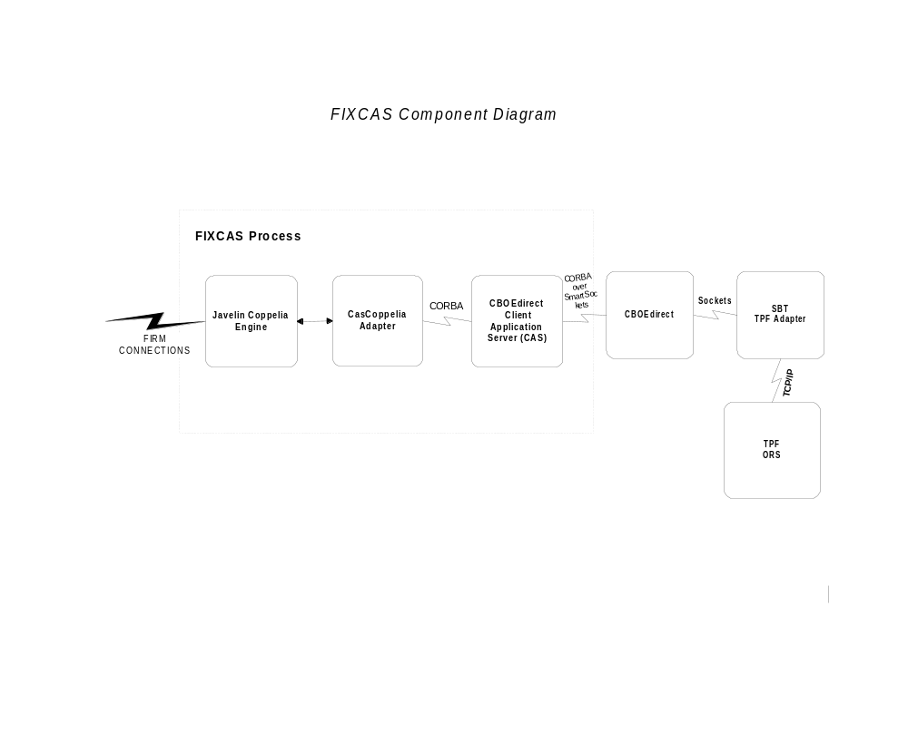

Appendix B – FIX/CAS High Availability Configuration
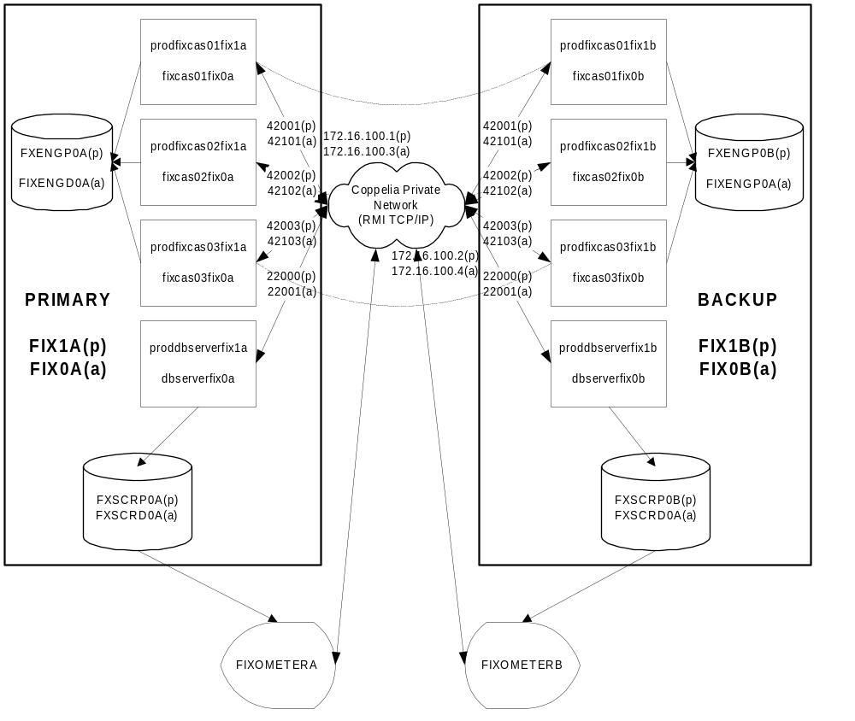

APPENDIX C – VIEWING THE FIX ENGINE ORACLE DATABASE TABLES

The FIX Engine’s Oracle Database tables (Oracle Instance FXENGP0A on fix1a and FXENGP0B on fix1b) can be viewed through the Access ODBC connection setup on the PC that runs the FIXometer by doing the following:
- Go to the folder C:\FIXORSDATABASE and open the table fxeng.mdb (double-click on fxeng.mdb).
- For each firm connection the following tables are available:
On fix1a (Instance=FXENGP0A):
Firm_Inbound
Firm_Outbound
Firm_Stats
On fix1b (Instance=FXENGP0B):
Firm_Inbound
Firm_Outbound
Firm_Stats
Where Firm is the Firm ID
- When a New Firm is added, the following steps need to be performed to add the link to the required Firm tables, 3 for FXENGP0Aand FXENGP0B:
Open the fxeng.mdb database and Click on New, Link Table. Chose Files of Type = ODBC Databases.
Enter the Service name (FXENGP0A or FXENGP0B) [User=coppelia, password=fixeng0]

