

CBOE FIX Operating Procedures and Support
Version 1.0a
Volume 1: FIX Server Cluster Operation and Support

Operation and support of the FIX Server Cluster, High Availability Features, Oracle Database Instances, Coppelia DBServer Processes, and FIXometer

CBOE Proprietary Information

20 Aug 2001
Document #[FIXOPS-01]

Front Matter

Disclaimer

Copyright © 1999-2001 by the Chicago Board Options Exchange (CBOE), as an unpublished work. The information contained in this document constitutes confidential and/or trade secret information belonging to CBOE. This document is made available to CBOE members and member firms to enable them to develop software applications using the CBOE FIX Protocol Support and its use is subject to the terms and conditions of a Software License Agreement that governs its use. This document is provided “AS IS” with all faults and without warranty of any kind, either express or implied.

Portions of this document have been taken from the Fix 4.2 Specification which is property of FIX Protocol Ltd. (http://www.fixprotocol.org). The FIX 4.2 Specification is property of FIX Protocol Ltd.

Preface

CBOE is providing the FIX protocol to support order routing to all CBOE markets. This will include the current open outcry markets, as well as the planned electronic trading system. CBOE has provided a leadership role in expanding the FIX protocol standard for use in accessing exchange based derivatives markets.

Author
Carol Vazirani

Table of Contents
Front Matter 2
Disclaimer 2
Preface 2
Author 2
Change Notices 6
About This Document 7
Purpose 7
Intended Audience 7
Related Documents 7
Introduction 9
Components of the FIX Cluster 10
Processes 10
High Availability Scripts 10
Fix Engine Clusters 10
Dbservers 10
Oracle Instances 10
FIXometer 10
High Availability Scripts 11
FIX Engine Cluster(s) 11
Coppelia DbServers 12
Oracle Databases 12
FIXometer 12
Startup and Shutdown Procedures 14
High Availability Scripts 14
Login 14
Startup 14
Shutdown 14
Oracle Databases 15
Login 15
Startup 15
Shutdown 16
FIX Servers 17
Monitoring the FIX Engine ORS System 18
High Availability Scripts 18
Failover and Recovery of the Fix Cluster 19
Important note on FIX Cluster High Availability behavior 19
HA failover for the private and firm network interface 19
Private Network Interface Information 19
High Availability Failover Script 19
Startup of FIX Server Cluster 20
NIC Failover 21
Cluster Network Alias Failover 22
Important note on FIX Cluster High Availability behavior 22
Cluster Failover Script 22
FIRM FAILOVER CONSIDERATIONS 25
Appendices 26
Appendix A – FIX Server Cluster Diagram 26
Appendix B – FIX Server Cluster High-Level Network Diagram 27
Appendix C – FIX Network Connection Diagram 28
Appendix D – Assigned Port Numbers 29
Appendix E – Cboe FIX Server Cluster Sun Hardware Components 30
Appendix G – BMC Patrol - Monitored Log Files 31
Appendix H – Viewing the FIX Server Cluster Oracle Database Tables 32
Appendix I – How to Recover from a Javelin HA Script Failure (Support Services Action to Restore System to Initial State, Without Rebooting) 33

Change Notices
The following change notices are provided to assist users of the CBOE FIX Services in determining the impact of changes to their applications.
Date | Version | Description of Change
25 Aug 2001 | 1.0a | Revised for initial production release of FIX 4.2.
23 March 2001 | 1.0 | Initial Draft after dividing document into three volumes

About This Document

Purpose
This document is intended to provide information and guidance on how to operate and support to the CBOE FIX systems.

Intended Audience
CBOE personnel involved in the operation and support of CBOE FIX applications.

Related Documents
Document Number | Document Description
FIXOPS-01 | CBOE FIX Operating Procedures and Support: Volume 1: FIX Server Cluster Operation and Support
FIXOPS-02 | CBOE FIX Operating Procedures and Support: Volume 2: FIX/ORS Operation and Support
FIXOPS-03 | CBOE FIX Operating Procedures and Support: Volume 3: FIX 4.2 Operations and Support
FIX-Roadmap | FIX Document Road Map
FIX-01 | CBOE FIX Volume 1: Overview & Concepts
FIX-02 | CBOE FIX Volume 2: FIX/ORS Programmer's Guide
FIX-03A | CBOE FIX Volume 3A: FIX 4.2 Programmer’s Guide: Introduction and Order Routing
FIX-03B | CBOE FIX Volume 3B: FIX 4.2 Programmer’ Guide: Quote, Market Data, and Security Definition
FIX-03C | CBOE FIX Volume 3B: FIX 4.2 Programmer’ Guide: Quote Risk Management Extensions
FIX-04 | CBOE FIX Volume 4: Connecting to CBOE FIX Services
FIX-05 | CBOE FIX Volume 5: FIX/ORS Certification Guide
FIX-06 | CBOE FIX Volume 6: FIX 4.2 Certification Guide
 | CBOE Systems Overview
 | Financial Information Exchange Protocol (FIX) Version 4.1, April 1, 1998 (available from http://www.fixprotocol.org )
 | Financial Information Exchange Protocol (FIX) Version 4.2 Final Draft, March 2000 (available from http://www.fixprotocol.org )

Introduction
This document is organized into three volumes.
Volume 1: addresses operation and support of the FIX Server Cluster including the High Availability and Oracle Database Servers. The configuration of the FIX servers (network connections, processes, hardware) is documented within this volume.
Volume 2: addresses operation and support of the FIX/ORS service. This includes starting, monitoring, stopping, running end of day.
Volume 3: addresses operation and support of the FIX/CAS service. This includes starting, monitoring, stopping, running end of day.

Components of the FIX Cluster
This section lists the system components that are used on the FIX Cluster that are common to all FIX applications. Volume 2 provides information on components specific to FIX/ORS. Volume 3 provides information on components specific to FIX 4.2.

Processes
Each server has the following processes running.

High Availability Scripts
/usr/bin/NicFailover –t FirmNic
/usr/bin/NicFailover –t PrivateNic

/usr/bin/CoppeliaSimpleCluster –t Cluster001
/usr/bin/CoppeliaSimpleCluster –t Cluster002
/usr/bin/CoppeliaSimpleCluster –t Cluster003
/usr/bin/CoppeliaSimpleCluster –t Cluster004
/usr/bin/CoppeliaSimpleCluster –t Cluster005

Fix Engine Clusters
Pri001 (Sec001 on fix1b)
Pri002 (Sec001 on fix1b)
Pri003 (Sec001 on fix1b)
Pri004 (Sec001 on fix1b)
Pri005 (Sec001 on fix1b)

Dbservers
Both FIX/ORS and the FixCAS (FIX 4.2) have their own Coppelia DBServer processes.

Oracle Instances
FXENGPOA (FXENGP0B on fix1b)
FXSCRPOA (FXSCRP0B on fix1b)
Listener

FIXometer
The FIX Engine GUI Administration and management program for Coppelia FIX Servers. The program is normally run from an NT workstation in the operations area, however the FIXometer can be started on server fix1b.
There is a separate instance of FIXometer (and a separate program files) for the FIX/ORS and FIX 4.2 Services.
If you start the FIXometer from the UNIX system you will have to set and export your DISPLAY variable – where the GUI will be displayed.

High Availability Scripts
These scripts that are started at the UNIX Run Level 2 of both servers fix1a and fix1b. There are 2 main scripts in /usr/bin:
NicFailover - This script fails over a Logical IP from a Primary Nic Card to a Backup NIC card. This script is called by /etc/rc2.d/fix1anicfailover(/etc/rc2.d/fix1bnicfailover on fix1b) to monitor 2 pairs of NIC cards on each server, namely the Firm NIC pair, and the PrivateNIC pair.
CoppeliaSimpleCluster – This script brings a FIRM Alias IP online depending on whether the Coppelia Engine is MASTER on the Server it is running. This is the script that will allow the FIRM to connect to a particular HOST and PORT on the FIX Cluster. This script is called by /etc/rc2.d/fixclusterfailover. It is currently setup to monitor 5 FIX Engine clusters.

FIX Engine Cluster(s)
Both FIX/ORS and FIX 4.2 Services are configured as pairs of FIX Engine processes referred to as a FIX Engine Cluster.
Each FIX Engine cluster comprises a process pair that runs on the primary server fix1a as MASTER, and its SLAVE that runs on the backup server fix1b. The MASTER accepts FIRM connections by LISTENING on the FIRM port. The SLAVE receives a duplicate copy of every message and syncs up its duplicate database.

Coppelia DbServers
Each FIX Service has its own separate database logging mechanism. So as to not be confused with a regular database server process, such as Oracle, the FIX database logging service should be referred to as the Coppelia DBServer. Refer to the separate volumes for each FIX Service for specifics on a particular Coppelia DBServer.

Oracle Databases
Oracle is used as the storage mechanism for FIX messages. Two Oracle databases are configured and operational on each FIX Server. FIX Services are provided a database schema specific to that service within these two databases.
Each server has 2 databases:
FXENGP0A/B – This is the High performance database used by the FIX Engine to maintain its persistence.
FXSCRP0A/B - This is the Backend database that the dbserver logs to. The messages can be viewed in a User friendly format via the FIXometer. This database is indexed and allows query searches.
The Oracle Instances and the Listener should be running on fix1a and fix1b and are maintained by cron jobs running on the servers. Manual intervention is only required when the servers are rebooted.

FIXometer
The FIXometer is the GUI Operations Front End Monitor FIX Engines.. There is a different FIXometer for each FIX Service. Refer to the specific FIX Service documentation for information specific. The FIXometer is used to:
- Monitor the status of the FIX Engine Clusters and FIRM connections.
- View messages received and sent from the Engines.
- Disconnect or to place on hold individual, group or ALL firm connections.
- Send test messages to firms.
- Run End of Day.

Startup and Shutdown Procedures

High Availability Scripts

Login
root

Startup

NIC FAILOVER SCRIPT
/etc/rc2.d/S68nicfailover start
FIX CLUSTER SCRIPT
/etc/rc2.d/S99fixclusterfailover start

Shutdown

NIC failover script
/etc/rc2.d/S68nicfailover stop
FIX CLUSTER SCRIPT
/etc/rc2.d/S99fixclusterfailover stop

Oracle Databases

Login
oracle

Startup

On fix1a
cd /orahome/home/bin
To start up Instance FXENGP0A:
ora_dbstartFXENGP0A
To start up Instance FXSCRP0A:
ora_dbstartFXSCRP0A

On fix1b
cd /orahome/home/bin
To start up Instance FXENGP0B
ora_dbstartFXENGP0B
To start up Instance FXSCRP0B
ora_dbstartFXSCRP0B
To startup the Listener on either box:
lsnrctl <Enter>
start

Shutdown

On fix1a
cd /orahome/home/bin
To stop database instance FXENGP0A
ora_dbstopFXENGP0A
To stop database instance FXSCRP0A
ora_dbstopFXSCRP0A

On fix1b
cd /orahome/home/bin
To stop database instance FXENGP0B
ora_dbstopFXENGP0B
To stop database instance FXSCRP0B
ora_dbstopFXSCRP0B
To stop the Listener on either box:
Lsnrctl <Enter>
stop

FIX Servers
Refer to Command Line Startup and Shutdown Procedures in both volumes two and three for startup and shutdown of FIX/ORS and FIX 4.2 Services.

Monitoring the FIX Engine Services

High Availability Scripts
Run the following command:
monitor_ha
Note: This script is located in /usr/bin.
The output from the monitor_ha command is shown below. There should be two daemons for NicFailOver and five daemons for the CoppeliaSimpleCluster.
Example Output:
---------------------------------------------
NIC FAILOVER SCRIPTS
---------------------------------------------
root 838 1 0 Aug 03 ? 6:37 /bin/sh /usr/bin/NicFailOver -t FirmNic -f /usr/tmp/nicfailoverlog_firm qfe2 qf
root 808 1 0 Aug 03 ? 5:52 /bin/sh /usr/bin/NicFailOver -t PrivateNic -f /usr/tmp/nicfailoverlog_priv qfe0
---------------------------------------------
HA CLUSTER SCRIPTS
---------------------------------------------
root 762 1 0 Aug 03 ? 36:56 /bin/sh /usr/bin/CoppeliaSimpleCluster -t Cluster004 -f /usr/tmp/clusterfix004l
root 763 1 0 Aug 03 ? 36:56 /bin/sh /usr/bin/CoppeliaSimpleCluster -t Cluster005 -f /usr/tmp/clusterfix005l
root 760 1 0 Aug 03 ? 37:04 /bin/sh /usr/bin/CoppeliaSimpleCluster -t Cluster002 -f /usr/tmp/clusterfix002l
root 761 1 0 Aug 03 ? 37:16 /bin/sh /usr/bin/CoppeliaSimpleCluster -t Cluster003 -f /usr/tmp/clusterfix003l
root 759 1 0 Aug 03 ? 36:38 /bin/sh /usr/bin/CoppeliaSimpleCluster -t Cluster001 -f /usr/tmp/clusterfix001l
---------------------------------------------
---------------------------------------------
PRIVATE NETWORK
---------------------------------------------
qfe0 1500 fix1aprivboot1 fix1aprivboot1 34 0 0 0 0 0
qfe4 1500 fix1apriv fix1apriv 1219624 0 1219413 0 0 0
---------------------------------------------
---------------------------------------------
FIRM NETWORK
---------------------------------------------
qfe2 1500 fix1afirm fix1afirm 443272 0 437259 0 0 0
qfe6 1500 fix1afirmboot2 fix1afirmboot2 6884 0 5017 0 0 0
---------------------------------------------
---------------------------------------------
FIX CLUSTER NETWORK ALIASES
---------------------------------------------
qfe2:1 1500 cboefix001.cboe.com cboefix001.cboe.com 0 0 0 0 0 0
qfe2:2 1500 cboefix002.cboe.com cboefix002.cboe.com 0 0 0 0 0 0
qfe2:3 1500 cboefix201.cboe.com cboefix201.cboe.com 0 0 0 0 0 0
qfe2:4 1500 cboefix202.cboe.com cboefix202.cboe.com 0 0 0 0 0 0
qfe2:5 1500 cboefix203.cboe.com cboefix203.cboe.com 0 0 0 0 0 0
---------------------------------------------
---------------------------------------------
FIX CLUSTER NETWORK ALIASES
---------------------------------------------
*.21501 *.* 0 0 0 0 LISTEN
*.21502 *.* 0 0 0 0 LISTEN
*.42501 *.* 0 0 0 0 LISTEN
*.42502 *.* 0 0 0 0 LISTEN
*.42503 *.* 0 0 0 0 LISTEN
---------------------------------------------

Failover and Recovery of the Fix Cluster

Important note on FIX Cluster High Availability behavior
Unlike other production servers at CBOE, the failover on fix1a and fix1b is AUTOMATIC and should require no manual intervention. The HA scripts start up when the servers are rebooted. Manual procedures that are documented in this section should be followed only in the event of a problem, with authorization from Support Services.

HA failover for the private and firm network interface

Private Network Interface Information

NIC CARDS
Private Nic Pair: qfe0, qfe4
Firm Nic Pair: qfe2, qfe6

High Availability Failover Script

/etc/rc2.d/S68nicfailover (symbolic link to /etc/init.d/fix1anicfailover on fix1a, symbolic link to /etc/init.d/fix1bnicfailover on fix1b).
To Manually Start
/etc/rc2.d/S68nicfailover start
To Manually Stop
/etc/rc2.d/S68nicfailover stop
NOTE: S68nicfailover starts/stops both the Private and Firm NicFailover scripts.

Status of FIX Server Cluster after Servers are Rebooted
The following shows the state of the private and firm NIC pairs at startup.

Step 1. Fix1a and Fix1b after Servers are Re-booted

PRIVATE NIC PAIR
NIC Card | HostName  (On fix1a) | IP Address | HostName  On fix1b) | IP Address | Comment
Qfe0 | Fix1aprivboot1 | 172.16.150.1 | Fix1bprivboot1 | 172.16.150.2 | PRIVATE SERVICE IP IS UNAVAILABLE
Qfe4 | Fix1aprivboot2 | 172.16.151.1 | Fix1bprivboot2 | 172.16.151.2

FIRM NIC PAIR
NIC Card | HostName  (On fix1a) | IP Address | HostName  (On fix1b) | IP Address | Comment
Qfe2 | Fix1afirmboot1 | 172.16.13.20 | Fix1bfirmboot1 | 172.16.13.21 | PRIVATE SERVICE IP IS UNAVAILABLE
Qfe6 | Fix1afirmboot2 | 172.16.14.20 | Fix1bfirmboot2 | 172.16.14.21

Step 2. Level 2 INIT State (/etc/rc2.d/S68nicfailover start)

PRIVATE NIC PAIR
NIC Card | HostName  (On fix1a) | IP Address | HostName  (On fix1b) | IP Address | Comment
Qfe0 | Fix1apriv | 172.16.100.1 | Fix1bpriv | 172.16.100.2 | PRIVATE SERVICE IPs ARE AVAILABLE
Qfe4 | Fix1aprivboot2 | 172.16.151.1 | Fix1bprivboot2 | 172.16.151.2

FIRM NIC PAIR
NIC Card | HostName  (On fix1a) | IP Address | HostName  (On fix1b) | IP Address | Comment
Qfe2 | Fix1afirm | 170.137.93.30 | Fix1bfirm | 170.137.93.31 | PRIVATE SERVICE IPs ARE AVAILABLE
Qfe6 | Fix1afirmboot2 | 172.16.14.20 | Fix1bfirmboot2 | 172.16.14.21

NIC Failover

Private NIC Failover
(HA Script is not able to ping partners service IP (fix1a pings 172.16.100.2, fix1b pings 172.16.100.1)
NIC Card | HostName  (On fix1a) | IP Address | HostName  (On fix1b) | IP Address | Comment
Qfe0 | Fix1aprivboot1 | 172.16.150.1 | Fix1bprivboot1 | 172.16.150.2
Qfe4 | Fix1apriv | 172.16.100.1 | Fix1bpriv | 172.16.100.2 | PRIVATE SERVICE IPs ARE AVAILABLE
NOTE: A private NIC failover on fix1a would initiate a failover on fix1b also. This is required, as the 2 networks are private and directly connected to each other via crossover cables.

Firm NIC Failover
(HA Script on fix1a is not able to ping well known address (170.137.93.254))

fix1a FAILOVER only
NIC Card | HostName  (On fix1a) | IP Address | HostName  (On fix1b) | IP Address | Comment
Qfe2 | Fix1afirmboot1 | 172.16.13.20 | Fix1bfirm | 170.137.93.31(service IP) | PRIVATE SERVICE IPs ARE AVAILABLE
Qfe6 | Fix1afirm | 170.137.93.30(service IP) | Fix1bfirmboot2 | 172.16.14.21

fix1b FAILOVER only
NIC Card | HostName  (On fix1a) | IP Address | HostName  (On fix1b) | IP Address | Comment
Qfe2 | Fix1afirm | 170.137.93.30(service IP) | Fix1bfirmboot1 | 172.16.13.21 | PRIVATE SERVICE IPs ARE AVAILABLE
Qfe6 | Fix1afirmboot2 | 172.16.14.20 | Fix1bfirm | 170.137.93.31(Service IP)

NOTE: The Firm NIC failover on fix1a is independent of the Firm NIC failover on fix1b. In other words, a Firm Nic failover on fix1a does not initiate a Firm nic Failover on fix1b and vice versa.

Cluster Network Alias Failover

Important note on FIX Cluster High Availability behavior
Unlike other production servers at CBOE, the failover on fix1a and fix1b is AUTOMATIC and should require no manual intervention. The HA scripts start up when the servers are rebooted. Manual procedures that are documented in this section should be followed only in the event of a problem, with authorization from Support Services.

NIC CARDS : qfe2 and qfe6

Cluster Failover Script

/etc/rc2.d/ S99fixclusterfailover (symbolic link to /etc/init.d/fixclusterfailover)

To Manually Start
/etc/rc2.d/S99clusterfailover start
To Manually Stop
/etc/rc2.d/S99clusterfailover stop
IMPORTANT NOTE: qfe2 and qfe6 are the 2 NICs that would house the Cluster Network aliases. One of these 2 interfaces should be UP and configured to the Service IP, before this script starts up.

This script starts up an instance of CoppeliaSimpleCluster(/usr/bin) for each FIX Engine cluster (currently 5 clusters are operational). Each instance is responsible for monitoring the alias firm port, as below:
Instance | Engine | Port | Alias IP online (when Engine is listening on port)
Cluster001 | CBOEFIX001 | 21501 | 170.137.93.41
Cluster002 | CBOEFIX002 | 21502 | 170.137.93.42
Cluster201 | PFIX201 | 42501 | 170.137.93.43
Cluster202 | PFIX202 | 42502 | 170.137.93.44
Cluster203 | PFIX203 | 42503 | 170.137.93.45

Step 1. FIX System CBOEFIX001-5 brought up on fix1a (fix1a is listening on port 21501-5)
NIC Card | HostName  (On fix1a) | IP Address | HostName  (On fix1b) | IP Address | Comment
Qfe2 | Fix1afirm | 170.137.93.30 | fix1bfirm | 170.137.93.31 | FIRM SERVICE IPs ARE AVAILABLE
Qfe2:1  (on fix1a) | Fix001-firm | 170.137.93.41 |  |  | Firms on fix001 can connect
Qfe2:2  (on fix1a) | Fix002-firm | 170.137.93.42 |  |  | Firms on fix002 can connect
Qfe2:3  (on fix1a) | Fix201-firm | 170.137.93.43 |  |  | Firms on fix201 can connect
Qfe2:4  (on fix1a) | Fix202-firm | 170.137.93.44 |  |  | Firms on fix202 can connect
Qfe2:5  (on fix1a) | Fix203-firm | 170.137.93.45 |  |  | Firms on fix203 can connect
Qfe6 | Fix1afirmboot2 | 172.16.14.20 | Fix1bfirmboot2 | 172.16.14.21

FAILOVER TYPE – NIC FAILURE on fix1a – The FIRM Service Address fails over to qfe6
NIC Card | HostName  (On fix1a) | IP Address | HostName  (On fix1b) | IP Address | Comment
Qfe2 | Fix1afirmboot1 | 172.16.13.20 | fix1bfirm | 170.137.93.31 | FIRM SERVICE IPs ARE AVAILABLE
Qfe6 | Fix1afirm | 170.137.93.30 | Fix1bfirmboot2 | 172.16.14.21
Qfe6:1 (on fix1a) | Fix001-firm | 170.137.93.41 |  |  | Firms on fix001 can connect
Qfe6:2 (on fix1a) | Fix002-firm | 170.137.93.42 |  |  | Firms on fix002 can connect
Qfe6:3  (on fix1a) | Fix201-firm | 170.137.93.43 |  |  | Firms on fix201 can connect
Qfe6:4  (on fix1a) | Fix202-firm | 170.137.93.44 |  |  | Firms on fix202 can connect
Qfe6:5  (on fix1a) | Fix203-firm | 170.137.93.45 |  |  | Firms on fix203 can connect

FAILOVER TYPE – PROCESS FAILURE or System Brought up as Master on fix1b – The FIRM aliases are disabled on fix1a and enabled on fix1b. (The table below shows all 5 Engines failing over to fix1b).
NIC Card | HostName  (On fix1a) | IP Address | HostName  (On fix1b) | IP Address | Comment
Qfe2 | Fix1afirm | 170.137.93.30 | fix1bfirm | 170.137.93.31 | FIRM SERVICE IPs ARE AVAILABLE
Qfe2:1  (on fix1b) |  |  | Fix001-firm | 170.137.93.41 | Firms on fix001 can connect
Qfe2:2  (on fix1b) |  |  | Fix002-firm | 170.137.93.42 | Firms on fix002 can connect
Qfe2:3  (on fix1b) |  |  | Fix201-firm | 170.137.93.43 | Firms on fix201 can connect
Qfe2:4  (on fix1b) |  |  | Fix202-firm | 170.137.93.44 | Firms on fix202 can connect
Qfe2:5  (on fix1b) |  |  | Fix203-firm | 170.137.93.45 | Firms on fix203 can connect
Qfe6 | Fix1afirmboot2 | 172.16.14.20 | Fix1bfirmboot2 | 172.16.14.21

FIRM FAILOVER CONSIDERATIONS
CBOE restricts a single FIX connection to one IP address.
In a minimal configuration, a firm is encouraged to maintain two FIX connections to CBOE. In the event of failure of one connection, the firm should design their application to route orders over the alternative line. There is a serious caveat with this approach. Execution reports on one connection (as identified by SenderCompID[49]) cannot be routed to an alternative connection. Reports will queue indefinitely until the firm restores the connection.
Security within the FIX engine is done by validating the IP address of the firm against their connection id (SenderCompID[49]). If a mismatch occurs, the session is terminated. CBOE does not provide a mechanism to define backup IP addresses for a connection.
The limitation in not being able to redirect reports to an alternative connection and the inability to be able to define multiple IP addresses per connection is why CBOE strongly encourages firms to use network address translation (NAT) on their site to enable back up hosts to be presented to CBOE as the same external IP address. This will permit the firm to switch to a backup FIX engine in the event of failure.

Commercially available high availability solutions are also supported by CBOE – whereby the client side IP address would migrate to a backup live FIX server that can resume the connection automatically – as long as the high availability solution supports a single IP per connection. Applications using such a solution should plan on restarting the connection in the event of fail over following the normal FIX session layer protocol of initiating a logout.

Appendices

This diagram shows the standard network design that CBOE has developed for firm connections. This standard was developed to provide complete redundancy and rapid and automatic fail-over in the event of problems.
Firms are highly encouraged to provide redundant routers and serial links to CBOE. They are also encouraged to investigate the redundancy of their own networks. CBOE will provide Ethernet interfaces on redundant routers. The CBOE network is also fully redundant.
The two CBOE routers and the two Firm routers are connected to a single common network. The Firm must provide a hub or switch for this network. They are highly encouraged to provide two hubs or switches to avoid a single point of failure. CBOE will provide the required cabling to connect the routers and hubs or switches.
Each CBOE FIX Engine server runs multiple FIX Engines. Each FIX engine accepts TCP/IP Firm connections over a separate alias IP address and Port number (Ref. To Appendix A). A FIRM is encouraged to have multiple TCP/IP connections distributed over multiple Engines.

Appendix C – FIX Network Connection Diagram

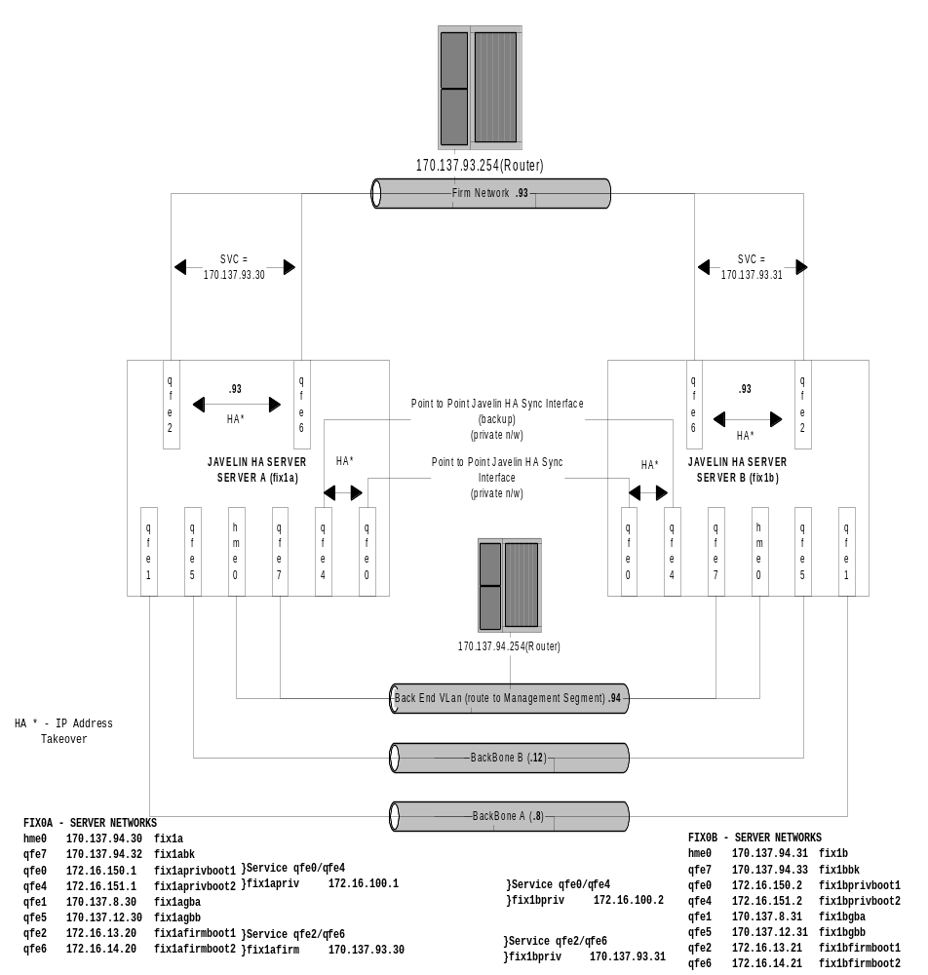

Appendix D – Assigned Port Numbers

 | COPPELIA RMI | COPPELIA FIRM | COPPELIA IIOP | TPF FIX SERVICE | TPF REMOTE SYNCRONIZER | HTTP PORT
DBSERVERA/B  FIX ORS | 21000
DBSERVERA/B  FIX 4.2 | 22000
CBOEFIX001A/B  FIX ORS | 21001 | 21501 | 21701  N/A | 22001 | 22301 | 22701
CBOEFIX002A/B  FIX ORS | 21002 | 21502 | 21702  N/A | 22002 | 22302 | 22702
FixCas01A/B  FIX 4.2 | 42001 | 42501 | N/A | N/A | N/A | 6201
FixCas02A/B  FIX 4.2 | 42002 | 42502 | N/A | N/A | N/A | 6202
FixCas03A/B  FIX 4.2 | 42003 | 42503 | N/A | N/A | N/A | 6203

Appendix E – Cboe FIX Server Cluster Sun Hardware Components

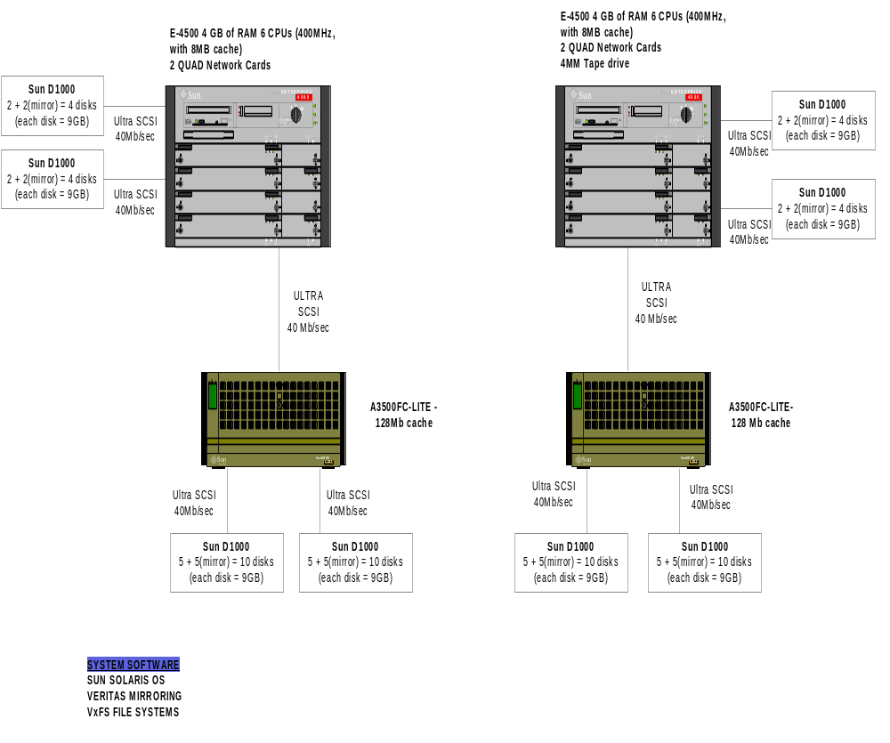

Appendix G – BMC Patrol - Monitored Log Files for FIX Servers
See documentation for each FIX Service for a list of files monitored for each specific service.
NOTE: See the CBOE Log Watch Knowledge Module on Patrol for more details.
Log File Full Path Name | Monitored for String | Description of Problem
/usr/tmp/nicfailoverlog_firm | MAC takeover | Nic failure of the FIRM Network Interface
/usr/tmp/nicfailoverlog_priv | MAC takeover | Nic failure of the Private Network Interface

The above files are monitored for certain error messages. The product used to monitor the logs is CBOE_LOGMATCH. Each log is represented by an icon, which is placed underneath in the CBOE_LOGMATCH container which is placed in the FIXapp container in this implementation. Once a condition is met the log's icon will turn red and a popup is generated. Once the alarm is generated it can be acknowledged from the popup window which clears the alarm.
From the main map traverse through the FIXapp container into the CBOE_LOGMATCH icon which contain the icons for all monitored files.
To clear an alert enter the following in the popup window.
Click on Acknowledge then the APPLY button followed by the CLOSE button.

Appendix H – Viewing the FIX Server Cluster Oracle Database Tables

The FIX Engine’s Oracle Database tables (Oracle Instance FXENGP0A on fix1a and FXENGP0B on fix1b) can be viewed through the Access ODBC connection setup on the PC that runs the FIXometer by doing the following:
- Go to the folder C:\FIXORSDATABASE and open the table fxeng.mdb (double-click on fxeng.mdb).
- For each firm connection the following tables are available:
On fix1a (Instance=FXENGP0A):
Firm_Inbound
Firm_Outbound
Firm_Stats
On fix1b (Instance=FXENGP0B):
Firm_Inbound
Firm_Outbound
Firm_Stats
Where Firm is the Firm ID
When a New Firm is added, the following steps need to be performed to add the link to the required Firm tables, 3 for FXENGP0Aand FXENGP0B:
Open the fxeng.mdb database and Click on New, Link Table. Chose Files of Type = ODBC Databases.
Enter the Service name (FXENGP0A or FXENGP0B) [User=coppelia, password=fixeng0]

Appendix I – How to Recover from a Javelin HA Script Failure (Support Services Action to Restore System to Initial State, Without Rebooting)
NOTE : This procedure requires Root Access. Only Support Personnel experienced in System Administration should perform these procedures.

What should you do if a NicFailover Script dies, or is killed accidentally?
Nothing. Do NOT attempt to bring up this script. The system should behave normally, provided there is no NIC card failure.

What should you do if a ClusterFailover Script dies, or is killed accidentally?
Nothing. As long as the FIX Engines are in Normal State, Intraday and do not need to failover, there should not be a problem. Restarting the script will interrupt firm traffic, so it is advisable not to bring up the script in this case.

What should you do is there is a serious problem and the Javelin HA scripts need to be bounced and the system returned to an Initial State?
You have 2 choices:
- You may reboot the server, although this is not recommended, unless there is no other choice.
- This procedure will reset the system to initial.
- Bring ALL Fix Engines on this Server DOWN. “StopFixSystem Primary/Secondary ALL”
- Login as Root. Stop ALL HA scripts. (Execute “monitor_ha” to find out the PIDs on the NIC Failover and Cluster scripts, then do a Kill –9 on these PIDs).
- On the 2 NICs (qfe2 and qfe6, qfe0, qfe4), execute the following to bring them to initial state:
Reset qfe0 to Boot Address using the following procedure:
- “ifconfig qfe0 down”
- “ifconfig qfe0 unplumb”
- “ifconfig qfe0 plumb”
- Execute “netstat –in” to verify that qfe0 is recognized by the system.
- Execute “setbootnic qfe0”. (This should set qfe2 to its BOOT IP).

Reset qfe4 to Boot Address using the following procedure:
- “ifconfig qfe4 down”
- “ifconfig qfe4 unplumb”
- “ifconfig qfe4 plumb”
- Execute “netstat –in” to verify that qfe2 is recognized by the system.
- Execute “setbootnic qfe4”. (This should set qfe4 to its BOOT IP).

Reset qfe2 to Boot Address using the following procedure:
- “ifconfig qfe2 down”
- “ifconfig qfe2 unplumb”
- “ifconfig qfe2 plumb”
- Execute “netstat –in” to verify that qfe2 is recognized by the system.
- Execute “setbootnic qfe2”. (This should set qfe2 to it BOOT IP).

Reset qfe6 to Boot Address using the following procedure:
- “ifconfig qfe6 down”
- “ifconfig qfe6 unplumb”
- “ifconfig qfe6 plumb”
- Execute “netstat –in” to verify that qfe2 is recognized by the system.
- Execute “setbootnic qfe6”. (This should set qfe6 to it BOOT IP).

- At this point qfe0, qfe4, qfe2 and qfe6 should be on their boot addresses. If not, do not proceed. If all interfaces are on boot address, proceed as follows:
- Execute “/etc/rc2.d/S68nicfailover start”.
- Wait for this script to bring the Service IP Addresses online on qfe0, qfe4, qfe2 and qfe6.
- Execute “/etc/rc2.d/S99fixclusterfailover start”
- Verify that all scripts start by doing a monitor_ha. If so, proceed to startup the FIX Engines.

