

CBOE FIX Operating Procedures and Support
Version 1.0a
Volume 2: FIX/ORS Operations and Support

How to operate and support the FIX/ORS server programs

CBOE Proprietary Information

1 August 2001
Document #[FIXOPS-02]

Front Matter

Disclaimer

Copyright © 1999-2001 by the Chicago Board Options Exchange (CBOE), as an unpublished work. The information contained in this document constitutes confidential and/or trade secret information belonging to CBOE. This document is made available to CBOE members and member firms to enable them to develop software applications using the CBOE FIX Protocol Support and its use is subject to the terms and conditions of a Software License Agreement that governs its use. This document is provided “AS IS” with all faults and without warranty of any kind, either express or implied.

Preface

CBOE is providing the FIX protocol to support order routing to all CBOE markets. This will include the current open outcry markets, as well as the planned electronic trading system. CBOE has provided a leadership role in expanding the FIX protocol standard for use in accessing exchange based derivatives markets.

Author
Carol Vazirani
Steve Blaha

Change Notices
The following change notices are provided to assist users of the CBOE FIX Services in determining the impact of changes to their applications.
Date | Version | Description of Change
120 Aug 2001 | 1.0a | Cleanup – added changes from Steve Blaha.
25 July 2001 | 1.0 | Updated with content from fixops-01.doc that is specific to FIX/ORS only.
23 Mar 2001 | 0.9 | Initial Draft after dividing document into three volums

Table of Contents
Front Matter 2
Disclaimer 2
Preface 2
Author 2
Change Notices 2
Regular Daily Operator Procedures for Startup/Shutdown and End of Day for FIX-ORS 6
Starting up the FIX-ORS System 6
Cleanup Verification Procedure 6
Verify Oracle is running using Patrol 7
End of Day – Running EOD and Stopping the FIX-ORS System 9
Special Operator Procedures for FIX-ORS 11
Starting up the FIX-ORS System as Primary on the backup server (fix1b) 11
Operations procedures after the FIX servers are rebooted 11
Components of the FIX-ORS System 13
FIX Engine Cluster(s) 15
Dbserver 15
Four-digit Strike Price File (symbol.table) from Compass Production Module 16
Log Files and Important Shortcuts 17
Login 17
Log File Descriptions 17
Aliases (Shortcuts) 18
Aliases for FIX Engine Log file locations 18
Aliases for FIX/ORS Software Component Locations 18
FIX-ORS – FAILURE CONDITIONS HANDLING PROCEDURES 20
System States 20
FIX Engine States 20
External Host Gateway (to TPF) Connection States 20
Firm Connection States 20
FIX Engine Failure Handling 22
Firm Connection Failure Handling 24
External Connections – (TPF Connection) Failure Handling 25
Issuing a Manual SUSPEND (Wack All) of Firm Connection(s) 26
Host Gateway/TPF Connection Failure – What happens when 26
Running End of Day if there are Queued Inbound/Outbound Messages 27
Command Line Startup and Shutdown Procedures for FIX/ORS 29
Login 29
Startup 29
Shutdown 30
Commands 31
Dbserver 31
Login 31
Startup 31
Shutdown 31
FIXometer 32
Login 32
Startup 32
Shutdown 32
Appendices 33
Appendix A – FIX Server Cluster Diagram 33
Appendix B – FIX Server Cluster High-Level Network Diagram 34
Appendix C – FIX/ORS Application Component Diagram 35
Appendix D – Coppelia FIX Engine – Process Detail 36
Appendix E – Host-Gateway Connection Port Numbers 37
APPENDIX F – PATROL MONITORED LOG FILES 37
APPENDIX G – VIEWING THE FIX ENGINE ORACLE DATABASE TABLES 39

Regular Daily Operator Procedures for Startup/Shutdown and End of Day for FIX-ORS
This section is all that Operations will require to maintain FIX/ORS on a daily basis. The rest of the document contains information about FIX/ORS that can be used by Support Services for trouble-shooting problems if they arise.

Starting up the FIX-ORS System

Cleanup Verification Procedure

Prior to starting FIX, verify that the cleanup was run and was successful from the previous evening.
Telnet into fix1a:
tn fix1a
login: fixprod
pswd: fixprod
To check the logs on engine1 type : fix001log;ls. The resultant display should show no dated log files.
If dated log files are present, then cleanup must be run prior to starting FIX.
Repeat this for every enigine. Fix002log;ls etc.
Repeat on fix1b.
Bring up the FIXometer, preferably on the NT workstation connected to the Management VLAN.
On the NT workstation from the C:\Fixometer directory execute the following command:
C:\Fixometer> startFixometerb.bat
Or
On UNIX Xterm:
Login to fix1b as fixprod, export the display and execute the command:
StartFixometerb
Note: All engines require a login initially to be accessed for command usage.
Login: FIX
Password: XIF

Verify Oracle is running using Patrol
From the Patrol Console, double-click on OracleApps Icon.
Double-click on oracleFXENGP0A oracle fix1a to ensure that all oracle processes are running.
Double-click on oracleFXENGP0B oracle fix1b to ensure that all oracle processes are running.
Double-click on oracleFXSCRP0A oracle fix1a to ensure that all oracle processes are running.
Double-click on oracleFXSCRP0A oracle fix1b to ensure that all oracle processes are running.
All oracle processing must be running before starting the FIX Application.
If any processing are not running you must start them from Patrol using the following instructions:
Right-click on oracle Icon
Select “start” from menu
Select “Start Oracle” or “Start Listener”
Double-click on oracle Icon to ensure that all oracle processes are running as described above.
To manually verify the ORACLE PROCESS are running on FIX1A: telnet fix1a then enter the following greps to display the critical oracle processes. ps –ef |grep ora_dbw, ps –ef |grep ora_lgwr, ps –ef |grep ora_pmon, ps –ef |grep ora_smon, ps –ef |grep tnslsnr.

To manually verify the ORACLE PROCESS are running on FIX1B: telnet fix1b then enter the following greps to display the critical oracle processes. ps –ef |grep ora_dbw, ps –ef |grep ora_lgwr, ps –ef |grep ora_pmon, ps –ef |grep ora_smon, ps –ef |grep ora_reco, ps –ef |grep tnslsnr.

From the Patrol Console, double-click on FIXApps Icon.
Right-click on FixPri icon and Click on Start All PrimaryServers. (Or telnet to fix1*) *= a or b whichever is primary
Right-click on FixSec icon and Click on Start All Secondary Servers. (Or telnet to fix1*) *= a or b whichever is primary

To manually start the FIX applications
telnet to fix1a as fixprod and execute startFixSystem Primary all) – for master (fix1a by default)
telnet to fix1b as fixprod and execute startFixSystem Secondary all) – for slave (fix1b by default)

To view monitored fix processes go to the patrol main view and click on FIXApps icon this will start another view with icons for fixPri and fixSec icons. Double-click on each of them to ensure that all icons are Green.
FixPri view:
Left click on icon to bring up the Primary process icon list.
Right click on fixPri icon list fix system processes shown as icons Pri001 through Pri002 in the view.
The Cluster00[1-2], DbSrv and PrivateNic, FirmNic processes are the failover and cluster processes which should be up at all times.

FixSec view:
Left click on icon to bring up the Secondary process list.
Right click on fixsec icon to list the fix secondary processes.
The Cluster00[1-2] DbSrv and PrivateNic, FirmNic processes are the failover and cluster processes which should be up at all times

End of Day – Running EOD and Stopping the FIX-ORS System
Use the FIXOMETER End Of Day Menu, to clear out the Database for the FIX Engines.

After purge Day orders/Nothing Done processing is complete on TPF, all Firm connections must be “SUSPENDED”.
Fixometer, Menu Commands, Option Suspend
Pick ALL engines and Select All.
Login using the required login: (fxscr,fxscr0 can be used as username,password on fix1b)
(coppelia, fixeng0 can be used as username,password on fixtest (dev only))
Verify “Suspended” status for all FIX firm connections. Then Run End of Day.
Fixometer, Menu Commands, Option Run End of Day
Pick ALL engines and Select All.

Note: All engines require a log in initially to be accessed for command usage.
Login: FIX
Password : XIF

NOTE: The FIXometer will issue a warning if there are queued messages and End of Day is run for that FIRM connection. If this happens, do the following:
Cancel out and do not Run the EOD.
Right click on the connection that has the Queue Count > 0 and View Queued Messages.
Execute Print, to print a hard copy of the queued messages and contact Support Services.
Make a note of the Order-Ids queued.
Proceed to run EOD.

Ensure that all the Sequence numbers and counts are reset for all firms.
Shutdown the FIXometer. On the Fixometer, Menu File, Option Exit
Stop FIX Engines on both fix1a and fix1b . First do the slave [fix1b], then do the master(fix1a).
Use Patrol to stop the system on fix1b
(or login to fix1b as fixprod and execute stopFixSystem Secondary all) – for slave (fix1b by default)
Use Patrol to stop the system on fix1a
(or login to fix1a as fixprod and execute stopFixSystem Primary all) – for master (fix1a by default)
Execute showFixProcesses on fix1a and fix1b to ensure that all processes are down.

[For test only: If the Simulator is UP, bring it down by running: stopTpfSimulator]

Use Patrol to Run CleanupFixSystem on fix1a and fix1b
(or login to fix1a and fix1b and Run the following command on the UNIX command line to cleanup Application Log files cleanupFixSystem )

If no errors are generated, the system is ready for the next production day.

Special Operator Procedures for FIX-ORS

Starting up the FIX-ORS System as Primary on the backup server (fix1b)
Operations may chose to bring up the FIX Engines as Primary on fix1b. Following are the procedures to do this.
To start the Primary on fix1b do the following.
Left double-click on either CBOEGroup_A or CBOEGroup_B icon and find the cboeFIX group.
Right click on the cboeFIX icon to start, stop or list the FIX processes.
This will bring up a node selection window in this window select Individual Fix server.
This will open another window with individual servers select the desired server and click ok.
Double-click on the AllServices icon. Right click on the FIX1B icon and select the “Break Connection” option from the pull-down menu. Right click on the FIX1B icon again and select the “Update Connection” option from the pull-down menu. The FIX1B icon should now reflect FixPri.

Follow the same procedure to start up fix1a as Secondary.

Use the following procedures to bring up the FIXometer:
Bring up the FIXometer, preferably on the NT workstation connected to the Management VLAN.
On the NT workstation:
Execute startFixometera.bat [C:\Fixometer]
Or
On UNIX Xterm:
Login to fix1a as fixprod, export the display and execute the command: startFixometera

Operations procedures after the FIX servers are rebooted
On reboot of fix1a and/or fix1b, the HA scripts should start automatically and hence require NO operator intervention. Status of this can be checked by running monitor_ha from the command line, or via patrol.
From the Patrol Console, double-click on FIXApps Icon.
Right-click on FixPri icon and Click on Monitor_HA.
Right-click on FixSec icon and Click on Monitor_HA.

Operations is however, require to bring up the 2 Oracle instances each and the Listener on fix1a and fix1b using Patrol:

From the Patrol Console, Double-click on OracleApp.
Select Instance FXENGP0A
Right click on FXENGP0A and Click on Start and then Click on Start Oracle
Select Instance FXSCRP0A
Right click on FXSCRP0A and Click on Start and then Click on Start Oracle
Select Instance FXENGP0A
Right click on FXENGP0A and Click on Start and then Click on Start Listener
– Note: There is only one Oracle Listener, which is shared by FXENGP0A and FXSCRP0A.

Select Instance FXENGP0B
Right click on FXENGP0B and Click on Start and then Click on Start Oracle
Select Instance FXSCRP0B
Right click on FXSCRP0B and Click on Start and then Click on Start Oracle
Select Instance FXENGP0B
Right click on FXENGP0B and Click on Start and then Click on Start Listener
– Note: There is only one Oracle Listener, which is shared by FXENGP0B and FXSCRP0B.

Ensure the status of the 2 Oracle Instances via Patrol Oracle App
Double-click on OracleApp. Select the Instance
FXENGP0A
FXSCRP0A
FXENGP0B
FXSCRP0B
Double-click each of the icons and verify that all the icons within show Green.

Or Operation can bring up the 2 Oracle instances each and the Listener on fix1a and fix1b using the following procedures:

Login to fix1a as user oracle :
cd /orahome/home/bin
Start up Instance FXENGP0A with the following command:
ora_dbstartFXENGP0A
Start up Instance FXSCRP0A with the following command:
ora_dbstartFXSCRP0A
Start up the listener with the following command:
Lsnctrl<Enter>
start

Login to fix1b as user oracle :
cd /orahome/home/bin
Start up Instance FXENGP0B with the following command:
ora_dbstartFXENGP0B
Start up Instance FXSCRP0B with the following command:
ora_dbstartFXSCRP0B
Start up the listener with the following command:
Lsnctrl<Enter>
start

Components of the FIX-ORS System
In addition to the processes outline in Volume 1 for the FIX Server Cluster, FIX/ORS has the following system components.

FIX Engine Cluster(s)
Fix1a and fix1b are currently setup to run two FIX/ORS Engine Clusters (Ref. To Appendix D for a process layout on the servers).
The FIX Engine Cluster is a process that contains 3 subsystems, running in-process, as described below:
The Coppelia FIX Engine - This is the FIX Engine Server that is responsible for maintaining firm connections.
The CoppeliaTPFAdapter - This is the interface that converts FIX messages to and from the TPF Format.
The TPF FIX Service - This is the generic connection server that makes a connection to TPF via the Host Gateway.

Each cluster comprises a process pair that runs on the primary server fix1a as MASTER, and its SLAVE that runs on the backup server fix1b. The MASTER accepts FIRM connections by LISTENING on the FIRM port (21501 and 21502). The SLAVE receives a duplicate copy of every message and syncs up its duplicate database.

Dbserver
Servers, fix1a and fix1b have a dbserver process running. This process establishes a connection with the MASTER FIX Engine. Each dbserver connects as SLAVE to the MASTER FIX Engine servers. They receive a duplicate copy of every message received by the MASTER and log these messages to the Back End Screen database (FXSCRP0A and FXSCRP0B).

Four-digit Strike Price File (symbol.table) from Compass Production Module
In order to handle 4-digit strike prices, the FIX-ORS application needs the file symbol.table from the Compass Production Module M8/M9, ftp’d is ASCII format to the RUN_DIR on fix1a and fix1b. A script named getCompassStrikePrice is cron’d for the fixprod user that automatically runs this script at 07:01am. If the script fails to ftp the file, a Patrol POPUP is sent to the Console. An email is also generated to fixsupport@cboe.com.

If this happens, Operations may manually run this script using Patrol: Right click on fixA/fix1B and select the “CompassFtp StrikePrice” option from the pull-down menu.

Or Opertation may manually run this script by logging into fix1a/fix1b user=fixprod. This script ftp’s the file symbol.table from M8/M9 production running_dir to directory. The newly ftp’d file should be loaded into the FIX system (if already started up) by using the Web Maintenance Screen. /apps/fixengine/prod/running_dir/log/getCompassftpfile.log is the logfile created by this script.

Log Files and Important Shortcuts

Login
Testing: fix
Assurance: fixassur
Production: fixprod

Log File Descriptions
FixEngine001.log (link to CYYYYMMDD.log) - FIX Engine Log File
FixEngine001.rej (link to CYYYYMMDD.rej) - FIX Engine Log File
The files above should contain all Session layer logging. Every FIX message to and from the FIX engine is also logged. Messages rejected by the FIX Engine will be logged to the .rej file.
CBOEFIX001.log (TPFAdapter and TPFFIXService log file)
This file will have errors specific to the adapter or FIX Service. Any TPF rejects will be logged in this file.
CBOEFIX001.debug (TPFAdapter and TPFFIXService log file, will have info when debug is turned on).
CBOEFIX001.out (Standard Output).
This file is the standard output file. View this file for errors generated as a result of FIX Server startup issues.

Aliases (Shortcuts)
The following tables show the shortcuts (UNIX shell aliases) that are defined to make access to various FIX/ORS files easier to access.
Note full path names are shown for login fixprod only. The path: /apps/fixengine/prod/running_dir is identified by the UNIX environment variable: ${RUN_DIR}. You can display the running directory by typing the following command:
echo $RUN_DIR

Aliases for FIX Engine Log file locations
Alias | Location
fix001log | (/apps/fixengine/prod/running_dir/log/CBOEFIX001)
fix002log | (/apps/fixengine/prod/running_dir/log/CBOEFIX002)
Dbserverlog | (/apps/fixengine/prod/running_dir/log/DBSERVER)

NOTE Regarding logfiles: Upon running cleanupFixSystem the logfiles from these directories are moved into the directory specified by the Day of the Week. Log files are stored for 7 days prior.

Aliases for FIX/ORS Software Component Locations
Alias | Description | Location
Copetc | Coppelia Engine Configuration Files (.ini files) | (/apps/fixengine/prod/Coppelia/etc)
Copclass | Coppelia executable code java class files JAR Files (.jar files) | (/apps/fixengine/prod/Coppelia/classes)
Servetc | Server Configuration Files for the FIX/ORS TPF Adapter (.properties files) | (/apps/fixengine/prod/Server/etc)
Servbin | Server Scripts for Startup, monitoring, and shutdown | (/apps/fixengine/prod/Server/bin)

FIX-ORS – FAILURE CONDITIONS HANDLING PROCEDURES
The FIXometer is used to monitor the FIX-ORS system. Among the various components monitored are:
FIX Engine Clusters(Master/slave) state
External Connections from the FIX Engine to TPF. This includes the Order Service, Report Service and the Tag Service for the Master and the Tag Service for the Slave Engine.
Firm Connections to each Fix Engine.

System States

FIX Engine States

State | Condition | Description
Master | Normal | The first FIX-Engine started in the cluster assumes the MASTER role.
Slave | Normal | The second FIX-Engine started in the cluster assumes the SLAVE role.
DOWN | Error | The FIX-Engine process is down.

External Host Gateway (to TPF) Connection States

State | Conditon | Description
UP | Normal | The FIX-Engine has successfully established a Host Gateway connection to TPF.
DOWN | Error | The external connection to TPF is not available.

Firm Connection States

State | Conditon | Description
UP | Normal | The Firm has successfully connected to the Engine
DISCONNECTED | Warning | The Firm has disconnected from the Engine.
DOWN | Warning | The Firm was not connected when the FIXometer stared.
LOGON | Error | A Logon message has been received from the firm but not acknowledged.
SUSPEND | Manual | One or more, or ALL connections have been manually suspended using the FIXometer. Firms are disconnected and logon messages will be rejected.
HOLD | Warning | The connection is on hold, incoming messages will be rejected.
SERVICE DOWN | Error | The External TPF connection is down. Firms are disconnected and logon messages will be rejected.

FIX Engine Failure Handling

Symptom | Condition | Handling
The FIXometer complains “SERVER IS DOWN”. The icon shows RED. No Firm traffic is affected | The Slave FIX-Engine is DOWN. | Ensure that the Master Engine is successfully receiving messages, uninterrupted. Firm Connection Status should show “UP”.  Login to the server where the slave is running and restart the process, or use Patrol to restart the Process.
The FIXometer complains “SERVER IS DOWN”. The icon shows RED. Firm Connections get DISCONNECTED. | The Master FIX-Engine is DOWN. | The Slave Engine should automatically take over as MASTER. Firm connections should switch to the new MASTER. Login to the server that runs the new MASTER and type “monitor_ha”. The FIRM IP aliases should show on the master.  Ensure that the new MASTER successfully connects to TPF. Verify the state UP for the Order Service, Report Service and Tag Service.  Ensure that the FIRM connections successfully re-connect after the switch. State should be UP.  Contact Support Services before bringing the failed engine back up. Restarting this engine will make it a SLAVE and sync messages from the MASTER.  If the Slave Engine, for some reason does not take over as MASTER, Operations should contact Support Services. Firms should be asked to route their traffic to their 2nd connection on another engine, while the failed engine is restarted. This is NOT normal behavior for the system and should be addressed with Javelin Tech.

Firm Connection Failure Handling

Symptom | Condition | Handling
FIXometer shows FIRM Connection state as “DISCONNECTED” | The Firm has disconnected from the Engine. | The Firm should automatically re-connect. Support Services should be contacted if manual intervention is required. This would be an abnormal condition.  IMPORTANT NOTE:  If a FIRM is unable to re-connect, any outbound Fill reports/cancel reports will be queued Outbound for that connection (FIXometer Outbound Queue reflects). Operations can view Outbound queued messages (Right-click mouse on Firm connection line and chose View Outbound queued messages. If the connection will not come back up, these queued messages should be printed (select ALL and Print) and faxed to the Firm contact before End of Day is run (the End of Day run will warn Operations if there are any Outbound queued messages).
DOWN | The Firm was not connected when the FIXometer stared | Handling is same as the DISCONNECTED state.
LOGON | A Logon message has been received from the firm but not acknowledged | Operations should DISCONNECT the FIRM using the FIXOMETER. (Right-click the mouse with the cursor on the FIRM connection). Only users with authorization will be allowed to perform this.
HOLD | The FIX-Engine has lost the connection to TPF and is de-queueing received orders. | Refer to External Connections – (TPF Connection) Failure Handling.
SERVICE DOWN | Connection to TPF is down. Firms have been disconnected. | Refer to External Connections – (TPF Connection) Failure Handling.
SUSPEND | This is a manual Operation that is executed via the FIXometer. | Operations/Support Services will Suspend Firms, when there is a business condition that should prevent firms from sending in orders to the CBOE. Operations may RELEASE Firms, when that condition has cleared.

External Connections – (TPF Connection) Failure Handling
NOTE:
The MASTER FIX Engine establishes 3 connections to TPF services:
- Order Service
- Report Service
- Tag Service

The SLAVE FIX Engine establishes 1 connection to TPF:
- Tag Service
The current release of the FIX Engine may or may not show the status of the connection to TPF for the SLAVE. This should be verified via Host Gateway instead (Enhancement will be provided in phase 2)

The FIX-Engine uses the TPF FIXService to establish connections to TPF. Each server has dual connections (over separate NIC cards) to Backbone A and Backbone B. Failover to the backup network/Hostgateway system is, as a result, automatically handled by the TPFFIXService and will require no Operator intervention.

Symptom | Condition | Handling
The FIXometer shows one Order Service DOWN. | The FIX-Engine has a problem establishing a connection to TPF over Host Gateway. | There is a 20 sec(configurable) duration where incoming orders will queue in the FIX-Engine. The FIXometer will reflect this in the Inbound Queue. The state will relect in Yellow if more than 3 orders are queued.  If the Engine cannot recover the TPF connection within 20 secs, it will set the FIRM connection status to HOLD. During this time, all inbound queued messages will be rejected with reason “ORS System is Unavailable”. New messages will be rejected with the same reason. When the queue is drained, the Firm connection state will be set to SERVICE DOWN. Firms will be disconnected and incoming connections will be refused, while the Engine retries the TPF connections.  When the TPF connections resume, Firm connections are automatically enabled. FIXometer will show the state as DISCONNECTED until the Firm re-connects and sets the state to UP.

Issuing a Manual SUSPEND (Wack All) of Firm Connection(s)
Firm connections may be manually suspended using the FIXometer:
Chose the FIXometer menu:
Commands
Suspend
This provides the option to pick a specific engine, or ALL engines. If a specific engine is picked, either a single firm or ALL firms can be picked from the GUI interface.

To perform a Wack All Operation:
Check Select All for Server Group Selection and Select All for Connection Selection, then hit the Suspend Button. If not previously logged into each engine, you will be prompted to login, specifically to each engine. The login once performed will persist until the FIXometer is exited.

Host Gateway/TPF Connection Failure – What happens when

- Report Service goes down and the Order Service is still UP.
In this case, Orders will still come in from firms and will be acknowledged by TPF. However, no Fill Reports will be sent to the firms, until the Report Service resumes. Fill Reports will be queued in TPF. When the connection does resume, these reports should be automatically sent out. If Operations/Support Services determines that orders should not come in, manual intervention is required. A Wack-All Operation will need to be performed in this case, if found necessary.

- One or all of the Host Gateway Connections (Order/Report/Tag Service) breaks:
The TPF Fix Service currently has a list of 4 destination IPs in its config table, m24a,m24b,m25a,m25b. If the connection to first IP fails or breaks it does the following:
- Retries this connection.
- If it fails to connect, it sleeps for 7secs.
- It then tries the next IP. It will try this for all the IPs in its list, until it succeeds.
- (Applies to Order Service only).
The TPFAdapter has a timeout period of 20secs. During this time, orders will come in and queue. If the TPFAdapter cannot make a connection to TPF within 20 secs, it will:
- stop the front door (new incoming messages will be rejected),
- reject any queued orders and
- Wack all Firms (disconnect connections and set the state to SERVICE DOWN)
When the connections do come back, the Adapter will automatically recover the connections (FIXometer will show HGW Order Service connection state as UP) and Release the Firm connections. This should change the state of Firm connections in the FIXometer to DISCONNECTED. IF the Firms have setup to automatically reconnect, their connections should succeed when this happens and normal processing should resume.

Running End of Day if there are Queued Inbound/Outbound Messages

NOTE: The FIXometer will issue a warning if there are queued messages and End of Day is run for that FIRM connection. If this happens, do the following:
- Cancel out and Do not Run the EOD.
- Right click on the connection that has the Queue Count > 0 and View Queued Messages. Operations should make a note of the Order-Ids that are queued.
- Execute Print, to print a hard copy of the queued messages and contact Support Services.
- Proceed to run EOD.

Command Line Startup and Shutdown Procedures for FIX/ORS

Login

Testing: fix
Assurance: fixassur
Production: fixprod

Startup

To start the FIX System as Primary(MASTER):
startFixSystem Primary all
To start the FIX System as Secondary(SLAVE)
startFixSystem Secondary all
To start a FIX Engine(001 or 002) as Primary(MASTER)
startFixSystem Primary 00n
(where n is the number of the FIX Engine from 1 to 5)

To start a FIX Engine(001 or 002) as Secondary(SLAVE)
startFixSystem Secondary 00n
(where n is the number of the FIX Engine from 1 to 5)

Shutdown

To stop the FIX System as Primary(MASTER)
stopFixSystem Primary all
To stop the FIX System as Secondary(SLAVE)
stopFixSystem Secondary all
To stop a FIX Engine(001 or 002) as Primary(MASTER)
stopFixSystem Primary 00n
(where n is the number of the FIX Engine from 1 to 5)

To stop a FIX Engine(001 or 002) as Secondary(SLAVE)
stopFixSystem Secondary 00n
(where n is the number of the FIX Engine from 1 or 2).

Commands

Dbserver

Login
Testing: fix
Assurance: fixassur
Production: fixprod

Startup

To start the dbserver on either box:
startDbServer

Shutdown

To stop the dbserver on either box:
stopDbServer

FIXometer
The FIXometer should be started from the NT workstation that is connected to the Management VLAN by execution startFixometerb.bat from C:\Fixometer directory. If the fix1b server is not available, use startFixometera.bat to connect to the fix1a server’s backend database.
To run on the UNIX side:

Login
Testing: fix
Assurance: fixassur
Production: fixprod

Startup

Export your DISPLAY (eg. export DISPLAY=xnv1:0.0)
NOTE: As a rule, always login to fix1b and start the FIXometer, unless fix1b is not available.
To start the FIXometer on fix1b:
startFixometerb (PREFERRED)
To start the FIXometer on fix1a:
startFixometera

Shutdown

From the Fixometer File Menu select the Exit command.

Appendices

Appendix A – FIX Server Cluster Diagram

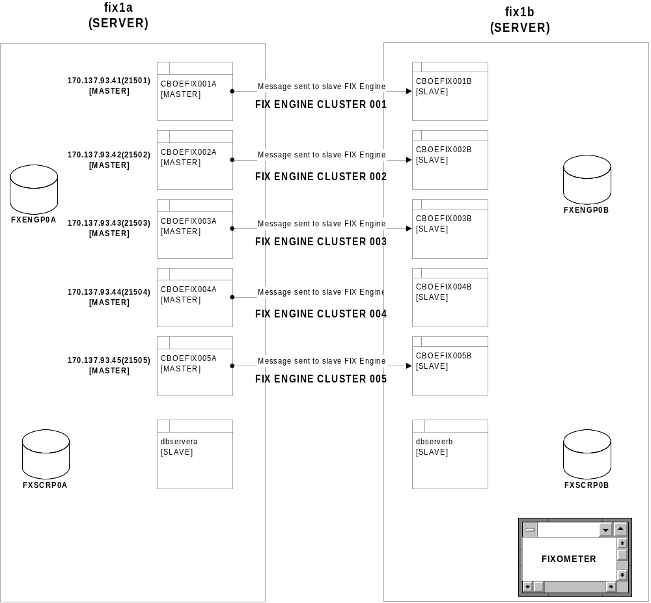

Appendix B – FIX Server Cluster High-Level Network Diagram

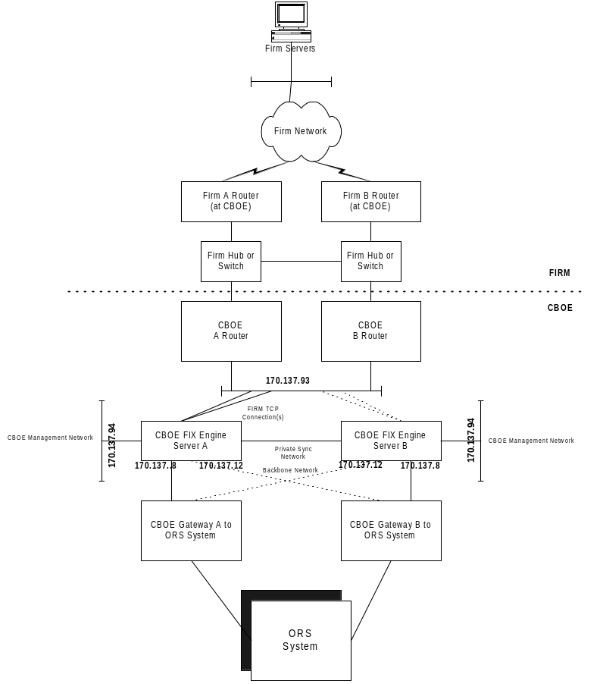

Appendix C – FIX/ORS Application Component Diagram
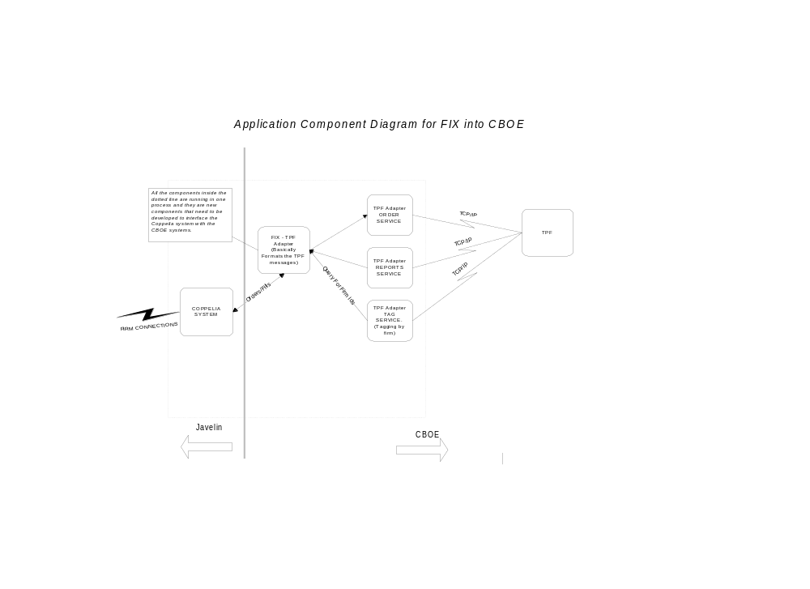

Appendix D – Coppelia FIX Engine – Process Detail
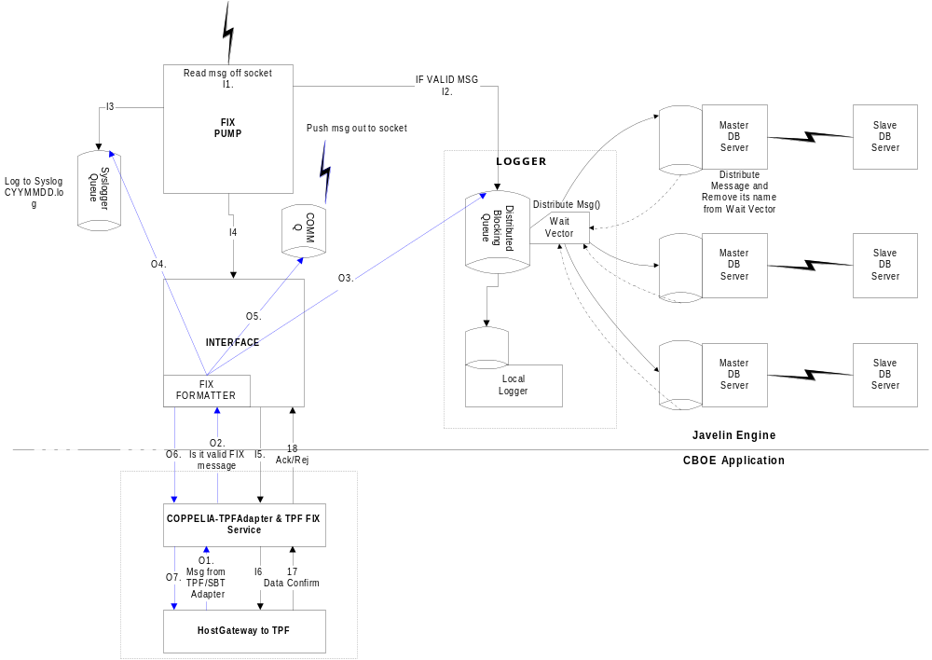

Appendix E – Host-Gateway Connection Port Numbers

PORT NAME | PORT-NUMBER | DESCRIPTION
Hgw_ords | 30030 | ORDER-SERVICE
Hgw_rpts | 30032 | REPORT-SERVICE
Hgw_tags | 30033 | TAG-SERVICE

Appendix F – PATROL MONITORED LOG FILES

Log File Full Path Name | Monitored for String | Description of Problem
/apps/fixengine/prod/running_dir/log/CBOEFIX001/FixEngine001.log  /apps/fixengine/prod/running_dir/log/CBOEFIX002/FixEngine002.log | - Is down  - Heartbeat failed | Slave Takeover of FIX Engine
/usr/tmp/nicfailoverlog_firm | MAC takeover | Nic failure of the FIRM Network Interface
/usr/tmp/nicfailoverlog_priv | MAC takeover | Nic failure of the Private Network Interface
/apps/fixengine/prod/running_dir/log/getCompassftpfile.log | FTP Failed | FTP of file symbol.table from Compass Production Module Failed.

NOTE: See CBOE Log Watch Knowledge Module for Patrol for more information.
The above files are monitored for certain error messages. The product used to monitor the logs is LOGWATCH. Each log is represented by an icon, which is placed underneath the icon for the physical server. Once a condition is met the log's icon will turn red. It will continue to be red until you disarm the condition.

Using server fix1a as an example the procedure to disarm the alert is as follows:

From the main map traverse through the AllServers icon->fix1a->Bitwatch->Logwatch
Here is where all the log icons are placed for fix1a, find the icon that is in alarm state and select it (single click).
With MB3 (right mouse) you will see a drop down menu. One option will be Admin->Reset->Reset Logfile Status.
After selecting that option the alarm is reset.

You can configure Logwatch to also present a popup window with the alarm condition. The above holds true for this type of configuration. The only difference is that any additional popup windows will be suppressed until the procedure to reset the alarm (exactly like above) is completed.

Appendix G – VIEWING THE FIX ENGINE ORACLE DATABASE TABLES

The FIX Engine’s Oracle Database tables (Oracle Instance FXENGP0A on fix1a and FXENGP0B on fix1b) can be viewed through the Access ODBC connection setup on the PC that runs the FIXometer by doing the following:
- Go to the folder C:\FIXORSDATABASE and open the table fxeng.mdb (double-click on fxeng.mdb).
- For each firm connection the following tables are available:
On fix1a (Instance=FXENGP0A):
Firm_Inbound
Firm_Outbound
Firm_Stats
On fix1b (Instance=FXENGP0B):
Firm_Inbound
Firm_Outbound
Firm_Stats
Where Firm is the Firm ID
- When a New Firm is added, the following steps need to be performed to add the link to the required Firm tables, 3 for FXENGP0Aand FXENGP0B:
Open the fxeng.mdb database and Click on New, Link Table. Chose Files of Type = ODBC Databases.
Enter the Service name (FXENGP0A or FXENGP0B) [User=coppelia, password=fixeng0]

