SYSTEMS DIVISION
IPD Testplan Phase2d.
TEST PLAN DOCUMENT
WR # 2111

DRAFT

Prepared By:
Back Office IPD Team

1. Regression Testing 4
1.1. Regression testing of IPD application using test plans from all earlier versions. 4
2. Standardize Inactivation Dates for Products based on A.M/P.M. settlement types and expiration class code. 4
2.1.1. Test Description: 4
2.1.2. Expected Results 4
2.1.3. Test Description : 6
2.1.4. Expected Results 6
2.1.5. Test Description : 6
2.1.6. Expected Results 6
2.1.7. Test Description ; 6
2.1.8. Expected Results : 6
2.1.9. Test Description ; 6
2.1.10. Expected Results : 6
3. Status Updates (“Magic Button”) 6
3.1. Test Change-To-Add 7
3.1.1. Transmit a Reporting Class update through the End of Day screen to SBT that will fail. (IPD development may need to help simulate an error condition). 7
3.1.2. In the SBT TransmitStatus window, click “Approved” for one record of the failed transmission. Click the Change To Add Button. 7
3.1.3. Refresh the SBT Reporting Class End of Day screen. The transmission type of the transmission should now read “Add” 7
3.1.4. Send the Reporting Class addition to SBT. Verify in TransmitStatus window. 7
3.1.5. Repeat test for Product Class and Product. 7
3.1.6. Repeat 3.1.1 to 3.1.5 for TPF. 7
3.2. Test Remove Transmit 7
3.2.1. Create a new dummy reporting class in the Reporting Class Maintenance Window. Make the effective date the next day. 7
3.2.2. Find the reporting class in the SBT End of Day screen. Transmit the reporting class. 7
3.2.3. In the SBT Reporting Class TransmitStatus Window, click Approved on the reporting class record in the transmit log table. 7
3.2.4. Click Remove Transmit. 7
3.2.5. Refresh to the End of Day screen. The reporting class should no longer appear. 7
3.2.6. Repeat test for Product Class and Product. 7
3.2.7. Repeat 3.2.1 to 3.2.6 for TPF. 7
4. Option spreadsheet delete-of-pending-addition change 8
4.1. Test procedure 9
4.1.1. In IPD maintenance, create a new series with an effective date of the following business day. The series will be inactive (IPD will prevent the listing state from being active). 9
4.1.2. Open the SBT end of day screen. The series should appear as a pending addition. Do not send it. 9
4.1.3. Find or create an Option spreadsheet Delete entry (see example below) for the series created in step 4.1.1. 9
4.1.4. Load the spreadsheet through the Excel Series -> Options screen. Approve the delete record. 9
4.1.5. After the spreadsheet load completes successfully, use the Product maintenance screen to verify that the Listing State is now Obsolete. 9
4.1.6. In the SBT end of day screen verify that the series no longer appears as a pending addition. There should be no record for that series. 9
4.2. Example delete records 9
5. Stock-related GUI changes. 10
5.1. Verify that derivatives now require users to explicitly find an underlying. 10
5.1.1. Open the Product Class maintenance screen. 10
5.1.2. Select an Option. Verify that only the Find button is enabled in the Underlying panel. 10
5.1.3. Create a new dummy Product Class. Verify that Find must be used to set the Underlying 10
5.1.4. After saving the new Product Class, change its underlying of the Find button. 10
5.1.5. Repeat for Future product class. 10
5.2. Equity maintenance changes 10
5.2.1. In the Product Class maintenance screen, display an Equity product class. 10
5.2.2. Verify that Session Code may now be assigned. Update the session code, save the record, and verify the update. 10
5.2.3. In the Product Class maintenance screen, create a new Equity. 10
5.2.4. Verify that Session Code can be assigned in the “Product Class” section and that Contract Size can be set in the “Reporting Class” section. Enter values (use “1” for the Contract Size) and save. 10

Regression Testing

Regression testing of IPD application using test plans from all earlier versions.

Standardize Inactivation Dates for Products based on A.M/P.M. settlement types and expiration class code.

Test Description:
SBT COUNT:
SELECT COUNT(*)
FROM product prd
WHERE
prd.INACT_DATE > 0
AND Convert_Java_Time(prd.inact_date) >= SYSDATE
--AND prd.PROD_CLASS IN (SELECT pc.DATABASEIDENTIFIER FROM prod_class pc
--WHERE pc.SETTLEMENT_TYPE =1)
--AND prd.PROD_NAME LIKE 'IBM%'
AND prd.prod_type_code IN (4,7)
AND NOT EXISTS (
SELECT * FROM prod_class pc WHERE pc.databaseidentifier = prd.prod_class
AND pc.IS_TEST_CLASS <> 1 AND EXISTS (SELECT * FROM rpt_class rc WHERE rc.TRAIN_IND ='Y'
AND rc.DATABASEIDENTIFIER = prd.rpt_class)
)
AND Convert_Java_Time(prd.inact_date) = TO_DATE(prd.EXPR_DATE,'YYYYMMDD')
-- AM SETTLEMENT TYPES
AND ( prd.PROD_CLASS IN (SELECT pc.DATABASEIDENTIFIER FROM prod_class pc
WHERE pc.SETTLEMENT_TYPE =1)
-- STANDARD OPTIONS
OR prd.rpt_CLASS IN (SELECT rc.DATABASEIDENTIFIER FROM rpt_class rc
WHERE rc.EXPR_CLASS_CODE ='S' AND rc.prod_type_code = 7)

TPF COUNT:
SELECT COUNT(*)
FROM product prd
WHERE
prd.INACT_DATE > 0
AND Convert_Java_Time(prd.inact_date) >= SYSDATE
--AND prd.PROD_CLASS IN (SELECT pc.DATABASEIDENTIFIER FROM prod_class pc
--WHERE pc.SETTLEMENT_TYPE =1)
--AND prd.PROD_NAME LIKE 'IBM%'
AND prd.prod_type_code = 7
AND Convert_Java_Time(prd.inact_date) = TO_DATE(prd.EXPR_DATE,'YYYYMMDD')
-- AM SETTLEMENT TYPES
AND ( prd.PROD_CLASS IN (SELECT pc.DATABASEIDENTIFIER FROM prod_class pc
WHERE pc.SETTLEMENT_TYPE =1)
-- STANDARD OPTIONS
OR prd.rpt_CLASS IN (SELECT rc.DATABASEIDENTIFIER FROM rpt_class rc
WHERE rc.EXPR_CLASS_CODE ='S' AND rc.prod_type_code = 7)

Execute the above the script to know the number of products which need to be converted.
Execute the SQL script InactDateConv.sql provided in a sql directory and verify the inactivation dates products with all types of expiration class codes and settlment types.

Expected Results
Inactivation Dates for the all combinations of settlement types and expiration class code should match as per table below.

 | INACTIVATION OF PRODUCTS BASED ON SETTLEMENT TYPE AM/PM
Sub_Type |  | AM/PM | Expiration Date | Inactivation Date | EOD Inactivate
Standard |  | AM | SAT | SAT-2 | SAT-2
Standard |  | PM | SAT | SAT-1 | SAT-1
Weekly |  | AM | (M-F) | (M-F)-1 | (M-F)-1
Weekly |  | PM | (M-F) | (M-F) | (M-F)
Monthly |  | AM | END OF MONTH | END OF MONTH -1 | END OF MONTH -1
Monthly |  | PM | END OF MONTH | END OF MONTH | END OF MONTH
Quaterly |  | AM | END OF QTR | END OF QTR -1 | END OF QTR -1
Quaterly |  | PM | END OF QTR | END OF QTR | END OF QTR
Standard |  | AM | FRI | FRI-1 | FRI-1
Standard |  | PM | FRI | FRI | FRI
Custom |  | AM | TBD | TBD | TBD
Custom |  | PM | TBD | TBD | TBD

Table A.

Test Description :
Using AR serverTransmit transmit all the products to TPF system and execute the SQL script SELECT COUNT(*) FROM ipd_product_transmit_log
WHERE msg_dest_code='T'
AND msg_stat_code=100001
AND prod_uid IN (
SELECT databaseidentifier FROM product WHERE lmod_username IN ('INACTIVATE DATE CONVERSION')
)

Expected Results
Count of the above SQL script should match the TPF count from the SQL in step 2.1.1 Test.

Test Description :
Using AR serverTransmit transmit all the products to SBT system .
Execute the SQL script UpdTpfTransmitLog.sql provided in a sql directory and execute the SQL script SELECT COUNT(*) FROM ipd_product_transmit_log
WHERE msg_dest_code='S'
AND msg_stat_code=100001
AND prod_uid IN (
SELECT databaseidentifier FROM product WHERE lmod_username IN ('INACTIVATE DATE CONVERSION')
)
Also Restart the server.

Expected Results
Count of the above SQL script should match the SBT count from the SQL in step 2.1.1 Test From the count exclude series with training reporting classes .

Test Description ;
Add as well as Update series for standard and also non standard options for both A.M as well as P.M settlement types.

Expected Results :
Inactivation Dates should be added or update as per Table A.

Test Description ;
Add as well as Delete series for standard and also non standard options for both A.M as well as P.M settlement types. Thru Excel Series load

Expected Results :
Inactivation Dates should be added or updated as per Table A.

Status Updates (“Magic Button”)
The status update feature replaces the Re-Send function on the Transmission Status window with two new options: Change-To-Add and Remove Transmit. The new features allow users to resolve problems caused by data differences between IPD and trading systems that can arise as a result of different purge behavior or other errors.
The screen shot below shows how the Transmit Status screen should now appear.

Test Change-To-Add

Transmit a Reporting Class update through the End of Day screen to SBT that will fail. (IPD development may need to help simulate an error condition).

In the SBT TransmitStatus window, click “Approved” for one record of the failed transmission. Click the Change To Add Button.

Refresh the SBT Reporting Class End of Day screen. The transmission type of the transmission should now read “Add”

Send the Reporting Class addition to SBT. Verify in TransmitStatus window.

Repeat test for Product Class and Product.

Repeat 3.1.1 to 3.1.5 for TPF.

Test Remove Transmit

Create a new dummy reporting class in the Reporting Class Maintenance Window. Make the effective date the next day.

Find the reporting class in the SBT End of Day screen. Transmit the reporting class.

In the SBT Reporting Class TransmitStatus Window, click Approved on the reporting class record in the transmit log table.

Click Remove Transmit.

Refresh to the End of Day screen. The reporting class should no longer appear.

Repeat test for Product Class and Product.

Repeat 3.2.1 to 3.2.6 for TPF.

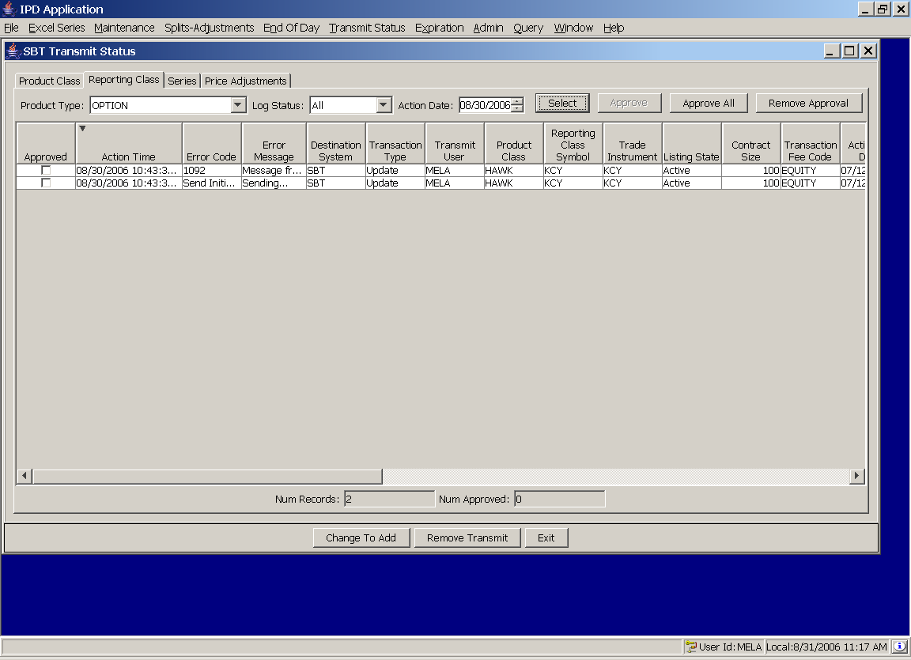

Option spreadsheet delete-of-pending-addition change
This change creates a feature to inactive series that have not become active. Typically this occurs on the week prior to expiration when spreadsheets containing many additions effective after expiration are loaded in advance and subsequent spreadsheets contain delete records that “undo” a prior addition.

Test procedure

In IPD maintenance, create a new series with an effective date of the following business day. The series will be inactive (IPD will prevent the listing state from being active).

Open the SBT end of day screen. The series should appear as a pending addition. Do not send it.

Find or create an Option spreadsheet Delete entry (see example below) for the series created in step 4.1.1.

Load the spreadsheet through the Excel Series -> Options screen. Approve the delete record.

After the spreadsheet load completes successfully, use the Product maintenance screen to verify that the Listing State is now Obsolete.

In the SBT end of day screen verify that the series no longer appears as a pending addition. There should be no record for that series.

Example delete records
Mar,E,BQQ,123.000,FS,20070616,D,20060830,,BQQ-A,Manual Delete,10:58 AM,
Mar,E,BQQ,119.000,FO,20070616,D,20060830,,BQQ-A,Manual Delete,10:58 AM,
Mar,E,BQQ,121.000,FQ,20070616,D,20060830,,BQQ-A,Manual Delete,10:58 AM,
Mar,E,BQQ,122.000,FR,20070616,D,20060830,,BQQ-A,Manual Delete,10:58 AM,

Stock-related GUI changes.

Verify that derivatives now require users to explicitly find an underlying.

Open the Product Class maintenance screen.

Select an Option. Verify that only the Find button is enabled in the Underlying panel.

Create a new dummy Product Class. Verify that Find must be used to set the Underlying

After saving the new Product Class, change its underlying of the Find button.

Repeat for Future product class.

Equity maintenance changes

In the Product Class maintenance screen, display an Equity product class.

Verify that Session Code may now be assigned. Update the session code, save the record, and verify the update.

In the Product Class maintenance screen, create a new Equity.

Verify that Session Code can be assigned in the “Product Class” section and that Contract Size can be set in the “Reporting Class” section. Enter values (use “1” for the Contract Size) and save.

