SYSTEMS DIVISION
IPD Testplan Phase 2e.
TEST PLAN DOCUMENT
WR # 2111

DRAFT

Prepared By:
Back Office IPD Team

1. New session code Hybrid W_MAIN.bob.index 3
1.1.1. Test Description: 3
1.1.2. Expected Results 3
2. Dupicate Opra Code . 4
2.1.1. Test Description: 4
2.1.2. Expected Results 4
2.1.3. Test Description: 4
2.1.4. Expected Results 4
3. Custom Expiration Type for futures. 4
3.1.1. Test Description: 4
3.1.2. Expected Results 5
3.1.3. Test Description: 5
3.1.4. Expected Results 6
3.1.5. Test Description: 6
4. Company Name Validation. 7
4.1.1. Test Description: 7
4.1.2. Expected Results: 7
5. Option Product Class Edit Reminder. 9
5.1.1. Test Description: 9
5.1.2. Expected Results: 9
6. Product Summary Screen. 9
6.1.1. Invalid Select Test Description: 9
6.1.2. Expected Results: 9
6.1.3. Select Test Description: 10
6.1.4. Expected Results: 10
6.1.5. Edit Test Description: 11
6.1.6. Expected Results: 11
7. EOD Status Updates. 13
7.1.1. Change To Add Test Description: 13
7.1.2. Expected Results: 13
7.1.3. Remove Test Description: 15
7.1.4. Expected Results: 15
8. New Data Warehouse load – under_sym_sess_asgn. 17
8.1.1. Remove Test Description: 17
8.1.2. Expected Results: 17
8.1.3. Confirm Results: 17
9. Data Warehouse load modifications. 17
9.1.1. Remove Test Description: 17
9.1.2. Expected Results: 18

New session code Hybrid W_MAIN.bob.index

Test Description:
Create a new Option Product Class using new hybrid session code W_MAIN.bob.index and transmit it to both SBT and TPF.

Expected Results
Successful creation and transmitting of the new Option Product Class .
Also QPE flag is set on TPF .

Dupicate Opra Code .

Test Description:
From the Product Maintenance screen try to add/update a series with the existing active series opra code

Expected Results
Data Validation Exception with Duplicate opra price code.

Test Description:
From the Product Maintenance screen try to add /update a series with the existing inactive series opra code

Expected Results
Successfully saved and transmitted

Custom Expiration Type for futures.

Test Description:
From the Product Maintenance screen try to add/update Future Reporting Class with Expiration Code as Custom Type.

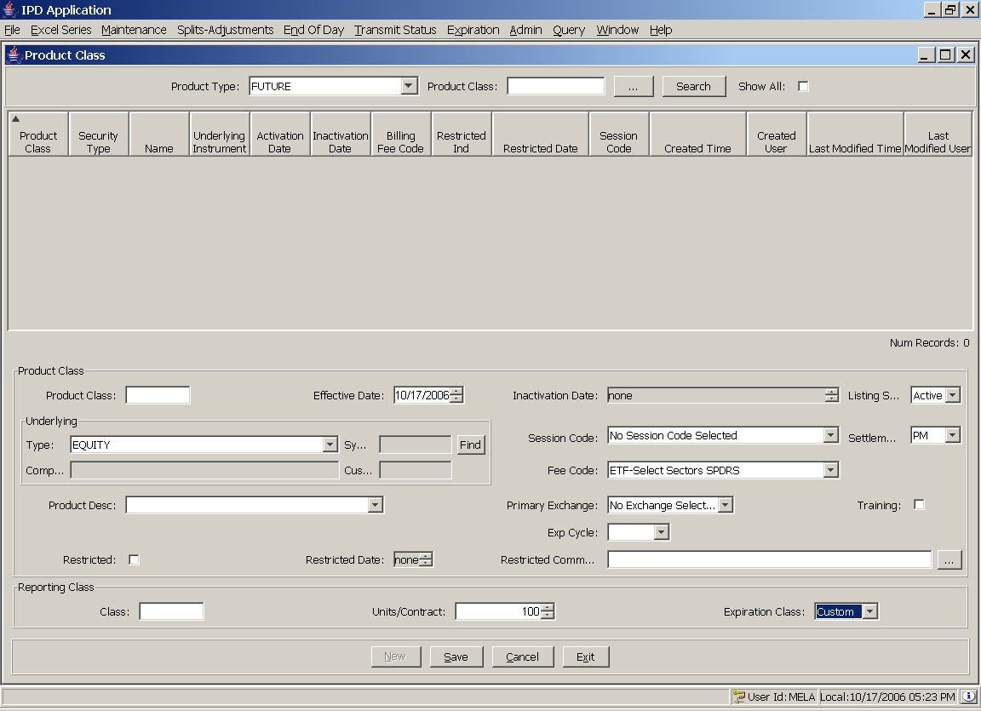

Expected Results
Successfully Saved and transmitted

Test Description:
From the Product Maintenance screen try to add/update Future Product and Reporting Class with Expiration Code as Custom Type.

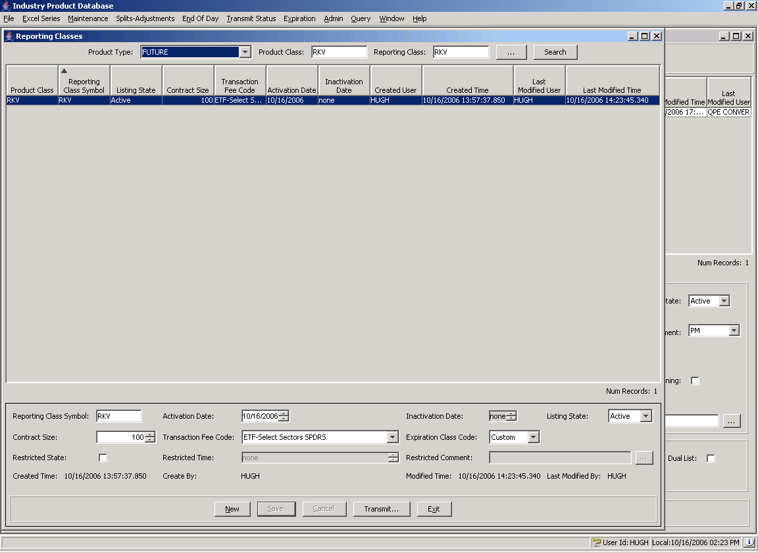

Expected Results
Successfully Saved and transmitted

Test Description:
From the Product Maintenance screen try to add/update future product with a custom expiration date

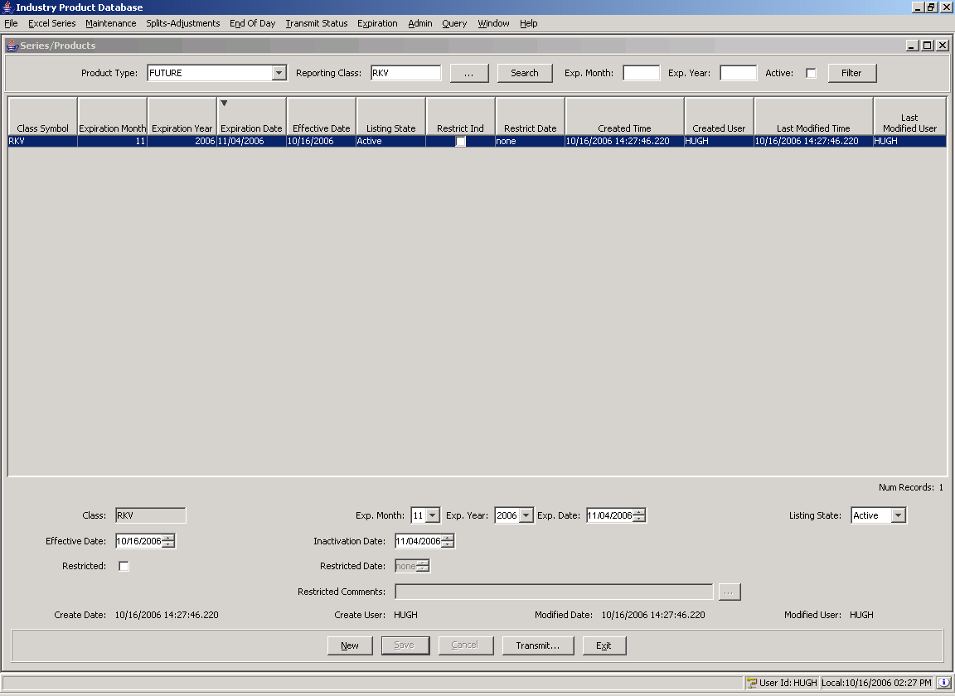

Expected Results
Successfully Saved with user provided expiration date and transmitted

Company Name Validation.

Test Description:
From the Product Maintenance screen select an equity product, remove the company name, and try to save. Cancel edit. Repeat for an index product.

Expected Results:
Error message.

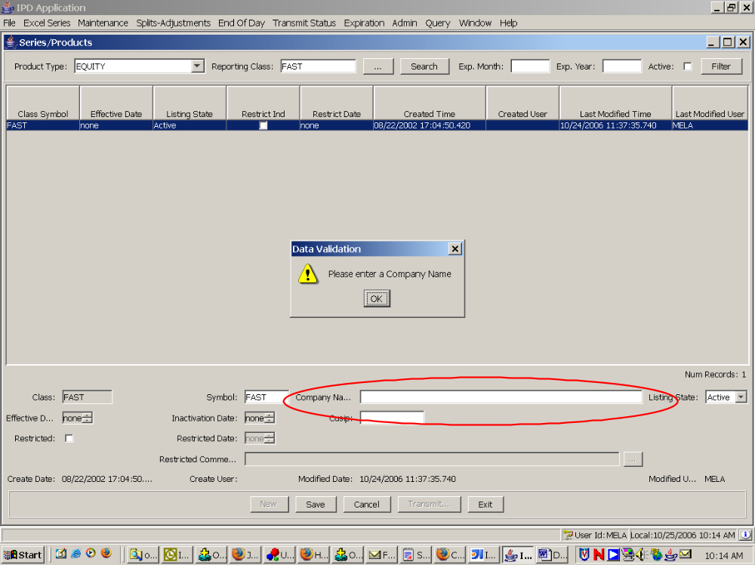
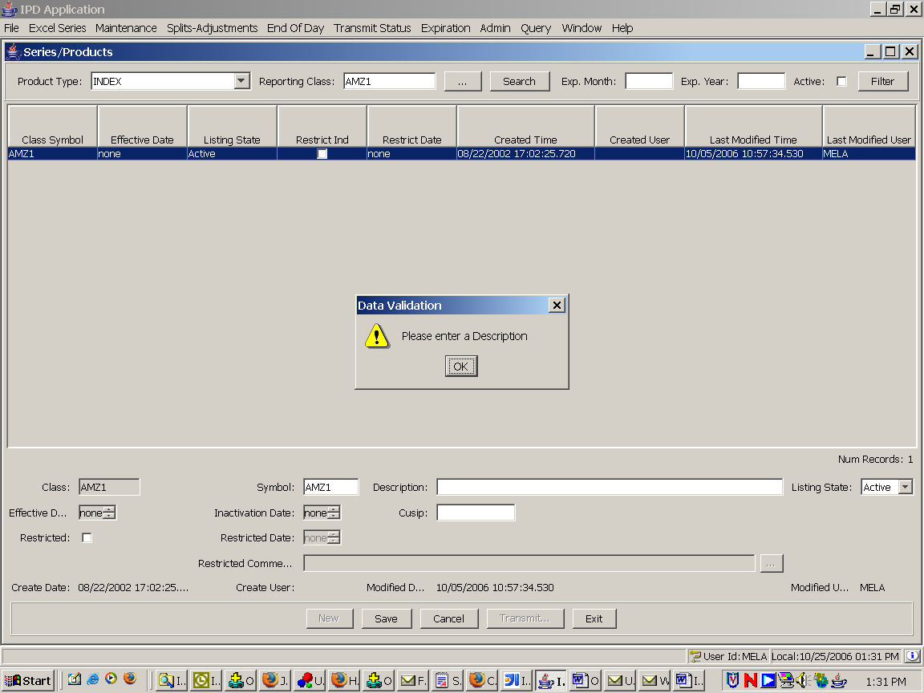

Option Product Class Edit Reminder.

Test Description:
From the Product Class Maintenance screen select an option product, change the Product Description, and save. Repeat by editing Session Code field.

Expected Results:
Changes save successfully and a reminder pop-up box appears.

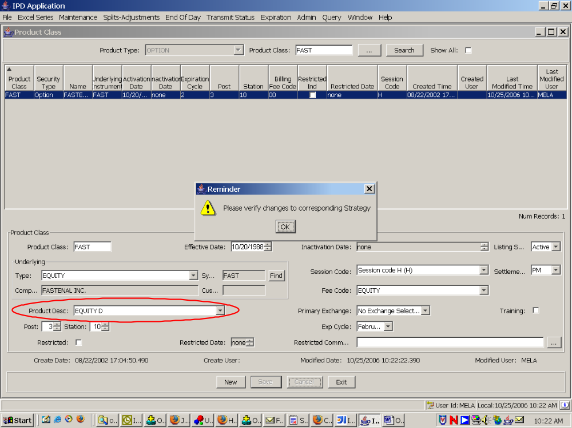

Product Summary Screen.

Invalid Select Test Description:
Open the Product Summary screen under the Maintenance menu. Select “option” in the product type drop down, enter a valid option symbol, and click Select..

Expected Results:
An exception dialog will appear reminding users to pick a valid underlying.

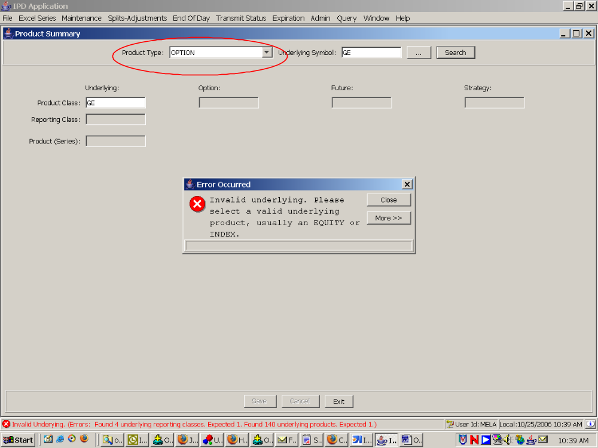

Select Test Description:
Open the Product Summary screen under the Maintenance menu. Select “equity” in the product type drop down and confirm that Select works for a valid equity symbol.

Expected Results:
The GUI displays the names of the three equity components – product class, reporting class, and product – as well the corresponding option, future, and strategy product class names, if any are found, and the list of derivative reporting classes.

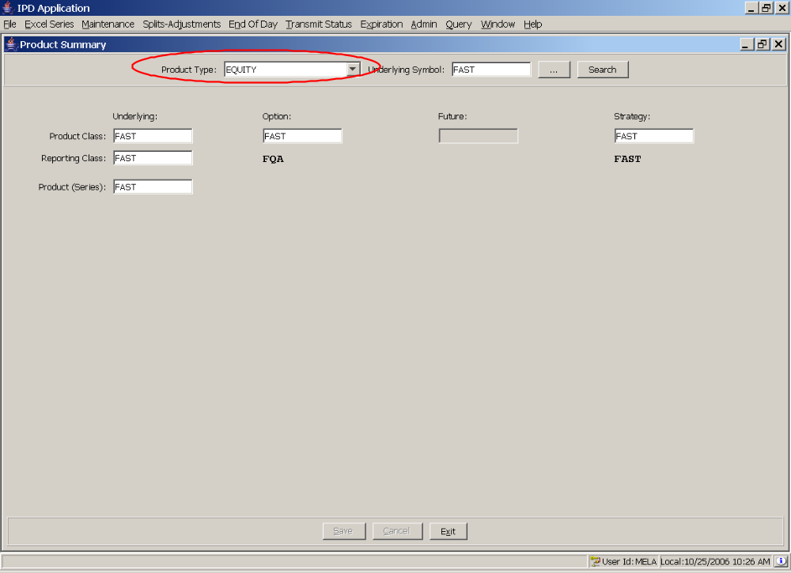

Edit Test Description:
Edit the symbol names by entering a new name in the Product Class field in the upper left-hand corner. The other editable fields should change as you type. Click save when done. Verify that the change applied correctly by searching for the new symbol name in the Product Class maintenance screen. Any derivatives should have the new name. For example, in the screens below the option and strategy product classes should change to the new name. The equity did not have a corresponding future so no future product class should be found.

Expected Results:
Save will execute without exceptions. The GUI will display the edited results. Other product maintenance screens will show the new symbol name.

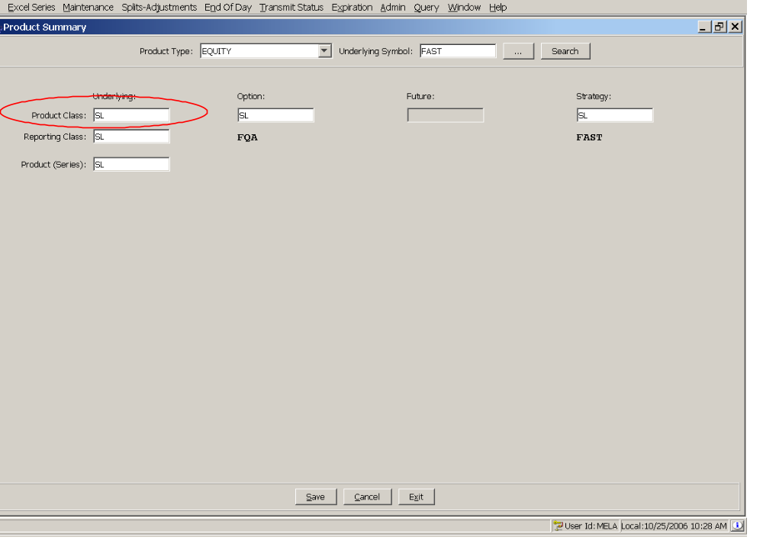
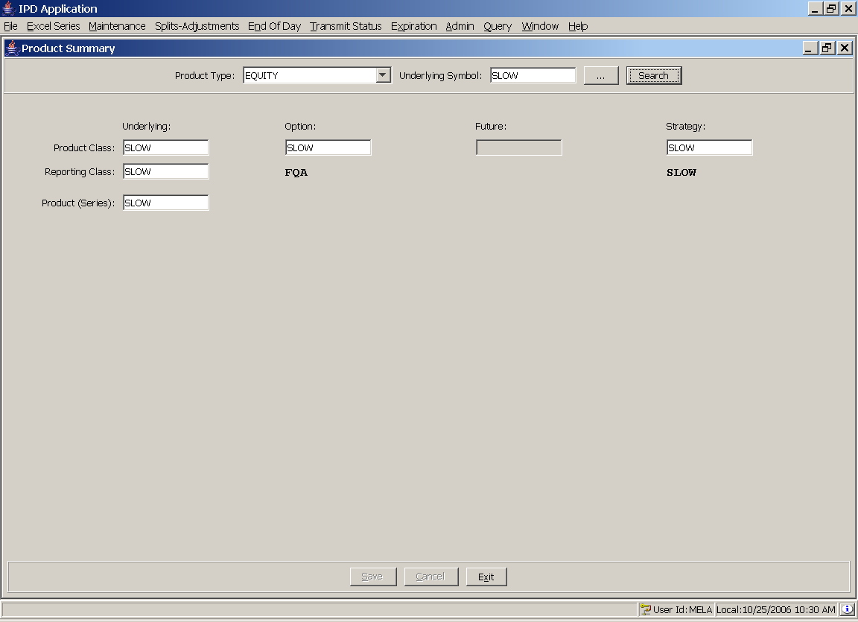

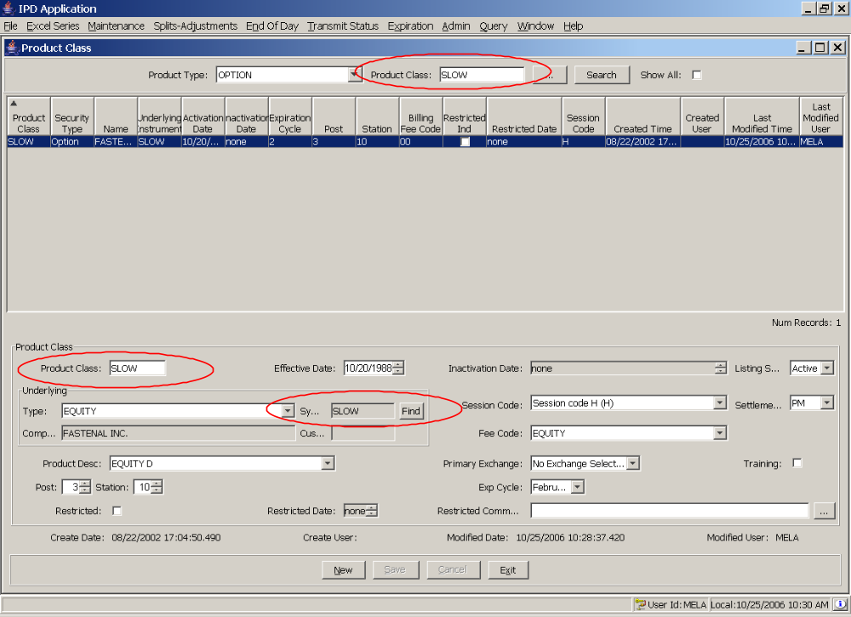

EOD Status Updates.

Change To Add Test Description:
Open the SBT EOD screen. Find an update record and click to approve. In the lower left-hand corner, click enable to turn on the status update feature. Then click Change To Add.

Expected Results:
A confirmation dialog will appear followed by a results dialog box. Click select again and the update should now appear as an add.

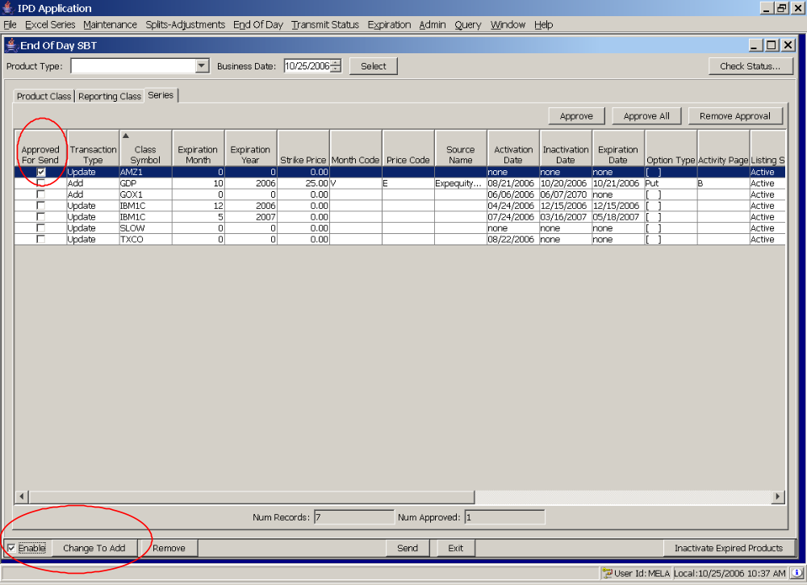
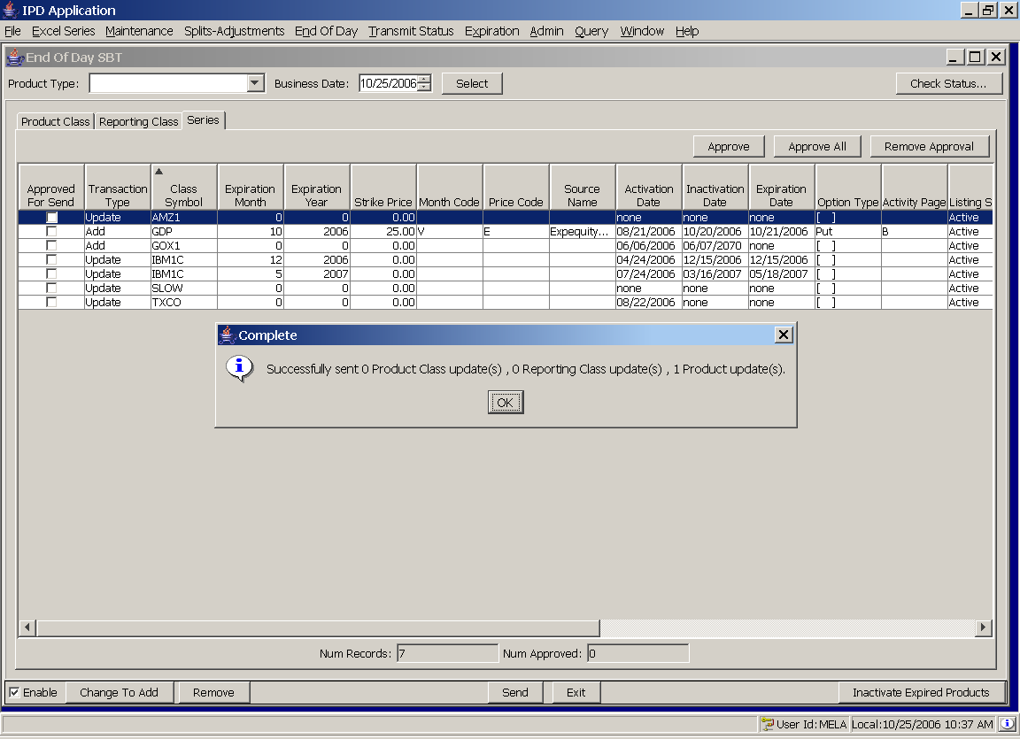

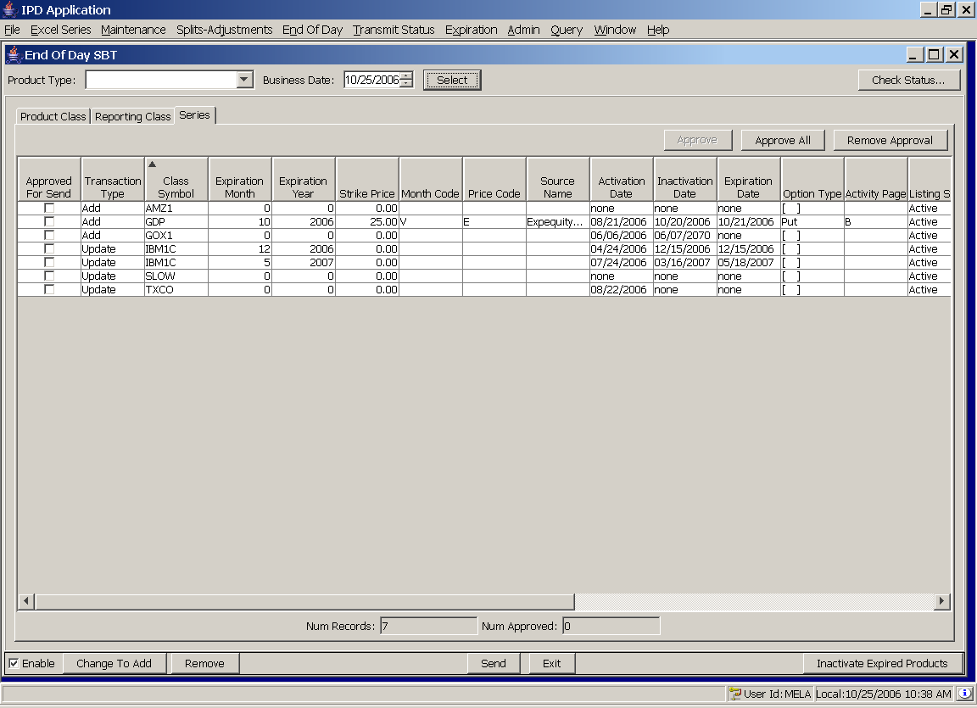

Remove Test Description:
Open the SBT EOD screen. Click to approve a row. In the lower left-hand corner, click enable to turn on the status update feature. Then click Remove.

Expected Results:
A confirmation dialog will appear followed by a results dialog box. Click select again and the selected row should no longer appear.

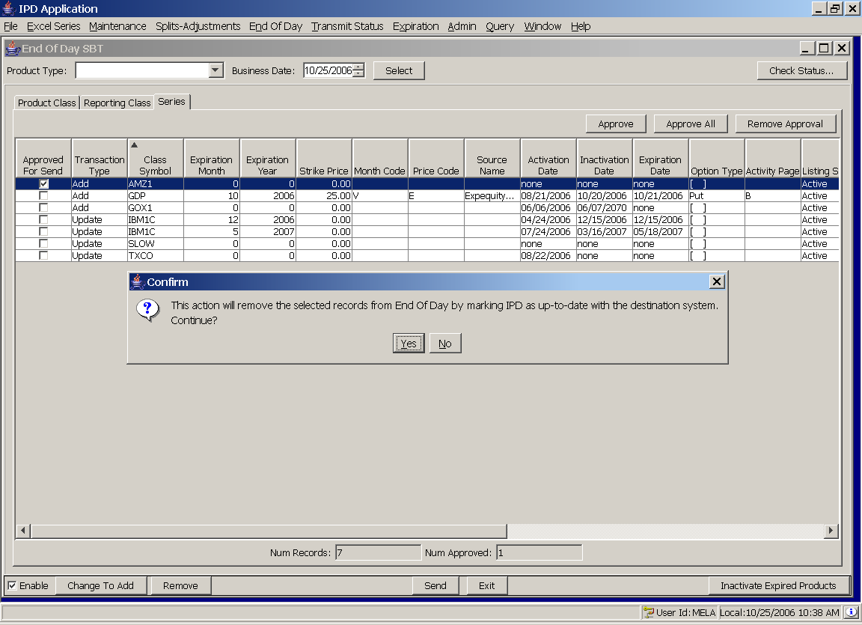

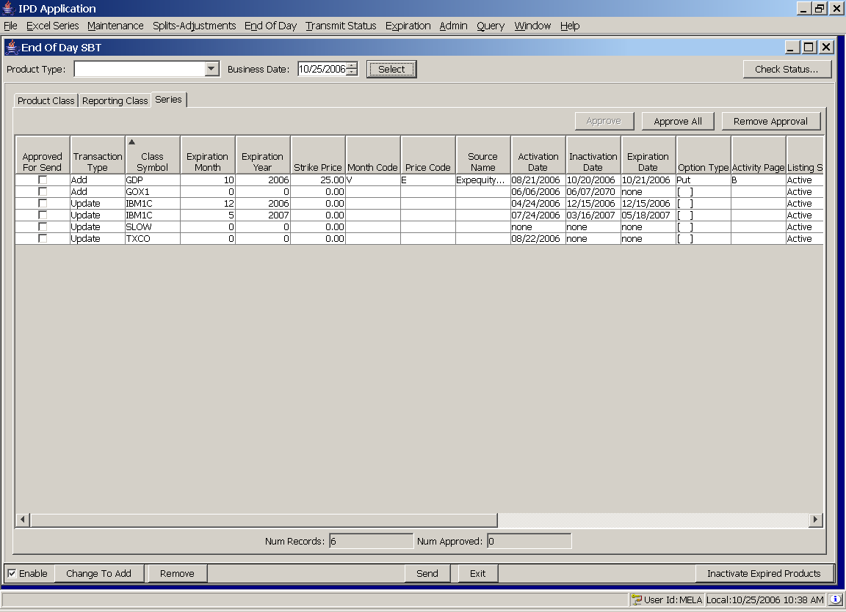

New Data Warehouse load – under_sym_sess_asgn.

Remove Test Description:
Test Under_sym_sess_asgn_daily load. Login to the IPD ATG server (asripd01a or b). in $RUN_DIR/bin execute under_sym_sess_asgn_daily.sh.

Expected Results:
Shell script will execute successfully (the message “Finished successfully” will appear on the screen among the output statements).

Confirm Results:
Login to the database (type loginDb at the Unix prompt). Type the following SQL statement and hit enter:
select count(*)
from under_sym_sess_asgn_daily;

The query should return a count of 2,500 to 3,500 records. 0 records indicates a failure.

Data Warehouse load modifications.

Remove Test Description:
Login to the IPD ATG server (asripd01a or b). in $RUN_DIR/bin execute the following shell scripts one after another. Check the results of each on the screen as you go.

class_daily.sh
class_after_adj_daily.sh
fut_class_daily.sh
fut_class_daily.sh
sec_type_daily.sh
series_daily.sh
series_arch_daily.sh
stk_class_daily.sh
trans_fee_daily.sh
undly_inst_daily.sh

Expected Results:
Shell scripts will execute successfully (the message “Finished successfully” will appear on the screen among the output statements after each job finishes).

Note: series_daily.sh and series_arch_daily.sh take about 15 minutes each. All other jobs run in about 2 minutes or less.

