SYSTEMS DIVISION
IPD Testplan Phase 2e -- DTCC
TEST PLAN DOCUMENT
WR # 2111

DRAFT

Prepared By:
Back Office IPD Team

1. Reporting Class Inactivation Warnings in GUI 3
1.1.1. Test Description: 3
1.1.2. Expected Results 3
1.1.3. Test Description: 3
1.1.4. Expected Results 3
1.1.5. Test Description: 3
1.1.6. Expected Results 4
2. Product Class Inactivation Warnings in GUI. 5
2.1.1. Test Description: 5
2.1.2. Expected Results 5
2.1.3. Test description 5
2.1.4. Expected results 5
2.1.5. Test description 5
2.1.6. Expected results 6
3. Combo Box “Best Choice” Change in GUI. 6
3.1.1. Test Description: 6
3.1.2. Expected Results 7
3.1.3. Test Description: 7
3.1.4. Expected Results 7
3.1.5. Test Description: 7
3.1.6. Expected results: 7
4. Support for NASD Symbol Format Change 8
4.1.1. Test Description: 8
4.1.2. Expected Results 8
4.1.3. Test Description: 8
4.1.4. Expected Results 8
5. DTCC Equity Master Load 8
5.1.1. Run batch job to copy equity master data from the data warehouse into IPD. 8
5.1.2. Expected Results 8
5.1.3. Open the IPD GUI. 8
5.1.4. Open the Equity Master Load Screen. 8
5.1.5. Load the Equity Master Data. 9
5.1.6. Select “P” in the Error/Processed drop down list and click search. 10
5.1.7. Approve an Addition 10
5.1.8. Verify the change. 10
5.1.9. Approve a Change. 10
5.1.10. Verify the update. 10
5.1.11. Approve Addition after changing to Index. 11
5.1.12. Verify Index addition. 12
5.1.13. Test filtering by symbol. 12
6. TPF Resync Report Changes For AM Settled Options 13
6.1.1. Description 13
6.1.2. Telnet to the IPD server. Cd to the bin directory. 13
6.1.3. Run resyncTPF 13
6.1.4. Identify reporting classes. 13
6.1.5. Find reporting class in GUI. 14
6.1.6. Verify AM settlement in Product Class screen. 14

Reporting Class Inactivation Warnings in GUI

Test Description:

Open the Reporting Class maintenance screen. Select an existing, active reporting class. Change the listing state to Inactive and click SAVE.

Expected Results
The GUI will display a warning message.

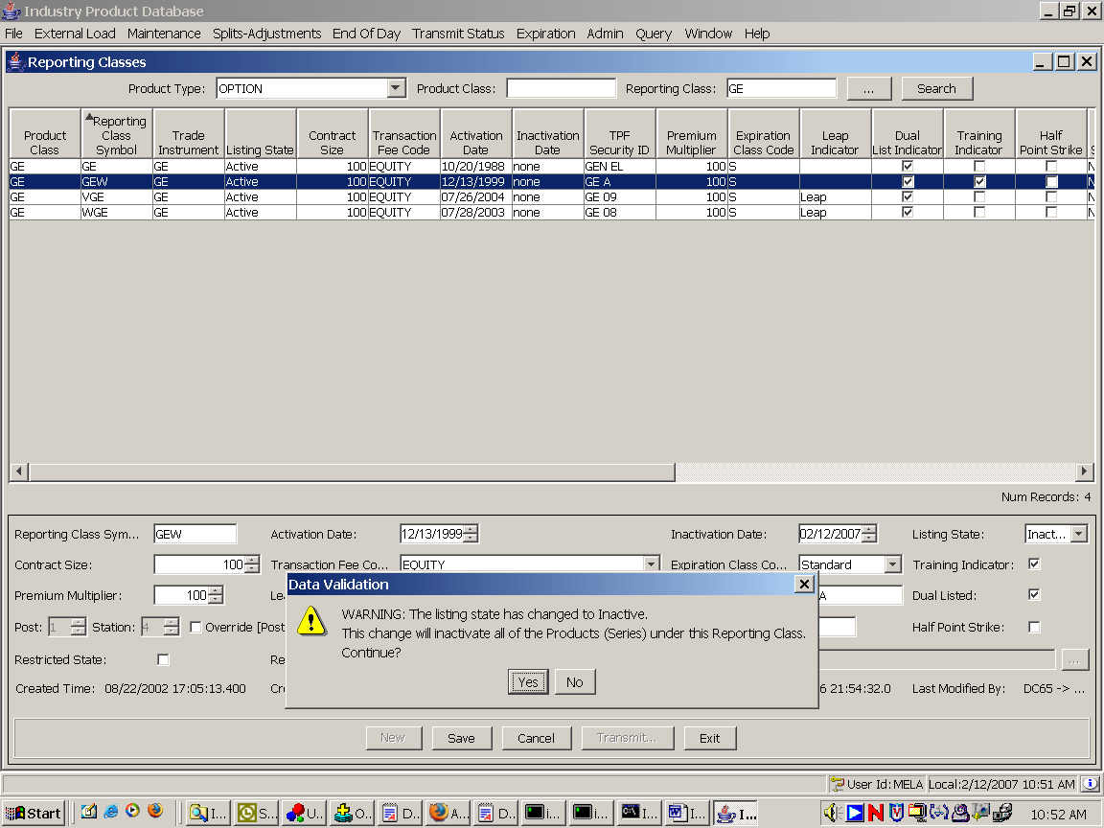

Test Description:

Click the No button on the warning dialog.

Expected Results
The reporting class change (inactivation) will not be saved. Click the Cancel button, followed by the Search button. The listing state should still appear Active.

Test Description:

Repeat step 1.1.1. This time, click Yes when the warning dialog appears.

Expected Results
The reporting class will be inactivated. The transmit dialog will appear. Afterward, click the Search button and verify that the listing state remains Inactive.

Product Class Inactivation Warnings in GUI.

Test Description:
Execute a batch script to create a ½ point strike file for CTMR and verify the data

Expected Results
A warning dialog will be displayed.
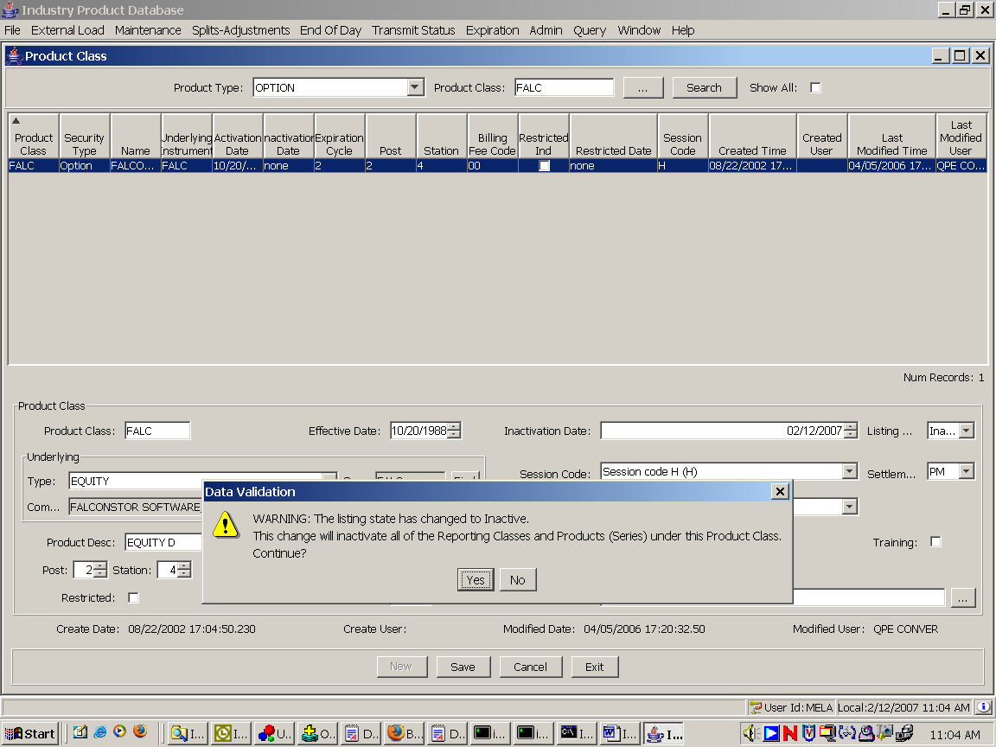

Test description
Click No on the dialog.

Expected results
The product class change will not be saved. Click Cancel and then click Search to verify. The product class listing state should be Active.

Test description
Repeat the test in section 2.1.1. This time, click Yes in the warning dialog box.

Expected results
The product class will be inactivated. Click Search to verify. Afterward, the listing state should still appear Inactive.

Combo Box “Best Choice” Change in GUI.

Test Description:

Open the Product Class maintenance screen and select an existing option product class. Click on the Product Description combo box to display the list of available product descriptions.

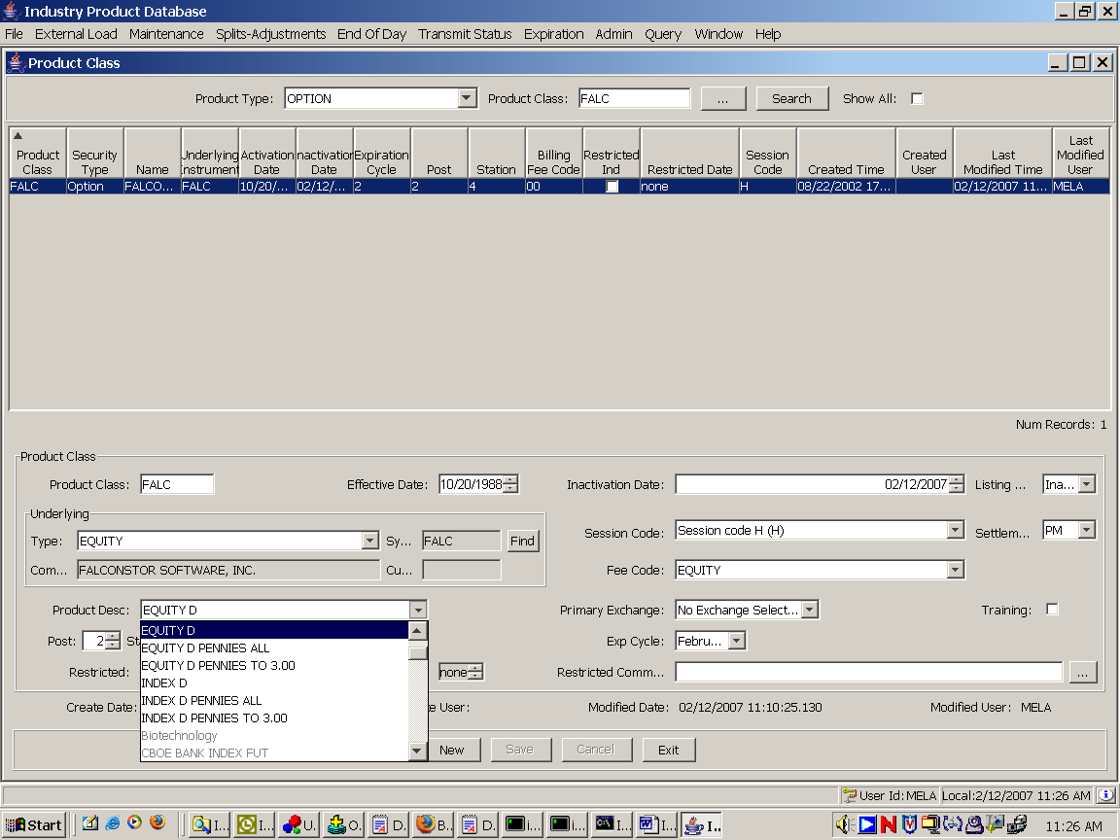

Expected Results
The most applicable choices will appear at the top while less likely choices will appear at the bottom in grey.

Test Description:
Verify that any choice works. In the test above, select “China Index” from the combo box and click SAVE. Then select “Equity D” and click SAVE. Then select the blank item (at the top) and click SAVE.

Expected Results
Each choice should be saved successfully.

Test Description:
Open the Product Class maintenance screen and select an existing Equity. Click on the Primary Exchange combo box. The list should display several choices at the top in black followed by more choices in grey. Select CSE and click SAVE. Then select NASD and click SAVE.

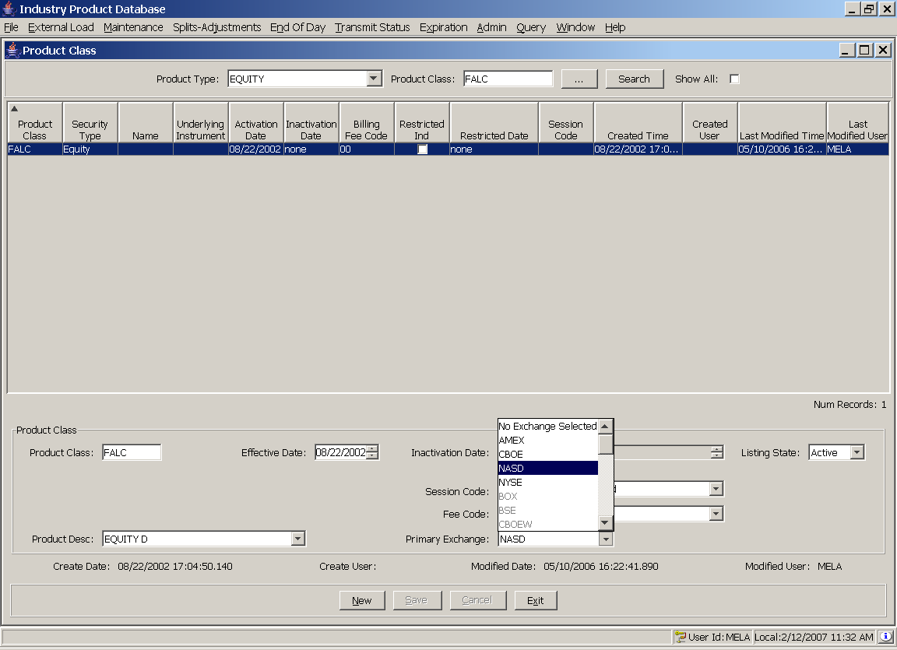

Expected results:
Each choice should be successfully saved.

Support for NASD Symbol Format Change

Test Description:

Open the Product Class maintenance screen and create a new Equity with the symbol “FAST:B”. Make sure the symbol includes the “:” (colon).

Expected Results
The new equity will be created successfully.

Test Description:
Create a new option product class “FAST:B” based on the equity created in step 4.1.1. Use any available symbol for the reporting class (FTB should work).

Expected Results
The new option will be created successfully.

DTCC Equity Master Load

Run batch job to copy equity master data from the data warehouse into IPD.
Telnet to the IPD server. In RUN_DIR/bin execute the script nsccDataLoad <yyyymmdd>. For example, to run for 3/5/2007, enter nsccDataLoad 20070305.

Expected Results
The script will output log data to the screen. The log should end with lines similar to the ones below, although the number of rows created will differ.

25112 rows created.

Commit complete.

Open the IPD GUI.

Open the Equity Master Load Screen.
Under the External Load Menu (formerly “Excel Series”). Select Equity Master from the menu to open the Equity Master Load screen. The screen should appear as below.

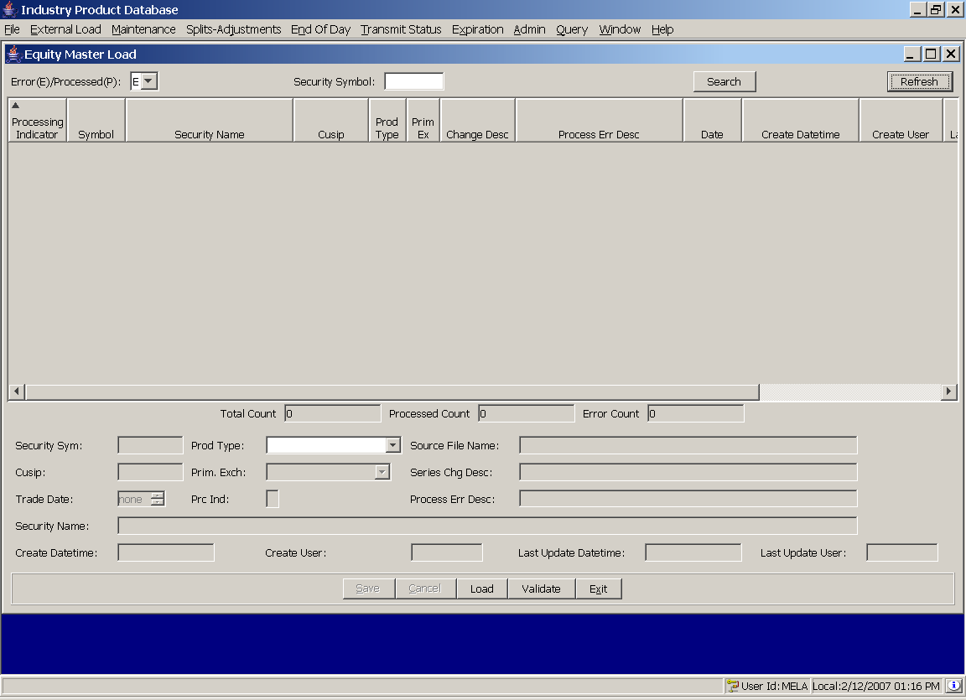

Load the Equity Master Data.
Click the Load button. After a few minutes, data should appear in the Equity Master Load screen, as below.
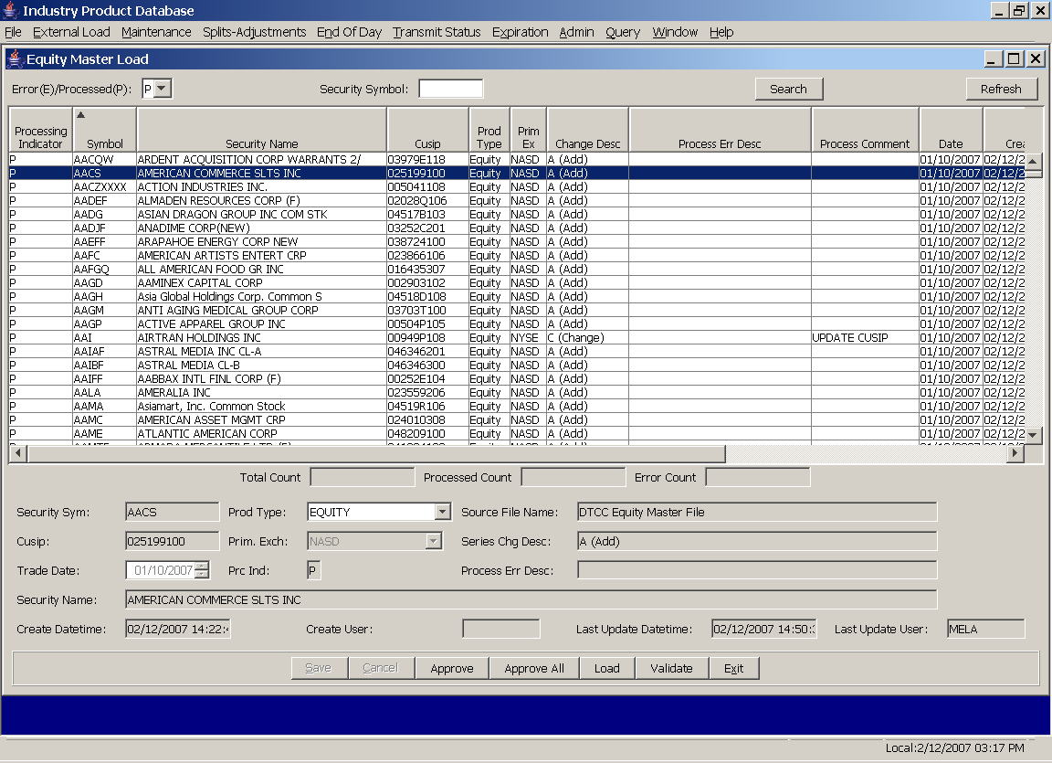

Select “P” in the Error/Processed drop down list and click search.

Approve an Addition
Select a row where the Change Desc is “Add” – like the row for symbol AACS (American Commerce SLTS Inc) above – and click Approve.

Verify the change.
Restart the IPD GUI. Verify that the change or addition was applied to IPD by finding the corresponding Equity product class, reporting class, and product (series) in the corresponding maintenance screens.

Approve a Change.
Select a row where the Change Desc is “Change”. Note the cusip number. Click Approve.

Verify the update.
Find the product (series) record for the updated Equity in the Series-Product maintenance screen. Verify that the cusip is updated to match the cusip in the equity master load. The example below shows the state of the Series/Product record for the equity AAI after the update to the cusip has been applied.
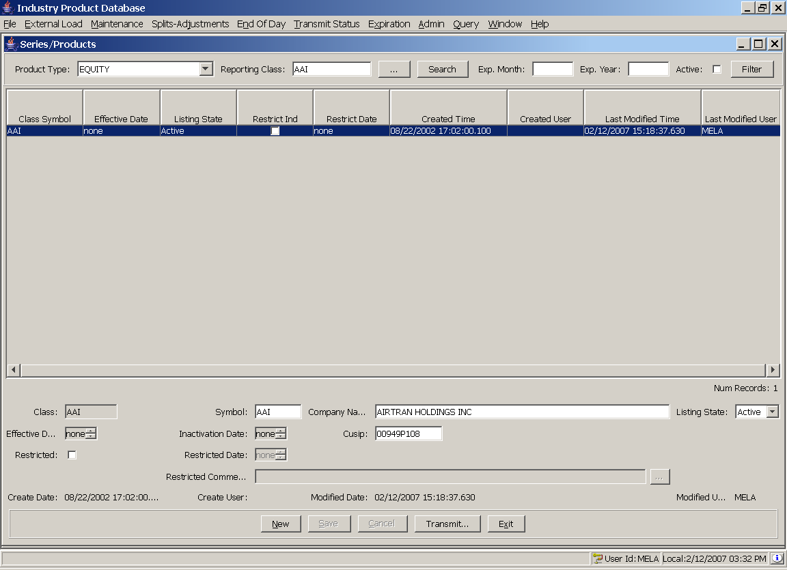

Approve Addition after changing to Index.
Select a record where the Change Description is “Add”. In the editor on the bottom of the screen, change the product type from Equity to Index. Click Save. The record should be saved. After saving, click Approve.
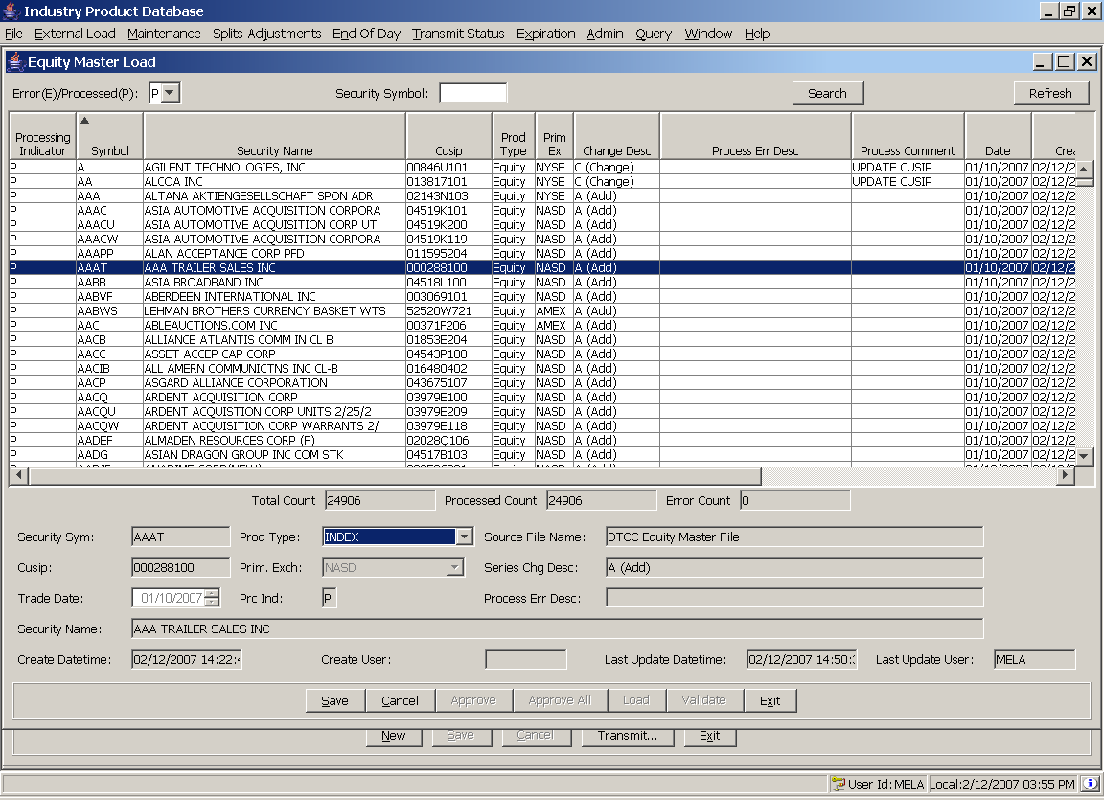

Verify Index addition.
Restart the GUI. Verify that the changes were applied by finding the Index added in step 5.1.11 in the product class, reporting class, and series/product maintenance screens. The product type should be set to Index for these queries.

Test filtering by symbol.
Test the query capability by entering a symbol in the Security Symbol text box and clicking the Search button. The table should display the matching record.

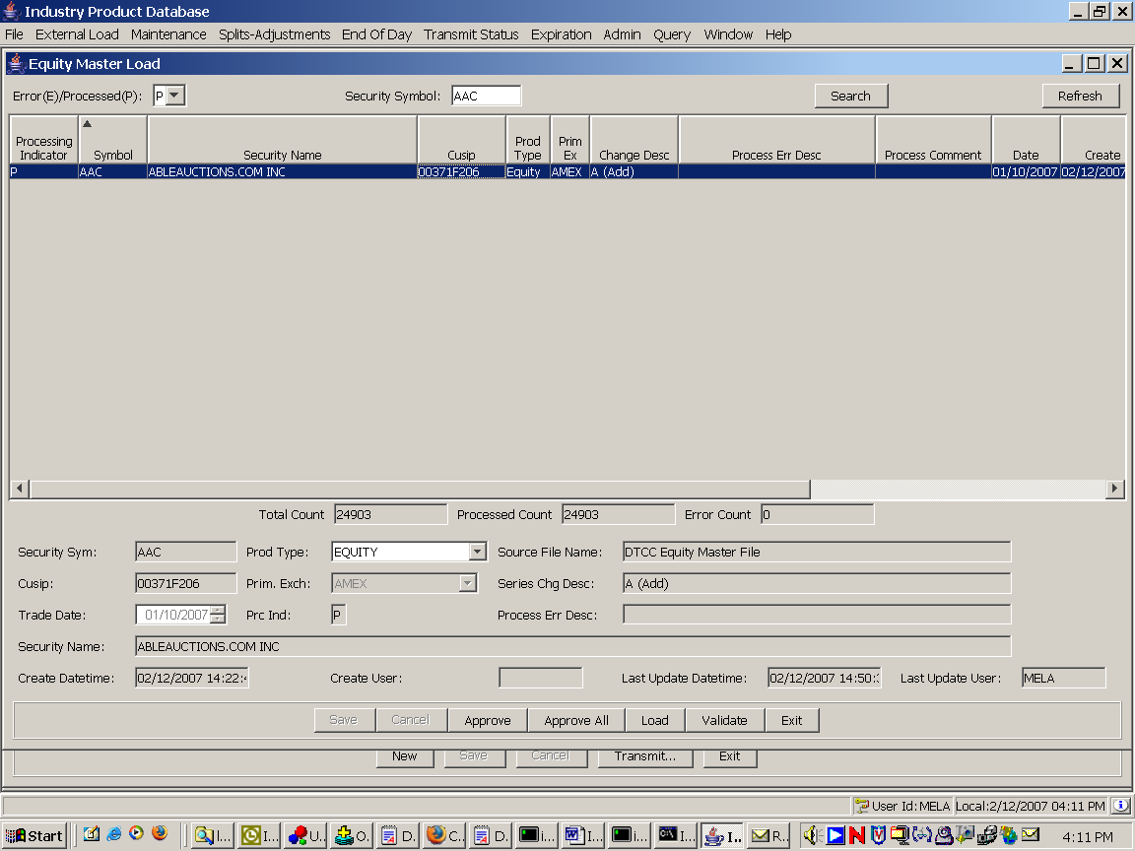

TPF Resync Report Changes For AM Settled Options

Description
On the Thursday before expiration, run the TPF Resync Report to verify that series inactivating that day for AM settled options appear in the Warning section.

Telnet to the IPD server. Cd to the bin directory.

Run resyncTPF

Identify reporting classes.
When the report is produced, identify the report class for series in the Warning section.

Find reporting class in GUI.
In the IPD GUI, open the reporting class maintenance screen. Find the Option reporting class record matching one of the reporting classes identified in step 6.1.4. Identify the product class for the reporting class.

Verify AM settlement in Product Class screen.
Open the product class maintenance screen and find the Option product class record for the product class identified in step 6.1.5. Verify that the Settlement Type is AM.

