SYSTEMS DIVISION
IPD Testplan Phase 2e.
TEST PLAN DOCUMENT
WR # 2111

DRAFT

Prepared By:
Back Office IPD Team

1. OCC file changes 3
1.1.1. Test Description: 3
1.1.2. Expected Results 3
1.1.3. Test Description: 3
1.1.4. Expected Results 3
1.1.5. Test Description: 3
1.1.6. Expected Results 3
2. New 1/2 point strike file for CTMR. 4
2.1.1. Test Description: 4
2.1.2. Expected Results 4
3. TPF purge validation. 4
3.1.1. Test Description: 4
3.1.2. Expected Results 5
3.1.3. Test Description: 5
3.1.4. Expected Results 6
3.1.5. Test Description: 6

OCC file changes

Test Description:

Inactivate few series with current date as the inactivation date .

Expected Results
Inactivated series should show up as delete in the OCC report.

Test Description:

Inactivate few series with next trade date as the inactivation date.

Expected Results
Inactivated series should not appear as delete in the OCC report

Test Description:

Create few series with next trade date as the inactivation date

Expected Results
Inactivated series should not appear as delete in the OCC report.

New 1/2 point strike file for CTMR.

Test Description:
Execute a batch script to create a ½ point strike file for CTMR and verify the data

Expected Results
Contents of the file should as in the required format as shown below.
01 HALF-PNT-REC.
05 HALF-PNT-CLASS PIC X(05) VALUE SPACES.
05 FILLER PIC X(05) VALUE SPACES.
05 HALF-PNT-STAMP.
07 FILLER PIC X(03) VALUE SPACE.
07 DATE-STAMP.
10 DATE-STAMP-YY PIC X(02).
10 DATE-STAMP-MM PIC X(02).
10 DATE-STAMP-DD PIC X(02).
07 FILLER PIC X(03) VALUE SPACE.
07 TIME-STAMP.
10 TIME-STAMP-HH PIC X(02).
10 TIME-STAMP-MM PIC X(02).
10 TIME-STAMP-SS PIC X(02).
07 FILLER PIC X(52) VALUE SPACES

TPF purge validation.

Test Description:

From the Expiration->Options Screen enter a vaid Reporting Class and current or previous expiration month

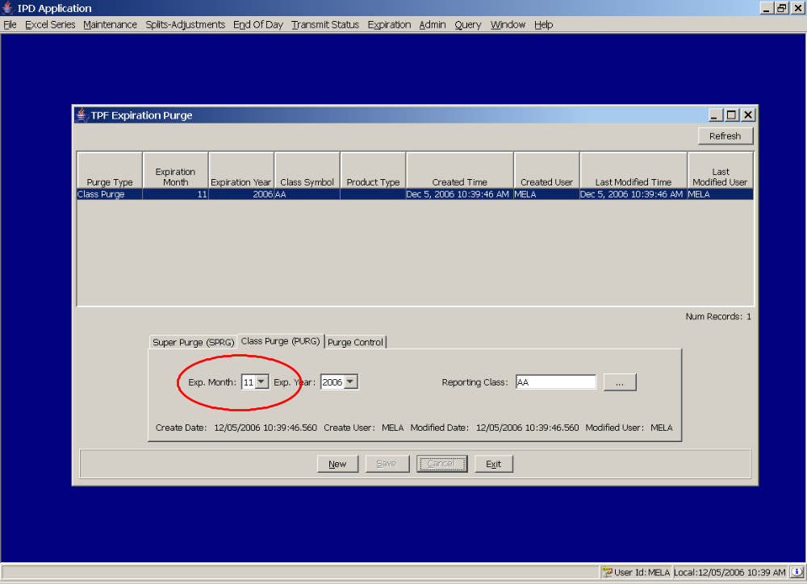

Expected Results
Successfully Saved

Test Description:
From the Expiration->Options Screen enter a vaid Reporting Class and expiration months in the future date

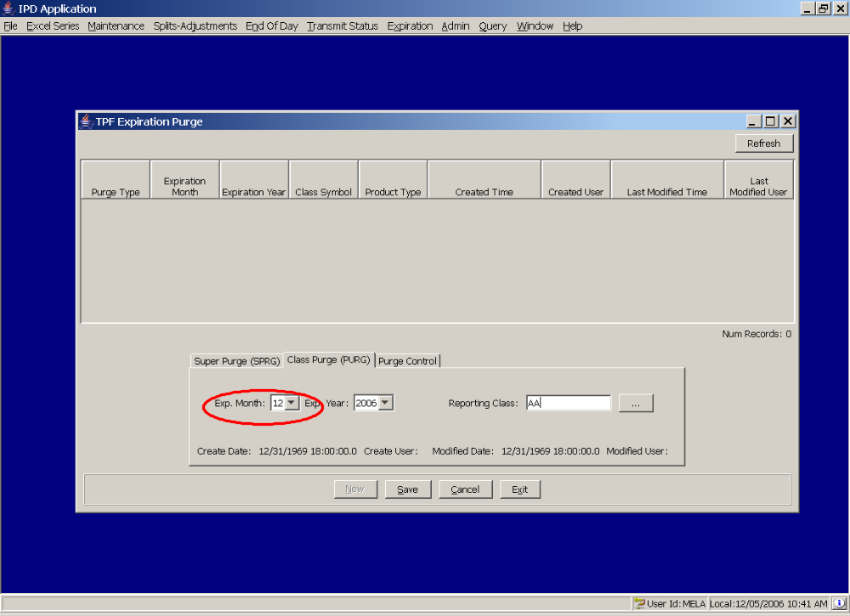

Expected Results
Data Validation Excception with message with options to Cancel or Save. Cancel should be the default option. Click Cancel. The purge entry should not appear in the table.
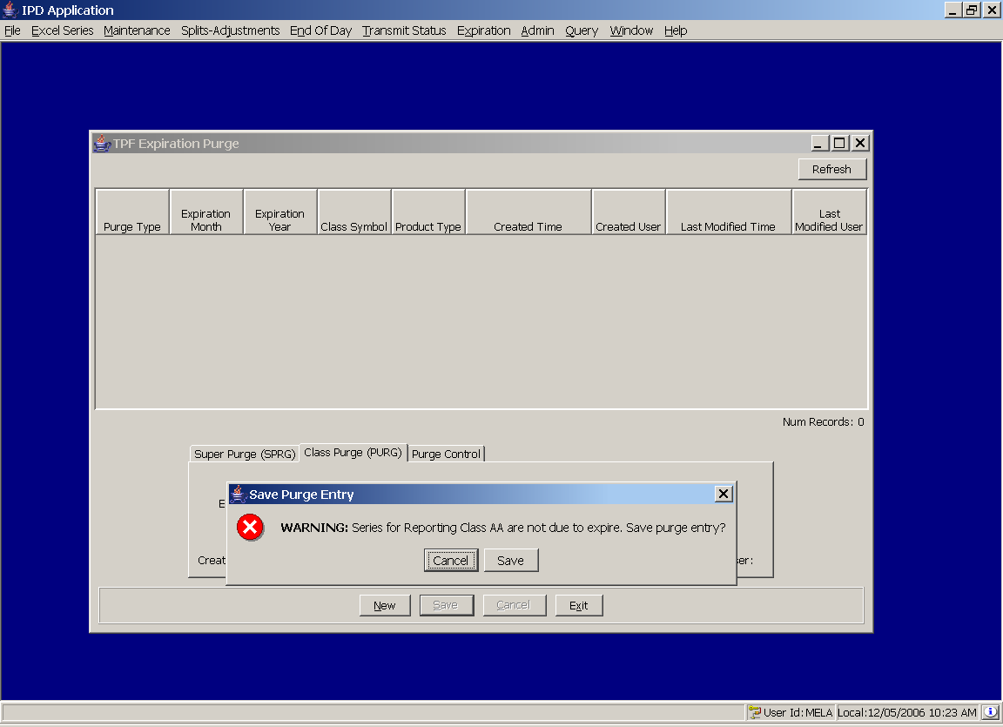

Test Description:
Repeat 3.1.3. When the exception appears, click Save.

Expected Results
Successfully Saved

