SYSTEMS DIVISION
IPD Testplan OHS Release
TEST PLAN DOCUMENT
WR # 2111

DRAFT

Prepared By:
Back Office IPD Team

1. OHS Flag disabled 3
1.1.1. Test Description: 3
1.1.2. Expected Results 3
1.1.3. Test Description: 3
1.1.4. Expected Results 3
1.1.5. Test Description: 4
1.1.6. Expected Results 4
2. Equity/Index Training Indicator 5
2.1.1. Test Description: 5
2.1.2. Expected Results 5
3. Transaction Fee Code Default 5
3.1.1. Test Description: 5
3.1.2. Expected Results 6
3.1.3. Test Description: 6
3.1.4. Expected Results 6

OHS Flag disabled

Test Description:

Verify that the OHS flag is visible, but disabled, for Options only. Open the Product Class maintenance screen, select Option product type, and search for an existing option class.

Expected Results
The OHS flag will appear but will not be editable.

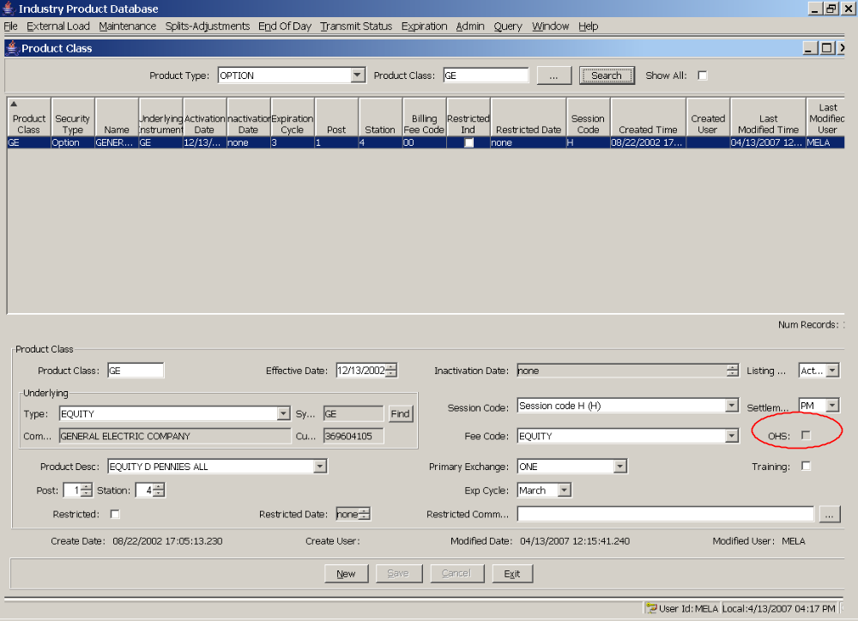

Test Description:

IPD systems staff will edit the GUI configuration file to enable the OHS indicator. After re-starting the GUI, repeat the original test.

Expected Results
The OHS indicator will now be editable.
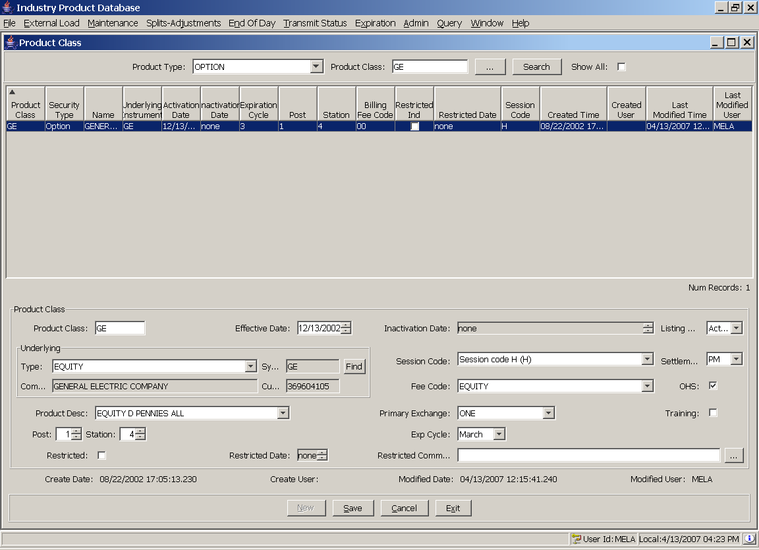

Test Description:

With the screen still open, select the OHS indicator and Save. After saving, click search to refresh the screen.

Expected Results
The OHS flag should be saved.

Equity/Index Training Indicator

Test Description:
Open the Product class maintenance screen and select Equity as the product type. Find an existing equity. Set the training indicator, save, and then click Search to refresh.

Expected Results
The Training indicator should be editable and should be saved successfully.
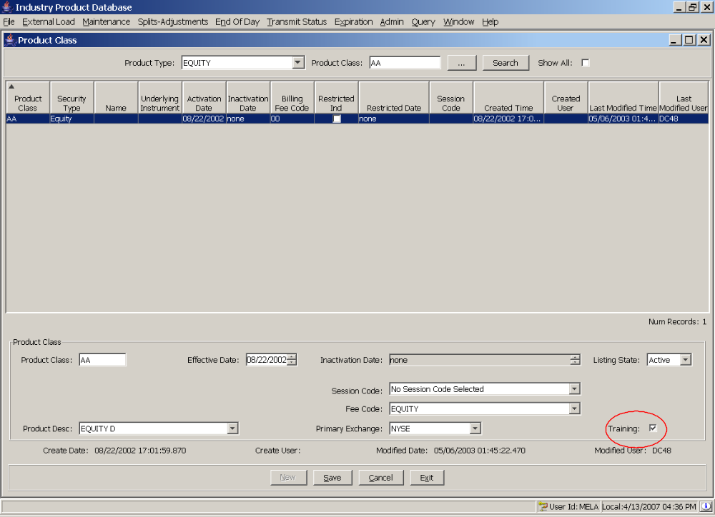

Transaction Fee Code Default

Test Description:

Open the Reporting Class maintenance screen. Find an existing product class. Create a new reporting class. (The new class does not have to be saved).

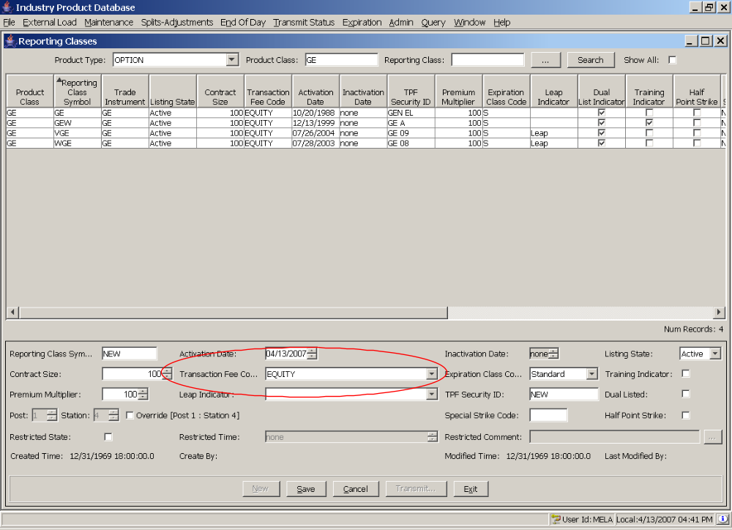

Expected Results
The transaction fee code should automatically default to the same fee code as the product class.

Test Description:
Edit the transaction fee code of the product class used in 3.1.0. For example, if the transaction fee code was originally set to EQUITY, change it to another value, such as BONDS. Return to the reporting class screen and create a new reporting class.

Expected Results
The transaction fee code of the new reporting class should now be set to match the edited value on the product class.

