SYSTEMS DIVISION
Testplan
IPD Credit Derivatives (Product Type Maintenance)
Updates for 5.2.37.50 release candidate
TEST PLAN DOCUMENT
WR # 5512

DRAFT

Prepared By:
Back Office IPD Team

1. Enhanced Product Type Summary Screen 3
1.1.1. Test Description: 3
1.1.2. Expected Results 3
1.1.3. Test Description 3
In the Summary screen, enter a new symbol for the underlying product class. The other symbols on the screen should change automatically. Save the results. 3
1.1.4. Expected Results 4
1.1.5. Test Description: 4
1.1.6. Expected Results 5
1.1.7. Test Description: 5
1.1.8. Expected Results 5
1.1.9. Test Description: 5
1.1.10. Expected Results 5
2. New Product Type Maintenance 5
2.1.1. Test Description: 6
2.1.2. Expected Results 6
3. Product Type Changes 6
3.1.1. Test Description: 6
3.1.2. Expected Results 8
4. Derivatives on New Product Types 9
4.1.1. Test Description: 9
4.1.2. Expected Results 10

Enhanced Product Type Summary Screen

Test Description:
Open the Product Type Maintenance Screen. Set the Product Type to Index and the Product Class to MNX (or similar). Click Search.

Expected Results
The screen will display summary data for the selected index.
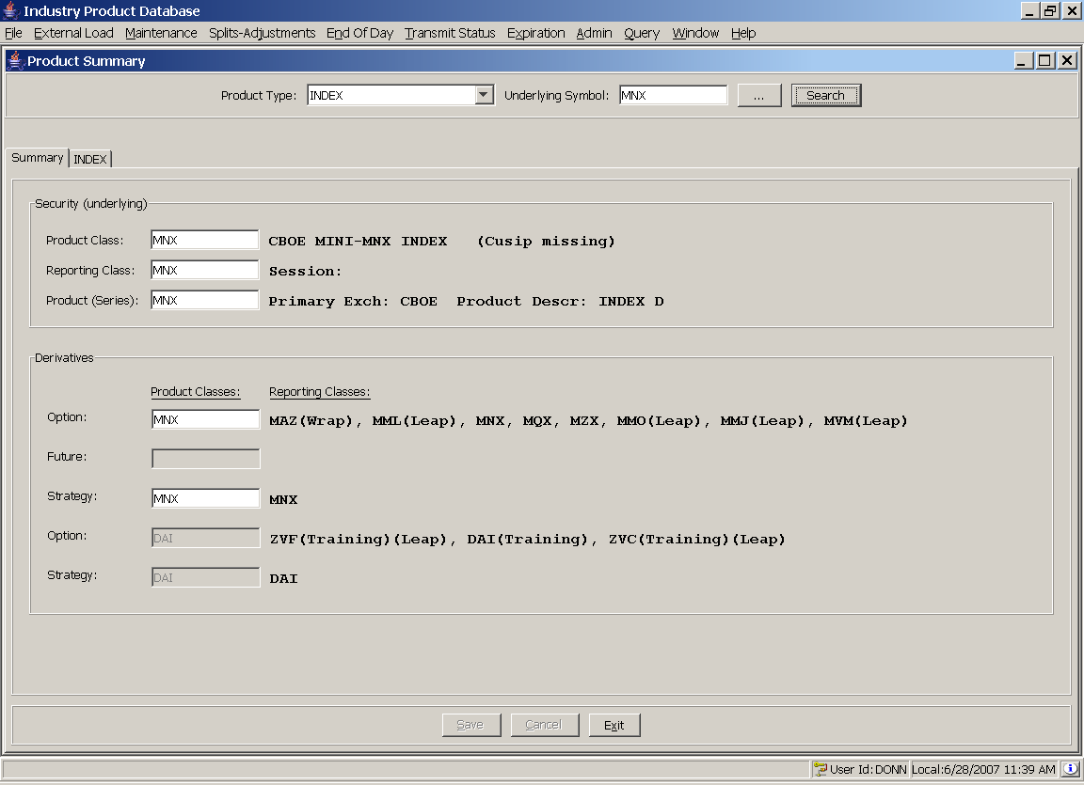

Test Description

In the Summary screen, enter a new symbol for the underlying product class. The other symbols on the screen should change automatically. Save the results.

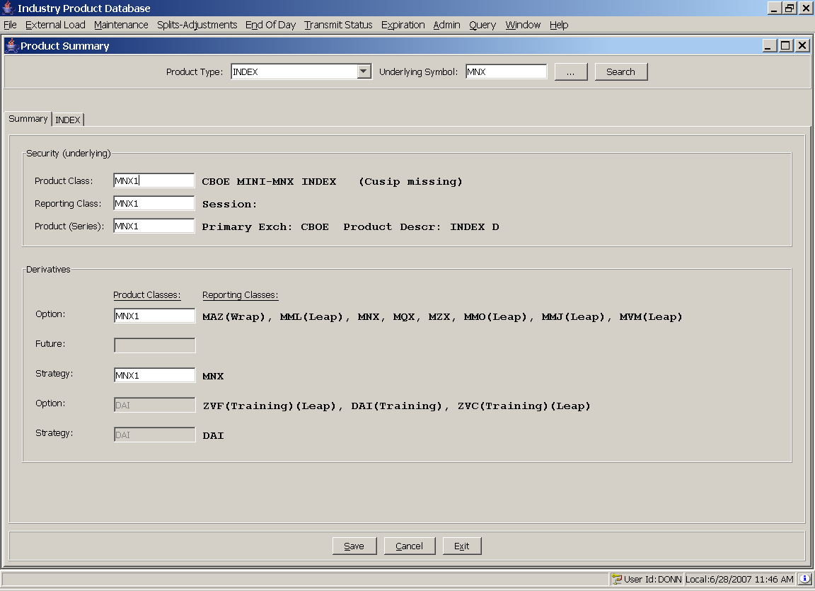

Expected Results
The update saves successfully.

Test Description:
Find an index underlying, such as BBH. Click on the INDEX tab. Modify a value, such as fee code, in the Product Class box. Click save. Open the End of Day – SBT screen and verify that the change appears. Transmit to SBT.
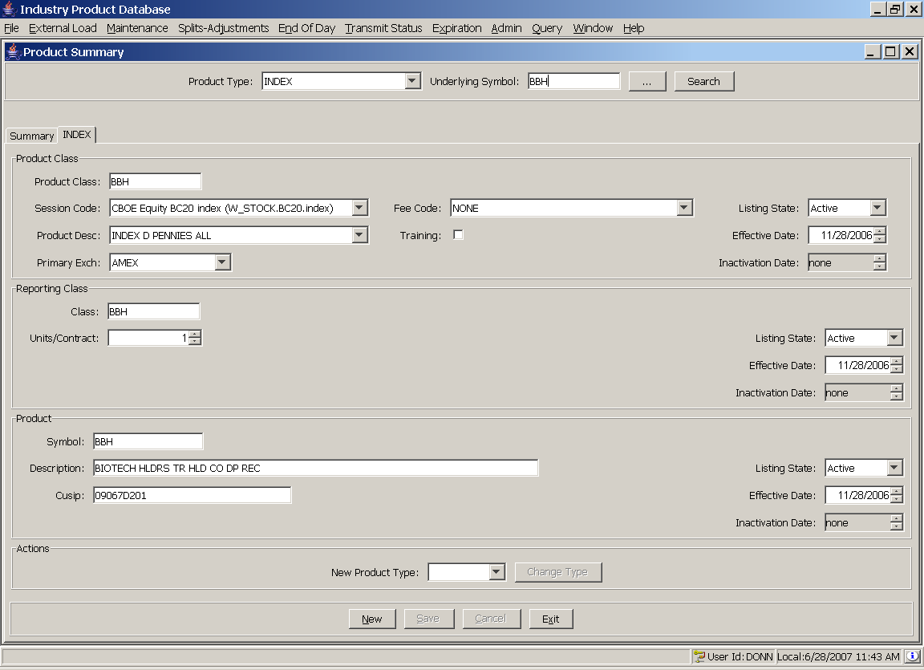

Expected Results
The update is saved successfully, appears in the End of Day Screen under the Product Class tab, and can be sent to SBT.

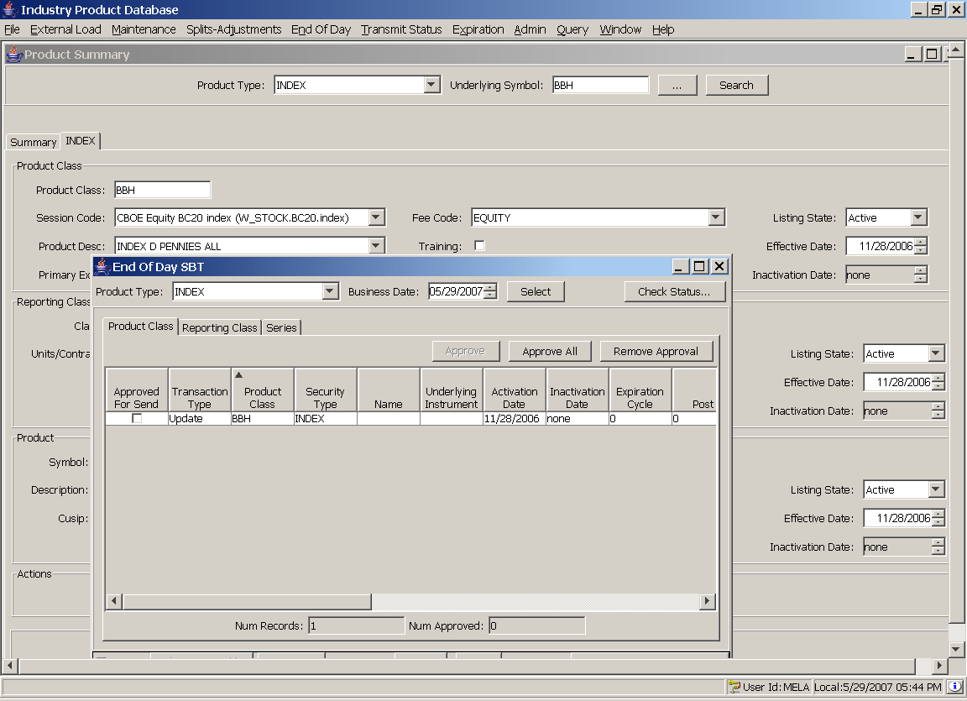

Test Description:
Modify the Units/Contract value in the reporting class section of the screen. Click save. Open the End of Day – SBT screen and verify that the change appears. Transmit to SBT.

Expected Results
The update is saved successfully, appears in the End of Day Screen under the Reporting Class tab, and can be sent to SBT.

Test Description:
Modify a value, either cusip or description, in the product section of the screen. Click save. Open the End of Day – SBT screen and verify that the change appears. Transmit to SBT.

Expected Results
The update is saved successfully, appear in the End of Day Screen under the Reporting Class tab, and can be sent to SBT.

New Product Type Maintenance

Test Description:
Create a new ETF through the product summary screen. Open the Product Summary screen, choose ETF as the product type, click the ETF tab, and click New. Enter test data and save. Transmit to SBT from the End of Day screens – the product class, reporting class, and product should appear and be sent. Verify that the new ETF appears in the SA-GUI as an Index.

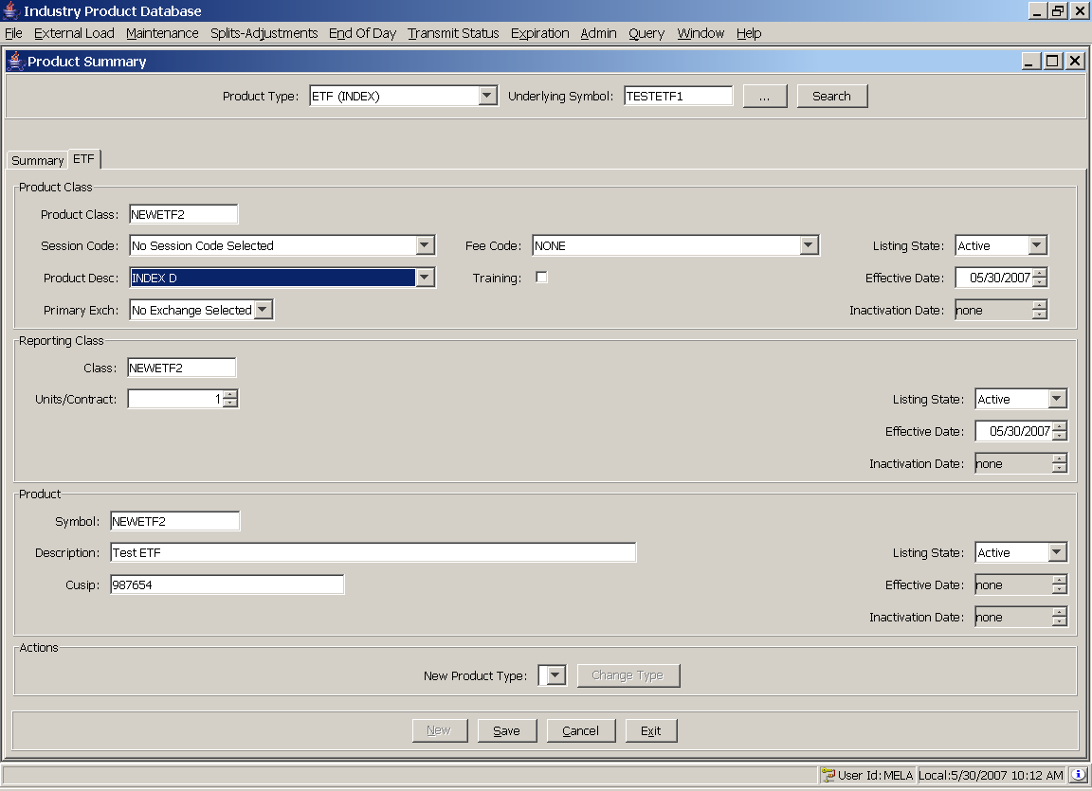

Expected Results
The new ETF is saved successfully and appears in end of day. It can be transmitted to SBT successfully. It appears in the Index folder in the SA-GUI.

Product Type Changes

Test Description:

Open the Product Summary screen and find an existing index. Click on the Index tab, set the New Product Type field to ETF, and click Change Type. A prompt should appear asking if you wish to continue. Click Yes.

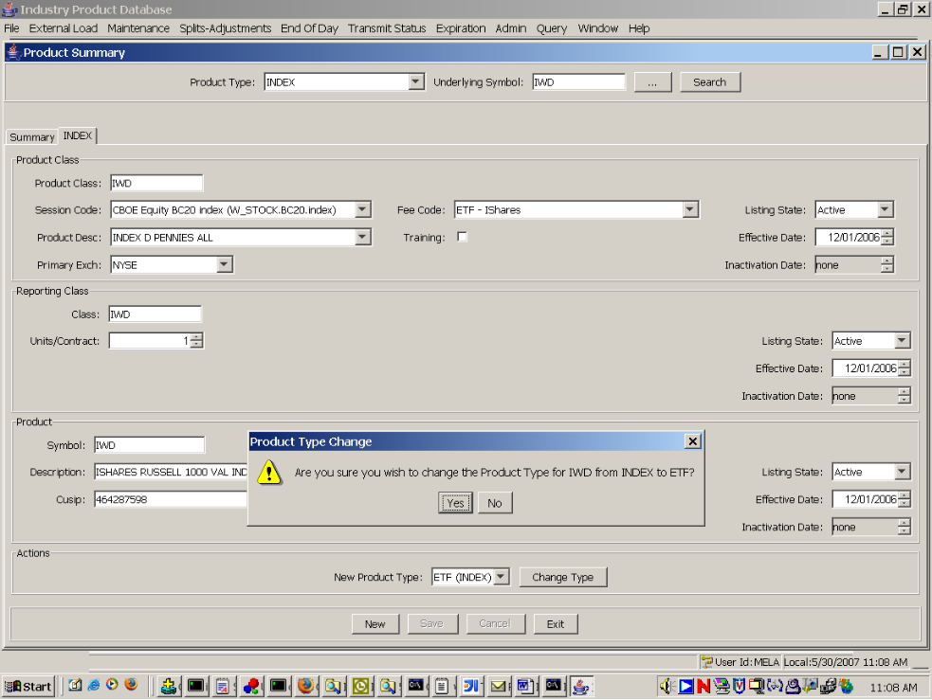

After a few seconds, a message box should appear with a message indicate success and providing a reminder that screens might need to be refreshed.

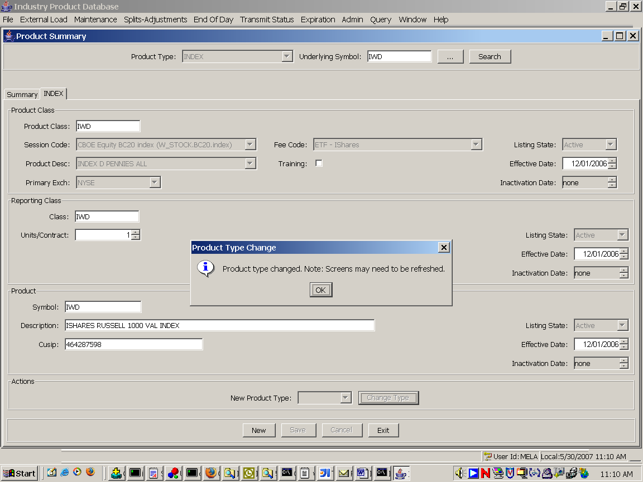

Expected Results
After the product type change, query for the original Index. For example, if IWD was converted from an Index to an ETF in this test, search for the IWD index. That query should now return no records.

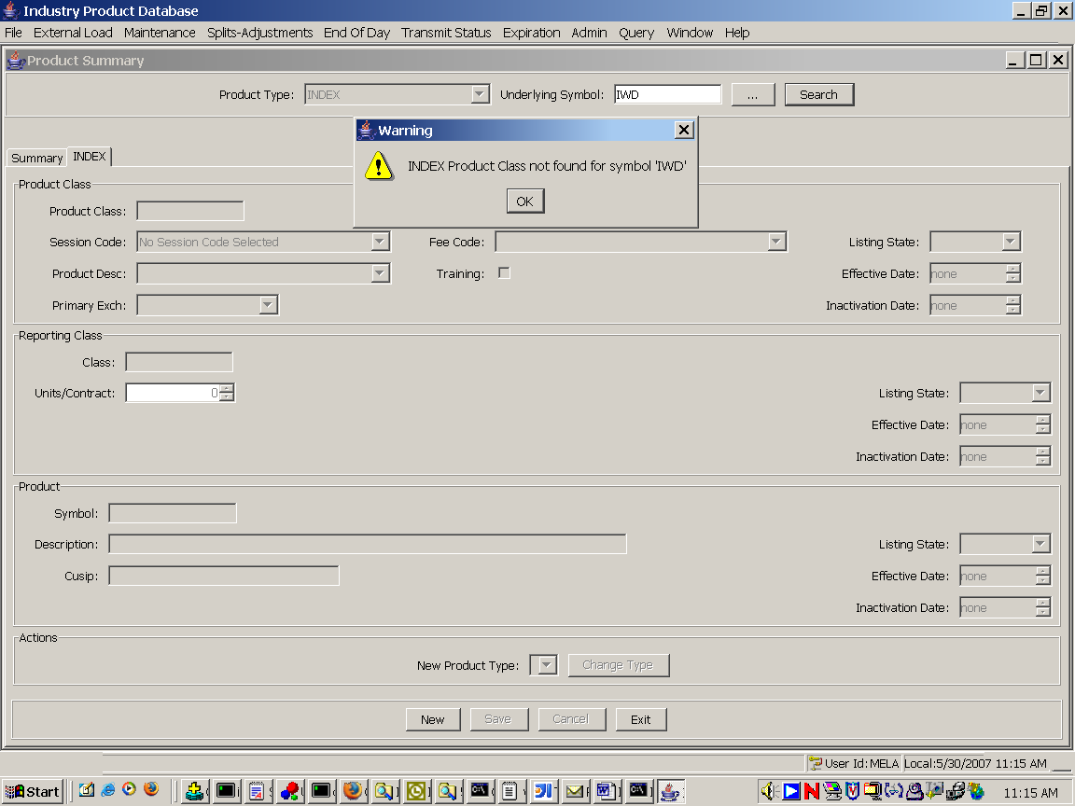

Change the product type to ETF and query again. For example, if IWD was converted from an Index to an ETF for this test, search for the IWD ETF. It should now appear.

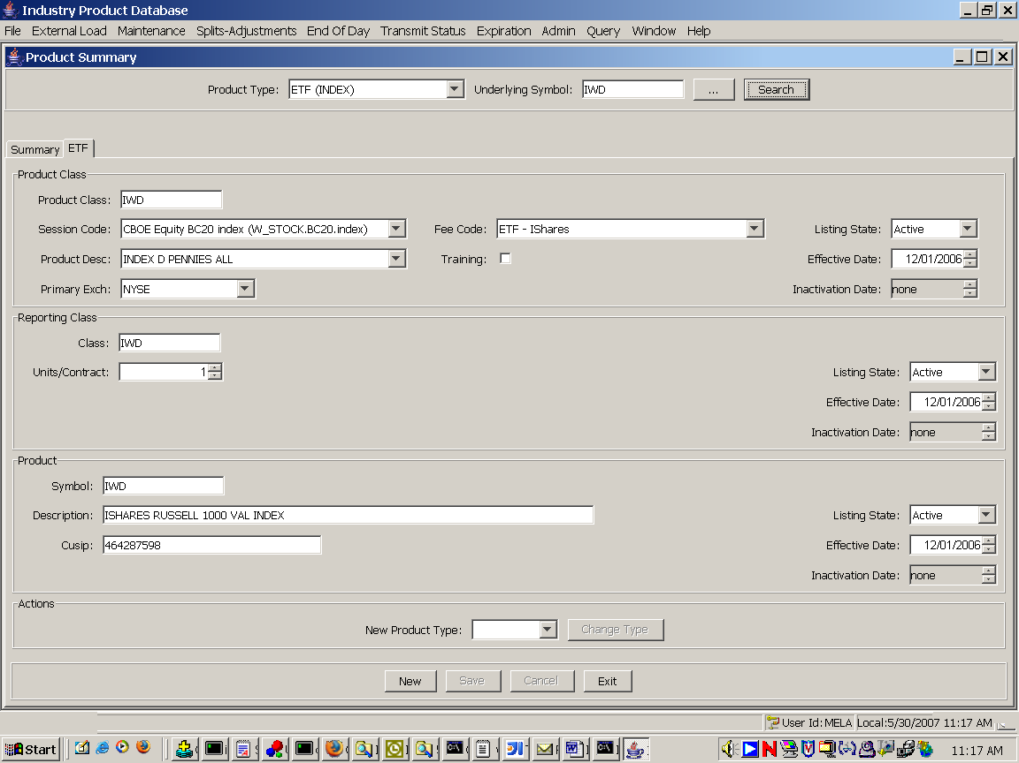

Finally, verify that the converted index does NOT appear in SBT End of Day screens. It should not appear because SBT does not support ETF product types and does not support product type changes. The product type change applies only to data in IPD.

Derivatives on New Product Types

Test Description:

Create a new option on an ETF underlying. Create a strike. Transmit to SBT and TPF. Verify that the option appears in both systems.
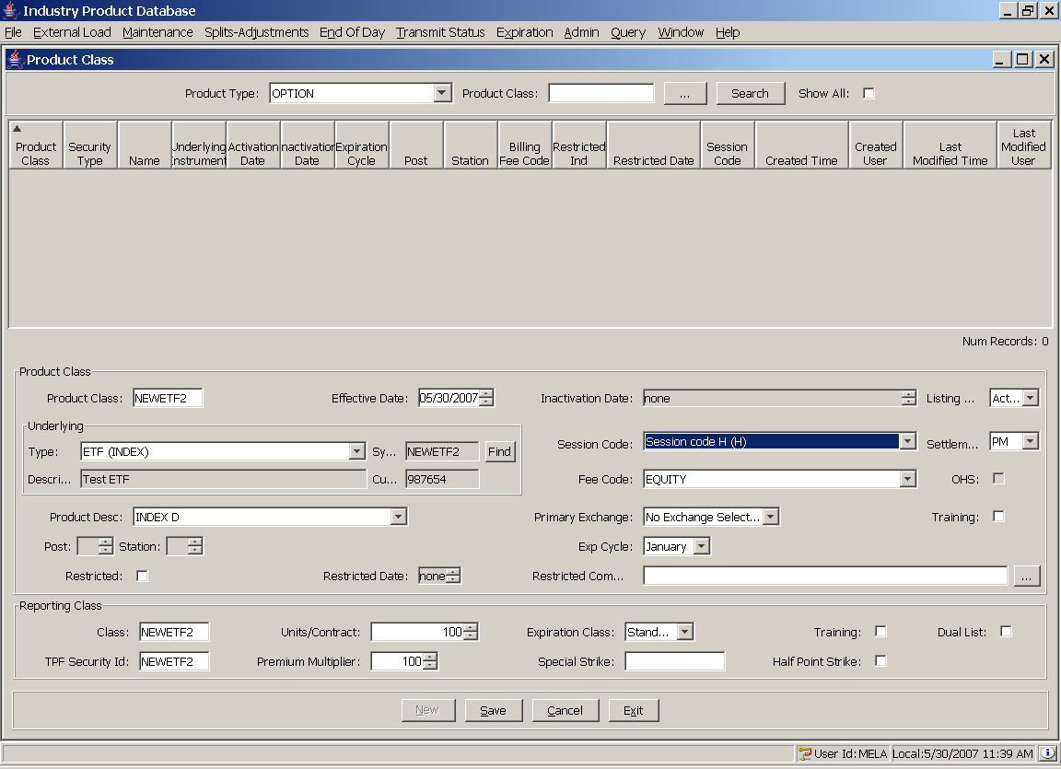

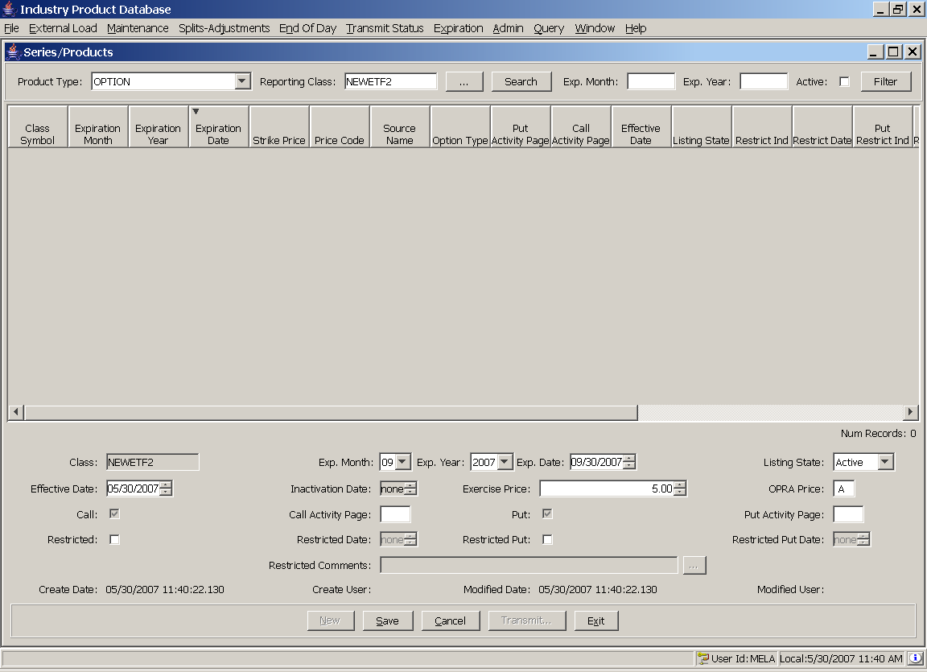

Expected Results

The option is created and transmitted to SBT and TPF successfully.

