SYSTEMS DIVISION

IPD Consolidated Series
TEST PLAN DOCUMENT
FOR PRODUCTION ROLLOUT
WR # 2111

DRAFT

Prepared By:
Back Office IPD Team

Table of contents

Introduction 3
Document Layout 3
IPD’s Notation’s and Terminology 4
IPDServer startup and connectivity to CBOEDirect and TPF 5
Introduction 5
Server startup procedures 5
IPD ProductMaintenance Tests 6
Introduction 6
Product Description 6
View Product Description 6
Update Product Description 8
Add Product Description 8
Transmits 11
Introduction 11
Intraday 11
Reporting Classes added prior to activation not sent 11
Reporting classes under new product classes are not sent 15
Reporting class sent successfully 27
Products added prior to activation are not sent 32
Products under reporting classes that have not been sent are not sent 35
Product sent successfully 43
IPDServer shutdown procedure and server configuration for first week of production 49

Introduction
This document highlights the testing procedures to be carried out during the IPD Production Rollout. The IPD system is responsible for the centralization of all industry product and series information into one central source of information. IPD will send all product and series information to the Trading Floor applications (CBOE Direct, TPF and PDS). IPD will provide a simplified mechanism to add new classes and series both intra-day and end-of-day. IPD will also provide an automated method of notifying all the affected parties.
To determine what sections of this document have changed since its last revision, see the section below. Also, throughout the document, revision bars are used in the margins to show paragraphs or sections of the document that have changed.

Document Layout
- IPDServer start up and connectivity to CBOEDirect and TPF – This section explains the steps necessary to bring up the IPD Processes and to verify that connectivity to CBOEDirect and TPF are established successfully.
- IPD Product Maintenance Test – This section explains testing procedures to ensure that the Product Maintenance aspect of IPD is functioning correctly and that the products/series etc is being transmitted successfully to CBOEDirect and TPF.
- IPDServer shutdown and server configuration for first week of production – This section explains shutdown procedures. In addition, the server will be configured such that no product data can be transmitted to either CBOEDirect or TPF during the first week of deployment.

IPD’s Notation’s and Terminology
IPD Name | Description
IPD Server | Comprises of 2 hosts one setup as primary and one setup as a backup. (Each host is also known as a ‘IPD Server’). All components common to the IPD system run on these servers.
TPF Adapter | Process that communicates with the TPF system
IPD Server Terminal | The ‘xterm’ terminal used for entering manual commands.
IPD GUI | Gui used for IPD’s Maintenance functions, Performing product state changes, intra day updates, end of day etc.
CAS | Client Application Services – The remote application that runs on the client side and communicates with the IPD system.

IPDServer startup and connectivity to CBOEDirect and TPF

Introduction
This section explains how to bring up the IPD server and to ensure that connectivity to CBOEDirect and TPF is established.

Server startup procedures

- Ensure that that CBOEDirect and TPF have been started up.
- Bring up the processes on the IPDServer using PATROL, which utilizes the startIpdSystem script in the /ipd/prod/ipd/run_dir directory.
- Ensure that the IPD processes have been brought up successfully using the following command; chk –c all all. There should be 3 processes for IPD namely
  - prodIPDServerprdipd01a
  - prodIPDSMSServerprdipd01a
  - prodIPDTpfGlobalprdipd01a
- Monitor these processes for about 5 minutes to ensure that they don’t terminate
- Start the outbound TPF Adapter service using the following ‘ar’ command
ar IPDTpfGlobal startService IPDTpfOutboundServiceConnection
- To check status of the TPF Adapter, use the followinf ‘ar’ command
ar IPDTpfGlobal showConnection IPDTpfOutboundServiceConnection
- Start up the CASs and ensure that the CASs are up using Patrol.
- Verify connectivity to CBOEDirect using the trader service query (to ensure that CBOEDirect’s ID service is running)
Eg: trader -query IDL:uuidService/IdService:1.0 -ping

IPD ProductMaintenance Tests

Introduction
This section explains the tests required to confirm proper functionality of the ProductMaintenance aspect of IPD. Basic tests will be conducted to ensure that IPD has been installed correctly and data is persisted correctly in the database. In addition, communication to CBOEDirect and TPF will be verified.

Product Description

View Product Description
This test will ensure that all the Product Descriptions are returned successfully from the database.

Step 1 Open the window using the Maintenance menu and selecting Product Descriptions
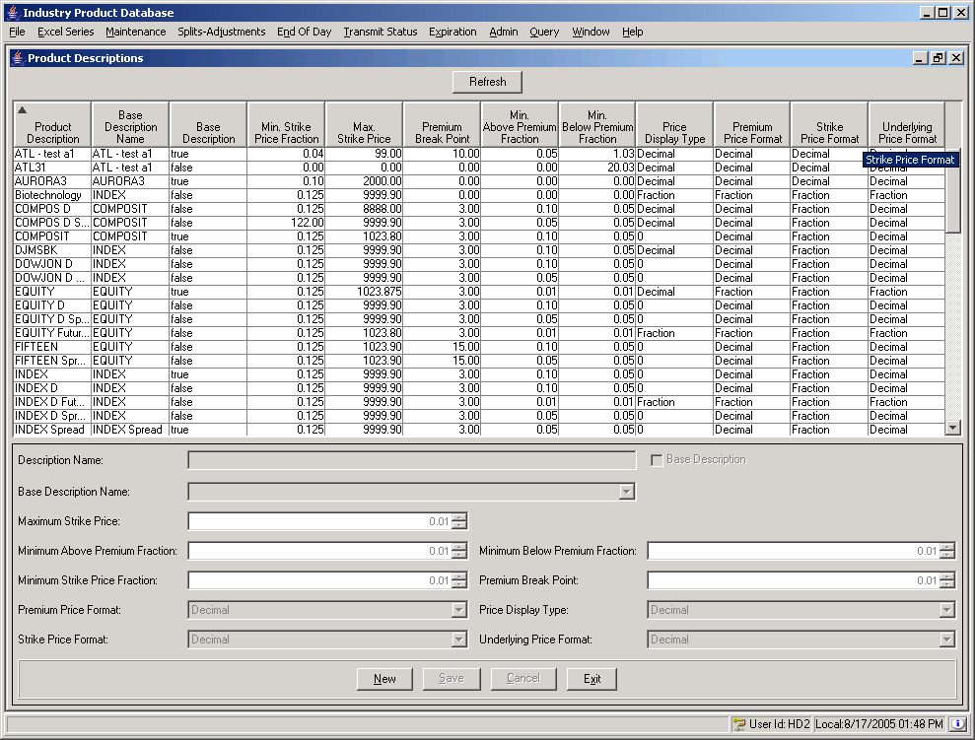
Step 2 Login to the database and verify that the number of rows is correct.
SELECT COUNT (*) FROM PROD_DESC
Expected Result | Actual Result | Pass/Fail
Rows in window matches rows in database

Update Product Description
Step 1 Click on the first row in the Product Description window.
Expected Result | Actual Result | Pass/Fail
The detail portion of the window should match the selected row

Step 2 Identify the selected row. Note the DATABASEIDENTIFIER.
SELECT * FROM PROD_DESC WHERE DESC_NAME = <value from Description Name field>

Step 3 Change the values in the detail portion of the window and click the Cancel button.
Expected Result | Actual Result | Pass/Fail
The detail portion of the window should display the original values for the record

Step 4 Change the values in the detail portion of the window and click the Save button.
Expected Result | Actual Result | Pass/Fail
The updated values should be reflected in the master portion of the window

Step 5 Verify the database row has been appropriately updated.
SELECT * FROM PROD_DESC WHERE DATABASEIDENTIFIER = <DBID noted in Step 2>

Add Product Description

Step 1 Click the New button.
Step 2 Enter field values as per the example 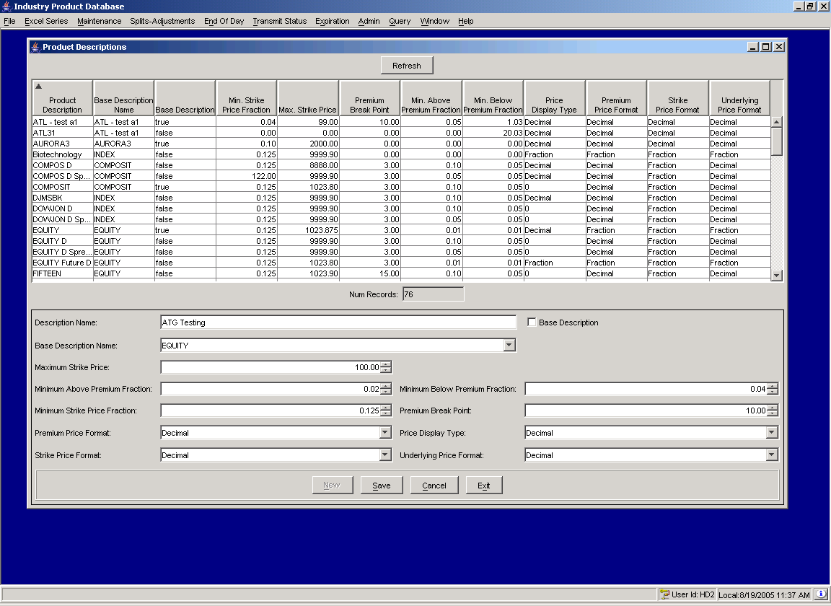
Step 3 Click Cancel
Expected Result | Actual Result | Pass/Fail
Values in the master portion of the window should not appear

Step 4 Repeat previous steps, using the Save button instead of Cancel.
SELECT * FROM PROD_DESC WHERE DESC_NAME = <Description Name entered on previous step>
Expected Result | Actual Result | Pass/Fail
New record should appear in the master portion of window (see below) and the new row should be highlighted
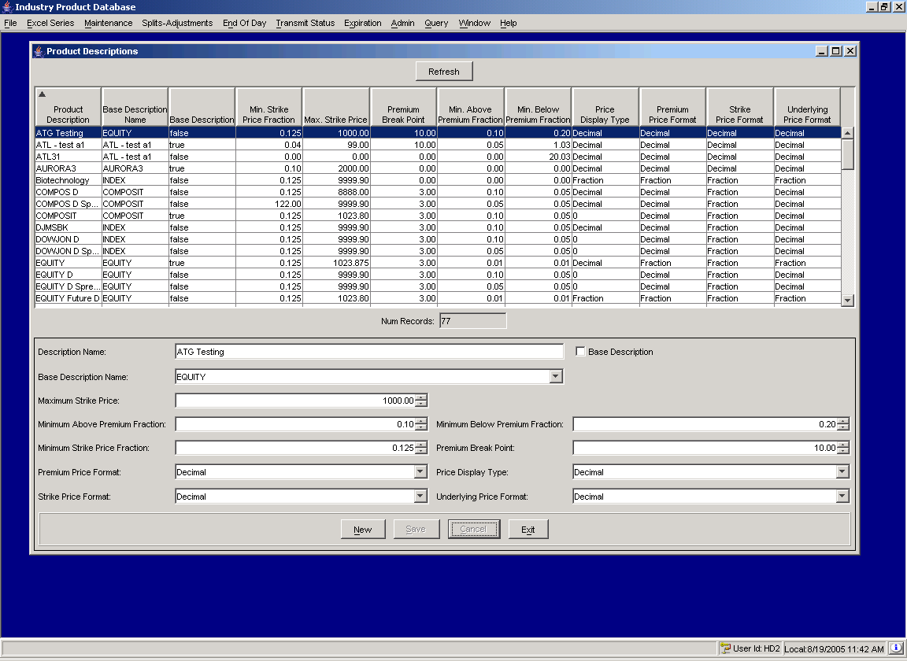

Transmits

Introduction
This section will test adding product class, reporting class and series to IPD and ensuring that these are transmitted successfully to TPF and SBT. These should be transmitted first to TPF and then to SBT. The transmits to SBT should be done to the CFE_MAIN and W_MAIN sessions.

Intraday

Reporting Classes added prior to activation not sent
Step 1 Open the Reporting Class window (Maintenance menu):
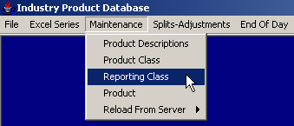

Step 2 Add a reporting class with a future activation date. Note: make sure server’s trade date matches system date on GUI:
- First, retrieve the reporting classes for the desired trading instrument that we will be adding a new future reporting class for:
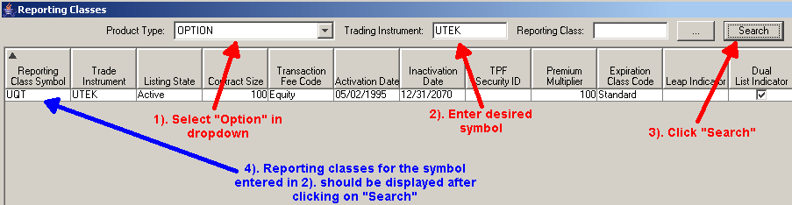
- Click on the “New” button at the bottom:
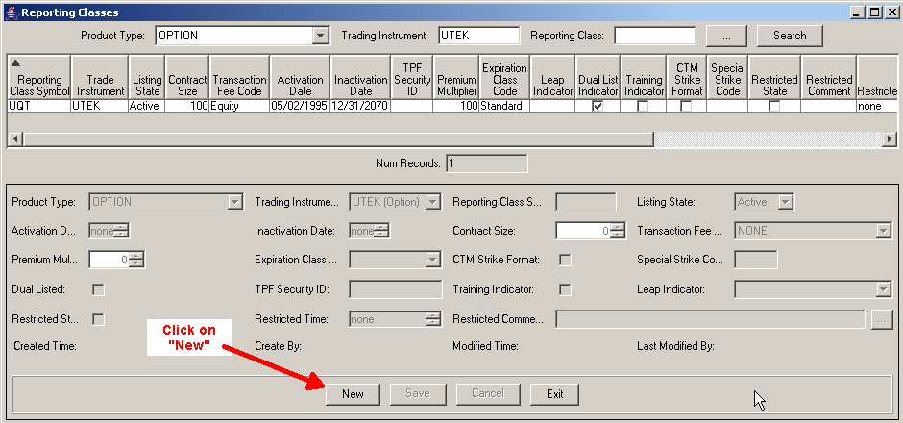
- Enter in the desired fields, making sure you enter in a future activation date, and click on “Save”:
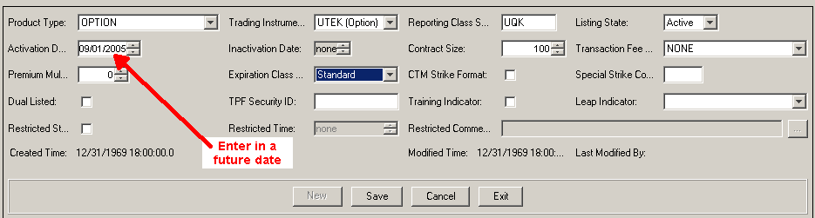
Expected Result | Actual Result | Pass/Fail
The intraday transmit window should not appear

Reporting classes under new product classes are not sent

Because product class information is not sent intraday, reporting classes under new product classes cannot be sent either. To test this scenario, start by adding a new active product class.

Step 1 SBT

a) Open the “Product Class” maintenance window:
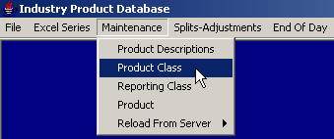

b) You might want to verify the new product class you are going to add does not exist. Search for the product class symbol you plan on adding verify it is not found. Enter a product type of “OPTION” and use the new product class symbol you want to add, then click “Search”. If you get the “not found” pop-up message, it’s a good one to use:
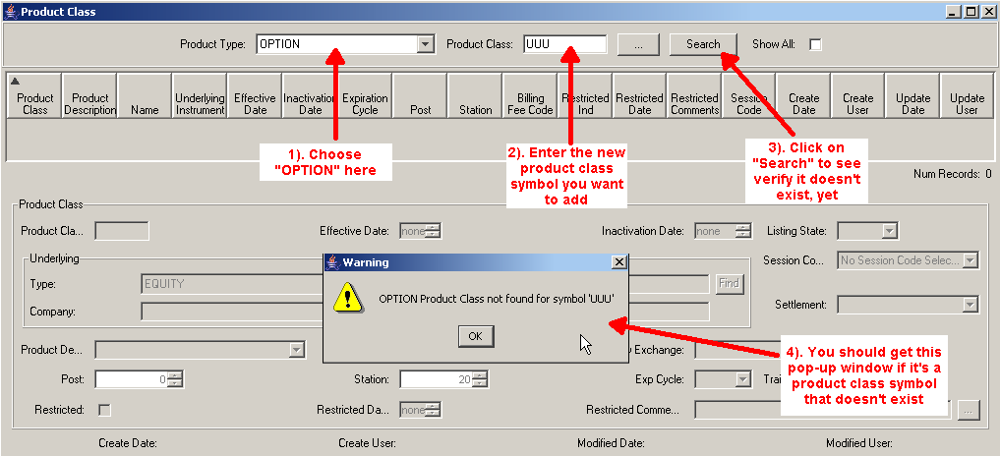

c) With the Product Type still set to “OPTION”, click on “New”:
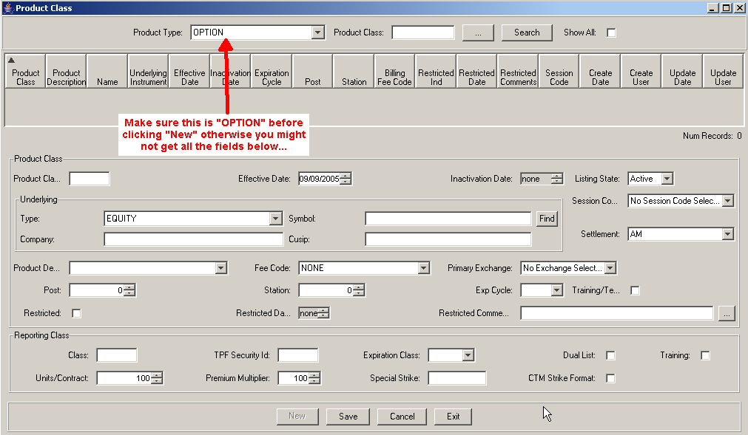
d) Enter in the values for the new product class and then click “Save”:
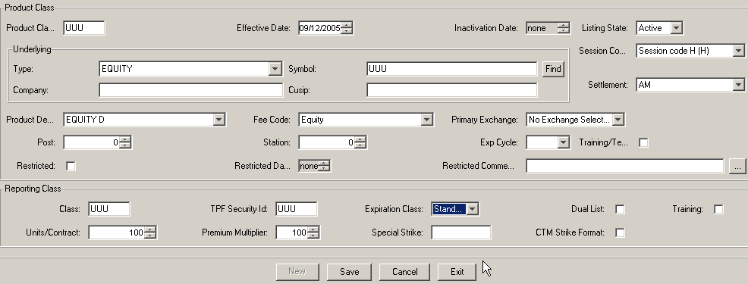

e) A confirmation message will be displayed, click “OK”:
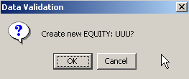

f) Next, open the “Reporting Class” maintenance window to add a new reporting class for a new product that has not been sent to SBT, yet.
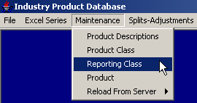

g) Use a Product Type of “EQUITY” and enter in the new product class symbol added in the previous step and click on “Search”. This will return the new reporting class entered in the previous step when we created the new product class. Since we are testing intra-day reporting class not sent for a new product class, we need to add a different new reporting class. Click “New”:
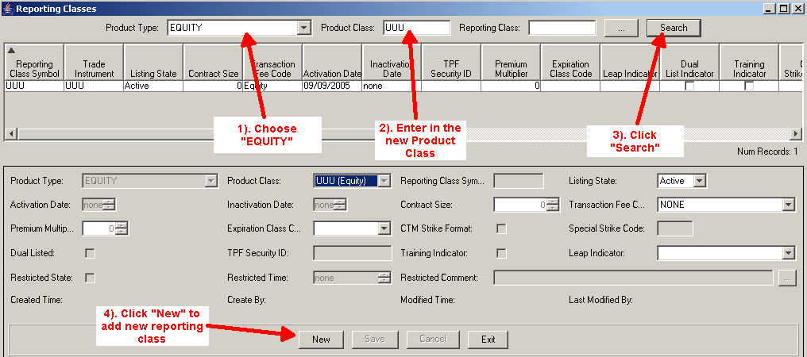

h) Enter in the values for the new reporting class. Use a different reporting class symbol than the one entered when you created the product class, then click on “Save”:
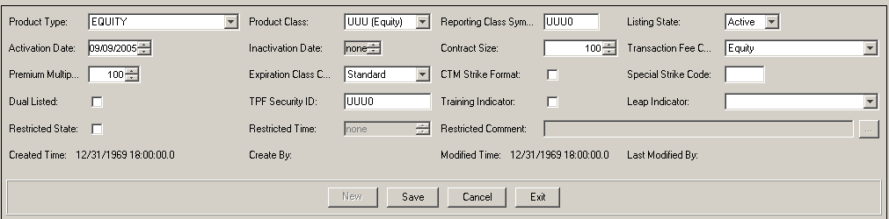

i) After clicking the Save button, the Intraday Reporting Class Transfer window will appear. Approve the record to be sent, select SBT as the Destination System and click the Send button:
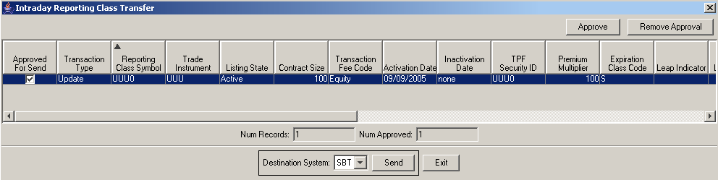
Click “OK” on the confirmation message:
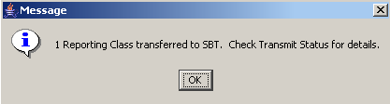

- Verify the record was not actually sent to SBT by using the SBT Transmit Status window (Transmit Status menu):

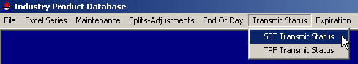

k) Click on the “Class” tab and use the product type of the reporting class that was added (in this case EQUITY), log status “Not Sent,” and the current date as filters.
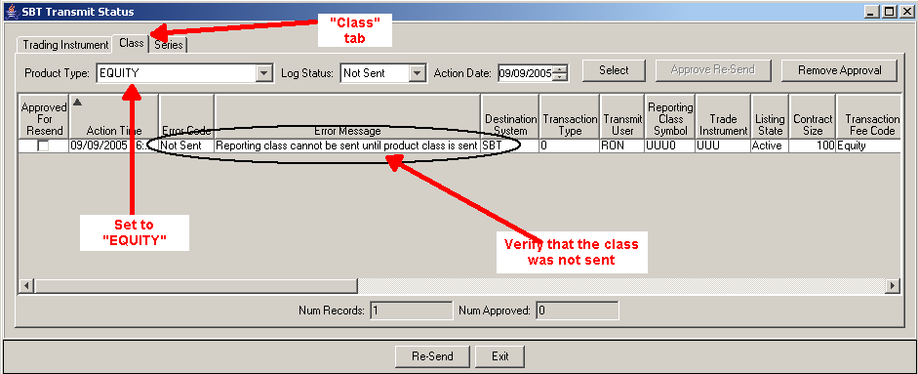
Expected Result | Actual Result | Pass/Fail
The record should not be sent and give an error message reading “Reporting class cannot be sent until product class is sent”

Step 2 TPF

a) From the Reporting Class window, add another new active reporting class to the product class added in the beginning of this test. Again, use the Product Type of “EQUITY” and the new product class symbol just added earlier. Then click on “Search” to return the reporting classes already added. Then click on “New” to allow you to define another reporting class:
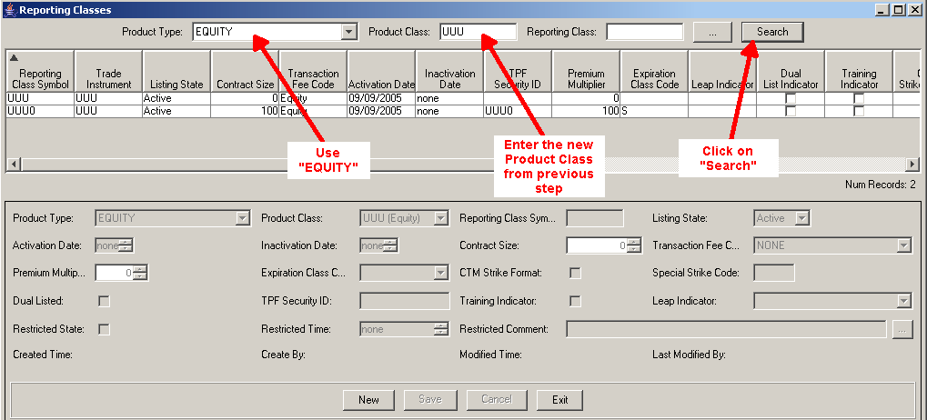

b) Enter in the values for the new reporting class and click “Save”:
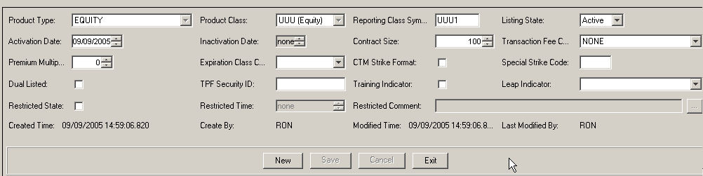

c) After clicking the Save button, the Intraday Reporting Class Transfer window will appear. Approve the record to be sent, select TPF as the Destination System and click the Send button:
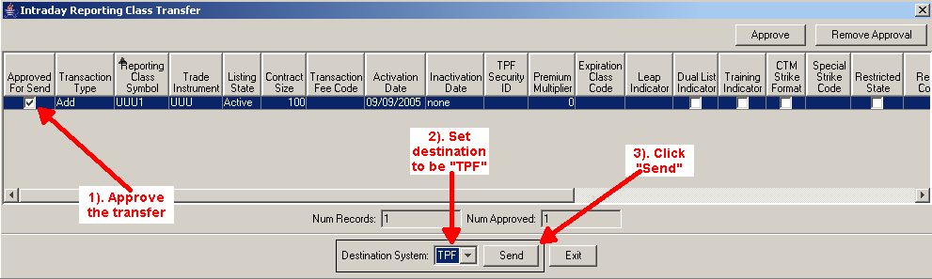
Click “OK” to the confirmation message:
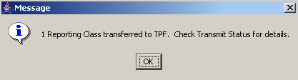
- Verify the record was not actually sent to TPF by using the TPF Transmit Status window (Transmit Status menu):

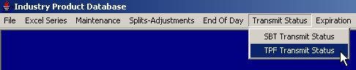

e) Use the product type of the reporting class that was added (in this case Option), log status “Not Sent,” and the current date as filters:
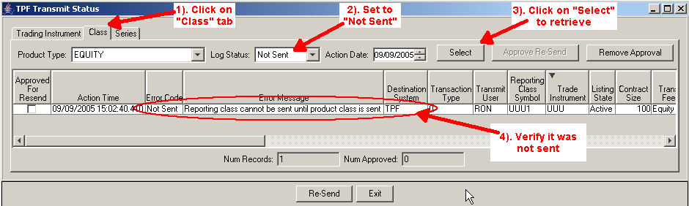

Expected Result | Actual Result | Pass/Fail
The record should not be sent and give an error message reading “Reporting class cannot be sent until product class is sent”

Reporting class sent successfully

Step 1 TPF

a) Add a new active reporting class to a product class already existing in the TPF environment being used.
b) Open the “Reporting Classes” window and search for the product class in which you will add a new reporting class to:
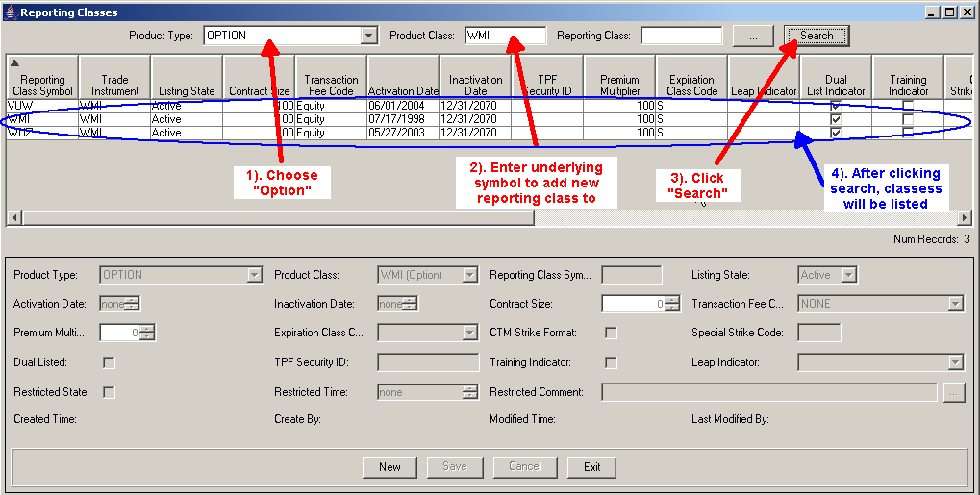
c) Click on the “New” button, enter in the values for the new reporting class and click “Save”:
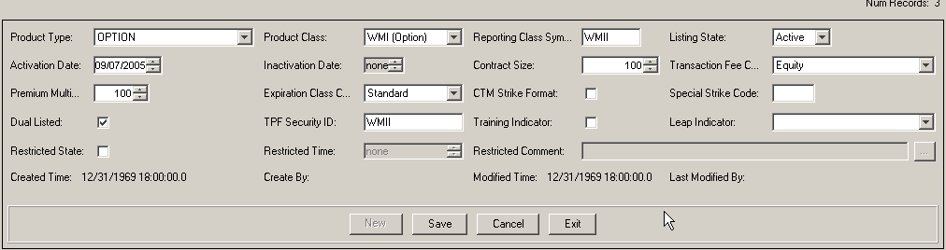

d) After clicking the Save button, the Intraday Reporting Class Transfer window will appear. Approve the record to be sent, select TPF as the Destination System and click the Send button:
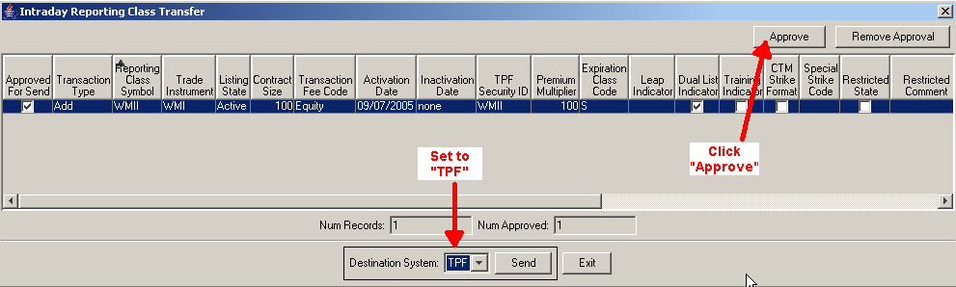
You should get a confirmation message:
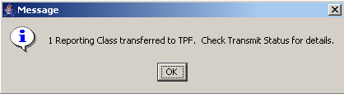

e) Verify the record was sent to TPF by using the TPF Transmit Status window (Transmit Status menu). Use the product type of the reporting class that was added (in this case Option), log status “Completed,” and the current date as filters.

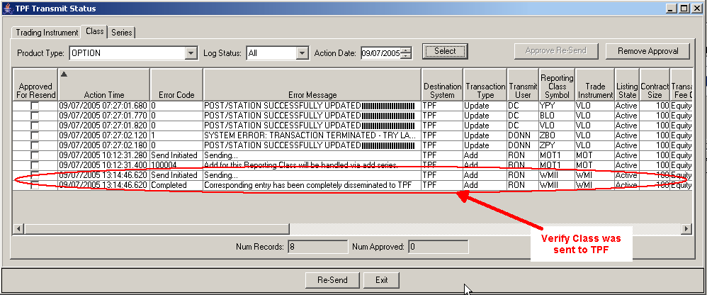

Expected Result | Actual Result | Pass/Fail
The record should be sent
View the new reporting class in TPF or otherwise confirm within TPF that the transfer was successful.

Step 2 SBT

- Add a new active reporting class to a product class already existing in the SBT environment being used.
- After clicking the SAVE button, the Intraday Reporting Class Transfer window will appear. Approve the record to be sent, select SBT as the Destination System and click the Send button
- Verify the record was sent to SBT by using the SBT Transmit Status window (Transmit Status menu). Use the product type of the reporting class that was added (in this case Option), log status “Completed,” and the current date as filters
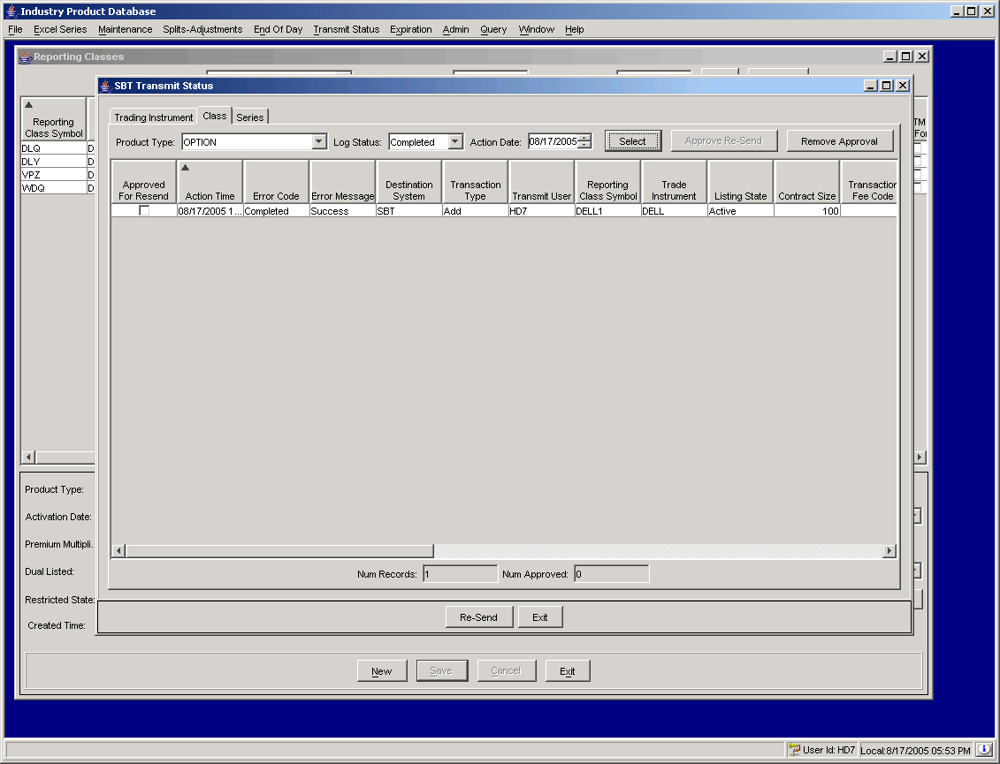
Expected Result | Actual Result | Pass/Fail
The record should be sent

d) View the new reporting class in SBT’s SAGUI or otherwise confirm within SBT that the transfer was successful.

Products added prior to activation are not sent

Step 1 SBT

a) Open the Series window (Maintenance menu):
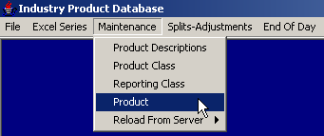

b) Retrieve a series list for an existing reporting class:
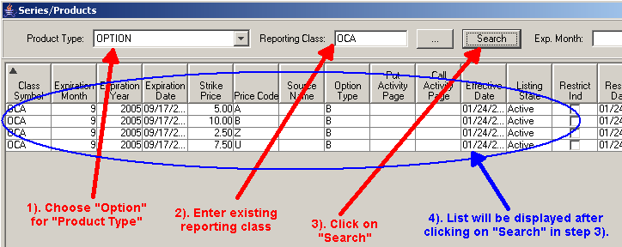

c) Add a product with a future activation date. Note: make sure server’s trade date matches system date on GUI.
- Click on the “New” button near the bottom of the window:
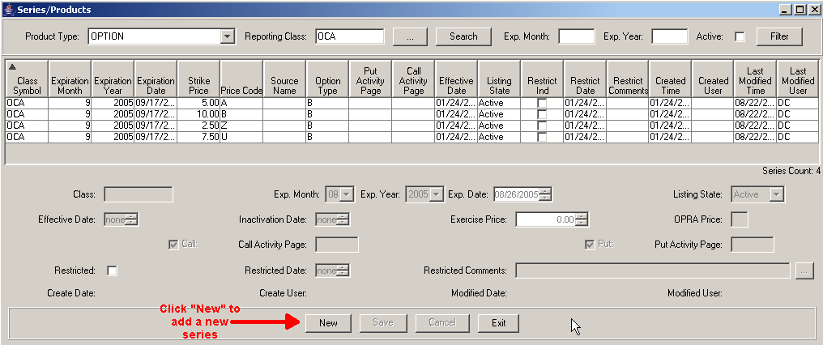
- Set the appropriate field values:
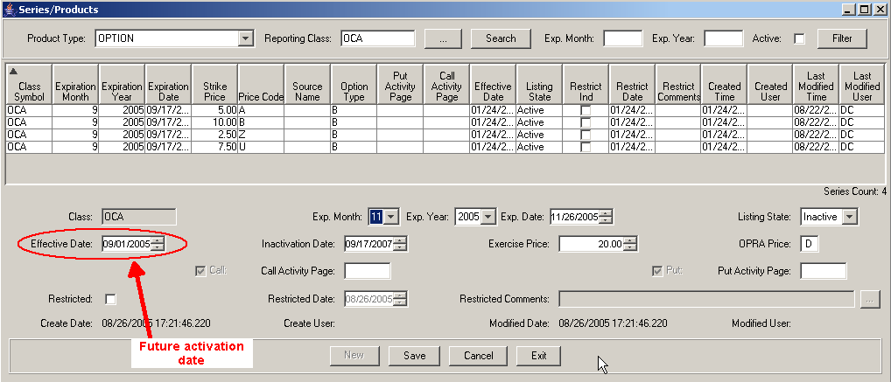
- Click on “Save”.
Expected Result | Actual Result | Pass/Fail
The intraday transmit window should not appear

Products under reporting classes that have not been sent are not sent

Step 1 SBT

If a reporting class is created but not sent intraday, any products under reporting classes cannot be sent either. To test this scenario, start by adding a new active reporting class. When the Intraday Reporting Class Transfer window appears, click the Exit button without sending the reporting class.
a) From the Series/Products window, add a new active series to the reporting class added in the previous step.
b) After clicking the Save button, the Intraday Product Transfer window will appear. Approve both records to be sent, select SBT as the Destination System and click the Send button.
c) Verify neither record was actually sent to SBT by using the SBT Transmit Status window (Transmit Status menu). Use the product type of the product that was added (in this case Option), log status “Not Sent,” and the current date as filters.
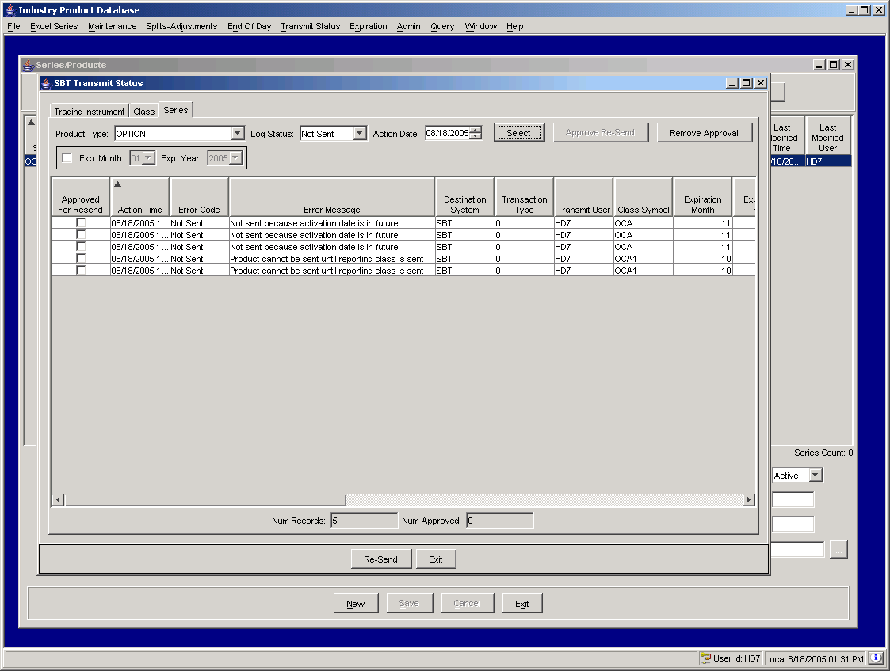
Expected Result | Actual Result | Pass/Fail
Neither record should not be sent; error message should read “Product cannot be sent until reporting class is sent”
Step 2 TPF

If a reporting class is created but not sent intraday, any products under reporting classes cannot be sent either. To test this scenario, start by adding a new active reporting class.
a) First open the “Reporting Class” maintenance window and search for the product class in which you will add a reporting class for (In the example below, entered Product Type of “OPTION” and Product Class of “TWX”:
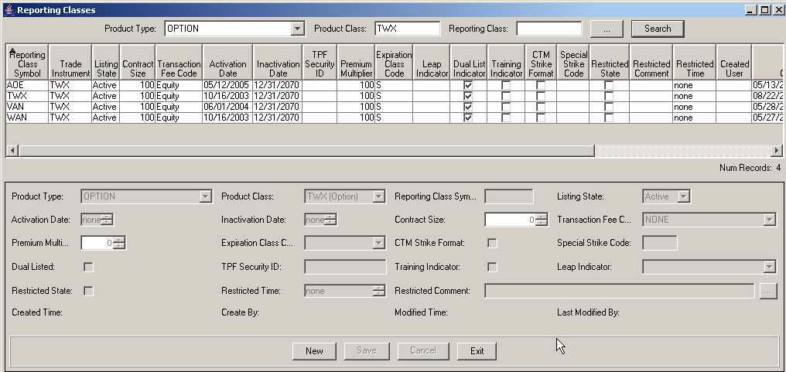
b) Next, click on the “New” button to add a new active reporting class and enter the appropriate values. Make sure the Listing State is “Active”. In the example below, the new reporting class symbol is TWIX:

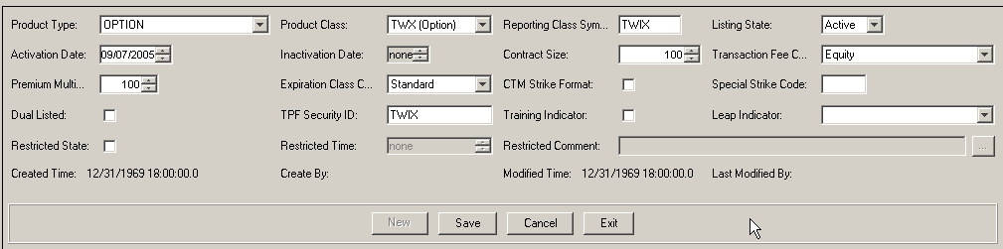

c) When the Intraday Reporting Class Transfer window appears, click the Exit button without sending the reporting class:
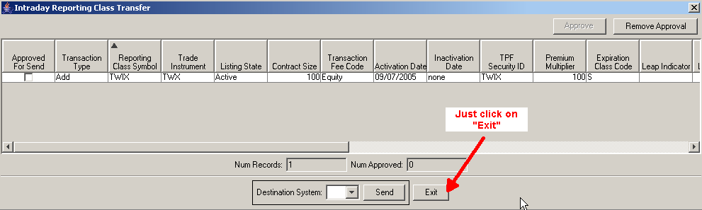
d) From the Series/Products window, add a new active series to the reporting class added in the previous step.
e) First select “Option” for Product Type and the new reporting symbol just added in the Reporting Class field then click on “New”:
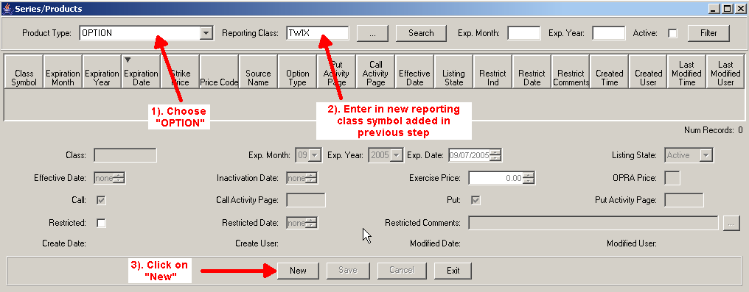
f) Enter in the appropriate values for the new series for the new reporting class:
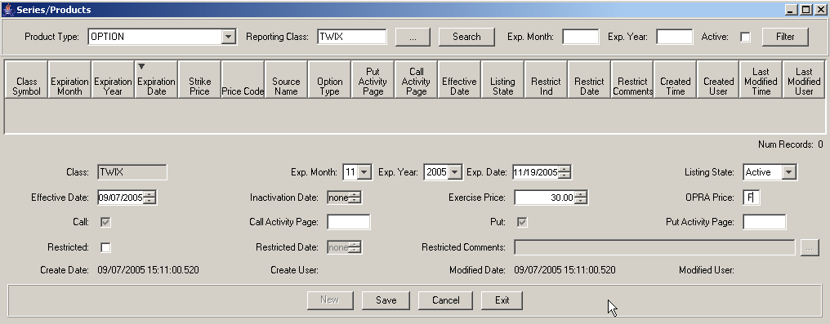
g) After clicking the Save button, the Intraday Product Transfer window will appear. Approve both records to be sent, select TPF as the Destination System and click the Send button:
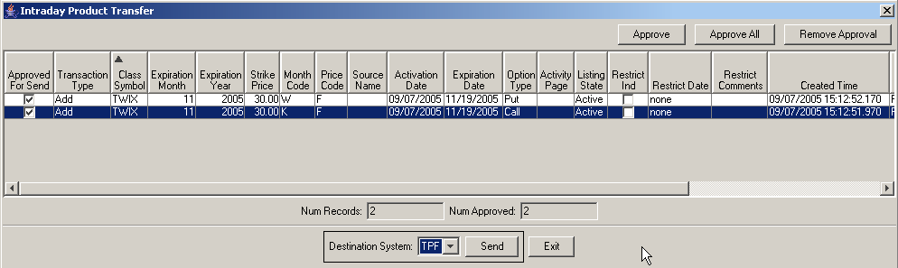

h) A verification window will display, click on “Ok”:
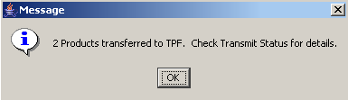

i) Verify neither record was actually sent to TPF by using the TPF Transmit Status window (Transmit Status menu). Use the product type of the product that was added (in this case Option), log status “Not Sent,” and the current date as filters:
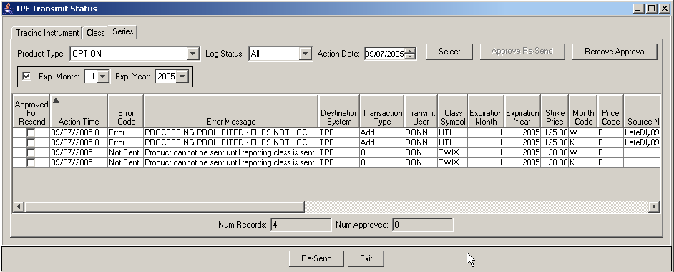
Expected Result | Actual Result | Pass/Fail
Neither record should not be sent; error message should read “Product cannot be sent until reporting class is sent”

Product sent successfully

Step 1 TPF

a) Add a new active product to a reporting class already existing in the TPF environment being used. First select an existing reporting class and click on the “New” button:
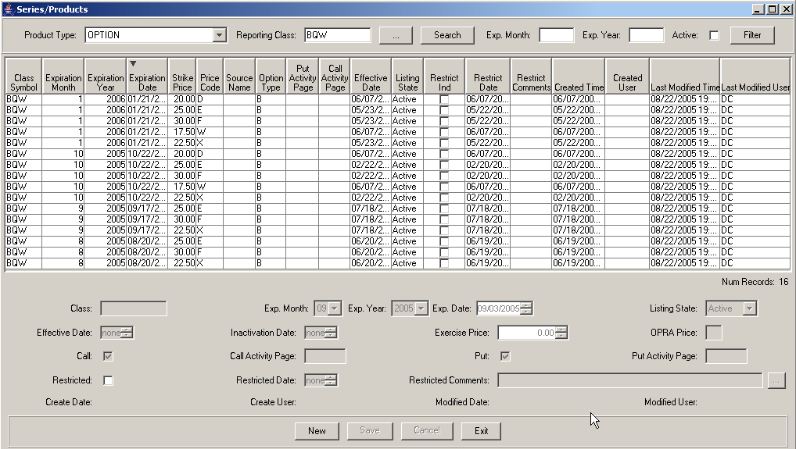

b) Enter in the details for the new reporting class and click on “Save”.
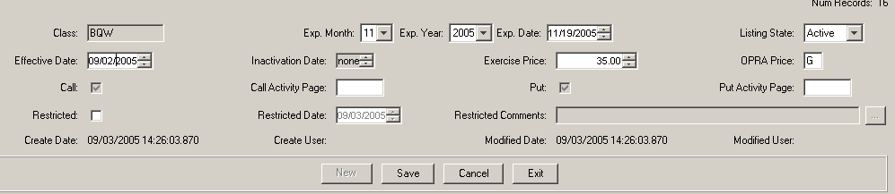

c) After clicking the Save button, the Intraday Product Transfer window will appear. Approve both records to be sent, select TPF as the Destination System and click the Send button.
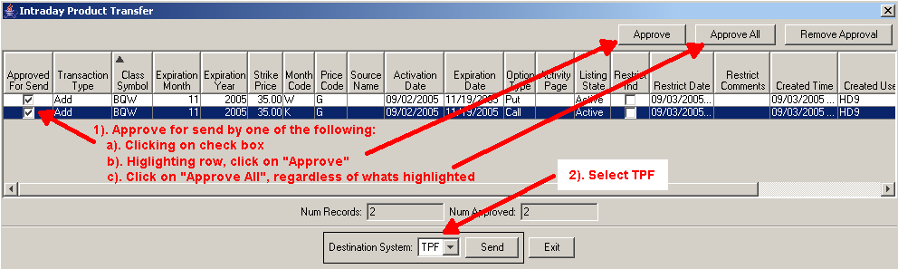
d) Confirmation message is displayed:
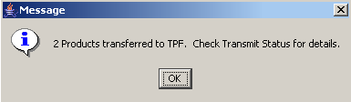

e) Verify both records were sent to TPF by using the TPF Transmit Status window (Transmit Status menu).
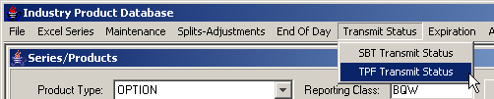

f) Use the product type of the product that was added (in this case Option), log status “Completed,” expiration month and year of the new reporting class entered and the current date as filters.
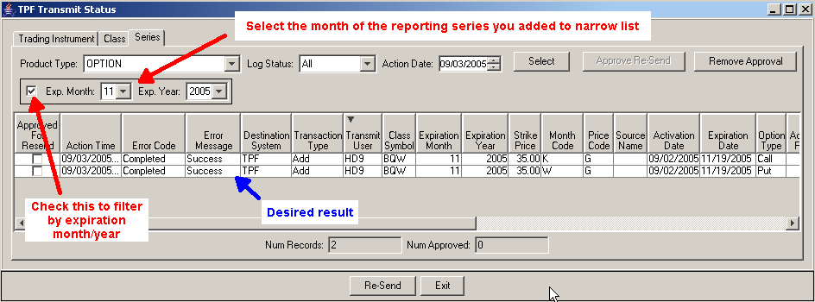
Expected Result | Actual Result | Pass/Fail
Both records should be sent

g) View the new products in TPF’s GUI? or otherwise confirm within TPF that the transfer was successful.

Step 2 SBT

a) Add a new active product to a reporting class already existing in the SBT environment being used.
b) After clicking the Save button, the Intraday Product Transfer window will appear. Approve both records to be sent, select SBT as the Destination System and click the Send button.
c) Verify both records were sent to SBT by using the SBT Transmit Status window (Transmit Status menu). Use the product type of the product that was added (in this case Option), log status “Completed,” and the current date as filters.
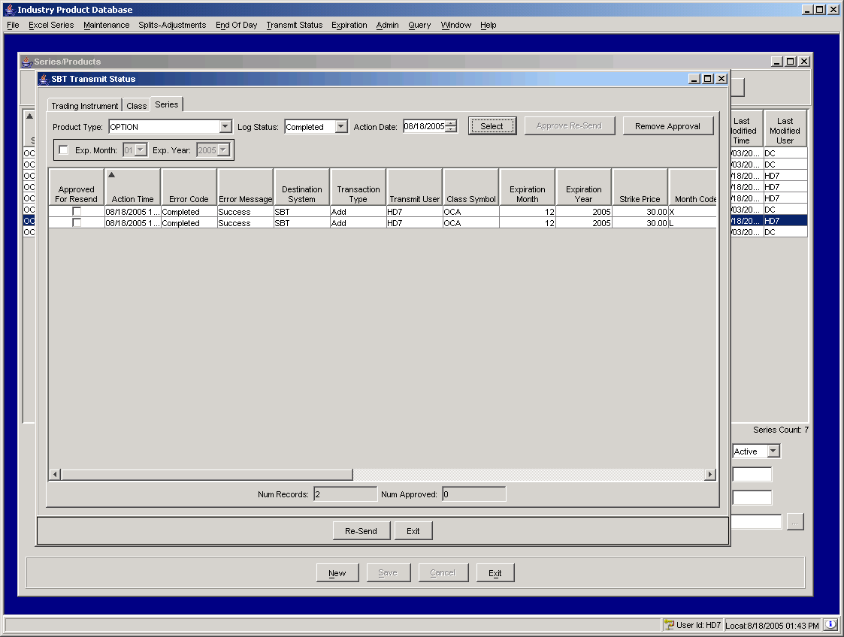
Expected Result | Actual Result | Pass/Fail
Both records should be sent

d) View the new products in SBT’s SAGUI or otherwise confirm within SBT that the transfer was successful.

IPDServer shutdown procedure and server configuration for first week of production

- Stop the TPF Adapter service using the following ‘ar’ command
ar IPDTpfGlobal stopService IPDTpfOutboundServiceConnection
- Bring down the processes on the IPDServer using PATROL, which utilizes the stopIpdSystem script in the /ipd/prod/ipd/run_dir directory.
- Ensure that the IPDServer processes have been stopped.
- Edit the IPMS.xml file in /ipd/prod/ipd/run_dir/properties/xml directory and remove the two dissemination destinations (‘SBT’ and ‘TPF’).
- Bring up the IPD processes again as highlighted at the start of the document.
- Redo the tests as above but this time, ensure that no information is sent to SBT and TPF.

The IPDServer will continue to remain in this state for the first week. Operations and users will be able to use the IPD application to familiarize themselves with its functionalities but no data will be transmitted to either TPF or SBT.

