

Industry Product Database User’s Guide
Version 1.0

Disclaimer

Copyright © 2005 Chicago Board Options Exchange. All rights reserved.
The information contained in this document constitutes confidential and/or trade secret information belonging to CBOE. This document is provided "As Is" with all faults and without warranty of any kind, either expressed or implied.

Change Notices

The following change notices are provided to assist users of the Industry Product Database in determining the impact of changes to their processing.
If you have any questions or review comments about this document, please contact Odalys Castro at (312) 786-8817.

Date | Version | Description of Change
02/09/06 | 1.1 | Updates prior to final rollout.
10/14/05 | 1.0-second draft | Updated Price Adjustment interfaces  Updated Transmit Status interfaces to include the Price Adjustment tab  Maintenance menu – changed Product selection to Series-Product  Added new interfaces for the Expiration menu
09/20/05 | 1.0-draft | First draft of Version 1.0.

Table of Contents
Table of Contents iii
Introduction v
Purpose v
Intended Audience v
Support and Questions v
Conventions Used in this Guide vi
Section 1: Industry Product Database 7
Getting Started 8
Login 8
About IPD 9
Excel Series Maintenance 10
Product Data Retrieval 10
Edit Column Preferences 13
Edit Product Information 14
Approve a Processed Product for Migration 15
Approve All Processed Products for Migration 15
Product Data Validation 15
Filtering Data 16
Delete Product Information 18
Product Maintenance 21
Product Description 21
Edit Product Descriptions 22
Create New Product Description 22
Edit Column Preferences 23
Define a Product 23
Create a New Future Product Class 23
Create a New Option Product Class 28
Create a New Equity Product Class 33
Create a New Index Product Class 37
Edit Column Preferences 41
Edit Existing Product Data 42
Edit Product Information 42
Product Class 42
Reporting Class 44
Product/Series 45
Edit Column Preferences 48
Price Adjustments 49
Create New Price Adjustment 49
Edit Price Adjustments 50
Delete 56
Edit Column Preferences 56
End of Day Transfer 57
SBT End of Day 57
TPF End of Day 60
Transmit Status 63
SBT Transmit Status 63
TPF Transmit Status 67
Expiration 72
Options Expiration 72
Super Purge (SPRG) 73
Class Purge – Not currently implemented 73
Category Purge – Not currently implemented 73
Futures Expiration 74
Admin Maintenance 75
Query Reports 76
Exit the System 77
Exit the System 77
Section 2: Reference Guide 78
Customizing IPD Windows 79
Edit Column Preferences 79
Display 81
Sizing IPD Windows 81
Console Window 82
Open Console Window 82

Introduction

Purpose | This user guide was written to assist the System Administrator in utilizing the Industry Product Database features.
Intended Audience | This user guide is intended for System Administrators or any person interested in the Industry Product Database administrator functions.
Support and Questions | Questions regarding this document can be directed to The Chicago Board Options Exchange at (312) 786 7831
Conventions  Used in this Guide | The Industry Product Database was designed so that you can perform all of your product maintenance from several display windows. Some fields are sensitive to both right and left mouse clicks. Window control functions can also be activated by using keyboard commands.  Section 1 of the document illustrates how to perform the necessary functions of the System Administrator. Additional information about window configuration and sizing can be found in Section 2: Reference Guide.  There are several conventions used throughout this guide to help trigger important information:
 | Bolding | Used to highlight menu selections (e.g., Login) and button names (e.g., Update)
 |  Note: | This notation is used to indicate important information you should note when performing the associated function.
 | Brackets [ ] | Used to highlight keyboard commands (e.g., [Alt]-[O]). Note that when [Alt] or [Ctrl] are used in conjunction with another key, hold down the first key while pressing the second.  Some button functions can be executed through keyboard commands. Hold down the [Alt] key and press the keyboard character of the underlined letter in the command. For example:  [Alt]-[R] Restores an active window
 | 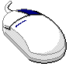 | This mouse graphic with the right mouse button highlighted will appear in the margin when accompanying instructions relate to functions activated by clicking the right mouse button.  All other mouse commands (such as double clicking to display a window) refer to a normal left mouse click.

 | Section 1:  Industry Product Database

This section of the user guide will direct you through all functions for the Industry Product Database.

Getting Started

 | When you launch the Industry Product Database application, the following login window will display.
 | 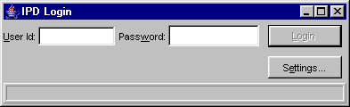
Login | Enter your User ID and Password. Both User ID and Password are case sensitive.  Click Settings, to change your login mode. The Session Settings window will display.
 | 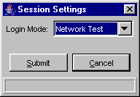
 | Select your login setting from the drop down list, click Submit. If you decide you do not wish to change your login mode, click Cancel. The system will return to the login window. Click Login.
Once you are logged into the system, the Industry Product Database window will appear.
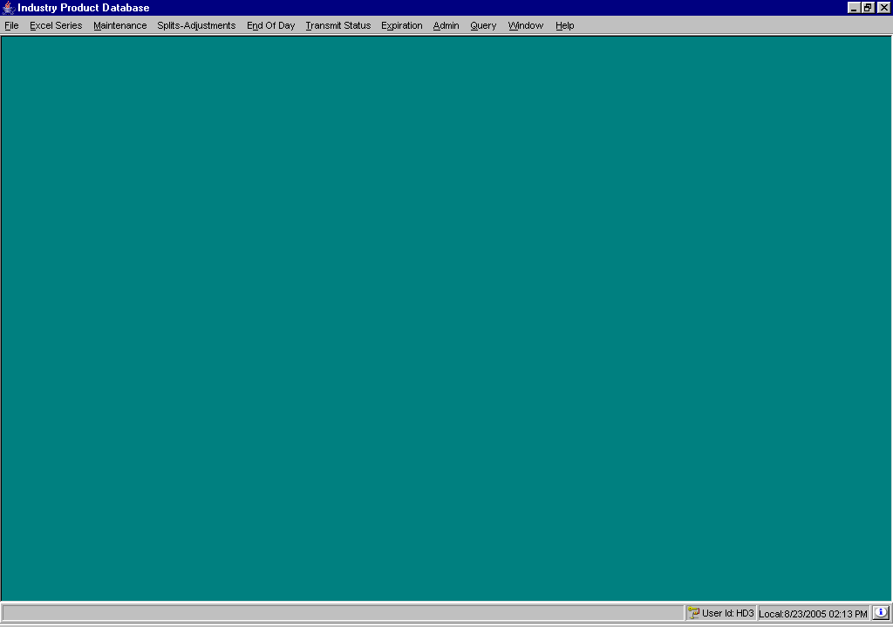
About IPD | To display IPD system information, click . The About window will display.
 | 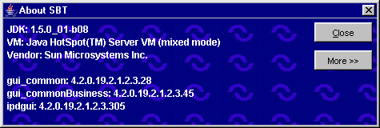
To view specific configuration information, click More. Detailed system information will display.
To exit the window, click Close.
 | You are now ready to perform product maintenance functions.
 | Excel Series Maintenance
Currently, CBOE manually enters new intra-day series adds and end-of-day series adds in an Excel program that is shared by all the options exchanges. The Industry Product Database application provides a single point of entry for both intra-day and end-of-day series and class additions.
The Excel Series window allows you to load product data from the Excel program. It allows you to correct errors, delete series and approve series for migration to the Industry Product Database product table.
To open the Excel Series window, click the Excel Series menu option and then click, Excel Maintenance or press [Alt]-[E] on your keyboard. The Excel Series window will display.
Click Exit at anytime to close the window.

Product Data Retrieval | When you initially open the Excel Series window, it will be blank. Click Refresh to retrieve the product data from the Excel program.  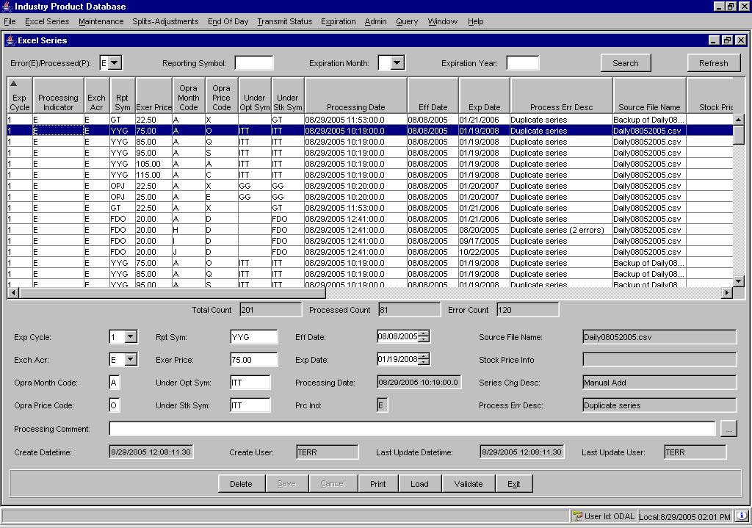
 | Scroll to the right to view additional data fields.
 | 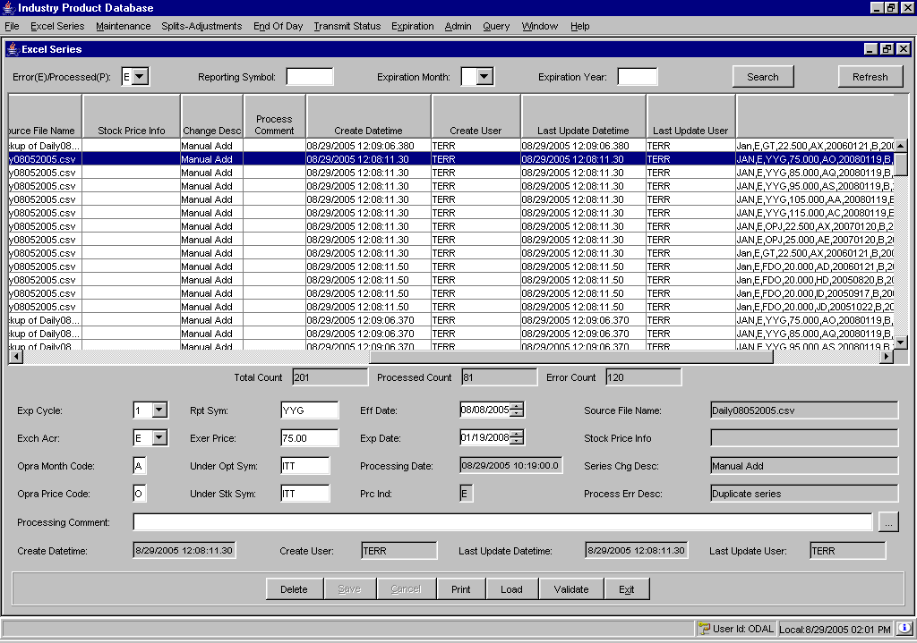
The Excel program data appears with product data that has errors and product data that has been processed. The default display is the product data with errors. Refer to the Process Err Desc column for a description of the error.
The total data count, processed data count and error data count display below the product data rows.
To retrieve the processed product data, select P from the Error(E)/Processed(P) drop down list and click Search.
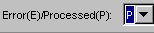
The processed data will display.
 | 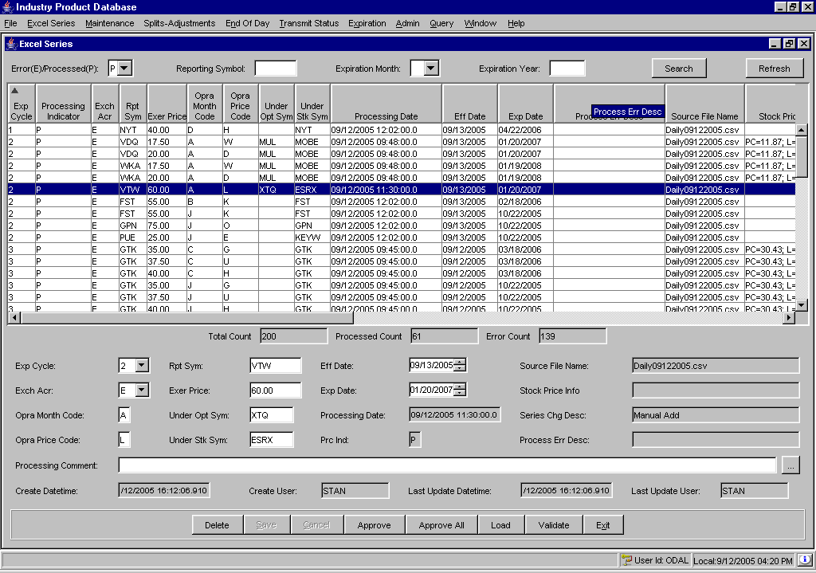
 | To retrieve a specific data file in the IPD staging directory, click Load. The system will open the file directory window.
 | 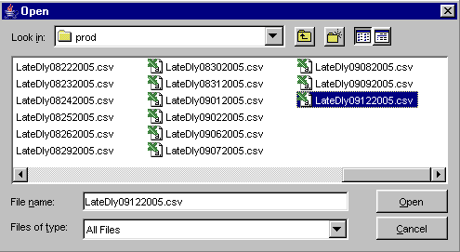
 | Click on the file you wish to retrieve and select Open. The system will prompt you to confirm the loading of the file.
 | 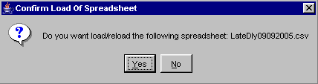
Click No to return to the Excel Series window.
Click Yes to load the file. The data will appear in the data row panel of the Excel Series window.
Once the product data is retrieved, you can edit or delete the product information before submitting it to the IPD product table.

Edit Column Preferences
You can customize your Excel Series windows by selecting or deselecting specific columns to display. To filter columns, right mouse click on a data row. Select Edit Preferences. The Edit Column Preferences window will display.
- Select or deselect columns for viewing and modify column arrangement as desired.
- To save your changes, click Ok.
- If you wish to retain the default settings, click Cancel.
For detailed information, refer to the Edit Column Preferences section, page 87.
Edit Product Information | The Excel Series window allows you to edit product information. Click on any product data row to display the details in editable format. Fields that cannot be edited are grayed out.  Editable fields include: Expiration Cycle (Exp Cycle:), Exchange Acronym (Exch Acr:), Opra Month Code:, Opra Price Code:, Reporting Symbol (Rpt Sym:), Exercise Price (Exer Price:), Underlying Option Symbol (Under Opt Sym:), Underlying Stock Symbol (Under Stk Sym:), Effective Date (Eff Date:), Expiration Date (Exp Date:) and Processing Comment.  - Edit the fields as required.  - To enter a Processing Comment, click to display the Processing Comment text box or place your cursor directly in the text box and type the information.
 | 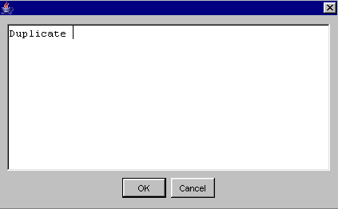
- Type in your text and click OK. Your comment displays in the Processing Comment text box.
- To close the text box without adding any comments, click Cancel.

- To save your changes, click Save. The changes will display in the product data row.
- If your changes do not pass validation, a Data Validation Error message will display describing your error. Click OK to return to the Excel Series window to update your changes.
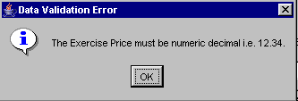
- To retain the existing data and remove your changes, click Cancel.
➢ | Approve a Processed Product for Migration  Products that have been processed can be approved for migration into the IPD product table.  To approve a product that has been processed, highlight the product data row and click Approve. The system will prompt you to confirm that you wish to approve the selected data row for migration into the IPD product table.
 | 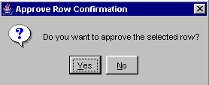
Click Yes to proceed with the approval.
Click No to remove the approval request.

➢ | Approve All Processed Products for Migration  To approve all the processed products for migration into the IPD product table, click Approve.  The system will prompt you to confirm that you wish to approve all the processed data rows, except the ones with error, for migration into the IPD product table.
 | 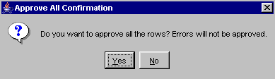
Click Yes to proceed with the approval.
Click No to remove the approval request.

Product Data Validation
You can revalidate all the product data at anytime by clicking Validate. The system will prompt you to confirm validation.
 | 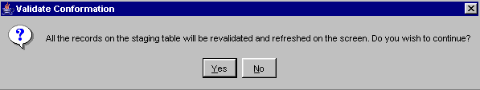
Click Yes to proceed with revalidating the data.
Click No to remove the validation request.
Filtering Data | Product data can be filtered by reporting symbol, expiration month or expiration year.
➢ | To filter the Excel program data by reporting symbol, enter the symbol in the Reporting Symbol text box and click Search.  - In this example, all the products for reporting symbol LXM will display on the Excel Series window.
 | 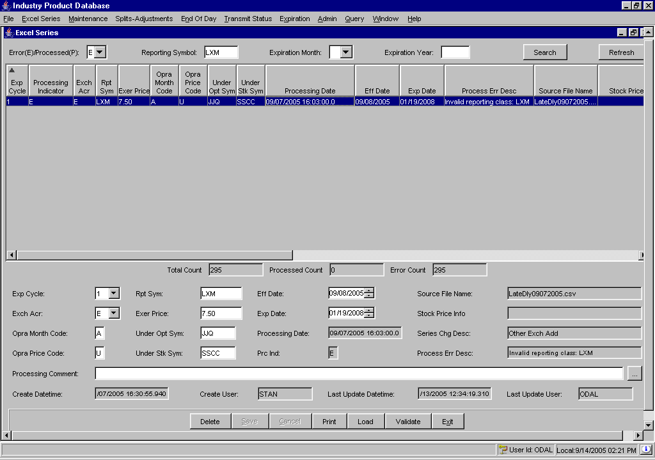
➢ | To filter the Excel program data by expiration month, select the Expiration Month from the drop down list and click Search.  In this example, only the Excel program products expiring in September appear in the Excel Series window.
 | 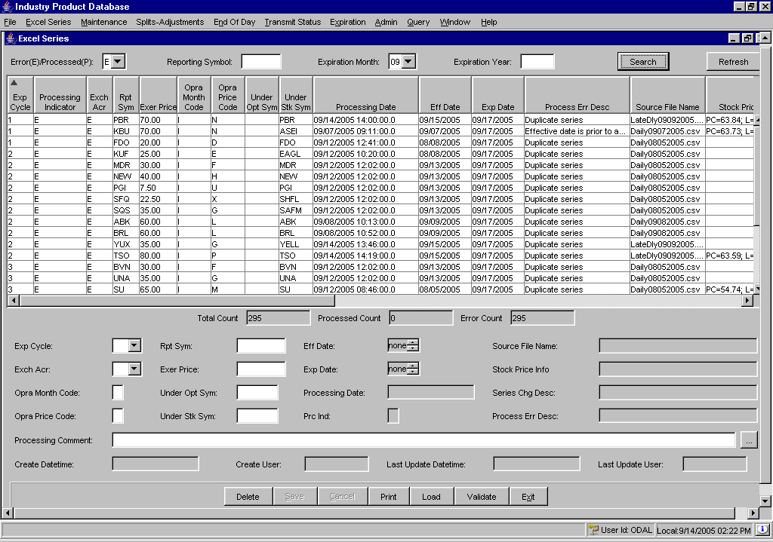
➢ | To filter the Excel program data by expiration year, select the Expiration Year from the drop down list and click Search.  In this example, only the Excel program products expiring in 2006 appear in the Excel Series window.
 | 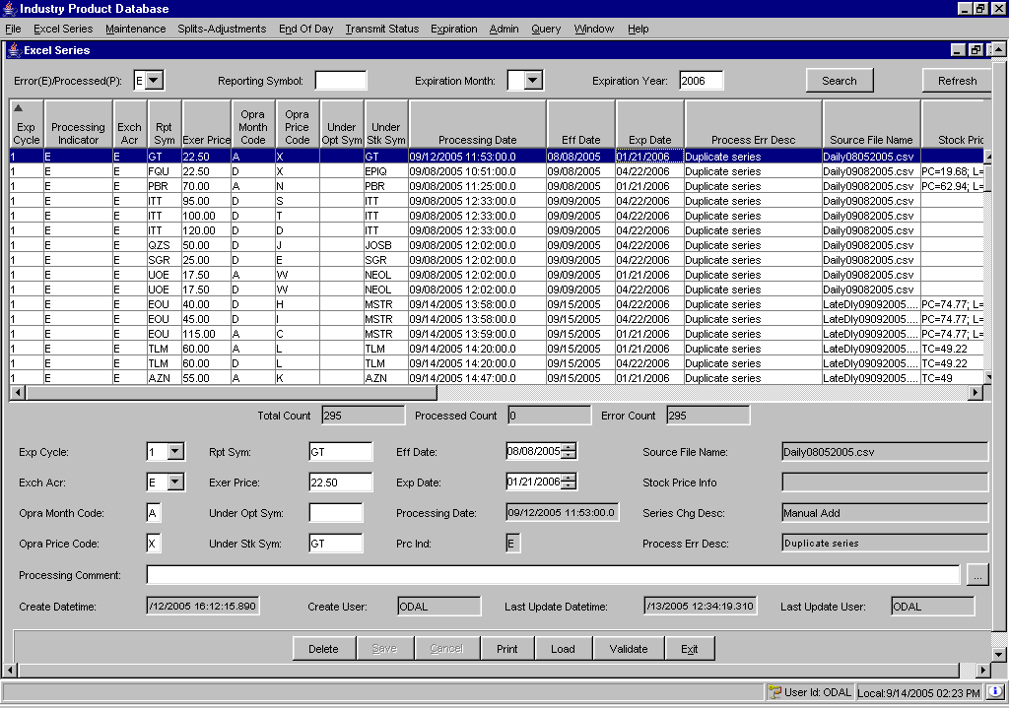
Delete Product Information | There are three ways you can delete a product from the Excel Series window: (1) by selected record, (2) by source file name or (3) by expiration date.
➢ | Delete a Specific Product Record:  To delete a specific product:  - Highlight the product data row from the Excel Series window. The details will populate in bottom panel of the window.  - Click Delete. The following menu will display.
 | 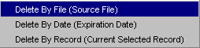
- Select Delete By Record. The system will prompt you to confirm the deletion.
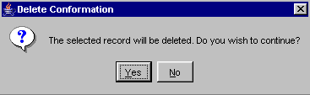
- Click No to exit the confirmation window without deleting the record.

- Click Yes to proceed with deleting the product. The product will be removed from the Excel Series window, thus removing it from the Excel program staging database.

➢ | Delete by Source File Name:  To delete by source file name:  - Click Delete and select Delete By File. The File Menu window will display.
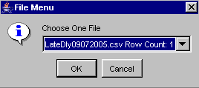
- Choose the file you wish to delete from the drop down list. The file name as well as the record count appear for selection.
- Click Cancel to exit the File Menu window and return to the Excel Series window.
- Click OK to proceed with deleting the source file. The system will prompt you to confirm the deletion.
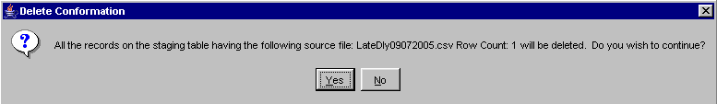
- Click No to exit the confirmation window without deleting the source file.
- Click Yes to proceed with deleting the source file. All the records on the Excel program having the selected source file will be removed from the Excel Series and the Excel program staging database.
➢ | Delete by Expiration Date:  To delete by expiration date:  - Click Delete and select Delete By Date. The File Menu window will display.
 | 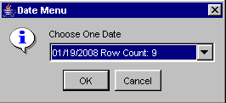
- Choose the file you wish to delete from the drop down list. The expiration dates present on the Excel Series window as well as the record count appear for selection.
- Click Cancel to exit the File Menu window and return to the Excel Series window.
- Click OK to proceed with deleting the source file. The system will prompt you to confirm the deletion.
 | 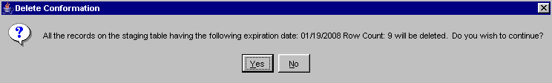
- Click No to exit the confirmation window without deleting the expiration date.
- Click Yes to proceed with deleting the expiration date. All the records on the Excel program having the selected expiration date will be removed from the Excel Series and the Excel program staging database.

Product Maintenance

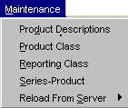 | The Industry Product Database (IPD) application allows you to perform various tasks for the maintenance of products. The features described in this section include: product description and product definition and editing.
Product Description | Product descriptions are unique by 'Description Name’. Every product that uses this name is sharing the product description. If a change is made to a product description, it affects all products using that name. Make sure that different product types have their own product descriptions.  To edit product descriptions, click Maintenance or press [Alt]-[M] on your keyboard and then select, Product Descriptions. The Product Descriptions window will display.
 | 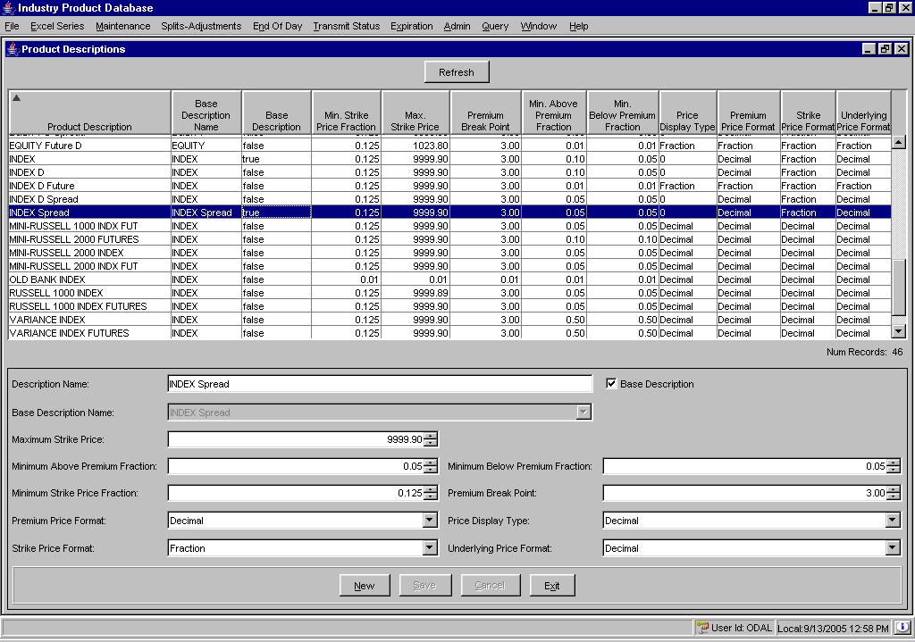
From this window, you can modify product descriptions and/or create new descriptions.
Click Refresh at anytime to update the display.
Click Exit at anytime to close the window and return to IPD’s main window.

Edit Product Descriptions
- To modify the description of a product, select the product description data row from the product description panel on the window. Description details display in editable format.
- Modify the Description Name by placing the curser in the text box and typing in the new information.
 Note: Any changes to a Product Description will change the description for all products that share the description.
- To update the Base Description Name, click on the drop down list and make your selection. If this is the base description for the trading product, select the Base Description checkbox.
In the example above, the trading product INDEX Spread is described as having a maximum strike price of 9999.90 and a minimum strike price fraction of 0.125, etc.
- Select the Maximum Strike Price, Minimum Strike Price, Minimum Below Premium Fraction and the Premium Break Point by clicking the up/down arrows until the desired value is reached.
- From the drop down lists, select the Premium Price Format, Price Display Type, Strike Price Format and the Underlying Price Format.
- To save the updates, click Save. The product displays in the product data row panel with updated information.
- If you decide not to modify the existing product, click Cancel.

Create New Product Description
- To add a new product description, click New.
- Enter the Description Name by placing the curser in the text box and typing in the new information.
 Note: The Product Description you enter will apply to all products that share the description.
- To enter the Base Description Name, click on the drop down list and make your selection. If this is the base description for the trading product, select the Base Description checkbox
- Select the Maximum Strike Price, Minimum Strike Price, Minimum Below Premium Fraction and the Premium Break Point by clicking the up/down arrows until the desired value is reached.
- The price formats default to decimal for Premium Price, Price Display Type, Strike Price and the Underlying Price. To change the price format to a fraction, select the fraction option from the corresponding drop down list for each price type.
- To save the description, click Save. The product displays in the product data row.
- If you decide not to enter the new product description, click Cancel.

Edit Column Preferences
You can customize your Product Description window by selecting or deselecting specific columns to display. To filter columns, right mouse click on a data row. Select Edit Preferences. The Edit Column Preferences window will display.
- Select or deselect columns for viewing and modify column arrangement as desired.
- To save your changes, click Ok.
- If you wish to retain the default settings, click Cancel.
For detailed information, refer to the Edit Column Preferences section, page 87.
Define a Product | The section of the user guide will walk you through the steps for creating a product class, reporting class and product/series using the Industry Product Database system.  From the Maintenance menu, select Product Class. The Product Class window will display.   Note: New product classes cannot be created intraday. Reporting classes can be entered intraday.
➢ | Create a New Future Product Class  When you initially open the Product Class window, it will be blank. To begin creating a new Future product class, select Future from the Product Type drop down list. Click New.
 | 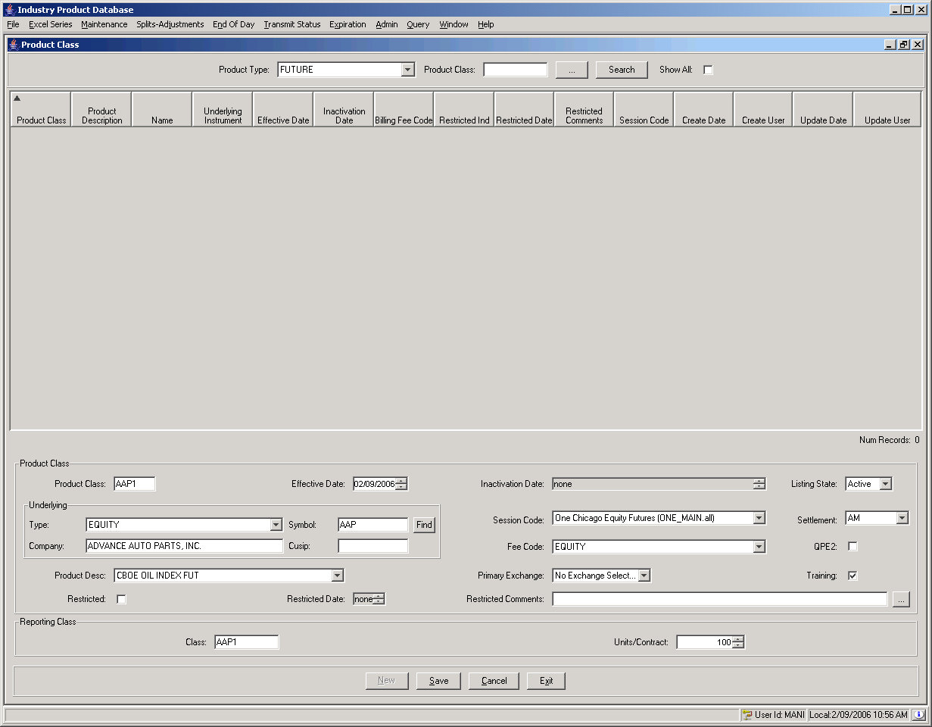
- Enter the class symbol for the new product class in the Product text box. The class symbol must be entered in capital letters.
- The Effective Date defaults to the current date. To change the default, click the up/down arrows until the desired date is reached.
- The Listing State defaults to Active. To make the class Inactive, Obsolete or Unlisted, make your choice from the Listing State drop down list.
- Select the session where the product class will trade by selecting the session code from the Session Code drop down list.
- If the new product class will be used for training, click the Training checkbox.
- From the Underlying section, choose the product type and symbol to be used as the underlying security. You can select the symbol by clicking Find. The underlying selector window will display.
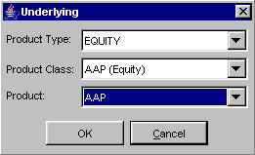
 Note: The IPD system will automatically create the underlying product if it does not exist.

- Select the product class’s primary exchange from the Primary Exchange and drop down list.
- To enter the activation and inactivation dates select the up/down arrows until the desired dates are reached.
- Select the product description from the Product Description drop down list box.
 Note: For product description features and limitations, refer to Product Description section, page 22.
- If creating a new underlying product, enter the Company Name and Cusip number.
- Select the fee code from the Fee Code drop down list box.
- Enter the Reporting Class symbol in the Reporting Class section of the window.
- If you decide you do no wish to create a new product class, click Cancel.
- To return to IPD’s main window, click Exit.
- To enter the new product class into the system, click Save. The new product class will display in the data row section of the window.
Create a Future Reporting Class
To create a new reporting class for an existing product class, select Reporting Class from the Maintenance menu.
 Note: Future classes can have only four reporting classes.
 | 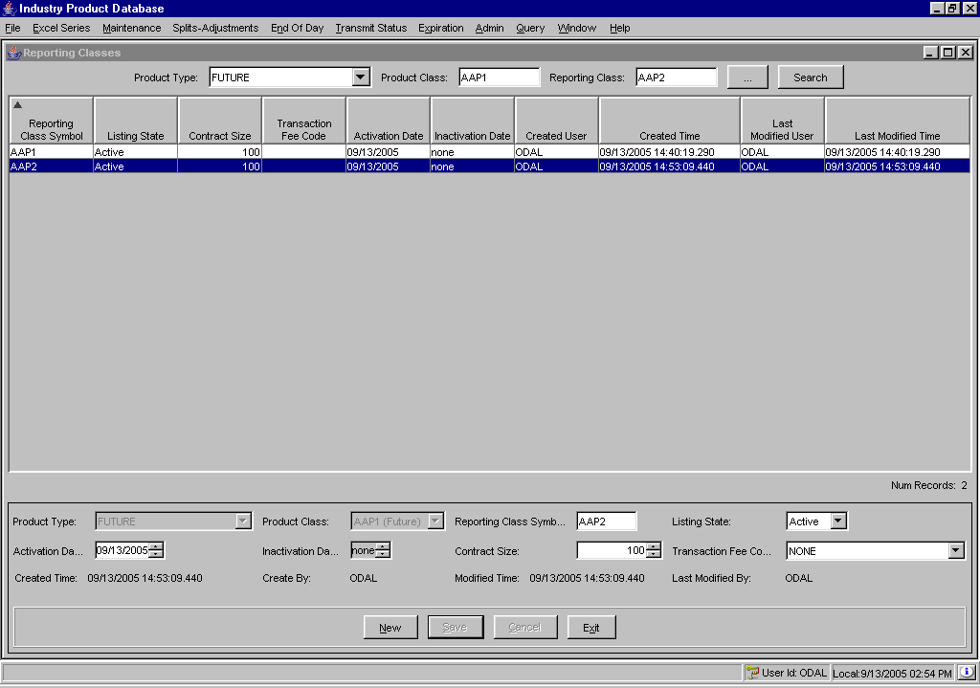
- Select the Product Type FUTURE from the drop down list.
- If you know the product class, enter it in the Product Class text box and click Search. The product class information will display.
Or, click on the selector button to select the Product Type, Product Class and existing Reporting Class. The product class and existing reporting class information will display.
- Click New. Enter the new Reporting Class Symbol. The class symbol must be entered in capital letters.
- Select the listing state from the Listing State drop down list.
- To enter the activation and inactivation dates select the up/down arrows until the desired dates are reached.
- Select the contract size.
- Select the fee code from the Transaction Fee Code drop down list box.
- If you decide not to create a new reporting class, click Cancel.
- To return to IPD’s main window, click Exit.
- To save the new reporting class, click Save. The Intraday Reporting Class Transfer window displays.

 | 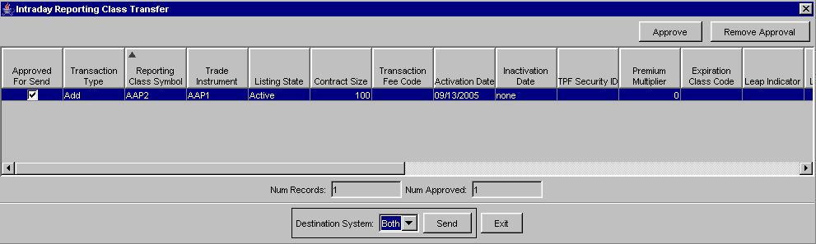
- Click Approve to confirm adding the intra-day reporting class to SBT, TPF or Both. A checkmark will appear in the Approved for Send column. To remove the approved request, click Remove Approval. The Approved for Send checkbox will appear deselected.
- From the Destination Systems drop down list, select whether to transfer the intra-day reporting class to SBT, TPF or Both.
- Click Exit to close the window without adding the intra-day reporting class.
- Click Send. The intra-day reporting class will be added to SBT, TPF or Both.
Create a New Future Product/Series
From the Maintenance menu, select Series-Product. The Series/Products window will display.
 | 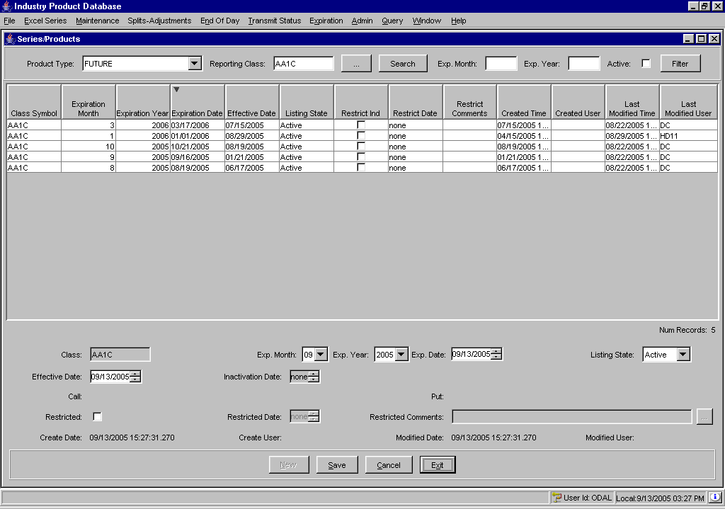
- Select the Product Type FUTURE from the drop down list.
- If you know the product class, enter it in the Product Class text box and click Search. The product class information will display.
- Or, click on the selector button to select the Product Type, Product Class and existing Reporting Class. The product class and existing reporting class information will display.
- Click New.
- From the drop down list boxes, select the Expiration month, year and date.
- Select the Effective Date and Inactivation Date from the up/down arrows.
- Elect if the product/series is Restricted by clicking on the Restricted checkbox and entering the Restricted Date.
- To return to IPD’s main window, click Exit.
- If you decide not to create a new product/series, click Cancel.
- To save the new product/series and transer them to another system, click Save. The Intraday Product Transfer window displays.
 | 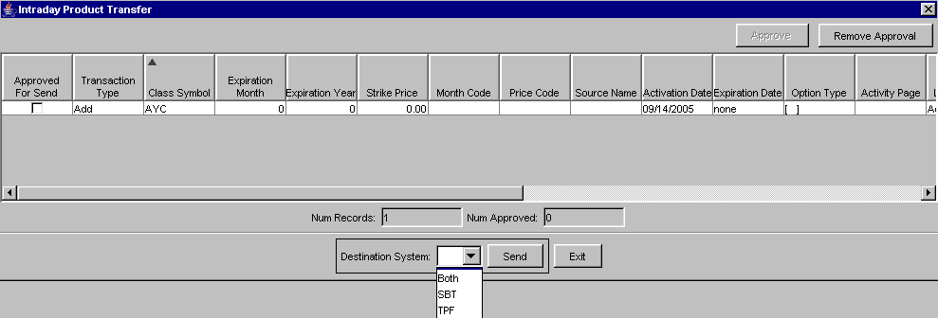
- Click Approve to confirm adding the intra-day reporting class to SBT, TPF or Both. A checkmark will appear in the Approved for Send column. To remove the approved request, click Remove Approval. The Approved for Send checkbox will appear deselected.
- From the Destination Systems drop down list, select whether to transfer the intra-day reporting class to SBT, TPF or Both.
- Click Exit to close the window without adding the intra-day reporting class.
- Click Send. The intra-day reporting class will be added to SBT, TPF or Both.
➢ | Create a New Option Product Class  - From the Maintenance menu, select Product Class. The Product Class window will display. To begin creating a new Option product class, select Option from the Product Type drop down list. Click New.  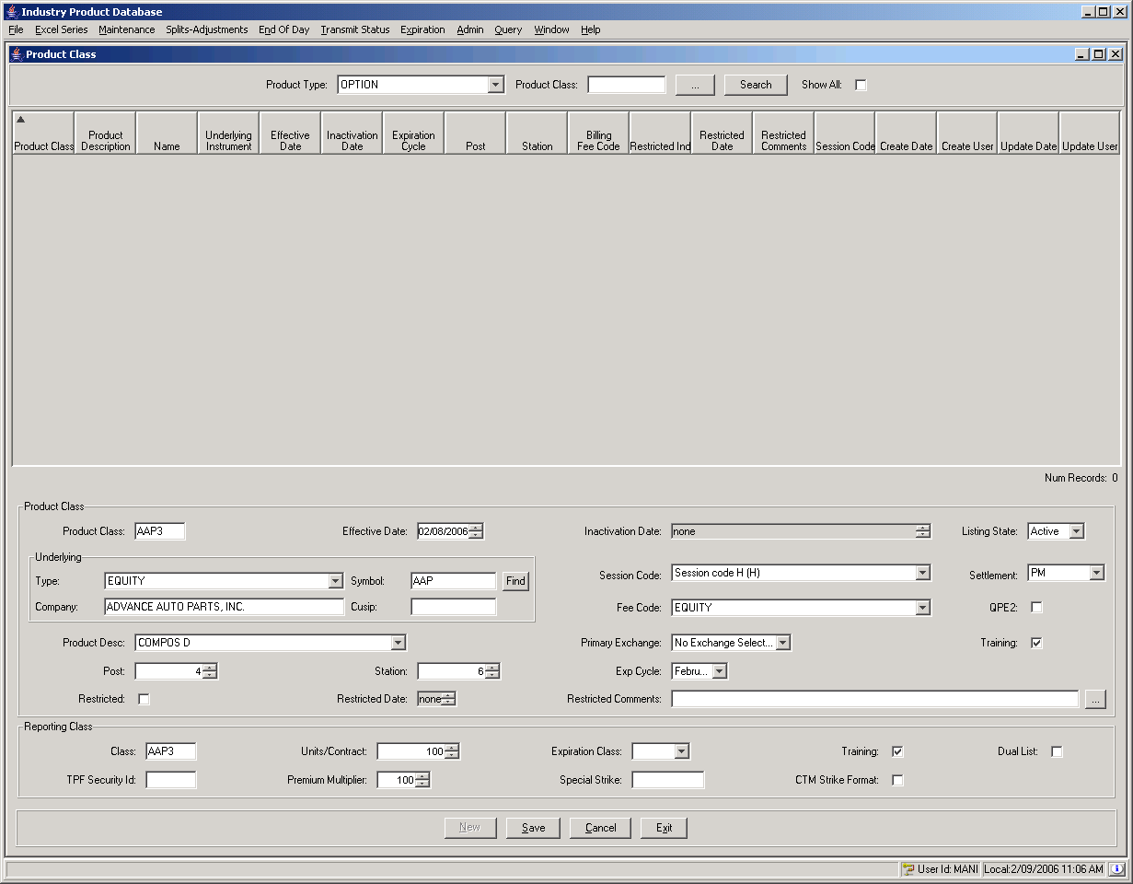
- Enter the class symbol for the new product class in the Product text box.
- The Effective Date defaults to the current date. To change the default, click the up/down arrows until the desired date is reached.
- The Listing State defaults to Active. To make the class Inactive, Obsolete or Unlisted, make your choice from the Listing State drop down list.
- Select the session where the product class will trade by selecting the session code from the Session Code drop down list.
- If the new product class will be used for training, click the Training checkbox.
- From the Underlying section, choose the product type and symbol to be used as the underlying security. You can select the symbol by clicking Find. The underlying selector window will display.
 Note: The IPD system will automatically create the underlying product if it does not exist.

- If creating a new underlying product, enter the Company Name and Cusip number.
- Select the product class’s primary exchange from the Primary Exchange and drop down list.
- To enter the activation and inactivation dates select the up/down arrows until the desired dates are reached.
- Select the product description from the Product Description drop down list box.
 Note: For product description features and limitations, refer to Product Description section, page 22.
- Select the fee code from the Fee Code drop down list box.
- Enter the Reporting Class symbol in the Reporting Class section of the window.
- To return to IPD’s main window, click Exit.
- If you decide not to create a new product class, click Cancel.
- To enter the new product class into the system, click Save. The new product class will display in the data row section of the window.
Create an Option Reporting Class
To create a new reporting class for an existing product class, select Reporting Class from the Maintenance menu.
 | 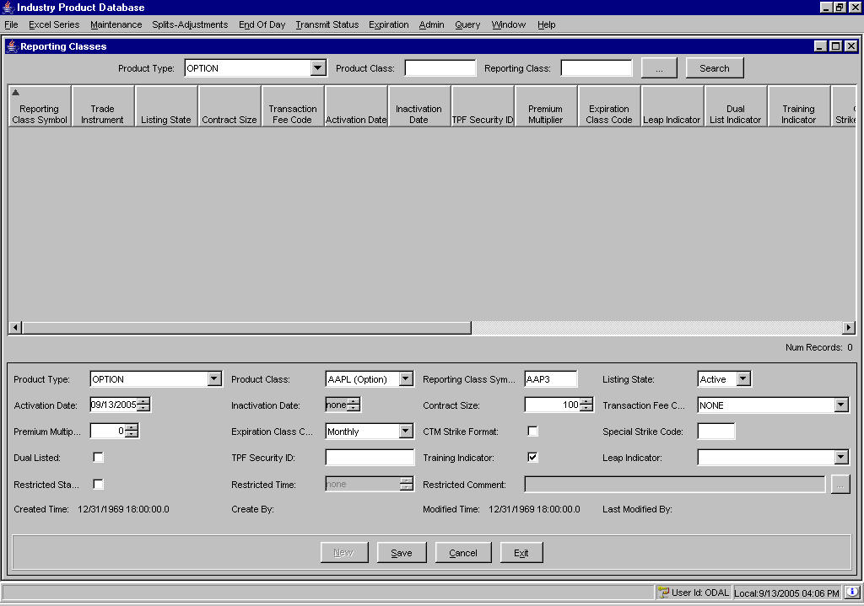
- Select the Product Type Option from the drop down list.
- If you know the product class, enter it in the Product Class text box and click Search. The product class information will display.
Or, click on the selector button to select the Product Type, Product Class and existing Reporting Class. The product class and existing reporting class information will display.
- Click New. Enter the new Reporting Class Symbol. The class symbol must be entered in capital letters.
- Select the listing state from the Listing State drop down list.
- To enter the activation and inactivation dates select the up/down arrows until the desired dates are reached.
- Select the contract size.
- Select the fee code from the Transaction Fee Code drop down list box.
- If you decide not to create a new reporting class, click Cancel.
- To return to IPD’s main window, click Exit.
- To save the new reporting class, click Save. The Intraday Reporting Class Transfer window displays.

- Click Approve to confirm adding the intra-day reporting class to SBT, TPF or Both. A checkmark will appear in the Approved for Send column. To remove the approved request, click Remove Approval. The Approved for Send checkbox will appear deselected.
- From the Destination Systems drop down list, select whether to transfer the intra-day reporting class to SBT, TPF or Both.
- Click Exit to close the window without adding the intra-day reporting class.
- Click Send. The intra-day reporting class will be added to SBT, TPF or Both.
Create a New Option Product/Series
From the Maintenance menu, select Series-Product. The Series/Products window will display.
 | 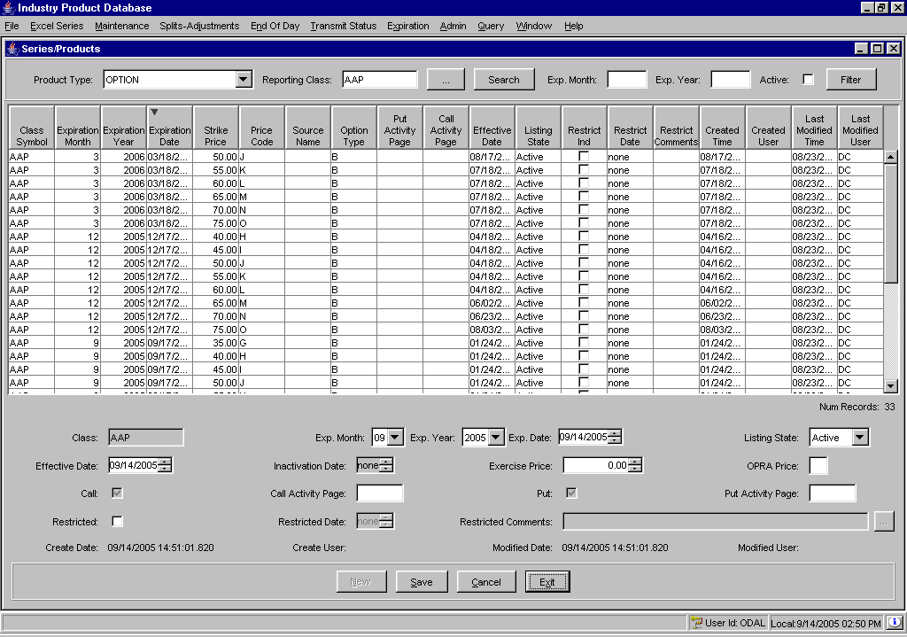
- Select the Product Type Option from the drop down list.
- If you know the product class, enter it in the Product Class text box and click Search. The product class information will display.
Or, click on the selector button to select the Product Type, Product Class and existing Reporting Class. The product class and existing reporting class information will display.
- Click New.
- From the drop down list boxes, select the Expiration month, year and date.
- Select the Effective Date and Inactivation Date from the up/down arrows.
- Elect if the product/series is Restricted by clicking on the Restricted checkbox and entering the Restricted Date.
- If you decide not to create a new product/series, click Cancel.
- To return to IPD’s main window, click Exit.
- To save the new product/series and transer them to another system, click Save. The Intraday Product Transfer window displays.
- Click Approve to confirm adding the intra-day reporting class to SBT, TPF or Both. A checkmark will appear in the Approved for Send column. To remove the approved request, click Remove Approval. The Approved for Send checkbox will appear deselected.
- From the Destination Systems drop down list, select whether to transfer the intra-day reporting class to SBT, TPF or Both.
- Click Exit to close the window without adding the intra-day reporting class.
- Click Send. The intra-day reporting class will be added to SBT, TPF or Both.
➢ | Create a New Equity Product Class  From the Maintenance menu, select Product Class. The Product Class window will display. To begin creating a new Equity product class, select Equity from the Product Type drop down list. Click New.  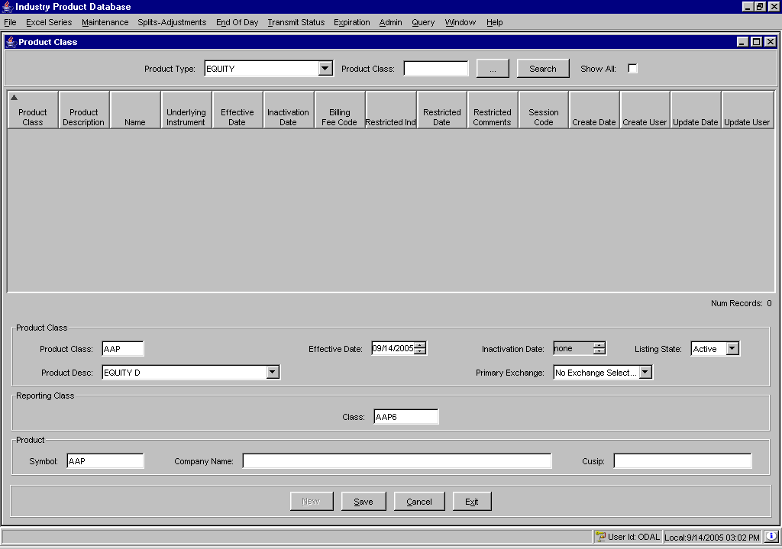
- Enter the class symbol for the new product class in the Product Class text box. The class symbol must be entered in capital letters.
- The Effective Date defaults to the current date. To change the default, click the up/down arrows until the desired date is reached.
- The Listing State defaults to Active. To make the class Inactive, Obsolete or Unlisted, make your choice from the Listing State drop down list.
- Select the session where the product class will trade by selecting the session code from the Session Code drop down list.
- Select the product class’s primary exchange from the Primary Exchange and drop down list.
- To enter the activation and inactivation dates select the up/down arrows until the desired dates are reached.
- Enter the Reporting Class symbol in the Reporting Class section of the window.
- Enter the product symbol in the Symbol text box and enter the Company Name and Cusip number.
- If you decide you do no wish to create a new product class, click Cancel.
- To return to IPD’s main window, click Exit.
- To enter the new product class into the system, click Save. The new product will display in the data row section of the window.
Create a New Equity Reporting Class
To create a new reporting class for an existing product class, select Reporting Class from the Maintenance menu.
 | 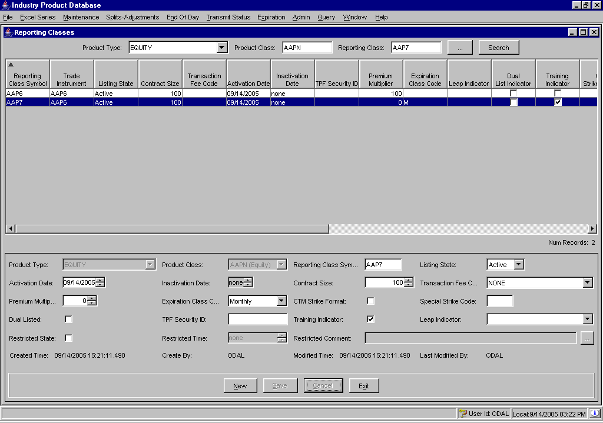
- Select the Product Type Equity from the drop down list.
- If you know the product class, enter it in the Product Class text box and click Search. The product class information will display.
Or, click on the selector button to select the Product Type, Product Class and existing Reporting Class. The product class and existing reporting class information will display.
- Click New. Enter the new Reporting Class Symbol. The class symbol must be entered in capital letters.
- Select the listing state from the Listing State drop down list.
- To enter the activation and inactivation dates select the up/down arrows until the desired dates are reached.
- Select the contract size.
- Select the fee code from the Transaction Fee Code drop down list box.
- If you decide not to create a new reporting class, click Cancel.
- To return to IPD’s main window, click Exit.

- To save the new reporting class, click Save. The Intraday Reporting Class Transfer window displays.

 | 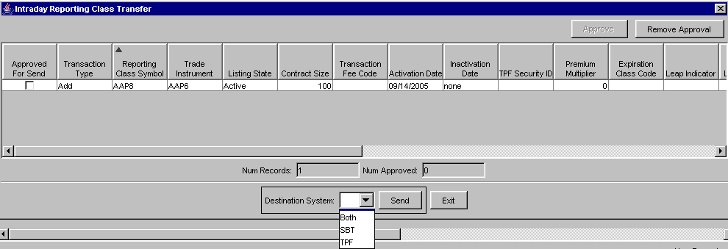
- Click Approve to confirm adding the intra-day reporting class to SBT, TPF or Both. A checkmark will appear in the Approved for Send column. To remove the approved request, click Remove Approval. The Approved for Send checkbox will appear deselected.
- From the Destination Systems drop down list, select whether to transfer the intra-day reporting class to SBT, TPF or Both.
- Click Exit to close the window without adding the intra-day reporting class.
- Click Send. The intra-day reporting class will be added to SBT, TPF or Both.
Create a New Equity Product/Series
From the Maintenance menu, select Series-Product. The Series/Products window will display.
 | 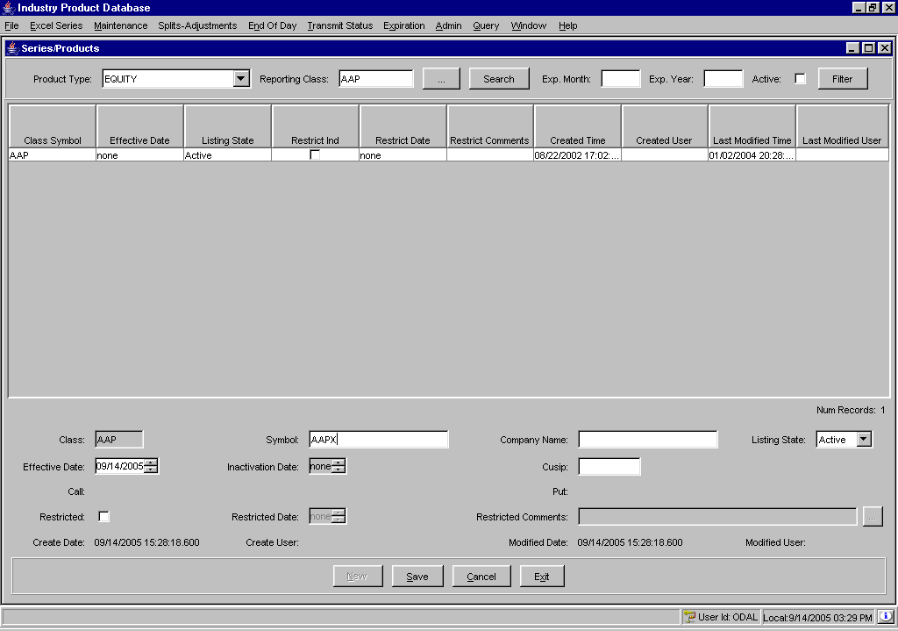
- Select the Product Type Equity from the drop down list.
- If you know the product class, enter it in the Product Class text box and click Search. The product class information will display.
Or, click on the selector button to select the Product Type, Product Class and existing Reporting Class. The product class and existing reporting class information will display.
- Click New.
- From the drop down list boxes, select the Expiration month, year and date.
- Select the Effective Date and Inactivation Date from the up/down arrows.
- Elect if the product/series is Restricted by clicking on the Restricted checkbox and entering the Restricted Date.
- If you decide not to create a new product/series, click Cancel.
- To return to IPD’s main window, click Exit.
- To save the new product/series and transer them to another system, click Save. The Intraday Product Transfer window displays.

- Click Approve to confirm adding the intra-day reporting class to SBT, TPF or Both. A checkmark will appear in the Approved for Send column. To remove the approved request, click Remove Approval. The Approved for Send checkbox will appear deselected.
- From the Destination Systems drop down list, select whether to transfer the intra-day reporting class to SBT, TPF or Both.
- Click Exit to close the window without adding the intra-day reporting class.
- Click Send. The intra-day reporting class will be added to SBT, TPF or Both.
➢ | Create a New Index Product Class  From the Maintenance menu, select Product Class. The Product Class window will display.  To begin creating a new Equity product class, select Equity from the Product Type drop down list. Click New.
 | 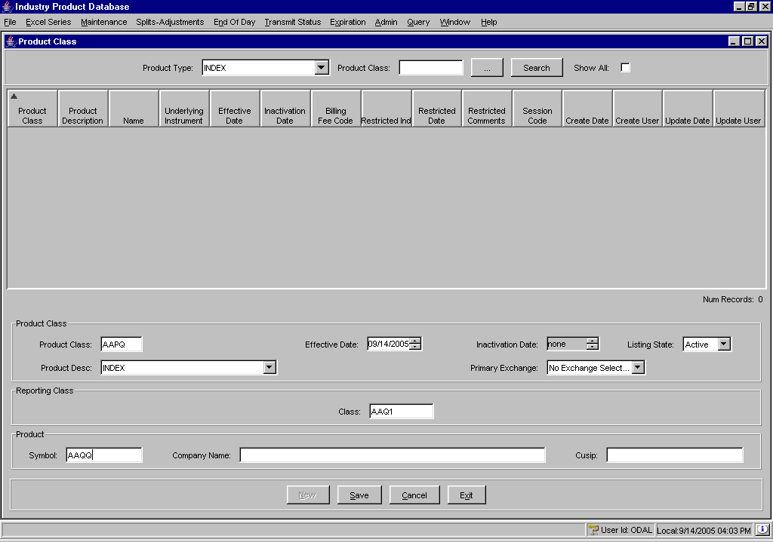
- Enter the class symbol for the new product class in the Product Class text box. The class symbol must be entered in capital letters.
- The Effective Date defaults to the current date. To change the default, click the up/down arrows until the desired date is reached.
- The Listing State defaults to Active. To make the class Inactive, Obsolete or Unlisted, make your choice from the Listing State drop down list.
- Select the session where the product class will trade by selecting the session code from the Session Code drop down list.
- Select the product class’s primary exchange from the Primary Exchange and drop down list.
- To enter the activation and inactivation dates select the up/down arrows until the desired dates are reached.
- Enter the Reporting Class symbol in the Reporting Class section of the window.
- Enter the product symbol in the Symbol text box and enter the Company Name and Cusip number.
- If you decide you do no wish to create a new product class, click Cancel.
- To return to IPD’s main window, click Exit.
- To enter the new product class into the system, click Save. The new product will display in the data row section of the window.
Create a New Index Reporting Class
To create a new reporting class for an existing product class, select Reporting Class from the Maintenance menu.
 | 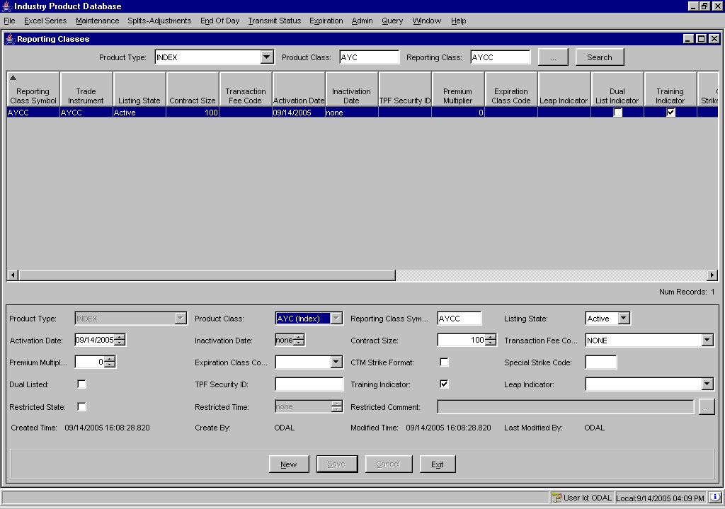
- Select the Product Type Index from the drop down list.
- If you know the product class, enter it in the Product Class text box and click Search. The product class information will display.
Or, click on the selector button to select the Product Type, Product Class and existing Reporting Class. The product class and existing reporting class information will display.
- Click New. Enter the new Reporting Class Symbol. The class symbol must be entered in capital letters.
- Select the listing state from the Listing State drop down list.
- To enter the activation and inactivation dates select the up/down arrows until the desired dates are reached.
- Select the contract size.
- Select the fee code from the Transaction Fee Code drop down list box.
- If you decide not to create a new reporting class, click Cancel.
- To return to IPD’s main window, click Exit.
- To save the new reporting class, click Save. The Intraday Reporting Class Transfer window displays.
 | 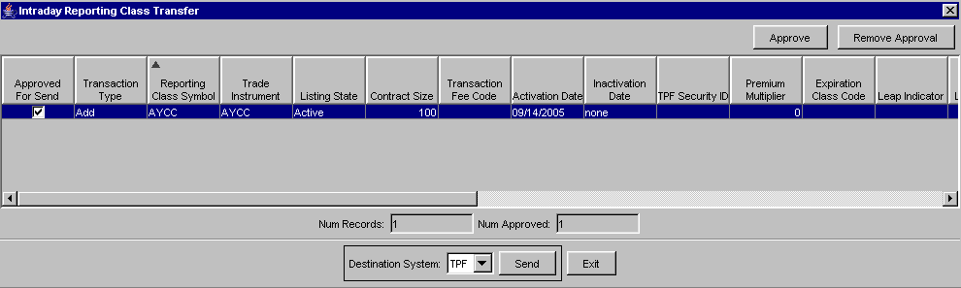
- Click Approve to confirm adding the intra-day reporting class to SBT, TPF or Both. A checkmark will appear in the Approved for Send column. To remove the approved request, click Remove Approval. The Approved for Send checkbox will appear deselected.
- From the Destination Systems drop down list, select whether to transfer the intra-day reporting class to SBT, TPF or Both.
- Click Exit to close the window without adding the intra-day reporting class.
- Click Send. The intra-day reporting class will be added to SBT, TPF or Both.
Create a New Index Product/Series
From the Maintenance menu, select Series-Product. The Series/Products window will display.
 | 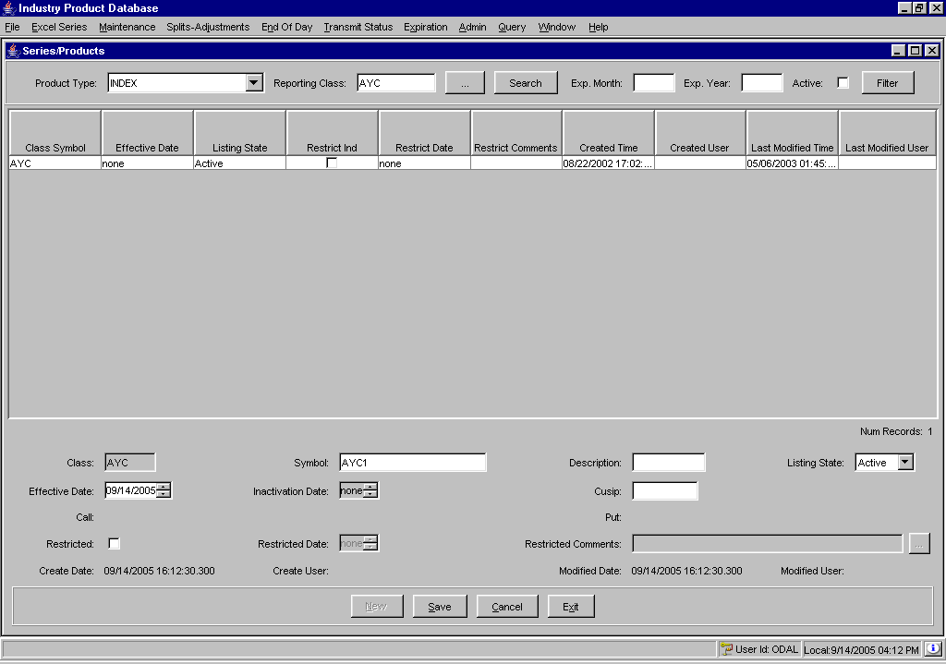
- Select the Product Type Index from the drop down list.
- If you know the product class, enter it in the Product Class text box and click Search. The product class information will display.
Or, click on the selector button to select the Product Type, Product Class and existing Reporting Class. The product class and existing reporting class information will display.
- Click New.
- From the drop down list boxes, select the Expiration month, year and date.
- Select the Effective Date and Inactivation Date from the up/down arrows.
- Elect if the product/series is Restricted by clicking on the Restricted checkbox and entering the Restricted Date.
- If you decide not to create a new product/series, click Cancel.
- To return to IPD’s main window, click Exit.
- To save the new product/series and transer them to another system, click Save. The Intraday Product Transfer window displays.
- Click Approve to confirm adding the intra-day reporting class to SBT, TPF or Both. A checkmark will appear in the Approved for Send column. To remove the approved request, click Remove Approval. The Approved for Send checkbox will appear deselected.
- From the Destination Systems drop down list, select whether to transfer the intra-day reporting class to SBT, TPF or Both.
- Click Exit to close the window without adding the intra-day reporting class.
- Click Send. The intra-day reporting class will be added to SBT, TPF or Both.

Edit Column Preferences
You can customize your Product Definition windows by selecting or deselecting specific columns to display. To filter columns, right mouse click on a data row. Select Edit Preferences. The Edit Column Preferences window will display.
- Select or deselect columns for viewing and modify column arrangement as desired.
- To save your changes, click Ok.
- If you wish to retain the default settings, click Cancel.
For detailed information, refer to the Edit Column Preferences section, page 87.
Edit Existing Product Data | Edit Product Information  The IPD system allows you to search for, filter and edit existing product class, reporting class and product/series information.

Product Class
To search for and edit existing product classes, select the Product Class option from the Maintenance menu. The Product Class window will display.
 | 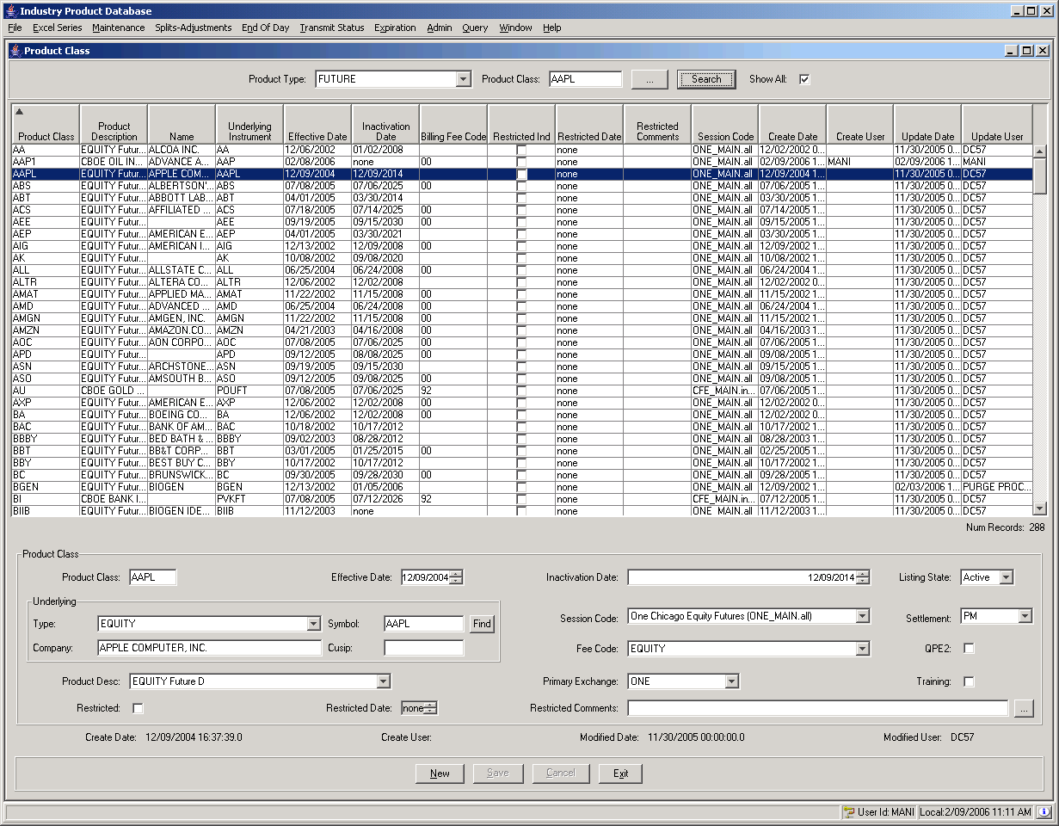
- Select the Product Type from the drop down list.
- Enter the product class you are searching for in the Product Class text box and click Search. This field is required.
Or, click on the selector button to select the Product Type and Product Class.
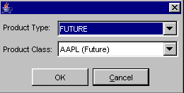
Click Cancel to exit the window without making a selection.
Click OK to enter the selection. Click Search on the Product Class window. The product class information will display.
 | - To search for all the product classes in the selected product type, select the Show All checkbox. Click Search. In the example above, all the Futures product classes display in data row format.
To filter product class information for a specific class:
- Enter the product class in the Product Class text box or select it from the selector button.
- Deselect the Show All checkbox.
- Click Search.
 | 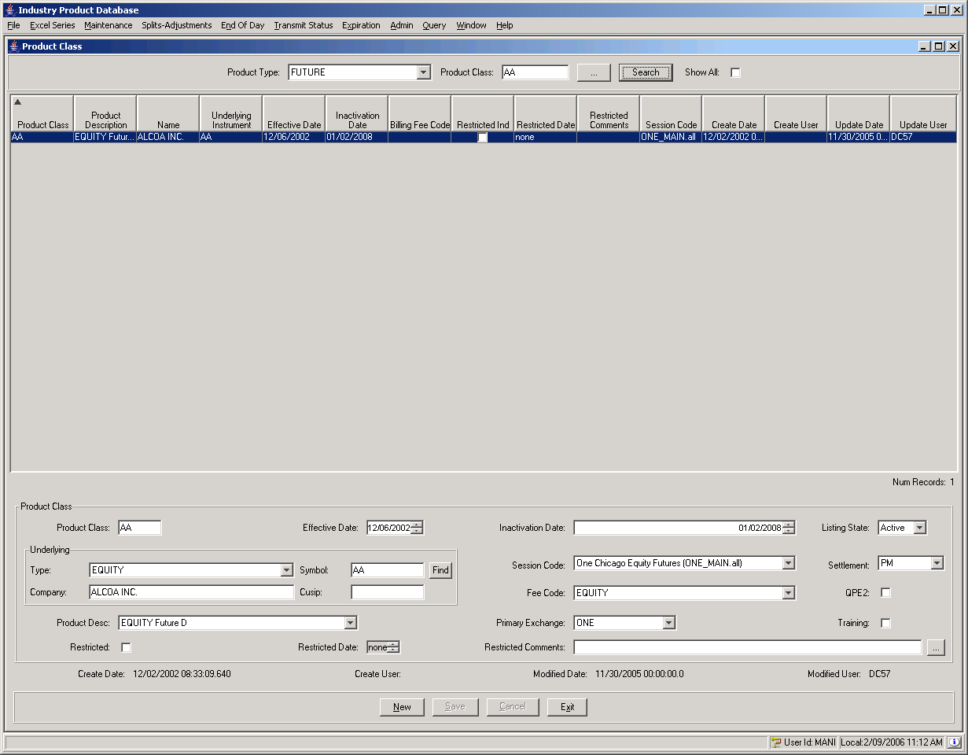
In the example above, product class AA has been filtered from the rest of the Future product classes. Editable fields display in the Product Class section of the window.
- Make any required changes.
- Click Cancel to remove the requested changes.
- Click Save to update the product class.

Reporting Class
To search for and edit an existing reporting class, select the Reporting Class option from the Maintenance menu. The Reporting Classes window will display.
 | 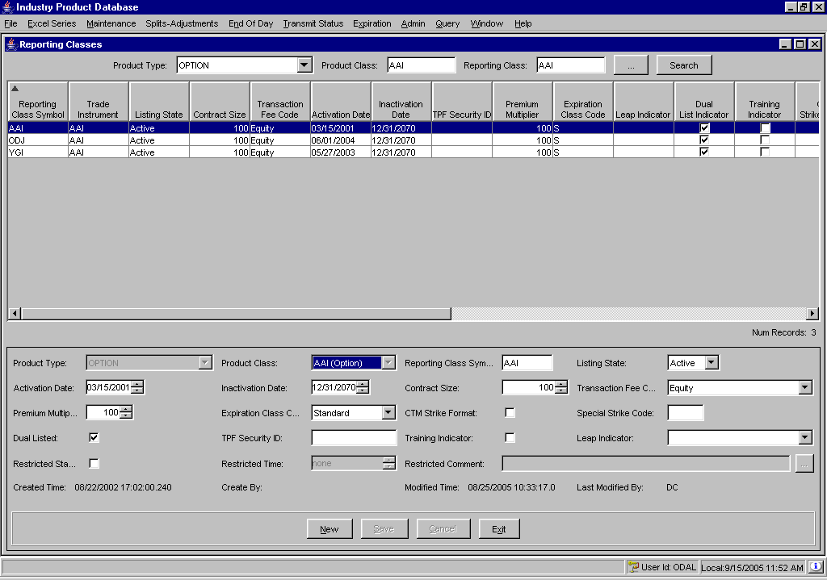
- Select the Product Type from the drop down list.
- Enter the product class and reporting class you are searching for in the Product Class and Reporting Class text box and click Search. These fields are required.
Or, click on the selector button to select the Product Type, Product Class and Reporting Class.
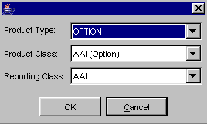
Click Cancel to exit the window without making a selection.
Click OK to enter the selection. The reporting classes information will display. Editable fields display in the Product Class section of the window.
- Make any required changes.

- Click Cancel to remove the requested changes.
- Click Save to update the product class.

Product/Series
To search for and edit an existing reporting class, select the Series-Product option from the Maintenance menu. The Product window will display.
 | 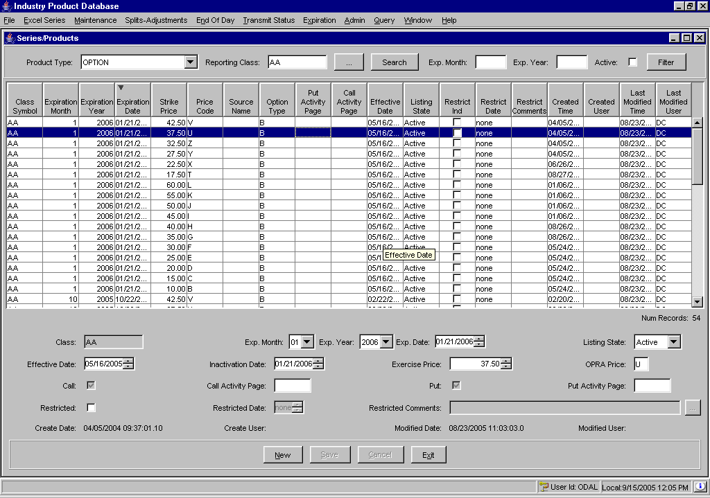
- Select the Product Type from the drop down list.
- Enter the reporting class in the Reporting Class text box and click Search. This field is required.
Or, click on the selector button to select the Product Type and Reporting Class.
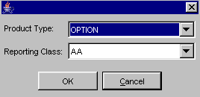
Click Cancel to exit the window without making a selection.
Click OK to enter the selection. The product information will display. Editable fields display in the lower panel of the window
Products/series can be filtered by expiration month, expiration year or by active state.
To filter a product/series by expiration month:
 | - Enter the expiration month in the Exp. Month text box. Click Filter. In the example below, only the products/series expiring in September are shown.
 | 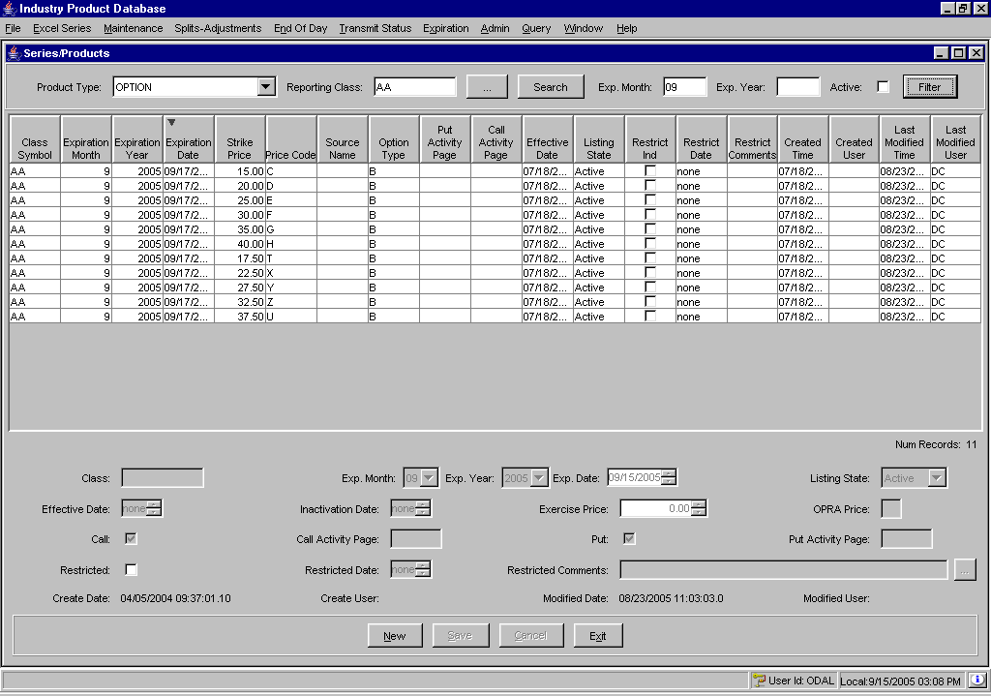
To filter a product/series by expiration year:
- Enter the expiration year in the Exp. Year text box. Click Filter. In the example below, only the products/series expiring in 2005 are shown.
 | 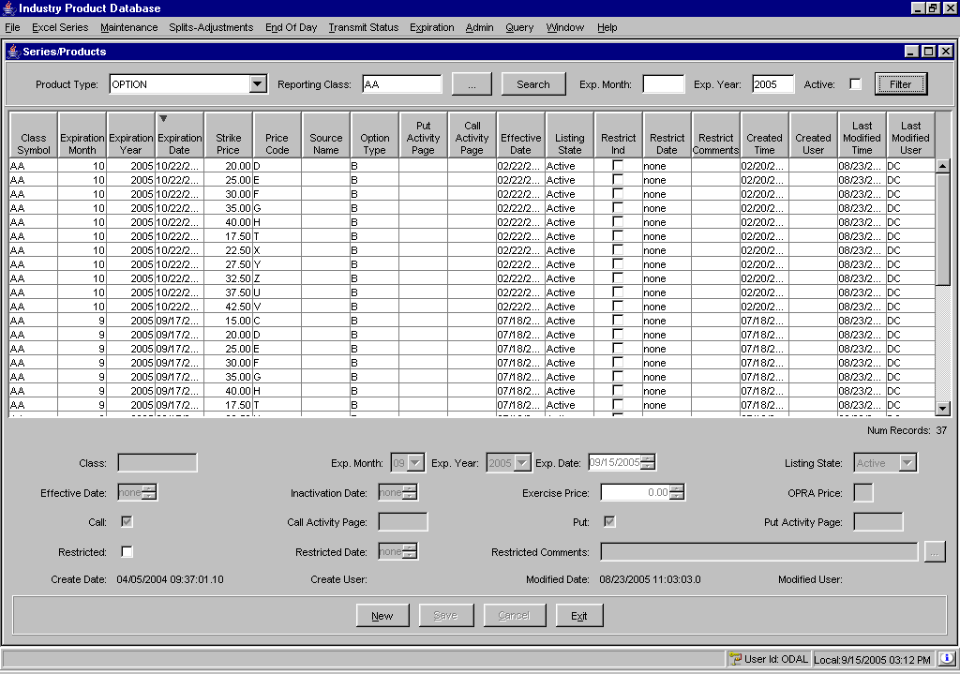
To display only active product/series:
- Select the Active checkbox. Click Filter. In the example below, only the Active products/series are shown.
 | 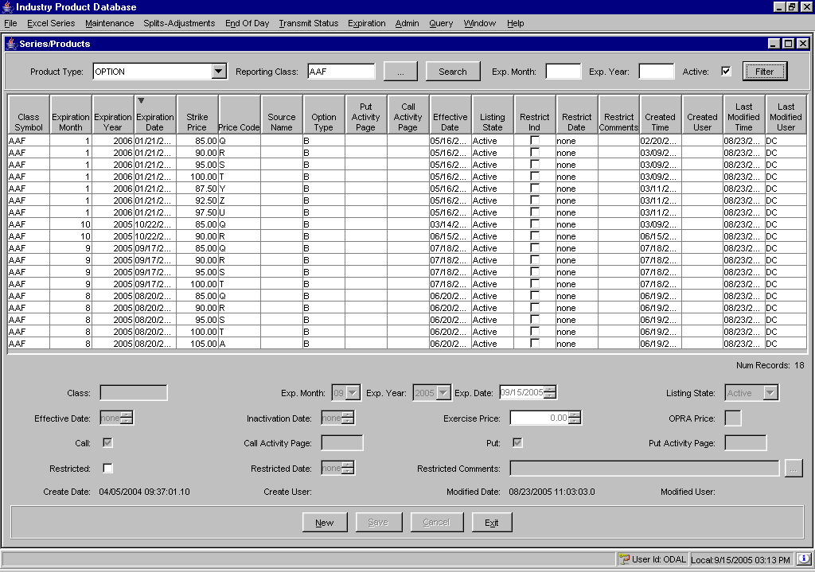

Edit Column Preferences
You can customize your Product Definition windows by selecting or deselecting specific columns to display. To filter columns, right mouse click on a data row. Select Edit Preferences. The Edit Column Preferences window will display.
- Select or deselect columns for viewing and modify column arrangement as desired.
- To save your changes, click Ok.
- If you wish to retain the default settings, click Cancel.
For detailed information, refer to the Edit Column Preferences section, page 87.

Price Adjustments

Price adjustments on orders are caused by changes in the underlying security, such as stock splits, stock dividends, symbol changes, etc.
From the Splits-Adjustment menu, select Adjustments or press [Alt]-[j] on your keyboard. The Adjustments window will display.
Click Exit at anytime to close the window.
Click Refresh to retrieve updated adjustment data.
 | 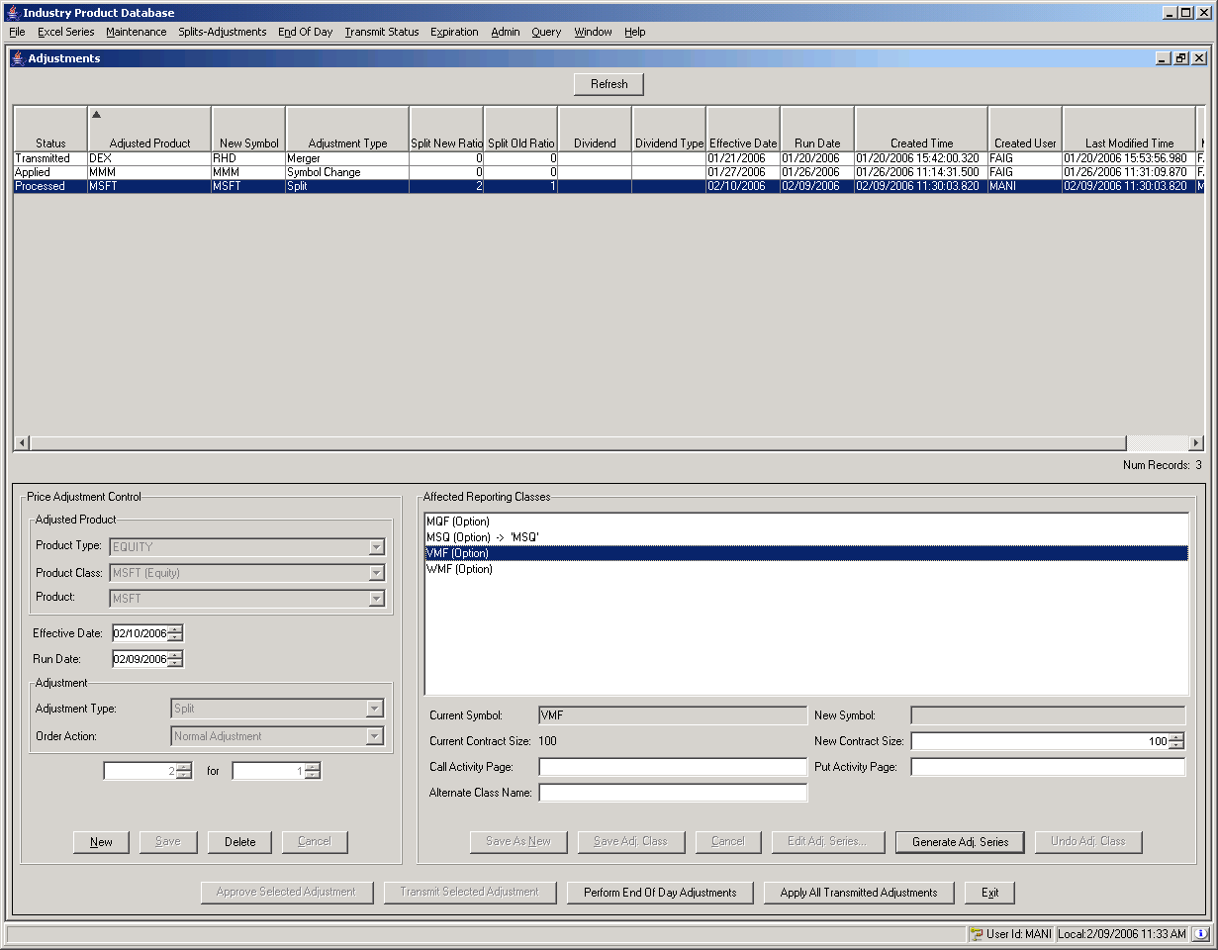
 | From this window, you can create, edit and delete product pricing information.
Create New Price Adjustment | To create a new price adjustment for a product:  - Click New.  - Select the product type, product class and product from the drop down lists.  - Select the effective date of the price adjustment by clicking the up/down arrows until the desired date is reached.
- Select the run date by clicking on the up/down until the desired date is reached.
- From the Adjusted Product section of the window, select the adjustment type from the drop down list.
- For a stock split adjustment, enter the stock split information below the adjustment type box.
- For a symbol change adjustment type, enter the new symbol in the New Symbol text box. Click Save. The new symbol will be applied to the reporting classes listed in the Affected Reporting Classes text box.
- For a dividend percent adjustment, enter the percent in the box below the adjustment type list box.
- For a dividend cash adjustment, enter the cash amount.
- For a merger adjustment, enter the new symbol in the box below the adjustment type list box.
- Select the type of Order Adjustment from the drop down list.
- You can clear your price adjustment entries at anytime by clicking Cancel.
- Verify that the information is correct. Click Save. The new price adjustment will display in the data row panel at the top of the window.
- To close the window and return to the IPD main window, click Exit.
Edit Price Adjustments | To edit price adjustment information for a product:  - Highlight the existing product from the data row panel at the top of the window. The price adjustment information displays.  - If required, change the effective date and run date by clicking on the up/down arrows until the desired date is reached.  - To remove your updates, click Cancel.  - Click Save to enter your changes into the system.
To approve all affected reporting classes for a price adjustment:
- Highlight the existing product from the data row panel at the top of the window. The price adjustment information displays.
- Click Approve Selected Adjustment. The system will generate a warning.
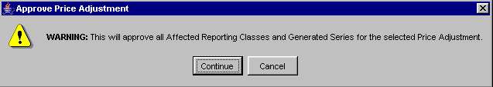
- Click Cancel to close the window without approving the price adjustment.
- Click Continue to approve all affected reporting classes for the price adjustment. The Status column will display Approved for the price adjustment.
- Once a price adjustment has been approved, you can transmit it to the TPF and SBT systems.
 Note: Special care should be taken for mergers as these can only be transmitted once. Because changes to the product table occur when a merger is transmitted, mergers cannot be deleted or changed after being transmitted.
  - Highlight the approved price adjustment from the data row panel at the top of the window.
  - Click Transmit Price Adjustment. The system will generate a warning message.
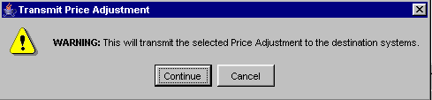
  - Click Cancel to exit the window without performing the transmission.
  - Click Continue to forward the information to the TPF and SBT systems.
- To delete all adjustments data in SBT and retransmit all eligible adjustments (all approved adjustments and any non-merger adjustments that have already been transmitted), click Perform End of Day Adjustments. The system will generate a warning message.
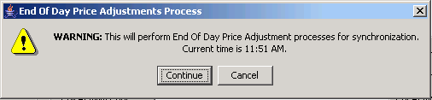
- To apply all transmitted price adjustments within IPD, click Apply All Transmitted Adjustments. The system will generate a warning message.
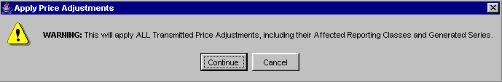
  - Click Cancel to exit the window without performing the transmission.
  - Click Continue to forward the information to the TPF and SBT systems.
➢ | To edit reporting class adjustments:  - Highlight the reporting class from the Affected Reporting Classes panel.  - If required, enter the New Symbol, New Contract Size, Call Activity Page and Put Activity Page in the corresponding text fields.
 | 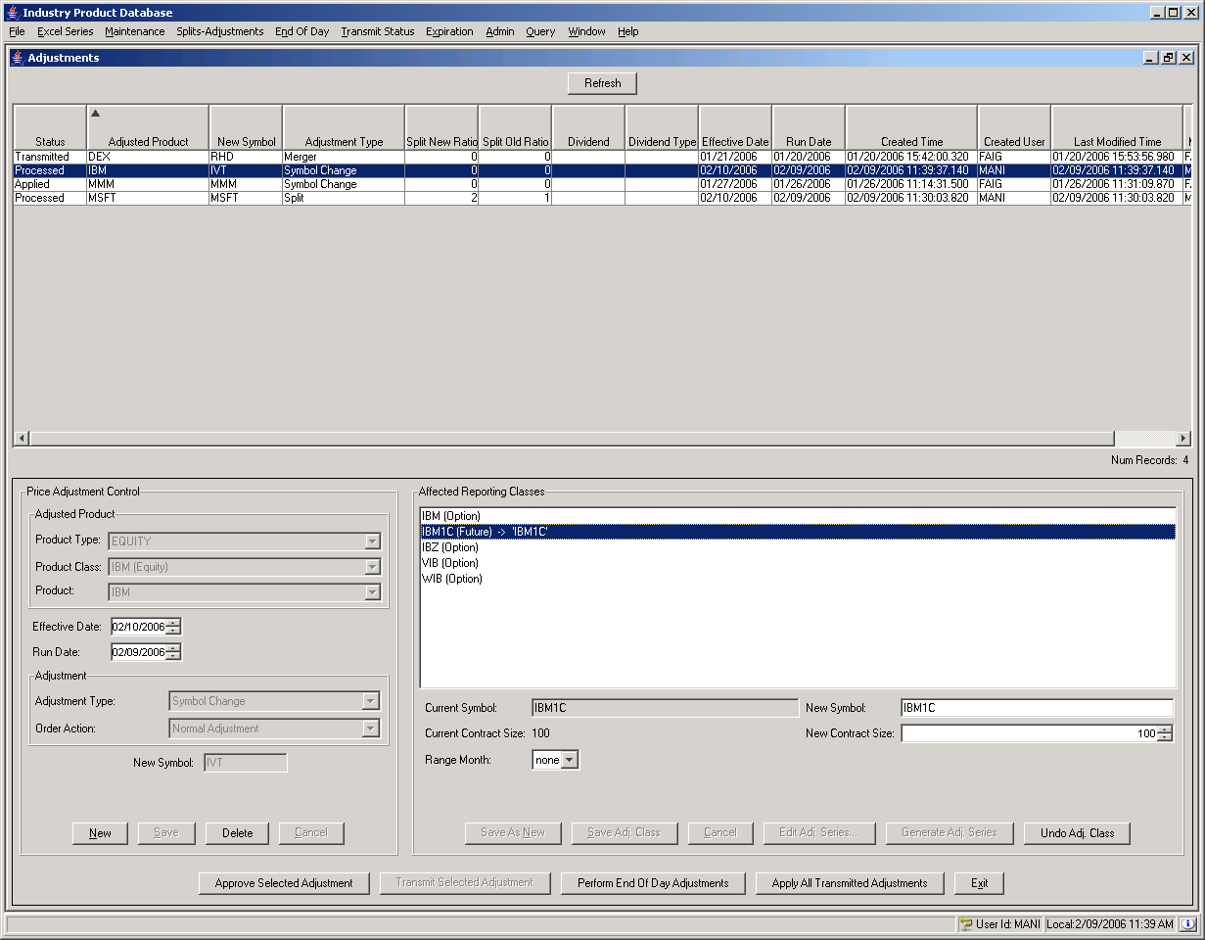
 Note: Restrictions apply based on the price adjustment type.
- If the price adjustment is a Split, the New Symbol field is not editable when the split denominator is 1 (i.e. 2 for 1 stock split).
- Call Activity and Put Activity fields are only editable whan an option reporting class is selected.
- The Alternate Class Name field is not editable if the price adjustment is a Leap Rollover.

 | 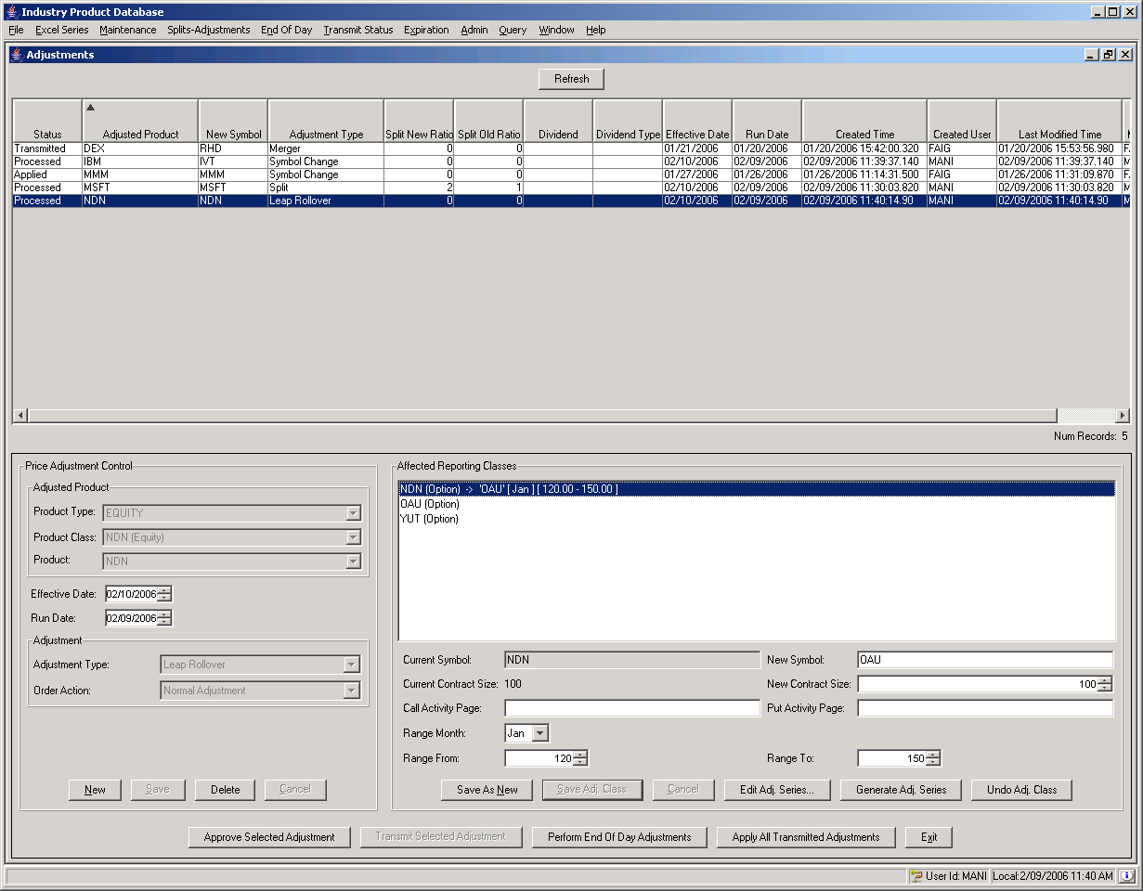
 | - You can only select a price range from the Range From and Range To fields if an option reporting class is selected, and if the price adjustment is either a Symbol Change or Leap Rollover.
- Click Cancel to remove you changes.
- Click Save Adj. Class to enter your changes into the system.
➢ | Add a new adjusted class  Certain conditions may require you to adjust the price range of an existing reporting class series.   Note: You can only add a new reporting class adjustment if an options reporting class is selected, and if the price adjustment is either a Symbol Change or Leap Rollover.  - Highlight the option reporting class from the Affected Reporting Classes panel.  - Enter the New Symbol in the corresponding text field.  - Click New Adj. Class. The system will prompt you generate a warning message.
 | 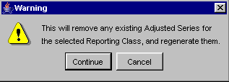
- Click Cancel to exit the window without regenerating the adjusted series.
- Click Continue to proceed with regenerating the adusted series data.
- Select the new adjusted reporting class.
- Enter the new price range in the Range From and To text fields.
- Click Cancel to remove your changes.
- Click Save Adj. Class to save your changes.
- If you wish reset the adjusted reporting class to its original values, click Undo Adj. Class. The system will display a warning message.
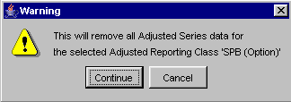
- Click Cancel to close the window without removing the adjusted series data.
- If you click Continue, any adjusted series that have been generated for the selected reporting class is removed from the system.
➢ | To generate all the adjusted series for a selected reporting class:  - Highlight the reporting class from the Affected Reporting Classes panel.  - Click Generate Adj. Series. The system will generate a warning message.  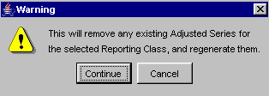
- Click Cancel without regenerating all the adjusted series.
- Click Continue to regenerate the adjusted series. If the adjusted series had already been generated, they will be removed and regenerated. This will remove any edits that had been made to the adjusted series by the users.
➢ | To edit adjusted product/series:  - Highlight the reporting class from the Affected Reporting Classes panel. The Current Symbol and Current Contract Size for the reporting class display.  - Click Edit Adj. Series. The Adjustment Items window will display.
 | 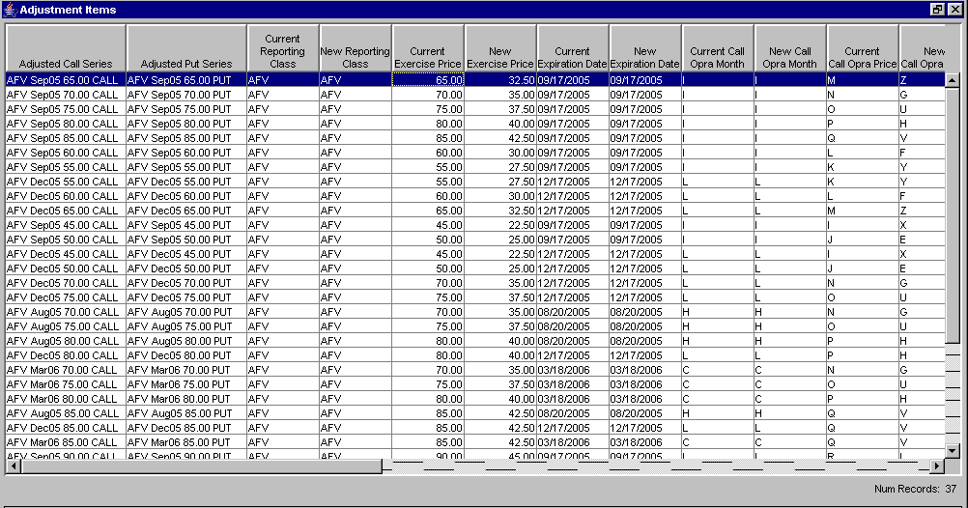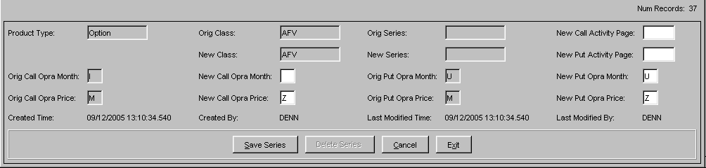
- Click on the product/series data row you wish to update. The editable fields for the product/series display in the bottom portion of the panel. Fields that are not editable display grayed out. Click Exit at any time to close the window and return to the Adjustments window.
- Make your desired changes.
- Click Cancel to remove your recent changes.
- Click Save Series to enter your changes into the system.
- If you wish to remove a product/series, highlight the data row and click Delete Series. The system will prompt you to confirm your request to delete the product/series.
 | 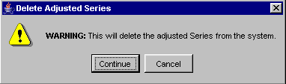
- Click Cancel to remove your delete request. The adjusted series will be deleted from the system.
- Click Continue to submit your delete request.

Delete
To delete price adjustment information:
- Hightlight the adjusted product from the price adjustment data row panel at the top of the window. Click Delete. The system will prompt you to confirm the removal of the price adjustment from the system.
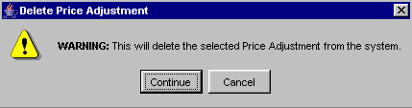
- To complete the delete request, click Continue.
- If you decide not to delete the price adjustment, click Cancel.

Edit Column Preferences
You can customize your Price Adjustment window by selecting or deselecting specific columns to display. To filter columns, right mouse click on a data row. Select Edit Preferences. The Edit Column Preferences window will display.
- Select or deselect columns for viewing and modify column arrangement as desired.
- To save your changes, click Ok.
- If you wish to retain the default settings, click Cancel.
For detailed information, refer to the Edit Column Preferences section, page 87.

End of Day Transfer

 | IPD allows you perform end of day (EOD) transfers to both SBT and TPF.
SBT End of Day | SBT end of day transfers can be performed for one class or for a number of classes at the same time.  To perform SBT EOD transfers, select End of Day from the Industry Product Database menu or press [Alt]-[N] on your keyboard. Click SBT Transfer. The End of Day SBT window will display with three tabs: Product Class, Reporting Class and Series.
 | 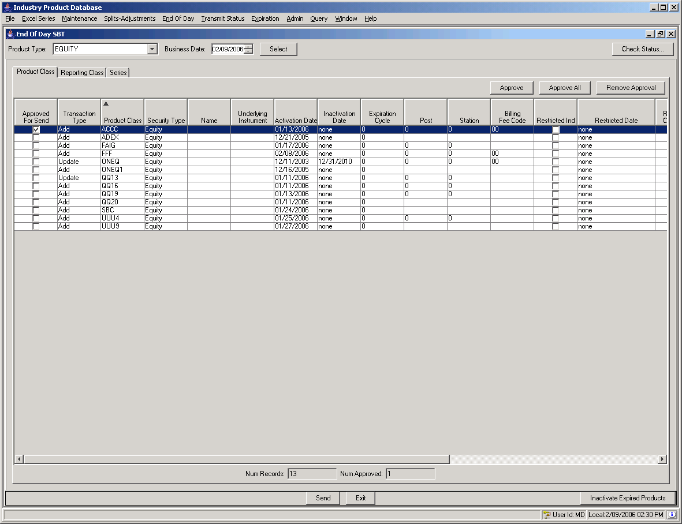
- Select the Product Type from the drop down list. Equity and Index records should be sent prior to Options and Futures records, which should be sent prior to Strategy records. For COF products, the Options should be sent prior to Futures. Attempting to send records out of order will generate errors in the Transmit Status tables.
- Enter the desired Business Date by pressing the up/down arrows until the date is reached. Regardless of the date used, active records that have not been sent will appear once data is selected. Changing the date will, however, show records that should be active on the specified date.
- Click Select. The product classes, reporting classes and products to be transmitted will be displayed in tab format. Active records that have not been sent and non-active records that need to be activated will appear.
- To approve one product class for transfer, highlight the data row and click the Approved For Send checkbox or highlight the data row and click Approve.
  - To appove all the product classes for transfer, click Approve All. The Approved for Send checkbox will be selected on all the data rows.
  - To remove the approval of a product class, highlight the data row and deselect the Approved for Send checkbox
  - To remove the approval of all product classes, click Remove Approval. The Approved For Send checkboxes appear deselected.
- Click Exit to close the window without transfering end of day data to SBT.
- Once you have confirmed your approval selection, click Send. The system will display confirmation of the transfer.
 | 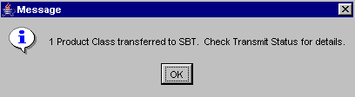
 | Click on the Class tab to display reporting class data ready for transfer.
 | 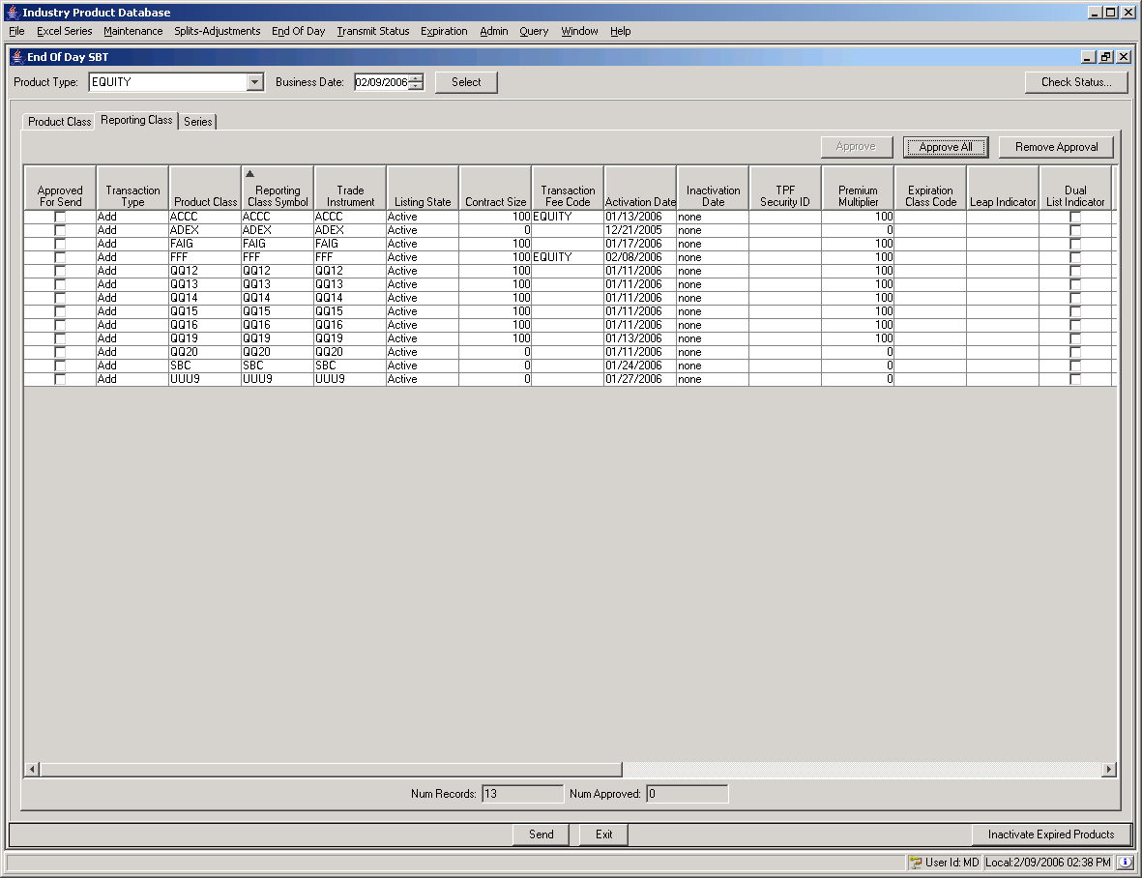
- To approve one reporting class for transfer, highlight the data row and click the Approved For Send checkbox or highlight the data row and click Approve.
  - To appove all the reporting classes for transfer, click Approve All. The Approved for Send checkbox will be selected on all the data rows.
  - To remove the approval of a reporting class, highlight the data row and deselect the Approved for Send checkbox
  - To remove the approval of all reporting classes, click Remove Approval. The Approved For Send checkboxes appear deselected.
- Click Exit to close the window without transfering end of day data to SBT.
- Once you have confirmed your approval selection, click Send. The system will display confirmation of the transfer.
 | Click on the Series tab to display product series information ready for transfer.
 | 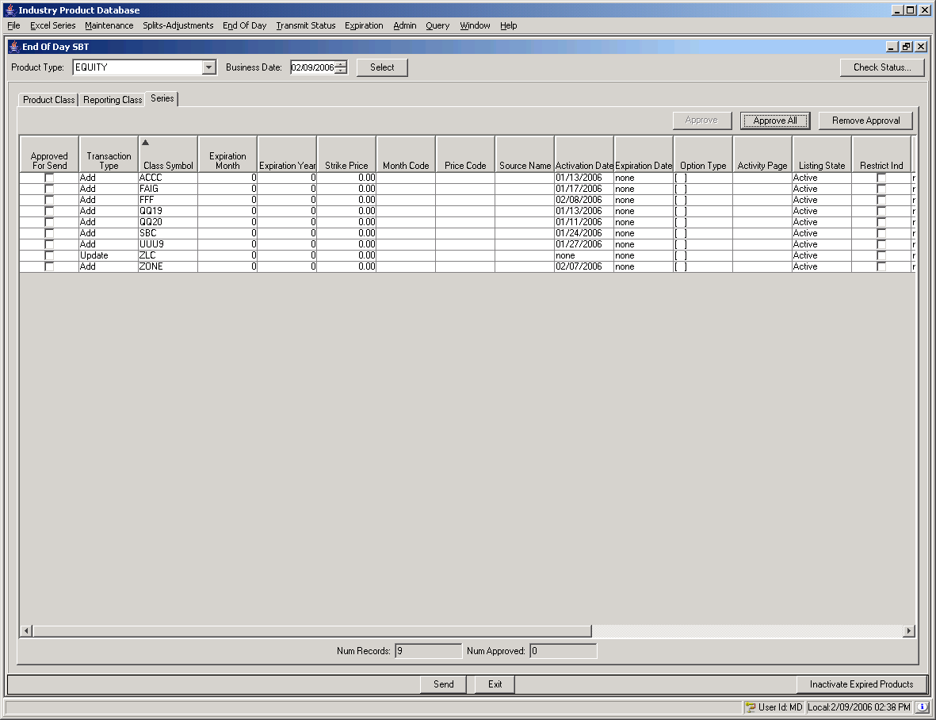
- To approve one series for transfer, highlight the data row and click the Approved For Send checkbox or highlight the data row and click Approve.
  - To appove all the series for transfer, click Approve All. The Approved for Send checkbox will be selected on all the data rows.
  - To remove the approval of a series, highlight the data row and deselect the Approved for Send checkbox
  - To remove the approval of all series, click Remove Approval. The Approved For Send checkboxes appear deselected.
- Click Exit to close the window without transfering end of day data to SBT.
- Once you have confirmed your approval selection, click Send. The system will display confirmation of the transfer.
TPF End of Day | To perform TPF EOD transfers, select End of Day from the Industry Product Database menu or press [Alt]-[n] on your keyboard. Click TPF Transfer. The End of Day TPF window will display.
 | 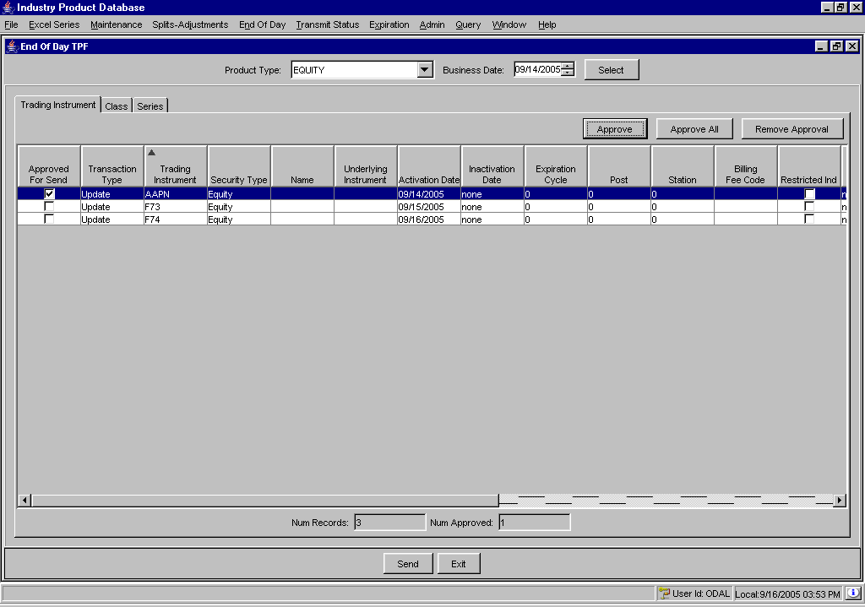
- Select the Product Type from the drop down list.
- Enter the desired Business Date by pressing the up/down arrows until the date is reached.
- Click Select. The updated trading instrument (product class), reporting class and product series display in tab format.
- To approve one product class for transfer, highlight the data row and click the Approved For Send checkbox or highlight the data row and click Approve.
  - To appove all the product classes for transfer, click Approve All. The Approved for Send checkbox will be selected on all the data rows.
  - To remove the approval of a product class, highlight the data row and deselect the Approved for Send checkbox
  - To remove the approval of all product classes click Remove Approval. The Approved For Send checkboxes appear deselected.
- Click Exit to close the window without transfering end of day data to TPF.
- Once you have confirmed your approval selection, click Send. The system will display confirmation of the transfer.
 | 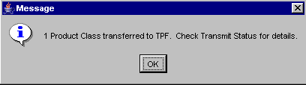
 | Click on the Class tab to display reporting class data ready for transfer.
 | 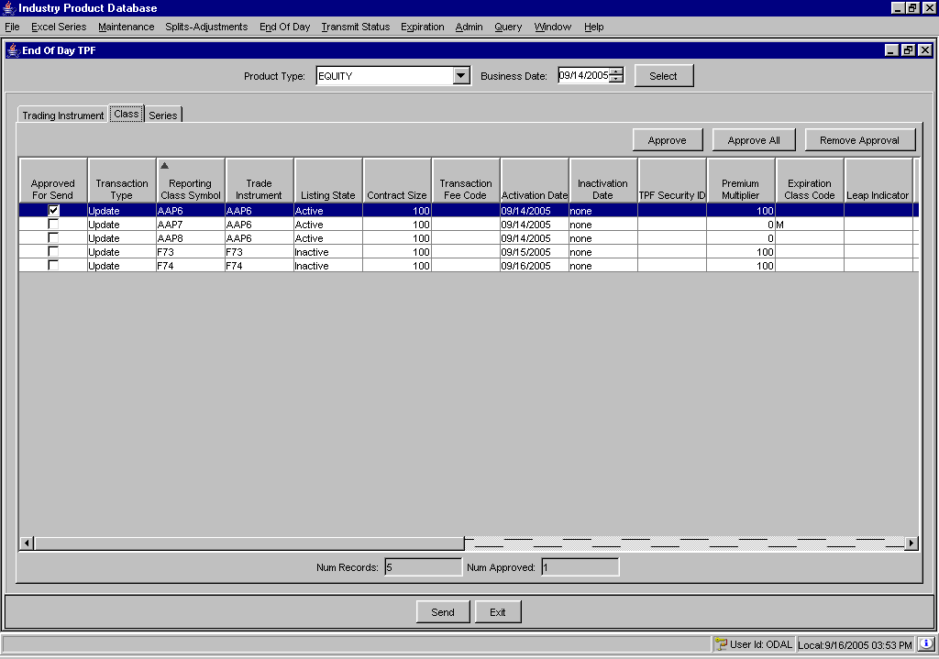
- To approve one reporting class for transfer, highlight the data row and click the Approved For Send checkbox or highlight the data row and click Approve.
  - To appove all the reporting classes for transfer, click Approve All. The Approved for Send checkbox will be selected on all the data rows.
  - To remove the approval of a reporting class, highlight the data row and deselect the Approved for Send checkbox
  - To remove the approval of all reporting classes, click Remove Approval. The Approved For Send checkboxes appear deselected.
- Click Exit to close the window without transfering end of day data to TPF.
- Once you have confirmed your approval selection, click Send. The system will display confirmation of the transfer.
 | Click on the Series tab to display product series information ready for transfer.
 | 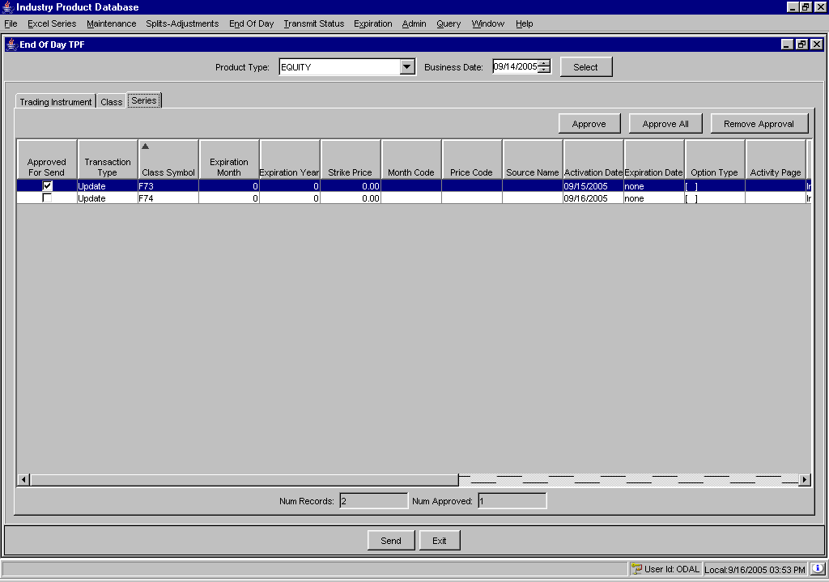
- To approve one series for transfer, highlight the data row and click the Approved For Send checkbox or highlight the data row and click Approve.
  - To appove all the series for transfer, click Approve All. The Approved for Send checkbox will be selected on all the data rows.
  - To remove the approval of a series, highlight the data row and deselect the Approved for Send checkbox
  - To remove the approval of all series, click Remove Approval. The Approved For Send checkboxes appear deselected.
- Click Exit to close the window without transfering end of day data to TPF.
- Once you have confirmed your approval selection, click Send. The system will display confirmation of the transfer.

Transmit Status

SBT Transmit Status | Product data that is transferred to either SBT or TPF can be verified in the Transmit Status window.  To open the Transmit Status window, click Transmit Status or press [Alt]-[T] on your keyboard and select SBT Transmit Status.
 | 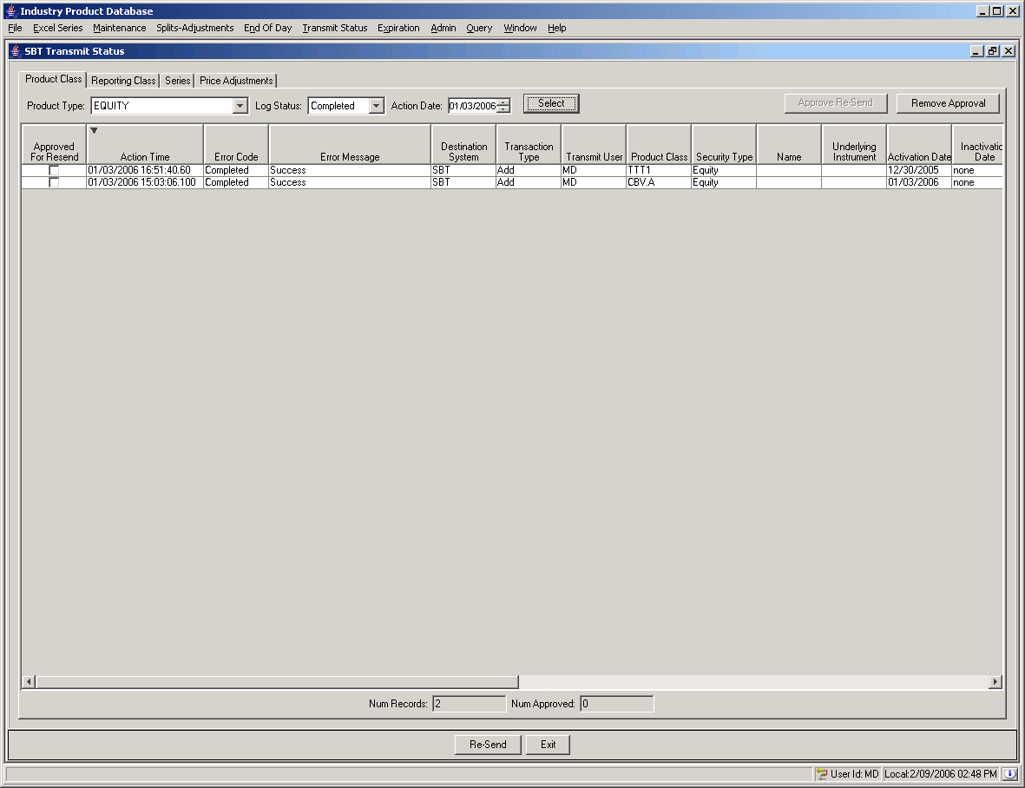
 | Product data displays in tab format by Product Class, Reporting Class and Series. The Product Class tab is the default.
➢ | To display the transmit status of a product class:  - Select the Product Type from the drop down list.  - Choose the Log Status from the drop down list. You have the option to verify All transmitted data, Completed data, Error data, data Not Sent or Send Initiated data.  - Select the date the transmission was requested from the Action Date date box.  - Click Select. In the example above, all the Equity product classes display for the transmission date of 1/3/06. The Error Code column displays the log status. The Error Message column shows the status of the transmitted data.
 | Any product data that was not successfully transmitted can be resubmitted through this window. Data being resent is considered an intra-day send as opposed to an end of day send.
- Highlight the data row you wish to approve for a resend.
- Select the Approved for Resend checkbox or click Approve Re-send.
- To remove the resend request, highlight the data row and deselect the Approved for Resend checkbox or click Remove Approval.
- Click Re-Send. The system will display the transmit message. Click OK to close the Message window.
➢ | Select the Class tab to verify transmission of reporting classes.
 | 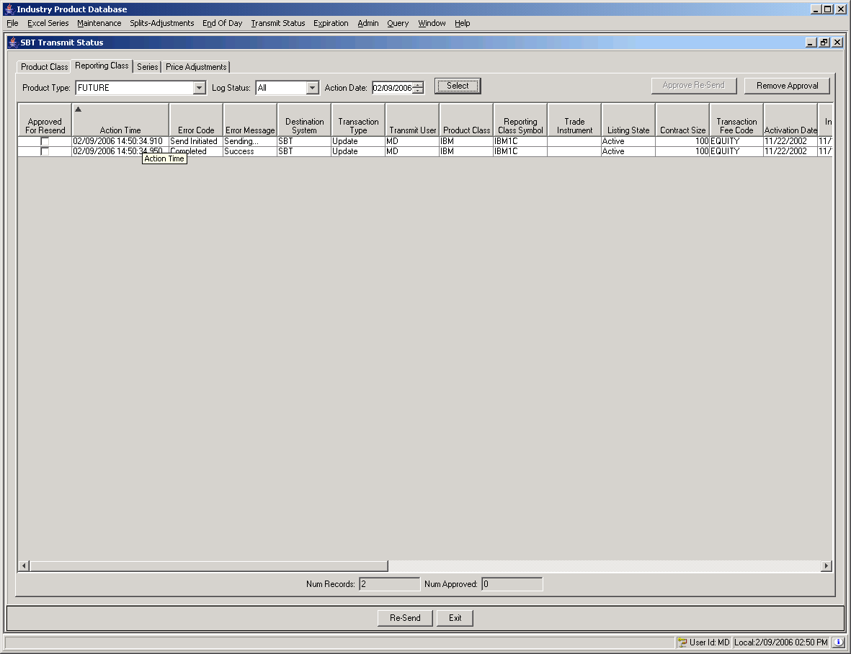
To display the transmit status of a reporting class:
- Select the Product Type from the drop down list.
- Choose the Log Status from the drop down list. You have the option to verify All transmitted data, Completed data, Error data, data Not Sent or Send Initiated data.
- Select the date the transmission was requested from the Action Date date box.
- Click Select. In the example above, all the Futures reporting classes display for the transmission date of 2/9/06. The Error Code column displays the log status. The Error Message column shows the status of the transmitted data.
 | Any reporting class that was not successfully transmitted can be resubmitted through this window.
- Highlight the data row you wish to approve for a resend.
- Select the Approved for Resend checkbox or click Approve Re-send.
- To remove the resend request, highlight the data row and deselect the Approved for Resend checkbox or click Remove Approval.
- Click Re-Send. The system will display the transmit message. Click OK to close the Message window.
➢ | Select the Series tab to verify transmission of product series.
 | 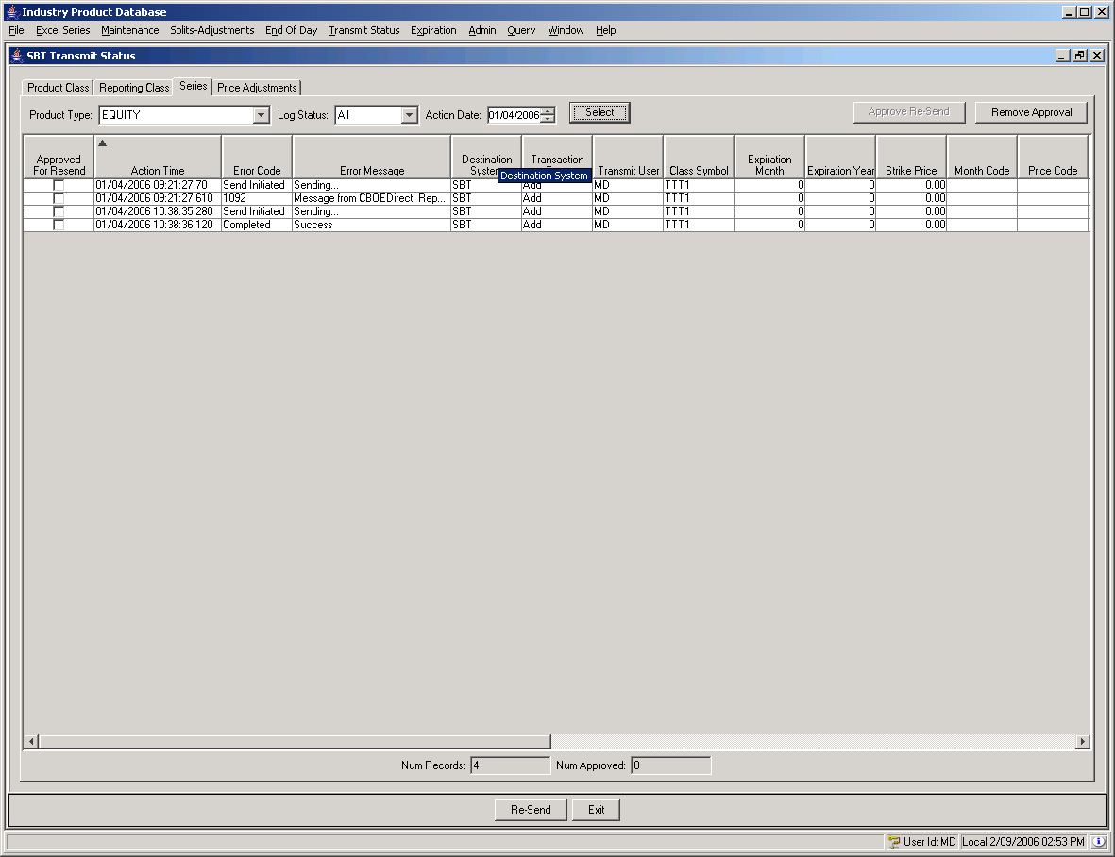
To display the transmit status of a product series:
- Select the Product Type from the drop down list. If you choose the Options product type, you can select the expiration date for the series as part of your filter.
- Choose the Log Status from the drop down list. You have the option to verify All transmitted data, Completed data, Error data, data Not Sent or Send Initiated data.
- Select the date the transmission was requested from the Action Date date box.

- Click Select. In the example above, all the Equity series display for the transmission date of 1/4/06. The Error Code column displays the log status. The Error Message column shows the status of the transmitted data.
 | Any series that was not successfully transmitted can be resubmitted through this window.
- Highlight the data row you wish to approve for a resend.
- Select the Approved for Resend checkbox or click Approve Re-send.
- To remove the resend request, highlight the data row and deselect the Approved for Resend checkbox or click Remove Approval.
- Click Re-Send. The system will display the transmit message. Click OK to close the Message window.
➢ | Select the Price Adjustments tab to verify transmission of products with price adjustments.
 | 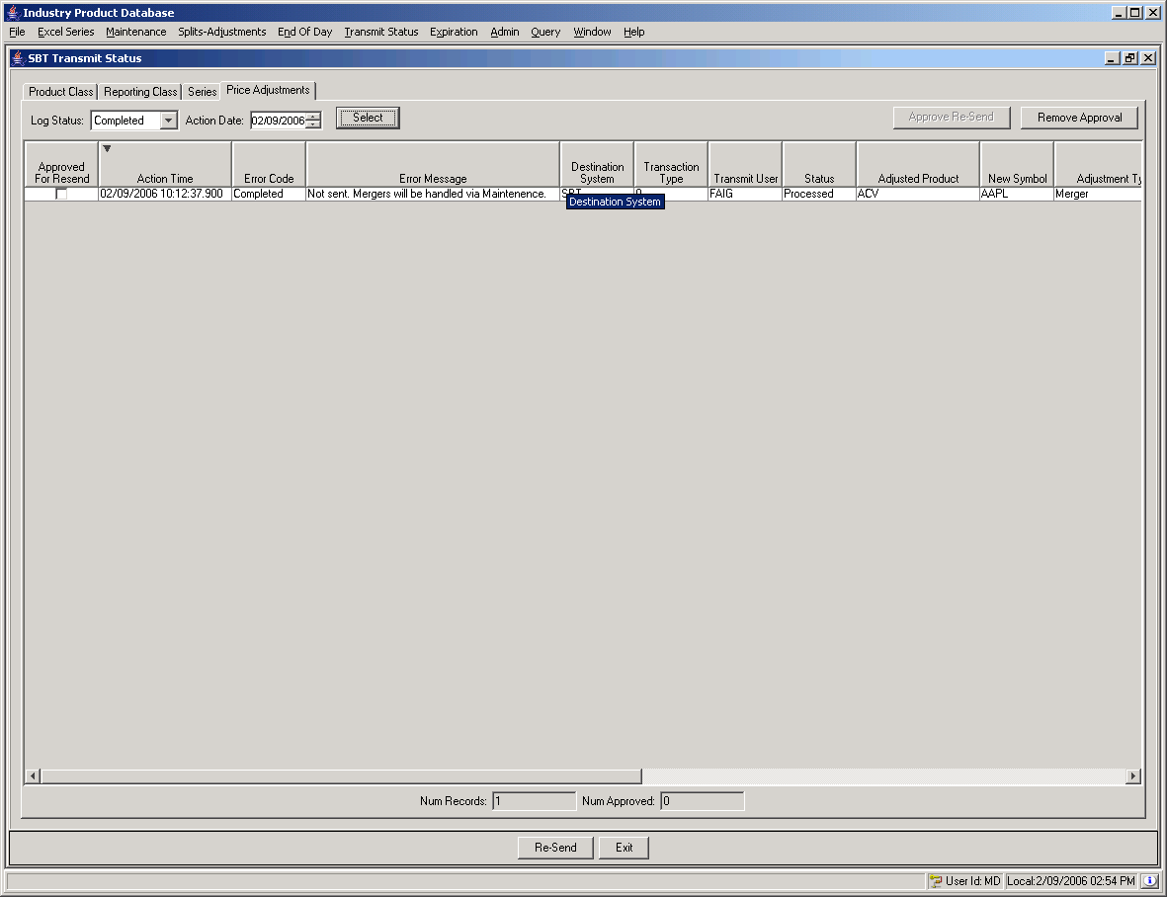
To display the transmit status of a price adjustment:
- Choose the Log Status from the drop down list. You have the option to verify All transmitted data, Completed data, Error data, data Not Sent or Send Initiated data.
- Select the date the transmission was requested from the Action Date date box.
- Click Select. In the example above, all the price adjustments display for the transmission date of 02/09/06. The Error Code column displays the log status. The Error Message column shows the status of the transmitted data.
 | Any price adjusment that was not successfully transmitted can be resubmitted through this window.
- Highlight the data row you wish to approve for a resend.
- Select the Approved for Resend checkbox or click Approve Re-send.
- To remove the resend request, highlight the data row and deselect the Approved for Resend checkbox or click Remove Approval.
- Click Re-Send. The system will display the transmit message. Click OK to close the Message window.
TPF Transmit Status | To view the status of the product data transmitted to the TPF system, click Transmit Status or press [Alt]-[T] on your keyboard and select TPF Transmit Status. The TPF Transmit Status window will display.
 | 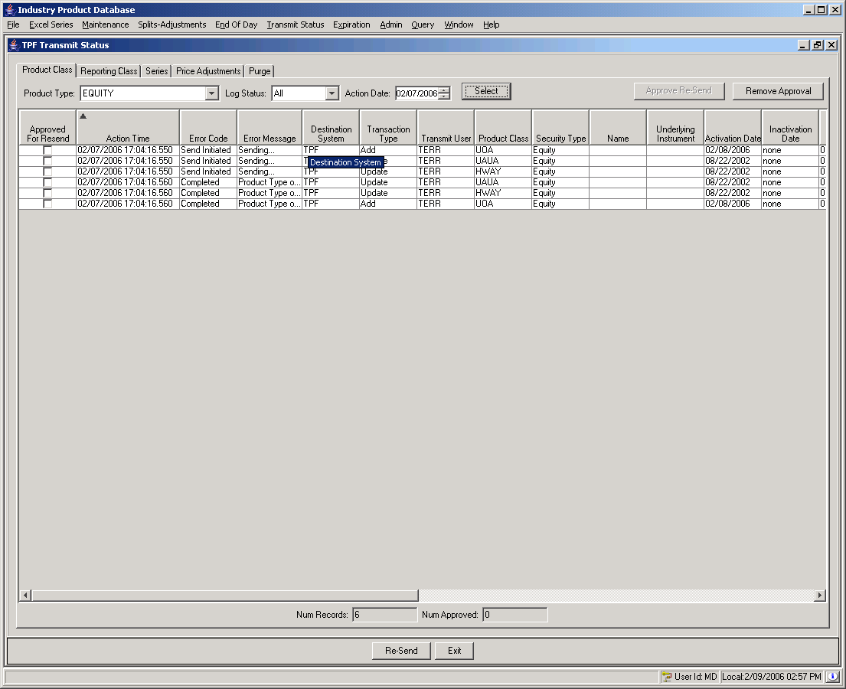
 | Product data displays in tab format by Product Class, Reporting Class and Series. The Product Class tab is the default.
➢ | To display the transmit status of a product class:  - Select the Product Type from the drop down list.  - Choose the Log Status from the drop down list. You have the option to verify All transmitted data, Completed data, Error data, data Not Sent or Send Initiated data.  - Select the date the transmission was requested from the Action Date date box.  - Click Select. In the example above, all the Equity product classes display for the transmission date of 2/7/06. The Error Code column displays the log status. The Error Message column shows the status of the transmitted data.
 | Product data that was not successfully transmitted can be resubmitted through this window.
- Highlight the data row you wish to approve for a resend.
- Select the Approved for Resend checkbox or click Approve Re-send.
- To remove the resend request, highlight the data row and deselect the Approved for Resend checkbox or click Remove Approval.
- Click Re-Send. The system will display the transmit message. Click OK to close the Message window.
➢ | Select the Class tab to verify transmission of reporting classes.
 | 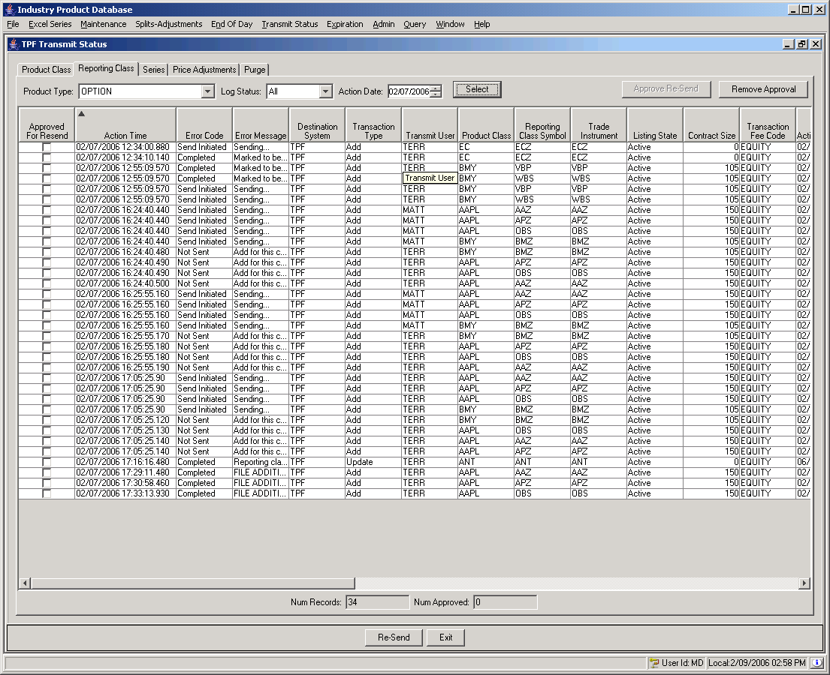
To display the transmit status of a reporting class:
- Select the Product Type from the drop down list.
- Choose the Log Status from the drop down list. You have the option to verify All transmitted data, Completed data, Error data, data Not Sent or Send Initiated data.
- Select the date the transmission was requested from the Action Date date box.
- Click Select. In the example above, all the Equity reporting classes display for the transmission date of 2/7/06. The Error Code column displays the log status. The Error Message column shows the status of the transmitted data.
 | Any reporting class that was not successfully transmitted can be resubmitted through this window.
- Highlight the data row you wish to approve for a resend.
- Select the Approved for Resend checkbox or click Approve Re-send.
- To remove the resend request, highlight the data row and deselect the Approved for Resend checkbox or click Remove Approval.
- Click Re-Send. The system will display the transmit message. Click OK to close the Message window.
➢ | Select the Series tab to verify transmission of product series.
 | 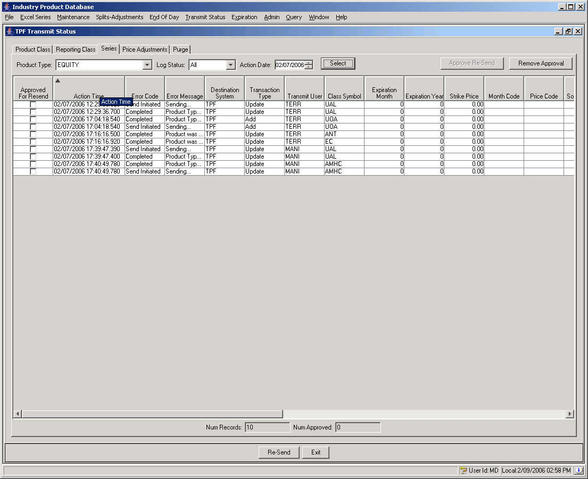
To display the transmit status of a product series:
- Select the Product Type from the drop down list. If you choose the Options product type, you can select the expiration date for the series as part of your filter.
- Choose the Log Status from the drop down list. You have the option to verify All transmitted data, Completed data, Error data, data Not Sent or Send Initiated data.
- Select the date the transmission was requested from the Action Date date box.
- Click Select. In the example above, all the Equity series display for the transmission date of 2/7/06. The Error Code column displays the log status. The Error Message column shows the status of the transmitted data.
 | Any series that was not successfully transmitted can be resubmitted through this window.
- Highlight the data row you wish to approve for a resend.
- Select the Approved for Resend checkbox or click Approve Re-send.
- To remove the resend request, highlight the data row and deselect the Approved for Resend checkbox or click Remove Approval.
- Click Re-Send. The system will display the transmit message. Click OK to close the Message window.
➢ | Select the Price Adjustments tab to verify transmission of products with price adjustments.
 | 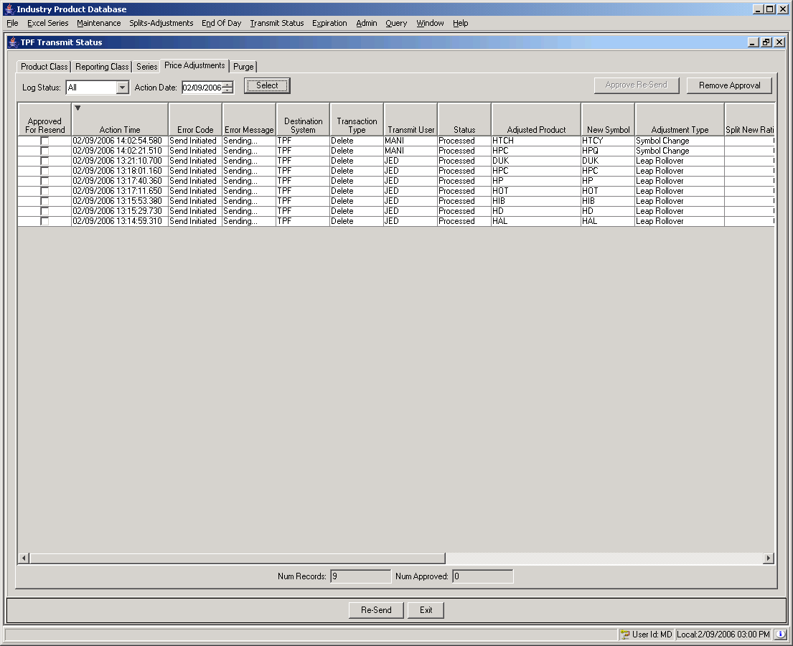
To display the transmit status of a price adjustment:
- Choose the Log Status from the drop down list. You have the option to verify All transmitted data, Completed data, Error data, data Not Sent or Send Initiated data.
- Select the date the transmission was requested from the Action Date date box.
- Click Select. In the example above, all the price adjustments display for the transmission date of 2/9/06. The Error Code column displays the log status. The Error Message column shows the status of the transmitted data.
 | Any price adjusment that was not successfully transmitted can be resubmitted through this window.
- Highlight the data row you wish to approve for a resend.
- Select the Approved for Resend checkbox or click Approve Re-send.
- To remove the resend request, highlight the data row and deselect the Approved for Resend checkbox or click Remove Approval.
- Click Re-Send. The system will display the transmit message. Click OK to close the Message window.

Edit Column Preferences
You can customize your transmit window by selecting or deselecting specific columns to display. To filter columns, right mouse click on a data row. Select Edit Preferences. The Edit Column Preferences window will display.
- Select or deselect columns for viewing and modify column arrangement as desired.
- To save your changes, click Ok.
- If you wish to retain the default settings, click Cancel.
For detailed information, refer to the Edit Column Preferences section, page 87.

Expiration

 | The IPD application allows you to send messages to TPF to purge product data.
Options Expiration | Data indicating what expired Options to purge is sent to TPF. To open the TPF Expiration Purge window, select Expiration and then Options.
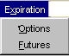 | 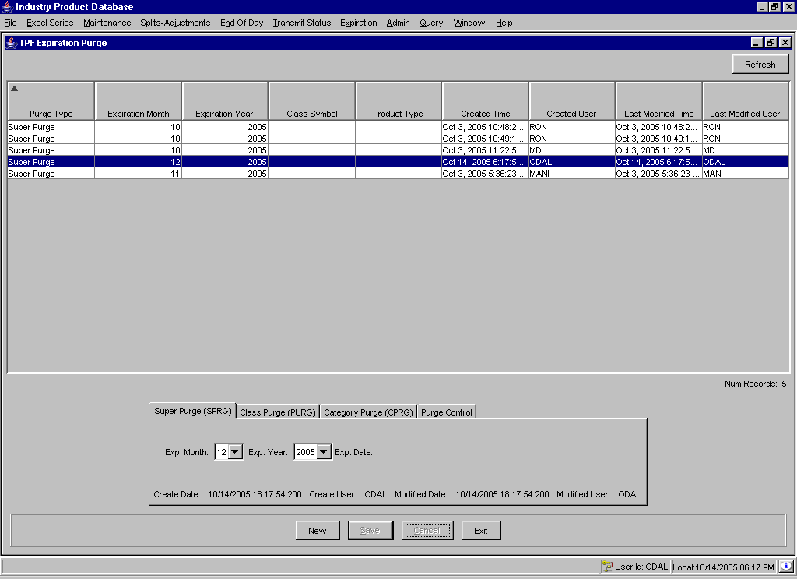
The window displays a data row panel with the types of purge the system will perform. The tabs at the bottom of the window: Super Purge (SPRG), Class Purge (PURG), Category Purge (CRPG), allow you to set data to be purged by expiration month and year, by class or by category.
Click Refresh to update existing data.
Click Exit at anytime to close the window.

Super Purge (SPRG)
To set the data to be purged by expiration month and year, select the Super Purge (SPRG) tab.
- Click New.
- Choose the expiration month and year from the Exp. Month and Exp. Year drop down lists.
- Click Cancel to clear the expiration date for the purge request.
- To continue with the purge request, click Save. The request will appear in the data row panel of the window.
- To remove a purge request from the system, highlight the row from the data panel.
  - Click on the Purge Control tab and click Delete. The system will generate a warning message.
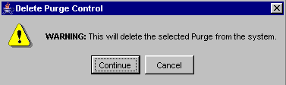
  - To remove your delete request, click Cancel.
  - To submit your delete request, click Continue. The purge request will be deleted
To send the purge request to TPF, highlight the row from the data panel and click on the Purge Control tab.
  - Click Send. The system will generate a warning message.
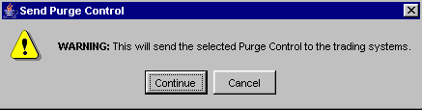
  - To send the purge request to the TPF system, click Continue.
  - If you wish to remove the send request, click Cancel.

Class Purge (PURG)
To set the data to be purged by class, select the Class Purge (PURG) tab.
- Click New.
- Choose the expiration month and year from the Exp. Month and Exp. Year drop down lists and the desired Reporting Class.
- Click Cancel to clear the expiration date for the purge request.
- To continue with the purge request, click Save. The request will appear in the data row panel of the window.
- To remove a purge request from the system, highlight the row from the data panel.
  - Click on the Purge Control tab and click Delete. The system will generate a warning message.
  - To remove your delete request, click Cancel.
  - To submit your delete request, click Continue. The purge request will be deleted
To send the purge request to TPF, highlight the row from the data panel and click on the Purge Control tab.
  - Click Send. The system will generate a warning message.
  - To send the purge request to the TPF system, click Continue.
  - If you wish to remove the send request, click Cancel.
 | Category Purge – Not currently used
Futures Expiration | At expiration, Futures products can be rolled forward into a new month by using the Expiration Futures window.  To open the Expiration Futures window, click Expiration or press [Alt]-[X] on your keyboard and select Futures.
 | 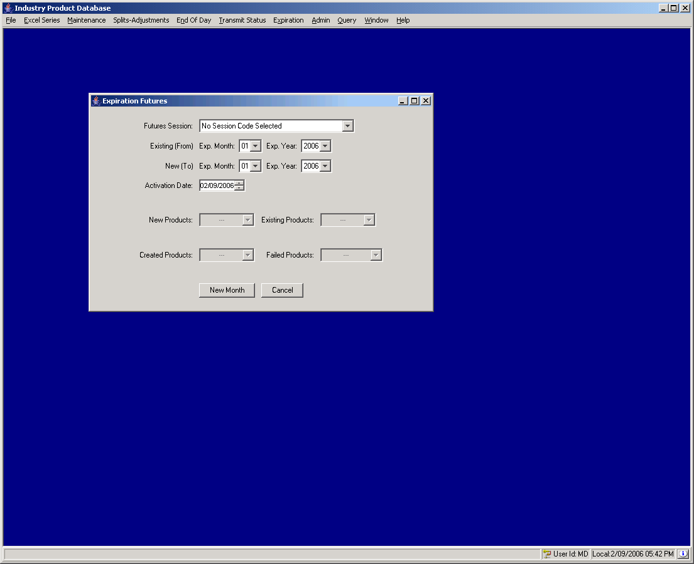
➢ | To roll Futures products forward into a new month:  - Select the Futures Session from which to pull products.  - Choose the expiration month and year from which to pull products using the Existing Exp. Month and Exp. Year drop down lists.  - Choose the expiration month and year for the new products using the New Exp. Month and Exp. Year drop down lists.  - Select the date on which the new products should become active using the Activation Date box.  - Click New Month. Any products to be created will appear in the New Products drop down. Any products that already exist for the new month will appear in the Existing Products drop down.
 | 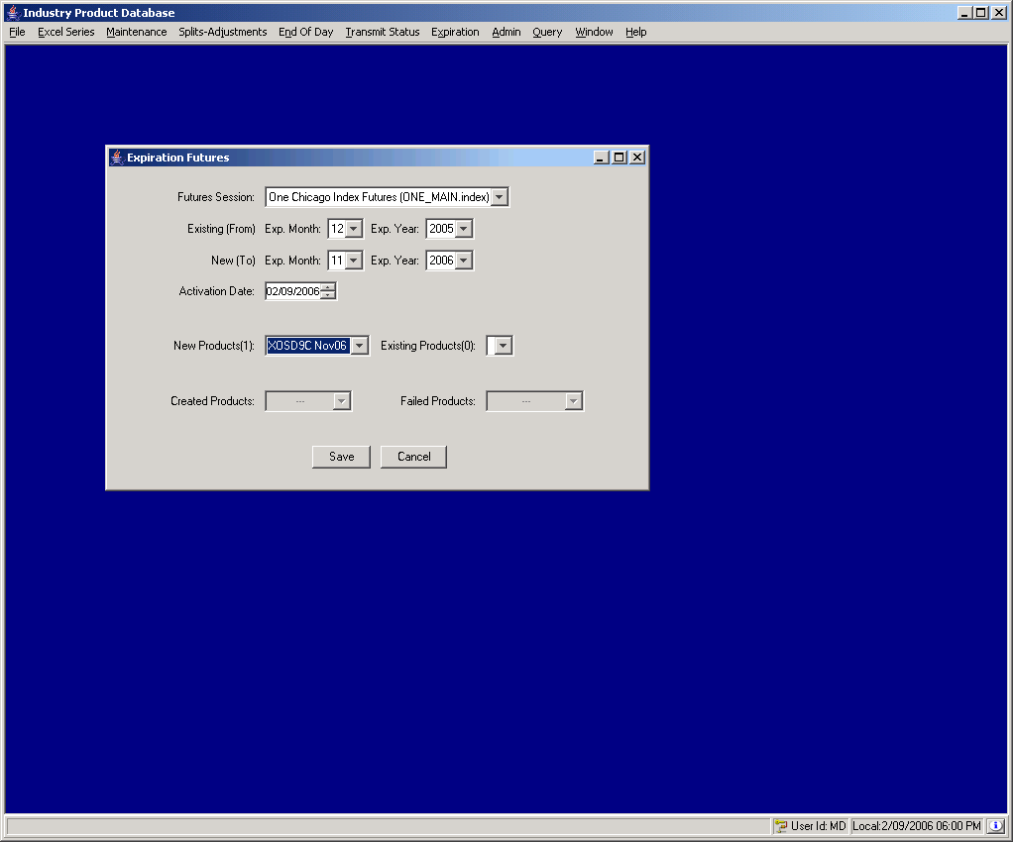
- If the data looks satisfactory, click Save to create the new products. The system will generate a warning message.
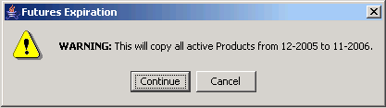
- To cancel your request, click Cancel.
- To copy the selected products, click Continue.
 | - After continuing, products that were created successfully will appear in the Created Products drop down and products that could not be created will appear in the Failed Products drop down.
 | 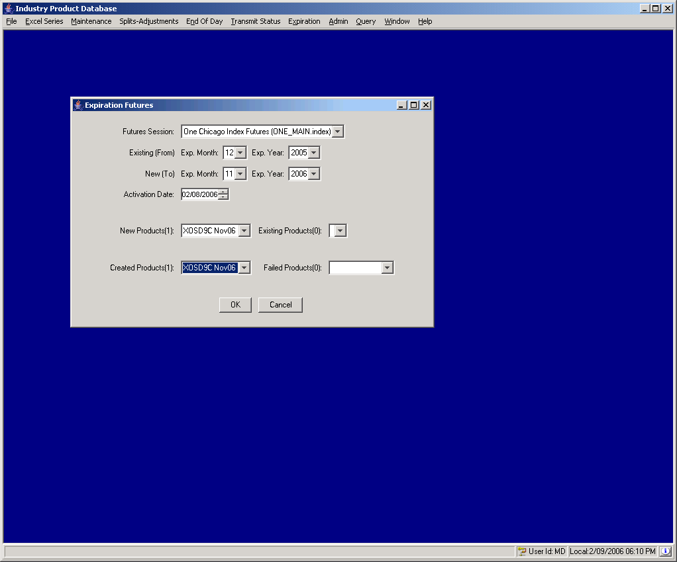
 | - To close the window, click OK or Cancel.

Admin Maintenance

Not currently implemented.

Query Reports

Not currently implemented.

Exit the System

 | You can log out and exit the system at any time during the day.
Exit the System | To exit the IPD system, select Exit from File Menu. You will be prompted to verify that you wish to close all windows and logout. Click Yes. The application will be closed and you will be returned to your system desktop.

◻ | Section 2:  Reference Guide

Customizing IPD Windows

Edit Column Preferences | Several IPD windows that exhibit data in column format can be customized to display specific information. For example, to modify your Price Adjustment window, right mouse click on any data row. Select Edit Preferences. The Edit Column Preferences window will display.  From this window, you can rearrange column positions and select or deselect columns for viewing.
 | 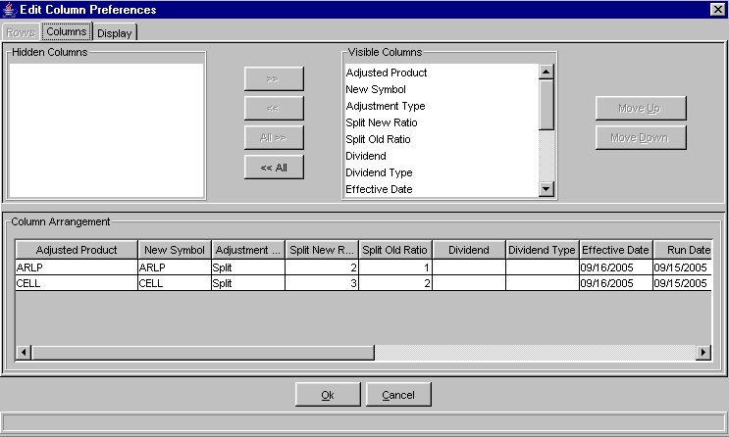
If there is a data column you do not wish to view:
- Select the column name in the Visible Columns list box. To select a continuous range of columns, hold down the shift key and highlight the column names. Hold down the ctrl key to select individual, non-continuous, column names.
- Click << to move the column name to the Hidden Columns list box.
- Click Ok to update the column arrangement.
- If you decide to retain the default layout, click Cancel.
To hide all columns:
- Click <<All to move all the column names in the Visible Columns to the Hidden Columns list box.
- Click Ok to update the column arrangement.
- If you decide to retain the default layout, click Cancel instead of Ok.

 Note: If you hide all columns, you will subsequently have to make some columns visible before the update will take effect.
To display a hidden column:
- Select the column name(s) from the Hidden Columns list box.
- Click >> to move the selected column name(s) to the Visible Columns list box.
- Click Ok to update the column arrangement.
- If you decide to retain the default layout, click Cancel instead of Ok.
To display all hidden columns:
- Click All>> to move the column names to the Visible Columns list box.
- Click Ok to update the column arrangement.
- If you decide to retain the default layout, click Cancel instead of Ok.
You may prefer to view data columns in a different order than the default display.
To move a column:
- Highlight the column name from the Visible Columns list box.
- Click Move Up or Move Down until you reach the new column location.
- Click Ok to update the column arrangement.
- If you decide to retain the default layout, click Cancel.
From the Column Arrangement section of the window, the columns can be resized to make viewing information easier for you.
To resize a column:
- Place the mouse on the right edge of the column header (where the column titles are displayed) until it becomes a two-sided arrow.
- Hold the left mouse button down and move it to the desired size.
- Click Ok to save the new column size.
- If you decide to retain the default column size, click Cancel instead of Ok.

Display
In addition to customizing column settings, IPD allows you to adjust the text on your windows. From the Edit Column Preferences window, select the Display tab.
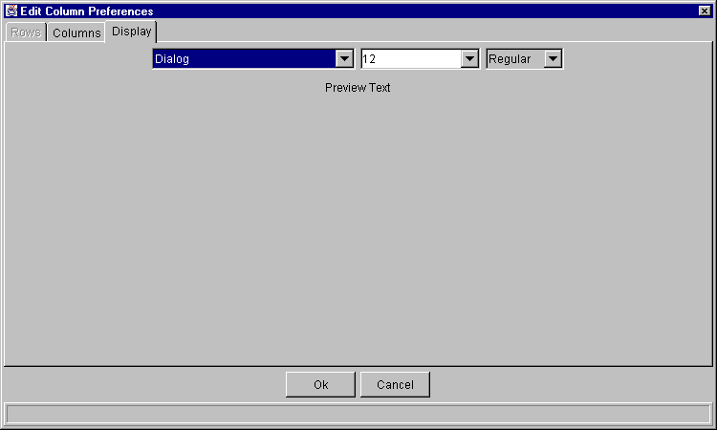
Select the font type, font size and font style from the drop down lists. Your selection will display in the Preview Text section of the window.
- Click Ok to set the new text style.
- If you wish to retain the default text settings, click Cancel.
Sizing IPD Windows | The IPD system windows are sizable. That is, they can be resized on the screen to make viewing information easier for you.
 | 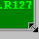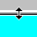 | Place the mouse on any edge of the window until it becomes a two-sided arrow. Hold the left mouse button down and move it to the desired size.
Resizing a window on the corner will expand or contract it in both directions (i.e. up and down and side-to-side). Resizing it on the side or top/bottom will expand or contract the window only in that one direction.
Windows can also be resized using the center glyph in the upper right corner of the window.
 |  | Click the left button () to minimize the window. Click the right button () to close the window. The center button is used for sizing.
If  is displayed, clicking it will increase the window size to a full-screen display.
If  is displayed, clicking it will return the window to its default size.

Console Window

Open Console Window | IPD allows you to view system messages that are generated by the functions you perform. To view these messages, select Open Console Window from the File Menu or press [Alt]- [F3] on your keyboard from anywhere on your screen. The Console Window will display.
 | 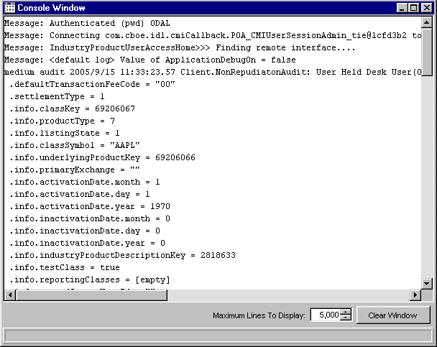
The information in this window can be copied to any text editor on your PC. To copy text from this window,
- Place your cursor on the line you want to copy and using your mouse highlight the text.
- Press Ctrl C on your keyboard to copy the text.
- Open your text editor (Word, Notepad, etc.) and place your cursor in the text entry area.
- Press Ctrl V on your keyboard. The text is copied to your editor.
The window defaults to display 5,000 lines. You can change the maximum amount of lines to display by entering a new quantity in place of the default value, or you can select a higher/lower quantity by clicking the up/down arrows until the desired quantity is reached.
If you wish to clear the window of all its contents, click the Clear Window button.

