

Industry Product Database
User’s Guide
Addendum – Credit Derivatives Release

Summary Of Changes
The main purpose of this release is to support new product types in IPD for underlying securities to provide more detailed alternatives to the Equity and Index types in use now. Initially, only one new type, Credit Derivative, will be added but eventually new types will be created for ETFs, HOLDRs, and others. The release also includes GUI enhancements to the Product Summary screen to improve maintenance of underlying (or “base”) securities, which is more common now that stocks trade in CBSX.

New Product Types
For the most part, new product types will act just like equities or indexes do now in IPD. New product types will appear in drop-down menus, tables, and fields as just the current types do. They can be created and updated in through the Maintenance screens. They will appear in End Of Day screens and transmit status screens.

However, there is one important difference: CBOEDirect will not support the new types initially. As a result, each new IPD product type will automatically “map” to an SBT product type when transmitted to SBT. For example, Credit Derivatives map to Indexes. If FDE is defined as a Credit Derivative in IPD, it will appear in Index folders in the SA-GUI. As a visual clue to how types are mapped, the IPD GUI will display the SBT type in parenthesis after product types that will be converted. TPF is unaffected since it does not have records for underlyings.

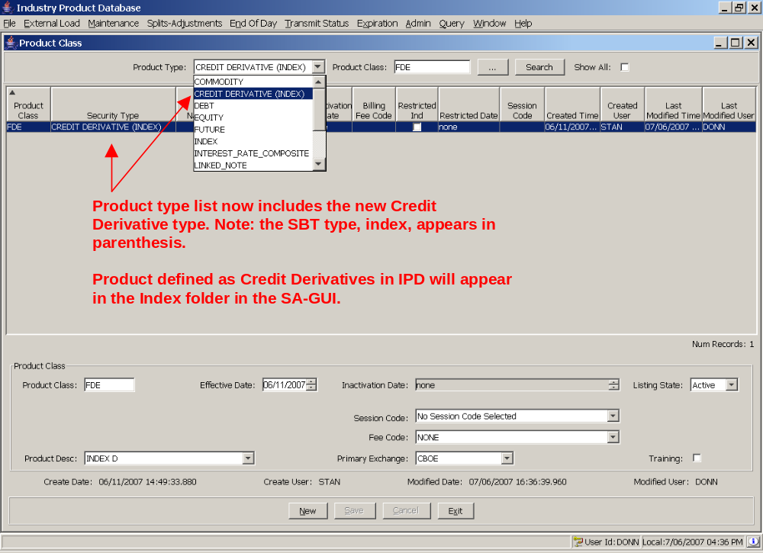

GUI Features
New GUI features appear in the Product Summary screen, which can be opened from the Maintenance Menu. The Product Summary screen has changed with this release to incorporate several new features:
- Display critical information for an underlying security, including what derivatives are based on it, in one place.
- Make editing stocks and viewing stock information easier, mostly for CBSX.
- Allow changes to underlying product types, where applicable.

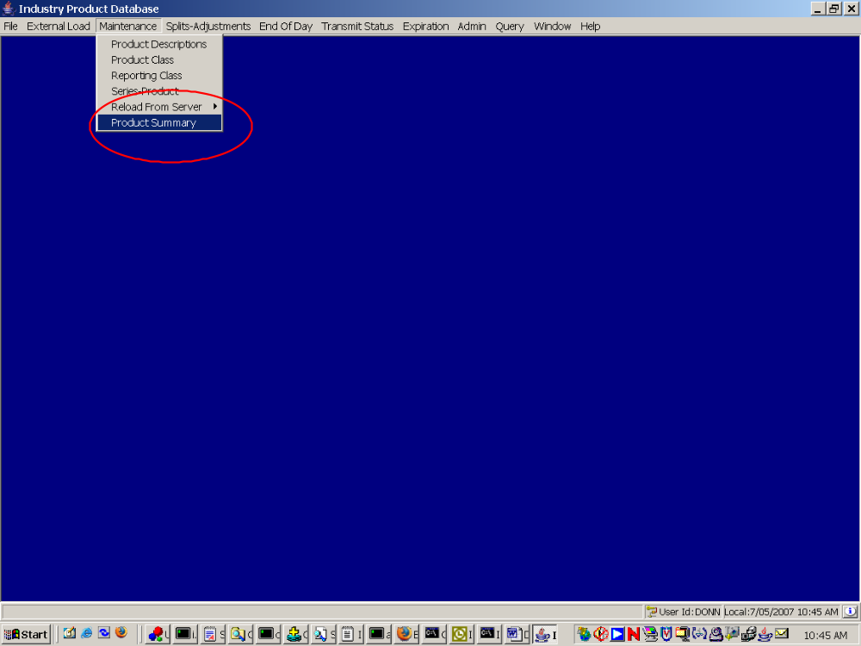

The Product Summary screen displays information about an underlying (usually an equity or index) and derivatives on that underlying. The main purpose of the screen is to show information regarding the underlying (including data for CBSX), option, futures, and strategy configuration all in one place. It also makes underlying symbol changes convenient by allowing the symbols for an underlying security and its derivatives to be edited in one place. Finally, a new tab in the screen handles lookup, updates and creation of base securities (stock, index, etc) in one place. In the past, new underlying symbols could be created in one place -- the product class screen -- but could not be edited there. Instead, editing or viewing details of an underlying often required separate trips to the product class, reporting class, and series maintenance screens. The new screen simplifies this process by putting the important data in one place, which should be especially helpful for CBSX products.

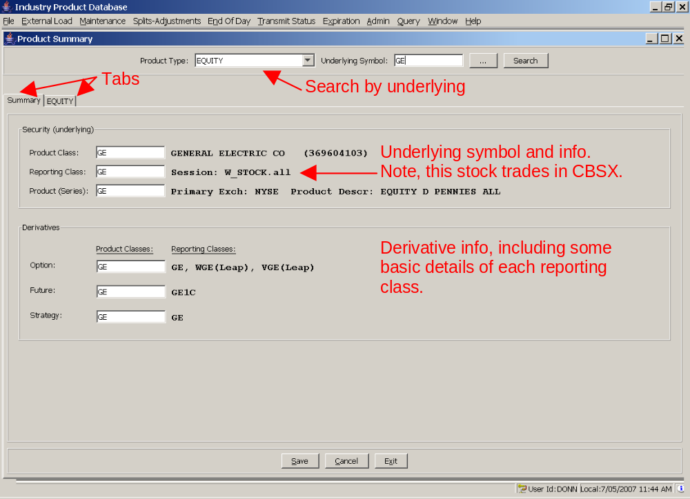

At the top of the Product Summary screen is the familiar symbol query bar. Here all searches are done at the underlying level. The middle section of the screen has two tabs. One is labeled “Summary” and the other will change depending on the selected underlying product type.

The summary tab has two sections. The top section of the displays the underlying product class, reporting class, and product (series) symbol. These should be the same. The right-hand side of the section shows the underlying’s company name, cusip number, primary exchange, and session. If the underlying has a session, then the stock or index trades in CBSX. The bottom section of the summary tab shows all derivatives tied to the underlying. The product class symbol is editable. The right-hand portion of the screen shows all reporting classes belonging to each derivative’s product class.

As in the previous version of the screen, entering a new symbol for the underlying product class (in the top left) will automatically change all of the other editable fields. Usually, that’s what happens during an underlying symbol change – the product class symbol for derivatives change to match the new underlying symbol. The automatic change can be overridden by typing in any of the other fields.

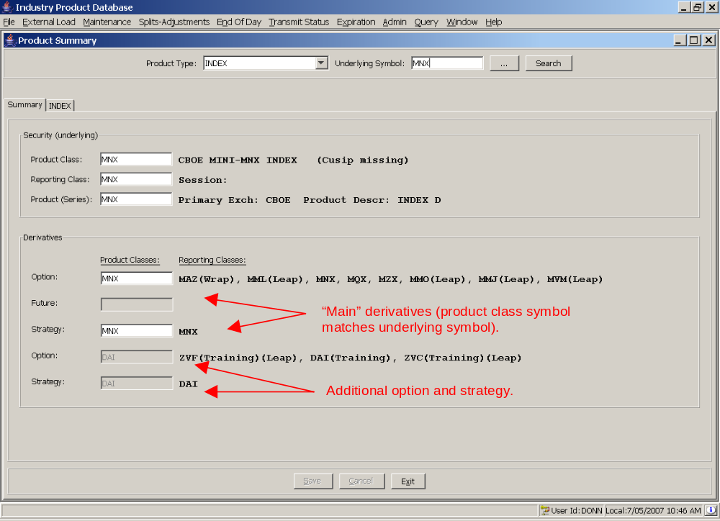

Starting with this release, the summary tab now supports multiple derivatives of the same type for an underlying. For example, the index MNX has two option and strategy product classes – MNX and DAI.

Note: If more than one derivative of a product type exists, then product class symbol for the derivatives whose symbol matches the underlying symbol is determined to be the “main” product classes, which is editable. Any other derivatives of the same type are displayed but the product class symbol is not editable.

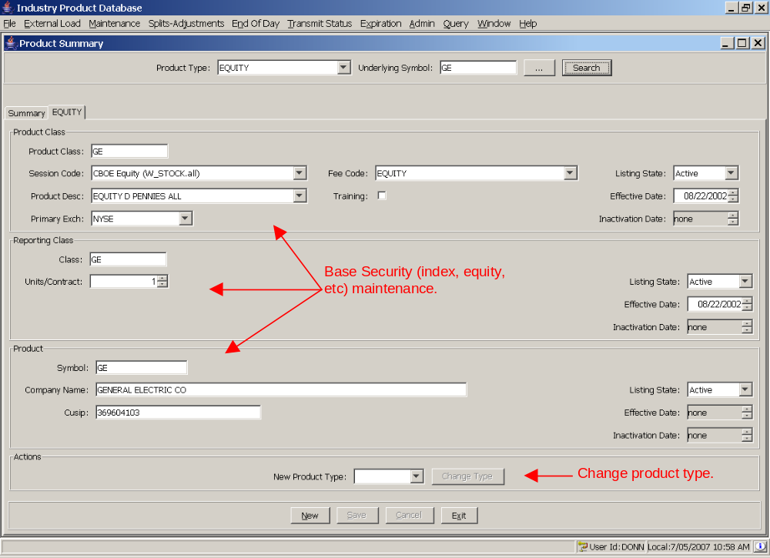

The label of the second tab will change to match the selected product type (if no type is selected it will simply read “underlying”). Since a base security type (equity, index, etc) consists of a one product class, reporting class, and product record, the screen groups fields by record level. Equity and index maintenance can be done through this screen.

The fourth section, labeled “Actions”, contains the new product type change feature. This feature will change the product type of an underlying product to a compatible type. For example, an Index may change to a Credit Derivative. This will be used mostly to change existing products to newly added types when new types are added.

