Introduction
The Java Grinder Persistence Layer is a framework that makes it easy for developers to integrate Java business applications with a database. JGPL increases developer productivity by handling persistence tasks for the developer and by providing support for managing transactions. The purpose and advantages to using transactional and persistence support are discussed in the ObjectWave JavaGrinder white paper. This document will deal with the application of this framework.
Each task of this tutorial demonstrates the transactional and persistence aspects of the JGPL. These tasks will build on each other. In task one you will create and store one simple domain object. In task two you will create an associate relationship between domain objects. Finally, in task three you will create an aggregate relationship between domain objects. The code for each task is provided for you although it will be more beneficial to write the code on your own by following the tutorial instructions. In addition, you can further test your code by using the provided test GUIs.

Requirements
JDK 1.1 and JFC 1.0 - This can be downloaded for free from JavaSoft web site.
Relational Database
ODBC must be setup/installed.

How it works
It is not necessary for you to understand the internal details of the framework in order to use it effectively. However, some explanation of what classes are used, the various functions of these classes, and the public interfaces to these classes should help you understand what the framework is providing for you. With this knowledge you can then use the framework to its greatest advantage. This section provides hierarchy information and interface instructions to the transactional and persistence portions of the JGPL framework. It is not important that you understand these concepts after the first read. The tutorial tasks are designed to help cement your knowledge of these concepts.

Transactional Support
The transactional support allows us to easily commit or rollback changes. The two main classes used in the transactional support of the JGPL are the transaction log and the object editor. The class diagram for these classes is presented in diagram 1.

Diagram 1 Transactional Support Class Diagram
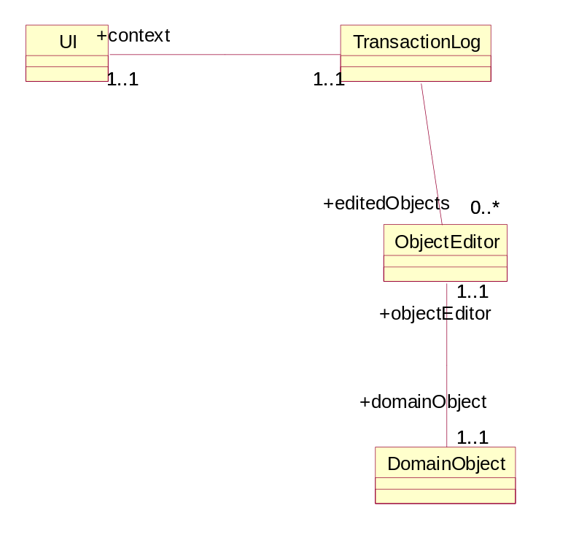

Typically a transaction log would be created when a user interface is started. As a domain object is modified the modifications are stored in an ObjectEditor, not the object itself. The changes are not added to the domain object until the transaction log is committed. Typically this would be when the user hits the OK button on the UI.

Persistence Support
The persistence support involves the interface between objects living in the virtual machine and some sort of persistence storage. In the case of a relational database this involves creating a connection to the database and mapping objects to database tables. The main classes for this are the PersistentBObject and the Broker. The Broker sets up a connection to the database. The PersistentBObject contains the mapping instructions between the PersistentBObject and its database table. When changes are committed the broker sets up a connection and sends these changes to the database based on the object-to-table mapping found in the PersistentBObject. In a relational database these changes would be in the form of SQL commands.

Getting Started
The first thing you need to do is check that your are set up properly. This involves the following steps:
- Setup your database. Create a new blank database, and save it.
- Setup a data source with the name: tutorial. Then connect that data source to the blank database you just created. On this data source, you should also setup a username and password. Remember this username and password, because you will need it later in this tutorial.
- Once you have downloaded the .zip file we provide for you on our website, you should unzip it into a directory. Verify that the files tutorial.jar and tutorial.ini exist. Then add the directory that you unzipped the zip file into and the jar file to the classpath. For example if you unzipped the tutorial.zip file into the directory C:\Tutorial (or ~/tutorial for unix users) then you would append the following to your classpath : C:\Tutorial;C:\Tutorial\tutorial.jar (Unix users would replace C:\Tutorial with ~/tutorial).
After you have created the data source, you should edit the initialization file. That initialization file is called 'tutorial.ini'. It should be located in the directory which you unzipped the tutorial.zip file which you downloaded off of the web. This file will look something like this:
ow.persistUser=user
ow.persistPassword=password
ow.connectUrl=jdbc:odbc:tutorial
ow.persistDriver=sun.jdbc.odbc.JdbcOdbcDriver
ow.databaseImpl=com.cboe.infrastructureServices.persistenceService.AccessBroker
ow.persistVerbose=true

The format of this file is key=value.
The changes you would need to make in this file are the following:
- Change the value for the key ow.persistUser to whatever username you entered for the datasource.
- Change the value for the key ow.persistPassword to whatever password you entered for the datasource.
- Change the value for the key ow.persistUser to 'tutorial'. (If the value already is tutorial, don't change anything).

Overview -
The general steps involved in creating persistent objects using JGPL are outlined below. Each test will cover each of these steps in order.
- Create class
- subclass PersistentBObject
- add mutator and accessor methods
- add initializeObjectEditor() method
- add initDescriptor() method
- add update method
- Database Table changes
- Test class changes

Task 1: In this task you will create a simple Domain Object and connect it to your database. It will look like this:

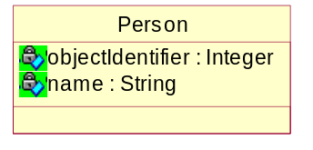

The underlying database table structure will look like this:

Person
databaseIdentifier : Number
name : Text

Step 1: Create the class.

A) Subclass PersistentBObject.
Create a new file called: Person.java.
The class definition for this Object will look like this:

- import com.cboe.infrastructureServices.foundationFramework.*;
- import com.cboe.infrastructureServices.persistenceService.*;
- import java.util.*;
- import java.lang.reflect.* ;

- public class Person extends PersistentBObject {
- protected String name ;

- static Field _name;

- static Vector classDescriptor ;

- static {
- try {
- _name = Person.class.getDeclaredField("name");
- }
- catch (NoSuchFieldException e) {
- e.printStackTrace();
- }
- }
18. }
Now let's talk about what is going on.
Lines 1-4 are fairly obvious. There are the minimum import statements that must be included in your class source.
Line 6 is the start of the actual class definition, and states what class you are going to extend. You MUST extend PersistentBObject or else none of the persistence/transactional support will work.
Line 7 declares an attribute of this object. Typically there will be a table field in the underlying relational database for each of these attributes.
Line 8 is the java.lang.reflect.Field that maps to the attribute. Every attribute should have a corresponding java.lang.Field. These are necessary because of the way that the altering of objects takes place. For now it is sufficient to say that java.lang.reflect.Field instance variables must be declared for each domain object attribute.
Line 9 is the instance variable for the class descriptor. The class descriptor keeps track of information about the attributes. More on the classDescriptor later, for now just understand that every Domain Object must have a classDescriptor.
Lines 10 - 17 define the Domain Object's static initializer. This is a block that will initialize the Domain Object's java.lang.reflect.Field whenever this class is referenced. Initialization of the static fields is accomplished as shown. All java.lang.reflect.Field's in the Domain Object should be initialized here in this way.
That does it for the class definition. Now let's add the methods this class needs.

B) Add Accessor and Mutator Methods
First let's add the accessor method for the name attribute:

- public String getName() {
- return (String)editor.get(_name, name) ;
- }

Line 1 is a typical accessor. It has the method visibility, the return type of the attribute, and the name of the method. The return type and the method name will change depending on the attribute we are accessing.
Line 2 shows the major difference between a typical accessor and the accessors needed by our Domain Objects. Instead of accessing the variable directly, we must access it via the Object Editor associated with the Domain Object. Changes are stored in this Object Editor until a commit is made. This would be the format for all accessors. The only changes needed to be made in line two are changing String to the proper type to cast the return value to, and changing "_name" and "name" to the proper Field and attribute variable respectively.

Now lets add a mutator to the Object.

- public void setName(String aValue) {
- editor.set(_name, aValue, name) ;
- }
Let's again analyze this method.
Line 1 is pretty typical of a mutator. The method name and the argument type will need to change depending on the attribute being set.
Line 2 is also pretty generic. The only change would be to change "_name" and "name" to the proper Field and attribute respectively.

Be sure to use the accessor and mutator methods whenever you need to access the value of an attribute. NEVER access the variable directly. Accessing variables directly will cause inconsistent results and improper PersistentBObject states.

C) Add initializeObjectEditor() method
Next add the following method:
- public ObjectChangesIF initializeObjectEditor(){
- final DBAdapter result = new DBAdapter(this);
- if (classDescriptor == null)
- initDescriptor();
- result.setTableName("person");
- result.setClassDescription(classDescriptor);
- return result;
- }

Let's look a bit more closely at this method. This is the method that is needed to define table name and the description of this class. The only thing that would need to be changed would be in Line 5 where we would change "person" to whatever table in your database was setup to store instances of this Object.

Line 2 also might be changed if the user wanted to use a different Adapter (ObjectEditor), but for the majority of applications, the default one will do.

D) Add initDescriptor() method
Next we want to add the following method:

- protected void initDescriptor() {
- synchronized (Person.class){
- if (classDescriptor != null) return
- classDescriptor = getSuperDescriptor();
- classDescriptor.addElement(
AttributeDefinition.getAttributeRelation("name", _name));
- }
- }

This method is actually a bit more complex then the others. The initDescriptor() method is a quite important method. What this method does is set up the classDescriptor and store information about the attributes in the Domain Object. The class descriptor, which was mentioned earlier, holds information pertaining to the different attributes of the Domain Object. The type of attribute each instance variable is stored in the classDescriptor. More will be said about this method later on in the tutorial. For now it is sufficient to understand what the classDescriptor is. Also understand that Line 3 is where we are actually adding information about the attributes to the classDescriptor. The "name" argument is actually the column name in the database table which will hold this attribute.

E) Add the update method
Finally, add the following method to your class :

- public void update(boolean get, Object [] data, Field [] fields) {
- for(int i = 0; i < data.length; i++) {
- try {
- if(get)
- data[i] = fields[i].get(this);
- else
- fields[i].set(this, data[i]);
- }
- catch(IllegalAccessException ex) { System.out.println(ex); }
- catch(IllegalArgumentException ex) { System.out.println(ex); }
- }
- }

This update method needs no changes. The update method is necessary in order to allow any changes to private instance variables. Otherwise it would be impossible to alter their value.
Your Domain Object is now complete.

Step 2: Setting up the database tables

So let's test it. First thing that must be done is to properly setup the database. It should consist of one table. That table should be called "Person". Your person table will look like this:

Person
DatabaseIdentifier : Number
name : Text
Select the databaseIdentifier field as the primary key for this table.

Step 3: Testing your Domain Objects.
Once the data source is setup, all that we have left is to create a Test class. So let's do that shall we?
Start by creating a file called Test.java (This should be stored in the same directory as your Person.java file). Then type the following class definition:

import com.cboe.infrastructureServices.persistenceService.*;
import com.cboe.infrastructureServices.foundationFramework.*;
import java.util.* ;

public class Test {
}

So far it is pretty simple, and there is not much to discuss. Now, let's add a constructor for the Test class.

- public Test() {
- super();
- com.objectwave.appArch.StartupRoutine.loadDefaults(this, "tutorial.ini");
- BrokerFactory.useDatabase();
- }

Line 3 is the only important line of code here. This line of code reads in the properties needed for the tutorial from an initialization file. Discussion of the initialization file is deferred until later on in the tutorial. You will have to change certain values to fit your needs. For now it is sufficient to state that certain properties are read from an ".ini" file. Any ".ini" file can be read from this same line of code, all you would need to change would be the name of the file ("tutorial.ini")
Line 4 tells the broker factory that we are going to be using a database as the underlying data storage.
This broker is responsible for opening connections and writing the Domain Objects to the underlying data storage (This can be a database, or an ObjectPool or just a file). Calling BrokerFactory.useDatabase() will also set the broker on the transaction log to use the default broker specified in the .ini file.

Now add the main method.

- public static void main(String args[]) {
- Test t = new Test();
- if (args.length > 0) {
- if (args[0].equals("populate"))
- t.populate();
- else if (args[0].equals("query"))
- t.doQueries();
- else System.out.println("invalid argument");
- return;
- } else {
- t.populate();
- t.doQueries();
- }
- }

This method simply calls the methods that will do the work. It checks the arguments passed via command line to decide whether it should populate the database, or query the database.

A) Insert Data
Next let's add the populate method. This is the method that will insert new instances into your database.

- public void populate() {
- BOSession ses = BOSession.createAndJoin(“aName”);
- ses.startTransaction();
- Person p = new Person();
- p.setName("John Smith");
- p.setObjectIdentifier(new Integer(100));

- p = new Person();
- p.setName("James Doe");
- p.setObjectIdentifier(new Integer(101));

- p = new Person();
- p.setName("Tom Jones");
- p.setObjectIdentifier(new Integer(102));

- p = new Person();
- p.setName("Michael Jordan");
- p.setObjectIdentifier(new Integer(103));

- p = new Person();
- p.setName("Sam Sneed");
- p.setObjectIdentifier(new Integer(104));

- p = new Person();
- p.setName("Nick Fitz");
- p.setObjectIdentifier(new Integer(105));

- try {
- ses.commit();
- }
- catch (UpdateException e) {
- ses.rollback()
- e.printStackTrace();
- }
- }

Let's talk about what is going on.
Line 3 starts the transaction, and returns a handle to the TransactionLog. Now the TransactionLog will keep track of any changes that are made to a Domain Object. Whenever we want to make a change to a Domain Object, we simply modify the value using a mutator, and then call commit on the transaction log.
The changes made by the mutator will be stored in the ObjectEditor until we commit the changes. After commiting, the changes will be applied to the Domain Object. We are using a particular type of transaction log, the BrokerTransactionLog. This is one that has been specifically written for use with Brokers and relational databases. This will probably be the most commonly used one. If you wanted to use a different transaction log, you would simply substitute BrokerTransactionLog.class with SomeOtherTransLog.class.

Lines 3-5,6-8, 9-11, etc. create a new PersistentBObject and set its values.
Line 25 then writes those changes to the database. commit() is the method that commits any alterations/creations of Domain Objects. (commit() throws an com.cboe.infrastructureServices.persistenceService.UpdateException that must be caught, hence lines 24 and 26-29. If any errors occur you should rollback any changes -- Line 28)

B) Query Data
Now lets add the query method. This is the method that will query the database and return any Domain Objects that fit the attributes you specify.

- public void doQueries() {

- Person p = new Person();
- ObjectQuery query = new ObjectQuery(p);
- p.setName("Michael Jordan");
- System.out.println("List of all emplyees with the name :" + p.getName());
- try {
- Vector v = query.find();
- for (int i =0; i < v.size(); i++) {
- Person result = (Person) v.elementAt(i);
- System.out.println("Name: " + result.getName() + " Id: " + result.getObjectIdentifier());
- }
- }
- catch ( PersistenceException e) {}

- Person p2 = new Person();
- query = new ObjectQuery(p2);
- p2.setName("%J%");
- query.setAsLike(true);
- System.out.println("List of all people with the letter 'J' in their name :");
- try {
- Vector v = query.find();
- for (int i = 0; i < v.size();i++){
- Person result = (Person) v.elementAt(i);
- System.out.println("Name: " + result.getName() + " Id: " + result.getObjectIdentifier());
- }
- }
- catch (PersistenceException e) { e.printStackTrace();}

- }

Lines 6 -8 create a new query, and sets the value to match. In this case the name being matched. This Query will return all people with the name "Michael Jordan".
Line 6 creates a blank Person Object. This is done so that the ObjectQuery object knows what kind of objects we will be looking up.
Line 7 creates the ObjectQuery object. The constructor takes a Domain Object as an argument in order to know which object (or table in this case) it will be looking up.
Line 8 sets the value of name in this person. This way the ObjectQuery will search for all people with the name "Michael Jordan".
Line 11 is the line that actually searches in the data storage. To initiate a search, we simply call the ObjectQuery.find() method. This method returns all the PersistentBObjects that match the criteria in a java.util.Vector.
Lines 18-21 demonstrate a more complex query. Lines 18 and 19 are the same as the previous example, but in Line 20, we are setting the name to the value "%J%". In JavaGrinder, the character % is a wildcard. So in this case we are searching for any Person with the letter J in his/her name.
Line 21 is also important. When doing a wildcard search we must tell the ObjectQuery to use a LIKE comparison instead of an = comparison. So we setAsLike(true) in order for ObjectQuery to handle the wildcard character properly and return the correct results.

Now we are ready to run this part. First, we must compile the classes we just created. To do this we must change to the directory where these files are stored. Then execute the command :
javac Person.java Test.java

If any errors are displayed, check the source code again and make sure it is correct.
Once compilation executes successfully we can run the test. We want to run the test twice. The first time will be to populate the database, the second to query.

To populate the database, execute the following command from the directory in which the Person.class and Test.class files are located:
java Test populate

Once it is finished executing, you should open the database and verify that the entries were indeed added to the proper tables. If it indeed did populate properly, then go we should execute the query. To do this, execute the following command from the same directory :
java Test query

This should run properly and you should the results of the queries that we created printed to System.out.
If for some reason you can not execute or compile, and it is not a syntactical error, check the classpath. Ensure that both the .jar file that was downloaded and the directory that contains that .jar file are both in the classpath. Also, ensure that the tutorial.ini file is in the same directory as the jar file. If your classpath is setup properly there should not be any problem compiling or executing, but if a problem persists, you can always execute a copy of this example that we provide by issuing the following command (from any directory):
java com.objectwave.tutorial.part1.Test populate
And then execute:
java com.objectwave.tutorial.part1.Test query

Task 2 In this task we will expand our original Domain Object (DO) and then we will create an associative relationship with a new Domain Object that we will create. It will look something like this:

The underlying database structure will look like this :
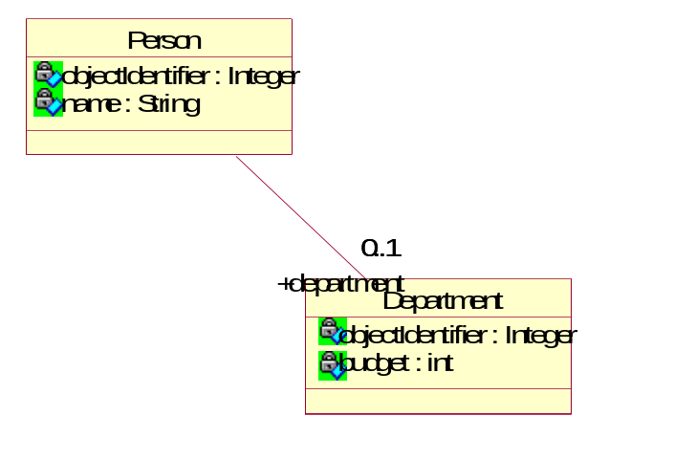

Person
databaseIdentifier : Integer
name : String
department : Department
Department
databaseIdentifier : Integer
budget : int
name : String

In a relational database, associative relationships are accomplished with the use of Foreign Keys. In this example, Person would have a foreign key to Department.

Step 1: Alter our existing Person class.
A) Subclass Domain Object

The new class definition will look like this :
- import com.cboe.infrastructureServices.persistenceService.*;
- import com.cboe.infrastructureServices.foundationFramework.*;
- import java.util.*;
- import java.lang.reflect.* ;
- public class Person extends PersistentBObject {
- protected String name ;
- protected Department department ;

- static Field _name;
- static Field _department ;

- static Vector classDescriptor ;

- static {
- try {
- _name = Person.class.getDeclaredField("name");
- _department = Person.class.getDeclaredField("department");
- }
- catch (NoSuchFieldException e) {
- e.printStackTrace();
- }
- }
- }

As you can see, on line 7, we added a new attribute: The department attribute. The department attribute will be an instance of Department, which we will create shortly. Department will also be a Domain Object.
Notice that on line 9 we also added a java.lang.reflect.Field instance that corresponds to the new attribute.
Then on line 14, we added the initialization of that field into the static initializer. This would have to be done on any new attributes added to a Domain Object. The rest of the class definition is the same.

Next we need to add accessors and mutators for the new attribute. The code for these methods will be very similar to the existing accessors and mutators. Let's take a look at the accessor first:

- public Department getDepartment() {
- return (Department)editor.get(_department, department) ;
- }

and the mutator:

- public void setDepartment(Department aValue) {
- editor.set(_department, aValue, department) ;
- }

No real explanation is necessary here. They are in the same format as the existing accessors and mutators. Only the types and field names have changed.
Now let's look at the initDescriptor() method :

- protected void initDescriptor() {
- synchronized (Person.class) {
- if (classDescriptor != null) return;
- classDescriptor = getSuperDescriptor()
- classDescriptor.addElement(
AttributeDefinition.getAttributeRelation("name", _name));
- classDescriptor.addElement(AttributeDefinition.getForeignRelation(Department.class, "department", _department));
- }
- }
Line 4 introduces a new concept. Not only will do we add another entry to the classDescriptor, but we are also introducing a new attribute type: the Foreign Key. When a Domain Object holds on to a reference to another Domain Object, they are said to have a foreign relation. That relation must be reflected in the classDescriptor. The way to do that is displayed in line 4.

Now let us begin to create our Department Object. Start by creating a file called Department.java.
Now let's add the class definition:

- import com.cboe.infrastructureServices.persistenceService.*;
- import com.cboe.infrastructureServices.foundationFramework.*;
- import java.util.*;
- import java.lang.reflect.*;
- public class Department extends PersistentBObject {
- static Field _budget;
- static Field _name;
- static Vector classDescriptor;
- protected String name;
- protected int budget ;
- static {
- try{
- _name = Department.class.getDeclaredField("name");
- _budget = Department.class.getDeclaredField("budget");
- }
- catch (NoSuchFieldException ex) {
- System.out.println(ex); }
- }
- }

This follows the format laid out by the Person object. Again, all Domain Objects will have the same format. Only the specifics of each will be different.

B) Add mutator and accessor methods
Now let's look at the accessor/mutator pairs. There is not much to discuss about it, just looking at the code should explain enough.
// Accessor for budget attribute
public int getBudget(){
return (int)editor.get(_budget, budget);
}
//Mutator for bugget attribute
public int getBudget(){
return (int)editor.get(_budget, budget);
}

//Accessor for name attribute
public String getName() {
return (String)editor.get(_name, name);
}

// Mutator for the name attribute
public void setName(String aValue){
editor.set(_name, aValue, name);
}

C) Add initializeObjectEditor method
And then the initializeObjectEditor() method must be added.

- public ObjectChangesIF initializeObjectEditor(){
- final DBAdapter result = new DBAdapter(this);
- if(classDescriptor == null) initDescriptor();
- result.setTableName("department");
- result.setClassDescription(classDescriptor);
- return result;
- }

Make sure that in line 4 you have the correct table name once again.

Then we can add the update() method. This will be the same as the update() method in Person :

public void update(boolean get, Object [] data, Field [] fields){
for(int i = 0; i < data.length; i++){
try {
if(get)
data[i] = fields[i].get(this);
else
fields[i].set(this, data[i]);
}
catch(IllegalAccessException ex) { System.out.println(ex); }
catch(IllegalArgumentException ex) { System.out.println(ex);}
}
}

D) Add initDescriptor method
And finally we add the initDescriptor() method.
- protected void initDescriptor() {
- synchronized (Department.class) {
- if (classDescriptor != null) return
- classDescriptor = getSuperDescriptor();
- classDescriptor.addElement(
AttributeDefinition.getAttributeRelation( "name",_name));
- classDescriptor.addElement(
AttributeDefinition.getAttributeRelation( "budget",_budget));
- }
- }

This method is also quite simple. Lines 3 and 4 mark the attributes as simple attributes.
So now we have created a new Domain Object and altered an existing one. So we have our new Person object with a foreign reference to a Department, and we have the Department Object.

Step 2: Setting up the tables in the database.
Now we must setup the database tables to hold on to our new Objects. So first, let us create the new Department table. The department Object will look like this :

Department
databaseIdentifier : Integer
budget : int
name : String

So add a table with the preceding attributes to your existing database. The databaseIdentifier attribute should be the primary key.

Next let's alter the Person table. Your new person Object will look like this:

Person
databaseIdentifier
name : String
department : Department

The only difference between the existing person table and the new one will be the department attribute. So go ahead and add the department attribute and set it to be a foreign key that references department.
Once you have added the tables and attributes, you should then save the new database schema.
After the schema has been altered at any time, you must go through and clear our any data that already exists in your database. We are now ready to test the new Domain Objects.

Step 3: Testing the new Domain Objects.
In order to test the new Domain Objects, we need to create a new Test class. So instead of re-writing the whole Test class, let's just alter the existing one. The changes to be made are to the populate() and the doQueries() methods. Lets look at the populate method first :

A) Insert Data
public void populate() {
BOSession ses = BOSession.createAndJoin(“aName”);
ses.startTransaction();
Department d1 = new Department();
d1.setName("Accounting");
d1.setObjectIdentifier(new Integer(30));
d1.setBudget(23000);

Department d2 = new Department();
d2.setName("Marketing");
d2.setObjectIdentifier(new Integer(31));
d2.setBudget(67000);

Department d3 = new Department();
d3.setName("Shipping");
d3.setObjectIdentifier(new Integer(32));
d3.setBudget(54000);

Department d4 = new Department();
d4.setName("Sales");
d4.setObjectIdentifier(new Integer(33));
d4.setBudget(43000);

Person p = new Person();
p.setName("John Smith");
p.setObjectIdentifier(new Integer(100));
p.setDepartment(d1);

p = new Person();
p.setName("James Doe");
p.setObjectIdentifier(new Integer(101));
p.setDeaprtment(d2);

p = new Person();
p.setName("Tom Jones");
p.setObjectIdentifier(new Integer(102));
p.setDepartment(d3);

p = new Person();
p.setName("Michael Jordan");
p.setObjectIdentifier(new Integer(103));
p.setDepartment(d4);

p = new Person();
p.setName("Sam Sneed");
p.setObjectIdentifier(new Integer(104));
p.setDepartment(d1);

p = new Person();
p.setName("Nick Fitz");
p.setObjectIdentifier(new Integer(105));
p.setDepartment(d2);

try {
ses.commit();
}
catch (UpdateException e) {
ses.rollback();
e.printStackTrace();
}
}

B) Query Data
Now let's take a look at the new doQueries() method :

- public void doQueries() {

- Department d = new Department();
- ObjectQuery q = new ObjectQuery(d);
- d.setName("Accounting");
- String dName = d.getName();
- System.out.println("Querying for departments with name " + dName);

- try {
- Vector v = q.find();
- System.out.println("Found " + v.size() + " department(s) with the name : " + dName);
- for (int i = 0; i < v.size(); i++) {
- d = (Department) v.elementAt(i);
- }
- }
- catch (PersistenceException e) { e.printStackTrace();}

- Person p = new Person();
- ObjectQuery query = new ObjectQuery(p);
- p.setDepartment(d);
- System.out.println("List of all employees in the " + dName + " department");
- try {
- Vector v = query.find();
- System.out.println("Found " + v.size() + " employees in the " + dName + " department");
- for (int i =0; i < v.size(); i++) {
- Person result = (Person) v.elementAt(i);
- System.out.println("Name: " + result.getName() + " Id: " + result.getObjectIdentifier());
- }
- }
- catch ( PersistenceException e) {}

- }

The goal of this query is twofold. First, we want to find all the departments with the name "Accounting" and then we want to find all the employees in those departments. Lines 3-15 accomplish the first half of the query.
Line 2: Creates a blank department.
Line 3: Creates a new ObjectQuery on that department.
Line 4: Sets the value of name (the attribute we will be using to search through the tables)
Line 8: Performs the query and stores the results in a Vector.
Line 9: Prints out the results.
Lines 10-12 loop through the results.

Then once the first half of the query is complete, the next part of the query will find all the employees within the set of departments returned by the first query.
Line 15 creates a blank person.
Line 16 creates a new Query on that person.
Line 17 sets the value of the department we want to match against.
Line 20 performs the query and returns the set of matching instances.
Line 22-25 loops through the results and prints them out.

You now have a complete Test class for Task 2. To execute the class, follow the instructions from Task 1.

If problems arise, and you can not run the class after checking for syntax, then try the following command :

java com.objectwave.tutorial.step2.Test populate
or
java com.objectwave.tutorial.step2.Test query

Task 3 - In Task 3 we will expand further on our existing Domain Objects in order to create an aggregate relationship. This relationship will look like this :

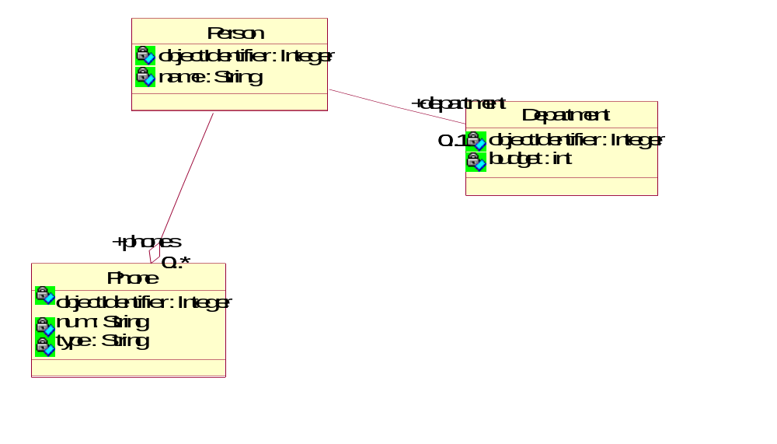

The underlying database will have three tables. The two will be the same as in Task 2, but the new table (the Phone table) will look like this.

Phone
databaseIdentifier : Integer
number : String
type : String
person : Person

Once this new table is added to the database, you should set number to be the primary key and person to be a foreign key to the Person table.
Notice that there is no direct connection from Person to Phones in the database model, even though in the object model, person is hold onto a vector of Phones. Based on the attribute type you will set in the initDescriptor() method (this will be shown later) JGPL will know to update or query this separate table for phones based on the person foreign key in the Phone table.

Step 1 Create Class
A) Subclass Domain Object
Let's start by creating our new Domain Object. The new Domain Object will be a Phone Object. This will represent a Persons Telephone number. A Phone Object will have 4 attributes : databaseIdentifier, number, a type and a person who this number belongs to.

Let's take a look at the class definition.
- import com.cboe.infrastructureServices.persistenceService.*;
- import com.cboe.infrastructureServices.foundationFramework.*;
- import java.lang.reflect.*;
- import java.util.*;
- public class Phone extends PersistentBObject {
- static Field _num;
- static Field _type;

- static Field _person;
- static Vector classDescriptor;

- protected Person person;
- protected String type ;
- protected String num ;
- static {
- try{
- _person = Phone.class.getDeclaredField("person");
- _type = Phone.class.getDeclaredField("type");
- _num = Phone.class.getDeclaredField("num");

- }
- catch (NoSuchFieldException ex) { System.out.println(ex); }
- }
- }

The class definition is pretty simple. It has the attributes and the Fields, and the initialization of the Fields. pretty standard

The constructor for this class is just as simple.

public Phone() {
super();
}
B) Add accessor and mutator methods
And the accessor/mutator pairs need no explanation.

public String getNum() {
return (String)editor.get(_num, num);
}
public void setNum(String aValue) {
editor.set(_num, aValue, num);
}
public Person getPerson(){
return (Person)editor.get(_person, person);
}
public void setPerson(Person aValue){
editor.set(_person, aValue, person);
}
public String getType(){
return (String)editor.get(_type, type);
}
public void setType(String aValue){
editor.set(_type, aValue, type);

C) Add initializeObjectEditor method
And then the initializeObjectEditor() method (all that needs to be changed here is the table name which is reflected below.

public ObjectChangesIF initializeObjectEditor()
{
final DBAdapter result = new DBAdapter(this);
if(classDescriptor == null) initDescriptor();
result.setTableName("phone");
result.setClassDescription(classDescriptor);
return result;
}

D) Add initDescriptor method
And finally, the initDescriptor() method.
- public void initDescriptor() {
- synchronized (Phone.class) {
- if (classDescriptor != null)
- return;
- classDescriptor = getSuperDescriptor();
- classDescriptor.addElement(
AttributeDefinition.getForeignRelation(Person.class, "person", _person));
- classDescriptor.addElement(
AttributeDefinition.getAttributeRelation("type", _type));
- classDescriptor.addElement(
AttributeDefinition.getAttributeRelation("num", _num));
- }
- }

The main thing to understand here is in Line 6. The Person attribute is a foreign key. It refers to the Person table.

E) Add update method
Then we should add the update() method which is also quite standard.
public void update(boolean get, Object [] data, Field [] fields)
{
for(int i = 0; i < data.length; i++){
try{
if(get)
data[i] = fields[i].get(this);
else
fields[i].set(this, data[i]);
} catch(IllegalAccessException ex) {
System.out.println(ex);
}
catch(IllegalArgumentException ex) {
System.out.println(ex);
}
}
}

And there you have a new Phone Domain Object.

The Department object from the previous examples will remain the same. There are no changes to be made. So let's move on to the Person object. The new class definition will look like this:

- import com.cboe.infrastructureServices.persistenceService.*;
- import com.cboe.infrastructureServices.foundationFramework.*;
- import java.util.*;
- import java.lang.reflect.* ;

- public class Person extends PersistentBObject {
- protected String name ;
- protected Department department ;
- protected Vector phones = new Vector() ;

- static Field _name;
- static Field _department;
- static Field _phones;
- static Vector classDescriptor;

- static {
- try {
- _name = Person.class.getDeclaredField("name");
- _department = Person.class.getDeclaredField("department");
- _phones = Person.class.getDeclaredField("phones");
- }
- catch (NoSuchFieldException e) {
- e.printStackTrace();
- }
- }
- }

The Person object now contains a new attribute. This new attribute is the phones Vector. This kind of attribute is known as a collection. It is a collection because it can contain multiple values (or instances of a Domain Object). In this particular example, the Person Object has a collection of phones because any person may have 0 or more phone numbers. A Person may have a home number and a fax number and a pager, etc. Since one attribute can not hold on to many different instances of a Domain Object, we instead add a collection attribute (in this case a Vector) that can hold many different instances of a Domain Object.

Once the class definition is modified, we must then add accessors and mutators for the new attributes. So lets take a look at those.

public Vector getPhones(){
return (Vector)editor.get(_phones, phones);

public void setPhones(Vector aValue) {
editor.set(_phones, aValue, phones);
}

Nothing to discuss about these methods. They conform to previous standards.
The next method that has changed is the initDescriptor() method.

- public void initDescriptor() {
- synchronized (Person.class) {
- if (classDescriptor != null) return;
- classDescriptor = getSuperDescriptor();
- classDescriptor.addElement(
AttributeDefinition.getAttributeRelation("name", _name));
- classDescriptor.addElement(AttributeDefinition.getForeignRelation(Department.class, "department", _department));
- classDescriptor.addElement(AttributeDefinition.getCollectionRelation(Phone.class, _phones));
- }
- }

Line 7 is the only change in this method from the previous. If we have a collection relation, we need to specify that in the classDescriptor. The way to do that is shown in line 7. The convenience method used is AttributeDefinition.getCollectionRelation(Class c, Field f);
The arguments of this method are :
c - the Class of the object that will be contained in this collection.
f - the java.lang.reflect.Field which corresponds to the attribute variable.

That is all that is necessary to designate an attribute as a collection. The rest of the method is the same as in the past.

The final method that we should add to our new Person Object is a convenience method. We will call it the addPhone() method. It will implement the addition of a Phone to a Person's collection of Phones. Let's take a look at the method:

- public void addPhone(Phone p) {
- p.setPerson(this);
- getPhones().addElement(p);
- }

Line 2 sets the current Person as the owner of the Phone passed to the method. This must happen in order for javaGrinder to properly understand the collection relation. If this step is not performed, the Person attribute of the Phone table in the database will not be filled out properly and thus any queries will produce improper results.
Line 3 adds the Phone to the collection of phones. This Line of code would vary depending on the structure of the Collection class and the API that the collection class uses.
I would recommend adding a convenience method to any Domain Object that contains a collection relation. The reason for this is to hide the underlying structure. Anyone who uses your Domain Objects should not know or care about what the underlying collection class is.

And that is your new Person Object. So now all we have left to do is to test it.

Step 2- Database table changes
So before we talk about the test class, we should go thorough and clear out any entries in the existing tables in our database.

Then we need to add the new Phone table. This table will look like this:

Phone
databaseIdentifier : Integer
number : String
type : String
person : Person

The number should be the primary key, and person should be a foreign key to the Person Table.

No other tables need to be altered. On the database side, the department and and the Person tables remain the same.
Step 3 - Test class changes
A) Insert data
Now lets alter the Test class. The only method that will change, obviously will be the populate() and the doQueries() methods.

Let's look at the populate() method first.
- public void populate() {
- BOSession ses = BOSession.createAndJoin(“aName”);
- ses.startTransaction();

- Department d1 = new Department();
- d1.setName("Accounting");
- d1.setObjectIdentifier(new Integer(30));
- d1.setBudget(23000);

- Department d2 = new Department();
- d2.setName("Marketing");
- d2.setObjectIdentifier(new Integer(31));
- d2.setBudget(67000);

- Department d3 = new Department();
- d3.setName("Shipping");
- d3.setObjectIdentifier(new Integer(32));
- d3.setBudget(54000);

- Department d4 = new Department();
- d4.setName("Sales");
- d4.setObjectIdentifier(new Integer(33));
- d4.setBudget(43000);

- Phone p1 = new Phone();
- p1.setType("fax");
- p1.setNum("708-413-3124");
- p1.setObjectIdentifier(new Integer(1));

- Phone p2 = new Phone();
- p2.setType("home");
- p2.setNum("773-890-0012");
- p2.setObjectIdentifier(new Integer(2));

- Phone p3 = new Phone();
- p3.setType("home");
- p3.setNum("312-459-0899");
- p3.setObjectIdentifier(new Integer(3));

- Phone p4 = new Phone() ;
- p4.setType("home");
- p4.setObjectIdentifier(new Integer(4)) ;
- p4.setNum("312-413-0098");

- Person p = new Person();
- p.setName("John Smith");
- p.setObjectIdentifier(new Integer(100));
- p.setDepartment(d1);
- p.addPhone(p1);
- p.addPhone(p2);

- p = new Person();
- p.setName("James Doe");
- p.setObjectIdentifier(new Integer(101));
- p.setDepartment(d2);
- p.addPhone(p3);

- p = new Person();
- p.setName("Tom Jones");
- p.setObjectIdentifier(new Integer(102));
- p.setDepartment(d3);
- p.addPhone(p4);

- try {
- ses.commit();
- }
- catch (UpdateException e) {
- ses.rollback();
- e.printStackTrace();
- }

- }

Line 3 actually creates a new Transaction (this is review).
Lines 4-7, 8-11, etc. create new Departments
Line 20-23, 24-27, etc. create new Phones

Lines 36-41 create a new Person. Let's examine these lines more closely.
Line 36: Create a new blank person.
Line 37 sets the name of the persoin.
Line 38 sets the databaseIdentifier.
Line 39 sets the department of the person (one of the departments we created earlier in the method).
Line 40 adds a Phone (one that was created earlier in the method) to the collection of phones via the convenience addPhone() method.
Line 41 adds another Phone to the collection of phones.
This is repeated for each person.

Line 53: We commit the changes and it all gets written to the database.

And that is the new populate method.

B) Query data
Now let's see the doQueries() method.

- public void doQueries() {

- Department d = new Department();
- ObjectQuery q = new ObjectQuery(d);
- d.setName("Accounting");
- String dName = d.getName();
- System.out.println("Querying for departments with name " + dName);

- try {
- Vector v = q.find();
- System.out.println("Found " + v.size() + " department(s) with the name : " + dName);
- for (int i = 0; i < v.size(); i++) {
- d = (Department) v.elementAt(i);
- }
- }
- catch (PersistenceException e) { e.printStackTrace();}

- Person p = new Person();
- ObjectQuery query = new ObjectQuery(p);
- p.setDepartment(d);
- System.out.println("List of all employees in the " + dName + " department");
- try {
- Vector v = query.find();
- System.out.println("Found " + v.size() + " employees in the " + dName + " department :");
- for (int i =0; i < v.size(); i++) {
- Person result = (Person) v.elementAt(i);
- System.out.println("Name: " + result.getName() + " Id: " + result.getObjectIdentifier());
- Vector newVector = result.getPhones();
- System.out.println(result.getName() + "'s Phone Numbers :");
- for (int j = 0; j < newVector. size(); j++ ) {
- System.out.println("\t" + ((Phone)newVector.elementAt(j)).getNum());
- }

- }
- }
- catch ( PersistenceException e) {}
- }

This is a 3-part query. It is meant to find every department with the name "Accounting", then find everyone in that department, and then print out the phone numbers of everyone in the account department.

The first two parts are the same as the previous example query. What has been added is in lines 23-30.
Line 22 and 23 cycles through the people in the accounting department.
Line 24 prints out the name.
Line 25 gets the collection of phones that this person has. Notice you don’t have to manually query the phones. That is because of the Collection Relation that we specified in the classDescriptor. Once we specify a collection in the classDescriptor, JavaGrinder will then go through and query the collection values on its own.
Line27 then traverses through the phone numbers while line 29 prints them out.

So now you have written 3 examples using Domain Objects. You are now well on your way to writing persistent objects using the JavaGrinder Persistence Layer.

Things not covered:
Support for nested transactions
Support for multiple transactions updating the same Transactional object

Although the attribute databaseIdentifier was not added to the Domain Object in this tutorial, it is an inherited attribute from com.cboe.infrastructureServices.persistenceService.DomainObject. It is the most important attribute as well. Every instance of a Domain Object must have a unique databaseIdentifier. It can be thought of as a primary key, except that in the table setup, you need not select databaseIdentifier as the primary key. (Any field in the table which will also be unique may be chosen as the primary key)
Not all instance variables are considered attributes. When the term "attribute" is used it implies that this variable holds information about the state of Domain Object. Other variables such as temporary, swap, or counter variables that do not contain information about the state of the Object should be marked as transient and should not have a corresponding java.lang.reflet.Field variable.
Although I state that any .ini file can be read ,the file must be located somewhere in the classpath or in a jar file
In this case we are using a Vector for our collection. But we are not tied in to Vector. We could use an array or some other type of collection class. As of right now though Vector and array are the only supported collections.
Even though we added an attribute we still do not need to alter the database table. The reason for this is that we added a collection attribute that can not be displayed in the database table. Therefore the only indication of the assosciation between Person and Phone will be the foreign key in Phone

