Rose Model Viewer
Defining a script in the Rose Model 3
Variable substitution 3
Viewing the State Machines defined in a Rose Model 5
Saving sequences from the Sequence Viewer 6

Defining a script in the Rose Model
Scripts are stored in the documentation section of the States/Transitions.
There are 2 "sections" of the documentation section:
The variable declarations and the script definition.
Variables are defined by the "DATA" keyword. The format for defining variables is the following:

DATA:
<var>: <value1>, <value2>, <value3>
endata

So, if you wanted to define 2 variables:
variable "x" which will have the values 1-3
variable "y" which will have the value 19

It would look like this:

DATA:
x: 1,2,3
y: 1
endata

Note: DATA must be in all capitol letters, and the colons (:) are NOT optional.

The script definition section is similar in format. Scripts are defined using the "define" keyword. The format is the following:

define <scriptname>:
//Text of script goes here
endef

You can define as many scripts in the documentation section as you like

Defining guards on State Transitions

Guards are test cases that will or will not allow a path to continue. Guards are defined in the "Condition" part of the State Transition. The guard should be a boolean test case. If the guard evaluates to true, (see Variable substitution ) then this transition will be added to the path (as well as the script being added to the current script). If the guard evaluates to false, then the sequence ends there and we go a different path (and a different sequence)

Variable substitution

In the data section of each state/transition, we may have defined some variables. For each possible value of the variables, the system replaces the variable with those values in the script. (This is also true for guards). For example, if you have defined the variable x with the possible values of 1,2,3 and you had the following script:

define Example:
print(%x);
endef

This will guarantee at least 3 additional sequences. One for each value of x :

If there is more than one variable defined, they are substituted together, as compared to nested. For example if you had a

x: 1,2,3
y: 9,8,7
z: 6,5,4

There would be 3 sequences with the value sets:

{1,9,6}
{2,8,5}
{3,7,4}

Note, if one variable has less values than the others, the last value of the variable is carried over to the next iteration.

Defined variables are visible by other states further down the tree. They will assume the value they were currently at when the system moved down the tree.

Example:

The Start state defines the following script.

DATA:
x: 1
endata

define Example2:
print(%x);
endef

That state has one transition that defines the following scripts

DATA:
var: 1,2
endata

define Example2:
print(%var);
print(%x);
endef

When the system traverses down this tree, the sequences produced by this would look like this:

sequence 1:
print(1); <===== produced from the Start State
print(1); <===== produced from the Transition
print(1); <===== produced from the Transition

sequence 2:
print(1); <===== produced from the Start State
print(2); <===== produced from the Transition
print(1); <===== produced from the Transition

As you can see, the x had a value of one when the system traversed down to the transition. That value of x was then used in the transition script. Any previously defined variables defined higher up the tree are visible to lower states/transitions. Its value is the same as it was before the system travered down the tree.

Running the Model Viewer
Start the model viewer with the “java com.cboe.scriptGenerator.ModelViewer” command. From the File menu, select load. Select the rose mdl or cat file that contains the State Diagrams from which you will be generating code.

Viewing the State Machines defined in a Rose Model
First select the "Load" option from under the "File" menu.
Next a FileDialog opens up. Select the Rose model file you wish to inspect.
All State Machines contained within that model will then be displayed.
Expand the State Machines to see the states with in the selected state
machine.
(See figure below)

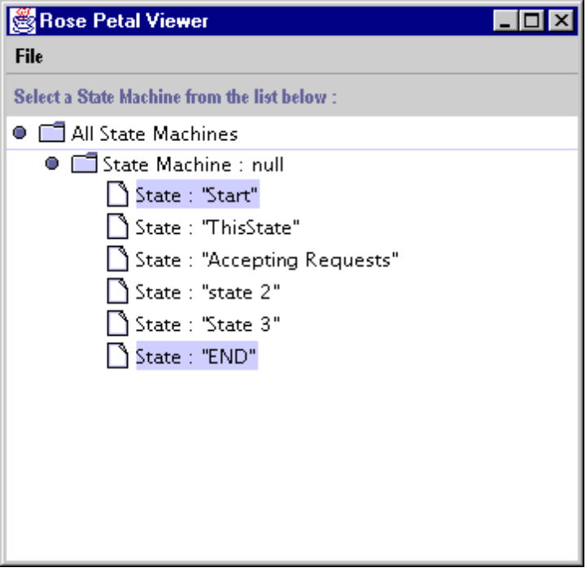

Viewing paths between states
In the tree view of the states, you can select any two states that you want to view the paths between. Select a start state by clicking on it. Then, press and hold control while simultaneously clicking on another state in order to select and end state. Once you have selected your start and end states, you will be prompted for a script name to generate. Type in the script name and then all possible paths will be displayed in a new window.
(See figure below)

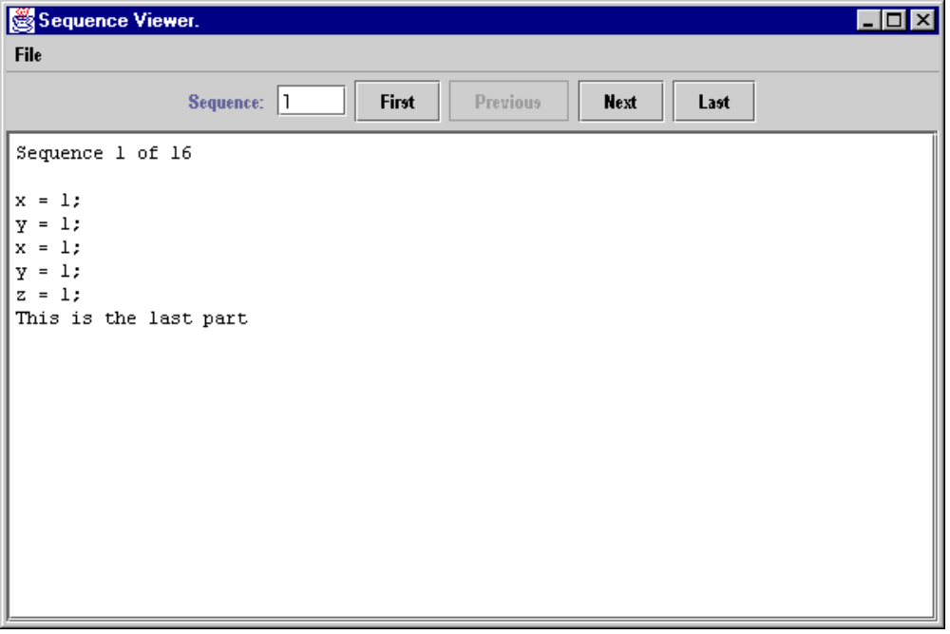

Saving sequences from the Sequence Viewer
From the sequence viewer's "File" menu, select the "Save" Option.
At this point you will see a split screen with all the possible sequences displayed.
Select on the left, the sequences you want to save and then press the ">" button to move those selections to the right side. Then press the "OK" button. At which point the system will prompt you for a prefix name.
Enter the prefix name and press ok. The system will then store all the sequences in separate files, prefixed with the prefix name specified.

Class Diagram

