AIM Auto Match with Limit

Overview:
Objectives
The goal of the Early Close by Product project is to allow AIM contras to have better control over the Auto match price.

Current Processing
- Auto Match order (MKT) trades with the PO along with responses at all price points. If no responses are available during the trade then it will trade out with the Primary Order.
- When an AIM submitter uses Auto match functionality, the AIM system automatically matches the best price submitted by any AIM responder.
- Auto match order is not applicable for AIM AON
New Requirement
- An Auto Match (MKT) order will have an option to specify a cap price from which point they would like be included in the trades, provided as a contingent price in the order.
- Auto match with Limit will be applicable for Simple, Complex and Cross Product AIM.
- If a responders’ price improves the Auto match limit price, there will be no Auto match at that price and the responder(s) will get the entire allocation.
- The Match Order will continue to match all responders as long as the Match Order’s Price cap (from the Contingency Price field) is not violated

AIM Opt Out

Overview:
Objectives
The goal of the Early Close by Product project is to allow AIM contras provide priority to other participants in allocation by choosing not to participate in responses trading with primary order.
Current Processing
- Auto Match order (MKT) trades with the PO along with responses at all price points. If no responses are available during the trade then it will trade out with the Primary Order.
- When an AIM submitter uses Auto match functionality, the AIM system automatically matches the best price submitted by any AIM responder.
- Auto Opt Out is not applicable for AIM AON
New Requirement
- Reject Opt Out AIM Orders for below :
  - Reject AIM Opt out with Limit Price.
  - Reject AIM Opt Out with AON contingency
  - QCT orders with Opt Out are rejected [Cancelled]
  - AIM C-C Opt Out orders with standard price increments are rejected [Canceled]
- An Auto Match (MKT) order will have an option to opt out of trading with the primary orders if the responses can satisfy trading with primary order
- Opt out AIM orders is applicable for Simple, Complex and Cross-Product orders.

Existing Flow for Simple AIM:

Process Auction Expire
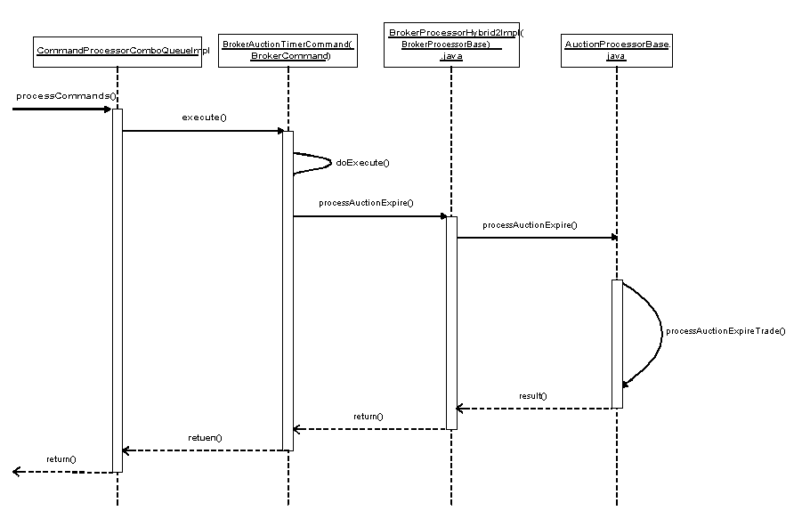

- BrokerAuctionTimerCommand is executed once timer is expired. This command will pass control to the appropriate broker assigned to a class and to process expiration of an auction.
- AuctionProcessorBase.java is a service which process auction validation, calculating of starting price for the auction and process auction trade once timer is expired.
AIM Processing (Creating Auction Trade)
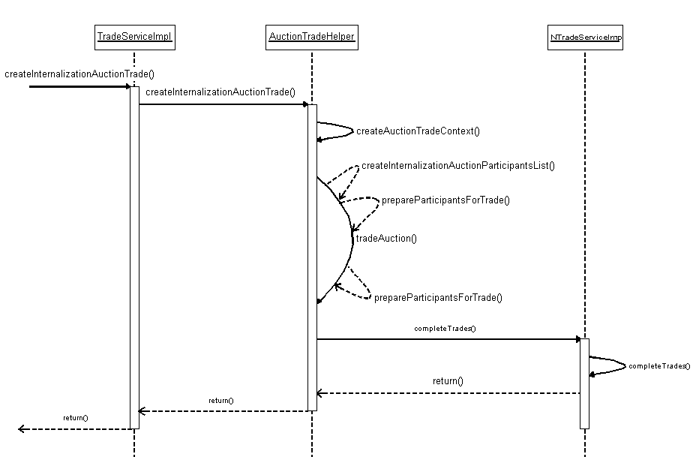

- TradeServiceImpl.java is the service where all trades are performed based on the trading rules defined in the trade service. It determines the type of trade and accordingly decides either the same side or opposite side incoming tradable should trade with an auction based on their prices and other business rules.
- AuctionTradeHelper.java It determines the trade context, creates the auction participants list. While creating an auction participant list it creates a priority set which determines which orders can participate in the trade. Currently we perform equal quantity matching for auction response orders and match order to fulfill the total quantity of the primary order. For auction response orders, orders are sorted according to best price. Then starting from first best price order, we take equal quantity from match order for each price point and allocate it to primary order. If the quantity of primary order is not fulfilled then we repeat the same steps until the primary order quantity is exhausted or auction responses quantity is exhausted. Further it passes these lists to Trade Service to complete the trade.

Existing Flow for Complex AIM:

Process Auction Expire
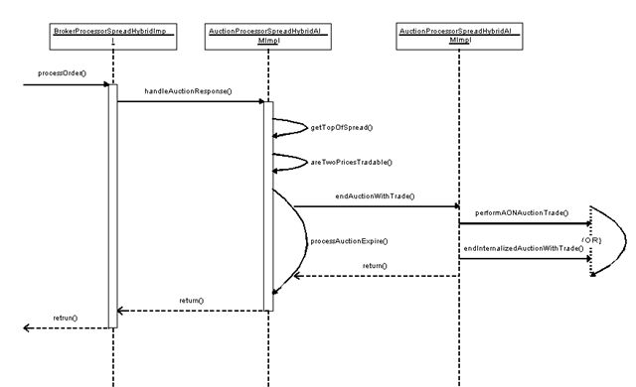

- BrokerProcessorSpreadHybridImpl.java is an entry point for the spread order. It is also the entry point for the spread auction response orders. It then gets the different processors to handle these orders.
- AuctionProcessorSpreadHybridImpl.java is a service which handles the auction and auction responses for the spread orders. At auction termination it performs the auction trade. It determines different complex orders with different contingencies and handles them differently.

AIM Processing (Creating Auction Trade)

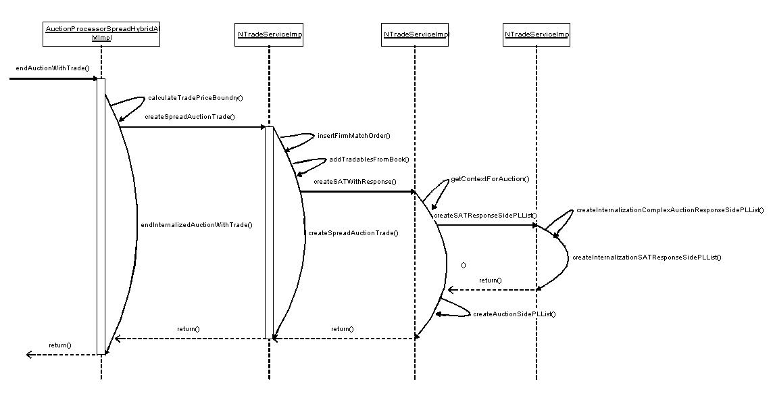

- AuctionProcessorSpreadHybridImpl.java handles AIM orders with no contingency differently. It calls the trade service to perform the trade.
- NTradeServiceImpl.java is a service which performs auction trade for orders. For AIM orders with no contingency it creates a participant list to allocate the tradable. Currently we perform equal quantity matching for auction response orders and match order to fulfill the total quantity of the primary order. For auction response orders, orders are sorted according to best price. Then starting from first best price order, we take equal quantity from match order at each price point and allocate it to primary order. If the quantity of primary order is not fulfilled we repeat the same steps until the primary order quantity is exhausted or auction responses quantity is exhausted.

Existing Flow for AIM AON:

AIM Processing (Creating Auction Trade for complex orders with AON contingency)
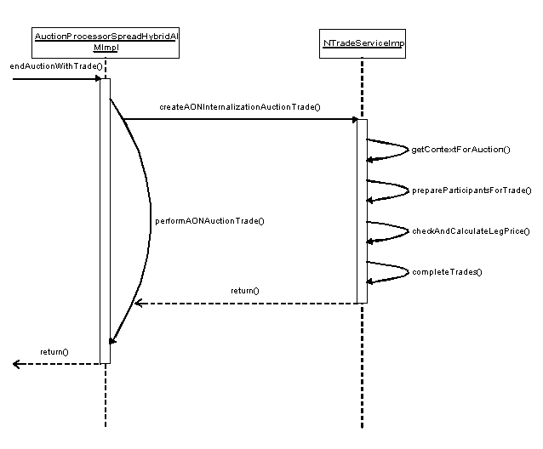

- AuctionProcessorSpreadHybridImpl.java handles AIM orders with AON contingency differently. It calls the trade service to perform the trade with AON contingency.
- NTradeServiceImpl.java is a service which performs auction trade for orders. For AIM orders with AIM contingency it creates a participant list to allocate the tradable. In current approach, from auction response orders we prepare two lists one for better price orders than market order price and one for equal price orders than market orders. If we can fulfill the quantity of primary order with total quantity of better price orders than market order is set for cancellation else market order is trades with primary order.

AIM Processing (Creating Auction Trade for simple orders with AON contingency)

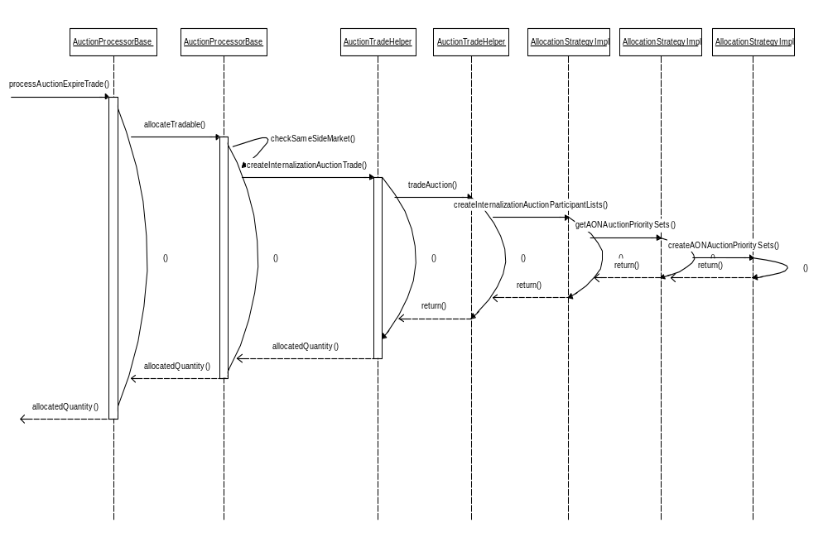

- AllocationStrategyImpl.java is a service which creates a participants’ list for the tradable orders for AIM AON auction. It then calculates the best price quantity available from the auction response orders. It then decides if sufficient best price total quantity can satisfy primary order quantity or else proceeds with trading match order with primary orders and cancel the auction responses.

Existing Flow for Cross Product:

AIM Processing (Creating Auction Trade for complex cross product orders)
- The flow for the cross product orders without AON contingency is same as for the complex product orders without AON contingency.

Implementation Approach:

Pseudo Code for Simple AIM Orders:

When Simple AIM trades with responses, Order Book Item and Match order, priority sets would be created based on the prices and quantities. For each price point Match order will be divided as per the quantity. For “Auto Match with limit”, we will not include Match order if response prices are better than the Auto match contingency price. In case of “Opt Out”, match order will be removed from the tradable list until all responses are traded.

while ((priceItems.hasNext() ||auctionResponsePriceItems.hasNext() ||firmMatchPriceItem != null
|| !prices[1].isNoPrice() || (!incomingOppositeTradableIsDone && !prices[0].isNoPrice())
) && volumeConstraint > 0 )
{
……….
……….
……….
AuctionTradeHelper.determineToIncludeMatchOrder(aContext, orderBookPriceItem, auctionBook, bestResponsePriceItem, theSide);
………..
………..
if(!aContext.getIgnoreMatchOrder()){
inputItrs[1] =currentFirmPriceItem.getPriceDetails();
}
…………
…………

// I f there is still Qty remaining after are AREs traded, reset IgnoreMatch flag to include it to trade remaining of PO before its cancelled
…
if(volumeConstraint >0 && firmMatchPriceItem == null) {
if (!aContext.getIgnoreMatchOrder()) {
firmMatchPriceItem = auctionBook.getFirmMatchedPriceItem();
}
}

}

Pseudo Code For Complex AIM Orders

When Complex AIM trades with responses, Order Book Item, match order and response side tradable list would be prepared based on the prices and quantities. For each price point Match order will be included based on the quantity to match up the responses. In this project system will not include Match order if response prices are greater than the Auto match contingency price. In case of “Opt Out” match order will be removed from the tradable list until all responses are traded.

while (auctionSideAvailableQ > 0 && responseSideTradables.size() > 0)
{
Price price = responseSideTradables.get(0).getPrice();
boolean isOptOutFirmMatchOrder = ((OrderImpl)firmMatchOrder).isOptOutFirmMatchOrder();
……….
……….
if(isOptOutFirmMatchOrder)
{
excludeFirmMatchIfOtherAvailable(tradableForAllocation,
responseSideTradables, responseSide);
}
………..
………..
if (tradableForAllocation.size() > 0) {
if (autoMatch && isValidAutoMatchWithLimit(price, responseSide,
firmMatchOrder))
{
getAutoMatchTradable(endTradingPrice,price, responseSide,
tradableForAllocation, firmMatchOrder,
auction.getFirmMatchOrder().getQuantityAllowed());
}
}
…………
…………
}

private void excludeFirmMatchIfOtherAvailable(TradableList currentTradablesList, TradableList aResponseSideTradables, Side responseSide) {
………..
for(int i = 0; i < currentTradablesList.size(); i++ ) {
tradable = currentTradablesList.get(i);
………..
}
if(currentTradablesList.size() > 1 && foundMatchOrder) {
currentTradablesList.remove(indexOfMatchOrder);
insertTradable(tradable, aResponseSideTradables, responseSide);
}

}
}

