API Enhancement SCRUM Feature #1 – Top of the Market – GUI Visual Design

There are a number of possibilities for how the customer and professional sizes for top of the market could be visually presented to the SBT user. Note that there are 4 new sizes to be displayed per single row:
- Market’s (asking) professional quantity at the best offer price
- Market’s (asking) customer quantity at the best offer price
- Market’s (bidding) professional quantity at the bid price
- Market’s (bidding) customer quantity at the best bid price

The current Market Display:

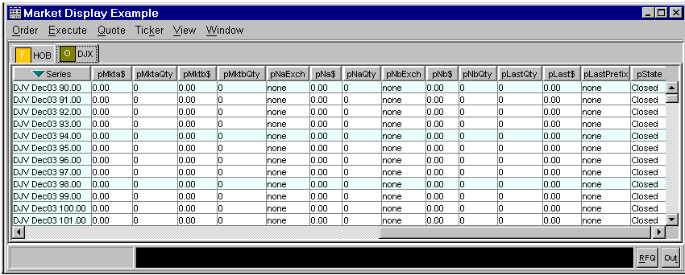

Proposal #1: Adding the two new sizes to the current market’s total quantity at the best price. This would add no new columns to the market display window and instead add two new values to the existing column:

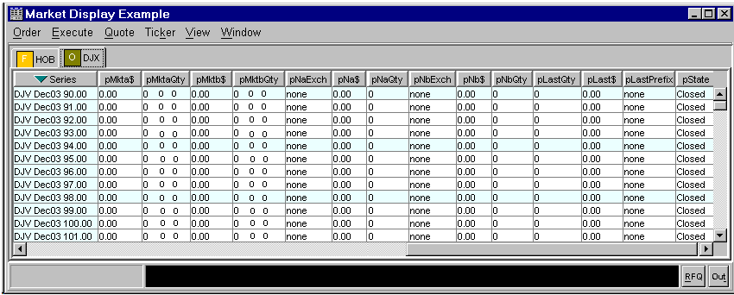

Note that in this layout, it is possible or probable that columns may not line up exactly. This is due to proportional font’s spaces and number characters have variable width. Also, if the ordering of the numbers does not sufficiently provide enough meaning for the user, it could be easy to add additional characters for formatting the three numbers, for example:
- T:0 P:0 C:0 or T-0 P-0 C-0 for Total, Professional, and Customer
- 0+0*(0) formatting as described for contingency order quantities in the SBT System Functional Specification section 10.3.1

Proposal #2: Add two new columns, one for the new asking customer and professional quantities and another column for the bidding new quantities. The two new column titles added below are: pMktaCPQty and pMktbCPQty, but these titles could be changed to whatever is desired. Adding two new columns would take somewhat more time to implement in the GUI and also requires a new task for preference conversion:

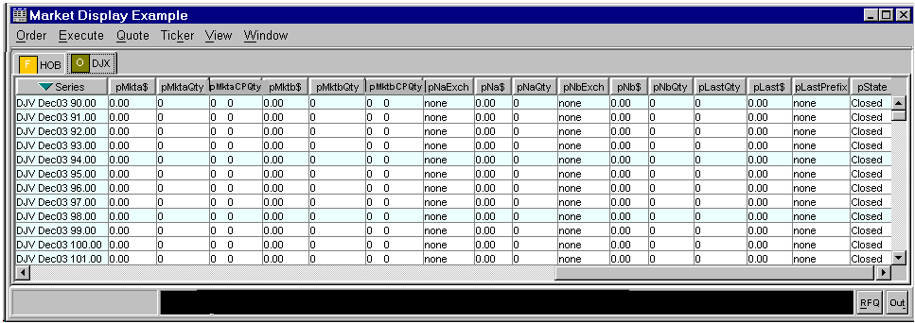

Proposal #3: Add each new size in its own individual column. The four new column titles added below are: pMktaPQty, pMktaCQty, pMktbPQty and pMktbCQty, but these titles could be changed to whatever is desired. Implementation time would be similar to proposal #2:

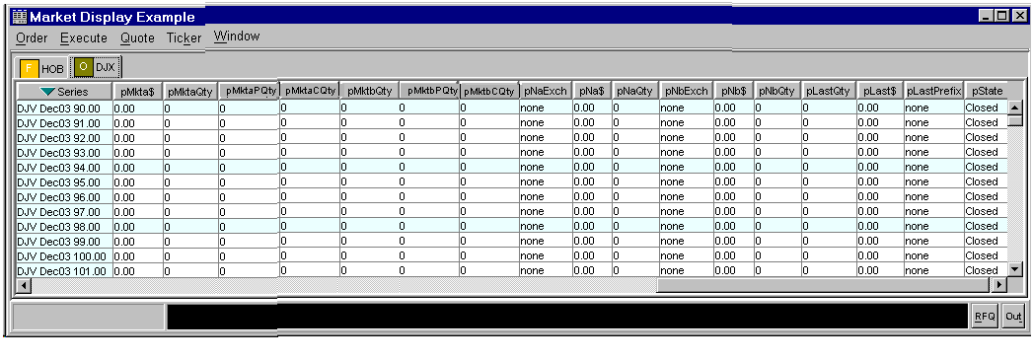

Three other choices need to be made:
- what should be displayed if the customer or professional quantity is not present (given by the CAS): 0 (zero) or leave blank? The above mock-ups display zero.
- the location (order) of the added columns (by default) when initially displayed
- for each new column added, whether it is visible by default or invisible

