

Component Description

7/25/2002

Table of Contents
Table of Contents 1
Table of Figures 1
Introduction 2
Logical View 3
Logical Packages 5
Presentation Services Package 5
Application Services Package 7
Business Services Package 14
External Integration Services 19
Event Channels 21
Infrastructure Services 23
Frameworks and Design Patterns 32
Foundation Framework 32
Internal Event Channel Framework 39
Message Translator Framework 39
Thread Pool Framework 39
Callback Framework (Observer Pattern) 39
Adapter Framework 40
Static/Dynamic Dispatching (Dispatcher/Concentrator/Broker) 40
Smart Proxy 41
Snapshot and Changed Events 43
Documentation and Models 44
Development 44
Operations 45
Systems Administration 45
Software 47

Table of Figures

Figure 1 System Logical Components and Context 3
Figure 2 SBT System Logical View 4
Figure 3 Presentation and Application Services Components 8
Figure 4. Foundation Framework Components Overview 34
Figure 5. Service Invocation 38
Figure 6 Adapter pattern 40
Figure 7 Dispatcher pattern 41
Figure 8 Smart Proxy pattern 42
Figure 9 Snapshot and Changed Events 43

Introduction
This document addresses the logical architecture of CBOEdirect™. It provides a description of the logical components, and addresses the functionality in each of the application packages.

Logical View
The diagram below shows the top-level logical structure and context of the SBT System (CBOEdirect™).
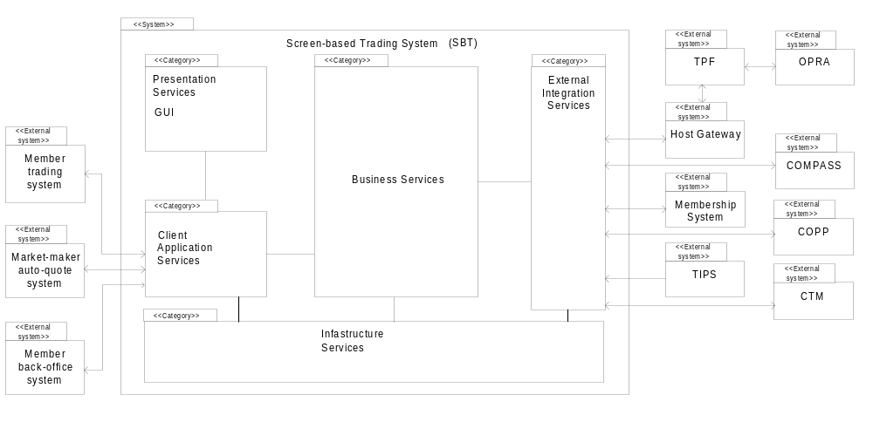
Figure 1 System Logical Components and Context
The CBOEdirect™ system is comprised of the following five logical packages of functionality (“Class Categories” in UML terminology):
- Presentation Services (GUI)
- Application Services (Client Application Server, Gateway)
- Business Services
- External Integration Services
- Infrastructure Services
The Presentation Services (GUI) package is constituted by applications that interact with the SBT system via the CBOE Market Interface (CMi) API described later. There are two types of client applications, those that provide a GUI to allow user interaction with the system directly and applications that automate trading functions.
The Application Services package contains subordinate packages that forward requests initiated by human or automated actors, to be executed by the appropriate Business Services package(s). In addition, the Application Services packages maintain instantaneously updated views that reflect the prevailing state of each actor’s information in the Business Services package.
The Business Services package contains the core functionality of the SBT system. It includes components that correspond to the key business object model entities of screen-based trading such as members, orders, books, products, quotes, et cetera. In addition, it includes components to administer and operate the SBT system.
The External Integration Services package consists of adapters that map the interaction paradigms of external systems to the ones in the SBT system architecture.
Finally, the Infrastructure Services package contains Commercial Off-the-Shelf Software (COSS) and extended infrastructure services that provide enterprise-wide support to CBOE systems.
Figure 2 SBT System Logical View below shows the detailed logical components of the SBT System and their key interactions within the system and with external systems.
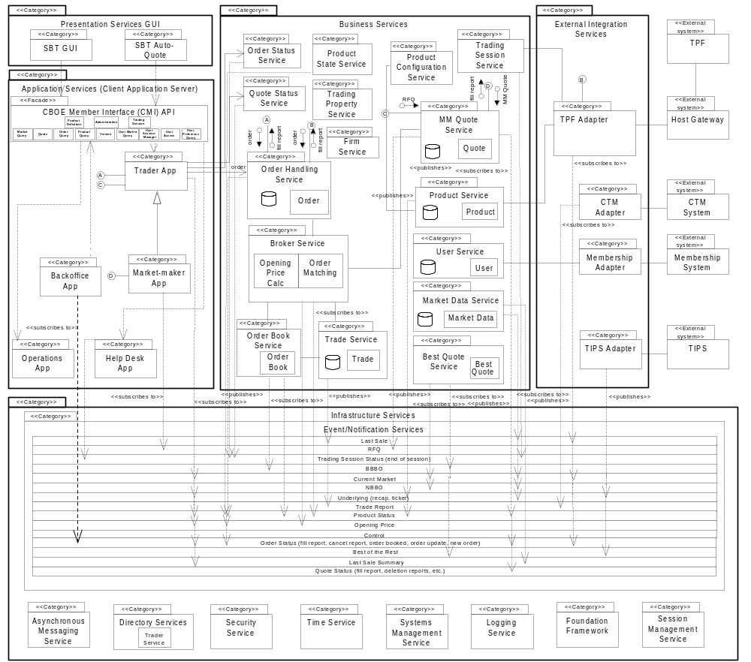
Figure 2 SBT System Logical View

Logical Packages
The following section describes the responsibilities of the subordinate packages in each of the top-level packages.

Presentation Services Package
The Presentation Services package contains six subordinate packages:
- SBT GUI – contains GUI applications to allow human actors interaction with the SBT system
- Models – contains MVC models
- Internal Event Channel
- Registered Callback Listeners
- API Translator

SBT GUI
The SBT GUI display is based on the model-view controller pattern. The SBT GUI Display is responsible for displaying the contents of a particular model to the screen and updating the display if the model’s contents change. This package contains several GUI applications, one for each of the major classes of human actors that use the SBT System: traders, market-makers, clearing firm brokers, firms, and system operators.
- Trader GUI – is used by regular traders. It consists of several GUI’s for displaying and entering orders, and market data.
- Market-Maker GUI – is an extension of the Trader GUI and is used by market-makers. It consists of several GUI’s for displaying and entering orders, quotes, and market data.
- System operation GUI – is used by system operators and help desk operators
- Class Display GUI – is a subset of the Trader GUI that provides access to market data only.

A GUI framework is implemented here to promote the consistency in look and feel and speed up the GUI development work.

Models
Certain models including product class, product and order/quote models are singletons within a distinct GUI application and thus will be shared among multiple frames and panels. For the purpose of speed of display, each market data display panel/frame has its own copy of a market data model and underlying model for those products in which a particular frame is interested. Each model that can be updated by a remote event implements the EventChannelListener interface.

Internal Event Channel
The internal event channel is a pattern that is based on Java custom events. For each type of custom event that can be registered, a model (EventChannelListener) can be added as a listener to the Event Channel. When a remote event is received, it is routed to the correct channel and all listeners of that channel are notified of the event and passed any user defined data that wants to tag along with the event. The internal event channel exists in its own thread and has a queue.

Registered Callback Listeners
When a remote method is called on the CAS/CMi, an optional callback object can be passed which then registers the Presentation Services for any update “callback” messages from the CAS/CMi. There is one listener for each type of message that can be received. When a listener receives a message from the CAS/CMi, it will forward the message to the appropriate “Internal Event Channel” where it will then be forwarded to any interested event channel listeners. Each callback listener lives in its own queued thread.

API Translator
The API Translator is responsible for hiding the complexities of communication with the CAS from the GUI and Models. All remote requests by the GUI go through the translator. The translator will take a request for data, register the Event Channel Listener, and create and pass the callback listener. It also keeps track of the user data so that the GUI does not need to supply it when making remote calls.

SBT Auto-Quote
This package contains a single application that duplicates the functionality of the auto-quote generation engine currently used by market-makers in CBOE’s trading floor posts.
The SBT Auto-Quote application will run remotely on the market-maker’s computer to comply with the “fairness in trading” requirement – if it ran centrally, market-maker’s would have an advantage over other traders as a result of reduced latency. Only the parameters for calculating auto-quotes are saved centrally to allow market-maker’s to move from one workstation to another. The SBT Auto-Quote will use the CBOE Market Interface API and will input quotes to the Market-Maker Application.
SBT’s own auto-quote facility should not be confused with the proprietary auto-quote facilities of market-makers, which will also utilize the CBOE Market Interface API. The SBT System is not responsible for storing the calculation parameters used by these proprietary auto-quote facilities, but only to accept orders, and quotes.
Note: SBT Auto-Quote will not be available in SBT Version 2.0.

Application Services Package
The Application Services package contains an application for each human actor in SBT. These applications submit requests to Business Services components, notify clients of business events, and maintain user-specific views of information in the Business Services.
This package encompasses a CBOE Market Interface (CMi) API that provides a single entry point to the system exposing the applications in the Application Services Package (i.e., Trader, Market-Maker). CBOE has chosen to support two different application programming interfaces. The first is a robust, full function API using the CORBA/IIOP protocol. This version of the API is intended for market makers and traders that plan on using high bandwidth functions, such as market data, and in the case of market makers, auto-quotation facilities.
Retail firms and some institutional customers will be interested in adopting the CBOE API FIX (Financial Information Exchange Protocol) Protocol version. CBOE is providing this protocol based upon the wide acceptance of FIX (4.2) as a standard for order entry, request for quotation (indication of interest), and execution reporting. The FIX Protocol is an industry standard created by retail and institutional investors for the trading of securities. The FIX protocol was extended to support derivatives in Version 4.1. The FIX protocol was originally designed to automate much of the trading that was done over telephone by providing messages for indications of interest, quotations, orders, and execution reports. The protocol was extended to the point where it is feasible to use this protocol for electronic trading from a retail or institutional perspective.
The FIX Protocol is implemented over the TCP/IP protocol. CBOE intends to support future versions of the FIX protocol - including the FIXML a standard from the FIX protocol working group implemented using the Extended Markup Language (XML).
Depending on existing systems, some firms may choose to adopt both APIs for different applications.
See CBOE Application Programming Interface for more information on the CBOE Market Interface.
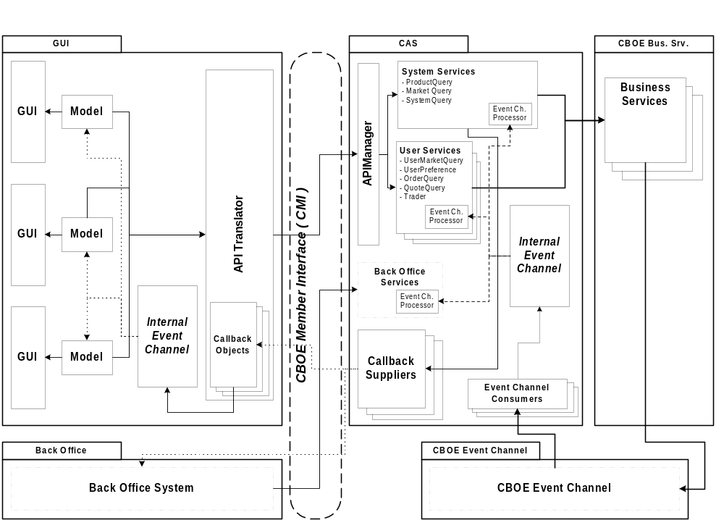
Figure 3 Presentation and Application Services Components

Trader Application
This package has the following specific responsibilities:
- Submit, cancel, update, and cancel/replace orders
- Submit requests for quotes
- Present the current status of the trader’s orders
- Present fill and cancel reports
- Present Market Best Bids and Offers for selected products
- Set the trader’s defaults and preferences
- Present underlying quotes/last sales and news alerts

Market-Maker Application
This package inherits the Trader App package’s responsibilities and adds the following:
- Submit and modify market-maker quotes
- Present requests for quotes
- Set the market-maker’s defaults and parameters
- Set auto-quote parameters
- Submit auto-quotes
- Present Book Depths for selected products

BackOffice App
This package is responsible for reporting order status information. This can include fill reports, cancel reports and new order notifications.

Operations App
This package has the following responsibilities:
- Start and shutdown the SBT system
- Start and stop trading of a product
- Change the status of a product’s market (pre-open, open, close, halt, etc.)
- Present logged system events
- Maintain SBT-specific trader information
- Maintain SBT-specific product information
- Maintain trading parameters (spread width, minimum market-maker order default size, required percent of responses to an RFQ, maximum response time to an RFQ, etc)

Help Desk App
This package has a subset of the responsibilities of the Operations App. The specific responsibilities have yet to be defined.

CBOE Market Interface API
The functionality of the Trader, Market-Maker, and BackOffice packages are exposed by a façade, the CBOE Market Interface (CMi) Application Programming Interface (API). The CBOE Market Interface exposes different subsets of functionality depending on the user that logged on to the system. The intention behind sharing a common API among the different trader classes is to allow workstations installed on the floor to service all of them.
The CBOE Market Interface API supports both SBT client applications and external applications owned by members. Members use the CBOE Market Interface API to link their existing computer systems to SBT, to submit orders electronically and to automate trading. Likewise, market-makers use the API to generate auto-quotes employing their proprietary systems, instead of the default auto-quote application provided by SBT.
A major requirement of the Screen-Based Trading system, as specified in the SBT Software Requirements Specification, is to provide an Application Programming Interface (API) to enable members’ computer systems to interact with the SBT system. The targeted users of this API are member firms, non-market-maker professional broker/dealers (BD), and market-makers (MM). Although these types of users have different capabilities, they are sufficiently similar to suggest the use of a single API with usage restrictions according to the type of user, as opposed to using multiple APIs.
The following SBT system functions must be accessible through the API:
- Session logon and logoff
- Market state inquiry and change notification
- Connection status inquiry and change notification
- Order entry, cancellation, and replacement
- Quote entry, cancellation, and replacement
- RFQ notification
- Order status inquiry and fill notification
- Subscription to product markets
- Best market quotes notification
- Book “depth” inquire and change notification
The API is not intended for automating administrative or configuration functions; members will have to use a SBT Workstation to manually perform these functions with proper authorization.
The API leverages the distributed infrastructure utilized by CBOE to ensure a reliable, efficient and secure transmission of messages to and from the SBT System. In addition, this leverage will substantially simplify the development of the API.
CBOE will provide a single portable API or a set of functionally-equivalent APIs for deployment in members’ platforms. In addition to the API, CBOE will provide the required libraries for the distributed infrastructure components such as Object Request Broker (ORB), messaging service, event service, security service etc. With the API, members will develop applications to automate trading or gateways to allow other computers to automate trading. These applications or gateways will run in member’s computers connected to CBOE via leased lines.
CBOE will make special simulation server components available to members to facilitate the development of applications. The simulation server components will support all the functionality of actual servers and provide a realistic environment for stress testing the member’s application.
The API’s functionality will be exposed as a set of CORBA IDL interfaces to facilitate its use from any language with a CORBA mapping. Alternatively, the API may be exposed as a framework in a particular language, such as Java, to be linked directly with an application, thus avoiding inter-process communication and consequently increasing response time.
To simplify application development and maximize performance, the API will be multi-threaded and thread-safe. Also, the API exposes the public interface of the underlying application (i.e., Trader, Market-Maker, UserAccess, etc.).
Replicated objects are persisted by the API—if the client application fails or the connection to server components is dropped, upon re-starting or reconnecting the API restores the objects to its prevalent state. The API only presents a snapshot of the member’s current trading state at any given time; the application is responsible for storing relevant transactions to reconstruct history. Whenever possible, data validations will be performed locally using cached data to avoid unnecessary network traffic.
The API conforms to the event-based programming model—the API calls back a registered event handler upon occurrence of an event, passing the details of the event to the event handler. For example, to receive notifications every time an order is (partially) filled, the application first needs to register an application object which implements an API-defined interface with the API. Once a fill occurs, the API will invoke a method defined in the interface on the application object.
Events are fired asynchronously as soon as they occur, however, an event may be delayed if the application is not ready to process it. This will depend on the threading support of the application development environment used.
Invocation of critical methods is synchronous in order to let the application know of the success or failure of the call. Armed with this information, the application can decide whether to continue normal processing or take corrective actions immediately, instead of having to wait for an asynchronous reply. Order and quote submissions are examples of synchronous calls.
To simplify the development of the application and the API, transaction boundaries will not span more than a single method invocation.
As described in Section 3.1.2, CBOE will support a FIX protocol in addition to the IDL-based interface.

UserAccess

The User Access service provides for authenticated login to the Application Server. The User Access service is the first and last service accessed by an application. The logon method returns a reference to the API Manager service - which provides access to the application server services.

UserSessionManager
The User Session Manager service provides access to the services provided by the Application Server. Access to the User Session Manager is returned after a valid user login. It is through the User Session Manager that access to all other services is obtained.

OrderEntry
The Order Entry service accepts orders, updates to orders, and requests to cancel orders.

MarketQuery
The Market Query service provides access to market data, and market data history. The query methods are used to retrieve data in snapshots - the currently available information being returned upon invocation. The MarketQuery service also is used to subscribe for market data. The Market Query service is used to subscribe to ticker data, sales summary, and last sales information. Methods are available to unsubscribe.

UserPreferenceQuery
The User Preference Query service is used to store and retrieve user preferences within the User Service.

Quote
The Quote service provides the following: Accepts one or more quotes for the client application, the ability to cancel the current quote for a product, retrieval of Request for Quotes ("RFQ"), and retrieval of quotation history.

OrderQuery
The Order Query service provides for the retrieval of orders. The order queries return the initial snapshot of orders meeting the selection criteria and at the same time subscribe the caller to subsequent updates to the orders that meet the criteria.

ProductQuery
The Product Query service provides for the retrieval of product information.

ProductDefinition
The Product Definition service provides the ability to request markets for new products by specifying contract terms and underlying products.

Version
The Version service provides a constant that identifies the CMi version.

Administrator
The Administrator service provides access to text messaging operations.

TradingSession
The Trading Session service provides users with information on trading sessions.

UserHistory
The User History service provides for the retrieval of a user’s trading activity.

UserTradingParameters
The User Trading Parameters service is used to store and retrieve market maker’s Quote Risk Management (QRM) preferences.

Application Services Components
The Application Services package contains the following types of components:
- Business Services Proxy/Cache
- Callback Suppliers
- Remote Event Listeners
- Remote Event Processors

Business Services Proxy/Cache
The Business Services Proxy/Cache provides the connection between the API and the CBOE business services. Any caching of remote data is accomplished in internal models owned by the Business Services Proxies.

Callback Suppliers
The callback suppliers are responsible for sending updated data through the Common Client API to a remote listening application. Each type of callback has its own supplier object. Similar to the Internal Event Channel used by the Presentation Services, a callback object is registered with a particular channel or set of channels. Each callback object then serves multiple remote callback clients and manages which types of data to send to which remote clients. The callback supplier object is threaded and queuing. Synchronous callbacks are used to communicate remotely in order to insure that the message is received by the Presentation Services layer.

Remote Event Listeners
The Remote Event Listeners are objects that listen to the Event Service (event channels). The Remote Event Listeners are responsible for registering any needed filters on the event channel and collecting any events in which the Application Services layer is interested. When a remote event is received off of the event channel, it is passed to a Remote Event Processor object to be processed before sending to the business services proxy/cache layer. A single Remote Event Listener object can have multiple registered Remote Event Processors. This allows multiple Business Services Proxies to listen for the same event. There is one Remote Event Listener object for each type of event in which the Application Services tier is interested. The Remote Event Listener object is threaded and queuing.

Remote Event Processors
The Remote Event Processors are owned by each of the different business services proxies. They are registered with the Remote Event Listeners and have the responsibility of manipulating any data received off of the event channel into the format in which the particular Business Service Proxy is interested. Different Business Services Proxies can have personalized Remote Event Processors that listen for the same event or to the same Remote Event Listener. Remote Event Processors are threaded and queuing.

Business Services Emulators
The Business Services Emulators provides simulations of the CBOE business services. These components are utilized by the CMi SDK to provide a stand-alone test platform for developers.

Business Services Package

Order Handling Service
The Order Handling Service package maintains the current state of all orders persistently. Specific operations may be exposed directly by Order objects, bypassing the Order Handling Service. Logically, Orders are components of this package. Specifically, the Order Handing Service and Order components are responsible for:
- Receiving and storing incoming orders (from SBT clients or TPF)
- Forwarding incoming orders to the Broker package for execution
- Receiving order state change notifications from the Broker and Order Book packages and updating stored orders with this information. The functionality is provided by exposing Orders and first-class objects, allowing the Broker and Order Book components to directly update the orders.
- Sending fill reports to originating traders upon receiving fill notifications from the Broker and Order Book packages
- Receiving order cancellation requests and forwarding them to the Broker and Order Book packages. Upon confirmation of a cancellation, notifying the originating trader of the result of the request and updating the stored state of the order
- Receiving order cancellation/replacement requests and forwarding them to the Broker and Order Book packages. Upon confirmation of the cancellation/replacement, notifying the originating trader of the result of the request and updating the stored state of the order
Note: includes the Order Maintenance Service, and Order Routing Service.

Broker Service
The Broker Service package is responsible for executing the following types of orders:
- Limit
- Market
- All or none (AON)
- Fill or kill (FOK)
- Immediate or cancel (IOC)
- Stop
- Stop Limit
- Spread
Upon trade execution, the Broker Service is responsible for notifying the Trade Service package of all the orders matched (all parties to the trade) in the trade. It is also responsible for notifying the Order Handling Service (i.e. Orders) and MM Quote Service (i.e. Quotes) of the fills.
The Broker Service is also responsible for routing orders for open-outcry products to TPF.

Order Book Service
The responsibilities of the Order Book Service package are:
- Cooperate with the Broker in calculating the opening price during a products pre-opening period
- Acknowledge that an order was accepted by publishing an event consumed by the Trader application which originated the order
- Cancel and cancel/replace resting orders
- Upon changes to the top of the book, publish the new BBBO, book depth (top N), and last sale

Trade Service
The responsibilities of the Trade Service package are:
- Receiving trade notifications from the Broker Service
- Formatting trade reports
- Storing trade reports
- Forwarding trade reports to CTM (via TPF)
- Receiving Trade Bust requests
- Receive Block Trades and Exchange for Physical (EFP) trades.

Note: includes the Trade Maintenance Service.

Market Maker Quote Service
The Market Maker (MM) Quote Service package is responsible for:
- Receiving requests for quotes (RFQs) from traders
- Submitting RFQs to market-makers assigned to the product for which the quote was requested (by publishing in the RFQ event channel)
- Receiving and logging market-maker responses to RFQs (market-maker quotes)
- Upon receiving a market-maker quote, saving it persistently and submitting them to the Broker Service package for execution.
- Sending fill reports to originating market-makers upon receiving fill notifications from the Broker and Order Book packages
- Canceling or updating a MM quote upon receiving a request from the originating market-maker by submitting the request to the Broker/Order Book.
- Upon inquiry, providing the history of the quotes submitted by a market-maker
- Monitoring a market-maker’s fill rate, and submitting a cancel request to the Broker when the rate exceeds the user’s fill rate limit (QRM - Quote Risk Management).

Product Query Service
The Product Query Service package maintains all product-related information. In order to perform these responsibilities, the Product Service package downloads and caches product information from TPF and TIPS (options only). The service also allows for the creation and maintenance of a variety of derivative products, e.g. equity futures. Note: includes the Product Maintenance Service.

User Service
The User Service package maintains all user-related information, both specific to SBT and contained in CBOE’s Membership System and Market Planning and Procedures (MPP) System. It provides a unified interface to SBT components accessing user information, hiding the actual location of the maintained data, thus simplifying client logic and facilitating replacement of the Membership System in the future.
The User Service maintains the information for:
- traders
- market-makers
- clearing firm brokers
- operators
- help desk personnel
- back-office personnel
Note: includes the User Definition Service, User Maintenance Service, User Maintenance Event Service, and User Trading Parameter Service.

Firm Service
The Firm Service package maintains all firm-related information, both specific to SBT and contained in CBOE’s Membership System. It provides a unified interface to SBT components accessing firm information. Note: includes the Firm Maintenance Service.

Exchange Service
The Exchange Service package maintains all exchange-related information, both specific to SBT and contained in CBOE’s Membership System. It provides a unified interface to SBT components accessing exchange information.

Trading Session Service
The Trading Session Service package maintains all business day and trading session-related information and manages the different states of a trading session, e.g. open, closed, and halted. What products are processed/traded in each trading session is also kept at this service. In order to perform these responsibilities, the Product Service package needs to download trading session and product information from TPF, as well as monitor events that affect products traded within a session. Note: includes the Trading Session Maintenance Service, and Trading Session Event State Service.

Product State Service
The Product State Service package is responsible for coordinating product state changes for all products, e.g. pre-opening, opening, trading, halting, closing, and post-closing. It works closely with the Broker Service to insure that state changes occur in a timely fashion. The service monitors events that affect products traded, such as monitoring the underlying market to detect when the primary exchange opens, closes or halts trading a product.

Product Configuration Service
The Product Configuration Service package is responsible for assigning a product’s trading/processing location. The information is used primarily by the Product Routing Service to route product-specific requests (e.g. orders) for processing. Additionally, the PCS can be used to create and populate logical groups of products for a variety of purposes.

Product Routing Service
The Product Routing Service package is responsible for providing the location of where a product is processed/traded. This information is primarily used to route product-specific requests (e.g. orders) for processing.

Order Status Service
The Order Status Service package provides subscription and notification services related to orders (i.e. fill reports, cancel reports, order accepted by book, etc.) Note: The service replaces the use of event channels for order status reporting, providing a more secure mechanism for status delivery, i.e. point-to-point, using the Order Status Subscription Service.

Quote Status Service
The Quote Status Service package provides subscription and notification services related to quotes (i.e. fill reports, deletion reports, etc.) Note: The service replaces the use of event channels for quote status reporting, providing a more secure mechanism for status delivery, i.e. point-to-point, using the Quote Status Subscription Service.

Trading Property Service
The Trading Property Service package maintains system wide trading parameters (e.g. exchange prescribed width, fast market spread multiplier) for use by various business services. The service supports hierarchical relationships for certain parameters that allow exchange-wide parameters to be overridden at the trading session, or product class level.

Market Data Service
The Market Data Service package maintains a current snapshot of market data, in addition to publishing market summary data. The package also provides an interface to clients to query historical market data (MDR). Note: includes the Market Data Summary Service.

Text Messaging Service
The Text Messaging Service package provides messaging between the help desk and other users.

User Activity Service
The User Activity Service package provides the ability to query for a user’s trading activity, which unifies order, RFQ, and quote-based activity.

Best Quote Service
The Best Quote Service package is responsible for calculating the market best (best quotes) for each product and sending them to COPP or TPF (which in turn forwards them to OPRA) for public dissemination. In addition, it is responsible for calculating and disseminating the NBBO. In order to perform its responsibility, the Best Quote package subscribes to the Best of the Rest event channel to receive the best bids and offers for all products and publishes the results to the Best Quote event channel, of which the COPP and TPF Adapters are subscribers.

External Integration Services
The External Integration Services package contains subordinate packages implementing the Adapter Pattern that “adapt” (or “wrap”) the native legacy interfaces to interfaces appropriate in the DTE/SBT environment. These new interfaces are designed in such a way that no changes will be necessary to SBT when DTE components eventually take over TPF’s responsibilities. In other words, DTE components will simply re-implement these interfaces and probably extend them with trading floor-specific functionality.

TPF Adapter
This package contains the adapter to allow SBT and TPF to interact. TPF data is received, repackaged, and broadcast/delivered to the appropriate components within SBT. Conversely, SBT data is received, either through direct invocation or event consumption, repackaged, and sent to TPF using its native interface. The TPF Adapter always maintains an active HGW connection. When failure is detected, it should reestablish the connection with the backup HGW.
The TPF Adapter handles the following data flows:
- Order (TPF to SBT) – TPF sends a member’s wire order received from COMPASS to SBT
- Cancel Order (TPF to SBT) – TPF sends cancellation of a member’s wire order received from COMPASS to SBT
- Cancel Request Status (SBT to TPF) – SBT either confirms the cancellation of a wire order, or responds that the cancellation was received after the order was filled, to TPF
- Order Fill Report (SBT to TPF) – SBT reports when a wire order is (partially) filled to TPF
- Best Quote Report (SBT to TPF) – SBT broadcast quotes for products traded in SBT to TPF for external dissemination via OPRA
- Order (SBT to TPF) – SBT sends a CMi trader’s order received from the CMi to TPF
- Cancel Request Status (TPF to SBT) – TPF either confirms the cancellation of a CMi entered order, or responds that the cancellation was received after the order was filled, to SBT
- Cancel Order (SBT to TPF) – SBT sends cancellation of a trader’s order received from CMi to TPF
- Order Fill Report (TPF to SBT) – TPF reports when an open-outcry routed order is (partially) filled to SBT
- TPF time (TPF to SBT) – TPF provides its time upon request, so SBT server nodes can synchronize their clocks
- Product related flows – TPF notifies SBT of intra-day events affecting products such as new series added, stock splits, et cetera

Membership Adapter
The Membership Adapter translates requests for member information received from SBT components into requests to the Membership System and returns the results after re-formatting. Note: includes market-maker assignments from the Market Procedures and Planning (MPP) system.

TIPS Adapter
The TIPS Adapter subscribes to TIPS to receive the external market data needed in the SBT environment, including underlying market data and the Best of the Rest of options listed in SBT. It is necessary to determine whether the Events Service is capable of notifying the TIPS Adapter of consumer subscriptions so that it can propagate these subscriptions back to TIPS.
Once subscribed, The TIPS Adapter reformats the market data received from TIPS and publishes it for consumption by SBT components.
Another responsibility of this adapter is to publish product state events when external markets change their states, for instance when they open, halt, close, etc.

COMPASS Adapter
This package contains the adapter to allow SBT and Compass to interact directly in support of single stock futures. Compass data is received, repackaged, and delivered to the appropriate components within SBT. Conversely, SBT data is received, repackaged, and sent to Compass using its native interface.
The Compass Adapter handles the following data flows:
- Order (Compass to SBT) – Compass sends a member’s wire order received from the firm to SBT
- Cancel Order (Compass to SBT) – Compass sends cancellation of a member’s wire order received from the firm to SBT
- Order Fill Report (SBT to Compass) – SBT reports when a wire order is (partially) filled to Compass
- Order Cancel Report (SBT to Compass) – SBT reports when a wire order is (partially) cancelled to Compass

COPP Adapter
The COPP Adapter receives SBT market data, e.g. last sales, and forwards it to COPP for dissemination to various data providers, e.g. OPRA.
The COPP Adapter handles the following data flows:
- Best Quote Report – SBT broadcast quotes for products traded in SBT to COPP for external dissemination via OPRA
- Last Sale Report – SBT broadcast last sales for products traded in SBT to COPP for external dissemination via OPRA

CTM Adapter
The CTM (CBOE Trade Match) Adapter receives SBT data and forwards it to CTM.
The CTM Adapter handles the following data flows:
- Trade Report (SBT to CTM) – SBT reports all the parties to a trade to CTM

Event Channels
One key mechanism by which SBT components interact with each other is by supplying and consuming events, implemented as a publish/subscribe pattern. The following list provides a brief description of the significant event flows/notification services (messaging services) depicted in the Events Service within the Infrastructure Services package in Figure 2 SBT System Logical View as well as their corresponding Quality of Service (QoS).
- RFQ – the MM Quote Service supplies Request for Quote (RFQ) events consumed by the Market-Maker Application. QoS: Store and forward, FIFO, time to live, filtered.
- BBBO – the Order Book supplies Book Best Bid Offer (BBBO) events consumed by the Best Quote Service. QoS: Best effort*, FIFO, Publisher transactional, low priority delivery, filtered.
- Book Depth – the Order Book supplies Book Depth (top N prices and quantities) events consumed by the Trader Application. QoS: Best effort*, FIFO, Publisher transactional, low priority delivery, filtered.
- Current Market – the Best Quote Service supplies Current Market Best and National Best Bid Offer (NBBO) events, containing a product’s best quote, consumed by the Market Data Service and Trader Application. The best quote indicates if the exchange has the best quote. QoS: Best effort*, FIFO, Publisher transactional, medium priority delivery, filtered.
- Best of the Rest – the TIPS Adapter component supplies best-of-the-rest events consumed by the Best Quote Service. QoS: Best effort*, FIFO, filtered.
- Logging – the Logging Service Proxy component supplies Log Service events consumed by the Log Service component. QoS: Best effort, priority, time to live.
- System Management – the Foundation Framework supplies System Management events consumed by the System Management component. QoS: Store and forward, FIFO.
- Instrumentation – the Instrumentation Service component supplies Instrumentation events consumed by both the System Management component and the Log Service component. QoS: Store and forward, FIFO.
- Ticker – the TIPS Adapter supplies underlying ticker events (prices, quotes, last sales, news alerts) consumed by the Trader Application and the Product Service. The Trade Service supplies ticker (last sale) events consumed by the Market Data Service and TPF Adapter. QoS: Best effort*, FIFO, low priority delivery, Publisher transactional (Trade Service), filtered.
- Recap – the TIPS Adapter supplies underlying summary events (high and low prices, volume) consumed by the Market Data Service and Trader Application. The Market Data Service supplies summary events, based on last sale, consumed by the Trader application. QoS: Best effort*, FIFO, low priority delivery, Publisher transactional (Market Data Service), filtered.
- Trade Report – the Trade Service supplies Trade Report events consumed by the TPF Adapter. QoS: Stable store and forward, FIFO, Publisher and Consumer transactional, high priority delivery.
- Product Status – the Product Service and Product State Service supply Product Status events (State, Price Adjustment, Configuration, and Update) events consumed by the Trader application, Order Handling Service, and TPF Adapter. QoS: Stable store and forward, FIFO, Publisher and Consumer transactional, high priority delivery, filtered.
- Trading Session Status – the Trading Session Service supplies Trading Session State events consumed by the Operations and Help Desk application. QoS: Stable store and forward, FIFO, Publisher and Consumer transactional, high priority delivery.
- End of Session Summary – the Trading Session Service supplies End of Trading Session Status events. QoS: Stable store and forward, FIFO, Publisher and Consumer transactional, high priority delivery.
- Opening Price – The Broker Service supplies Opening Price events consumed by the Trader Application. QoS: Best effort*, FIFO, medium priority delivery, filtered.
- Control – the Operations and Help Desk applications supply Control events, possibly through the System Management component, consumed by Business Services and External Integration Services components. QoS: guaranteed, ordered, high priority delivery.
- Order Status – the Order Handling Service (Order) supplies Fill Report, Cancel Report, Updated Order, New Order, and Order Accepted by Book events consumed by the Order Status Service, and TPF Adapter. QoS: Stable store and forward, FIFO, Publisher and Consumer transactional, high priority delivery, filtered.
- Quote Status – the MM Quote Service (Quote) supply Fill Report, and Delete Report events consumed by the Quote Status Service. QoS: Stable store and forward, FIFO, Publisher and Consumer transactional, high priority delivery, filtered.
Note: * refers to a snapshot

Product Groups
The Notification Service provides the capability for a consumer to apply filters to an event channel to limit the number of events received, since many consumers are only interested in a limited subset of events within an event channel. This capability greatly reduces the messages sent by the system by eliminating the publication of unwanted events.
Many of the event channels handle events related to products, both classes and series (e.g. Trading Session Status). A typical consumer will use filtering to receive only a subset of products. Since the number of products in a class can be large, and the overhead of applying a large number of filters to an event channel can reduce performance, many event channels provide the capability to filter at the product group level. A product group defines a set of related products (e.g. all products trading in a virtual pit). Publishers of events involving products will include a set of product groups in the event. Consumers can reduce the number of filters by filtering on a product group, rather than each product in the group. The Product Configuration Service provides product group information for both consumers and publishers.

Infrastructure Services
Overall there are four major tiers of the application that can be identified. The business services handle all the SBT trade matching, execution and reporting functionality. It provides the repository for all SBT information data. The application services handle the application presentation and act as the application front end to the business services. Different views of the business services and collaboration of business objects are grouped together and are presented to the user based on logon authentication and authorization level. The two tiers communicate to each other by two supported tiers: the infrastructure services and external integration services. The infrastructure services take care of the plumbing underneath to provide a seamless integration between the application services and business services. The external integration services provide the access to the external system.
Most of the common services are grouped together inside the Infrastructure Services. The services are defined when possible using standard service specification (CORBA services) and technology engines to minimize the cost of development and deployment. At the same time, this approach also ensures the openness of the application architecture without locking the architecture into any one vendor product and technology. Below is the high level description of the common service and usage pattern of how the business object interact with the common services

Directory Services
Directory Services provide the ability to register an object and its properties, and the ability to locate them in the distributed environment. Directory Services does not include a Naming service. The Trader service will be used for the Naming service functionality.
The Directory Service (consisting of Trader Services) will be constructed following the CORBA specification. This will give a consistent structure to the layout and implementation of the supporting interfaces.
Due to Directory Service’s importance in providing clients location data, its availability is paramount. At this time, there is no specification for levels of resilience within the Object Management Group (OMG) specification. In addition, no commercially available implementation of the Trader Service adequately supports CBOE’s needs. For this reason, the functionality will have to be developed in-house.
The Directory Service will need to persist the data registered with the service, and ensure that it can be recovered in the event of a failure. This may be accomplished by a replication strategy utilizing multiple instances of the Directory Service.
The Directory Service will utilize a commercial Lightweight Directory Service Protocol (LDAP) server to store persistent data, and provide replication and redundancy.
See Directory Service Requirements for more information on the Directory Service.

Trader Service
Objects advertise their service with the Trader Service. The object service consumer can query the Trader Service to locate the service. When registering for a service, objects can specify the properties of the service. There can be multiple registrations of services with different properties. When querying the Trader, the object service consumer can query the Trader using the service type and property(s) to narrow down the service for which it is looking.
Application Service objects are the primary user for the business object registration. An application like the Trader application would establish a session with the Client Session Management, which in turn, contacts the Trader Service to retrieve the available services.

Messaging Services
The CBOE Integration Architecture identifies two paradigms for messaging: Publish and Subscribe (P&S), and Asynchronous Messaging (AM). The first addresses a model in which the sender knows nothing of the receiver or target of the messages that it is sending. Likewise, the receiver does not know the origin of the messages it receives. The result is a powerful multi-point to multi-point mechanism, which supports graceful system evolution.
The Asynchronous Messaging model extends the basic point-to-point synchronous invocation model of CORBA to support asynchronous invocation, independent of client or server related failures.
See Messaging Service Requirements for more information on the Event/Notification and Asynchronous Messaging Service.

Event/Notification Service
The Event Service provides a publish and subscribe mechanism for delivering and receiving messages where the message supplier does not have the knowledge of the message consumers. CORBA Event Service Specification translates the message into event channel object. It specifies two models for providing the delivery of the message. With the push model, the supplier sends a push method invocation on the event channel object. The event channel object, in turn, pushes the event data to the consumer objects. With the pull model, the consumer issues a pull method invocation on the event channel object. The event channel object, in turn, pulls the event data from the supplier. Event data can be typed to allow business objects to describe the contents of events.
The CORBA Notification Service, recently adopted, extends the Event Service specification with the additional capabilities, including:
- The ability for clients to specify exactly which events they are interested in receiving, by attaching filters to each channel
- The ability for event suppliers to discover the event types requested by consumers, avoiding the transmission of events in which no consumers have interest
- The ability to configure various quality of service properties on a per-channel, per-proxy, or per-event basis.
Within SBT, the interface and processing model using the Event Service is sufficient to provide the messaging service, but the quality of service such as guarantee message delivery, priority event, message queuing will borrow from the Notification Service specification. Performance is also a concern in the SBT environment where certain messages (like quotes) can be extremely high in volume. Using a normal communication transport layer where messages are sent round-robin to each of the consumers is not acceptable. The messaging service infrastructure encapsulates all the quality of services while preserving the simple but flexible interface of the Event Service.
In SBT, the business object services and the application object services delegate the message delivery responsibility to the messaging infrastructure by specifying the quality of service when creating the event channel object. The mechanism of invoking and receiving all events is the same.
The following are the different Quality of Service (QoS) that are provided by the Event Service infrastructure:
- Transport Properties
- Ordering Properties
- Lifecycle Properties

Transport Properties
Transport properties specify the guarantee vis-à-vis messaging handling, by the elements of the messaging services infrastructure, and between Suppliers and Consumers. Transport properties are set as an administrative attribute of the Channel.
- Best Effort – this QoS transport property expresses that the publish and subscribe messaging service should attempt, within implementation-dependent bounds, to transport a message. If these bounds are exceeded, the service drops the message.
- Store and Forward (Guaranteed) –this QoS transport property specifies that the publish and subscribe messaging service must keep one or more copies of a given message within the infrastructure elements so as to tolerate failure of one of those components.

In addition, this property can support disconnected usage.

- Stable Store and Forward –this QoS transport property specifies that the publish and subscribe messaging service must store each message on a persistent storage device at elements within the infrastructure so as to tolerate failure of any or all of those elements.

- Transactional Distribution –this QoS transport property specifies that the publish and subscribe messaging service must receive from Suppliers, and deliver to Consumers, under a transaction. This allows the messaging service to coordinate message state handling with application processing to assure that messages are properly delivered and processed.

Ordering Properties
Ordering Properties specify constraints on the sequence in which messages are delivered relative to one another.
- FIFO –this QoS ordering property specifies that messages should be delivered based on source ordering.

- Priority –this QoS ordering property places an absolute priority on processing a message relative to other messages.

- Temporal –this QoS embodies the concepts of applying a time-based ordering scheme to determine delivery sequence. Older publications are handled before more recent publications.

- Deadline –this QoS embodies the concepts of applying a deadline-based scheme to determine delivery sequence. The publications with deadlines occurring first are handled before publications with deadlines further out.

Lifecycle Properties
Timeliness Properties are concerned with how quickly publications are processed. These properties are of interest to suppliers and consumers in time sensitive applications. There are several potential schemes that the Publication Service should support.
- Time to Live –this QoS is indicative of the length of time a publication can exist in the system and still be considered valid. Suppliers and consumers who support time critical applications need the ability to define how long a publication can be considered valid.

In the process of creation of an event channel, multiple QoSes can be specified. (Only some QoSes are mutually exclusive to the others: Best Effort and Guaranteed, Ordered and Last Only Ordered)

Asynchronous Messaging Service
The Asynchronous Messaging Service provides an interface (AMI) that allows point-to-point, or point-to-group, communications where the client or the server are potentially disconnected when the other is processing a request or response. When using the AMI, a Callback Handler is passed from the client to the server, and the server returns the results of the operation by invoking an operation on the handler. The use of AMI is completely transparent to the server, allowing the server to provide both synchronous and asynchronous operations from a single interface. In addition, the service provides various Qualities of Service (QoS) with timeout notification.

Security Service
The Security Service provides the mechanism to control and to monitor access to the resources (objects) of the system. The following functional areas are addressed:
- Authentication
- Authorization (Access Control)
- Integrity and Confidentiality Protection
- Non-repudiation
With authentication, the user and server components are securely identified. It guards the SBT from the security threat of someone impersonating an authorized user of the system in order to perform actions, and have these actions attributed erroneously to other authorized users.
Authorization provides the specification and enforcement of access rights to the system resources (objects) based on the authenticated user or group. It guards the SBT from the security threats of someone invoking operations on the system without authorization. Access can be defined on a per-object or per-operation basis.
Integrity and Confidentiality Protection provides assurance of the accuracy and secrecy of the transmitted information. It guards the SBT from the security threats such as: someone eavesdropping to gain access to confidential information, someone gaining malicious or accidental access to information that should be hidden, someone tampering with the messages while in transit through the corporate network in order to alter their contents.
Non-repudiation provides the irrefutable evidence of actions such as proof of data sent and data received. It guards the SBT from the security threat of denying usage action.
In a CORBA environment, Security Service “policy” and “role” software agents will be defined, built, and distributed across multiple servers. These agents will be implemented as CORBA objects, allowing security administrators to control their operation remotely and change the set of policies enforced.
Secure CORBA ORBs can provide authentication, access control, auditing, and message protection. The CORBA philosophy is to protect objects that are not security-aware in such a way that security policy enforcement can be performed automatically by the ORB. Two “interceptors,” the access control function and secure invocation, are the mechanism by which the ORB can invoke security operations (e.g. policy agents) on behalf of CORBA objects.
The environment will enable fully specified policies defined at the operation level.
The Security Service will utilize a commercial Lightweight Directory Service Protocol (LDAP) server to store persistent data, and provide replication and redundancy.
See CBOE Security Requirements and SBT Security Policy or more information on the Security Service.

Logging Service
The Log Service (Logging) provides clients the following functionality:
- System Monitoring: Logged messages alert system administrators of abnormal events and enables the general “health” and performance of the system to be monitored.
- Debugging: Logged messages allow system administrators to detect, trace, and diagnose system problems.
- Auditing: Logged messages provide an audit trail that enables system administrators to verify the valid use of system resources and assign accountability for actions
- Non-repudiation: Logged messages allow system administrators to confirm that a given transaction occurred and cannot be disputed by the client that initiated the transaction
In addition, the Log Service must provide these services in such a way that system performance, scalability, extensibility, and resilience are not compromised.
The Log Service is responsible for the creation and delivery of log messages intended for human viewing. It is not intended to provide inter-process communication or archiving and retrieval of data.
The Log Service is comprised of three basic components:
- The Logging Server process(es)
- Client-side proxies
- Frameworks or API’s that facilitate monitoring and management of the Log Service by system administrators
The Logging Server provides a central Log Service, accessed indirectly by clients through a proxy. The central Log Service will have a repository for storing all log messages. A system may be comprised of a number of Logging Servers, providing for increased scalability and resilience.
The Client-side proxies provide a local object that directs log messages to an appropriate destination. The destination of the log message is unknown by the client, providing for a simple interface. The client-side proxy can be statically or dynamically configured to route various log messages, based on type or priority, to a variety of destinations (e.g. standard error, a local file, central Log Service). This approach provides an easily configurable, extensible framework for handling the variety of log messages during the various phases of the system lifecycle (e.g. development, testing, deployment).
The Control API allows control parameters to be initialized, queried, or set by an outside entity (e.g. system administrator). It provides for the static initialization of the Log Service through a configuration file, and the runtime configuration of the service through an exposed interface.
See Log Service Requirements Document for more information on the Logging Service.

System Management Service
System Management Service addresses the aspect of SBT system management, system monitoring and configuration. Each component in the business services and infrastructure services has to participate by exposing an administrative interface that will allow for remote management.
The System Management Service is based on the CORBA Management Facilities Architecture, which supports the X/Open Systems Management Reference Model. The specification defines four services:
- Managed Set Service: Organizes Managed Objects, resources that need to respond to management interactions in order to be managed, into hierarchical structures
- Policy-Driven Base Service: Allows Managed Objects to be managed by policy regions
- Instance Management Service: Provides basic creation and management capabilities for all types of Managed Objects
- Policy Management Service: Used to establish policy regions, assign Managed Objects to policy regions, report policies, and define policies
The services included in the CORBA Management Facilities form a powerful framework for implementing an object model of distributed, policy-driven Managed Objects representing resources in an installation. The object model is shared among all system management applications, thus promoting consistency and enforcement of enterprise-wide management policies.
Patrol has been identified to provide the user interface for monitoring and controlling SBT resources.
Application configuration is responsible for maintaining system-wide configuration parameters not associated with users, members or products. These parameters include, but are not limited to the following:
- Maximum time period for market-makers to respond to RFQs
- Percent of responses required to continue execution of market orders
- Current version and location of executables or dynamically loadable classes to support automatic component deployment
See System Management Requirements for more information on System Management.

Persistence Service
Persistence Service provides the ability to “persist (store)” objects data beyond the application that creates the object or the client that uses it. Persistence is provided by using a Persistence Framework within the Foundation Framework.
At the SBT Business Service tier, all business objects that require persistence use the Foundation Framework to store their state in an underlying persistent store. The Persistence Framework supports multiple products that provide persistence, such as a relational database system (Oracle), or a file system.
At the SBT Application Service tier, application objects are constructed by connecting to the business object service. After initialization, the application service builds a cache of all necessary application objects. Object state changes are propagated from the business object to the application service cache object through the event infrastructure.

Session Management Service
The Session Management Service manages user session by providing the facilities to create user session via logons. The service manages and monitors all user connections, and provides session clean up when the client process terminate (both gracefully and ungracefully). Business services can register with the service to be notified when a user session is terminated, allowing them to apply application specific clean up.

Time Service
Time Service provides the global time synchronization between the components within SBT from TPF. The server processes synch up the time with TPF in the morning and whenever they restart. The service is available as a global service. In addition, the Time Service provides timer functionality, allowing clients to be notified at the end of a specified time interval.
An alternate implementation, utilizing NNTP, is also available.

Frameworks and Design Patterns

Foundation Framework
The Foundation Framework is an application server framework consisting of a set of Java classes that enables using certain SBT infrastructure services in a consistent and effective manner for both the Application Service developers and Business Service developers.
Overall, the Foundation Framework functionality provides a default standard usage of the SBT infrastructure service. The developers will not be affected by the changing infrastructure technology, and they are not required to work with the infrastructure services directly. However, it will not force the developers to use the framework to get to the infrastructure services.
The framework provides an application or business server process with the ability to have multiple execution contexts where many service objects can be deployed using specified execution policies and a mechanism to provide authorization validation at the method invocation level. A mechanism is provided that collects and instruments the service statistical profile data by intercepting the invocation of the business service object, capturing the necessary information, then delegating the work back to the business service object. The service process is consistently managed by exposing an administration interface to allow an external application management process to have reactive or proactive control over the process operation. It facilitates logging integration, allowing a developer to statically define all log information at the development phase, and dynamically control the amount of log information to propagate to a central log repository. It also provides a standard interface to use the Persistent Framework/Service. The framework specifies creating, deleting, and finding operation interfaces. The implementation of the operation for each business object and the actual operation of maintaining the mapping between the object and the persistent layer is outside the scope of the Foundation Framework. The framework simply provides a façade interface to enable an underlying Transaction Framework/Service. There is no additional functionality of transaction management to be implemented at the framework.
This list details the Foundation Framework’s specific functionality:
- Thread management—provides the following threading policy:
- Reuse threading—uses the same thread as the caller. In this model, the framework relies on the developer to provide a threading model (the developer can implement the threading at the business object implementation, at the ORB, or at the Event Infrastructure).
Other threading policies that can be implemented in the future include:
- Shared thread policy—all incoming invocations are handled by a single shared thread. Service invocation is serviced one at a time by the shared thread.
- Thread per request policy—for each incoming service invocation a thread is created and services the request. Service invocations are serviced in parallel.
- Directory Service Integration—provides an easy interface to the Directory Service, simplifying its usage.
- Security Integration—provides the security mechanism to validate authorization with the Security Service at the service invocation level. It collaborates with the Security Service to provide the authorization.
- Session Management Integration—provides an interface to the Session Management Service to establish and terminate user sessions. In addition, the interface provides the capability to register for notification of terminated user sessions.
- Application management interface:
- Provides a mechanism to collect and calculate the service statistical data (Instrumentation)
- Provides an interface to process administration and operation commands from an external management process (Command Callback)
- Provides a standard interface to allow access and control application/service properties (Admin)
- Logging Integration—provides an easy access entry point to the Logging Service. From this log access, the developer can control the logging and the amount of log information to be propagated to the Logging Service.
- Event/Notification Integration—provides an easy access entry to enable the use of the Event/Notification Infrastructure.
- Generic Exception Facility—provide a default implementation of generic exception to interface with the Logging Service.
- Time Service Integration—provides an easy access entry to enable the use of the Time Service.
- Persistent Service Integration—specifies the factory, finder, load and store interfaces a developer needs to implement to. The underlying persistence framework is JGrinder. The developers implement the business objects using “wrapper” classes for the underlying JGrinder interfaces.
- Transaction Management— provides the common access to the session object in the JGrinder transaction framework. From this session object the developer can start a transaction, commit, and rollback transactional business objects. They can allow a thread to join or leave a session using the same exposed session object. The specific behaviors of these operations are details in the JGrinder documentation.
See Foundation Framework Requirements for more information on the Foundation Framework.

Components and Concepts
The following diagram details the overview components and concepts of how the Foundation Framework operates.
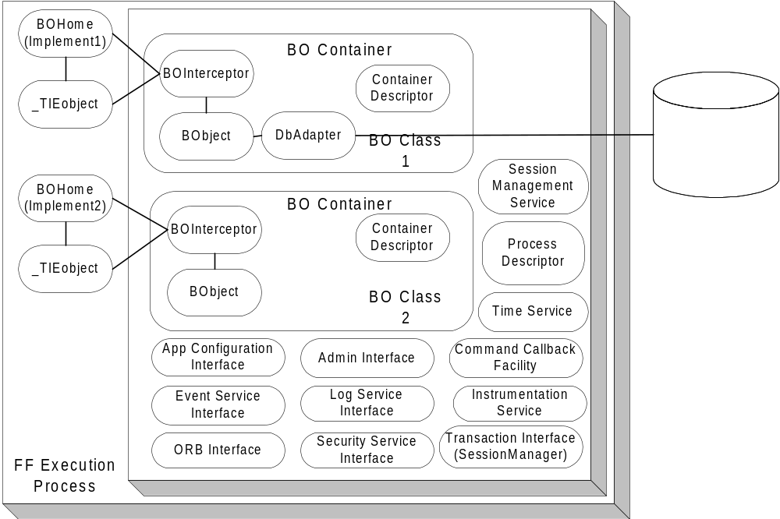

Figure 4. Foundation Framework Components Overview

Foundation Framework Execution Process
The Foundation Framework Execution Process is a singleton object that encapsulates all the infrastructure functionality and exposes an easy-to-use interface for the underlying infrastructure services. It contains a list of execution BOContainers, a Process Descriptor, the interface to the Application Configuration Service, ORB Service, Log Service, Event Service, Security Service, Session Management Service, Time Service, Instrumentation Service, Transaction Service (SessionManager), an Admin interface, and a Command Callback Facility. The developer simply instantiates the Foundation Framework Execution process in the main Java VM program to deploy business service objects to operate in the specified execution containers.
Each of the BOContainers provides a different execution container for a group of business service object instances (BObject). A service method invocation is always invoked on a BOInterceptor, a peer object to the BObject. The Foundation Framework code to implement the functionality is interjected at the interceptor level and the actual work to service the request is delegated back to the BObject.
At this level, all the process level information that is shared between BO Containers is specified and exposed in the Process Descriptor. It contains:
- The process security identity—the identity of the whole process.
- A list of execution containers.
- A list of home implementations.
- An environment property provides the customizable name pair values, which can be defined and retrieved using the standard Properties object.
Within the process boundary, the framework exposes at this level the following interfaces:
- The Application Configuration Service interface – through this interface the start up default properties of the process can be accessed.
- The Security Service interface – provides the access to the Security Service
- The Session Management Service interface – provides the access to the Session Management Service
- The Transaction Service interface – provides the interface to the JGrinder SessionManager object. From this SessionManager, Session can be created to groups a number of threads together working on a set of transactional objects. The transactional objects will be commit and rollback together using session commit and rollback operations.
- The ORB Service interface – through this interface the basic Object Request Broker functionality like network parameters (request queue, time-out. The Trader service can be accessed through this interface.
- The Event Service interface – provides a simple access to the Event Service.
- The Log Service interface – provides the access to the Log Service. From this interface, the control of propagation level and the logging functionality is delegated to. The Logging Service defines the following log types: DEBUG, INFORMATION, ABORTION, THROTTLE, SYSTEM, RESOURCE and EXCEPTION. Each log type has ten levels of priority ranging from the one (lowest) to ten (highest). Along with the priority log level, a quality of service can be specified. The quality of service used to control the amount of messages to package and send at the sender type depends on the repetition of the message sent. Refer to the Log Service for the detailed quality of service.
- Instrumentation Service interface –provides the mechanism to actively collect the service statistical profiles.
The framework also exposes an Admin interface beyond the process boundary so that it can participate in the system control and management.

Business Object Container (BOContainer)
A business object container provides an execution container for a group of business service objects. Each service invocation is intercepted and controlled by the policies in the BOContainer Descriptor. The following policies are shared at the container level:
- A Transaction Policy: OBJECT_MANAGED and CONTAINER _MANAGED. With OBJECT_MANAGED, the business service object will make calls to the Foundation Framework Transaction Management directly. With CONTAINER_MANAGED, the transactional begin demarcation and commit demarcation will be provided at the peer interceptor object.
Only the OBJECT_MANAGED is available for the first release of SBT. The framework will expose a JGrinder session object per container. The transactional object will manage its transaction begin and end explicitly.
- Thread Policy: REUSE_THREAD, SHARED_THREAD and THREAD_PER_REQUEST. The REUSE _THREAD policy executes the task in the same thread of the caller. The SHARED_THREAD policy uses the single shared thread in the execution container to process tasks one at a time. Incoming tasks are blocked in this model until the current task is finished. The THREAD_PER_REQUEST will execute the task in a separate thread. For each task, a new thread is created and the dispatching of the task happens within the new thread. Tasks are dispatched in parallel.
Only the REUSE_THREAD is available for the first release of SBT.
- Instrumentation Policy: ON and OFF. ON policy starts the process of collection and instrumentation of the statistical profile data of service invocations. The running average timing and the number of invocation at the request level will be collected and stored in memory. OFF policy turns the processing off. The instrumentation data will be available when request and also available in the public broadcast event channel.
- Security Policy: PROCESS_IDENTITY and SPECIFIED_IDENTITY. The PROCESS_IDENTITY policy uses the process level security identity as the identity to validate the authorization. The SPECIFIED_IDENTITY policy allows the container to control the identity at the invocation level (in this case a client identity can be used instead of the process identity).
- Exception Policy: THROW_BACK, ABORT_CURRENT_TASK, and ABORT_PROCESS. TRHOW_BACK policy propagates the exception thrown to the caller. ABORT_CURRENT_TASK policy dictates the execution container to abort the current task, log the exception, and continue to the next task. ABORT_PROCESS policy allows the exception to be logged and other execution containers to be notified that shutdown is in process, and finally terminates the process.
Since the Foundation Framework will not have any threading implementation for the first release of SBT, the only exception policy support is THROW_BACK. The developers have to code the EXCEPTION event log directly at the time of exception raise and it will be raised back to the caller the normal way.

Business Service Object Home (BOHome)
For each business service object class in the system, a Business Object Home is available to provide the finding and creation of a service object instance and its peer interceptor. In the case of implementing a CORBA object the TIE object can be managed by the BOHome as well. A Business Service Object Home is shared between the execution containers. There is only one Business Service Object Home per class of business service object in the VM process.
There can be multiple BOHome objects. Each one can handle the creation and finding of a selected implementation of a business service object. One BOHome object can be responsible for the CORBA proxy object (which in turn communicates with a server business service object). Another BOHome object can be responsible a local stubbed out version of a business service object; and one can take care of the actual business server service object at the server side. These multiple homes facilitate a consistent usage pattern and promote the iterative development effort.

Business Service Object Interceptor (BOInterceptor)
For each business service object instance (BObject), a peer service interceptor object is created. It is a one-to-one relationship between the peer interceptor object and the instance object. This peer object exposed all the service that a BObject provides. At this interceptor level all Foundation Framework features are provided. The interceptor delegates the actual work to the business service object instance.

Business Object Instance (BObject)
BObject is an instance of a business object. A Business Object is defined as a large-grained object that provides some business or application service, or represents a significant entity in the business domain.
There are two types of business objects. A service object is a large-grained object that provides some business or application service. There are a small number of service object instances in the process. The main process usually creates the service object instance at the initialization stage. The service object is running until the process is terminated. There is no activation and passivation of a BObject by the framework. The service object instance is typically a transient object with no persistent data. However, a service object can manage a collection of persistent objects.
Entity objects represent significant, small-grained domain objects (e.g. Order, Quote). These objects are typically persistent, outliving the process in which they were created, with cardinality greater then one.
When implemented with the JGrinder persistence framework, a JGrinder DBAdapter will be associated with the object to provide the persistence capability. There are different DBAdapters to persist data to different persistent medium: one for a relational database, one for a text file, and one for a binary file. When implemented with the JGrinder Transactional interface, a BObject will implement the interface to support commit and rollback of the data (the in process memory data attributes)
A business object can be a CORBA IDL implementation object or an object intended to be used exclusively within a process.

Service Invocation Dispatching
When the service invocation (a business method) arrives to the peer interceptor object, the interceptor accepts the invocation. Before submitting the service invocation and processing the reply invocation, the interceptor object enables the Foundation Framework functionality.
To enable the Foundation Framework functionality, the service invocation only needs to go through the interceptor object. To the caller, the syntax and calling signature is the same between the service instance and its interceptor. If the service object is a CORBA object, use the interceptor object as the implementation object instead of the service object to inherit the Foundation Framework functionality.
When using the TIE approach to provide the CORBA object, the tie object (server side IDL generated object) can be associated with the interceptor object to enable the Foundation Service functionality the same way. Dispatching the CORBA request to the interceptor using the TIE mechanism and the dispatching between the interceptor and the instance object should proceed normally.
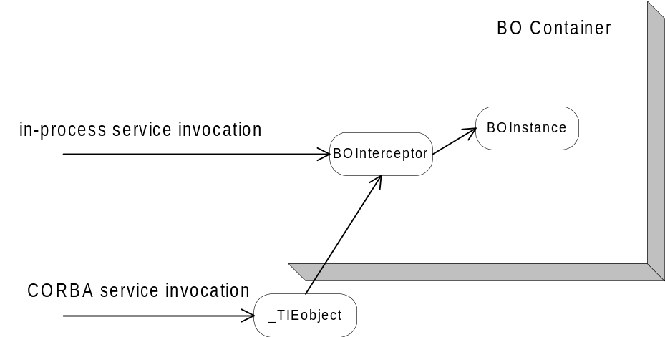
Figure 5. Service Invocation

Application Process Management
At the process level a Command Callback facility is exposed. It contains a map of registered callbacks, allowing the Foundation Framework to enable the process to be controlled and managed from an external process. A developer register “command” as a string key name to an action at initialization stage and the call back will be invoked from an IDL admin interface.
An external management process binds to the admin interface to retrieve process configuration information, to change process behaviors, and to retrieve the statistical instrumentation profile data.

Internal Event Channel Framework
The internal event channel framework is based on Java custom events. For each type of custom event that can be registered, a model (EventChannelListener) can be added as a listener to the Event Channel. When a remote event is received, it is routed to the correct channel and all listeners of that channel are notified of the event and passed any user defined data that wants to tag along with the event. The internal event channel exists in its own thread and has a queue.

Message Translator Framework
The API (Message) Translator framework is responsible for hiding the complexities of communication with the CAS from the GUI and Models. All remote requests by the GUI go through the translator. The translator will take a request for data, register the Event Channel Listener, and create and pass the callback listener. It also keeps track of the user data so that the GUI does not need to supply it when making remote calls.

Thread Pool Framework
The Thread Pool framework provides a lightweight, asynchronous implementation of the Command pattern. The framework accepts commands, implemented as subclasses of an abstract ThreadCommand class, and dispatches them to the next available worker thread. If no thread is available, the command is queued until a thread becomes available. Upon completion, the command can be programmed to update zero or more objects, simulating a return value.
The framework is used within the Broker Service for order and quote processing, as well as the Internal Event Channel.

Callback Framework (Observer Pattern)
The GUI Client Application is a thin client that only provides the presentation and the input controller of the SBT Application Services. The observer pattern is nicely fit to provide the presentation need for the GUI Client Application. Each of the object data can be mapped to form a one-to-many dependency with the GUI widgets. When the object data changes state, all the GUI widgets are notified and updated automatically.
When a remote method is called on the CAS/CMi, an optional callback object can be passed which then registers the Presentation Services for any update “callback” messages from the CAS/CMi. There is one listener for each type of message that can be received. When a listener receives a message from the CAS/CMi, it will forward the message to the appropriate “Internal Event Channel” where it will then be forwarded to any interested event channel listeners. Each callback listener lives in its own queued thread.
Within the CAS, the callback suppliers are responsible for sending updated data through the CBOE Market Interface to a remote listening application. Each type of callback has its own supplier object. Similar to the Internal Event Channel used by the Presentation Services, a callback object is registered with a particular channel or set of channels. Each callback object then serves multiple remote callback clients and manages which types of data to send to which remote clients. The callback supplier object is threaded and queuing. Synchronous callbacks are used to communicate remotely to insure that the message is received by the Presentation Services layer.

Adapter Framework
The intent for the adapter pattern is converting the interface of a class into another interface clients expect. In SBT all the external interfaces can be grouped into this category (e.g. TIPS Adapter, TPF Adapter). An object wrapper is created for data that needs to be accessed from the external system. The object wrapper converts requests to external native function calls to fulfill the request. Several frameworks are available to support application to application messaging, e.g. ApplAppl framework.
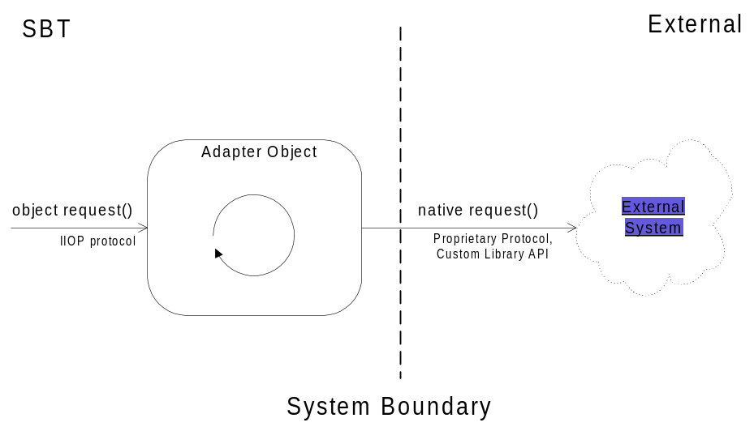
Figure 6 Adapter pattern

Static/Dynamic Dispatching (Dispatcher/Concentrator/Broker)
In a dispatching pattern, fault-tolerance and scalability of service are addressed by providing multiple registered services with a dispatcher. The dispatcher receives a service request and dispatches the request to the registered service. More than one instance of service can register to provide reliability and/or load balancing. The information needed to dispatch the request to a pool of services is available in the Trader Service (all the services advertise their capability using service type and properties with the Trader Service.) The concentrator uses the information in the Trade Service to route an incoming request to the appropriate object. The mapping process can be lazy instantiated (only maps out the service that is required at the time of execution) or fully instantiated for performance depending on the service usage pattern.
The Dispatcher can use a simple round robin algorithm for load balancing among the registered services. This method of load balancing is appropriate when the service is stateless, and any instance of the service can satisfy the request. An alternate strategy is used when the service instances are not identical, or contain state that must be retained from one invocation to the next. In this case, the concentrator must use some mechanism to determine which service instance can handle the request. An example is a concentrator for the Order Handing Service. There may be many instances of the service; each instance assigned a subset of the all the products. This approach maximizes load balancing and reliability by partitioning the products across a number of service instances, typically running on different platforms. The concentrator is responsible for determining the correct service instance for an incoming request. This is accomplished by examining one or more fields/parameters in the request, along with information obtained from the Trader Service about the properties of the service instances, to determine the appropriate destination.
With static dispatching, the client requests an instance of the service from the dispatcher. All further communication is performed directly between the client and the service. This style of dispatching is good for a stateful connection between a client and a service provider. With dynamic dispatching, the client always sends the request to the dispatcher and relies on the dispatcher to relay the message. This style of dispatching is better at stateless communication between a client and a service provider.
Routing Proxies utilized by the Front End hosts implement the dispatcher pattern, forwarding product-specific requests (e.g. orders) to the appropriate business server, locating business objects (e.g. orders) when a product is unknown, and coordinating federated queries which require all business servers (e.g. getAllOrders).

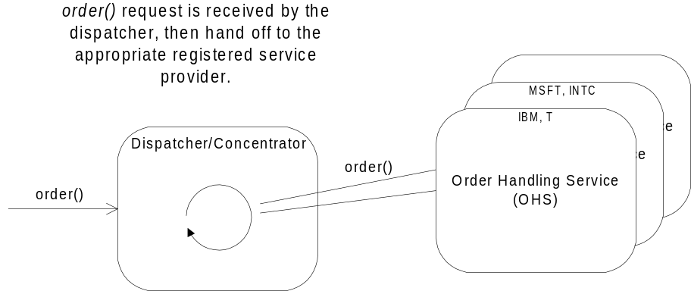
Figure 7 Dispatcher pattern

Smart Proxy
A standard proxy provides a placeholder for another object to control access to it. A typical usage is in a distributed application where a local proxy for a remote object is provided to a client. The proxy appears to the client as the remote object, forwarding requests to the remote object and returning results to the client.
A smart proxy extends the standard proxy with additional capabilities. Within SBT, smart proxies can be used to provide transparent fault tolerance to clients. Each smart proxy will contain references to two remote services (e.g. Order Handling Service). One reference will be designated as a primary, and the other as a secondary, or backup. Upon receiving a request, the smart proxy will attempt to forward the request to the primary reference. If a failure occurs, the smart proxy can transparently retry the request, or attempt to use the secondary reference. The number of retries can be configurable. The smart proxy can be implemented to always try the primary reference first, or completely bypass the primary after a number of failures. If a failure occurs due to a lost connection, the smart proxy can attempt to reestablish the connection on the primary reference while servicing the request through the secondary reference.
Use of smart proxies simplifies the development of client applications, by isolating complex error handling and fault tolerance code in a common implementation.
The smart proxy object can optionally cache the data for performance purpose.
The CAS uses a smart proxy for each Business Service (Order Handling Service, Order Book Service, Market Data Service, Market-Maker Quote Service, and Product Service). In addition, the Product Service proxy implements caching, which reduces the number of calls to the remote service. Also, each server process is configured with smart proxies for all services that reside out-of-process. For example, the Trade Server and the TPF Servers use caching proxies for the Product Service.

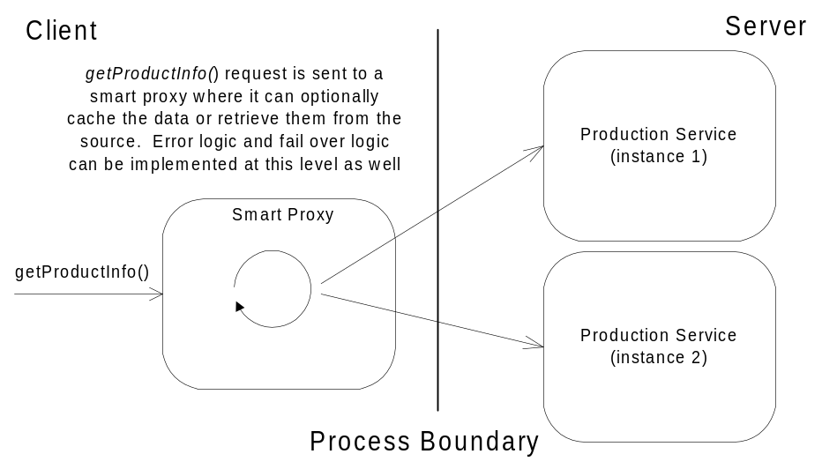
Figure 8 Smart Proxy pattern

Snapshot and Changed Events
Caching data on the client is an excellent way to increase system performance by reducing the number of calls to the server to retrieve data. The difficulty lies in ensuring that the cached data accurately reflects the state of the data on the server. There is little difficulty when the data is read-only. The data can be retrieved at one time (snapshot), or fetched on an as-needed basis (lazy instantiation).
When the cached data can potentially change at the source level (server), a notification mechanism needs to be in place to propagate the changes to the client. Given the SBT environment, a solution can be provided using event infrastructure to propagate a changed event (the delta data) to the local cached object. Every snapshot and changed event has to be time stamped or sequenced before sending out. At the client side, the proxy object should start subscribing to the changed event before getting the snapshot. A snapshot is then retrieved and the proxy start applies the delta change to the local snapshot. The changed event that arrived before retrieving the snapshot should be discarded. This approach will ensure that the cached object is synchronized with the object on the server.
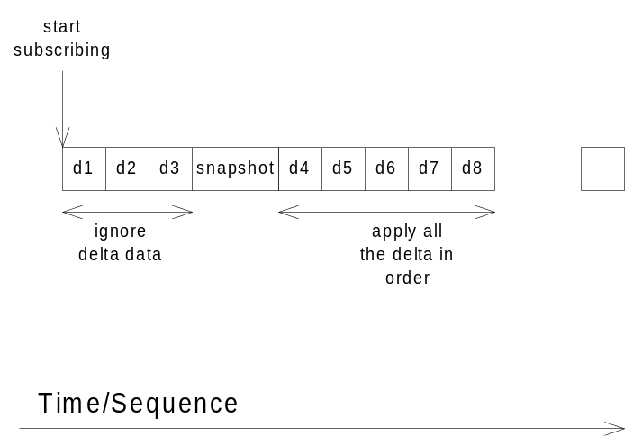
Figure 9 Snapshot and Changed Events
The CAS uses the snapshot pattern for maintaining the consistency of orders and quotes. The Order Status Service is used to propagate changes (e.g. fills, cancels) to the CAS whenever the actual object residing on the server changes.

Documentation and Models
This section describes the documentation set available for CBOEdirect™.

Development
- Screen-based Trading System Functional Requirements.
- Screen Based Trading (SBT) Application Architecture
- Use case documents (~80).
- Screen Based Trading Analysis Model (Rose UML Model).
- Screen Based Trading Design Model (Rose UML Model).
- CBOE Application Programming Interface (12 Volumes).
- CBOE Market Interface (CMi) API Design Model (Rose UML Model).
- SBT Version 2.0 Test Specification.
- CBOEdirect™ Configuration Version 2.0.
- Product Definition and Trading Session Maintenance User’s Guide Version 2.0.
- Market Maker User's Guide Version 2.0.
- Help Desk User's Guide Version 2.0.
- ClearCase Task Development Procedure.
- CBOE Java Programming Guidelines.
- CBOE Object-Oriented Development Process.
- Foundation Framework Development Kit.
- Directory Service User’s Guide.
- Directory Service Development Kit.
- Logging Service User’s Guide.
- Logging Service Development Kit.
- Messaging Service User’s Guide.
- Messaging Service Development Kit.
- Security Service User’s Guide.
- Security Service Development Kit.
- System Management Service User’s Guide.
- System Management Service Development Kit.
- DDTS Report.

Operations
- CBOEdirect™ Operator Procedures Version 2.0.
- SBT Patrol Operations Procedures.
- SBT Environment Setup Guide.
- Production Environment Configuration Map.
- Screen Based Trading Configuration.
- SBT Startup/Shutdown Checklist.
- General Screen Based Trading Operating Procedures.
- Patrol/Manual Screen Based Trading Procedures.
- SBT Recovery (Major Components).
- SBT Failover Mechanisms and Tests.
- Infrastructure Support/Recovery Procedures.
- Various Computer Operations Diagrams (Visio).
- Veritas Netbackup Configuration and Procedures.
- Assurance Test System Startup and Shutdown Procedures.

Systems Administration
- Database Backup.
- Database Import.
- CDB Cluster Reboot and Shutdown Procedures.
- BC/GC Cluster Reboot and Shutdown Procedures.
- CDB High Availability Overview and Procedures.
- BC/GC High Availability Overview and Procedures.
- CBOEdirect™ Unix/Network/Database Environment High-level Overview.
- SBT Unix Systems Operating Environment.
- SBT Software Inventory.
- SBT Layer 3 Security Model (Visio).
- CAS Security Notes.
- CBOEdirect™ Security Contingency Plan.
- SEC Security Response.
- SBT Security Policy.
- Various VISIO diagrams showing firm connections, cboefd routers, etc.
- Hardware Configurations (Assurance/Production/Development).
- Quality Assurance: Software Configuration.
- Directory Service Administrator’s Guide.
- Logging Service Administrator’s Guide.
- Messaging Service Administrator’s Guide.
- Security Service Administrator’s Guide.
- System’s Management Service Administrator’s Guide

Software
The following software artifacts are provided on CD-ROM for the Sun Solaris (CAS, FE, BC, and GC) and Windows NT (Trader Workstation, and Help Desk Application) platforms.

- Java source files (.java files)
- Java archive files for Solaris and Windows NT (.class files packaged in .jar files, i.e. machine-readable object code)
- C++ source files (.cc and cpp files)
- C++ libraries for Solaris (.so files, i.e. machine-readable object code)
- Build scripts for Solaris (.ksh, .sh, and .mk files)
- Installation scripts for Solaris (.ksh files)
- Configuration files for Solaris (.xml and .dtd files)
- Execution scripts for Solaris (.ksh files)
- SQL script files for Solaris (.sql files)

