Web Based Trading (WBT) Application Architecture
Chicago Board Options Exchange

17 November 1999
The Chicago Board Options Exchange

Change History:
Version | Date | Author | Reason for Change
0.1 | 11/17/99 | Mark Woyna | Original document.
Document Cross Reference:
No. | Title | Reference

Document Tracking Information
File Name: | 0000.doc
Document  Reference: | Screen Based Trading (SBT)  Application Architecture/Document/0000.doc/CBOE1/WBT
Version: | Version 0.1
Status: | Draft
Contents
Sign-off
Authorized by Mark Novak/CBOE
Signature

1. Introduction 4
1.1 Business Drivers 4
1.2 Technology Drivers 4
1.3 Overview 4
2. Use Case View 5
2.1 SBT User Logon 5
2.2 SBT User Logout 5
2.3 Enter SBT Order 5
2.4 Cancel Order 6
2.5 Update Order 6
2.6 Hit the Bid / Take the Offer 7
2.7 Display Fill Report 7
2.8 Display Order Status 7
2.9 Display Market Best 7
2.10 Display Last Sale 7
2.11 Display National Best Bid Offer (NBBO) Error! Bookmark not defined.
2.12 Display Underlying Market Data 9
2.13 Display Trader’s Activity Log 9
2.14 Query Market History 10
2.15 Enter Market-Maker Quote 10
2.16 Cancel Market-Maker Quote 10
2.17 Display Book Depth 10
2.18 Display Market-Maker Quotes 10
2.19 Enter RFQ 11
2.20 Set Auto-Quote Parameters 11
2.21 Generate Auto-Quote 11
2.22 Disseminate Best Quote to TPF 11
2.23 Disseminate Reports to TPF 11
2.24 Start-up System 12
2.25 Shutdown System 12
2.26 Pre-Open Product 12
2.27 Open Product 12
2.28 Halt Product 12
2.29 Close Product 13
2.30 Post-Close Product (End of Day Process) 13
2.31 Set Trading Parameters 13
2.32 Set Trader’s Defaults and Preferences 13
2.33 Set Market-Maker’s Defaults and Preferences 13
2.34 Set Clearing Firm Broker Defaults and Preferences 13
2.35 CFB Takes over Trader’s Privileges 14
3. Logical View 15
3.1 Logical Packages 17
3.1.1 Presentation Services Package 17
3.1.2 Application Services Package 19
3.1.3 Business Services Package 28
3.1.4 External Integration Services 32
3.1.5 Event Flows 33
3.1.6 Infrastructure Services 35
3.2 Processing Paradigm 44
3.2.1 Foundation Framework 44
3.2.2 Internal Event Channel 51
3.2.3 Message Translator 51
3.2.4 Thread Pool Framework 51
3.2.5 Callback Framework (Observer Pattern) 51
3.2.6 Adapter 52
3.2.7 Static/Dynamic Dispatching (Dispatcher/Concentrator/Broker) 52
3.2.8 Smart Proxy 54
3.2.9 Snapshot and Changed Events 56
3.3 External Interfaces 57
3.4 User Interfaces 57
3.5 System State 60
3.5.1 Pre-opening 61
3.5.2 Opening 61
3.5.3 Trading 61
3.5.4 Halted 61
3.5.5 Closing 61
3.5.6 Post-Closing (End of Day Processing) 61
3.6 Significant Scenarios 62
3.6.1 Enter Order 62
3.6.2 Display Fill Report 63
3.6.3 Display Book Depth 63
3.6.4 Disseminate Trade Report to TPF 64
4. Process View 66
4.1 Trader Workstation (GUI and Client Application Server) 66
4.2 MM Workstation 67
4.3 CFB Workstation 68
4.4 Admin/Operator Workstation 69
4.5 Routing Server 70
4.6 Distributed Trade Server 71
4.7 Systems Management Server 72
4.8 Market Data Service 72
4.9 Wire Order Server 73
4.10 User Server 73
4.11 Product Server 74
4.12 TIPS Server 75
4.13 Best Quote Server 75
5. Deployment View 77
5.1 Processing Needs (Application Layer) 78
5.1.1 Physical 78
5.1.2 Performance 78
5.1.3 Availability/Reliability 79
5.1.4 Functionality 80
5.1.5 Migration 81
5.2 Data Needs (Information Layer) 81
5.2.1 Physical Location 81
5.2.2 Capacity 81
5.2.3 Integrity 82
5.2.4 Access 82
5.2.5 Management 82
5.2.6 Migration 82
5.3 External Interfaces (Communication Layer) 82
5.3.1 Physical/Logical Connectivity 82
5.3.2 Performance 82
5.3.3 Capacity 83
5.3.4 Security 83
5.3.5 Migration 83
5.4 User Interfaces (Presentation Layer) 83
5.4.1 Physical 83
5.4.2 Performance 83
5.4.3 Security 83
5.4.4 Standards and Guidelines 83
5.4.5 Migration 83
5.5 Hardware Installation 83
5.6 Third-Party Products 84
5.7 Software Installation 84
5.8 Maintenance 84
6. Appendix 85
7. Glossary 86
7.1 Acronyms 86
7.2 Terms 90
8. Index 98

Figures
Figure 1 SBT System Context 4
Figure 2 System Logical Components and Context 11
Figure 3 SBT System Logical View 13
Figure 4 Presentation and Application Services Components 17
Figure 5. Foundation Framework Components Overview 43
Figure 6. Service Invocation 47
Figure 7 Adapter pattern 49
Figure 8 Dispatcher pattern 50
Figure 9 Smart Proxy pattern 52
Figure 10 Snapshot and Changed Events 53
Figure 11 SBT External Interfaces 54
Figure 12 Market Data Window 56
Figure 13 Order Entry Window 57
Figure 14 Enter Limit Order 59
Figure 15 Display Fill Report 60
Figure 16 Display Book Depth 61
Figure 17 Disseminate Reports to TPF 62
Figure 18 Deployment Overview 73
Figure 19 Global Service Server 75
Figure 20 Service Partition Server 76
Figure 21 SBT Functional Deployment 77

Foreword
The application architecture is a blueprint for what the developers will build. Like a building blueprint, it outlines the major features both physical and functional. It details the type of hardware, if not the specific hardware. It outlines the dimensions of the architecture by specifying the boundaries. It builds-in any required security, capacity, performance, maintenance, and operational needs. It specifies all external and user interfaces to the application. The application architecture is the vision for what the built system should look like. Although the architecture may change slightly over time, it gives the designers and developers a view of what the final product should be.
Scope
The application architecture covers the high level view of the final system. It will provide the vision for other more detailed documents. It will cover both the logical, physical and functional aspects of the application. Although the application architecture is not enough for a developer to begin building the application, it is necessary for providing a common vision and determining synchronization points for multiple teams.
Audience
The system owner should read this document to ensure it captures the owner’s vision for functionality and presentation. The system architect should read this document to ensure it adheres to the enterprise architectural vision and philosophy. The information architect should read this document to ensure it properly captures the business functionality. The infrastructure architect should read the document to ensure that the application uses the infrastructure items wherever possible. The technology architect should read this document to ensure the application properly uses the appropriate technologies. The system engineer should read this document to understand the vision and constraints placed on the system. The system engineer will reference this document when building the system requirements and performing system analysis. The designer should read this document to ensure his design captures the architect’s intent. The developer should read this document to ensure the implementation realizes the architect’s vision of the application.
Prerequisites
Readers should be familiar with the system architecture, the information architecture, the infrastructure architecture, and the technology architecture for this project.

Organization
- 1. The Introduction section contains background information, the business driver force and the technical driver force for the system, and an overview of the system context.
- 2. The Use Case View section provides the motive and describes the system needs in concrete term.
- 3. The Logical View section describes the static and dynamic aspect of the system in terms of packages, subsystems, components, and their responsibilities.
- 4. The Process View section represents the decomposition of components in terms of execution flows. Process View also represents the synchronization between the components and the availability and reliability of them at the process level.
- 5. The Deployment View section describes how the processes are deployed at the processor level. It discusses the scalability and fault tolerance features of the system. The hardware and software tools are also documented here.

Open Issues The following open issues still exist within this document.

- User Browser options
- Use of Java Applets/JavaScript/HTML/DHTML/XML
Conventions
Special terms defined in the Glossary begin with uppercase.
Commands you need to key in and programming code appear in Courier New.
Menu items appear in Title Case. Menu paths follow in order Main Menu>Menu or Submenus>Command. For example, saving a file is File>Save.
Keys or keystroke combinations appear in bold.
Files and directory names appear in italics.
Notes look like:

Note
Description of the hint, problem, or precaution.
Related Documents
- SBT Application Architecture, Chicago Board Options Exchange (CBOE)
- CBOE Application Programming Interface, Chicago Board Options Exchange (CBOE)

1. Introduction
This document addresses the application architecture of a Web Based Trading (WBT) system that CBOE may deploy as part of its option trading business.

1.1 Business Drivers
WBT extends the capability of the Screen Based Trading (SBT) System by allowing access via the internet (World Wide Web) utilizing standard internet protocols and tools (e.g. HTML, JavaScript, Web Browser). With the growth of internet-based trading systems, WBT will provide an investor a direct connection to the SBT system without requiring the installation of custom software on the client’s workstation.

1.2 Technology Drivers
In order for CBOE to provide WBT capabilities by the target date (XX/XX/XXXX), it must leverage existing internet tools and technologies. WBT will provide an alternative, web-based interface by converting the existing SBT interfaces (i.e. GUI) to HTML/JavaScript/Java, compatible with standard web browsers. A new adapter component will allow WBT to utilize the existing SBT API (CMI) by converting HTTP requests to CMI calls, and convert outbound data to HTML/XML for rendering by the client’s browser.

1.3 Overview
The Web Based Trading (WBT) system provides an alternate, web-based interface to SBT. See the SBT Application Architecture document for a full description of the capabilities of SBT.
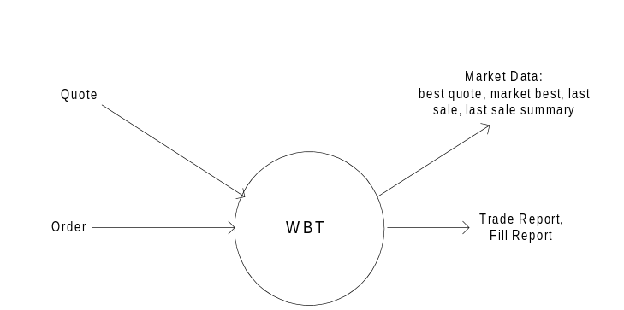
Figure 1 WBT System Context
The WBT system processes orders and quotes by forwarding them to SBT. It produces fill reports, cancel reports, trade reports and market data (best quote data, last sale summary).

2. Use Case View
This section provides an overview of the use cases that the WBT System must support. It is not intended to be a substitute for more detailed descriptions found in the Analysis Model (see use case documents in the Analysis Model), but only provide the background and context for the rest of the Application Architecture. The set of Use Cases supported is a subset of SBT.

2.1 WBT User Logon
This use case models the required interactions between a Web Based Trading User and the Trading Engine software when an WBT user logs in. Any actor (human or automated) must first be authenticated by the System before being allowed to use it. This use case (UC) comprises not only the initial actor authentication, but also the necessary initialization tasks in preparation for interacting with the System (i.e. downloading cached data, establishing a session, subscribing to receive events).
Actors using this use case:
- Trader
- Market-Maker

2.2 WBT User Logout
This use case models the required interactions between a Web Based Trading User and the Trading Engine software when an WBT user logs.
Logging off from the system involves disconnecting the session, unsubscribing from events, et cetera.
Actors using this use case:
- Trader
- Market-Maker

2.3 Enter SBT Order
The System accepts orders from an actor for execution. The System accepts the following types of orders:
- Limit
- Market
- All or none (AON)
- Fill or kill (FOK)
- Immediate or cancel (IOC)
- Spread (Combination/Strategy)
Each type of order has a specific set of execution rules. Upon receiving an order, the system attempts to execute it according to the execution rules of its type. Depending on the execution rules and whether or not the order was (partially) filled, this UC may trigger (use) other use cases, including Display Fill Report, Disseminate Trade Report, Send RFQ, etc.
Actors using this use case:
- Trader
- Market-Maker

2.4 Cancel Order
An actor may cancel the unfilled portion of any of his/her resting orders.
Actors using this use case:
- Trader
- Market-Maker

2.5 Update Order
An actor may update an order, or cancel an order and replace it with another otherwise identical order but with a different price or increased quantity. An update request that includes a different price or an increased quantity results in a cancel/replace operation. All other changes to the order result in an update or revision of the order.
Actors using this use case:
- Trader
- Market-Maker

2.6 Hit the Bid / Take the Offer
An actor may electronically ‘hit the bid’ or ‘take the offer’ in a selected product market.
Actors using this use case:
- Trader
- Market-Maker

2.7 Display Fill Report
Upon filling an order (partially or completely), the System reports the fill to the originating actor.
Actors using this use case:
- Trader
- Market-Maker

2.8 Display Order Status
An actor may request a display of the current status of his/her filled and unfilled orders. The System will update the status of the orders in real time as long as the actor maintains the display active.
Actors using this use case:
- Trader
- Market-Maker

2.9 Display Market Best
An actor may request a display of the Market's Best Bids and Offers for a selected product. This information includes price and aggregate volume for the best bids and best offers, and an indication if the prices represent the National Best Bid and Offer (NBBO). The System will update the data in real time as long as the actor maintains the display active.
Actors using this use case:
- Trader
- Market-Maker

2.10 Display Last Sale
An actor may request a display of the last sale for a selected product. The System will update the figure in real time as long as the actor maintains the display active.
Actors using this use case:
- Trader
- Market-Maker

2.11 Display Underlying Market Data
An actor may request a display of the market data (status, last sales, and news alerts) for a selected product. The System will update the data in real time as long as the actor maintains the display active.
Actors using this use case:
- Trader
- Market-Maker

2.12 Display Trader’s Activity Log
An actor may request a display of his/her trading activity, including orders entered, cancelled, replaced, and filled during a selected period of time.
Actors using this use case:
- Trader
- Market-Maker

2.14 Query Market History
An actor may request a display of the quote and trade history of a selected product. This information includes the best bids and offers, last sales, and their times and dates disseminated by the System since a specified time and date.
Actors using this use case:
- Trader
- Market-Maker

2.15 Enter Market-Maker Quote
A market-maker may submit a Market-Maker Quote representing his/her intention to trade a product. The System treats a Market-Maker Quote as a pair of limit orders, and as such, it attempts to execute them immediately or otherwise book them for later execution.
Actor using this use case:
- Market-Maker

2.16 Cancel Market-Maker Quote
A market-maker may cancel the unfilled portion(s) of his/her quote in a selected product.
Actor using this use case:
- Market-Maker

2.17 Display Book Depth
A market-maker may request a display of the book depth of a selected product. This display is only a snapshot that needs to be refreshed manually.
Actor using this use case:
- Trader
- Market-Maker

2.18 Display Market-Maker Quotes
A market-maker may request a display of his/her outstanding quotes. The System will update the data in real time as long as the market-maker maintains the display active.
Actor using this use case:
- Market-Maker

2.19 Enter RFQ
An actor may submit a Request for Quote (RFQ) to notify market-makers to provide quotes. An RFQ can also be generated automatically, while executing a market order, for example. The System will maintain a log of market-maker quotes submitted in response to RFQs to periodically evaluate the fulfillment of the market-makers’ obligation to provide liquidity to the market.
Actors using this use case:
- Trader
- Market-Maker

2.32 Set Trader’s Defaults and Preferences
An actor using a workstation may set defaults and preferences applicable to any trader in order to customize trading as well as the user interface to his/her needs.
Actors using this use case:
- Trader
- Market-Maker

2.33 Set Market-Maker’s Defaults and Preferences
A market-maker using a workstation may set defaults and preferences specific to market-makers in order to customize trading as well as the user interface to his/her needs.
Actors using this use case:
- Market-Maker

3. Logical View
The diagram below shows the top-level logical structure and context of the WBT System.
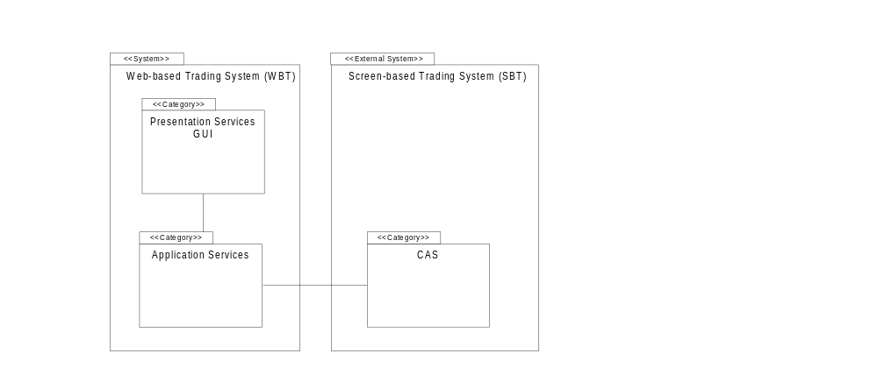
Figure 2 System Logical Components and Context
The WBT System is comprised of the following two logical packages of functionality (“Class Categories” in UML terminology):
- Presentation Services (GUI)
- Application Services (CMI Adapter)
The Presentation Services (GUI) package is constituted by web-based applications that interact with the SBT system via Application Services package. Client applications can consist of a combination of HTML, DHTML, XML, JavaScript, and Java. The appropriate technology is dependent on the amount of dynamic content presented by the user interface. Static displays (e.g. Order/Quote entry forms, query results) can be rendered using HTML/XML, while dynamic displays (e.g. Market data, RFQ status) can utilize Java applets.
The Application Services package contains subordinate packages that interact with the SBT system via the CBOE Member Interface (CMI) API described later. The package servers as an adapter that converts HTTP client requests into IIOP requests, and converts callback requests from the CMI into HTML/XML.

Figure 3 WBT System Logical View below shows the detailed logical components of the WBT System and their key interactions within the system and with external systems.
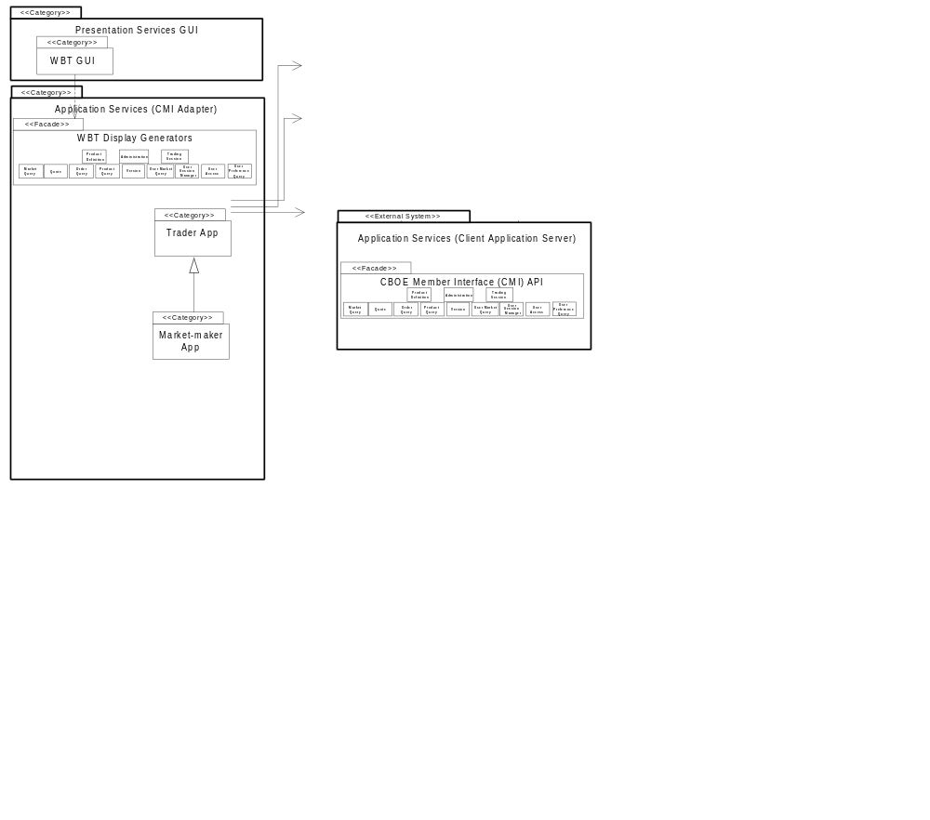
Figure 3 WBT System Logical View
The following section describes the responsibilities of the subordinate packages in each of the top-level packages.

3.1 Logical Packages

3.1.1 Presentation Services Package
The Presentation Services package contains six subordinate packages:
- WBT GUI – contains GUI applications to allow human actors interaction with the SBT system
- Models – contains MVC models (Java applets only)
- Internal Event Channel (Java applets only)
- Registered Callback Listeners (Java applets only)
- API Translator (Java applets only)

3.1.1.1. WBT GUI
The SBT GUI display is based on the model-view controller pattern. The SBT GUI Display is responsible for displaying the contents of a particular model to the screen and updating the display if the model’s contents change. This package contains several GUI applications, one for each of the major classes of human actors that use the SBT System: traders, market-makers, clearing firm brokers, and system operators.
- Trader GUI – is used by regular traders. It consists of several GUI’s for displaying and entering orders, and market data.
- Market-Maker GUI – is an extension of the Trader GUI and is used by market-makers. It consists of several GUI’s for displaying and entering orders, quotes, and market data.
- System operation GUI – is used by system operators and help desk operators

A GUI framework is implemented here to promote the consistency in look and feel and speed up the GUI development work.

3.1.1.2 Models
Certain models including product class, product and order/quote models are singletons within a distinct GUI application and thus will be shared among multiple frames and panels. For the purpose of speed of display, each market data display panel/frame has its own copy of a market data model and underlying model for those products in which a particular frame is interested. Each model that can be updated by a remote event implements the EventChannelListener interface.

3.1.1.3 Internal Event Channel
The internal event channel is a pattern that is based on Java custom events. For each type of custom event that can be registered, a model (EventChannelListener) can be added as a listener to the Event Channel. When a remote event is received, it is routed to the correct channel and all listeners of that channel are notified of the event and passed any user defined data that wants to tag along with the event. The internal event channel exists in its own thread and has a queue.

3.1.1.4 Registered Callback Listeners
When a remote method is called on the CAS/CMI, an optional callback object can be passed which then registers the Presentation Services for any update “callback” messages from the CAS/CMI. There is one listener for each type of message that can be received. When a listener receives a message from the CAS/CMI, it will forward the message to the appropriate “Internal Event Channel” where it will then be forwarded to any interested event channel listeners. Each callback listener lives in its own queued thread.

3.1.1.5 API Translator
The API Translator is responsible for hiding the complexities of communication with the CAS from the GUI and Models. All remote requests by the GUI go through the translator. The translator will take a request for data, register the Event Channel Listener, and create and pass the callback listener. It also keeps track of the user data so that the GUI does not need to supply it when making remote calls.

3.1.1.6. SBT Auto-Quote
This package contains a single application that duplicates the functionality of the auto-quote generation engine currently used by market-makers in CBOE’s trading floor posts.
The SBT Auto-Quote application will run remotely on the market-maker’s computer to comply with the “fairness in trading” requirement – if it ran centrally, market-maker’s would have an advantage over other traders as a result of reduced latency. Only the parameters for calculating auto-quotes are saved centrally to allow market-maker’s to move from one workstation to another. The SBT Auto-Quote will use the CBOE Member Interface API and will input quotes to the Market-Maker Application.
SBT’s own auto-quote facility should not be confused with the proprietary auto-quote facilities of market-makers, which will also utilize the CBOE Member Interface API. The SBT System is not responsible for storing the calculation parameters used by these proprietary auto-quote facilities, but only to accept orders, and quotes.

3.1.2 Application Services Package
The Application Services package contains an application for each human actor in SBT. These applications submit requests to Business Services components, notify clients of business events, and maintain user-specific views of information in the Business Services.
This package encompasses a CBOE Member Interface (CMI) API that provides a single entry point to the system exposing the applications in the Application Services Package (i.e., Trader, Market-Maker). CBOE has chosen to support two different application programming interfaces. The first is a robust, full function API using the CORBA/IIOP protocol. This version of the API is intended for market makers and traders that plan on using high bandwidth functions, such as market data, and in the case of market makers, auto-quotation facilities.
Retail firms and some institutional customers will be interested in adopting the CBOE API FIX (Financial Information Exchange Protocol) Protocol version. CBOE is providing this protocol based upon the wide acceptance of FIX as a standard for order entry, request for quotation (indication of interest), and execution reporting. At this current time, FIX does not provide for a publish-subscribe mechanism required for distribution of real time market data. The FIX Protocol is an industry standard created by retail and institutional investors for the trading of securities. The FIX protocol was extended to support derivatives in Version 4.1. The FIX protocol was originally designed to automate much of the trading that was done over telephone by providing messages for indications of interest, quotations, orders, and execution reports. The protocol was extended to the point where it is feasible to use this protocol for electronic trading from a retail or institutional perspective. FIX was not designed for high volume distribution of market data, leaving it unacceptable for use by market makers at this point in time.
The FIX Protocol is implemented over the TCP/IP protocol. CBOE intends to support future versions of the FIX protocol - including the FIXML a standard from the FIX protocol working group implemented using the Extended Markup Language (XML).
Depending on existing systems, some firms may choose to adopt both APIs for different applications.
See CBOE Application Programming Interface for more information on the CBOE Member Interface.
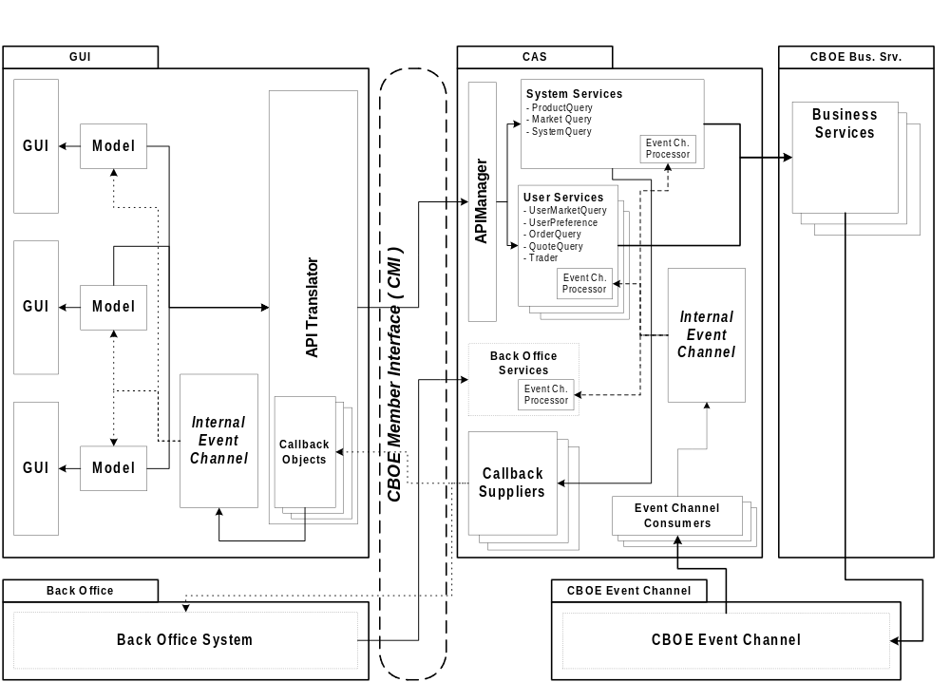
Figure 4 Presentation and Application Services Components

3.1.2.1. Trader Application
This package has the following specific responsibilities:
- Submit, cancel, update, and cancel/replace orders
- Submit requests for quotes
- Present the current status of the trader’s orders
- Present fill and cancel reports
- Present Market Best Bids and Offers for selected products
- Set the trader’s defaults and preferences
- Present underlying quotes/last sales and news alerts

3.1.2.2. Market-Maker Application
This package inherits the Trader App package’s responsibilities and adds the following:
- Submit and modify market-maker quotes
- Present requests for quotes
- Set the market-maker’s defaults and parameters
- Set auto-quote parameters
- Submit auto-quotes
- Present Book Depths for selected products

3.1.2.7. CMI Adapers
For applet-based components, the application server package provides an adapter that calls the appropriate CMI method(s).
The functionality of the Trader, Market-Maker, and BackOffice packages is exposed by a façade, the CBOE Member Interface (CMI) Application Programming Interface (API). The CBOE Member Interface exposes different subsets of functionality depending on the user that logged on to the system. The intention behind sharing a common API among the different trader classes is to allow workstations installed on the floor to service all of them.
The CBOE Member Interface API supports both SBT client applications and external applications owned by members. Members use the CBOE Member Interface API to link their existing computer systems to SBT, to submit orders electronically and to automate trading. Likewise, market-makers use the API to generate auto-quotes employing their proprietary systems, instead of the default auto-quote application provided by SBT.
A major requirement of the Screen-Based Trading system, as specified in the SBT Software Requirements Specification, is to provide an Application Programming Interface (API) to enable members’ computer systems to interact with the SBT system. The targeted users of this API are member firms, non-market-maker professional broker/dealers (BD), and market-makers (MM). Although these types of users have different capabilities, they are sufficiently similar to suggest the use of a single API with usage restrictions according to the type of user, as opposed to using multiple APIs.
The following SBT system functions must be accessible through the API:
- Session logon and logoff
- Market state inquiry and change notification
- Connection status inquiry and change notification
- Order entry, cancellation, and replacement
- Quote entry, cancellation, and replacement
- RFQ notification
- Order status inquiry and fill notification
- Subscription to product markets
- Best market quotes notification
- Book “depth” inquire and change notification
The API is not intended for automating administrative or configuration functions; members will have to use a SBT Workstation to manually perform these functions with proper authorization.
The API leverages the distributed infrastructure utilized by CBOE to ensure a reliable, efficient and secure transmission of messages to and from the SBT System. In addition, this leverage will substantially simplify the development of the API.
CBOE will provide a single portable API or a set of functionally-equivalent APIs for deployment in members’ platforms. In addition to the API, CBOE will provide the required libraries for the distributed infrastructure components such as Object Request Broker (ORB), messaging service, event service, security service etc. With the API, members will develop applications to automate trading or gateways to allow other computers to automate trading. These applications or gateways will run in member’s computers connected to CBOE via leased lines.
CBOE will make special simulation server components available to members to facilitate the development of applications. The simulation server components will support all the functionality of actual servers and provide a realistic environment for stress testing the member’s application.
The API’s functionality will be exposed as a set of CORBA IDL interfaces to facilitate its use from any language with a CORBA mapping. Alternatively, the API may be exposed as a framework in a particular language, such as Java, to be linked directly with an application, thus avoiding inter-process communication and consequently increasing response time.
To simplify application development and maximize performance, the API will be multi-threaded and thread-safe. Also, the API exposes the public interface of the underlying application (i.e., Trader, Market-Maker, UserAccess, etc.).
Replicated objects are persisted by the API—if the client application fails or the connection to server components is dropped, upon re-starting or reconnecting the API restores the objects to its prevalent state. The API only presents a snapshot of the member’s current trading state at any given time; the application is responsible for storing relevant transactions to reconstruct history. Whenever possible, data validations will be performed locally using cached data to avoid unnecessary network traffic.
The API conforms to the event-based programming model—the API calls back a registered event handler upon occurrence of an event, passing the details of the event to the event handler. For example, to receive notifications every time an order is (partially) filled, the application first needs to register an application object which implements an API-defined interface with the API. Once a fill occurs, the API will invoke a method defined in the interface on the application object.
Events are fired asynchronously as soon as they occur, however, an event may be delayed if the application is not ready to process it. This will depend on the threading support of the application development environment used.
Invocation of critical methods is synchronous in order to let the application know of the success or failure of the call. Armed with this information, the application can decide whether to continue normal processing or take corrective actions immediately, instead of having to wait for an asynchronous reply. Order and quote submissions are examples of synchronous calls.
To simplify the development of the application and the API, transaction boundaries will not span more than a single method invocation.
As described in Section 3.1.2, CBOE will support a FIX protocol in addition to the IDL-based interface.

3.1.2.8 Application Services Components
The Application Services package contains the following types of components:
- Business Services Proxy/Cache
- Callback Suppliers
- Remote Event Listeners
- Remote Event Processors

3.1.2.8.1 HTML Page Generators

3.1.2.8.1 CMI Proxy/Adapters
The CMI Proxy/Adapters provides the connection between the API and the CBOE business services. Any caching of remote data is accomplished in internal models owned by the Business Services Proxies.

3.1.2.8.2 Callback Suppliers
The callback suppliers are responsible for sending updated data through the Common Client API to a remote listening application. Each type of callback has its own supplier object. Similar to the Internal Event Channel used by the Presentation Services, a callback object is registered with a particular channel or set of channels. Each callback object then serves multiple remote callback clients and manages which types of data to send to which remote clients. The callback supplier object is threaded and queuing. Synchronous callbacks are used to communicate remotely in order to insure that the message is received by the Presentation Services layer.

3.2 Processing Paradigm
This section describes the common processing paradigm using software design patterns. It details the collaboration between objects in a certain context to achieve a generic software construction.

3.2.1 Web Application Server

Enterprise Java Beans (EJB)

Servlets

Java Server Pages

Foundation Framework
The Foundation Framework is a set of Java classes that enables using certain SBT infrastructure services in a consistent and effective manner for both the Application Service developers and Business Service developers.
Overall the Foundation Framework functionality will provide a default standard usage of the SBT infrastructure service. The developers will not be affected by the changing infrastructure technology, and they are not required to work with the infrastructure service directly. However, it will not force the developers to use the framework to get to the infrastructure services.
In more detail, the framework provides an application or business server process with the ability to have multiple execution contexts where many service objects can be deployed using specified execution policies and a mechanism to provide authorization validation at the method invocation level. A mechanism is provided that collects and instruments the service statistical profile data by intercepting the invocation of the business service object, capturing the necessary information, then delegating the work back to the business service object. The service process is consistently managed by exposing an administration interface to allow an external application management process to have reactive or proactive control over the process operation. It facilitates a logging integration, allowing a developer to statically define all log information at the development phase, and dynamically control the amount of log information to propagate to a central log repository. It also provides a standard interface to use the Persistent Framework/Service. The framework specifies creating, deleting, and finding operation interfaces the developer will code to. The implementation of the operation for each business object and the actual operation of maintaining the mapping between the object and the persistent layer is outside the scope of the Foundation Framework. The framework simply provides a façade interface to enable an underlying Transaction Framework/Service. There is no additional functionality of transaction management to be implemented at the framework.
This list details the Foundation Framework’s specific functionality:
- Thread management—provides the following threading policy:
- Reuse threading—uses the same thread as the caller. In this model, the framework relies on the developer to provide a threading model (the developer can implement the threading at the business object implementation, at the ORB, or at the Event Infrastructure).
Other threading policies that can be implemented in the future include:
- Shared thread policy—all incoming invocations are handled by a single shared thread. Service invocation is serviced one at a time by the shared thread.
- Thread per request policy—for each incoming service invocation a thread is created and services the request. Service invocations are serviced in parallel.
- Directory Service Integration—provides an easy interface to the Directory Service, simplifying its usage.
- Security Integration—provides the security mechanism to validate authorization with the Security Service at the service invocation level. It collaborates with the Security Service to provide the authorization.
- Session Management Integration—provides an interface to the Session Management Service to establish and terminate user sessions. In addition, the interface provides the capability to register for notification of terminated user sessions.
- Application management interface:
- Provides a mechanism to collect and calculate the service statistical data (Instrumentation)
- Provides an interface to process administration and operation commands from an external management process (Command Callback)
- Provides a standard interface to allow access and control application/service properties (Admin)
- Log Integration—provides an easy access entry point to the Log Service. From this log access, the developer can control the logging and the amount of log information to be propagated to the Log Service.
- Event Integration—provides an easy access entry to enable the use of the Event Infrastructure.
- Generic Exception Facility—provide a default implementation of generic exception to interface with the Log Service.
- Time Service Integration—provides an easy access entry to enable the use of the Time Service.
- Persistent Service Integration—specifies the factory, finder, load and store interfaces a developer needs to implement to. The underlying persistence framework is JavaGrinder. The developers will implement the business object using “wrapper” classes for the underlying JavaGrinder interfaces.
- Transaction Management— provides the common access to the session object in the JavaGrinder transaction framework. From this session object the developer can start a transaction, commit, rollback transactional business object. They can allow a thread to join or leave a session using the same exposed session object. The specific behaviors of these operations are details in the JavaGrinder documentation.

- See Foundation Framework Requirements for more information on the Foundation Framework.

3.2.1.1 Components and Concepts
The following diagram details the overview components and concepts of how the Foundation Framework operates. <<Need to add SMS>>
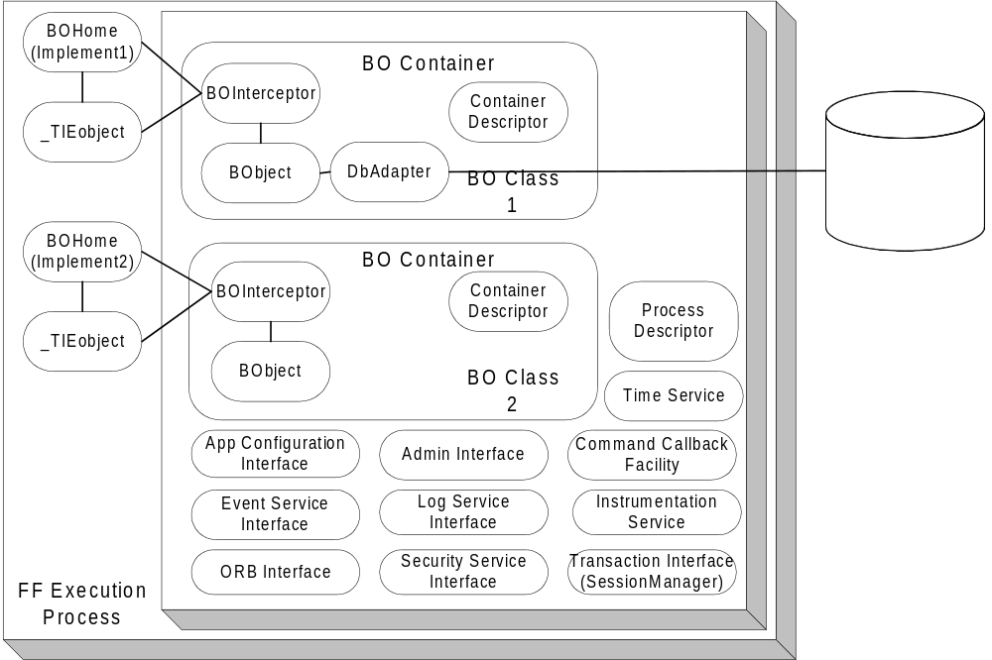
Figure 5. Foundation Framework Components Overview

3.2.1.1.1 Foundation Framework Execution Process
The Foundation Framework Execution Process is a singleton object that encapsulates all the infrastructure functionality and exposes an easy-to-use interface for the underlying infrastructure services. It contains a list of execution BOContainers, a Process Descriptor, the interface to the Application Configuration Service, ORB Service, Log Service, Event Service, Security Service, Session Management Service, Time Service, Instrumentation Service, Transaction Service (SessionManager), an Admin interface, and a Command Callback Facility. The developer simply instantiates the Foundation Framework Execution process in the main Java VM program to deploy business service objects to operate in the specified execution containers.
Each of the BOContainers provides a different execution container for a group of business service object instances (BObject). A service method invocation is always invoked on a BOInterceptor, a peer object to the BObject. The Foundation Framework code to implement the functionality is interjected at the interceptor level and the actual work to service the request is delegated back to the BObject.
At this level, all the process level information that is shared between BO Containers is specified and exposed in the Process Descriptor. It contains:
- The process security identity—the identity of the whole process.
- A list of execution containers.
- A list of home implementations.
- An environment property provides the customizable name pair values, which can be defined and retrieved using the standard Properties object.
Within the process boundary, the framework exposes at this level the following interfaces:
- The Application Configuration Service interface – through this interface the start up default properties of the process can be accessed.
- The Security Service interface – provides the access to the Security Service
- The Session Management Service interface – provides the access to the Session Management Service
- The Transaction Service interface – provides the interface to the JavaGrinder SessionManager object. From this SessionManager, Session can be created to groups a number of threads together working on a set of transactional objects. The transactional objects will be commit and rollback together using session commit and rollback operations.
- The ORB Service interface – through this interface the basic Object Request Broker functionality like network parameters (request queue, time-out. The Trader service can be accessed through this interface.
- The Event Service interface – provides a simple access to the Event Service.
- The Log Service interface – provides the access to the Log Service. From this interface, the control of propagation level and the logging functionality is delegated to. The Logging Service defines the following log types: DEBUG, INFORMATION, ABORTION, THROTTLE, SYSTEM, RESOURCE and EXCEPTION. Each log type has ten levels of priority ranging from the one (lowest) to ten (highest). Along with the priority log level, a quality of service can be specified. The quality of service used to control the amount of messages to package and send at the sender type depends on the repetition of the message sent. Refer to the Log Service for the detailed quality of service.
- Instrumentation Service interface –provides the mechanism to actively collect the service statistical profiles.
The framework also exposes an Admin interface beyond the process boundary so that it can participate in the system control and management.

3.2.1.1.2 Business Object Container (BOContainer)
A business object container provides an execution container for a group of business service objects. Each service invocation is intercepted and controlled by the policies in the BOContainer Descriptor. The following policies are shared at the container level:
- A Transaction Policy: OBJECT_MANAGED and CONTAINER _MANAGED. With OBJECT_MANAGED, the business service object will make calls to the Foundation Framework Transaction Management directly. With CONTAINER_MANAGED, the transactional begin demarcation and commit demarcation will be provided at the peer interceptor object.
Only the OBJECT_MANAGED is available for the first release of SBT. The framework will expose a JavaGrinder session object per container. The transactional object will manage its transaction begin and end explicitly.
- Thread Policy: REUSE_THREAD, SHARED_THREAD and THREAD_PER_REQUEST. The REUSE _THREAD policy executes the task in the same thread of the caller. The SHARED_THREAD policy uses the single shared thread in the execution container to process tasks one at a time. Incoming tasks are blocked in this model until the current task is finished. The THREAD_PER_REQUEST will execute the task in a separate thread. For each task, a new thread is created and the dispatching of the task happen within the new thread. Tasks are dispatched in parallel.
Only the REUSE_THREAD is available for the first release of SBT.
- Instrumentation Policy: ON and OFF. ON policy starts the process of collection and instrumentation of the statistical profile data of service invocations. The running average timing and the number of invocation at the request level will be collected and stored in memory. OFF policy turns the processing off. The instrumentation data will be available when request and also available in the public broadcast event channel.
- Security Policy: PROCESS_IDENTITY and SPECIFIED_IDENTITY. The PROCESS_IDENTITY policy uses the process level security identity as the identity to validate the authorization. The SPECIFIED_IDENTITY policy allows the container to control the identity at the invocation level (in this case a client identity can be used instead of the process identity).
- Exception Policy: THROW_BACK, ABORT_CURRENT_TASK, and ABORT_PROCESS. TRHOW_BACK policy propagates the exception thrown to the caller. ABORT_CURRENT_TASK policy dictates the execution container to abort the current task, log the exception, and continue to the next task. ABORT_PROCESS policy allows the exception to be logged and other execution containers to be notified that shutdown is in process, and finally terminates the process.
Since the Foundation Framework will not have any threading implementation for the first release of SBT, the only exception policy support is THROW_BACK. The developers have to code the EXCEPTION event log directly at the time of exception raise and it will be raised back to the caller the normal way.

3.2.1.1.3 Business Service Object Home (BOHome)
For each business service object class in the system, a Business Object Home is available to provide the finding and creation of a service object instance and its peer interceptor. In the case of implementing a CORBA object the TIE object can be managed by the BOHome as well. A Business Service Object Home is shared between the execution containers. There is only one Business Service Object Home per class of business service object in the VM process.
There can be multiple BOHome objects. Each one can handle the creation and finding of a selected implementation of a business service object. One BOHome object can be responsible for the CORBA proxy object (which in turn communicates with a server business service object). Another BOHome object can be responsible a local stubbed out version of a business service object; and one can take care of the actual business server service object at the server side. These multiple homes facilitate a consistent usage pattern and promotes the iterative development effort.

3.2.1.1.4 Business Service Object Interceptor (BOInterceptor)
For each business service object instance (BObject), a peer service interceptor object is created. It is a one-to-one relationship between the peer interceptor object and the instance object. This peer object exposed all the service that a BObject provides. At this interceptor level all Foundation Framework features are provided. The interceptor delegates the actual work to the business service object instance.

3.2.1.1.5 Business Object Instance (BObject)
BObject is an instance of a business object. A Business Object is defined as a large-grained object that provides some business or application service, or represents a significant entity in the business domain.
There are two types of business objects. A service object is a large-grained object that provides some business or application service. There are a small number of service object instances in the process. The main process usually creates the service object instance at the initialization stage. The service object is running until the process is terminated. There is no activation and passivation of a BObject by the framework. The service object instance is typically a transient object with no persistent data. However, a service object can manage a collection of persistent objects.
Entity objects represent significant, small-grained domain objects (e.g. Order, Quote). These objects are typically persistent, outliving the process in which they were created, with cardinality greater then one.
When implemented with the JavaGrinder persistence framework, a JavaGrinder DBAdapter will be associated with the object to provide the persistence capability. There are different DBAdapters to persist data to different persistent medium: one for a relational database, one for a text file, and one for a binary file. When implemented with the JavaGrinder Transactional interface, a BObject will implement the interface to support commit and rollback of the data (the in process memory data attributes)
A business object can be a CORBA IDL implementation object or an object intended to be used exclusively within a process.

3.2.1.1.6 Service Invocation Dispatching
When the service invocation (a business method) arrives to the peer interceptor object, the interceptor accepts the invocation. Before submitting the service invocation and processing the reply invocation, the interceptor object enables the Foundation Framework functionality.
To enable the Foundation Framework functionality, the service invocation only needs to go through the interceptor object. To the caller, the syntax and calling signature is the same between the service instance and its interceptor. If the service object is a CORBA object, use the interceptor object as the implementation object instead of the service object to inherit the Foundation Framework functionality.
When using the TIE approach to provide the CORBA object, the tie object (server side IDL generated object) can be associated with the interceptor object to enable the Foundation Service functionality the same way. Dispatching the CORBA request to the interceptor using the TIE mechanism and the dispatching between the interceptor and the instance object should proceed normally.
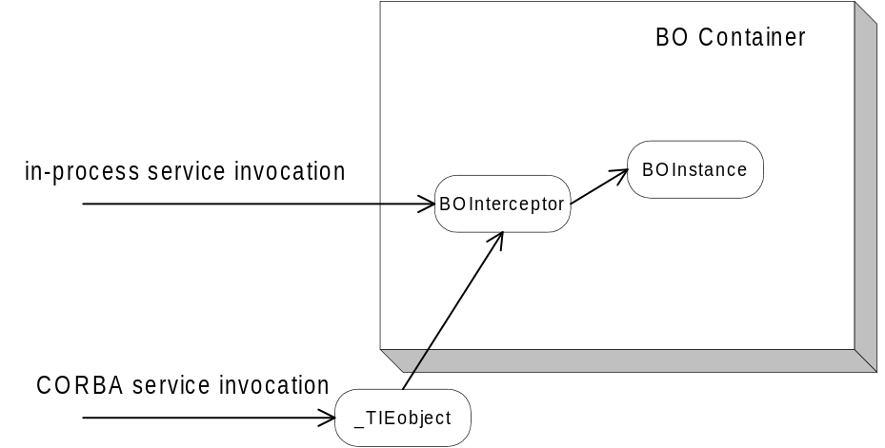
Figure 6. Service Invocation

3.2.1.1.7 Application Process Management
At the process level a Command Callback facility is exposed. It contains a map of registered callbacks, allowing the Foundation Framework to enable the process to be controlled and managed from an external process. A developer register “command” as a string key name to an action at initialization stage and the call back will be invoked from an IDL admin interface.
An external management process binds to the admin interface to retrieve process configuration information, to change process behaviors, and to retrieve the statistical instrumentation profile data.

3.2.2 Internal Event Channel
The internal event channel is a pattern that is based on Java custom events. For each type of custom event that can be registered, a model (EventChannelListener) can be added as a listener to the Event Channel. When a remote event is received, it is routed to the correct channel and all listeners of that channel are notified of the event and passed any user defined data that wants to tag along with the event. The internal event channel exists in its own thread and has a queue.

3.2.3 Message Translator
The API (Message) Translator is responsible for hiding the complexities of communication with the CAS from the GUI and Models. All remote requests by the GUI go through the translator. The translator will take a request for data, register the Event Channel Listener, and create and pass the callback listener. It also keeps track of the user data so that the GUI does not need to supply it when making remote calls.

3.2.4 Thread Pool Framework
The Thread Pool Framework provides a lightweight, asynchronous implementation of the Command pattern. The framework accepts commands, implemented as subclasses of an abstract ThreadCommand class, and dispatches them to the next available worker thread. If no thread is available, the command is queued until a thread becomes available. Upon completion, the command can be programmed to update zero or more objects, simulating a return value.
The framework is used within the Broker Service for order and quote processing, as well as the Internal Event Channel.

3.2.5 Callback Framework (Observer Pattern)
The GUI Client Application is a thin client that only provides the presentation and the input controller of the SBT Application Services. The observer pattern is nicely fit to provide the presentation need for the GUI Client Application. Each of the object data can be mapped to form a one-to-many dependency with the GUI widgets. When the object data changes state, all the GUI widgets are notified and updated automatically.
When a remote method is called on the CAS/CMI, an optional callback object can be passed which then registers the Presentation Services for any update “callback” messages from the CAS/CMI. There is one listener for each type of message that can be received. When a listener receives a message from the CAS/CMI, it will forward the message to the appropriate “Internal Event Channel” where it will then be forwarded to any interested event channel listeners. Each callback listener lives in its own queued thread.
Within the CAS, the callback suppliers are responsible for sending updated data through the CBOE Member Interface to a remote listening application. Each type of callback has its own supplier object. Similar to the Internal Event Channel used by the Presentation Services, a callback object is registered with a particular channel or set of channels. Each callback object then serves multiple remote callback clients and manages which types of data to send to which remote clients. The callback supplier object is threaded and queuing. Synchronous callbacks are used to communicate remotely in order to insure that the message is received by the Presentation Services layer.

3.2.6 Adapter
The intent for the adapter pattern is converting the interface of a class into another interface clients expect. In SBT all the external interfaces can be grouped into this category (e.g. TIPS Adapter, TPF Adapter). An object wrapper is created for data that needs to be accessed from the external system. The object wrapper converts requests to external native function calls to fulfill the request.
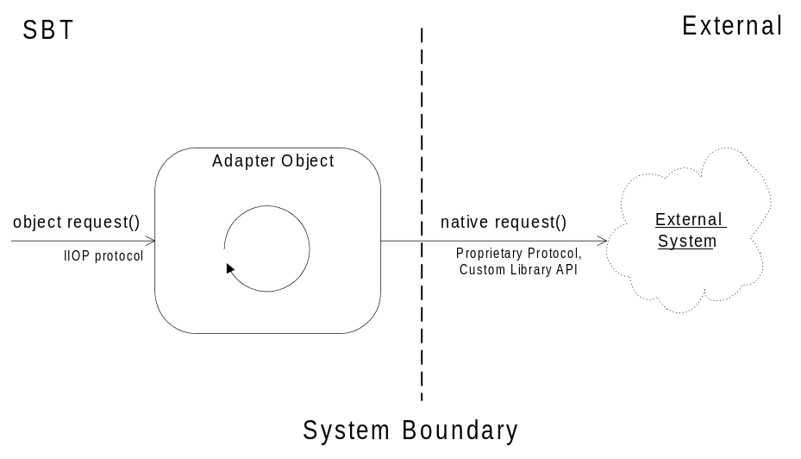
Figure 7 Adapter pattern

Figure 8 Smart Proxy pattern

3.3 External Interfaces
The WBT interfaces to the following systems:
- SBT – provides the CMI interface for entering orders and quotes, and receiving reports and market data.
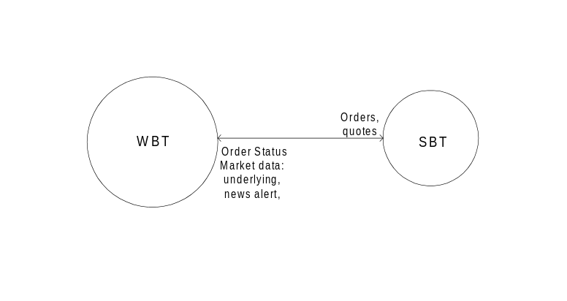
Figure 9 SBT External Interfaces

3.4 User Interfaces
This Presentation Services (GUI) package contains one GUI application:
- Trading GUI – is used by regular traders, and market-makers. It consists of several GUI’s for displaying and entering orders, quotes, and market data.
Packaging the GUIs in single applications shared by all users in a class is intended to reuse a substantial number of common GUI components and maintain a consistent look and feel.
In the context of the Model-View-Controller design pattern, the SBT GUI applications act as views and controllers, while the applications in the Application Services Package, described in section 3.1.2, act as models. A GUI framework is implemented here to promote the consistency in look and feel, and speed up the GUI development work.
The following are general design requirements or principles that have to be considered in designing the various components of the SBT system.
- The user interface should be designed to be flexible and configurable by the user. The user should be able to specify the columns of data he/she wants to see in displays such as the Market Display, the Order Status Display, the Trades and Quotes Log, the AutoQuote Setup Display, etc. The user should also be able to specify the background colors, the font size, etc.
- The use of popup windows should be minimized to provide the trader a constant , unobstructed view of his trading screens.
- Speed in interactions with the system is of the utmost importance. Mouse and keyboard operations for each transaction, especially the most frequently used transactions, should be kept to a minimum.
- Keyboard operations equivalent to the mouse operations for certain critical transactions, for example, the Delete All Quotes transaction, should be available for use in case of mouse failure.
A prototype of the SBT system was developed to assist in defining the requirements and look-and-feel of the user interface. The prototype interfaces will serve as the basis for the design of the SBT user interfaces. The individual user interfaces are detailed in the set of CBOE Use-Case Reports. Examples of two SBT GUI windows are given below.

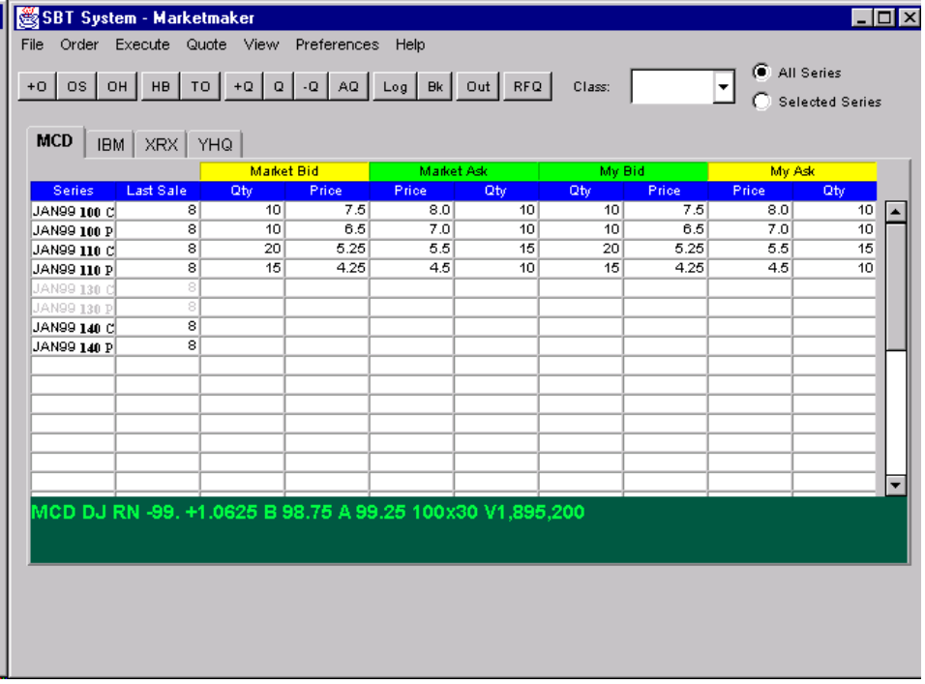

Figure 10 Market Data Window

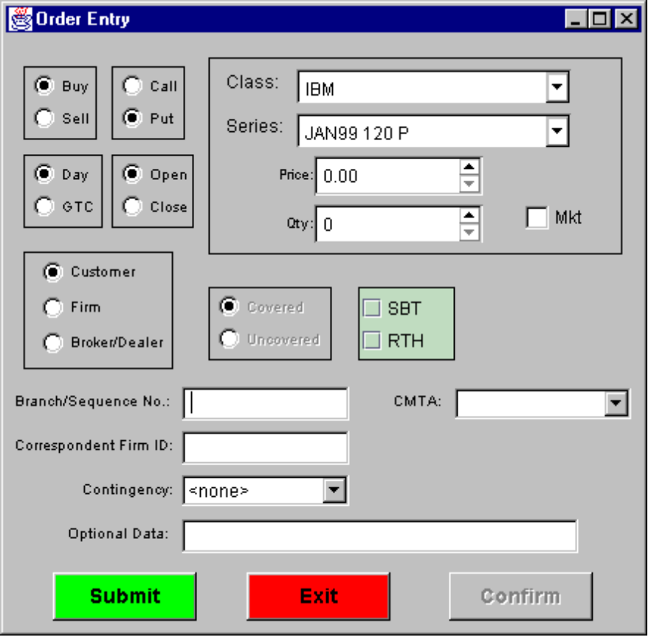
Figure 11 Order Entry Window

3.6 Significant Scenarios
This section provides an overview of the several important scenarios (functions) that the WBT System must support. It is not intended to be a substitute for more detailed descriptions found in the Analysis Model, but only provide the background and context for the rest of the Application Architecture.

3.6.1 Enter Order

The System accepts orders from an actor for execution. The System accepts the following types of orders: Limit, Market, All or none (AON) , Fill or kill (FOK), Immediate or cancel (IOC), Stop (STP), Stop Limit (STP LIMIT), and Spread. Each type of order has a specific set of execution rules. Upon receiving an order, the system attempts to execute it according to the execution rules of its type. Depending on the execution rules and whether or not the order was (partially) filled, this UC may trigger (use) other use cases, including Display Fill Report, Disseminate Trade Report, Send RFQ, etc.
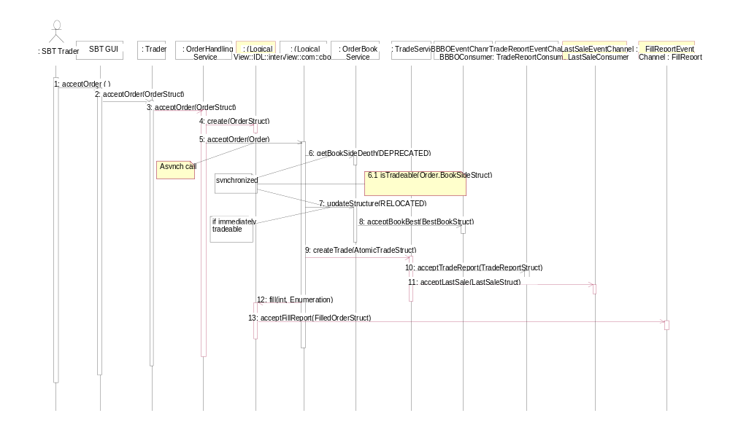

Figure 12 Enter Limit Order

3.6.2 Display Fill Report
Upon filling an order (partially or completely), the System reports the fill to the originating actor.

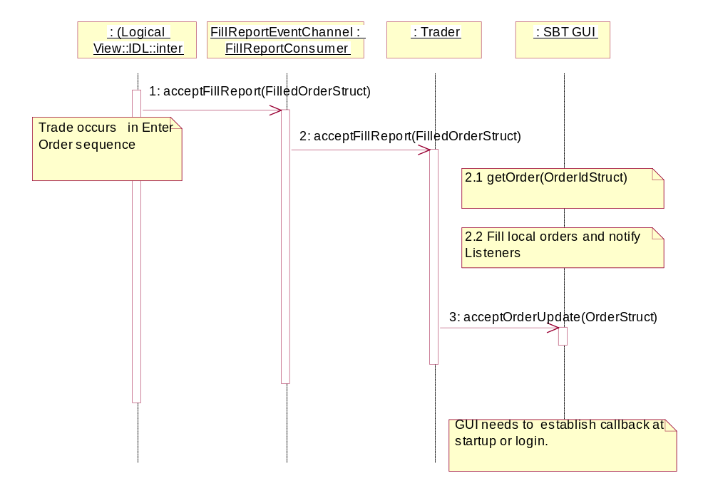
Figure 13 Display Fill Report

3.6.3 Display Book Depth
A market-maker may request a display of the book depth of a selected product. This display is only a snapshot that needs to be refreshed manually.

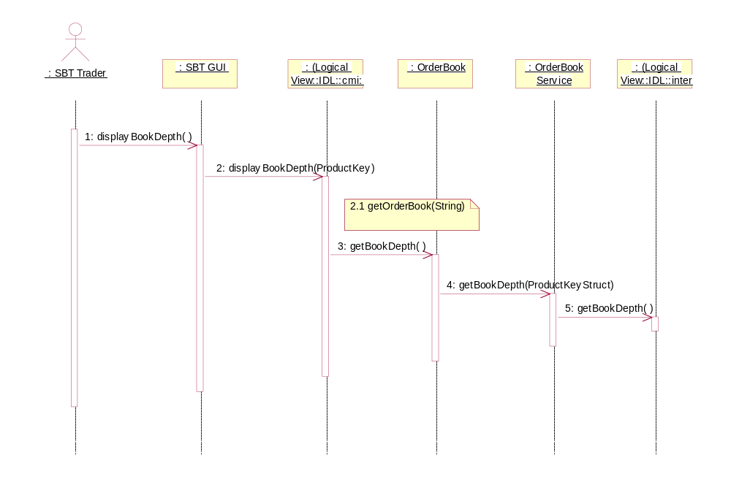

Figure 14 Display Book Depth

4. Process View
WBT is a distributed application based on an Abstract Integration Model. The fundamentals: uniform type, reference, and invocation system in a distributed environment are the key ingredients to the integration view. The Common Object Request Broker: Architecture and Specification (CORBA) is selected as the technology for the Abstract Integration Model. It provides the basic elements: type, interface, object, reference, operation, parameter, context and exception needed to define a flexible architecture that is able to adapt to changing technology. Using CORBA, business services are implemented as CORBA object servers. The business data and functionality are described in a development language neutral syntax called Interface Definition Language (IDL). The business objects are designed to be deployed in a distributed environment for performance scalability and high availability. The following process views represents the decomposition of SBT components in terms of execution flows (process and threads of task), the synchronization between flow, and the allocation of components within the various flows.
The process grouping below is established and is guided by the frequent interaction between the components. It is leaning toward minimal physical I/O transaction and network traffic. Some of the independent process should be analyzed further to see if they can be deployed together in a single process to minimize the system usage (physical memory, virtual memory, swap space, paging …) and network usage (socket, connection to global service server …).

4.1 Trader Workstation (GUI and Client Application Server)
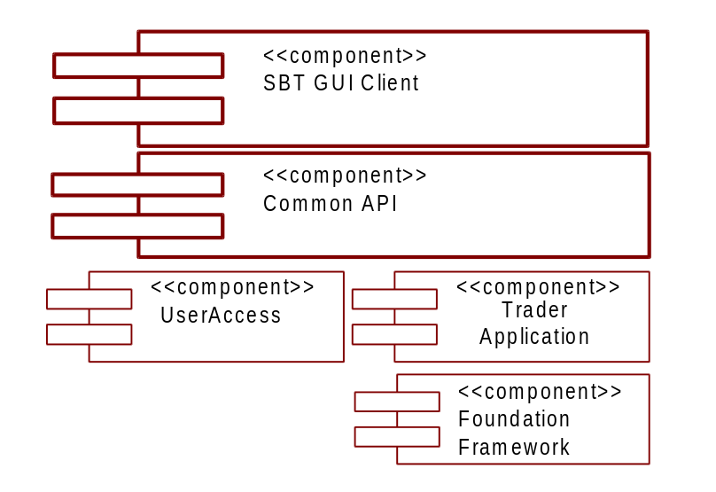

The SBT GUI Client component provides the interaction mechanism between the Trader Workstation process(es) and the SBT system. The Trader Workstation is comprised of two parts: a GUI, and a Client Application Server (CAS). The two components are defined as CORBA objects, and as such, can be executed in a single process or multiple processes. In the two process model, the CAS is started first, and publishes an Interoperable Object Reference (IOR) for the SBT Access object (a.k.a. LogonApp) in a location that the GUI can access. When the GUI process starts, it obtains the IOR for the SBT Access object, and opens a GUI screen prompts the user for logon information. The entered information passes through the Common API component to the SBT Access component. Upon validating the authentication and authorization, the CAS returns a reference to the Trader (a.k.a. Trader App) and starts
- receiving and processing Trade commands through the SBT GUI component
- monitoring and processing events from the Event Infrastructure
The Trader Workstation process contains a trader view of the orders and the top of the book (BBBO). The view of the data should be retrieved when the process is started up and cached locally for performance. The view needs to be updated as the data changed at the business services. There is no need for transaction management in this process.

4.2 MM Workstation
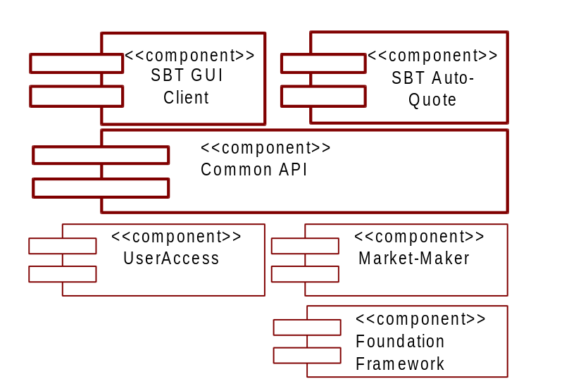

The SBT GUI Client component provides the interaction mechanism between the Market-Maker Workstation process(es) and the SBT system. The Market-Maker Workstation is comprised of two parts: a GUI, and a Client Application Server (CAS). The two components are defined as CORBA objects, and as such, can be executed in a single process or multiple processes. In the two process model, the CAS is started first, and publishes an Interoperable Object Reference (IOR) for the SBT Access object (a.k.a. LogonApp) in a location that the GUI can access. When the GUI process starts, it obtains the IOR for the SBT Access object, and opens a GUI screen prompts the user for logon information. The entered information passes through the Common API component to the SBT Access component. Upon validating the authentication and authorization, the CAS returns a reference to the Market-Maker (a.k.a. Market-Maker App) and starts
- receiving and processing Market Maker commands through the SBT GUI component
- monitoring and processing events from the Event Infrastructure. In processing a Request For Quote event, the MM App might pass the request to the Auto Quote for a system generated quote.
The MM Workstation process contains all the Trader Workstation views of the data and the Market-Maker book depth aggregrated view. The view of the data should be retrieved when the process is started up and cached locally for performance. The view needs to be updated as the data changed at the business services. There is no need for transaction management in this process.
The SBT Auto-Quote component is defined as a CORBA object, and as such may execute in the same process as the GUI and CAS, but will most likely execute within its own process. In its own process, the SBT Auto-Quote will establish a connection to the Market-Maker through a well-known IOR.

5. Deployment View
The following is not a definitive layout, but rather a first high level cut of a possible deployment of WBT. This view is necessary in order to identify security, reliability, availability, performance, and capacity needs. It will be updated throughout the lifecycle of the application, as each phase dictates.
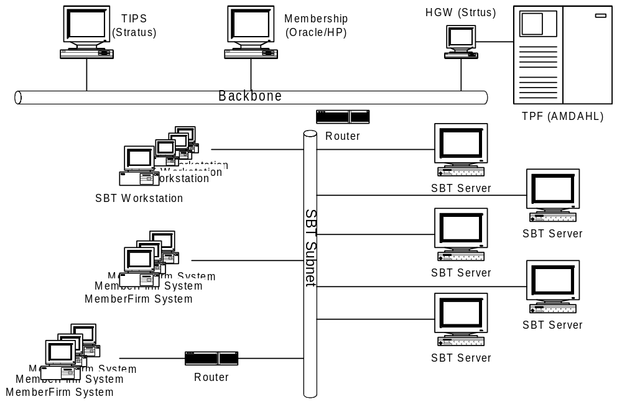
Figure 15 Deployment Overview

5.1 Processing Needs (Application Layer)

5.1.1 Physical

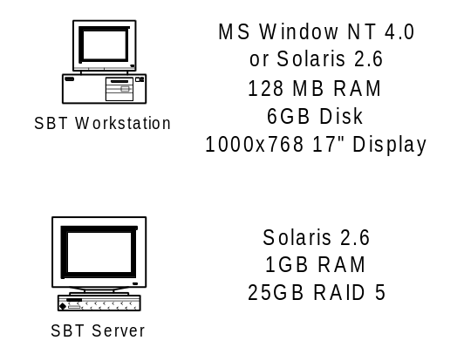

5.1.2 Performance
SBT services are deployed in servers using three different styles of services: front end server, global service server and service partition server. With a front end server, requests are received and routed to the appropriate server for processing by the front end. The processing at the front end is minimal. Multiple instances of the front end are running to provide the performance needed, and to provide a level of fault-tolerance. A client can connect to any of the front ends and receive the same service. A client will typically be assigned a primary and secondary front end server.
With global service server, a number of servers with identical services are deployed. Each of the global service servers is self-contained and has a complete set of replicated data to function by itself. The characteristics of deployment for this style of service are:
- Global usage of service, where the client does not care which instance of the server processes the request.
- Frequency of service is less frequent than the other style. For example, the service is only needed on the initialization or when validating data (using some type of caching after getting the initial data).
- There is more querying than updating to the data source that the global service servers contain. This is to minimize the replication effort between them.
The performance on this style of server is up scaled by deploying additional instances of the server.
With the service partition server, the processing of services is partitioned among instances of servers. Each instance of a server is responsible for a mutually exclusive group of products (classes). All the instances of services are using the same processing logic, but the processed data are all different between server instances. In SBT, the processing of products can be logically divided by products (IBM Jan 110 CALL, IBM Mar 110 PUT…). The characteristics of deployment for this style of service are:
- Frequency of service at an aggregation can be significantly far more than any instance a server provides.
- Does not distinguish about the usage pattern of data (read vs. write) beside the fact that each of the server instances owns its data.
The performance for service partition server style is achieved by balancing the arrangement of products to evenly distribute the processing load, and deploying more server instances.

5.1.3 Availability/Reliability
The many benefits of distributed computing systems come with a price: an increase in potential faults. Each of the distinct components in a distributed system is a potential failure point. Dealing with availability and reliability are delegated as much as possible down at the component level (Event Messaging Infrastructure has guaranteed message delivery capability; each service component has self logic error checking …) but where the component interacts the potential failure point is there.
When deploying the front end server, multiple instances of the server should be available. A client can connect to an additional secondary front end for high availability. All the requests are sent using the primary in the normal way until the primary goes down. The client can switch to the secondary as the new primary and, optionally, another secondary can be selected and reconnected.
When deploying the global service server, a minimum of two instances of servers are required on two separate machines. The single point of failure for services running on this style is eliminated by retrying the service on the next available server. The interruption of service is handled transparently by the smart proxy pattern of communication. Note: When multiple instances are deployed they are sharing the load of the whole system because each of them is self-contained.
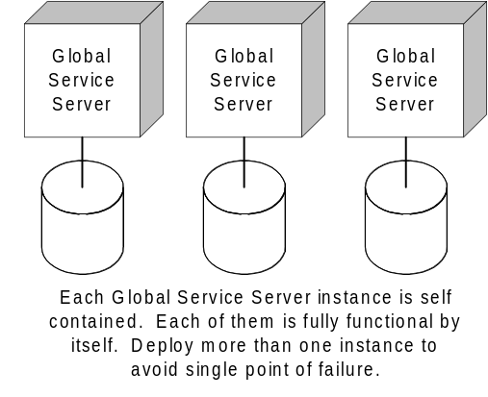
Figure 16 Global Service Server
Another approach for deployment of Global Service Server is having a single set as primary and a backup as secondary. The secondary takes over the primary job when it detects the failure. The interruption of service for this approach is the time for the secondary to take over the primary. During this time interval, no service is available for servicing requests.
The service partition servers are deployed with primary and secondary backup. The secondary can be a hot backup when setup is in a high availability mode, where the secondary can assume the working environment as soon as the primary goes down. The secondary can also be set up in a pool of secondary machines where the disk array on the primary data can be manually switched to a secondary machine when the primary goes down. The interruption of service is localized to the set of partitions for the service. In SBT, only the products that are supported by the primary server are not available until the secondary is up and running.

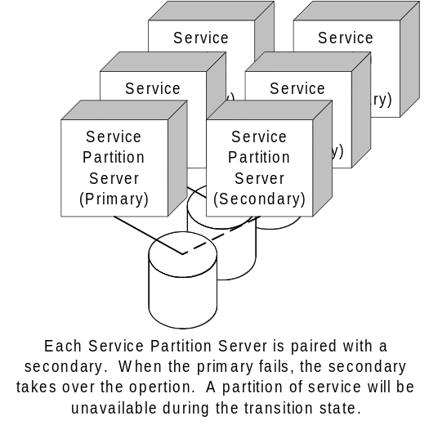
Figure 17 Service Partition Server

5.1.4 Functionality
Below is a mapping of SBT functionality to the system resource. Using the UML notation, each of the boxes denotes a host machine that provides the service. Each of the processes (denoted as square box inside a host machine) are deployed as one or more processes. Database notations are attached to the host machine to signify the fact that a Database Management System is deployed as the data repository. <<Need to add Product Configuration Service>>
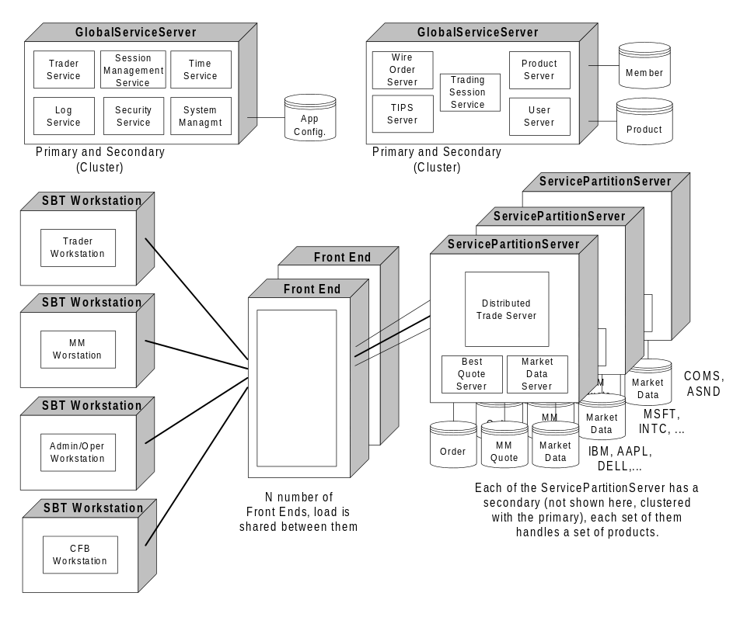
Figure 18 WBT Functional Deployment

5.1.5 Migration
All the interfaces between components are versioned to ensure the migration between the iteration and phases of development. SBT services are deployable with multiple versions. As far as deployment is concerned, each service and version comprise a unique deployable service.

5.2 Data Needs (Information Layer)

5.2.1 Physical Location
[Describe the proposed physical location of data. Identify the application’s persistent and transient data items. Address issues with both centralized and distributed persistent data. Address issues and needs for any shared data. Identify the bottlenecks and performance issues associated with any centralized data. Identify the application’s distribution and synchronization issues associated with any distributed data.]

5.2.2 Capacity
[Discuss the application’s expected memory and disk capacity needed to support the transient and persistent data. The analysis should include at least a five-year forecast for the data capacity.]

5.2.3 Integrity
[Discuss the integrity requirements of each data item. Address the application’s reliability and auditing issues, as well as its backup and recovery needs.]

5.2.4 Access
[Discuss the access by systems and individuals to each data item. Address security issues and expected policies for handling security breaches and violations.]

5.2.5 Management
[Discuss the management of data for the application. Identify the target database management system or file system in which each data item will reside. Identify in as great a detail as possible the vendor, version, and operating system for any DBMS.]
Oracle 8.1 (Solaris 2.6) will be used for data management for the Distributed Trade Servers, and for Systems Management and Configuration. Oracle Parallel Server (OPS) will provide failover capabilities by running instances of the database server on each node in the cluster.
Netscape’s LDAP (Solaris 2.6) will be used for data management for the Directory and Security Services.
The file system and Oracle 8.1 (Solaris 2.6) will be used for Log Service messages, depending on quality of service.

5.2.6 Migration
[Discuss what data should migrate for legacy systems or from the previous version of the application. Identify a strategy for rolling the data forward with the capability of rolling the data backwards, when aborting an installation.]
No data will be required to be migrated to SBT. The system is designed to obtain product and membership data directly via the appropriate adapters.

5.3 External Interfaces (Communication Layer)

5.3.1 Physical/Logical Connectivity
[Discuss the proposed physical connections and protocols the application will use to implement each external interface. Determine if each interface is either asynchronous or synchronous. Identify the data/message format from the integration architecture that each interface will use. Identify in as great a detail as possible the vendor, version, and operating system of any off-the-shelf product the application uses to implement each external interface, or identify the infrastructure services the application uses to implement the interface.]

5.3.2 Performance
[Perform some high level analysis of the size of data to be sent as well as the frequency and speed required for sending the data across each interface.]

5.3.3 Capacity
[Analyze the projected network, memory, and disk capacity needs to support each interface for at least the next five-years.]

5.3.4 Security
[Address all security constraints on each interface. Identify the network security requirements in the integration architecture that apply to this application.]

5.3.5 Migration
[Identify the strategy the communication layer will use to handle multiple versions of hardware, software, and data during any migration period.]

5.4 User Interfaces (Presentation Layer)

5.4.1 Physical
[Identify the target platform(s) for the user interface. Identify hardware needs, such as, mouse, color monitor, speech recognition, etc.]

5.4.2 Performance
[Document the forecasted number of concurrent user interfaces to the application over a five-year period. Identify any performance expectations on the application in support of the user interface.]

5.4.3 Security
[Address security needs such as user identification. From the choices in the technology architecture, select hardware and/or software that the application will use to implement user identification.]

5.4.4 Standards and Guidelines
[Identify any standards, like Windows programming standards or Motif programming standards, that apply to the user interface paradigm selected from the technology architecture. Identify all presentation policies from the integration architecture that the application will implement.]

5.4.5 Migration
[Identify the strategy the presentation layer will use to handle multiple versions of data and messaging during any migration period.]

5.5 Hardware Installation
[Describe the expected order in which to install the hardware. Describe dependencies in both installation and in system startup/shutdown order. Define the setup of each system for user access, disk configuration, backup facilities, and monitor/control capabilities.]

5.6 Third-Party Products
This section identifies the third-party products required by SBT by name, version, and patches.
- JavaSoft JDK 1.3 (Java 2)
- JavaSoft Swing 1.0.3
- Web Application Server (IBM WebSphere, BEA WebLogic, iPlanet Application Server)
- JavaIDL ORB (CMI to client

5.7 Software Installation
[Describe the expected method of deploying the application into the operational environment. Define the media and format for deploying the system. For example, the application could be a Java JAR on a server that each client downloads and installs. Describe the state of the system before and after the software installation. Define any dependencies on hardware, third party software, or other applications.]

5.8 Maintenance
[Describe the approach for routine maintenance, such as software patches. Describe emergency maintenance procedures, such as backing out an installed version of the application to the previous version, due to some catastrophic errors in the software.]

6. Appendix
[Use for any elaboration of concepts introduced in the previous sections of the document.]

7. Glossary

7.1 Acronyms
Acronym | Definition
AON | See 7.2 terms - All or None Order.
BART | Booth Automated Routing Terminal is a CBOE client/server system used by booth staff to receive and re-route Orders.
BQS | The Best Quote Service is responsible for calculating the market best (best quotes) for each product. It also calculates and disseminates the NBBO.
BBBO | Best Book Bid Offer
BS | The Broker Service is responsible for executing various types of orders (i.e. Limit, Market, All or None, Fill or Kill, Immediate or Cancel, Stop, Stop Limit, Spread). It notifies the Trade Service of all the orders matched in the trade and it also notifies the OHS and MMQS of the fills.
CAS | Client Application Server
CBOE | Chicago Board Options Exchange
CFB | See 7.2 terms - Clearing Firm Broker.
CMI | CBOE Member Interface
COMPASS | A CBOE system that connects member firm branches with the trading engine. It sends Orders to the trading engine and receives fill reports from the trading engine.
COPP | CBOE OPRA Participant Processor is a CBOE system that forwards price reports, quote reports, and administrative messages to OPRA for dissemination to vendors and the general public.
COSS | Commercial off-the-Shelf Software
CQS | Consolidated Quote System is a SIAC system that receives stock quotes from stock exchanges and disseminates them to data feed vendors and the general public.
CTM | See 7.2 terms - Trade Match System.
CTS | Consolidated Tape System is a SIAC system that receives stock trade reports from stock exchanges and disseminates them to data feed vendors and the general public.
DART | Direct Access Routing Terminal is a CBOE system (currently known as BERS) used by the following:  - Booth staff to enter Orders into the trading engine  - Fill reporters to enter fill reports into the trading engine  - Floor workers to enter inquiries into the trading engine  - The display subsystem to display information to floor workers
- DTE | Distributed Trading Engine
EB Backup | Electronic Book Backup is a CBOE system that provides a view of the book if the trading engine fails.
EPW | See 7.2 terms - Exchange Prescribed Width.
FIX | Financial Information Exchange Protocol
FOK | See 7.2 terms - Fill or Kill Order.
GTC | Good Till Cancelled.
ICS | Integrated Class Series is a CBOE system used for entry and storage of information concerning valid products. Will become the IPS.
IOC | See 7.2 terms - Immediate or Cancel Order.
IPS | Integrated Product System which will replace ICS.
MDS | The Market Data Service maintains a snapshot of market data, in addiiton to publishing market summary data. It also provides an interface to clients to query historical market data.
MIN | See 7.2 terms - Minimum Order.
MMHH | Market-Maker Hand-Held is the PSP application responsible for accepting trade data that a Market-Maker enters into his/her Market-Maker Terminal. MMHH routes the trade to CTM and forwards price reports to the trading engine. In addition, it receives and displays trade acknowledgments from RAES.
MMQS | The Market-Maker Quote Service is responsible for receiving and submitting RFQs, sending fill reports, and cancelling or updating quotes. It also provides the history of the quotes submitted by a Market-Maker.
MMT | Market-Maker Terminal is a hand-held terminal used by Market-Makers to enter trade reports. It also provides tools to help the Market-Maker trade more efficiently, such as position tracking, risk management, equivalent stock position, delta analysis, pricing models, and graphic position monitor. The MMT is also the hardware component of the MMHH application that interacts with a Market-Maker.
NASDAQ | National Association of Securities Dealers Automated Quotation System
NBBO | National Best Bid Offer.
NMMPT | See 7.2 terms - Non-MarketMaker Professional Trader.
OBO | Order Book Official is a CBOE employee who maintains the book and trades booked Orders.
OBS | The Order Book Service is responsible for publishing the new BBBO and last sale upon changes to the top of the book. It cancels and cancel/replaces resting orders and it acknowledges that an order was accepted. The OBS also assists in calculating the opening price during a products pre-opening period.
OCC | Options Clearing Corporation is an organization owned equally by the US options exchanges. It is responsible for clearing options transactions and makes possible the secondary market for options by severing the contractual link between the buyer and the seller.
OHS | The Order Handling Service application maintains the current state of all orders. It is responsible for creating, cancelling and updating orders. Notification of changes in order status is supported by the Order Handling Service as well.
OPG | See 7.2 terms - Opening Only Order.
OPRA | Options Price Reporting Authority.
ORB | Object Request Broker
ORS | The Order Routing System is a TPF application responsible for routing electronic Orders to RAES, EBOOK, PAR, or booth terminals.
OSS | The Order Status Service provides subscription and notification services related to orders (i.e. fill reports, cancel reports, order accepted by book, etc.).
P&S (Purchase-and-sale) statement | A statement sent by a brokerage firm to a customer when a futures or options position is offset or extinguished by delivery. A P&S statement typically shows the number of contracts involved, the prices at which and dates on which the contracts were bought and sold, the gross profit or loss, the commission charges, the net profit or loss on the transactions and the account balance.
PAR | Public Automated Routing is a CBOE system used by Floor Brokers to process public Orders.
PCS | The Product Configuration Service is responsible for providing the location of where a product is processed/traded.
PDS | Post Data Server is the part of the display subsystem that is the central repository of class and series information for a specific post. The trading engine sends display information (e.g., CBOE best quotes and NBBO quotes) to the PDS. The Display Subsystem is a CBOE system used to display information on AutoOrder, Datawall, MMT, PAR, RCN, SideBySide, DART, and WPT.
PS | The Product Service maintains all product-related information. It downloads the product information from TIPS and TPF.
PSS | The Product State Service is responsible for coordinating product state changes for all products, e.g. pre-opening, opening, trading, halting, closing and post-closing.
QSS | The Quote Status Service provides subscription and notification services related to quotes (i.e. fill reports, deletion reports, etc.).
RAES | Retail Automated Execution System is used for executing small market Orders automatically.
RAT | RAES Trade Tape is a tape created by the trading engine at the end of the day that contains information about all the trades for the day.
RFQ | Request for Quote.
ROS | Rapid Open System is a CBOE system used by OMM’s to determine the opening price for options.
RTH | Regular Trading Hours.
SBT | Screen-Based Trading.
STP | See 7.2 terms - Stop Order.
STP LIMIT | See 7.2 terms - Stop Limit Order.
TAT | Trade Acknowledgment Ticket is a notification to a Market-Maker that he / she is the counter-party for a trade.
TIPS | Ticker Processing System is the CBOE system that forwards market information, e.g., stock prices, stock quotes, NBBO quotes, etc., from external exchanges to the trading engine.
TS | The Trade Service is responsible for receiving trade notification from the Broker Service, formatting and storing trade reports, and forwarding trade reports to CTM via TPF.
TSS | The Trading Session Service maintains all business day and trading session-related information and manages the different states of a trading session, e.g. open, closed, halted.
US | The User Service maintains all user-related information, both specific to SBT and contained in CBOE's Membership System. If provides a unified interface to SBT components accessing user information, hiding the actual location of the maintained data, thus simplifying client logic and facilitating replacement of the Membership System in the future.

7.2 Terms
All or None Order | This type of Order can be executed at anytime and has to be filled completely, not partially, or not at all.
American Option | An option that can be exercised on any business day before it expires.
Ask | Also called “offer. ” Indicates a willingness to sell an options contract at a given price. (See Bid).
At-The-Money | An option whose strike price equals the current price of the underlying commodity, security, currency, index or futures contract.
Bear | One who expects a decline in prices. The opposite of a "bull.”
Bear Market | A market in which prices are declining.
Beta (or Beta coefficient) | A statistical measure of the relationship between the price volatility of an individual stock or stock portfolio and the price volatility of the overall market. Beta is often used in computing hedge ratios for stock index futures positions.
Better | In the context of a purchase, price A is Better than price B if A < B. In the context of a sale, price A is Better than price B if A > B.
Bid | An Order to buy at a given price.
Book | Contains pre-open Orders, limit Orders, and intra-day limit Orders at least one tick away from the same-side market quote.
Book Staff Clerk | Someone who maintains book Orders using the trading engine.
Broker | A person who is paid a fee or commission for executing Orders. In futures and options trading, the term may refer to: (1) a floor broker, i.e., an exchange member who executes Orders on the trading floor of an exchange; (2) an account executive or associated person who deals with customers for a futures or options commission merchant or introducing broker; and (3) a futures or options commission merchant.
Bull | One who expects a rise in prices. The opposite of a “Bear.”
Bull Market | A market in which prices are rising.
Call Option | An option that gives the buyer (holder) the right, but not the obligation, to purchase a specific asset or obtain a long futures position at a fixed price within a specified period of time.
Class | The Underlying Asset of an Option, e.g., IBM stock, S&P 100 index.
Clearing | The procedure through which the clearinghouse becomes the buyer to each seller of a futures or options contract and the seller to each buyer and assumes responsibility for the financial integrity of each open contract.
Clearing Firm Broker | A broker employed by a Member Clearing Firm.
Clearing Member | A member of a clearinghouse through whom all trades must be settled.
Clearing Member Firm | A firm, member of an exchange, which is also a clearing member of a clearinghouse. In the case of CBOE, a Clearing Member Firm is a member of OCC.
Clearinghouse | An adjunct to a futures or options exchange through which transactions executed on the floor of the exchange are matched, settled and guaranteed. Charged with assuring the adequate financial protection of trading through collection and payment of margin and the proper conduct of the exchange's delivery procedures.
Contingency Order | One of the following types of Orders:  - OPG – Opening Only Order  - AON – All or None Order  - FOK – Fill or Kill Order  - IOC – Immediate or Cancel Order  - MIN – Minimum Order  - STP – Stop Oder  - STP LIMIT – Stop Limit Order  - MOC – Market On Close
- Covered Call Writing | To grant, or write, a call option while holding or having a long position in the underlying security, commodity, currency, index or futures contract.
Cross-Hedge | Hedging a cash market risk in a futures or options contract for a different but price-related commodity, security, currency, or index.
Day-Trading | Establishing a futures or options position and offsetting it the same day.
Default | Failure to perform on a futures or short options contract as required by exchange rules.
Delivery | The tender and receipt of an actual commodity or financial instrument, or cash in settlement of a futures or options contract.
Delta | The amount of change of an option's price or theoretical value for a unit change in the price of the underlying security, commodity, currency, index or futures contract
Exchange Prescribed Width | The maximum difference allowed between the market’s Bid andAsk Prices for the quote to be considered valid.
Exercise or Strike Price | The price at which the holder (buyer) may purchase or sell the underlying asset upon the exercise of an option.
Expiration Date | The last day that an options contract may be exercised.
Fill or Kill Order | This type of Order has to be filled completely within a predefined period of time or otherwise killed (cancelled).
Hedging | Taking a position in a futures and/or options market to minimize the risk of an adverse price change in a position held in the cash market.
Holder | One who purchases an option.
Immediate or Cancel Order | This type of Order can be partially or completely filled. However, if it is partially filled, the remaining quantity is cancelled.
Initial Margin | Customers' funds put up as security to guarantee contract fulfillment at the time a futures or options position is established.
In-The-Money | A call option with a strike price lower, or a put option with a strike price higher, than the current market price of the underlying asset or futures contract.
Intrinsic Value | For a call option, the excess of the current market price of the asset or futures contract underlying the option over the strike price of the option; for a put option, the excess of the strike price over the current market price of the asset or futures contract underlying the option.
Limit Move | A price that has advanced or declined the permissible amount during one trading session, as fixed by the rules of an exchange.
Limit Order | An Order that can only be matched to another, opposite-side Order at the Limit Order Price or Better price, but not at a Worse price.
Limit Order | This type of Order can only be filled at the specified Limit Price or better. See “” for further details about execution of this type of Order.
Liquidation | (1) Offsetting or closing out a futures or options position; (2) a market in which open interest is declining.
Long | (1) One who has bought a futures or options contract to establish a market position; (2) a market position that obligates the holder to take delivery; (3) one who owns an inventory of commodities or securities.
Margin Call | (1) A request from a brokerage firm to a customer to bring margin deposits back to initial levels, normally because of losses resulting from an adverse price move; (2) a request by a clearinghouse to a clearing member to make payments to or increase deposits at the clearinghouse.
Market Ask Price | The lowest price of all Outstanding sell Orders.
Market Bid Price | The highest price of all Outstanding buy Orders.
Market Order | This type of Order is filled at the standing Bid or Offer quote. If the available quantity is insufficient, certain rules apply to execute the remaining volume.
Market-Maker | A Market-Maker is a broker member of an exchange that trades exclusively for himself. Market-Makers provide liquidity to the market by acting as contrabrokers in trades of pre-specified products.
Market-Maker Quote | Two Orders – a buy Order and a sell Order – for the same product and quantity and with prices within the EPW, entered simultaneously by a Market-Maker.
Mark-To-Market | The daily adjustment of margin accounts to reflect profits and losses.
Matching an Order | The action of trading an Outstanding Limit Order against another, opposite-side, Outstanding Limit Order for the same product at a certain price. If the quantities specified on the Orders are not equal, the Order with the greater quantity is filled partially and its quantity reduced by the quantity of the other Order. Thus, each Order has an Original Quantity, and optionally, a Fill Quantity and a Remaining Quantity.
Membership | The CBOE system that maintains member, Trader, and firm information.
Minimum Order | In this type of Order, the filled quantity should at least equal the minimum volume specified.
Minimum Price Fluctuation | Smallest price change possible in a futures or options contract. Also called the tick value.
Nearby | The nearest active trading month of a futures or options contract. Also referred to as "lead month."
News Wire
Non-MarketMaker Professional Trader | A broker trading for himself off the floor. Also known as broker/dealer.
Offer | An indication of willingness to sell at a given price; opposite of Bid. Also known as “Ask.”
Offset | (1) Liquidating a purchase of futures or options through the sale of an equal number of contracts of the same delivery month, or liquidating a sale of futures or options through the purchase of an equal number of contracts of the same delivery month; (2) matching total long with total short contracts for the purpose of determining a net long or net short position.
Open Interest | All futures or options contracts that have been entered into and not yet liquidated by an offsetting transaction or by delivery.
Open Order | An Order to a broker that is good until it is canceled or executed.
Open Outcry | A system of trading in which Traders stand in pits announcing the prices at which they want to buy or sell and consummating trades.
Opening Only Order | Opening Only Order. This type of Order is executable only in the opening trade; it expires after the opening trade or after the opening quote is disseminated.
Opening Price (Or Range) | The range of prices at which the first bids and offers were made or first transactions were completed.
Opening, The | The period at the beginning of the trading session during which all transactions are considered made or first transactions were completed.
Option | A contract that gives the buyer the right but not the obligation to buy or sell a specified quantity of an asset at a specific price within a specified period of time, regardless of the current market price of the Underlying Asset.
Original Execution Price | The price at which an Order is initially filled.
Out-of-the-money | A call option with a strike price higher or a put option with a strike price lower than the current market price of the underlying commodity, security, currency, index or futures contract.
Outstanding Order | A simple Limit Order pending matching.
Out-Trades | A situation that results when there is some confusion or error on a trade. A difference in pricing, with both Traders thinking they were buying, for example, is a reason why an out-trade may occur.
Position Trader | A futures or options Trader who buys or sells contracts and holds them for an extended period of time--as distinguished from a day Trader, who normally initiates and offsets positions within a single trading session and ends the day "flat."
Post | A specially constructed arena on the trading floor where futures and options trading is conducted. Also called Pit.
Premium | The amount agreed upon between the purchaser and seller for the purchase or sale of an option – purchasers pay the premium and sellers (writers) receive the premium.
Product | A Series traded at CBOE.
Put | An option to sell a specified amount of a commodity, security, currency, index or futures contract at an agreed-upon price within a specified period of time.
Regular Trading Hours | The period of time during which open outcry trading takes place.
Round Turn | A completed transaction involving both a purchase and a sale.
SBT Server | The SBT Server is the server software component of the SBT application.
SBT Workstation | A SBT Workstation is a computer running the client sotfware component of the SBT application. The SBT client application is used by an SBT user to interact with the SBT application.
Scalp | To trade for small gains. Scalping normally involves establishing and liquidating a position quickly, usually within the same day, hour or even just a few minutes.
Scalper | A speculator on the trading floor of an exchange who buys and sells frequently, holding positions for only a short period of time during a trading session. In liquid markets, scalpers stand ready to buy at the minimum price change (tick) below the last transaction price and to sell at a tick above.
Series | A specific option defined by:  - Class or the underlying asset, e.g., IBM  - Type of option: Call or Put  - Strike Price  - Expiration Date
- Settlement Price | The price at which the clearinghouse each day settles all accounts between clearing members for each open position in each contract month of each futures or options contract. Settlement prices are used to determine both margin calls and invoice prices for deliveries.
Short | (1) The selling side of an open futures contract; (2) a Trader whose net position in the futures market shows an excess of open sales over open purchases; (3) selling (granting) an options contract.
Short-Covering | Buying to offset an existing short position.
Spot | Market for immediate delivery and payment of the product.
Spread | The purchase of one futures or options contract against the sale of another futures or options contract of the same or related commodity, security, currency or index.
Squeeze | Situation in which those who are short cannot repurchase their contracts, except at an artificially inflated price,
Stop Limit Order | This type of Order becomes a Limit Order when a quote or trade takes place at or through the stop price
Stop Order | This type of Order becomes a Market Order when a Order or Trade takes place at or through the Stop Price.
Stop Order (or Stop) | An Order to buy or sell at the market when and if a specified price is reached.
System Operator | A CBOE employee who maintains the operation (e.g., startup, shutdown, control functions) of CBOE systems.
Tick | Refers to a change in price, either up or down. Minimum price fluctuation of a futures or options contract.
Time Value | The excess, if any, of an option's premium over its intrinsic value.
Trade Match System | The CBOE system that matches trades based on trade report information sent from various CBOE systems and from member firm submissions.
Trend | The general direction of the market.
Underlying Asset | The asset that the writer of an option is obligated to buy from or sell to the buyer of the option. Such asset may be a commodity, security, currency, index, or futures contract on one of them.
Valid Market Quote | The market for a Product is said to have a valid quote if:  There exist a Bid Price and an Ask Price, and  The difference between the two is lower than or equal to the Exchange Prescribed Width.
Variation margin | Settlement via the clearinghouse of daily or intraday gains and losses between clearing member firms.
Vendor Machine | The machines maintained by vendors and used to send vendor quotes to the trading engine.
Volatility | A measure of variability, usually of prices, and a major factor influencing the price of an option. The standard deviation of a price series is commonly used to measure price volatility.
Volume | The number of contracts (either the long or the short side of the market) traded during a specified period of time.
Worse | In the context of a purchase, price A is Worse than price B if A > B. In the context of a sale, price A is Worse than price B if A < B.
Write | The act of selling or granting an options contract.
Writer | The seller or grantor of an option.

8. Index
[Optionally, provide an index for referencing important topics.]

