Book Depth

Detail Design

9/02/2008

Table of Contents
Table of Contents 1
Introduction 3
Implementation Phases 3
Pilot Phase 1 3
Phase 2 3
Changes To Messaging Mechanism To Help Offset Cost 4
Current Architecture 4
Offsetting the Cost of Book Depth: Inefficiencies In the Current Quote Processing Path 4
Improving Efficiency in the Quote Processing Path of the Trade Server 5
Proposed new Messaging Architecture: Pilot Phase 1 7
Proposed new Messaging Architecture: Phase 2 8
Software Changes 9
Market Data Buffer 9
Trade Server Changes 11
Market Data Bridge 13
Book Depth Feed Handler (XBD) 15
Recovery / Failure Scenarios 16
Failover Related Messages 16
Book Depth Feed Handler to Data Feed Subscriber 16
BC to Book Depth Feed Handler (XBD) 16
Book Depth Feed Handler (XBD) to BC 16
Failover Scenarios From Book Depth Feed Handler (XBD) To Data Feed Subscriber 16
Data Feed Subscriber Outage 16
CFN or Other Network Related Outage 16
Book Depth Feed Handler (XBD) Outage 17
Internal Failover / Outage Scenario Processing 17
Book Depth Feed Handler Outage / Failover 17
Book Depth Feed Processor Detects Gap Or Fails to See Ping from BC In X Seconds 17
Excessive Refresh / Duplicate Refresh Mitigation 18
BC Startup and Failover Scenarios 18
Further Offsetting The Cost Of Book Depth Processing 19
MarketMakerQuoteServiceLocalImpl acceptQuotesForClassV3() and Forward Code Path 19
Remove Extra Lookup of Broker by ClassKey in MarketMaketQuoteServiceLocalImpl 19
Remove Repeated Array Indexing in QuoteBlockIteratorImpl 19
Remove repeated getTradingProductHome() call in QuoteBlockIteratorImpl 19
validateQuote(i) 19
Remove repeated implicit delegations to getTradingClass() in QuoteBlockIteratorImpl 20
Refactor QuoteBlockIteratorImpl.validateIPPMinSize() 20
Use ZERO_PRICE constant instead of PriceFactor.create(0.0) 20
Remove Extra Lookup of Broker by ClassKey in QuoteBlockIteratorImpl 21
Remove Extra TradingProduct Lookup by Refactoring Broker.areQuotesAccepted() path 21
Speed up TradingClassImpl.isValidPriceForQuote() 22
Speed up PremiumPrice.isValidForQuote() 23
Speed up ValuedPrice 24
Speed up PriceFactory.create() lookup code 24
Eliminate Integer Object Allocation in BrokerHomeImpl, TradingProductHomeImpl 25
Replace BrokerHomeImpl brokersByClass map with ConcurrentIntHashMap (Per-class Integer alloc) 25
Replace maps in TradingProductHomeImple with IntHashMap (Per-product Integer alloc) 25
BrokerImpl.acceptQuoteBlock(QuoteBlockIterator) and Forward 26
Investigate IntHashtable Use in QuoteHomeImpl.findQuote() 26
Eliminate Integer Object Allocation in RequestForQuoteFactory Or Re-Design 26
Remove Extra TradingProduct Lookup in BrokerImpl by Refactoring Quote 26
Refactor isFirstBetter() Price Comparison Method in Side Implementations 27
General Quote Code Path Cleanup 28
Repeated lookups of the same data across a broad code path 28
Repeated references to JGrinder fields 28
Integer Object Creation and HashMap Lookups 29
Integrate Data Into the TradingClass and TradingProduct Master Data Structure To Avoid Lookups 29

Introduction
Please review the requirements document for requirements information. A brief description of the requirements for this project will be re-stated here:
The goal of the Book Depth project is to deliver an Options book depth data feed over the CBOE Financial Network (CFN) using an Industry-Standard message format such as FAST (FIX Adapted for STreaming), and to do so with little or no additional latency cost to the Trade Server.
A key requirement of this project is to provide Book Depth information with little or no cost in latency to the Trade Server, particularly the Quote processing path. This means that the existing Trade Server Book Depth implementation must be modified, because it currently adds latency to the Quote processing path.

Implementation Phases
This project contemplates implementation in two phases. The “pilot” phase 1, and “Phase 2”. If the pilot phase has adequate performance, it will be installed into production.

Pilot Phase 1
For the Pilot Phase 1, the following will be implemented:
- MarketDataBuffer utilities and application Codecs for Quote History and Book Depth.
- Replace existing Quote History path out of TradeServer with data path that combines Quote History and Book Depth into a single MarketDataBuffer and transmit to Bridge process (new process).
- New Bridge process that runs on Trade Server machine and forwards MarketDataBuffer to new MarketDataBuffer Channel, and converts QuoteHistory back to legacy format and transmits to History Server.
- Interface between TradeServer and Bridge and for MarketDataBuffer Channel. New MarketDataBuffer Channel to transport BookDepth.
- New BookDepthFeedHandler process(es) (does not run on Trade Server) that will collect all Book Depth updates from all Trade Servers, reconstruct the order Book, and transmit Book Depth feed to CFN network using IP Multicast and data formats that are FAST compliant.

Phase 2
For Phase 2, the following will be implemented:
- Add CurrentMarket to MarketDataBuffer containing Quote History + Book Depth data and transmit to Bridge. Modify TradeServer to no longer use CurrentMarketStruct internally if possible and use MarketDataBuffer and a stripped-down CurrentMarket-like structure that has data required only for NBBO calculation and MarketDataHistory.
- Modify Bridge to convert CurrentMarket data in MarketDataBuffer to legacy CurrentMarketStruct and publish on legacy CurrentMarketChannel. This is for legacy systems still using the CurrentMarket Channel.

Changes To Messaging Mechanism To Help Offset Cost

Current Architecture
The following diagram shows the current Book Depth Messaging architecture. In order to offset the cost of publishing Book Depth, the current architecture will be modified.
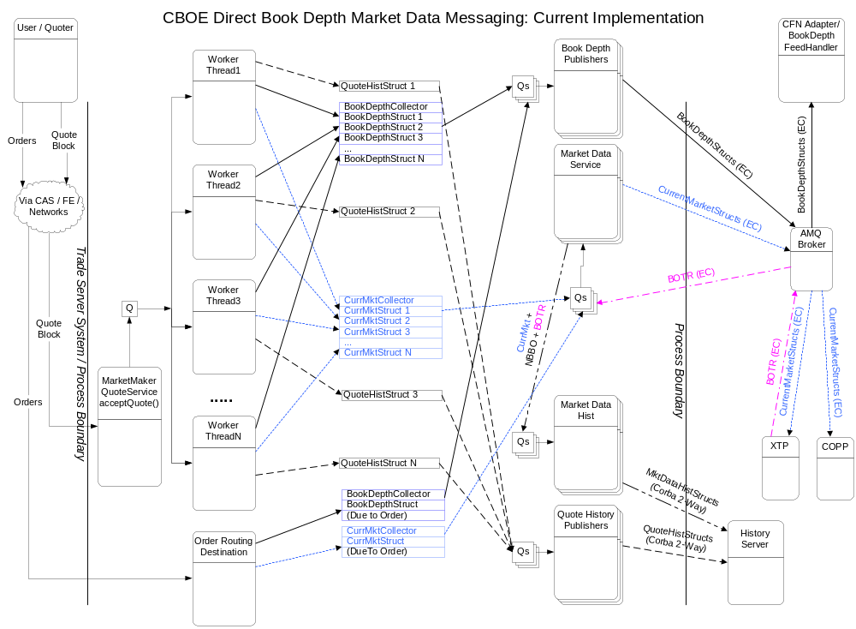

Offsetting the Cost of Book Depth: Inefficiencies In the Current Quote Processing Path
The current quote processing path in the Trade Server has several inefficiencies which can be leveraged to help offset the cost of providing Book Depth functionality. These are described below:
- When a quote occurs, it always results in a Book update and a Quote History update. In addition, approximately 80% of all quotes affect the top of book and result in a Current Market update as well. Thus 80% of the time, 3 artifacts result from a quote, and the remaining 20% of the time 2 artifacts result from a quote.
- In the Trade Server, Quote History, Book Depth updates, and Current Market updates take 3 separate paths to exit the process. In addition, the structures to represent the data for these 3 paths are different as well.
- The 3 updates to Quote History, Book Depth and Current Market contain much of the same information. For example, the product key, session, exchange id and Bid and Ask prices are all identical in all 3 updates. Where they differ is in some additional details that exists for one versus the other, and in quantities that are delivered to each entity. For example:
- Quote History contains the user id that entered the quote and that user’s quote volume.
- Book Depth contains the consolidated volume of the Book entry after the quote is applied, and what kind of change it is, I.E. whether it is a new price level, removal of a price level, or a change in total volume to an existing price level. There is no user information required for Book Depth.
- Current Market contains a breakdown of the various kinds of volumes related to the Book entry including Best Market, Best Limit Market, Best Public Market, Best Public Market At Top, and Manual Quote Market.
- The Quote History, Book Depth, and Current Market information not only contain some of the same data, but the size and number of objects created is not insignificant. For example, a single Current Market update has been determined to be 7 new objects minimum. Extensive studies have not been done for Quote History and Book Depth, but these must be at least 2 objects and most likely more. Since much of the data in these object structures is similar, this means that several redundant memory allocations occur and occupy memory, which in turn impacts garbage collections in the Trade Server.
- Initially it was thought that garbage collection was a major reason for latency in the Trade Server, but it has been shown that there are other factors that represent the majority of the “bad” latency in the Trade Server. However, projects are underway to fix those problems, so over time, garbage collection and object creation will shift towards being higher percentages of the latency in the Trade Server. Therefore, if there is some way to reduce the garbage, this should benefit the Trade Server in the long run and should be a long-term goal.
- Elsewhere in the quote processing path unrelated to the redundancy of Quote History, Book Depth, and Current Market, some inefficiencies have been found. These provide an opportunity to offset the cost of the Book Depth functionality which will be added to the quote processing path.

Improving Efficiency in the Quote Processing Path of the Trade Server
The observations of the quote processing path inefficiencies have led to some ideas for how to offset the cost of publishing Book Depth:
- Instead of publishing Quote History, Book Depth, and Current Market to separate 3 destinations, reduce the Trade Server workload by offloading this distribution and multiple publishing processing from the Trade Server into another process.
- Consolidate the Quote History, Book Depth, and Current Market update resulting from a quote into a smaller set of objects, and publish one message containing all artifacts resulting from a quote in a single message. Quote History and Book Depth will be consolidated in the pilot phase, and Current Market will be consolidated into the same message in phase 1.
- If possible, remove the redundant information from the message by storing it only once in each message, I.E. Common data like product key, session, etc., QuoteHistory data, Book Depth data, and Current Market data as 4 separate “templates” in the one message that will be published.
- If possible, compact or compress the data to be published by leveraging knowledge of the potential values the data normally has. For example, whole prices for Options rarely exceed $127, so this can be transmitted across the network in a single byte versus using 4 bytes by using certain data compaction techniques.
- Refactor code in the quote transaction path that is inefficient or can be re-written to run faster.
One problem with consolidating different kinds of data to be published is that it is difficult to represent lots of different kinds of related data or complex structures in Java with plain old Java objects unless one creates numerous Java objects, or unless one introduces complex dependency coupling between those objects. This is a case where Java’s strong Object typing model and lack of direct memory access actually gets in the way.
It would be useful to have some kind of utility where a correlated set of data to be published could be stored without creating lots of objects, and without explicit inter-dependencies, and to be able to put that data into a single or small set of objects for transport / publication purposes.
For example, a Quote History update would not know about a Book Depth update, yet if both occurred in the same transaction, the data resulting from them could be placed into contiguous memory so that when that data needs to be published, one could publish the contiguous block of memory without traversing an object structure and without explicit knowledge of that object structure in the publishing mechanism. In addition, by placing the data into a contiguous block of memory, this block can be implemented using a small number of objects.
This is the idea behind a “Market Data Buffer” which is a key component of the re-design of the messaging architecture.
For the pilot phase, the MarketDataBuffer (see later documentation for details) will be introduced and will be used for the data that is transported between processes. In this phase, only Book Depth and Quote History will be combined together into a single MarketDataBuffer. It is thought that since the Trade Server already transmits Quote History to another process and this occurs with every quote, that “piggy-backing” Book Depth on top of this same message should not incur a large performance penalty. In this phase CurrentMarket will remain untouched.
For phase 1, CurrentMarket will be added to the MarketDataBuffer in addition to the Quote History and Book Depth. This should further reduce some cost in the Trade Server, because the CurrentMarket publish will be removed.
The combined Quote History, and Book Depth and eventually Current Market will be transmitted to a new Bridge process. The Bridge process will forward the MarketDataBuffer to the recipients that require it (via a new MarketData Event Channel), and it will convert the Quote History contained in the MarketDataBuffer to the legacy QuoteHistory structure format for use by the History Server process. In the phase 1 implementation CurrentMarket will be converted to the legacy CurrentMarketStruct and will be published to supply Current Market to applications that still require it.
A diagram illustrating the messaging changes for the pilot phase 1 and phase 2 follows:

Proposed new Messaging Architecture: Pilot Phase 1
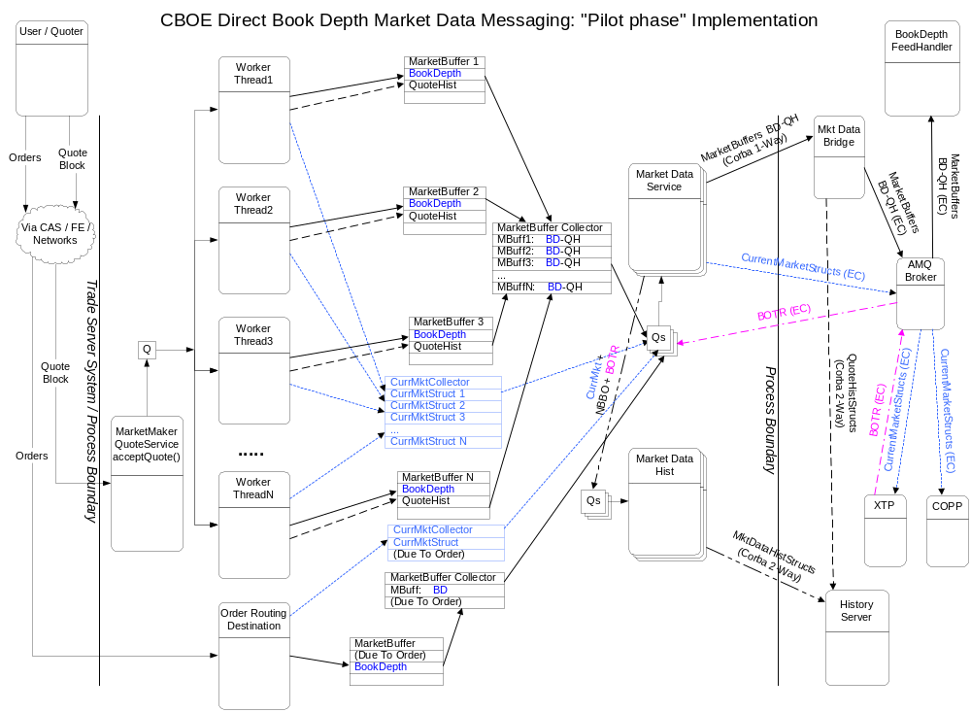

Proposed new Messaging Architecture: Phase 2
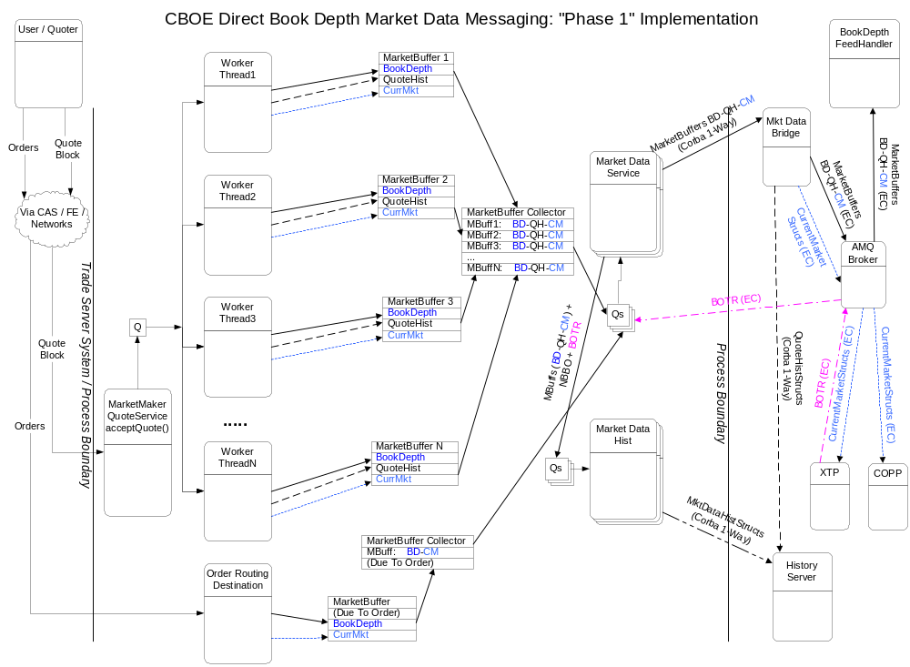

Software Changes

Market Data Buffer
To consolidate different kinds of data to be published into a single entity that occupies contiguous memory, a logical choice is to use a byte array and store the data in serialized format.
The idea for the market data buffer is relatively simple. For every set of correlated results of a transaction, create one MarketDataBuffer. In the case of an individual quote update, it’s corresponding artifacts, Quote History, Book Depth update, and Current Market update would all be stored in this one buffer. As part of the broader transaction that represents an entire block of quotes, a collector that ties together the individual MarketDataBuffers together would also be built. Each quote update and it’s artifacts occupy one buffer and act as one unit of delivery to a downstream process.
One problem with passing around encoded data in serialized format is to insure that knowledge of how the bytes are physically stored and the order of the fields in the encoded data is strictly limited to a single or very small number of Java Classes, and to enforce some kind of encapsulation. In addition, as knowledge of how to better compact data and better encode it in the future comes about, some kind of upgrade path provision for adding new fields, supporting new types of encoding, etc. must be supported.
To facilitate encapsulation of how primitive types are encoded and decoded a “Codec” (coder / decoder) is contemplated for each kind of primitive type, and where necessary, for small business-level objects (such as prices and other small commonly used structures).
Field level primitive Codecs are assembled into groups (like a struct) or sequences (like an array) and ultimately into a “Message Codec” which represents some business-level structure “template”. Access to a Message Codec is controlled by the business-level implementation of that Message Codec. The access is similar to the way one would access IDL-generated Java structs, except the fields are not public and can only be accessed via methods, which makes it better encapsulated. Further, the business-level Message Codec is in control of what fields can be modified and the interface in which they modify them. If necessary, validation could be done to insure invalid values are not allowed, and all kinds of things are possible since the business Message Codec is a Java object that is written and is not generated code like IDL.
The Message Codec knows how to encode itself into and decode itself from a MarketDataBuffer. Access to the MarketDataBuffer will be controled so that only Message Codecs may access it’s physical storage directly.
A UML Class diagram of the low-level classes follows:
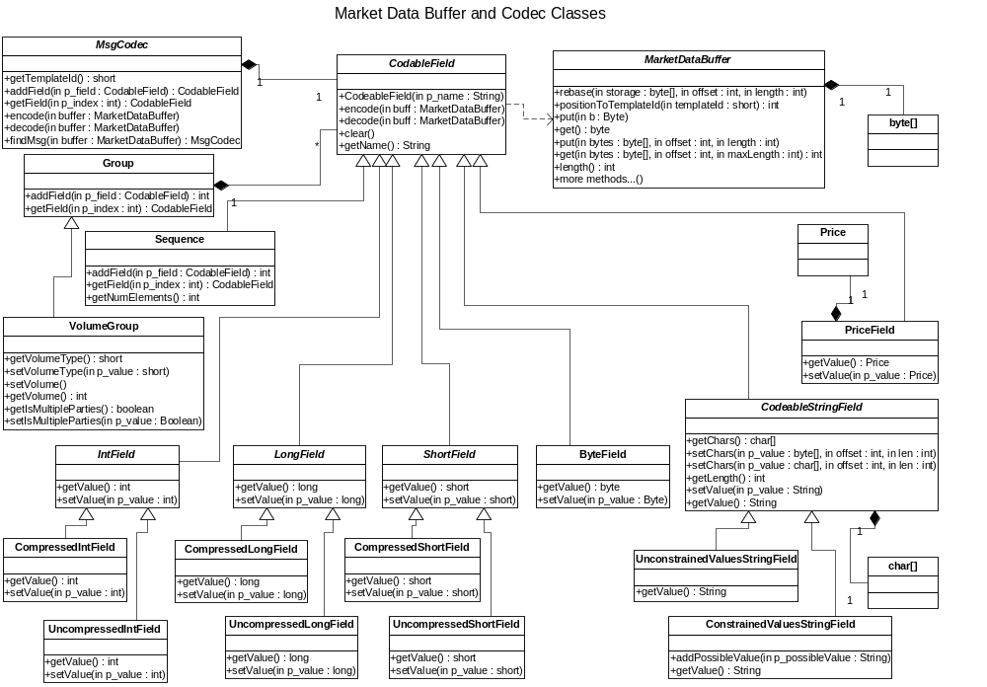

An example of a business-level object structure (Current Market Codec) follows:
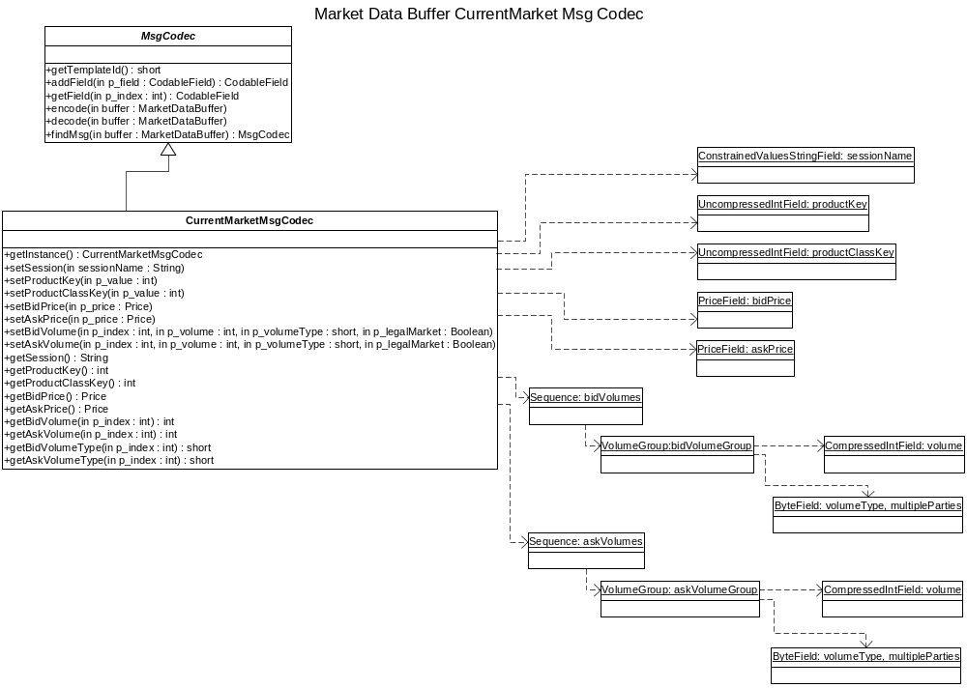

Trade Server Changes
The Trade Server will be changed so that instead of creating Quote History Structs and sending them to the History Server, and instead of creating Book Depth Structs and sending them to a Book Depth Channel, it will instead store both types of data into a MarketDataBuffer. This MarketDataBuffer will be transmitted to the Market Data Bridge process (see below and diagrams earlier). The Market Data Bridge process will take the data from that point and forward it or convert it to what the Trade Server formerly directly transmitted this data to. Doing this will combine similar data into a single block of data to be sent out of the Trade Server, and will reduce the number of destinations to which the Trade Server directly transmits data. The distribution of the data to different locations will be offloaded from the Trade Server to the Market Data Bridge.
A summary of the changes for the pilot phase follows:
- At the beginning of a Quote transaction, create a MarketDataBuffer. Store this in a ThreadLocal or a SessionLocal that is local to the transaction being executed. The MarketDataBuffer should be added to a MarketDataBuffer Collector, which temporarily holds all of the MarketDataBuffers for the transaction. The Collector should be registered as a transaction listener so that when the transaction commits, it is notified.
- At the beginning of any order transactions where the Book Depth may be updated, , create a MarketDataBuffer if BookDepth is turned on. The MarketDataBuffer should be added to a MarketDataBuffer Collector, which temporarily holds all of the MarketDataBuffers for the transaction. The Collector should be registered as a transaction listener so that when the transaction commits, it is notified.
- In places where the Trade Server builds a Quote History Struct to be transmitted to the History Server, instead access a QuoteHistory Codec fill in it’s values, and then access the MarketDataBuffer that was created for the transaction and encode the data into the MarketDataBuffer.
- In places where the Trade Server builds a Book Depth Struct and walks the book for N levels, this code should relocated to the place in the Trade Server just before where the actual book is updated.
- At places just before where the Book is updated, the Trade Server must first check to see if Book Depth is turned on. If so, it must check the current values against the values it is about to update to determine whether the update is an insertion of an existing price level, a deletion of a price level, or a change to a price level. When that is determined, access a Book Depth Codec and store the values in it that represent the Book Depth update. Encode the Book Depth Codec’s contents it into the MarketDataBuffer created for the Transaction. This should be the SAME MarketDataBuffer that the QuoteHistory was filled in (if the transaction is a quote). If the transaction is an order, no QuoteHistory will exist, but the MarketDataBuffer should be created.
- When the transaction commits, the MarketDataBuffer Collector transaction listener will be notified. It should send it’s data to the MarketDataService, which will be modified to accept a list or array of MarketDataBuffers.
- MarketDataService should be modified to allow a list or array of MarketDataBuffers. When those buffers are seen, the MarketDataService should buffer them up and transmit them to the Market Data Bridge.

Market Data Bridge
The Market Data Bridge is a new process. It’s job is to take MarketDataBuffer data from the Trade Server and distribute it to the necessary downstream entities, in some cases converting it to legacy structures.
Market Data Buffer data comes into the process (as bytes). It is re-constructed into MarketDataBuffers, and enqueued to N sets of Threads, possibly using different dispersion mechanisms (by class vs product for example) to expliot better performance for the different sets of Threads as needed.
One set of Threads will re-block the MarketDataBuffer data into a block for transmission to the MarketBuffer Channel. Another set of Threads will convert the Quote History data contained in the MarketDataBuffer to a legacy QuoteHistoryStruct. This will then be transmitted to the History Server for recording to Quote History.
Diagrams for the process structure for the pilot phase follows:
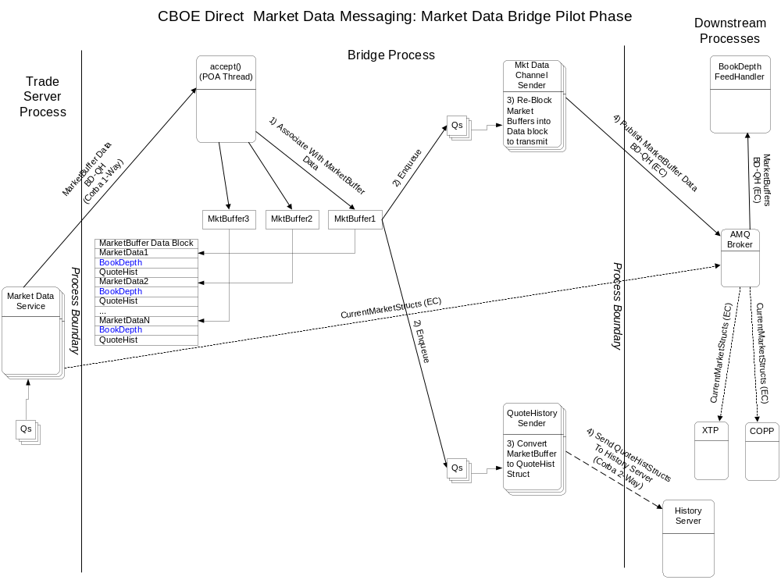
In Phase 2, when CurrentMarket publishing is offloaded from the Trade Server and the MarketDataBuffer contains CurrentMarket data, the Bridge will convert CurrentMarket data contained in the MarketDataBuffer to CurrentMarketStructs.
It will look like this at that time:
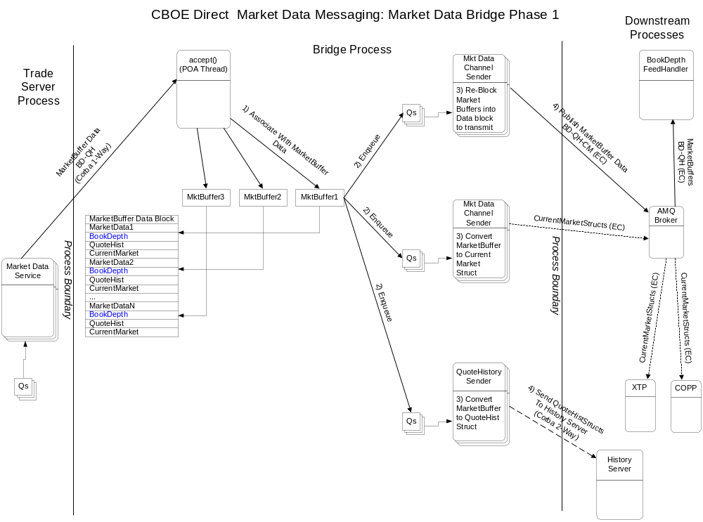

Book Depth Feed Handler (XBD)
The Book Depth Feed Handler is a new process. It is contemplated it will be based on XTP software because it seems like a natural fit and many of the building blocks required to implement it are available in XTP. Because of this, it has been given the name “XBD” (eXtreme Book Depth) in keeping with the “XTP” naming.
The Book Depth Feed Handler will take Refresh and incremental Book Depth updates from each BC and store it in a Cache, which will be a reconstruction of the Order Book’s price levels, but without the individual quotes and orders.
When a book entry is updated, the Book Depth Feed Handler will figure out what levels of the book changed and will fire an update event. Attached to that update event will be code that knows the format of the data required for the data feed to be transmitted out the CFN network. That data will be queued to another Thread that will then attach a sequence number and encode the data into FAST format and transmit it out a Multicast group to Data Feed Subscribers.
The Book Depth Feed Handler is illustrated below:
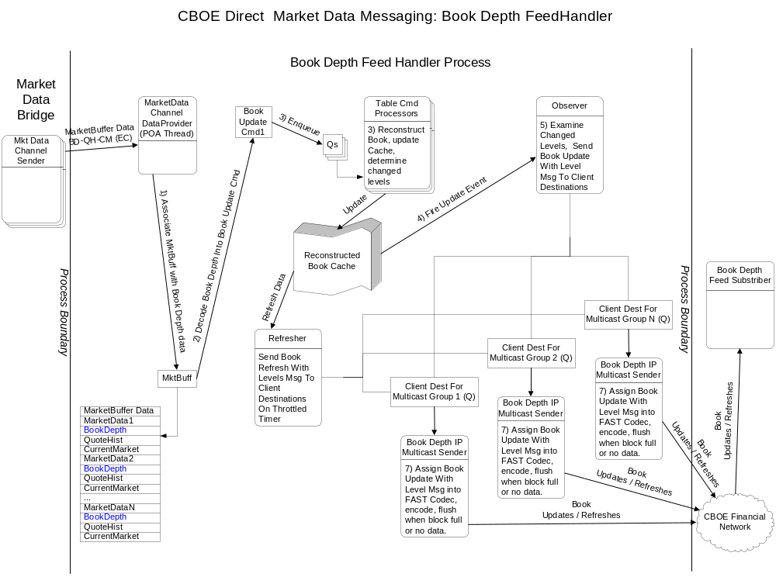

Recovery / Failure Scenarios
In order to insure that CBOE does not incur liability and to insure that the subscriber to the Book Depth Data Feed gets accurate data, several failover scenarios must be considered. These scenarios and the related processing are documented below:

Failover Related Messages

Book Depth Feed Handler to Data Feed Subscriber
To handle various outage scenarios between the Book Depth Feed Handler and Data Feed Subscriber (see below) the Book Depth Feed Handler will transmit a Full Refresh message containing all levels of the book that are normally published.
The content of the Refresh message will vary depending on the nature of the outage. See below for scenarios.

BC to Book Depth Feed Handler (XBD)
To handler internal outage scenarios (see below), it is necessary for the following messages and data to exist in messages between the BC and the Book Depth Feed Handler:
- A Full Refresh message is required from BC to Book Depth Feed Handler. This must contain a full image of the book for a particular series.
- A kind of “ping” message is required from the BC to Book Depth Feed Handler. This will be used to assist in outage detection and sychrnonization of recovery activities between the Book Depth Feed Handler and the BC.
- All messages (incremental, Ping, and Full Refresh) must have a sequence number. In addition, a Trade Server + Sender ID must be transmitted from the BC to the Book Depth Feed Handler.

Book Depth Feed Handler (XBD) to BC
- A Request-refresh message is required between the Book Depth Feed Handler and the BC. This message is per-BC specific, and only one BC should answer this request.

Failover Scenarios From Book Depth Feed Handler (XBD) To Data Feed Subscriber

Data Feed Subscriber Outage
In the event a Data Feed Subcriber goes down and comes back up, they should zero-out their book entries for all products or mark them unusable, etc. The Subscriber must wait for a Refresh message for a particular product before using it for trading. Incremental messages for the same product may appear, but they should be discarded until a Refresh message for that product appears.

CFN or Other Network Related Outage
The Subscriber to the Book Depth Feed will get 2 duplicate sets of Book Depth feeds over different IP Multicast groups and ports and over different physical networks. In order to handle single-network outages between CBOE and the Subscriber, the Subscriber should read both sets of feeds simulaneously and choose which message to read using the sequence number. If one of the redundant feeds does not have a particular message due to some kind of network problem, then that message should appear on the other network (except in rare dual network failure scenarios or if networks are not designed properly at the customer site and really go through a single source, etc.).If there is no problem and both identical messages are read, the Subscriber must choose one and discard the other.
In the event of a dual-network outage, the Subscriber should either detect that there is no data for some small period of time (a few seconds) or a sequence gap should be detected. In either case, all products that are transmitted over the problematic Multicast Feed must be considered stale and made invalid. The Subscriber must then wait for a Refresh message for each product before it may be used again.

Book Depth Feed Handler (XBD) Outage
In the event of a Book Depth Feed Handler outage, the backup Book Depth Feed Handler will take over processing, however, this failover may take a few seconds. During the failover time period, the Subscriber should detect no data arriving for some number of seconds, which should trigger the “idle data feed” scenariod described above in CFN or Other Network Related Outage above.
When the backup Book Depth Feed Handler takes over, it will issue a new sequence number that is higher than the last known sequence number and this too should trigger the Subscriber’s failover scenario described above because there will appear to be a sequence gap on the Subscriber’s side.

Internal Failover / Outage Scenario Processing
Between the BC and the Book Depth Feed Processor, there will be a “Ping” or “heartbeat” message that is transmitted every few seconds. In addition, all messages between BC and Book Depth Feed Processor are sequenced to insure nothing is dropped and if something is dropped, that it can be detected. Below are the outage scenarios and actions:

Book Depth Feed Handler Outage / Failover
The Book Depth Feed Handler will have a primary and a backup (Master/Slave). Both will receive Book Depth updates and will keep a Cache that reconstructs the Book. They will operate independently with regard to Internal outage scenarios that follow.
However, in the event of a failover between the primary / backup, a failover will do the following:
- Disable the outbound feeds on one Book Depth Feed Handler
- Enable the outbound feeds on the backup Book Depth Feed Handler
The act of enabling the outbound feeds activates the following processing:
- Walk the entire book and mark it as “transmitRefreshOnNextUpdate”. If an incremental update is seen when this flag is set, it causes the update to send a Refresh to the Data Feed Subscriber. Once this occurs, this flag is then turned off.
- Make a second, throttled walk through the entire book. Because this is due to a failover, however, this Refresh might be throttled at a faster rate than the “standard” Refresh that continuously runs in the background. For each record with the flag transmitRefreshOnNextUpdate still on, transmit a Refresh message to the Data Feed Subscriber and turn off the flag.
- After this initial refresh is completed, the normal speed continuous refresh is transmitted.
As described above, Data Feed Subscribers should detect this failover by either lack of data or by the sequence gap that will occur when the backup becomes the primary. Data Feed Subscribers should trigger their recovery mode and wait for the next Refresh for any given product.

Book Depth Feed Processor Detects Gap Or Fails to See Ping from BC In X Seconds
In this scenario, there is a gap in the sequence numbers coming from the BC, or there is the absence of data from a particular BC in some number of seconds. These scenarios are identical with respect to the Book Depth Feed Processor’s viewpoint, and it does the following:
- Walk the Book Cache for those products that are updated via the BC for which the outage was detected.
- For all products in the Book Cache for that BC, zero out the Book entry data and transmit a Refresh message to all Data Feed Subscribers containing zero book entries for that product. This indicates that the Book for that product is no longer valid and must not be used.
- Mark the zeroed-out book entries for each product so that a fullRefresh is required before incremental updates will be accepted again. When this flag is on, any incremental update for that product will be discarded.
- Wait for a Ping from the BC for which the sequence gap or lack of data was detected. AFTER the ping arrives, request a Refresh from that BC.
Once a Refresh is seen for a particular product, it’s book is updated, the “full-Refresh-Required” flag is turned off, and a Refresh is sent to all Data Feed Subscribers. This is how things get back to normal.

Excessive Refresh / Duplicate Refresh Mitigation
There should be some kind of logic to mitigate repeated Refresh requests from bombarding the BC, and there should be some logic in the BC to permit only one Refresh to be active at a given time. In addition, in the BC the Refresh could be throttled so that the Refresh processing does not interfere with normal processing. The Throttle could be set so that the refresh lasts some period of time or transmits no more than X number of messages per second. For example, a BC with 15,000 products at 500 msgs / second would take 30 seconds to complete the Refresh.
To prevent repeated rapid refresh requests in the event of a frequent sequence gap scenario, the Book Depth Feed Handler should make Refresh requests only every so often, perhaps tens of seconds. If a gap or outage is detected and a request is outstanding, it should avoid repeated frequent duplicate Refresh requests until some time period has passed. Though not strictly required, but if it is possible with relative little difficulty, it would be useful if the Book Depth Feed Handler could also detect if it is in a situation where sequence number gaps are repeating frequently and it is frequently requesting refreshes. This should be an extremely rare situation, however, so it may not be worth the effort to detect. Not much could be done about it anyway that isn’t addressed by mitigating the frequency of the Refresh requests from the BC.
To prevent impacting the BC excessively when a Refresh is requested, the BC should know when it is already in the middle of a Refresh. If another Refresh request comes in, the BC may do one of two things depending on which is easier or more logical to implement:
- Abandon the current Refresh and start over.
- Implement the Refresh as a circular traversal where the begin and end-points may be modified during mid-traversal . If in the middle of a Refresh another Refresh is received, reset the start to be the next product and the end to be the product for which a Refresh was just transmitted.
In addition, the Refresh processing in the BC should be throttled vs run at full speed to minimize impact.

BC Startup and Failover Scenarios
At BC startup and in a BC failover scenario, there is a step where the BC rebuilds it’s order book. When this occurs, the BC should transmit a Ping message to the Book Depth Feed Handler to indicate it is ready to accept a Refresh request.
If the Book Depth Feed Handler is active, it should be in a state where it thinks the BC is down and it should be waiting for the Ping from the BC to trigger it’s request for a Refresh.

Further Offsetting The Cost Of Book Depth Processing
The introduction of the MarketDataBuffer and combining similar data into a single publish by the Trade Server should result in some offset to the cost of Book Depth processing in the Trade Server, though not a complete offset. Book Depth must necessarily add some processing, so the cost must be recovered in other ways as well.
In order to further offset the cost of Book Depth processing, the quote code path has been examined for inefficiencies. So far many of these have nothing to do with Book Depth processing, but is simply code that can be written to run faster. By reducing the cost of this code, the goal is to offset the extra cost of Book Depth processing.
Suggested refactorings are listed below.

MarketMakerQuoteServiceLocalImpl acceptQuotesForClassV3() and Forward Code Path
This is the main entry point for quotes into the Trade Server. A CORBA call is invoked from the CAS via the FE and into the TradeServer when a user submits a block of quotes. This method executes in the POA Thread of the ORB in the Trade Server. The code path from this method and “forward” is where modifications should be made.

Remove Extra Lookup of Broker by ClassKey in MarketMaketQuoteServiceLocalImpl
(Extra per quote block classKey lookup, Integer alloc, (global?) synchronized lookup #1)
In MarketMakerQuoteServiceLocalImpl.acceptQuotesForClassV3() a redundant lookup of the Broker can be eliminated.
This removes 1 synchronized Hashtable lookup and 1 Integer object creation per quote block, and is very simple and localized.
Modify this call:
getBrokerService().acceptQuoteBlock(blockIterator);
To this:
blockIterator.getBroker().acceptQuoteBlock(blockIterator);
The QuoteBlockIterator already got the broker during it’s validation, so there is no need to look it up again.

Remove Repeated Array Indexing in QuoteBlockIteratorImpl
In QuoteBlockIteratorImpl.setupIterator(), refactor to not repeatedly index quotes and processingResults arrays by introducing local variables.
This change will make a tiny impact, but it is simple and isolated.

Remove repeated getTradingProductHome() call in QuoteBlockIteratorImpl
In QuoteBlockIteratorImpl.validateQuote()modify to pass TradingProductHome.
This avoids a method call + null check for every product. It is very low-impact, but also simple and isolated.
To do this, modify validateQuotes to do this:
TradingProductHome tpHome = getTradingProductHome();
once into local variable before loop where validateQuote() is called for each quote in the quote block. Pass tpHome as parameter to validateQuote() method, and refactor validateQuote() to use the parameter instead of calling getTradingProductHome() to lookup TradingProduct

validateQuote(i)
Add parameter of type TradingProductHome to avoid call to getTradingProductHome() which was already done
Remove getTradingProductHome() call, replace with reference to tradingProductHome parameter (avoids method call + null check).

Remove repeated implicit delegations to getTradingClass() in QuoteBlockIteratorImpl
In QuoteBlockIteratorImpl.validateQuote() there are several places where the TradingProduct is asked questions about some attribute that is actually known at the class level.
For example, the call to method: TradingProduct.isValidPriceForQuote(quotePrice) is implemented in TradingProduct so that it asks the TradingClass by delegating to it.
Instead of asking TradingProduct this could be refactored to ask TradingClass directly, which would avoid 2 extra method calls.
To make this change, introduce local variable and assign as follows after looking up TradingProduct:
TradingClass tradingClass = product.getTradingClass().getProductClassKey());
Replace the following method calls to product with the corresponding method on tradingClass.
- Replace product.getTradingClass().getProductClassKey() with
tradingClass.getProductClassKey()
- Replace lotSize = product.getTradingClass().getTradingPropertyLotSize() with tradingClass.getTradingPropertyLotSize()
- Replace product.isValidPriceForQuote(quotePrice) (2 occurrences, bid/ask) with
tradingClass.isValidPriceForQuote(quotePrice)
- Replace product.isStrategy()) with
tradingClass.isStrategy())
- Replace TradingProduct parameter in methods validateIPPMinSize() and getIPPMinSize()with TradingClass parameter type. Remove delegation of product.getTradingClass().getTradingPropertyIPPMinSize(); in getIPPMinSize() to ask tradingProduct directly for IPPMinSize.
The above replacements will eliminate several calls to getTradingClass() which occur at various points in the quote validation code path. However, this has a side-effect in that it gives knowledge to the QuoteBlockIteratorImpl code that some of the questions it asks of the product are really stored in the TradingClass and not in the TradingProduct itself. This means it “knows” the implementation of TradingProduct and the fact that it uses the TradingClass to store these parameters. Arguably this could be a maintenance issue if for some reason TradingProduct was modified to keep this information itself for example. However, this is unlikely to change because doing so would fundamentally change the relationship between TradingProduct and TradingClass, so that argument is rather weak.

Refactor QuoteBlockIteratorImpl.validateIPPMinSize()
The checks done in the method validateIPPMinSize() in QuoteBlockIteratorImpl should be able to be refactored. It is not known how exactly, but there should be a way that avoids the repeated checks of bidQuantity and askQuantity != 0 and == 0. The code to refactor currently looks like this:
if( ( aQuoteStruct.quote.bidQuantity < ippMin &&
aQuoteStruct.quote.bidQuantity != 0 &&
aQuoteStruct.quote.askQuantity != 0)
|| (aQuoteStruct.quote.askQuantity < ippMin &&
aQuoteStruct.quote.askQuantity != 0 &&
aQuoteStruct.quote.bidQuantity != 0)
|| (aQuoteStruct.quote.bidQuantity == 0 &&
aQuoteStruct.quote.askQuantity < ippMin)
|| (aQuoteStruct.quote.askQuantity == 0 &&
aQuoteStruct.quote.bidQuantity < ippMin))

Use ZERO_PRICE constant instead of PriceFactor.create(0.0)
QuoteBlockIteratorImpl.validateQuote() compares the bidPrice to zero by using this code:
Price zeroPrice = PriceFactory.create(0.00);
if(!theBidPrice.equals(zeroPrice))

This can be refactored so that ZERO_PRICE is a static constant of type Price that is obtained once statically, and re-used over and over instead of getting a zero-price every time.
For zero-bid quotes such as deep out of the money quotes, this will avoid a lookup and several math operations to locate a price with a zero value.

Remove Extra Lookup of Broker by ClassKey in QuoteBlockIteratorImpl
(Extra per quote block classKey lookup, Integer alloc, (global?) synchronized lookup #2)
There exists a line of code in QuoteBlockIteratorImpl.validateQuote() that does this::
if (!getBroker().areQuotesAccepted(aQuoteStruct.quote.productKey))
getBroker() does a lookup that is unnecessary because the Broker can be obtained directly from the TradingClass via the getBroker() method on it. An earlier refactoring stores the TradingClass into a local variable after getting the TradingProduct. The instance var classBroker in QuoteBlockIteratorImpl should be assigned the Broker returned by tradingProduct.
Note, that due to a prior-mentioned refactoring, of MarketMakerQuoteServiceLocalImpl.acceptQuotesForClassV3(), the method getBroker() should be retained on QuoteBlockIteratorImpl.
This removes 1 synchronized Hashtable lookup and 1 Integer object creation per quote block, and is very simple and localized.
The getBroker() method on TradingProduct appears to be used infrequently, and it is unclear whether the Broker for the product is set at startup time or not (the code lazily initializes it).
If this change is done, it may be necessary to invoke getBroker() for every product as part of startup or failover when building the in-memory TradingProducts. Not sure where this code would have to be placed, need CBOE Direct help on this one.
If getBroker() is not called on TradingProduct as part of startup or failover, the first quote for any product will pay the penalty of doing the lookup, which is the worse time to be paying this penalty.

Remove Extra TradingProduct Lookup by Refactoring Broker.areQuotesAccepted() path
(Extra per-product lookup, , Integer alloc, no synchronization #1)
In QuoteBlockIteratorImpl there is a call to Broker.areQuotesAccepted():
if (!getBroker().areQuotesAccepted(aQuoteStruct.quote.productKey))
This takes a code path that delegates to BrokerStrategyFactory.find() which in turn looks up the TradingProduct and obtains a state code which is used to determine a BrokerStrategy, which is then asked areQuotesAccepted().
This is a more widespread change that spans a few classes, but if this code path was refactored, it will eliminate an extra lookup of TradingProduct which has already been looked up, and an Integer object creation.
There are a few ways to do this, but here is one way:
- Add new method boolean areQuotesAccepted(TradingProduct product) to Broker interface and implementations. The implementation of this method will invoke a new find() method on BrokerStrategyFactory (below) and will then ask the returned BrokerStrategy areQuotesAccepted()
- Add 2 new methods to BrokerStrategyFactory:
static BrokerStrategy find(TradingProduct product,boolean useTargetState)
abstract BrokerStrategy findQuoteStrategy(TradingProduct product,
boolean useTargetState)
The new static find() method will delegate to the new findQuoteStrategy() abstract method.
- Implement the abstract method BrokerStrategy findQuoteStrategy(TradingProduct, product, boolean useTargetState) in BrokerStrategyFactoryImpl. This method should behave similarly to the existing method findQuoteStrategy(int productKey), except it should not look up the TradingProduct. Instead ask the TradingProduct directly for the appropriate state code based on useTargetState, then select the appropriate quote BrokerStrategy, and return it.
Also, refactor the existing findQuoteStrategy(int productKey) method to lookup the TradingProduct and then invoke this new method to avoid duplicate code.

Speed up TradingClassImpl.isValidPriceForQuote()
(JGrinder elimination)
The method TradingClassImpl.isValidPriceForQuote() is called twice for every product in a quote block; once for bidPrice and once for askPrice to validate quote prices to make sure they are in the proper increment based on the break point values.
The method isValidPriceForQuote() does this:
return PremiumPrice.isValidForQuote(premiumPrice,
getPremiumBreakPoint(),
getTickSizeBelow(),
getTickSizeAbove(),
getProductType());
The 4 method calls that are made to obtain the last 4 arguments to this method all access instance variables in TradingClassImpl via a JGrinder editor call like this:
protected Price getPremiumBreakPoint() {
return (Price) editor.get(_premiumBreakPoint, premiumBreakPoint);
}
It is thought that the code path taken in editor.get() is the shortest possible JGrinder code path because nothing has been modified yet in the current Transaction, however, even the shortest JGrinder code path is many times longer than if the instance variables for the price break-points were accessed directly.
Normally, variables that may be involved in a transaction must be accessed via JGrinder, but these price point values represent a highly special case. It is very unlikely that these values ever change intra-day. The only reason these values would change intra-day is if they were entered incorrectly, and this would be a manual one-time change done as a maintenance request, most likely from the Help Desk.
So the question is what would be the impact in directly accessing the field instance variables versus accessing them via the JGrinder call?
For all practical purposes, there should be no harm. If for some reason the values had to be changed, then this means the price points are incorrect in the first place, and this implies that quotes are either being allowed through that should not be allowed through, or quotes are being rejected that should not be rejected.
Assume for example, that the values were incorrectly set to:
breakPoint == 3.00, tickSizeBelow == 0.05, and tickSizeAbove == 0.10
Assume that the correct values are being reset to:
breakPoint == 4.00, tickSizeBelow == 0.01, and tickSizeAbove == 0.05
If you were in the middle of a transaction commit and the values were partially changed, you could see any of the following inconsisten values if the JGrinder editor were not used to access the variables:
- breakPoint == 3.00, tickSizeBelow == 0.05, and tickSizeAbove == 0.10
- breakPoint == 3.00, tickSizeBelow == 0.01, and tickSizeAbove == 0.10
- breakPoint == 3.00, tickSizeBelow == 0.05, and tickSizeAbove == 0.05
- breakPoint == 3.00, tickSizeBelow == 0.01, and tickSizeAbove == 0.05
- breakPoint == 4.00, tickSizeBelow == 0.05, and tickSizeAbove == 0.10
- breakPoint == 4.00, tickSizeBelow == 0.01, and tickSizeAbove == 0.10
- breakPoint == 4.00, tickSizeBelow == 0.05, and tickSizeAbove == 0.05
- breakPoint == 4.00, tickSizeBelow == 0.01, and tickSizeAbove == 0.10
- Null pointer exception accessing one or of the variables?
In the above scenarios, there is a small time window during a transaction commit where quotes that were formerly allowed that are now not allowed, or quotes that were not allowed could be allowed, or perhaps a null pointer exception could be thrown.
In any case, the question is does any of this matter from a practical standpoint? If the values were wrong in the first place, then is means some quotes were allowed or rejected that should not have been allowed or rejected. If during the commit the values are seen inconsistently, then the same thing occurs; some quotes may be allowed or rejected that should not have been allowed or rejected. The only difference is which quotes are allowed or rejected during the brief time during the commit will differ from the values that were allowed or rejected when the values were just incorrect. Does it really matter in what way things are wrong, if they are still wrong?
It is thought that for all practical purposes, this would not matter, and the likelihood of this being a problem is so great that it is more than offset by the performance gain that would result.
This scenario needs to be reviewed by some business people perhaps, and certainly some CBOE Direct developers, but it is thought that this could be a somewhat significant gain, certainly as much as removing a lookup per product because of the length of the code path through JGrinder.

Speed up PremiumPrice.isValidForQuote()
The method above: TradingClassImpl.isValidPriceForQuote() delegates to a method in another class: PremiumPrice.isValidForQuote(), which is not optimized. This is too tedious to explain in text, see the code below. Refactor this code for a shorter code path when aPrice isValuedPrice(), which nearly all of the time.:
Current Code:
boolean premiumIsValid = false;
if ( !aPrice.isMarketPrice() && isValidTick(aPrice, premiumBreakPoint,
premiumBelowTick,
premiumAboveTick) ) {
premiumIsValid = true;
if ( productType != ProductTypes.STRATEGY && aPrice.isValuedPrice() &&
aPrice.lessThanOrEqual(ZERO_PRICE) ) {
premiumIsValid = false;
}
if ( aPrice.isValuedPrice() &&
aPrice.greaterThanOrEqual(ABOVE_MAX_PREMIUM_PRICE) ) {
premiumIsValid = false;
}
}
return premiumIsValid;

Refactor as follows:
boolean premiumIsValid;
if (aPrice.isValuedPrice()) {
long aPriceLong = aPrice.toLong();
premiumIsValid = isValidTickValuedPrice(aPriceLong, premiumBreakPoint,
premiumBelowTick,
premiumAboveTick);
if (productType != ProductTypes.STRATEGY && aPriceLong <= ZERO_PRICE_LONG)
premiumIsValid = false;
if (aPriceLong >= ABOVE_MAX_PREMIUM_PRICE_LONG)
premiumIsValid = false;
}
else {
premiumIsValid = false;
}
return premiumIsValid;

The method isValidTickValuedPrice(aPriceLong...) is a new method that is similar to isValidTick(), but takes a long value instead of a Price. This avoids repeatedly converting the price toLong().
This change removes repeated redundant virtual method calls, repeated calls to toLong() on aPrice, and virtual method calls on aPrice.lessThanOrEqual() and aPrice.greaterThanOrEqual() which are also not optimal.
This is probably significant, particularly when combined with ValuedPrice optimizations recommended below.

Speed up ValuedPrice
The quote validation logic in QuoteBlockIteratorImpl uses several methods on Price to compare equals(), greaterThanOrEqual(), etc when validating the quote prices.
These methods on the class ValuedPrice are not optimal and can be sped up by a significant amount.
In the class ValuedPrice make the following modifications:
- Modify implementation of the methods: lessThan, equals
- Implement greaterThan, greaterThanOrEqual, lessThanOrEqual
Modify / implement these methods as follows:
- Check first for anotherPrice.isValuedPrice() as this will be the majority case.
- If anotherPrice is a ValuedPrice, downcast to ValuedPrice and access value field of anotherPrice directly. This avoids a virtual toLong() method call
- Use long value of anotherPrice directly against local value and use language-level operators ==, <, <=, >, and >= instead of getWhole(), getFraction() which are again virtual method calls AND they do division / modulus
This refactoring will shorten the price comparison code path by a significant amount.
(This one should be significant and has a pretty widespread impact all over whenever price comparisons are done, which it is suspected happens a lot).

Speed up PriceFactory.create() lookup code
The method PriceFactory.create() checks to see if the price being created is an even penny increment, and if so and price caching is turned on, it looks up the price in the price cache.
The logic to determine whether a price is an even penny increment currently does this:
if ((aFraction % PENNIES_MULTIPLICATION_FACTOR) != 0) {
return null;
}
int whole = aWhole;
int fraction = aFraction / PENNIES_MULTIPLICATION_FACTOR;
CacheStruct[][] array = cachePositiveValues;
// More code here...
return array[whole][fraction];
At the very least, there is a redundant extra division operation here. Instead of checking the modulus for zero and then dividing, this could be done instead:
int pennies = aFraction / PENNIES_MULTIPLICATION_FACTOR;
int modulus = aFraction – (pennies * PENNIES_MULTIPLICATION_FACTOR);
if ((modulus != 0) {
return null;
}
CacheStruct[][] array = cachePositiveValues;
// More code here...
return array[whole][fraction];
This avoids the modulus + divide sequence, which is doing an expensive division operation twice. Modulus can be implemented as a divide and subtraction with integer multiplication, which runs slightly faster. This makes the failure cases run slightly slower (when price is not an even penny increment), but it is thought that nearly all cases are pennies, so the extra divide implicit in the modulus is avoided for the most likely case.
Alternatively, it might be worth spending some time researching a possible alternative to division since this method is called quite a lot in the course of a Quote transaction. For example, it may be possible to do the integer division through “Division by Invariant Integers using Multiplication”. For a reference to this, see the comment above the JDK method Integer.toString() and see Integer.getChars() for an example of how this works. It is unknown whether this technique will work for long values or not, or if is a special case for numbers < 65536. It might be worth trying, however.
Another alternative could be to examine the bit patterns of the 100 integer values in billions that are even pennies. There might be some pattern that is somewhat easily discerned. For example, for even pennies some set of the lower N bits are likely to never be turned on, so these could be checked first. If none are on, then perhaps they could be shifted right to reduce the magnitude of the value for the fraction without losing precision. This would have the affect of dividing the value by a power of two. If doing so would preserve the accuracy enough, then perhaps the value could be shifted until a residual value < 65536 is left, from which point the “Division by Invariant Integers Using Multiplication” trick could maybe work. Another possbility might be once the value is reduced, perhaps a small table lookup would end up being faster than using division.

Eliminate Integer Object Allocation in BrokerHomeImpl, TradingProductHomeImpl
(Integer alloc)
Two new classes will be created: ConcurrentIntHashMap and IntHashMap. These are copies of the Java VM ConcurrentHashMap and HashMap, but will be custom modified to be natively indexed by an int data type instead of an Object data type. Since almost all maps in CBOE Direct are indexed by product key or by class key, this change will reduce object creation, and will speed up the lookup. The lookup will avoid virtual method calls to hashCode() and to equals(), and the comparison check for the key can be simplified to no longer compare the hash values for equality (that comparison was an optimization to avoid calls to equals()).

Replace BrokerHomeImpl brokersByClass map with ConcurrentIntHashMap (Per-class Integer alloc)
Modify brokersByClass in BrokerHomeImpl to be of type ConcurrentIntHashMap instead of ConcurrentHashMap.
Modify findByClass method to avoid creating a new Integer object

Replace maps in TradingProductHomeImple with IntHashMap (Per-product Integer alloc)
Modify tradingProducts and unknownProducts to be of type IntHashMap instead of HashMap, natively key by int instead of Integer. Remove all Integer allocation.
Reverse the roles of the 2 methods queryByKey(int productKey) and queryByKey(Integer productKey). Currently the method queryByKey(int productKey) calls queryByKey(Integer productKey) creating a new Integer from it’s int productKey. This should be reversed so that instead queryByKey(Integer productKey) invokes queryByKey(int productKey) using the productKey.intValue() of the Integer. The body of the Integer argument method should be transferred to the int argument method.

BrokerImpl.acceptQuoteBlock(QuoteBlockIterator) and Forward
This method is called by MarketMakerQuoteServiceLocalImpl.acceptQuotesForClassV3(). Up until this method call has been primarily quote validation, price checking, etc.
From this code forward is the business logic that is involved in executing the quote update.

Investigate IntHashtable Use in QuoteHomeImpl.findQuote()
The method QuoteHomeImpl.findQuote(int productKey,String userId) looks up an IntHashtable by userId. A ConcurrentHashMap is indexed by user and contains an IntHashtable which is synchronized AND is created with the default size of 101 entries. It will resize automatically to size * 2 + 1 when 75% full, but this table is thought to go through several resizings per day for heavy quote users with lots of quotes. The resizing by currSize*2+1 results in non-prime-number table sizes, which could impact the collisions in the hash table. It would be interesting to know how long the hash chains are if possible. Also, this implementation uses modulus by table size which may be more expensive than using Hashmap’s hash() spreading algorithm and shifting and using power-of-two for the table size. It would require some experimentation with some product keys to figure this out, but this one might be worth looking at actually. Every user’s quote is looked up in this kind of table.
(Could be significant, but may be tedious to figure out impact of current code).

Eliminate Integer Object Allocation in RequestForQuoteFactory Or Re-Design
(Per product Integer alloc)
QuoteBlockIterator.getCurrentQuote() finds the Quote for the User and calls updateQuoteResponsesOfRFQ() which in turn calls RequestForQuoteFactory.findByProduct(int productKey).
RequestForQuoteFactory.findByProduct(int productKey) uses a ConcurrentHashMap indexed by product id to hold RequestForQuote objects. There are 2 problems with this:
- rfqTable is declared as a Map, for no good reason. The get() method call is a virtual method call, which makes it run slower.
- rfqTable creates an Integer object implicitly through auto-boxing. This is particularly nasty because unless you have certain IDE syntax highlighting or compiler warnings turned on, you will not see this auto-boxing at all.
Implement rfqTable as ConcurrentIntHashMap which natively indexes by scalar int value. This will avoid an Integer object creation at least.
Question: Do we get many request for quotes?
Can this be re-designed?
If there are very few requests for quotes, then this lookup is a waste of time because it is likely to find nothing, yet every quote must attempt the lookup. Perhaps there is a better way to determine if the lookup is even required. It is unclear how this could be done at this point, but something to think about at least briefly; perhaps there’s something not so obvious that is more easily doable.

Remove Extra TradingProduct Lookup in BrokerImpl by Refactoring Quote
(Extra per-product lookup, (no alloc, no synchronization) #2)
In BrokerImpl.acceptQuoteBlock is this call:
BrokerStrategy strategy = BrokerStrategyFactory.find(nextQuote, true);
This does a lookup of BrokerStrategy. However, it does not allocate an Integer nor synchronize at least.
Earlier, in Remove Extra TradingProduct Lookup by Refactoring Broker.areQuotesAccepted() path it was recommended to add a method to BrokerStrategyFactory to find() using a TradingProduct. The QuoteImpl has a TradingProduct available for the asking, but the interface does not expose this method.
Another possibility (a hack, but it would work) would be to ask Quote if it’s a QuoteImpl, and if so, ask for the TradingProduct and use the new method, otherwise use the old lookup method.
Things such as DerivedQuote don’t necessarily have a TradingProduct, but I’m not sure how this is all used.
Need CBOE Direct assistance on this one to see if it’s OK to expose Broker on Quote interface.
No issue with first-time lookup penalty however, because lookup penalty occurs all the time now. If this change is implemented, penalty will be first quote for each product for each user only vs all the time.

Refactor isFirstBetter() Price Comparison Method in Side Implementations
The code from AcceptQuoteCommand.doExecute() follows this code path:
AcceptQuoteCommand.doExecute()
BrokerProcessorHybridImpl.processQuote()
BrokerProcessorBase.processQuote()
BrokerProcessorHybridImpl.processQuoteSides()
BrokerProcessorBase.processQuoteBidSide();
BrokerProcessorBase.processQuoteSide();
BrokerProcessorBase.processTradable(Tradable, OrderBook);
BrokerProcessorBase.processTradable(Tradable,OrderBook,Price)
BrokerProcessorBase.processTradableWrap();
SideBaseImpl.isFirstBetterOrEqual();
SideBaseImpl.isFirstBetter();
SideBaseImpl and BuySide implement method isFirstBetter that compares 2 prices and returns true if the first is “better” than the second. That code is implemented similarly in SideBaseImpl and BuySide, and it does a somewhat complex boolean expression or sequence of boolean expressions. This code is called many times when processing a quote. It seems like it should be able to be refactored to run faster, particularly with the most likely case which is thought to be when both prices are non-null prices of type ValuedPrice.
The current code does the following in SideBaseImpl:
The numbered comments is the number of conditionals that will be evaluated when both prices are non-null and are ValuedPrice
public boolean isFirstBetter(Price firstPrice, Price secondPrice) {
// 1 2
if (firstPrice == null || firstPrice.isNoPrice()) return false;
// 3 4
if (secondPrice == null || secondPrice.isNoPrice()) return true;
// 5
if (secondPrice.isMarketPrice()) return false;
// 6 7
return firstPrice.isMarketPrice() || firstPrice.lessThan(secondPrice);
}
The 99% case should be that both prices are ValuedPrice, so this means 7 evaluations are made each time this method is called. This refactoring reduces the code path a bit:
public boolean isFirstBetter(Price firstPrice, Price secondPrice) {
// 1 2
if (firstPrice != null && secondPrice != null) {
// 3 4
if (firstPrice.isValuedPrice() && secondPrice.isValuedPrice()) {
// 5
return firstPrice.lessThan(secondPrice);
}
if (secondPrice.isMarketPrice()) return false;
if (firstPrice.isNoPrice()) return false;
if (secondPrice.isNoPrice()) return true;
}
else {
if (firstPrice == null) return false;
if (secondPrice == null) return true;
}
Another possible refactoring that could be tested IF the 99% case is that non-null values are normally sent to this method would be to eliminate the null checks and surround the code with a try-catch block. It is not clear whether this would be more or less expensive, but it could be easily tested to see which runs faster. If it turns out that a try catch block runs faster, then eliminate the 2 null checks and “speculatively” check for isValuedPrice(). This would reduce the number of checks when both prices are valued prices to 3 instead of 5. This should definitely be tested, however, because try-catch blocks are not without some expense. It is not clear what that expense is relative to the null check however, so it should be tested before assuming one way or the other will run faster.

General Quote Code Path Cleanup
The code changes recommended above are incomplete. There are numerous additional code changes “forward of” the BrokerImpl.acceptQuoteBlock(QuoteBlockIterator) call that could be done that were only briefly analyzed due to time constraints, but also due to a discovery that was made that calls into question whether it is even productive to document these changes in the way they have been documented here.
During the course of identifying and documenting the above code changes, the author would document some changes one day and continue documenting the following day. In order to remember where things were left off, some of the prior code change recommendations were re-read and located, as one would do if this documentation were given to someone as a task to perform. What was discovered is that reading this document, locating the code, and understanding what needs to be changed took almost as much time- as discovering and documenting the change in the first place. This time will increase even more when these tasks are given to someone unfamiliar with the code
This raises the question of how productive it is to continue to document the changes in the manner described here. Perhaps there is a more concise way to document the changes, but the vast majority of making these changes will require one to study the code as intensely as was done to figure out the changes to be made in the first place to make sure nothing is broken in the process, etc.
It is thought that a more productive use of time would be to have the person that will make the actual code changes continue the research and simply make the code change and then document it with before/after code snapshots followed by a formal code review. A code review should be required anyway in order to mitigate risk and as a check and balance to insure errors are caught. No one person should be responsible for making these kinds of changes without some oversight; it is very risky.
With that in mind, the remaining code change recommendations will be expressed as “principles” or techniques to follow and what to look out for when studying the code to identify modifications to improve performance.

Repeated lookups of the same data across a broad code path
This is particularly difficult to document in a way that is coherent because the duplicated lookups crosses many Class and method boundaries. Most often a lookup occurs in one location in the code path, and then many hundreds of code instructions and method calls later, a duplicate lookup occurs, normally in an entirely different class. In order to eliminate some of these duplicate lookups, some method call interfaces must be changed so the caller provides information to avoid the lookup. In some cases this will increase dependencies and coupling, but this is often a trade-off when performance is of paramount importance.

Repeated references to JGrinder fields
JGrinder value lookups are expensive to execute. Where possible, try to limit the access of a transaction-oriented field managed by JGrinder to a single location, so that it does not have to be repeatedly accessed. Fields that change rarely if ever could perhaps be made into non-JGrinder fields with little or no real risk to the Trade Server.
The price breakpoint fields are thought to fall into this category, and could perhaps be made into non-JGrinder fields. However, this decision must be made by someone more knowledgable on how often these fields change before making such a change.
Another technique that could be done is cache copies of the field that are good only for the duration of the transaction. If a field is modified only once inside a transaction, but then checked or accessed repeatedly, these kinds of fields would be candidates for this treatment. This is not trivial however, because the caching must be done so that the cached value is forgotten when the transaction is committed. It is unclear how that might be accomplished other than copying the values out explicitly by the outer-most code and passing them around. If the fields in question are held by objects that are passed around, then this becomes more difficult because the object has no good way to know when to forget the cached value.

Integer Object Creation and HashMap Lookups
In several cases, some lookups can be eliminated entirely, but for those that must remain, it would be useful to modify some of the data structures to use an “IntHashMap” or “ConcurrentIntHashMap” that are natively indexed by primitive int type values instead of Integer Object values. This would require copying the Java JDK HashMap and ConcurrentHashMap code and modify it to be natively indexed by int values.
Doing so would eliminate many Integer object creations in the Quote code path that occur per product. In addition, the lookup would be slightly faster because equals() is not called, but instead a language-level == operator is used. It would also not be necessary to check the eqality of the hashCode() value itself since this is implicitly handled by comparing the key values themselves (the hashCode() is compared only because equals() on longer keys can be expensive)
In addition, the “hashCode spreading function” could be experimented with to perhaps reduce it’s cost. It is not a large cost, but neither is it a trivial amount of code. In addition, some functionality such as being able to analyze the collisions in the table and see what is colliding could be added, which is something that cannot be done with the JDK code since it cannot be modified. This information can be used to size tables appropriately when needed.

Integrate Data Into the TradingClass and TradingProduct Master Data Structure To Avoid Lookups
Upon examining the Trade Server code it appears there is no obvious “master plan” for when data is placed into the TradingClass or TradingProduct data structures. On nearly every transaction, the TradingProduct is looked up. In some cases, “attributes” or “states” of the TradingProduct that are related to certain transactions are attached directly to the TradingProduct, but in other cases, attributes related to the TradingProduct are stored in a separate Home with it’s own table indexed by productKey. In some cases, the separate table indexed by productKey results in inefficiency because if the data were attached to the TradingProduct instead, a smaller-scale lookup could be done, or in some cases no lookup at all.
One very good example of this is the RequestForQuoteFactory. The RequestForQuoteFactory keeps track of a Map of RequestForQuote objects indexed by productId when which there a request for quote. This table is global, which means that every quote entered into the system must lookup a value in this table. The table is implemented as a ConcurrentHashMap, so this costs “half a synchronization” to do the lookup.
However, RequestForQuote is quite rare, so the lookup normally does not locate anything. This is a waste of time because effort is spent when the vast majority of the time the effort will produce no productive results.
To optimize this, a RequestForQuote Map (or perhaps a simple List) could be attached to the TradingProduct which has already been looked up (or perhaps attach to the TradingClass if requests for quote are very rare). Rather than do a lookup, the size of the Map/List could be examined first. If the size is zero, this means no lookup is required and this check costs very little. Only if the size of the Map/List is non-zero would a lookup be required. Note that this operation cannot be done on the global table because if any request for quote for any product were made, it would result in a lookup.

