CBOE
Book Depth For Options Project

Requirement Specification Document
Version 1.0



 | 

Cognizant Technology Solutions Limited
www.cognizant.com
The information contained in this document is confidential and intended for the named recipient only. This information is joint property of “CBOE” and “Cognizant Technology Solutions”, and copying or disclosure by any other person is strictly prohibited. If you have received this documentation in error, please notify sender immediately.
Table of Contents
1 Introduction 5
1.1 Background 5
1.2 Purpose & Scope of this document 5
1.3 Intended Audience 5
1.4 Document Structure 5
1.5 Important terms 6
2 System Overview 7
2.1 Current Book Depth Processing Flow 7
2.2 New Book Depth Processing Flow 8
3 Requirement Analysis – Book Depth 9
3.1 Stakeholders 9
3.2 High-level functionalities to be implemented 9

Document Revision History

Sr. No | Description | Date | Version | Created / Modified By
1. | Template Created, Overview | 08-21-2008 | Version 1.0 | Jerry Hamm
2.
3.
4.

Introduction

Background
The goal of the Book Depth project is to deliver an Options book depth data feed over the CBOE Financial Network (CFN) using an Industry-Standard message format such as FAST (FIX Adapted for STreaming), and to do so with no additional latency cost to the Trade Server.
The functionality to deliver the top N book levels currently exists in CBOE Direct and is used to transmit Book Depth data to One Chicago and CFE customers. However, the format of this existing feed is implemented in inefficient ASCII encoding using a proprietary CBOE message format that is non-standard. CBOE wishes to use an industry-standard message encoding such as FAST which improves efficiency. In addition, if possible without copyright or legal issues, CBOE wishes to use the same message format for Book Depth messaging as already exists in the industry elsewhere, or at least something very similar. In doing so, the adoption of the CBOE Book Depth feed by customers should be easier because little or no coding would be required by customers.
In addition, this project comes at a time when the latency of Quote processing on the Options Trade Server is a serious concern, and attempts are being made via other projects to reduce it. Since Book Depth updates on every quote, the last thing the Trade Server can afford right now is additional processing that will increase latency. Because of this, another goal has been attached to this project, which is to “do no harm” to latency while at the same time implementing the Book Depth functionality in the Trade Server. This means the existing implementation cannot be used because it is known to add latency to the main Quote processing path in the Trade Server.
Tests were conducted to determine what the current implementation would do to latency in the Trade Server. It resulted in an unacceptable increase in processing times for Options quotes. A quote step-up test was conducted on the Options Trade Engine with and without the existing Book Depth functionality turned on.
The following are the results:
Test Scenario | CAS | avg resp time
38K step up baseline test | perfcas5 | 4.7 - 6.2ms
38K step up with book depth on | perfcas5 | 6.4 - 8.9ms

This testing shows that transaction times uncrease from 36 to 43% with the existing Book Depth functionality turned on. This is deemed to be unacceptable so it must be “payed for” by refactoring the way it works and/or by possibly refactoring completely unrelated code in the Quote processing code path in order to offset the cost.

Purpose & Scope of this document

Intended Audience

Document Structure

Important terms

System Overview

Current Book Depth Processing Flow
The diagram below shows the data flow of Book related data in the Trade Server.
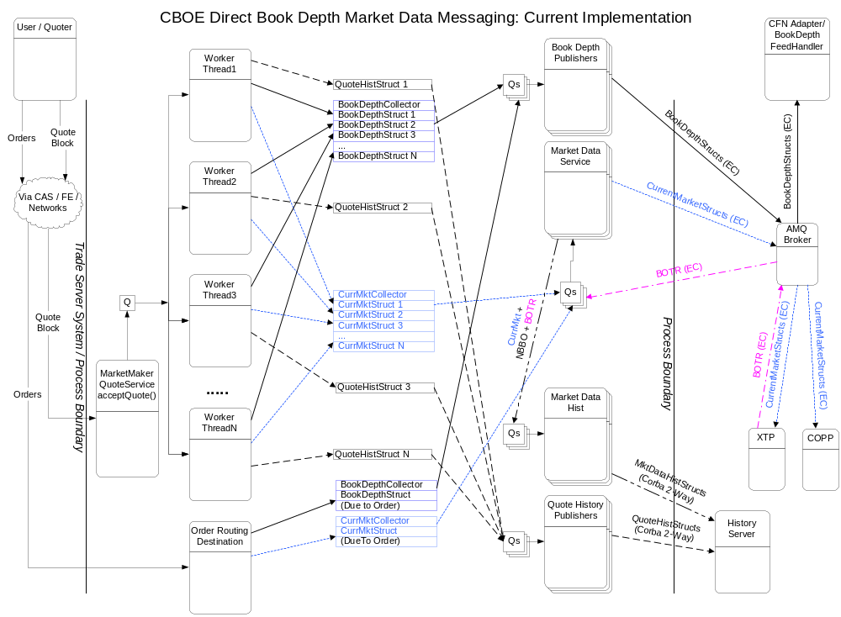

New Book Depth Processing Flow
The diagram below shows the new data flow of Book related data in the Trade Server
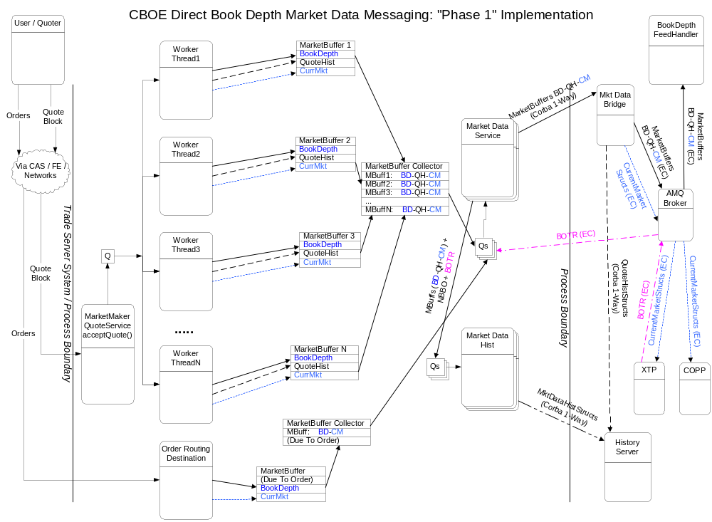
For an explanation of the proposed changes, see the detail design document.

Requirement Analysis – Book Depth

Stakeholders

High-level functionalities to be implemented

