CBOEDirect
Property / Trading Property Design

Table Of Contents
Overview 1
Current trading property setup and usage 1
Affects of current trading property setup and usage 1
Proposed changes to use property service. 1
Components of new trading property approach 2
PropertyService changes 2
TradingPropertyService changes 2
Domain Objects (New) 2
PropertyServiceFacade 2
Trading Property Flow 3
Setting a domain based trading property 3
AuctionMinMaxOrderSizeGroup 3
TPSPropertyServiceFacade 3
AuctionMinMaxOrderSize 3
PropertyTradingPropertyService 3
Current Property / Trading Property Flow (diagrams) 4
New Property / Trading Property Flow (diagrams) 5
Domain object to Trading_Property persistent mapping 6
Trading_Property persistent layout 6
TradingProperty domain object layout 6
Mapping persistent to domain 6

Overview

Current trading property setup and usage
Currently, trading properties are accessed and stored by the TradingPropertyService on the GlobalServer. Each property is defined as an IDL struct definition along with a set of setting and getter methods and persisted in a database.
Each BC needing trading property information uses the getter method for that property via a proxy to the TradingPropertyService.
Setting a property can be accomplished by an AdminRequest on the GlobalServer or by using the SAGUI/SACas. The SAGUI/SACas accesses these properties via the TradingPropertyMaintenance Service interface.

Affects of current trading property setup and usage
Because the trading properties are implemented through the IDL, all addition and changes impact all of the services that set/get these properties.
With regard to the SAGUI and SACAS, this impact requires that a new version of the SAGUI and SACAS be released in lock step with the implementation of that property on the GlobalServer. It is this lock step association between the SACAS and the TradingPropertyService that is being severed by the new approach.

Proposed changes to use property service.
The existing property service uses a seldom changing, generically formatted IDL structure and set of methods to implement properties needed by the system. Specific business type definition and/or logic is applied to these generic formats via domain objects at the time of need.
It is the intent of the new trading property design to leverage the property service’s generic IDL such that new trading properties can be set/get via consistent, non-changing IDL structs and formatted to the business needs via domain level formatters.
By decoupling the trading properties from the IDL in the above-mentioned way, rollout of new trading properties will no longer require a matching, lock step release of the SACAS or SAGUI.
To accomplish these changes, the property service’s already existing property type of TradingProperty wil be implemented and a standard, base framework of domain objects for getting and setting any new trading properties will be designed and created. Further, a standard approach to coordinate the storing and retrieval of trading properties to the existing persistent storage will be setup so that any/all other access routes to these new trading properties will still function without change (i.e. SQL scripts, reports, etc….). Any publish/consume usage will equally be setup so as to provide backwards compatibility for existing trading properties as well as like usage for new trading properties.

Components of new trading property approach

PropertyService changes
Main changes in the PropertyService are those needed to determine the property type (category==TradingProperty) and implement new code to get/set/update/delete the property data against the existing trading property persistent storage.
Existing property service categories are processed as usual.

TradingPropertyService changes
Changes involve supporting any backward compatible routes (i.e. AdminRequest) and verifying no interference with existing operation.

Domain Objects (New)
New domain objects have been created to handle the translation and mapping of generic, trading property values retrieved from or sent to the property service via the property service IDL.
There are base objects to store and cache group information. These groups contain 1 to (n) “rows” of trading properties based on a common key (SessionName, ClassKey, TradingPropertyName) and provide the ability to represent complex trading property information such as properties that require sub-groups or interrelated groups of values.
From these group objects, specific TradingProperty base objects are provided to map the individual values or each trading property “row” to a specific and defined business defintion.
Access to the above collections can be obtained via a factory or through the use of specific, trading property objects which are derived off the base implementations for the group and individual property.

PropertyServiceFacade
The is a new implementation of an existing PropertyService façade interface originally used by the SAGUI. It provides a common and consistent interface of methods to get/set/manage properties from the domain objects to the “PropertyService” responsible for supporting the changes. This “PropertyService” access is implemented differently for say the SACAS vs. the server (BC).

Trading Property Flow

Setting a domain based trading property
The following outlines a rough call / object sequence for getting a trading property via the new domain object / property service route using the AuctionMinMaxOrderSize property.

AuctionMinMaxOrderSizeGroup
This implements the TradingPropertyGroup interface and provides top level access to the data values for the trading property. It also provides a “typed” object for the property – much like the IDL struct does for the existing trading properties.
Through its getGroup() method, all of the data values associated with the “implementation” of the trading property, AuctionMinMaxOrderSize, are obtaines, collected and cached.
From this object, individual AuctionMinMaxOrderSize domain objects can be retrieved based on finer, sub-group type information.
The group object takes the standard PropetyService IDL information and generically represents it as the “rows” from the Trading_Property database table.

TPSPropertyServiceFacade
This class implements the PropertyServiceFacade interface which serves as the domain objects’ reference to the actual PropertyService. As domain objects will be implemented on multiple, distributed systems, each façade implementation may be different depending on the pattern used to connect to the PropertyService itself.

AuctionMinMaxOrderSize
This domain object represent the final, “typed” structure for the trading property it is responsible for – AuctionMinMaxOrderSize. It implements the TradingProperty interface for generic getter/setter needs and ultimately implements the business value of the property data itself through specific methods.
Each AuctionMinMaxOrderSize objects represents a single row from the Trading_Property database table and effectively maps the columns from that row to the business data values required and defined by the trading property type – in this case, the minimum and maximum sizes for an auction order.

PropertyTradingPropertyService
This is an extension of the current PropertyService with modifications to determine the type of property being requested (set). If the property type is a TradingProperty, the get/set request is performed against the Trading_Property database table; otherwise, the request is passed to the parent property service implementation for handling.

Current Property / Trading Property Flow (diagrams)
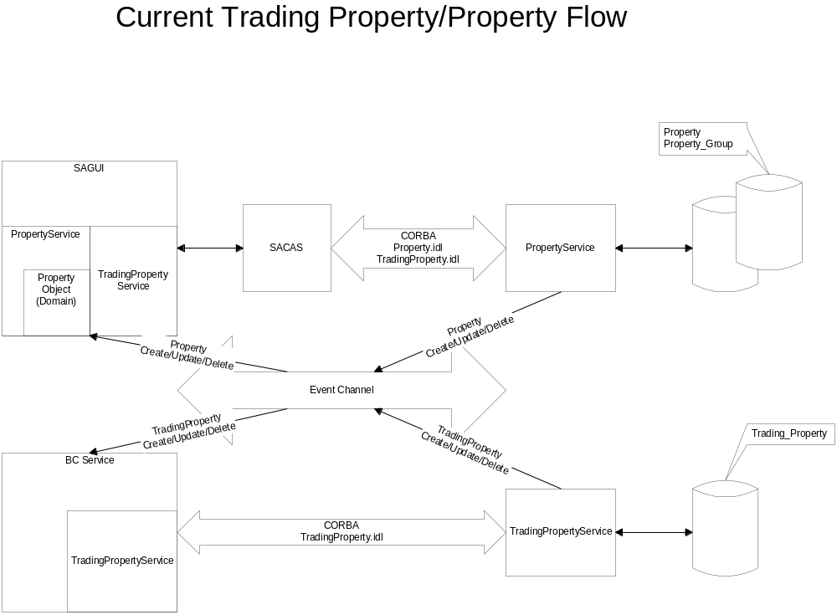
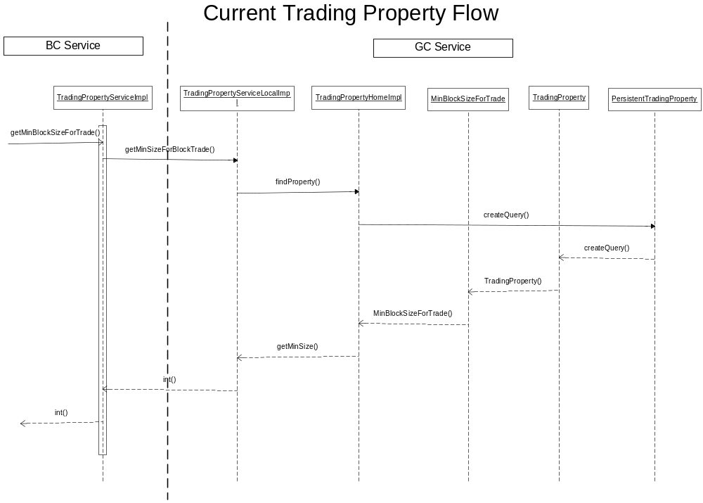

New Property / Trading Property Flow (diagrams)
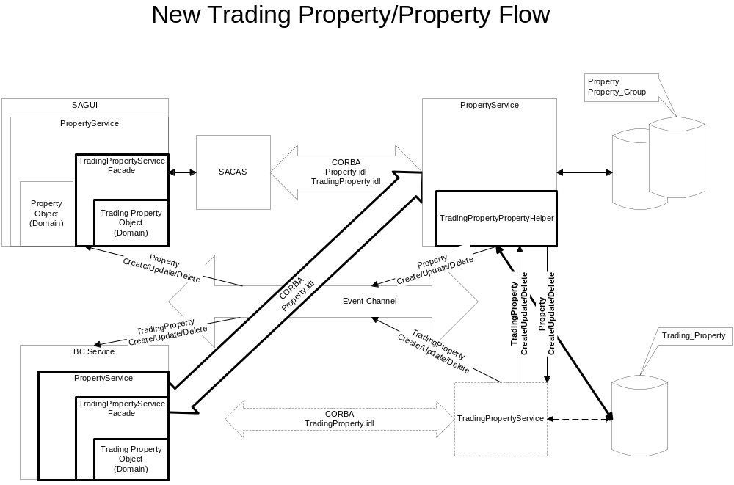
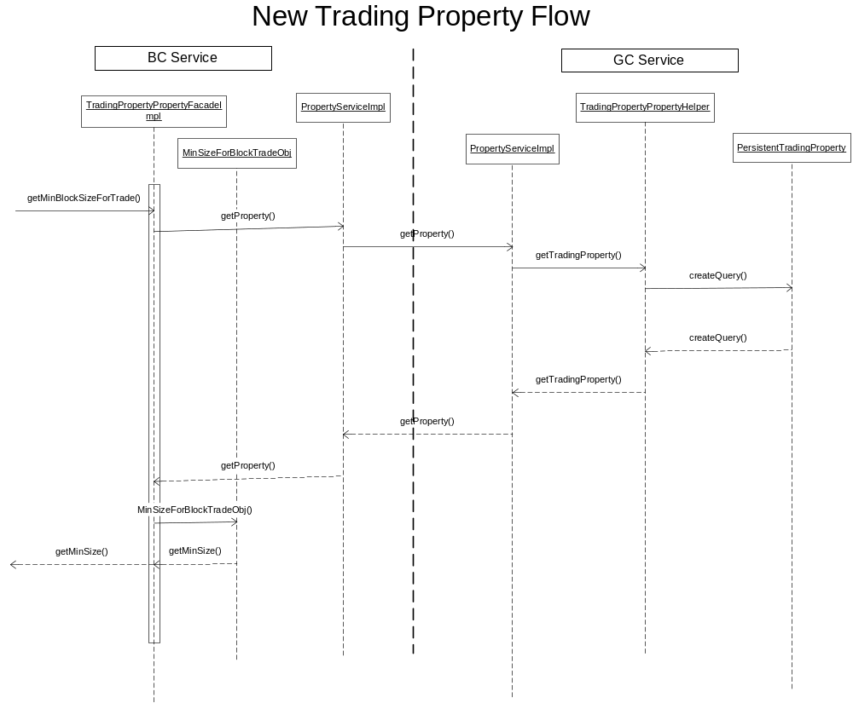

Domain object to Trading_Property persistent mapping
The following section outlines how the trading_property persistent elements (table rows and columns) are “mapped” to a given TradingProperty domain object – and then, the actual, named, property domain object.

Trading_Property persistent layout
The trading_property persistent object currently maps an object to a given row/column arrangement in the trading_property table. The following is the layout of that object to database row relationship.

Name | Null? | Type
DATABASEIDENTIFIER | NOT NULL | NUMBER(20)
SESSION_NAME |  | VARCHAR2(30)
CLASS_KEY |  | NUMBER(20)
PROP_TYPE |  | NUMBER(5)
SEQ_ID |  | NUMBER(20)
INT_VAL1 |  | NUMBER(12)
INT_VAL2 |  | NUMBER(12)
INT_VAL3 |  | NUMBER(12)
DBL_VAL1 |  | NUMBER(20,8)
DBL_VAL2 |  | NUMBER(20,8)
DBL_VAL3 |  | NUMBER(20,8)

TradingProperty domain object layout
All domain level, trading property objects are derived from a base object, TradingPropertyElements. The base object contains attribute members which serve as the direct holders of the equivalent column values from the trading_property table row – with each instance of the object representing a specific row.

public class TradingPropertyElements
{
private int integer1;
private int integer2;
private int integer3;
private double double1;
private double double2;
private double double3;
private int sequenceNumber;
…
…
}

Mapping persistent to domain
The mapping or translation of the persistent elements into the domain object is accomplished through the use of the existing PropertyService IDL calls and a predetermined, embedded delimiter format for the information obtained via the PropertyService calls.
The extended PropertyServiceImpl, after determining a trading property request has been made, executes its own persistence calls to obtain the required data from the trading_property table. The return result set is then “formatted” into an appropriate PropertyService, IDL struct and returned to the caller. On the caller side, the domain level objects receive, parse and reformat the PropertyService, IDL struct return into a TradingPropertyElements representation which is then rolled into a collection or group. The final result is a domain level collection of domain level objects representing the result set return from the trading_property table.

