CAAP GUI TESTING PLAN

Prepared by:

Jian Fu and Broderick Hall
Date: 2/18/2005
Table of Contents
GUI Testing 3
Description 3
Test Cases 3
Start Internalization Order 3
View Auctions 3
Respond an Auction 4
Appendix 5
Add Internalization Dialog Screen 5
Auction Display Window Screen 6
New Class Selector Dialog Screen 6
Auction Response Dialog Screen 7

GUI Testing

Description
The implementation of Internalization Order on Market Display window adds the ability to create auction orders via the Trader GUI. The Auction Display window will keep track of auctions the user has subscribed for by class with a specific auction type(s), which has quoted on by Class or Series (configured on the server, so you need to verify). Other enhancement is the new Class Selector dialog for subscribing class with auction type(s) on Auction Display window.

Test Cases

Start Internalization Order
To bring up an internalization order dialog, select a product on Market Display:
- Select Order -> Add New Internalization Order from pop up menu
- Select Add New Internalization Order from Order menu
- Enter CTRL+SHIFT+I

Verify the primary order and matched order have different sides and initial sequence number.

Make sure that the buy/sell button will be changed on matched order tab, if user changes the buy/sell button on primary order tab. Vice versa.

After successfully submitting the order, verify with the order status window and there should be two new entries and the Auction Display window will have one new entry.

View Auctions
To view auctions, the user needs to create a new Auction Display window from the main menu, and add the class from the View menu on Auction Display window.

Verify that the new Class Selector dialog is able to allow the user to select multiple auction types from the type list.

Check that the new Class Selector dialog won’t add the tab until at least one auction type is selected.

Verify that the Auction Display window will only create one tab for one class no matter how many auction types it is subscribed for.

Make sure that only the user(s), who subscribed to the class with internalization auction type and quoted on that Class or Series (configured on the server, so you need to verify), will be able to see the auction started on that Class or Series, no matter whether she/he initially started the auction or not.

Respond an Auction
To respond an auction displayed on Auction Display window, user must select one auction and bring up the response dialog from menu Order -> Response to Auction.

Verify that on the auction response dialog, the contingency field is set to AUCTION RESPONSE and disabled, and fields are pre-filled based on the auction.

Appendix

Add Internalization Dialog Screen
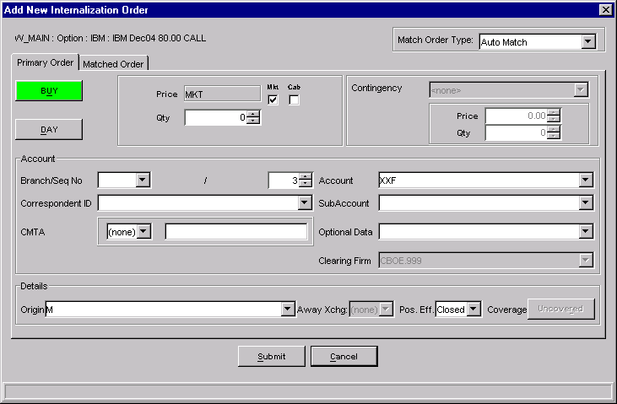
Primary Order Tab View

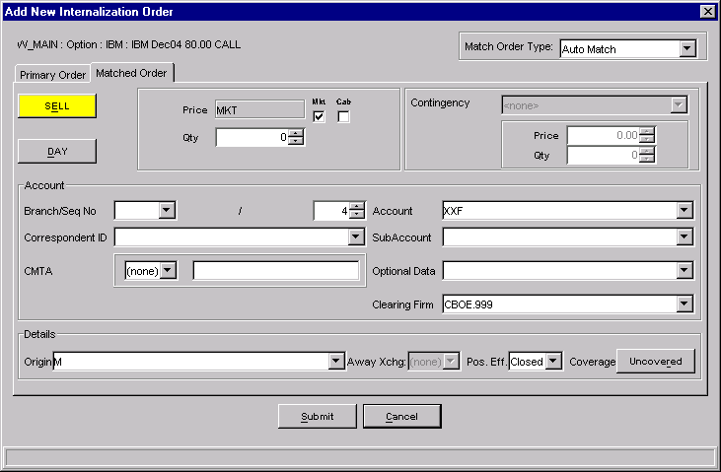
Matched Order Tab View

Auction Display Window Screen
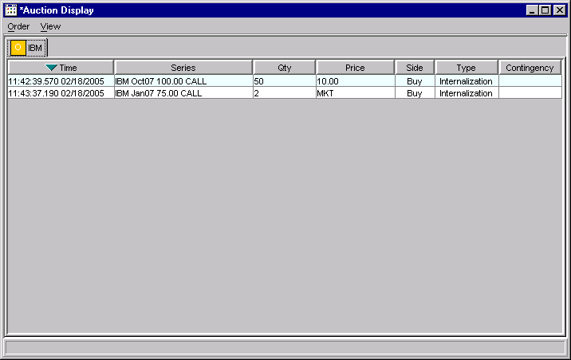

New Class Selector Dialog Screen
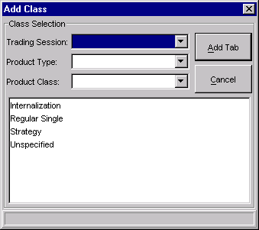

Auction Response Dialog Screen
