CDX Fast Failover
Incorporate Distributed Cache

WR#: 6538

Prepared by

Hemant Thakkar
Distributed Cache Implementation Design

Introduction

This document outlines the high-level design for incorporating Oracle Coherence distributed caching solution for the fast-failover feature. The goal is to synchronize the following domain objects between a master and slave BC to remove the need for database queries on slave-to-master transition.
- Orders between master and slave OHServer processes.
- Orders between master and slave trade server processes. For multiple trade server (MTS) configuration, there will be an independent cache between each pair of master-slave trade server processes
- Trading products between master and slave trade server processes. Unlike order synchronization between trade server processes in MTS configuration, there will be only one central trading product cache for all participating trade servers.

Although Oracle Coherence allows visibility into a distributed cache from any machine on the network, the current design goal is to limit visibility of distributed caches within the boundaries of a master/slave pair of a single BC. This is achieved by configuring a unique cache instance per BC. The insertion of the distributed caching is to be minimally invasive to minimize alteration to current implementation of BC processes. The following sections describe the general topology to be used for each domain object cache and the specific details on how the current implementation will be adjusted to make use of the distributed caches.

General Architecture

All cache instances will use the Distributed Cache Service (DCS) of Oracle Coherence with dedicated cache servers. The figure below shows this architecture from viewpoint of

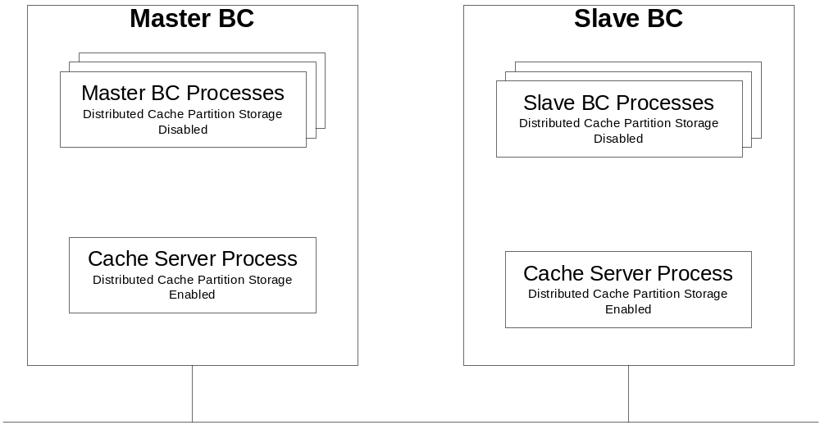
individual BC process pair. Each master-slave pair of BC processes is a participant node in the DCS along with one pair of cache server processes. The Oracle Coherence DCS partitions the cache data storage amongst participating nodes of the DCS, however, the local storage of DCS partitioned data can be disabled. This necessitates the need for the dedicated cache servers. The purpose of the cache server processes is for data storage of the distributed cache instances. The BC processes do not contribute to the responsibility of storing the data partitioned by the Oracle Coherence DCS for reasons of shield the BC processes from garbage collection overhead.

Order Synchronization – OHServer

One cache instance will be configured for sharing order updates from master OHServer to slave OHServer process. The figure below shows the proposed modifications overlaid on existing implementation in dotted line format.

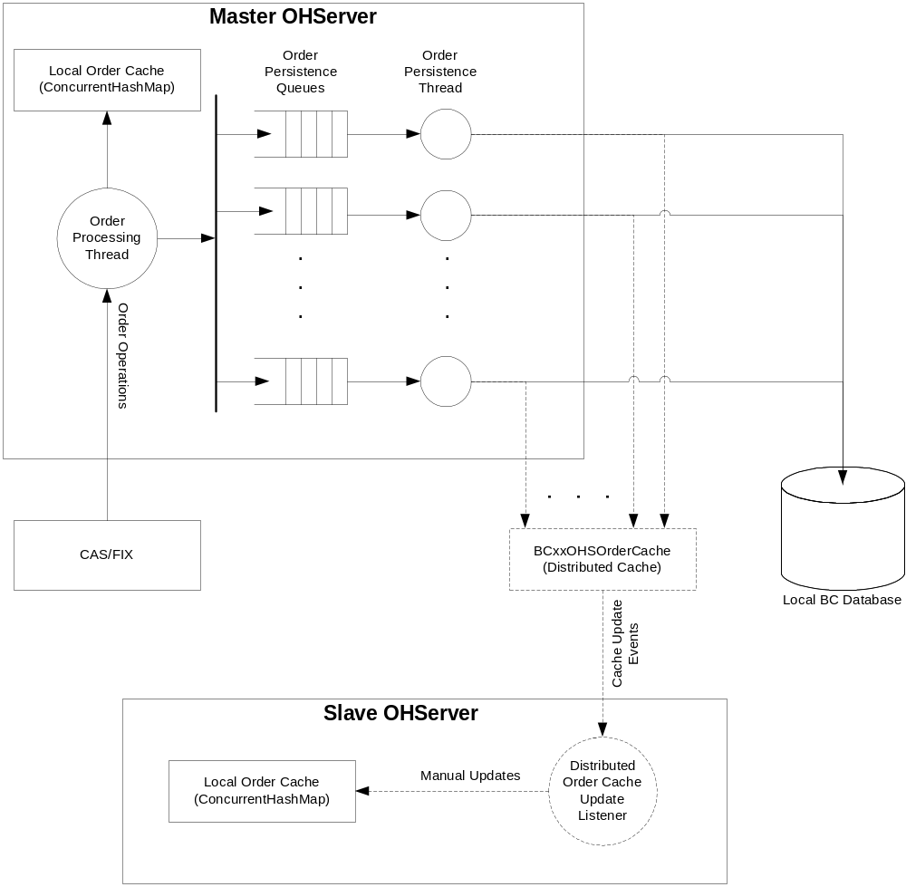

Currently the OHServer maintains a local cache using the ConcurrentHashMap and maintains persistence in the local BC database schema. The local cache maintains a small subset of all orders processed during the current trading session. The criteria for which orders are maintained in the local cache are specified in XML configuration. All orders processed during the current trading session are persisted in the local BC database schema. The database schema serves as the synchronization point between the master and slave OHServer process on failover and as a source for database replication. The updates to the database are performed asynchronously from the main order processing thread.

The current implementation involving the local ConcurrentHashMap and the local BC database will be maintained. The distributed OHS order cache will be incorporated as shown in figure below. The slave OHServer will attach a listener on the distributed cache to receive update events with the new or updated Order objects. The listener will update the local ConcurrentHashMap on the slave OHServer. The local ConcurrentHashMap on the slave OHServer will be in-sync with master OHServer for a fast failover without having to perform database queries as done in current implementation. The database will serve as a back-up to any issues encountered with the distributed OHS order cache.

Order Synchronization – Trade Servers

One order cache instance per master-slave pair of trade server will be employed. Currently the trade servers receive orders via a CORBA call from the OHServer. All orders targeted for electronic processing are dispersed through multiple trade servers within the same BC. Therefore it is necessary to maintain a separate order cache instance per master-slave trade server pair on a BC.

On a failover, each trade server retrieves its share of the orders from OHServer via a CORBA call, and builds the order book. With the use of distributed order cache, the slave trade server will have a ready view of its share of the orders immediately. Furthermore, the slave trade server will also keep the order book updated based on the updates to the orders in the distributed order cache. The master trade server will make updates to the distributed order cache on following incidents.
- Receiving a new order
- Creating new orders for matching linkage orders received from away exchanges?
- Returning the order back to OHServer
- Order cancel
- Order fill
- Order auction start and end
- Order booked

This updates will aid the slave trade server in keeping an updated view of not only the orders but also the order book. The figure below shows the proposed modifications overlaid on existing implementation in dotted line format.

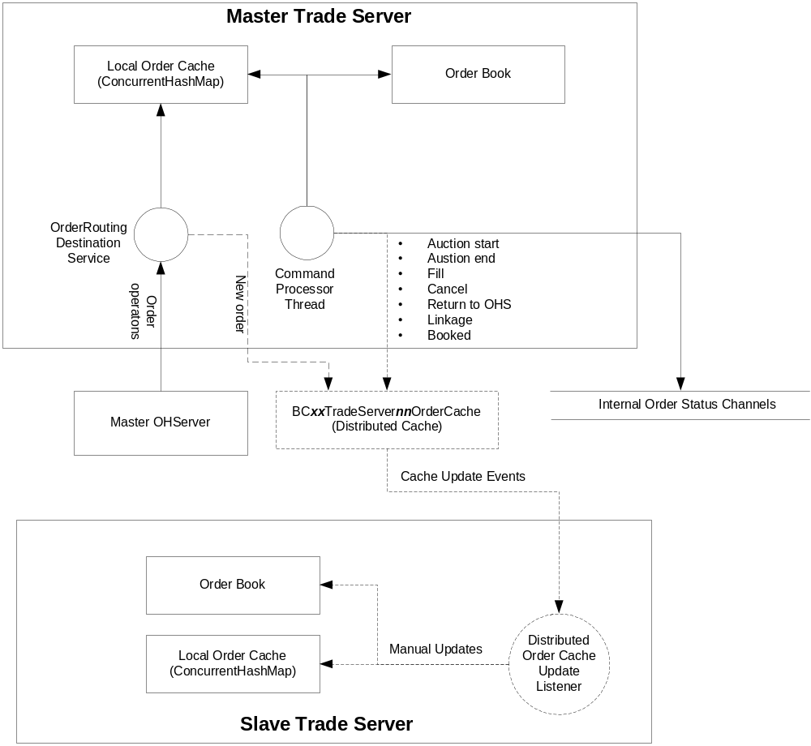

Trading Product Synchronization

Current implementation has the trade server performing a query on GlobalServer to obtain the latest snapshot of the trading product set it is assigned. The trading product set is persisted in the local BC database. Any subsequent restart of master or slave trade server skips the query to the GlobalServer. Instead the trading product set is retrieved from the local BC database on any subsequent restart of either the master or slave trade server. The database query for trading products occurs during the slave-to-master mode transition so as to cover the case of failover. Once the master trade server is started, it makes updates to a small subset of the following parameters in the trading product during trading session. These updates are also persisted in the local BC for failover reasons.
- A new product is added
- Product state is changed
- Continuous update of last sale price, volume and prefix

In implementation of the fast-failover, the storage of trading product set in local BC database is completely removed as it is not necessary so long as the slave trade servers load and maintain their local cache of trading products. Both master and slave trade servers will execute a query to the GlobalServer for the trading to load their local cache of trading products. Just as the master trade server does in current implementation, the slave trade server will also keep its local cache of trading products updated throughout the day.

The slave server will accomplish the task of maintaining its trading product cache current with the aid of a trading products distributed cache and listening on the TradingSession event channel for new product updates. The figure shows the proposed modifications with the current implementations.

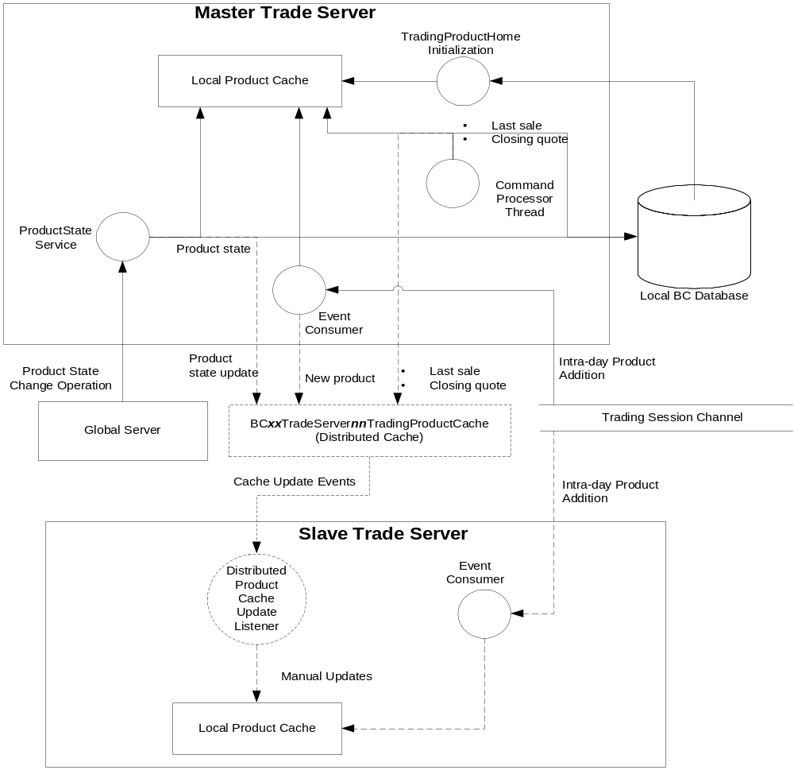

Issues

