CDX Fast Failover
Event Channel Modification

WR#: 6538

Prepared by

Hemant Thakkar
Table of Contents
ISSUE 3
CURRENT MODE OF OPERATION 4
PROPSED MODIFICATIONS 6
TEST PLAN 8

ISSUE

Currently the majority of event channel connections are being made during the time when processes are transitioning to master mode. While individual event channel connection operation is not heavy, multiple event channel connections significantly delays the completion of master mode transition. This is problematic for fast-failover when BC processes transition from slave to master mode.

CURRENT MODE OF OPERATION

There are two patterns of implementation for event channel connections. The first approach is the classical one based on the EventHomeBaseImpl. The second newer approach is primarily used in the OHServer processes, though the OHServer also uses the classical method for some event channel connection management.

Event Channel Connection with Classical Method

The figure below shows an example of the classical approach with respect to connections to event channels. The base class EventHomeBaseImpl provides low level operations to the underlying event channel. The next higher abstraction level class provides services to manage consumer subscriptions to the OptionTicker event channel. A specific event channel abstraction class supports interface to allow the consumers of that event channel to add or remove themselves as subscribers to that event channel. In the example below for the OptionTicker event channel, the OptionTickerConsumerHomeImpl is the specific event channel abstraction class and the TradeThroughMonitoringServiceImpl is the event channel consumer.
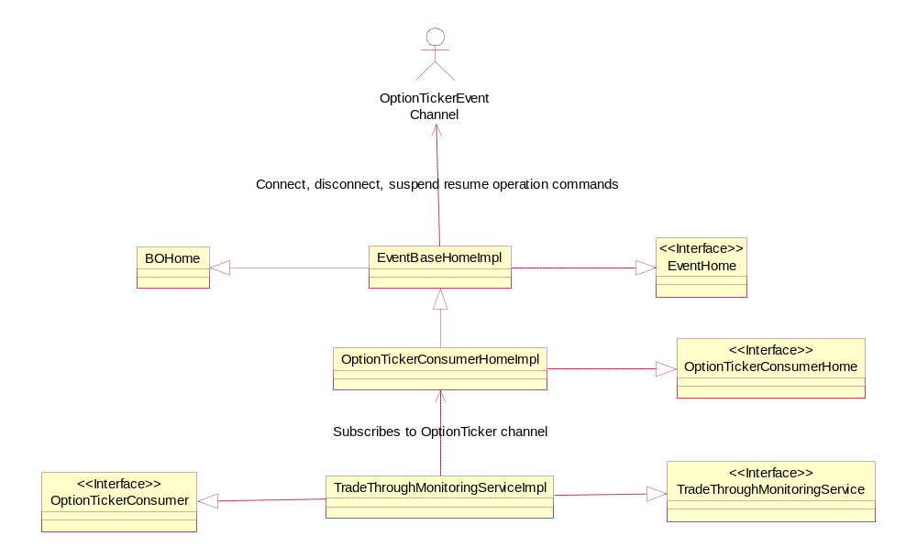
In current implementation, the event channel consumers typically add themselves as subscribers using one of the specific event channel abstraction classes. In the example above this would correspond to the TradeThroughMonitoringServiceImpl invoking addConsumer operation made available by OptionTickerConsumerHomeImpl. The specific event channel abstraction class creates appropriate channel filters and delegates the actual connection to the underlying event channel to the base class EventHomeBaseImpl which performs the connection operations on the underlying event channel.

The trade server and OHServer processes contain consumers to a number of channels. Some consumers register themselves during transition to slave mode while some delay this action until the process is transitioning to master mode. Irrespective of when the consumer registers itself, the actual connection to the event channel is delayed until the process is transitioning to master mode either during a full startup as master process or during a failover. There are some exceptions to such typical behavior as some event channel consumption is performed even in slave mode. This exception is dictated by the configuration property of the specific event channel abstraction class.

An XML configuration property named consumingWhenSlave for each event channel indicates whether the channel is to be consumed in slave mode. This boolean property is defined in the XML configuration of the event channel abstraction class. In the example above, this property, if necessary, would be defined in OptionTickerConsumerHome.xml. When this property is absent in the XML configuration, the default mode is to not consume in slave mode. If channel consumption is required, this property must be added and set to value of “true”.

Although the consumingWhenSlave property is available, there are certain event channel abstraction classes that simply hard-code a value to allow for event channel consumption in slave mode. Going forward, however, we should depend on the configuration properties and correct the current implementation.

Event Channel Connection with New Method

The figure below shows an example of new event channel connection management
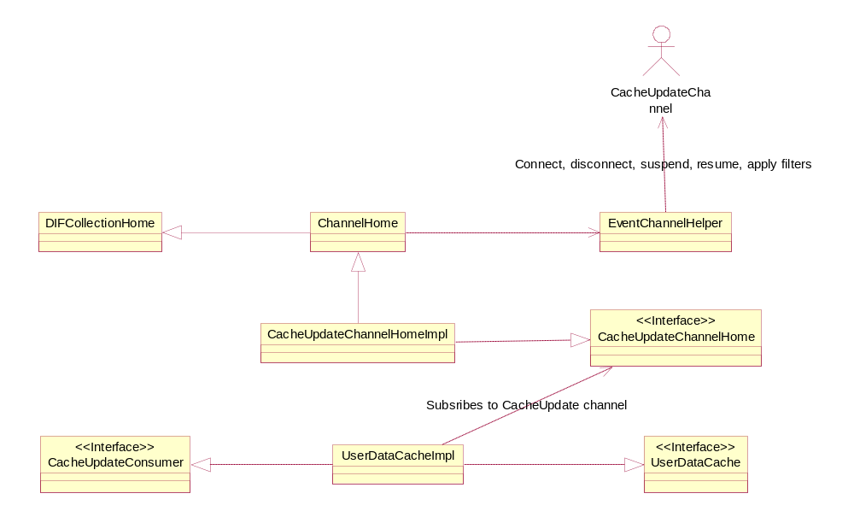
method. It is very similar to the classical approach with the EventChannelHelper performing all actual event channel connection operations. The CacheUpdateChannelHome and its implementation are the specific channel abstraction classes while the UserDataCahceImpl is the event channel consumer. Unlike the EventHomeBaseImpl, however, neither the EventChannelHelper nor the ChannelHome classes manage deferment of actual connection to the event channel and consumption from the event channels. That responsibility lies completely with the event channel consumer class and the EventChannelHelper and ChannelHome are stateless helper classes. If the UserDataCacheImpl invokes registration in slave mode, the channel connection will be made immediately. Thus the timing of the event channel connection must be manually coordinated by the event channel consumer as there is currently no XML configuration property to signify deferment of event channel connection or deferment of channel consumption to master mode even if the consumer registered itself during slave mode.

Because of the lack of configuration properties, the other difference is that all specific event channel abstraction classes share one common XML configuration file named OhsChannelHome.xml.

PROPSED MODIFICATIONS
The cumulative delay of connect operations to the multiple event channels adds significant delay in the transition to master mode. This is fine when the process is started up in master mode; however it is unacceptable when the process is transitioning to master mode during failover. Therefore it is proposed that all event channel connection be made during the slave mode transition.

To connect all consumers to their specific event channels, the following modifications are proposed for the classical approach.

- All event channel consumers must register with its specific event channel abstraction class during slave mode transition. Any such consumer registration currently performed in master mode transition must be moved to slave mode transition.

- Make connection to all event channels during slave mode transition based on a new XML configuration property connectWhenSlave. Certain event channels are consumed by non-BC processes as well as the BC processes. The current goal is to migrate event channel connections made only by BC processes. A distinct set of XML configuration properties (identified by a managedResource dedicated to the BC usage) must be defined, and this property set for BC process must set the connectWhenSlave flag to “true”. While all others properties sets (i.e. managedResorces) must set the value to “false”. Note that the semantics of connectWhenSlave was previously associated with the consumingWhenSlave as the purpose of consumingWhenSlave is changed to enable/disable forwarding of event messages to the consumer when consumer is registered with the event channel.

- Enable/disable event message flow to the registered consumers based on XML configuration property consumingWhenSlave. Event though the new mode of operation would have all event channel consumers in a BC process registered with the event channel in slave mode, it is undesirable for slave processes to consume some of the event channels. Unlike the current purpose of consumingWhenSlave property which is used to decide whether to make the connection to the event channel, the new semantics will be enable/disable event messages flow to the consumer.

The following modifications are proposed for the new OHS-centric approach.

- Add a consumer registration method in the specific event channel abstraction classes to allow for registration with immediate channel consumption or deferred channel consumption. In the example above, the CacheUpdateChannelHome and CacheUpdateChannelHomeImpl will be modified to add two new methods while removing the current consumer registration method. In the case, the consumer registered with deferred consumption, a new method will be added to allow this consumer to resume consumption at a later time.
  - Remove: registerConsumer
  - Add: registerConsumerImmediateConsumption
  - Add: registerConsumerDeferredConsumption
  - Add: resumeConsumption

- For each channel consumer that registers with the specific channel abstraction class, a change must be made to accommodate the changes highlighted in the previous bullet item. In the example above, the UserDataCacheImpl will be adjusted to call one of the new consumer registration method depending on its requirement as to when to connect and start consuming the events.

The following is a list of all event channels consumed by BC processes of W_MAIN session.

TEST PLAN

