CDX Fast Failover
Trade Engine Order Synchronization

WR#: 6538

Prepared by

Hemant Thakkar
Trade Engine Order Synchronization Design

Introduction

This document outlines the high-level design for maintaining order synchronization between master trade engine (TE) and the slave trade engine.

General Architecture

The master TE will forward orders to the slave TE to maintain order book synchronization with respect to orders. The master TE does not forward the quotes; therefore the order book on slave only contains orders. The master TE forwards all orders to the slave TE except for the following order types.
- Quote-like orders
- Express orders.

A third-party distributed caching solution is used to relay the orders to slave TE by master TE. Current plan is to use the replicated caching scheme of the open-source Infinispan distributed caching.

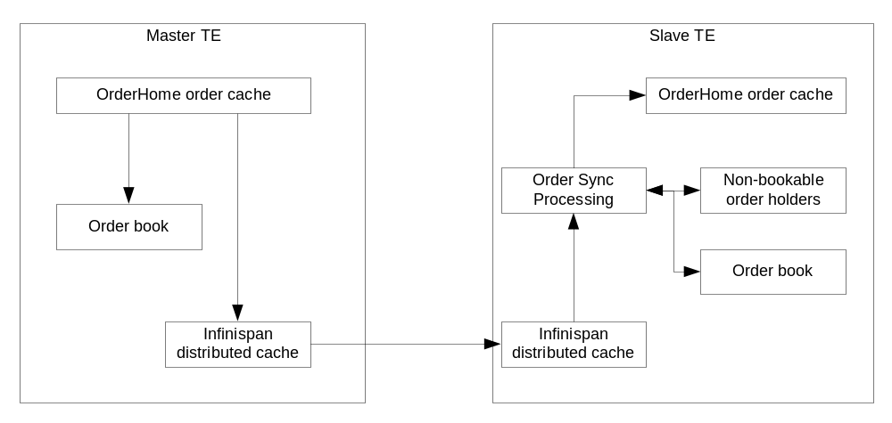

As shown in the figure above, the master TE will make updates to the remote cache (i.e. distributed cache) when a new order is received or an existing order is updated. The updates by master TE results in the slave TE receiving an update or remove event from remote cache. The slave TE responds by creating, updating or removing the order from the OrderHome cache. Additionally the slave TE either puts the order in the order book or places it in one of the non-bookable order holders. The next section describes the logic used by slave TE to determine whether the order is booked or stored in one of the non-bookable order holders.

Slave TE Order Sync Event Handling

The slave TE uses the flow logic shown in figure below to determine whether the order should be placed in the book or in one of the non-bookable order holders. Orders that are not in active states are directed to one of the non-bookable order holders depending one or more of contingency types or linkage status.
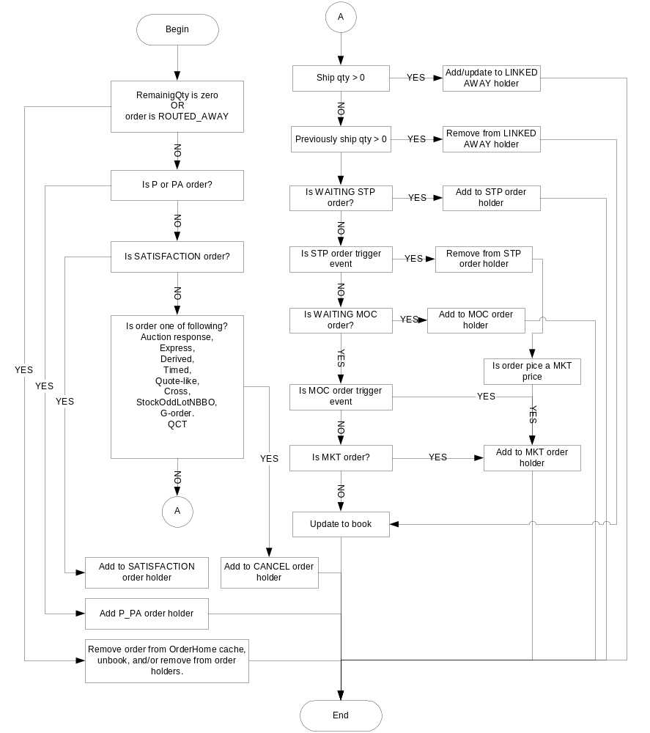

Upon fast-failover, the orders in the book will remain in the book and are ready for processing after failover such as cancel and fills. The orders in the non-bookable holders are handled according to their holder type on a fast-failover. In the case of the legacy slow failover, the classical failover procedure is followed. In slow failover, the order-books are purged, all non-bookable orders holders are ignored and the orders are reloaded from the OHS. The failover action on the non-bookable order holders is described in the next section.

Fast-Failover processing

Any order not placed in one of the non-bookable order holder is already present in the order book at the time of the failover and are ready to be acted upon (i.e. cancel, fill, etc) immediately after fast failover completes. Orders held in the non-bookable holders are processed in a background thread.

Non-bookable order holder processing on fast-failover

Processing of the non-bookable order holders fall into one of three possible categories: Throw away the orders, cancel the orders, and process the orders through normal broker service processing.

Linked away order holder
The throw away holder type is one where the orders are being held temporarily in a holder until a final disposition on the order is made. Currently only the linked-away orders fall into this category. Any order that is linked away partially or fully by the master TE, is placed in the LINKED_AWAY holder by the slave TE while awaiting the final linkage status. When the linked order gets filled or rejected and the any remaining quantity is booked by the master TE. The update is forwarded to the slave TE via remote cache, where the order is removed from the LINKED_AWAY holder and the booked on the slave side. Thus any order that is present in the LINKED_AWAY holder on the slave side at the time of failover is one whose linkage fill response had not yet arrived. As such, the slave TE simply ignores this order as part of the fast-failover processing. The rationale behind this paradigm is that the delayed linkage response will be handled by OHS and proper updates will be forwarded to the TE.

Cancel order holder
Orders that are cancelled on current slow-failover mode of operations are placed in the cancel holder by the slave TE. Orders in the cancel order holders are collected, and a CORBA call is made to the OHS to cancel these orders. This operation is identical to that performed currently in the non-fast-failover mode. See the slave TE order sync processing logic flowchart for the types of orders placed in the cancel order holder.

Normal order processing holders

Orders in the STP, MOC, and MKT order holders are played back through the broker service upon fast-failover. The broker service will process these orders according to their contingency types, price and market condition. As such the orders will be appropriately routed to their special master TE order holders (i.e. the MOC holder and the STP holder). This processing also occurs in a background thread which is spawned during the fast-failover.

Design model
The figure below shows the coupling of the distributed caching service provided by infrastructure and the server application code. The distributed caching solution (Infinispan) is decorated by the infrastructure caching service and is exposed by the JCache and JCacheFactory classes.
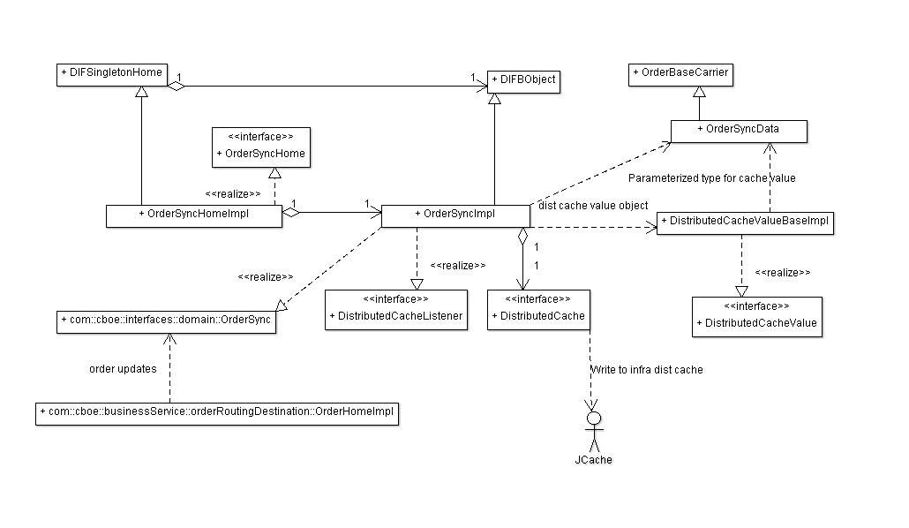
The TE application code adds a layer of abstraction on top of JCache by means of the DistributedCacheHome and the DistributedCache interfaces and their implementations. This abstraction adds the following value.
- Provide a single listener to the remote cache with local listener model implemented by the DistributedCacheListener class, thus avoiding multiple listeners directly to the remote cache.
- Provide a master/slave switch to ensure that the slave application does not write to the remote cache.
- Provide a generic value object with the DistributedCacheValue interface for the value object in the key-value pair of the JCache.

The TE order sync is implemented by the OrderSyncHome and uses the services provided by the DistributedCacheHome. The master TE makes updates to the DistributedCache and the slave TE receives event notifications from the DistributedCache as a DistributedCacheListener. The OrderSyncHome group of classes in slave TE process each update event as shown in the figure below.

When OrderSyncImpl receives update events as a DistributedCacheListener, it makes the updates (creates, if new order) to the local copy of the order in OrderHome cache and forwards the event to the OrderSyncEventProcessor for further processing.

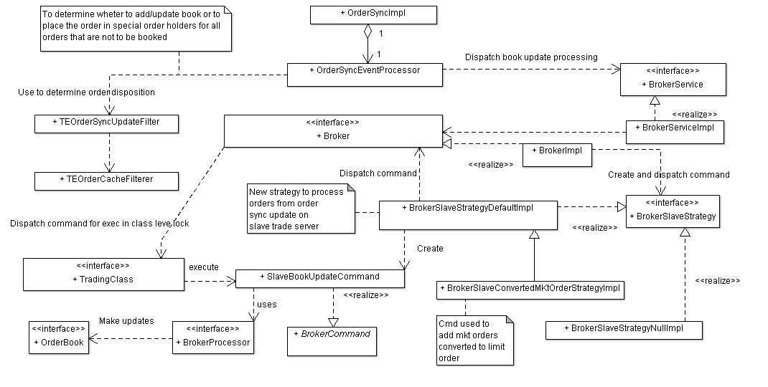
The OrderSyncEventProcessor uses the TEOrderSyncUpdateFilter to determine the actions to perform. The TEOrderSyncUpdateFilter with the aid of the TEOrderCacheFilter implement the logic described in the flowchart in the earlier sections of this document. Once the action is determined, the OrderSyncEventProcessor either puts the order in one of the non-bookable order holder and/or performs an add/update/remove operation on the order-book using the new BrokerSlaveStrategy and its implementation. The existing broker service is enhanced to accept the use of the new BrokerSlaveStrategy and the SlaveBookUpdateCommand classes.

On a fast-failover, the OrderSyncImpl detaches itself as a listener to the DistributedCache and assumes the role of writing the updates to the DistributedCache. Since the order-books had been maintained for order synchronization, the process of loading and populating order books is omitted. The orders in the non-bookable order holders are processed in a background thread thus allowing the failover to complete as required by fast-failover requirements.

On a slow-failover, the process of retrieving orders and building the order books is identical to that used currently. OrderHome cache is cleared and reloaded from OHS. The orders are filtered using the existing logic in TEOrderCacheFilterer into bookable and to-be-cancelled orders. The to-be-cancelled orders are sent to OHS for cancellation, and the bookable orders are populated in order-book when the order books are built. One additional step in the new slow-failover is that the remote cache is also cleared out.

Issues

