

CFLEX 2.0
System High Level Design Document
Version 1.0

Prepared by: CFLEX Design Team

Last updated Date: April 21, 2010

CBOE Confidential & Proprietary

Table of Contents
Table of Contents 1
1 Introduction 7
2 CFLEX 2.0 Ecosystem 8
3 Product Class Definition 9
3.1 CMI IDL adding new FLEX_OPTION type in cmiConstants.idl 9
3.2 IPD 10
3.2.1 IndustryProductMaintenanceService and IndustryProductQueryService 10
3.2.2 IPD GUI 11
3.2.3 IPD/DWH Interface 11
3.3 CBOEdirect Server 11
3.3.1 GLOBAL:ProductMaintenaceService and ProductQueryService 11
3.3.2 BC Changes – Copp Bridge 13
3.3.3 BC Changes – Trade Server 14
3.3.4 Database changes for CBOEDirect 14
3.4 SACAS/CAS/FIX 14
3.5 SAGUI 14
3.6 GUI 14
3.7 CTMR/CTMi 14
3.8 COPP 14
3.9 XTP/BDX/CSM 15
3.10 CDB 15
3.11 DWH/Archive 15
3.12 Billing 15
3.13 Market Replay 15
4 Product Definition 16
4.1 CMI IDL adding new Price Type in cmiConstants.idl 16
4.2 IPD 16
4.2.1 IPD will no longer be creating products for CFLEX. 16
4.3 CBOEdirect Server 16
4.3.1 GLOBAL:ProductMaintenaceService and ProductQueryService 16
4.3.2 Business Cluster: Price and PriceFactory, SQL Encoding 17
4.3.3 Business Cluster: Product Opening 17
4.4 GUI 17
4.5 SAGUI 18
4.6 CTMr/i 19
4.7 CSM/BDX 19
4.8 XTP 19
4.9 CDB 20
4.10 DWH/ARCHIVE 20
4.11 Billing 21
4.12 Market Replay 22
5 New CFLEX Trading Session 23
5.1 CMI/API 23
5.2 IPD 23
5.3 CBOEdirect Server 23
5.3.1 GC configuration to support new session/subsession, trade servers, ProductConfigurationGroup and routing group assignment. 23
5.3.2 BC Configuration on CoppBridge, CFlexTradeServers, OHServerCFlex, and STSCFlexTradeServer. 23
5.4 INFRA 23
Infra to configure new extend maps, channels to support the new processes and events. 23
5.5 SAGUI/GUI 23
5.6 FIX 24
5.7 CTMr/i 24
5.8 XTP 24
5.9 CSM/BDX 24
5.10 CDB 24
5.11 DWH/ARCHIVE 25
5.12 Billing 26
5.13 Market Replay 27
6 CFLEX Entitlements/Enablements 28
6.1 MPP/TPS 28
6.2 CBOEdirect Server 29
6.2.1 Support User Enablement update for CFLEX new enablement type 29
6.3 CAS/FIX 30
6.4 SAGUI 30
6.5 CTMr/CTMi 30
6.5.1 CTMr 30
6.6 CDB 30
6.7 DWH/ARCHIVE 30
6.8 Billing 30
6.9 Market Replay 30
6.10 Other Processes 30
7 Initiating FLEX Auction 31
7.1 CMI/API 31
7.1.1 For CFLEX2.0, CMI will introduce a new version cmiV10.idl 31
7.1.2 cmiConstants.idl 31
7.1.3 cmiOrder.idl 32
7.1.4 cmiErrorCodes.idl 32
7.1.5 cmiV10.idl - FlexTradeService Interface 32
7.1.6 cmiCallback10.idl 33
7.2 CBOEdirect Server 33
7.2.1 IDL changes for OrderHandlingService, OrderRoutingDestination 33
7.2.1 IDL changes for OrderBookService 33
7.2.3 IDL new interface for AuctionService 33
7.2.4 GLOBAL Server See ProductDefintion Feature above 33
7.2.5 GLOBAL Server TradingProperty related changes 34
7.2.6 Business Cluster (BC) changes - OHS 34
7.2.7 Business Cluster (BC) changes – OrderRoutingDestination 34
7.2.8 Business Cluster (BC) changes – Auction Related Services 34
7.2.9 Business Cluster (BC) changes – AuctionConsumer 35
7.2.10 Business Cluster (BC) changes – Broker Service 35
7.2.11 Business Cluster (BC) changes – MarketDataService and MarketDataBuffer 35
7.2.12 Business Cluster (BC) changes – OrderBookServices 36
7.3 CAS/SACAS/MDCAS/FIX 36
7.4 GUI 36
7.5 SAGUI 40
7.6 CSM/BDX 41
7.7 CDB 41
7.8 DWH/ARCHIVE 41
7.9 Market Replay 43
7.10 Other Processes 43
8 Other FLEX Auction 44
9 AIM Auction and AIM AON Auction 45
9.1 CMI/API 45
9.1.1 cmiV10.idl 45
9.2 CBOEdirect Server 45
9.2.1 IDL changes for OrderHandlingService, OrderRoutingDestination 45
9.2.2 GLOBAL Server See ProductDefintion Feature above 45
9.2.3 Business Cluster (BC) changes - OHS 45
9.2.4 Business Cluster (BC) changes - ORD 45
9.2.5 Business Cluster (BC) changes – AuctionService 46
9.2.6 Business Cluster (BC) changes – BrokerService 46
9.3 CAS/SACAS/FIX 46
9.4 GUI 46
9.5 CDB 46
9.6 DWH 46
9.7 Market Replay 46
9.8 Other Processes 47
10 Order Entry (none auction related) 48
10.1 CMI/API 48
10.2 CBOEdirect Server 48
10.2.1 IDL changes for OrderHandlingService, OrderRoutingDestination 48
10.2.2 Business Cluster (BC) changes - OHS 48
10.2.3 Business Cluster (BC) changes - ORD 49
10.2.4 Business Cluster (BC) changes - OrderBook 49
10.2.5 Business Cluster (BC) changes – BrokerService 49
10.3 CAS/SACAS/FIX 49
10.4 GUI 49
10.5 SAGUI 50
10.6 CDB 51
10.7 DWH/ARCHIVE 51
10.8 Billing 51
10.9 Market Replay 51
10.10 Other Processes 52
11 Allocation for Trades 53
11.1 CBOEdirect Server 53
11.1.1 Constants.idl adding new AllocationTradeType for FLEX Auction Allocation 53
11.1.2 Trade Service: 53
11.1.3 Regular Order Allocation: 53
11.1.4 FLEX Auction - AuctionProcessorFlexAuctionImpl processAuctionExpire: 53
11.1.5 FLEX Auction - TradeService 53
11.1.6 AIM Auction - AuctionProcessorCFlexAIMAuctionImpl processAuctionExpire: 54
11.2 SAGUI 54
11.3 Other Processes 54
12 Pending Trade – Fixed Strategy Trade 55
12.1 CMI/API 55
12.1.1 cmiConstants.idl new ReportType for Fill Report 55
12.1.2 cmiTrade.idl new Struct for trade summary report to get trades 55
12.1.3 cmiV10.idl to support query and accepting prices for pending trades 55
12.2 CBOEdirect Server 56
12.2.1 IDL changes to support query and update trade prices/status (TradeMaintenanceService and TradeQueryService). 56
12.2.2 GLOBAL changes - TradingProperty 56
12.2.3 OHS changes – OrderHistory 56
12.2.4 OHS changes – OrderHandlingService 56
12.2.5 BC changes – TradeMaintenanceService 56
12.2.6 BC changes – TradeQueryService 57
12.2.7 BC changes – OrderRoutingDesitination 57
12.3 SAGUI 57
12.4 GUI 57
12.5 SACAS 58
12.6 CAS 58
12.7 FIX 58
12.8 CDB 58
12.9 DWH 58
12.10 Market Replay 58
12.11 Other Processes 58
13 Pending Trade – Percentage Simple Order Trade 59
13.1 CMI/API 59
13.1.1 cmiV10.idl to support accepting prices for pending trade 59
13.2 CBOEdirect Server 59
13.2.1 IDL Changes to support product resolution and CMI/API new methods 59
13.2.2 GlobalServer changes – ProductMaintenanceService and ProductQueryService 59
13.2.3 OHS changes – OrderHistory 60
13.2.4 OHS changes – OrderHandlingService 60
13.2.5 BC changes – OrderRoutingDesitination 60
13.2.6 BC changes – TradeMaintenanceService 60
13.2.7 BC scripts 60
Trade Match Data recovery to be updated to only resend unacked reports on approved trades. 60
13.2.8 BC changes – StatusServer 60
Only publish unacked reports on final fill reports. 60
13.3 SAGUI 60
13.4 GUI 60
13.5 SACAS 60
13.6 CAS 61
13.7 FIX 61
13.8 CDB 61
13.9 DWH/ARCHIVE 62
13.10 Billing 63
13.11 Market Replay 64
13.12 Other Processes 64
14 Pending Trade – Percentage Strategy Order Trade 65
14.1 CMI/API 65
14.2 SOSABridge (new CorpSys process) 65
14.3 CBOEdirect Server 65
14.3.1 OHS changes – OrderHistory 65
14.3.2 OHS changes – OrderHandlingService 65
14.3.3 BC changes – OrderRoutingDesitination 65
14.3.4 BC changes – TradeMaintenanceService 65
14.4 SAGUI 66
14.5 GUI 66
14.6 SACAS 66
14.7 CAS 66
14.8 FIX 66
14.9 CDB 66
14.10 DWH/ARCHIVE 67
14.11 Billing 67
14.12 Market Replay 68
14.13 Other Processes 68
15 Block Trade 69
15.1 CBOEdirect Server 69
15.1.1 TradeMaintenanceService IDL 69
15.1.2 BC changes – TradeMaintenanceService 69
15.2 SAGUI 69
15.3 GUI 69
15.4 SACAS 69
15.5 CAS 69
15.6 FIX 70
15.7 CDB 70
15.8 DWH 70
15.9 Market Replay 70
15.10 Other Processes 70
16 Trade Bust 71
16.1 CBOEdirect Server 71
16.1.1 BC changes – TradeMaintenanceService 71
16.2 SAGUI 71
16.3 GUI 71
16.4 SACAS 71
16.5 CAS 71
16.6 FIX 71
16.7 CDB 71
16.8 DWH/ARCHIVE 71
16.9 Billing 71
16.10 Market Replay 72
16.11 Other Processes 72
17 Trade Match 73
17.1 CTMR 73
17.2 CTMi 73
17.3 CDB 73
17.4 DWH/ARCHIVE 73
17.5 Other Processes 74
18 Open Interest 75
18.1 CMI/API 75
18.1.1 cmiProduct and ProductQuery related IDL changes 75
18.2 CBOEdirectServer 75
18.2.1 Global – ProductMaintenanceService 75
18.3 SAGUI 75
18.4 GUI 75
18.5 SACAS 75
18.6 CAS 75
18.7 FIX 75
18.8 CDB 75
18.9 DWH/ARCHIVE 76
18.10 Other Processes 76
19 End of Session 77
19.1 CBOEdirectServer 77
19.1.1 BC changes – TradeMaintenanceService 77
19.2 Other Processes 77
20 End of Day 78
20.1 CBOEdirectServer 78
20.1.1 Global - cleanupServer 78
21 Reporting 79
21.1 CBOEdirectServer 79
21.1.1 Global Server – MarketDataReportingService 79
21.2 CTMR 79
21.3 DWH 79
21.4 Market Replay 79
21.5 Other Processes 79
22 Billing 80
22.1 Billing 80
22.2 Other Processes 80
23 Surveillance 81
Rollout 82
CBOEdirect 82
Market Replay 83
Other Processes 83
Appendix 84
Glossary 84
CFLEX Component Grid and Notes 85

1 Introduction
This document contains high level system design based on CFLEX Requirement document. Changes required for each system component are separated by features proposed in the system to be implemented. The design described here is based on current CBOEdirect code base as it is required that any changes to the system need to incorporate into the current code base and maintain the one code base across all trading sessions.

2 CFLEX 2.0 Ecosystem
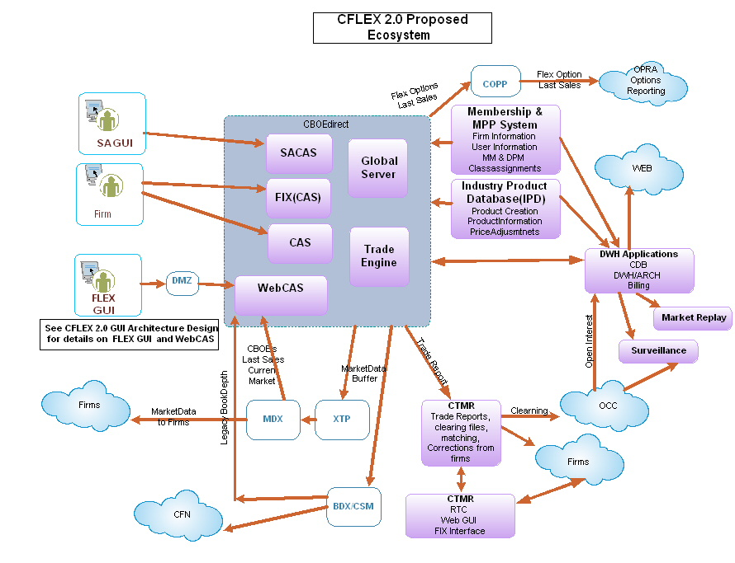

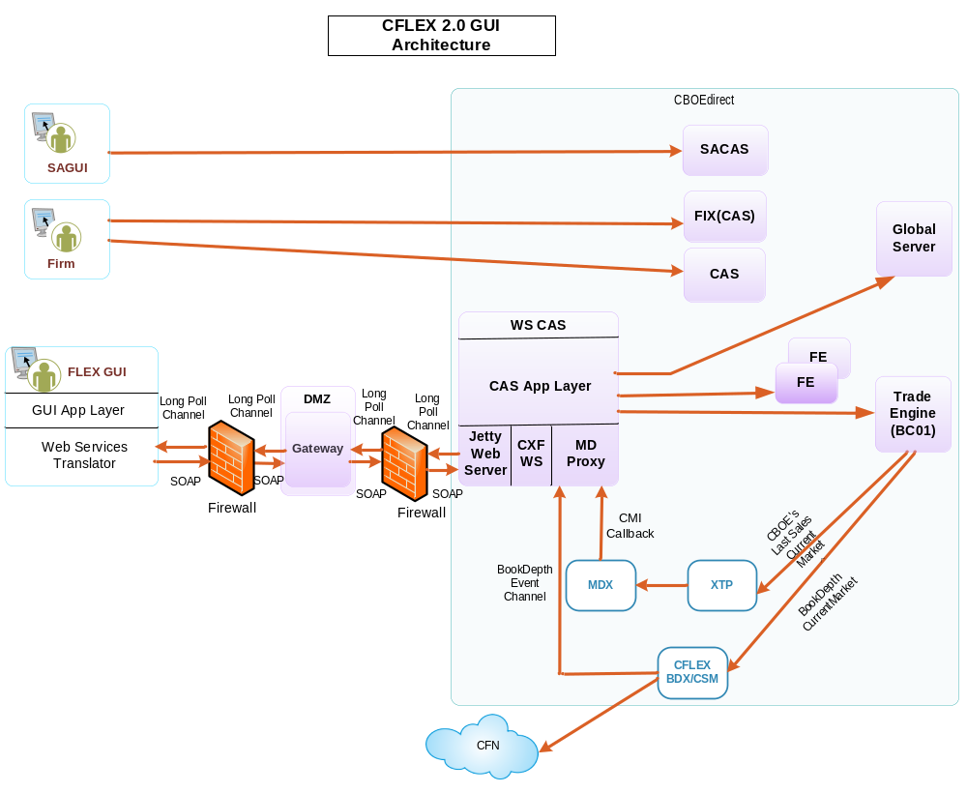

3 Product Class Definition
Note: It is recommended to review the corresponding sections of the requirements document for this feature before reading through this section.

For each option class we could have up to 4 FLEX Options and 4 Strategies depending on if it has an underlying of type equity or index.

For example, for underlying symbol XXX we could have: (note that the expiration style is encoded in the class symbol)
1XXX – Flex Option (type 7) and Strategy (type 11)
2XXX – Flex Option (type 7) and Strategy (type 11)
3XXX – Flex Option (type 7) and Strategy (type 11)
4XXX – Flex Option (type 7) and Strategy (type 11)

Each Class will also have a reporting class created.

3.1 CMI IDL adding new FLEX_OPTION type in cmiConstants.idl
- cmiProduct.idl

  - Define char def for ExerciseStyle

typedef char ExerciseStyle;

- cmiConstants.idl

  - Add a new product Type for CFLEX product

interface ProductTypes
{
...
const cmiProduct::ProductType FLEX_OPTION = 13;
}

  - Add a new constant for percentage price type.

interface PriceTypes
{
...
const cmiUtil::PriceType PERCENTAGE = 5;

}

  - New auction type for CFLEX

interface AuctionTypes
{
...
const cmiOrder::AuctionType FLEX_AUCTION = 9;
}

  - New constants for Exercise Style

interface ExerciseStyles
{
const cmiProduct::ExerciseStyle NONE = 'N';
const cmiProduct::ExerciseStyle AMERICAN = 'A';
const cmiProduct::ExerciseStyle EUROPEAN = 'E';
};

3.2 IPD

3.2.1 IndustryProductMaintenanceService and IndustryProductQueryService
- Support server validation rules for creation and updates of new product class creation of type FLEX_OPTION. See requirements documentation for details of validation rules.
- Both Strategy Flex Option and the related reporting classes will need to be created. See example above.
- Ensure that flex classes are not inactivated due to having no products.
- Support expiration style transmission via new interface method to GlobalServer. See CBOEdirect Server GLOBAL section.
- Encode expiration style in class name definition (i.e., the numeric suffix to the class symbol).
- Have product class definitions support 4 decimal strikes and provide this data to DWH.
- Test and verify that Corporate Actions are taken care of by current logic.
- IPD will automatically create CFLEX option and strategy classes based upon parameters defined by the Trade Match (First Floor) Group. The parameters need to be stored in IPD. IPD needs to be modified to handle CLFEX automation.
- The IPD/CBOEdirect “resync report” needs to be modified to include CFLEX classes.
- The IPD Data Integrity report needs to be modified to include CFLEX business rules.
- IPD server interfaces need to be updated and the IPD GUI needs to be modified to use the new interfaces. The IPD server must be backward compatible with previous versions of the GUI.
- IPD must be updated to reference the CBOEdirect CFLEX release.

3.2.2 IPD GUI
- Product Class support new product type and decimal points
- EOD GUI screen.

3.2.3 IPD/DWH Interface

- Provide data for FLEX_MAIN in underlying_sym_asgn.

3.3 CBOEdirect Server

3.3.1 GLOBAL:ProductMaintenaceService and ProductQueryService
- Back-fill the existing option classes with the expiration style now originating from IPD.)
- Implement and support the new interface method between IPD and Global ProductMaintenanceService and impls for processing and committing the expiration style.
Product.idl
struct ClassDefinitionStructV5
{
ClassDefinitionStructV3 classDefinition;
cmiProduct::ExpirationStyle expirationStyle;
};

struct ProductClassStructV6
{
product::ProductClassStructV3 prodClass;
cmiProduct::ExerciseStyle exerciseStyle
};
typedef sequence <ProductClassStructV6> ProductClassStructV6Sequence;

ProductMaintenanceService.idl
- New method to add CFLEX product class from IPD

product::ProductClassStructV6 addProductClassWithKeyV6(in product::ClassDefinitionStructV6 updatedProductClass)
raises(
exceptions::SystemException,
exceptions::CommunicationException,
exceptions::DataValidationException,
exceptions::TransactionFailedException,
exceptions::AuthorizationException
exceptions::AlreadyExistsException
);

- New method to update CFLEX product class information from IPD

product::ProductClassStructV6 updateProductClassWithKeyV6(in product::ClassDefinitionStructV6 updatedProductClass)
raises(
exceptions::SystemException,
exceptions::CommunicationException,
exceptions::DataValidationException,
exceptions::TransactionFailedException,
exceptions::AuthorizationException
);

- New method to add CFLEX product class with session code

product::ProductClassStructV6 addProductClassV6(in product::ClassDefinitionStructV6 newClass)
raises(
exceptions::SystemException,
exceptions::CommunicationException,
exceptions::DataValidationException,
exceptions::TransactionFailedException,
exceptions::AuthorizationException,
exceptions::AlreadyExistsException
);

- New method to update CFLEX product class with session code

product::ProductClassStructV6 updateProductClassV6(in product::ClassDefinitionStructV6 updatedProductClass)
raises(
exceptions::SystemException,
exceptions::CommunicationException,
exceptions::DataValidationException,
exceptions::TransactionFailedException,
exceptions::AuthorizationException
);
ProductQueryService.idl

  - New method to get product classes by class key

product::ProductClassStructV6Sequence
getProductClassesByKeyV6(in cmiProduct::ClassKeySequence productClassKeys, in boolean includeReportingClasses,
in boolean includeActiveOnly) raises(
exceptions::SystemException,
exceptions::CommunicationException,
exceptions::DataValidationException,
exceptions::AuthorizationException
);

  - New method to get product class by key

product::ProductClassStructV6
getProductClassByKeyV6(in cmiProduct::ClassKey productClassKey, in boolean includeReportingClasses,
in boolean includeProducts, in boolean includeActiveOnly) raises( exceptions::SystemException,
exceptions::CommunicationException,
exceptions::DataValidationException,
exceptions::NotFoundException,
exceptions::AuthorizationException
);

  - New method to get product classes by type

product::ProductClassStructV6Sequence
getProductClassesByTypeV6(in cmiProduct::ProductTypeSequence productTypes,
in boolean activeOnly, in boolean includeReportingClasses, in boolean includeProducts)
raises(
exceptions::SystemException,
exceptions::CommunicationException,
exceptions::DataValidationException,
exceptions::AuthorizationException
);

- Make sure new product type is accepted and strategies can be created for the new flex option product class.
- Support adding product classes without using IPD. (Useful during testing when there is no IPD for the test environment – can be implemented as an admin command)

3.3.2 BC Changes – Copp Bridge
- Copp Bridge will not send messages to Copp unless it is last sale.
- Copp Bridge will send last sale information to Copp via but it will be via a text message rather than a ‘last sale’ COPP-formatted message.
- Last sales on legs on a strategy trade will be of type “no price”. We will send to Copp with FLEX TBD price in the text message.

3.3.3 BC Changes – Trade Server
- Changes required, to be delegated to the 'trading session' section

3.3.4 Database changes for CBOEDirect
Addition of a new data field in table PROD_CLASS .This will store the Exercise Style as ‘European’ or ‘American‘ or ‘None’
Details for the column added:
- Field name: EXER_STYLE
- DDL: VARCHAR2 (1 BYTE)

3.4 SACAS/CAS/FIX
- Verify capacity for managing the new product classes (~500% increase in classes) and new product FLEX_OPTION type.
- Parse/format expiration style in FIX
- Support new tag value on new product type in FIX.

3.5 SAGUI
- Changes for new Product Type – formatters, Product Selectors, Product Type Combo box
- Modify ProductClassFormatterStrategy to display the proper string for the new Flex Option class.
- SA GUI Product Definition and Product State Maintenance screens need to be modified to deal with 9 times more Product Classes (~30K). Both screens load all product classes for all sessions on start up. This may cause memory and performance issues.

3.6 GUI
- Changes for new Product Type – formatters, Product Selectors, Product Type Combo box
- Modify ProductClassFormatterStrategy to display the proper string for the new Flex Option class.

3.7 CTMR/CTMi
- Need to compile with new IDL for new Product Type to support new product type for clearing.
- RTC will be modified to handle 4 –digit prices while maintaining backward compatibility with the existing record format.

3.8 COPP
- Do not disseminate FLEX trades to OPRA. See “3.3.2 BC Changes – Copp Bridge”

3.9 XTP/BDX/CSM
- Need to add support for new product type.

3.10 CDB
- See “4 Product Definition” feature.

3.11 DWH/Archive
- See “4 Product Definition” feature.

3.12 Billing
- No FIRM58 changes are required for FLEX products.

3.13 Market Replay
(No change specific for product class create and maintenance is required.)
- Verify that FLEX product classes can be displayed and selected

4 Product Definition
Note: it is recommended to review the requirement document for this feature before reading through this section.

Please Note: The only CMI mechanism for creation of a CFLEX product is via auction entry, block trades and pending trade on percentage strike price resolution. Please reference those features.

Note regarding the scopr of this section: The information in this section is restricted to specifying changes required for global server and related components to create the product based on the definition provided via order entry, auction request, or block trade.

The creation of products based on open interests will be discussed in a separate feature which is only between back office and the global server.

4.1 CMI IDL adding new Price Type in cmiConstants.idl

This change is to support a new price type with percentage strike prices.

interface PriceTypes
{
...
Const cmiUtil::PriceType PERCENTAGE = 5;
}

4.2 IPD

4.2.1 IPD will no longer be creating products for CFLEX.

- Need to transmit these products to IPD and DSW at EOD though.
- A small change is needed to support a minimum strike increment for 4 decimal strikes.

4.3 CBOEdirect Server

4.3.1 GLOBAL:ProductMaintenaceService and ProductQueryService
- Need to modify validation rules to allow for percentage price strikes
- Need to validate 4 decimal CFLEX strikes.
- New validation rules for CFLEX strategies.
- New validation rules for buy/write for mixed product classes based on same underlying and not supporting percentage type.
- Update the formatting of the product.prod_name column for percentage price strikes based on product definition.

4.3.2 Business Cluster: Price and PriceFactory, SQL Encoding
- Implement changes to support 4 decimal price strikes and the percentage price type
- May need to widen column definitions in the BC database tables.
- ProductDataCache (in-memory cache of product information) may need changes to support the new type of strike price.

4.3.3 Business Cluster: Product Opening
- Do not allow EOP (Expected Opening Price) publication in FLEX_MAIN.
- Implement a timer to transition product states from pre-open to Opening Rotation. As a corollary: CFLEX options will not use the Underlying tick to transition to any product state other than HALT (below).
- When underlying HALTs, products should go to halt.
- The broker Service implementation of acceptOpeningRotation will have new behavior based on a new configuration switch, and will not use timer based on a configuration switch when this switch is set. If switch is off, the timer-based transition from OpeningRotation to Open will be a it is currently implemented.

4.4 GUI
Product Creation [also see separate features on FLEX Auction, AIM Auction and BlockTrade]
- The new Price Type (percentage) will be needed for Percentage Strike Prices. Product formatters need to support new Price Type. Price formatters need to support new Price Type.
- Price Entry Controls and Price Formatters need to support 4 digit strike prices. Report formatting needs to be updated.
- Product creation will be initiated from the GUI as part of all of RFA and AIMAuction . The product info will be provided by the user in terms of the Underlying Class, Strike Price, Expiration Date, AM/PM settlement, and Expiration Style. The new API will be used to create a FLEX Product.
We need to create new panel/controller components to allow the user to enter product information:
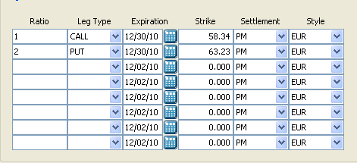

4.5 SAGUI
- The new Price Type (percentage) will be needed for Percentage Strike Prices. Product formatters need to support new Price Type. Price formatters need to support new Price Type.
- Price Entry Controls and Price Formatters need to support 4 digit strike prices. Report formatting needs to be updated.
- Product creation will be initiated from the SA GUI as part of the Block Trade Entry. The product info will be provided by the user in terms of the Underlying Class, Strike Price, Expiration Date, AM/PM settlement, and Expiration Style.
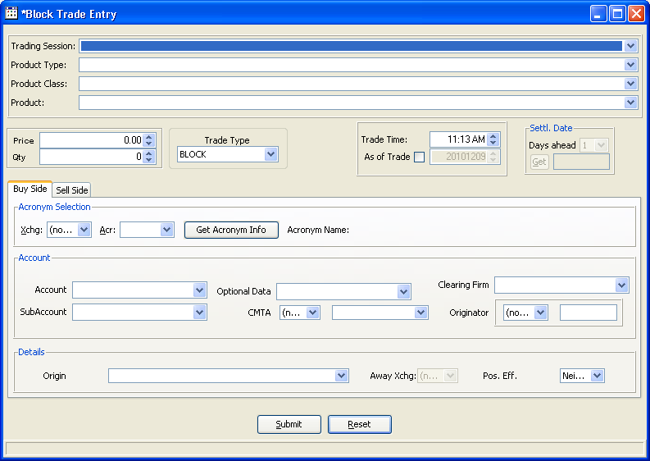

- The SA GUI Product Definition needs to support creation and editing of the FLEX Classes and Products (as a backdoor to fix problems).

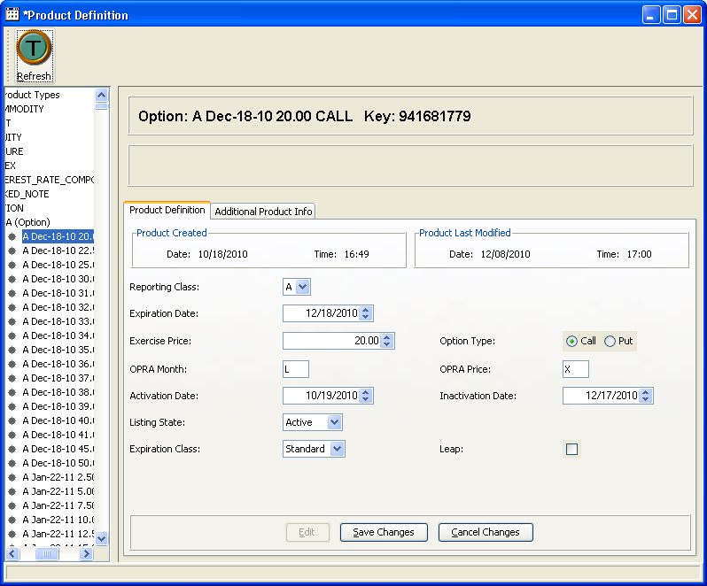

4.6 CTMr/i
- Small update on validation rules, table definitions for 4 decimal price strikes and percentage price type

4.7 CSM/BDX
- We may need changes for CSM of current market for 4 decimal price strikes and percentage price type.

4.8 XTP
- A small change is needed to to support data formats and data structure for 4 decimal price strikes and percentage price type
- Changes to support Product Class:
- Add a new column Expiration Style to GC_OWNER.PROD_CLASS_T table in CDB database
- Modify PROD_CLASS_P package to replicate Expiration Style column to CDB database
- Changes to support Product:
- Add a new column ORIG_EXPR_PRICE in GC_OWNER.PRODUCT_T table in CDB
- Modify PRODUCT_P package to replicate ORIG_EXPR_PRICE column to CDB database.
- Changes to support Four decimal strikes
- Regression test to Four decimal strikes code in Prod_desc table

4.9 CDB

- Support a new PRODUCT TYPE CODE =13 for CFLEX. Regression testing only
- Changes to support Product Class:
- Add a new column Exercise Style to GC_OWNER.PROD_CLASS_T table in CDB database
- Modify PROD_CLASS_P package to replicate Expiration Style column to CDB database
- Changes to support Product:
- Add a new column ORIG_EXPR_PRICE (may be Pricve_ind) in GC_OWNER.PRODUCT_T table in CDB
- Modify PRODUCT_P package to replicate ORIG_EXPR_PRICE column to CDB database.
- Changes to support Four decimal strikes
- Regression test to Four decimal strikes code in Prod_desc table

4.10 DWH/ARCHIVE
- Changes to support Product Class:
- Add a new column Expiration Style to SBT_JOBS.TEMP_PROD_CLASS_T and
- SBT_OWNER.PROD_CLASS_T in DWS and ARHCP databases.
- Modify SBT_JOBS.TEMP_PROD_CLASS_P and SBT_JOBS.PROD_CLASS_P packages to replicate Expiration Style column to DWS database.
- Changes to support Product
- Add a new column ORIG_EXPR_PRICE to SBT_JOBS.TEMP_PRODUCT_T and
- SBT_OWNER.PRODUCT_T in DWS and ARHCP databases.
- Modify SBT_JOBS.TEMP_PRODUCT_P and SBT_JOBS.PRODUCT_P packages to replicate ORIG_EXPR_PRICE column to DWS database.
- Changes to support FLEX_Class_Arch and FLEX_SERIES_ARCH:

- Create 2 new tables in DWS/ARCH to load DW_OWNER.FLEX_CLASS_ARCH and DW_OWNER.FLEX_SERIES_ARCH Series from SBT_OWNER schema. Create a new DWS load application supporting data de-normalization rules for these new tables.
- Create a new Archival Group FLEX_PRODUCT in ARCH_OWNER.ARCH_GROUP_CONFIG_T table in ARCHP database.
- Create configuration entries in ARCH_OWNER.ARCH_TABLE_CONFIG_T in ARCHP database to archive load DW_OWNER.FLEX_CLASS_ARCH and DW_OWNER.FLEX_SERIES_ARCH tables.
- Create a new archival job FLEX_PRODUCT to replicate data from DWS to ARCHP

  - Changes to support Four decimal strikes
    - Regression test to Four decimal strikes code in Prod_desc table
    - Bestex_load_pb.sql package uses under_sym_sess_asgn.min_price_incr_code
to find trading increment into table bstex_order_exec_hist.

CASE
WHEN event_type = FILL_ORDER
THEN
CASE
WHEN orders_rec.MIN_PRICE_INCR_CODE = 1 and TRADE_PRICE < 3.00
THEN 0.05
WHEN orders_rec.MIN_PRICE_INCR_CODE = 1 and TRADE_PRICE >= 3.00
THEN 0.1
WHEN orders_rec.MIN_PRICE_INCR_CODE = 2 and TRADE_PRICE < 3.00
THEN 0.01
WHEN orders_rec.MIN_PRICE_INCR_CODE = 2 and TRADE_PRICE >= 3.00
THEN 0.05
WHEN orders_rec.MIN_PRICE_INCR_CODE = 3
THEN 0.01
WHEN orders_rec.MIN_PRICE_INCR_CODE = 4
THEN 0.05
END
ELSE
NULL
END TRADING_INCREMENT,

4.11 Billing

  - Changes to support Four decimal strikes

    - BILLOUT – FIRM58 option product extract.
We would need to change definition on document for new codes for FIRM58

    - IBS – Regression testing of Hal rebate feeder to determine penny classes. min_price_incr_code in (‘2’, ‘3’), then they are penny classes and will be considered for the HAL step up rebate. Adding new codes, as long as they are not traded in penny increments, should not affect this load.

4.12 Market Replay

  - Change Product Display for new percentage strike (The class symbol will identify new exercise style and new settlement type, no support for these fields)
  - Change all screens to support display of percentage strike products
  - Verify 4 decimal place strike supported
  - Verify strategies for FLEX supported

5 New CFLEX Trading Session
Note: it is recommended to review the requirement document for this feature before reading through this section.

5.1 CMI/API
- Documentation update for new session.
- ACL changes to support new session.

5.2 IPD
- Need to support new session FLEX_MAIN.
- Need to support new sub-sessions FLEX_MAIN.index and FLEX_MAIN.equity

5.3 CBOEdirect Server

5.3.1 GC configuration to support new session/subsession, trade servers, ProductConfigurationGroup and routing group assignment.
- Configuration work is required, including xml, scripts, property files, trading properties, and setContext related files. See examples for other session configuration already done, such as C2_MAIN HowToExamples\C2_MAINConfigurations.doc
- Trading Property defaults for all existing properties need to be reviewed.HowToExamples\TradingProperties.xls

5.3.2 BC Configuration on CoppBridge, CFlexTradeServers, OHServerCFlex, and STSCFlexTradeServer.
- Configuration work is required, including xml, scripts, property files and setContext related files. See example for other session configuration we have already done.HowToExamples\C2_MAINConfigurations.doc
- Workflow for OHServerCFLEX should be similar to COF_MAIN session instead of C2 as we don’t need to support all the features such as Linkage and “reasonability edits” in C2 or W_MAIN.
- FLEX_MAIN will be an all-electronic session.
- A CFLEXTradeServer process will be configured similar to HybridTradeServer with support of multiple instances
- Some source files will need to be changed to support the new session name.

5.4 INFRA

Infra to configure new extend maps, channels to support the new processes and events.

5.5 SAGUI/GUI
Add new session to Session Selectors. Verify that a new session appears properly in all SAGUI windows.

5.6 FIX
FIX engines may have some configuration work to do

5.7 CTMr/i
Large amount of configuration is required.

5.8 XTP
Some configuration work to do.
XTP will publish underlying data only to FLEX TradeServer but not Mdx. Mdx will receive the CFLEX options data and trade server will receive the corresponding underlying.

5.9 CSM/BDX
Large amount of configuration is required.

5.10 CDB
- Make changes in CDB configure tables to replicate FLEX_MAIN data
- Create new control M jobs to support CDB replication process for FLEX_MAIN
- Create a new schema ss07_owner in CDB0P03 database
- Replicate 21 business tables from Flex BCD schema into ss07_owner schema on CDB

CBOEdirect Table Name | CDB Table Name
BULK_ACTION_DTL | BULK_ACTN_DTL
BULK_ACTION_REQUEST | BULK_ACTN_REQ
LINKAGEORDERRELATIONSHIP | LINKAGE_ORDER_RELAT
MKT_DATA_HIST | MKT_DATA_HIST
NBBOAGENTMAP | NBBO_AGENT_MAP
ORDER_EXCHANGE_MARKET | ORDER_EXCH_MKT
ORDER_MARKET_MONITOR | ORDER_MKT_MNTR
ORDERRELATIONSHIP | SBT_ORDER_RELAT
RFQ_HISTORY | RFQ_HIST
AUCTION_ORDER_RELAT | AUCTION_ORDER_RELAT
ORDERRELATIONSHIP | SBT_ORDER_RELAT
SBT_TRADEREPORT | SBT_TRADE_RPT
SBT_TRADEREPORTENTRY | SBT_TRADE_RPT_DTL
SBTAGENTASSIGNEDORDER | SBT_AGENT_ASGN_ORDER
SBTAUCTION | SBT_AUCT
SBTORDER | SBT_ORDER
SBTORDERHISTORY | SBT_ORDER_HIST
SBTORDERLEGDETAIL | SBT_ORDER_LEG_DTL
SBTQUOTEHISTORY | SBT_QUOTE_HIST
SBTTRADENOTIFICATION | SBT_TRADE_NOTIF
SBTTRADENOTIFICATIONCONTRA | SBT_TRADE_NOTIF_DTL

- CDB replication for FLEX_MAIN should use standard existing packages which are used for replication of other sessions.

- Configure EOD CDB processes for FLEX_MAIN session

- Support 2 sub sessions: FLEX_MAIN.index and FLEX_MAIN.equity

5.11 DWH/ARCHIVE
- Changed to DWS-REPL application:
  - Make changes in DWS configure tables to replicate FLEX_MAIN data from CDB
  - Create new control M jobs to support DWS LOAD process for FLEX_MAIN
  - Replicate 21 business tables from CDB ss07_owner schema into SBT_OWNER schema in DWS

DWS Table Name
FLEX_BULK_ACTN_DTL
FLEX_BULK_ACTN_REQ
FLEX_LINKAGE_ORDER_RELAT
FLEX_MKT_DATA_HIST
FLEX_NBBO_AGENT_MAP
FLEX_ORDER_EXCH_MKT
FLEX_ORDER_MKT_MNTR
FLEX_SBT_ORDER_RELAT
FLEX_RFQ_HIST
FLEX_AUCTION_ORDER_RELAT
FLEX_SBT_ORDER_RELAT
FLEX_SBT_TRADE_RPT
FLEX_SBT_TRADE_RPT_DTL
FLEX_SBT_AGENT_ASGN_ORDER
FLEX_SBT_AUCT
FLEX_SBT_ORDER
FLEX_SBT_ORDER_HIST
FLEX_SBT_ORDER_LEG_DTL
FLEX_SBT_QUOTE_HIST
FLEX_SBT_TRADE_NOTIF
FLEX_SBT_TRADE_NOTIF_DTL

  - Create new DWS packages

DWS Table Name
FLEX_BULK_ACTN_DTL_P
FLEX_BULK_ACTN_REQ_P
FLEX_LINKAGE_ORDER_RELAT_P
FLEX_MKT_DATA_HIST_P
FLEX_NBBO_AGENT_MAP_P
FLEX_ORDER_EXCH_MKT_P
FLEX_ORDER_MKT_MNTR_P
FLEX_SBT_ORDER_RELAT_P
FLEX_RFQ_HIST_P
FLEX_AUCTION_ORDER_RELAT_P
FLEX_SBT_ORDER_RELAT_P
FLEX_SBT_TRADE_RPT_P
FLEX_SBT_TRADE_RPT_DTL_P
FLEX_SBT_AGENT_ASGN_ORDER_P
FLEX_SBT_AUCT_P
FLEX_SBT_ORDER_P
FLEX_SBT_ORDER_HIST_P
FLEX_SBT_ORDER_LEG_DTL_P
FLEX_SBT_QUOTE_HIST_P
FLEX_SBT_TRADE_NOTIF_P
FLEX_SBT_TRADE_NOTIF_DTL_P

- Changes to Archival

- Create a new Archival Group CD_FLEX in ARCH_OWNER.ARCH_GROUP_CONFIG_T table in ARCHP database.
- Create configuration entries in ARCH_OWNER.ARCH_TABLE_CONFIG_T in ARCHP database to archive 21 SBT_OWNER FLEX tables
- Create new archival Control_M jobs to replicate data from DWS to ARCHP

- IPD _GLOB_LOAD application
- Regression test of Under_Sym_Sess_Asgn table load to accept data from FLEX_MAIN session.

5.12 Billing
- Changes to FIRM58 extract for C1 Billing

Integrate CFLEX trades into the existing Trade History record layout.
Support multiple FLEX trade data sources for FIRM58 extract application until class rollout to CFLEX 2.0 is completed.
Disable CFLEX 1.0 data source from FIRM58 extract after rollout is completed.

5.13 Market Replay
- Add new trading session to MR selection input screen (XML change)
- Add new Infra role for new trading session
- New JSP for selection screen because of no Post/station,
- Add new auction selection criteria on JSP, (add corresponding service, etc )

6 CFLEX Entitlements/Enablements
Please review the requirement document for this feature before reading through this section.

6.1 MPP/TPS
As a part of new CFLEX system CBOE Direct needs information about acronyms that are enabled for CFLEX from BOSS environment. Currently CFLEX related information is stored as approved products in BOSS. CFLEX_MBR_DAILY is the interface table which feeds the current CFLEX system to identify the acronyms that are CFLEX enabled. For the CFLEX 2.0 project, TPS needs to update the flex enablements in CBOEdirect, which are handled by assigned FLEX_MAIN session enablements to a CBOE acronym.

For CBOE Direct to identify the user acronyms that are enabled for CFLEX, TPS will keep track of session related information and update Global directly via BOGA (BackOffice Global Adapter). TPS will send the session enablement after the firm or broker has been defined in CBOEdirect. To capture, transmit and display session information in TPS a new data model subject area, TPS EXCH SESSION, including a new transmit queue table will be added.

Summary of Changes

- Following changes would be made in BOSS database for CFLEX enablement:
  - BOGA will be using CBOEDirect API to enable CFLEX session.
  - Due to the new subject area for session and DWS interest in storing CFLEX ennoblements, Membership Data Warehouse interface will be modified to send this information across.
  - New subject area TPS EXCH SESSION will be created along with a new transmit queue table to BOSS Database.
- The following systems do not need to change as part of this project:
- No change to current snapshots to CBOE Direct. CFLEX session enablement will be through TPS which will internally use BOGA (BackOffice Global Adapter) to update CBOE Direct global directly without using Membership Adapter.
- There is no change to the information sent to CTMR. This was reviewed and agreed on April 15, 2011.
Changes to Original Requirements
The original high-level design for CFLEX 2.0 stated that CFLEX enablements would be transmitted from TPS to CBOEdirect via the existing Membership Adapter/interface table snapshot. In that approach the adapter and interface tables would need to be modified to set the CFLEX session enablement based on a flex indicator on the interface. The design was changed because the Membership Adapter/interface table approach has been deprecated. It will be replaced in a project scheduled to complete in the fourth quarter of 2011.
Assumptions and Issues
Questions and Responses during various meetings

- Is DWS using CBOE_SESS, MBR_GROUP_SESS_AUTH, INDV_SESS_AUTH tables to retrieve information and what the impact would be if the new data model is used for storing session information?
Response from Tejas Shah:
CBOE_SESS – DWS CBOE_SESS_OVRD_TRADE_TIMES table has trigger which uses CBOE_SESS table references to SESS_NAME column.
MBR_GROUP_SESS_AUTH – DWS applications (FUTCFT, FUTONE, and FUTNFA) uses this table in conjunction with JADPM_PART_ASSOC_HIST using MBR_GROUP_EXCH_ACR.
INDV_SESS_AUTH – Only replicated to DWS but not used by any of DWS applications.

- CTMR Membership Related questions
Response form Jeff Schweitzer - April 15th 2011 meeting

How or for what CTMR uses Membership data?
CTMR uses Membership data to validate if the broker acronym and exchange combination is active or inactive.
Does CTMR currently use session related information from Membership? No.
How would CTMR recognize if a particular user is enabled for CFLEX?
CTMR does not care and clears all CFLEX trades from CBOE Direct.
Does CTMR need to validate against Membership Data for CFLEX enablement? No
Does DWS need to validate between the various systems for CFLEX enablement? No

C2 application
N/A

6.2 CBOEdirect Server

6.2.1 Support User Enablement update for CFLEX new enablement type
- TPS will update GlobalServer directly with user enablements (properties stored in the global table same as existing user enablements)
- Adding new user enablement type (IDL constants) for CFLEX related new operations such as new auction for FLEX, subscribeAllXXXXX types of operations only allowed for FLEX_MAIN session.
- New methods in the API when implemented in the CAS in various features will add checks on this new enablement type.
- New method to update User Enablement based on underlying symbol for a user and session.

6.3 CAS/FIX
- ACL updates.

6.4 SAGUI
- SA GUI User Maintenance window needs to add CFLEX enablement to the Enablement tab at the Acronym level. Enablement default (on/off) needs to be decided on.
- Need to define a default set of enablements for CFLEX user

6.5 CTMr/CTMi

6.5.1 CTMr
- To be updated to read the changes in brkr_sbt_auth table for eligibility to trade CFLEX

6.6 CDB
No changes

6.7 DWH/ARCHIVE
  - DWS – TPS interface
- Enhance DWS TPS tables MBR_GROUP_HIST, INDV_HIST, SEAT_ASGN_HIST to accept data for FLEX_MAIN
- Apply table changes to ARCHP database

6.8 Billing

  - BILLOUT application
- Change DWS extract to provide FLEX_MAIN TPS data to FIRM58.

6.9 Market Replay
- Update XML map to include Flex trading session to CBOE exchange acr.
( CBOE will still be User Firm Service exchange ACR for FLEX session )

6.10 Other Processes
- No Changes.

7 Initiating FLEX Auction
Please review the requirement document for this feature before reading through this section.

7.1 CMI/API
Please note in order to avoid changing all the related order interface methods, we will use extensions field for additional fields added for orders for CFLEX.

7.1.1 For CFLEX2.0, CMI will introduce a new version cmiV10.idl
Adding one interface FlexTradeService for all CFLEX related new methods through UserSessionManagerV10
interface FlexTradeService
{
// has all new methods for CFlex2.0 needed in cmi
}
interface UserSessionManagerV10 : cmiV9::UserSessionManagerV9
{
cmiV10::FlexTradeService getFlexTradeService()
raises(
exceptions::SystemException,
exceptions::CommunicationException,
exceptions::AuthorizationException,
exceptions::AuthenticationException,
exceptions::NotFoundException
);

};
interface UserAccessV10
{
UserSessionManager10 logon(
in cmiUser::UserLogonStruct logonStruct,
in cmiSession::LoginSessionType sessionType,
in cmiCallback::CMIUserSessionAdmin clientListener,
in boolean gmdTextMessaging )
raises(
exceptions::SystemException,
exceptions::CommunicationException,
exceptions::AuthorizationException,
exceptions::AuthenticationException,
exceptions::DataValidationException,
exceptions::NotFoundException
);

};

7.1.2 cmiConstants.idl
- Introduce new auction type for FLEX_AUCTION.
interface AuctionTypes
{
...
const cmiOrder::AuctionType FLEX_AUCTION = 9;
}
- Introduce new MarketDataHistoryEntryType for Auction
interface MarketDataHistoryEntryTypes

{
...
const cmiMarketData::MarketDataHistoryEntryType AUCTION_ENTRY = 8;
// might change if other projects add values prior to CFLEX project.
}

7.1.3 cmiOrder.idl
- CDServer will use existing AuctionStruct extensions field to include T1 timer and hedge instructions
- CDServer will use AuctionStruct extensions field to include expired time when auction expired for Auction Expired event published by server.
- New Struct for Order Book Hedge instructions
struct OrderBookHedgeInstructionStruct
{
cmiProduct::ProductKeysStruct productKeys;
cmiSession::TradingSessionName sessionName;
String hedgeInstructions;
String extensions;
cmiUtil::PriceStruct price;
cmiUtil::Side side;
int volume;
cmiOrder::OriginType orderOriginType;
};
typedef sequence < OrderBookHedgeInstructionStruct > OrderBookHedgeInstructionStruct;

7.1.4 cmiErrorCodes.idl
- New Error Code for Auction in Progress in order to reject any auction requests or order entries other than responses (FLEX or AIM auctions) when auction currently on the product is in progress.
- If product is not allowed to start auction due to product state or allowed time range for product opening rotation timer set on trading session, use existing error code such as invalid state, etc.

7.1.5 cmiV10.idl - FlexTradeService Interface
- SubscribeAuctionForAllClasses(userId, sessionName) For FLEX_MAIN only.
- SubscribeTickerForAllClasses(userId, sessionName) For FLEX_MAIN only
- SubscribeRecapForAllClasses(userId, sessionName) For FLEX_MAIN only
- SubscribeCurrentMarketForAllClasses(userId, sessionName) For FLEX_MAIN only
- OrderBookHedgeInstructionStructSequence getOrderBookHedgeInstructions(SessionName, productKey, price);
- requestForAuction(userId, newProductDefinitionStructToSupportBothSimpleAndComplex, T1Timer), size and side in the product definition is optional.
- withdrawFromAuction(userId, productKey, auctioned) to support Initiator’s request to cancel his interest in the auction during T2.
- AuctionStruct[] getAllAuctions(StartTime, EndTime, classKeys, sessionName, auctionState) – to be added to OrderQuery interface. Only allowed on FLEX_MAIN session.
  - classKeys[] = 0 will return auctions for all classes in the session.
  - auctionState = 0 will return all auctions including the ones expired.
- AuctionStruct[] getAuctionById(auctionId, SessionName) – to be added to OrderQuery interface. Only allowed on FLEX_MAIN session.
- Order for auction execution by initiatior will use existing acceptOrder method.

7.1.6 cmiCallback10.idl
- acceptAuctionExpired to notify users that auction has ended (auctioned, productKey, reason and time ended).

7.2 CBOEdirect Server

7.2.1 IDL changes for OrderHandlingService, OrderRoutingDestination
- Support new methods for API cmiV10.idl changes above.

7.2.1 IDL changes for OrderBookService
- Support new methods for API cmiV10.idl getOrderBookHedgeInstructions changes above to query order book hedge instruction. Only supported for FLEX_MAIN.

7.2.3 IDL new interface for AuctionService
- AuctionStruct[] getAllAuctions(StartTime, EndTime, classKeys, sessionName, auctionState) – to be added to OrderQuery interface. Only allowed on FLEX_MAIN session.
  - classKeys[] = 0 will return auctions for all classes in the session.
  - auctionState = 0 will return all auctions including the ones expired.
- AuctionStruct[] getAuctionById(auctionId, SessionName) – to be added to OrderQuery interface. Only allowed on FLEX_MAIN session.
- requestForAuction(userId, newProductDefinitionStructToSupportBothSimpleAndComplex, T1Timer), size and side in the product definition is optional.
- withdrawFromAuction(userId, productKey, auctioned) to support Initiator’s request to cancel his interest in the auction during T2.

7.2.4 GLOBAL Server See ProductDefintion Feature above
- Global Server ProductMaintenanceService will be called by the trade engine to create CFLEX simple or complex product.

7.2.5 GLOBAL Server TradingProperty related changes
- New trading property to support min and max range for Flex Auction Timer 1 (T1) specified by the initiator.HowToExamples\Trading Properties Version 2.0 New Development Guide.doc

7.2.6 Business Cluster (BC) changes - OHS
- Route the order to Trade Server ORD service using workflow already has defined for FLEX_MAIN session.

7.2.7 Business Cluster (BC) changes – OrderRoutingDestination
- ORD impl needs to support new methods.
- OrderValidationCFlexStrategy will need to be created.
  - Validate the price type of the responses and initiator’s order are the same type as the product definition. For example: If Product is defined as Percentage, the price of the order has to be percentage.
- CancelReplace not supported.
- acceptCancel of an order need to be fully cancelled order, no partial cancel on responses.
- acceptOrder should replace the existing auction response order.

7.2.8 Business Cluster (BC) changes – Auction Related Services
- Auction table changes for new columns
  - T1 timer;
  - initiator userId;
  - hedgeExecutionInstruction;
  - hedge_reference_type (hedge 1 or reference 2);
  - hedge_reference_price (string);
  - prefacilitationprice;
  - delta_value;
  - allow auctioned order id to be nullable;
- AuctionTerminateReasons adding a new reason for initiator requested cancel (RFA_CANCELLED). Might need to expose the reasons thru CMI/API constants. Right now it is in a JAVA file. We will be using extensions in AuctionStruct if the reason needs to be given to the user on query or event dissemination.
- AuctionImpl to support related column changes. Order auctioned could be null as there will be no auctioned order for FLEX_AUCTION.
- AuctionLocalImpl to book response (for FLEX auction ONLY) into REAL order book instead AUCTIONBOOK in order to make responses part of the book display and current market.
- AuctionServiceHomeImpl and AuctionHomeHomeImpl to return auctions queried by cmi based on input parameters on classKeys or auctionId. Hedge information and T1 timer will be in the extensions field.
- AuctionServiceImpl implements the new AuctionService IDL interface.
  - Auction response from initiator should be considered request for auction execution to cause trades and termination of the auction.
  - Validate the time is within the system product opening rotation timer and close timer allowed time for request for Flex Auction.
  - Validate product state for request.
    - For existing product, product state has to be ROTATION, OPEN, FAST.
  - Query/create flex product(s) as requested. For strategy definition, it is possible one of all legs will need to be created as well besides creating a new strategy.

- Common facility class to map extensions field using name/value pair. Can be shared with GUI.
- AuctionProcessorFlexAuctionImpl, a new impl for FLEX auction which will handle
  - execution of an auction (trade initiator’s order with responses , responses trade with each other, cancel remaining, etc), then open product.
  - Update auction to set the auctioned order when initiator enters the order.
  - publishing of new auction event to include the new T1 timer and auction expiration event. T1 timer and expiration time will be part of extensions field.
  - processCancel of auction response order.

- AuctionProcessorSpreadFlexAuctionImpl, a new impl for FLEX auction which will handle
execution of an SPREAD FLEX auction (trade initiator’s order with responses , responses trade with each other,
- AuctionValidationFlexAuctionImpl, a new impl for FLEX auction to
  - Validate for a Request for Execution (RFE) that the userId is the initiator of the auction.
  - Validate if the auction response for the user already has response on the same side, cancel the old response and reprocess the new one. The user will lose priority with the replacement response order.
  - Check during T1, initiator cannot withdraw interest from the auction (WFA).

7.2.9 Business Cluster (BC) changes – AuctionConsumer
- Support subscription of auctions on all classes.
- Implement new method for notification of auction expiration.

7.2.10 Business Cluster (BC) changes – Broker Service
- Broker Service, Broker, BrokerProcessor interfaces and new impls to support new interface methods passed by the new API methods specified by CMI.
- New Broker commands for Request for Auction (RFA), Withdraw Interest for Auction (WFA), and Request for Auction Execution (RFE), etc.
- OPEN product when auction is started.
- During HALT product state processing to not trade out the responses (different than other auctions)
- During CLOSED product state update, will expire auctions and trade what can be traded (same as other auctions)

7.2.11 Business Cluster (BC) changes – MarketDataService and MarketDataBuffer
- A new event type for market data history for flex auction started.
- New database field auction_id to be added to mkt_data_hist;
- Market Data Service needs to capture market data indicating product has been put on FLEX Auction. Make sure it is support all types of auction, not just FLEX auction. AuctionId will be persisted.
- Market Data Buffer and Codec to support new price type for percentage.
- Market Data Service query results will need to include auctionId in extensions field if is Auction history entry.

7.2.12 Business Cluster (BC) changes – OrderBookServices
- Implement idl change to support query for order book hedge instruction on a given product and price point.

7.3 CAS/SACAS/MDCAS/FIX
- Implement new methods in CMI/API. All subscription for all classes’ methods will only support when sessionName is FLEX_MAIN. We are not supporting subscription for all classes on other sessions.
- New Auction Query implementations. Proxies will need to be coded to handle federated call results.

7.4 GUI
- Implement new APIs described above.
- New Auction display screen – display all current auctions/responses. Process Auction events and update the screen:

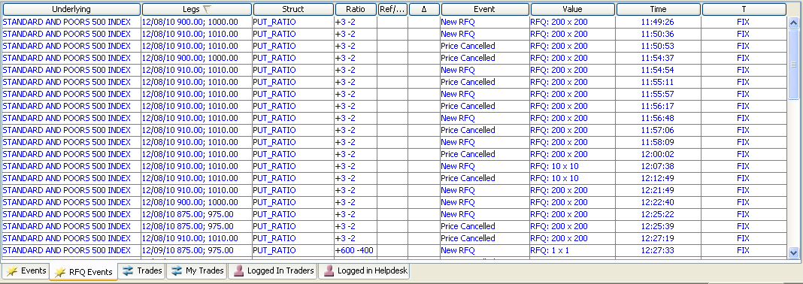

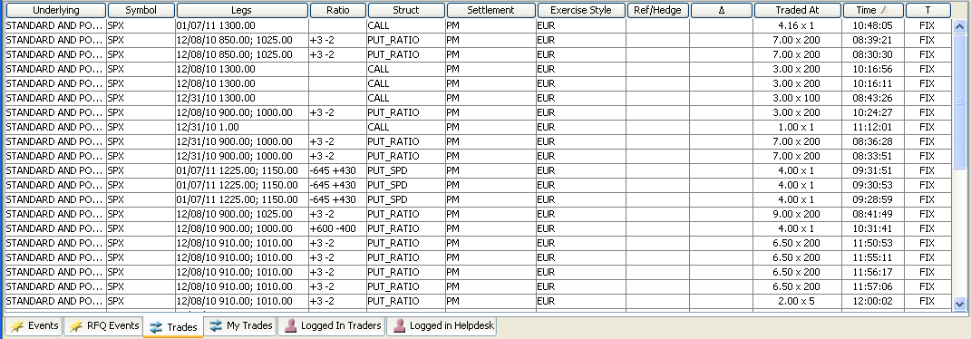

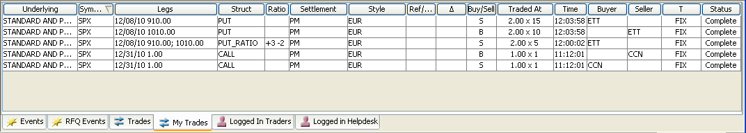

- New RFA screen to submit a new request for Auction. The RFA screen includes product definition details:

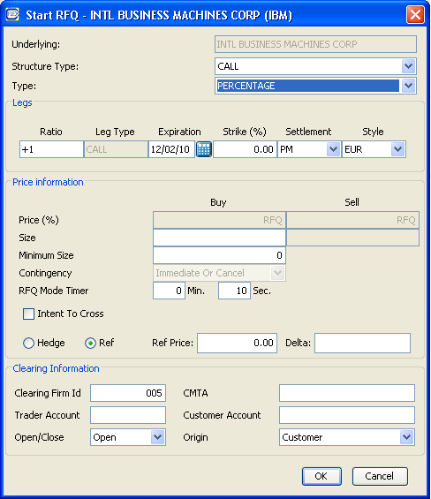

- FLEX_AUCTION subscription
- Auction Response
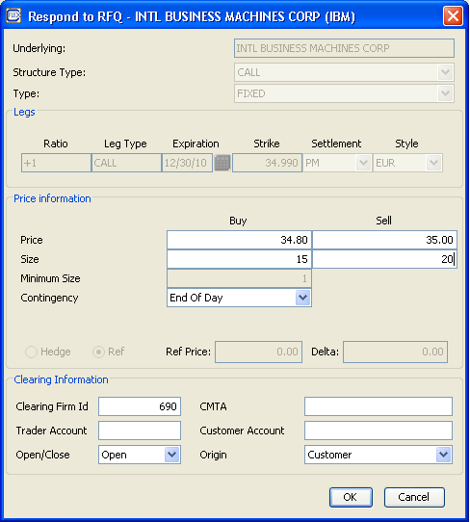

- New Screen to request Auction Execution:

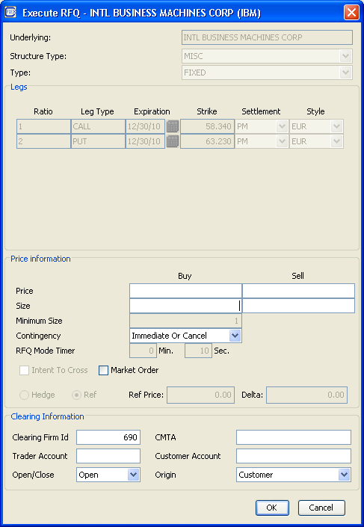

- Auction Book display.

7.5 SAGUI
- Support new trading property for min-max T1 timer range.
- Auction Display and Auction book display screens should be available for SA GUI users.

7.6 CSM/BDX
- Translate to legacy Book Depth feed (similar to ONE_MAIN) to clients for dynamic book depth support to GUI/CAS
- Publish FLEX on separate ports than W_MAIN.

7.7 CDB
- Changes to support SBT Auction
1. Add new columns to SBT_Auct table in CDB for all SSXX_OWNER schemas:
Raw_Expr_Price
Expr_Price_Ind Valid value “P”
T1 time
User ID
Hedge Execution Instructions
Hedge_Reference_type
Hedge Reference Price
Pre-facilitation Hedge Price
Delta value

- Allow null value on order ID.
- Add a new value for ACTN_TYPE: FLEX_AUCTION = 9
- Modify SBT_AUCT_P package to replicate new columns .
- Modify EOD_PROCESS_BC.SBT_AUCT procedure to include new columns into Missing logic code
- Regression testing Count Validation Logic

- Changes to support MKT_DATA_HIST

- Add a new event type AUCTION_ENTRY = 8
- Add new columns in CDB for all SSXX_OWNER schemas:
Auct_ID
- Modify MKT_DATA_HIST_P package to replicate a new column
- Modify EOD_PROCESS_BC.MKT_DATA_HIST procedure to include new columns into Missing logic code
- Regression testing Count Validation Logic

7.8 DWH/ARCHIVE
- Changes to support SBT Auction in DWS
- Add new columns to SBT_JOBS.TEMP_SBT_Auct table in DWS.

RAW_EXPR_PRICE
EXPR_PRICE_IND
T1 time
USER ID
Hedge Execution Instructions
Hedge_Reference_type
Hedge-Reference Price
Pre-facilitation Hedge Price
Delta value
- Add new columns to SBT_Auct, FLEX_AUCTION = 9 into TEMP and PERM tables

RAW_EXPR_PRICE
EXPR_PRICE_IND Valid Value “P”
T1 time
USER ID
Hedge Execution Instructions
Hedge_Reference_type
Hedge-Reference Price
Pre-facilitation Hedge Price
Delta value

- Add new columns to SBT_AUCT, FUT_SBT_AUCT, ONE_SBT_AUCT , STK_SBT_AUCT , OPT_FUT_SBT_AUCT, FLEX_SBT_AUCT tables in DWS and ARCHP

Raw_Expr_Price
Expr_Price_Ind Valid value “P”
T1 time
User ID
Hedge Execution Instructions
Hedge_Reference_type
Hedge-Reference Price
Pre-facilitation Hedge Price
Delta value
- Allow null value on order ID for SBT_AUCTION.
- Modify TEMP_SBT_AUCT_P, SBT_AUCT_P, FUT_SBT_AUCT_P, ONE_SBT_AUCT_P, STK_SBT_AUCT, OPT_FUT_SBT_AUCT_P packages to replicate new columns .
- Add new columns to SBT_AUCT_EXCPT_LOG table in DWS/ARCH
- Regression test DWS_REPL_P.EXCPT_TB_LOAD procedure
- Regression testing Archival jobs

- Changes to support MKT_DATA_HIST in DWS /ARCHP

- Replicate new event types AUCTION_ENTRY = 8
- Add new columns to SBT_JOBS.TEMP_OPT_MKT_DATA_HIST and
SBT_JOBS.TEMP_MKT_DATA_HIST table in DWS.

Auct_ID

- Add new columns to SBT_MKT_DATA_HIST, FUT_ MKT_DATA_HIST, ONE_ MKT_DATA_HIST, STK_ MKT_DATA_HIST, OPT_FUT_ MKT_DATA_HIST, FLEX_ MKT_DATA_HIST tables in DWS and ARCHP

Auct_ID

- Modify TEMP_ MKT_DATA_HIST _P, MKT_DATA_HIST _P, FUT_ MKT_DATA_HIST _P, ONE_ MKT_DATA_HIST _P, STK_ MKT_DATA_HIST, OPT_FUT_ MKT_DATA_HIST _P, FLEX_ MKT_DATA_HIST _P packages to replicate new columns .
- Add new columns to MKT_DATA_HIST_EXCPT_LOG table in DWS/ARCH

- Regression test DWS_REPL_P.EXCPT_TB_LOAD procedure

- Regression testing Archival jobs

7.9 Market Replay
- Create new selection criteria screen (new Action class, Form, JSP, Model)
- Create new screen to display RFQ (FLEX Auction) list,
- Create new screen to display auction detail (events) with responders, auction initiator’s order, and trades. Add additional raw_expr_price, expr_price_ind, T1 time, user ID, instructions per SBT_AUCT additional column specifications.
- Create new RFQ (auction) service/domain/IDL – includes changes to auction table

7.10 Other Processes
No changes

8 Other FLEX Auction
Please review the requirement document for this feature before reading through this section.

This is the same as Initiating Flex Auction except that there might be orders in the book and product already existed.

9 AIM Auction and AIM AON Auction
Please review the requirement document for this feature before reading through this section.

9.1 CMI/API

9.1.1 cmiV10.idl
Please note all order entries should be using the old OrderEntryStruct using extensions for hedge information as described in OrderEntry feature below.
- acceptInternalizationOrdersForProduct(ProductDefinition, PrimaryOrderEntryV2Struct, MatchOrderV2Struct).

9.2 CBOEdirect Server

9.2.1 IDL changes for OrderHandlingService, OrderRoutingDestination
- Support new methods for API cmi.idl changes above.
  - acceptInternalizationOrdersForProduct

9.2.2 GLOBAL Server See ProductDefintion Feature above
- Global Server ProductMaintenanceService will be called by the trade engine to create CFLEX simple or complex product requested for the AIM auction.

9.2.3 Business Cluster (BC) changes - OHS
- Validate the time is within the system trading property allowed time for request for AIM Auction.
- Validate product state for request.
  - For existing product, product state has to be OPEN, FAST .
- Query/create flex product(s) as requested. For strategy definition, it is possible one of all legs will need to be created as well besides creating a new strategy.
- OrderValidationCFlexStrategy to validate order prices for primary is LMT, response orders are the same price type as the product definition (fixed or percentage respectively).
- Route the paired orders to Trade Server ORD service. Might need to make sure the workflow supports Aim paired order.
- Only paired orders are allowed. Separate orders coming to system to AIM for existing product will be rejected.

9.2.4 Business Cluster (BC) changes - ORD
- OrderRoutingDestination(ORD) impl needs to implement new methods.
- CancelReplace not supported.
- acceptCancel of an order need to be fully cancelled order, no partial cancel on responses.
- AcceptOrder on an auction response is to cancel existing if any for the user on the same side and replace with new response.

9.2.5 Business Cluster (BC) changes – AuctionService
- AuctionProcessorCFlexAIMAuctionImpl, a new impl for CFlex AIM auction
  - Nothing prematurely ends the auction (unless is HALT/CLOSE)
- AuctionValidationCFlexAIMAuctionImpl, a new impl for CFlex AIM auction to
  - Start AIM even if is Cust-Cust orders.
  - New Auction Starting Price calculation based on rules for CFlex AIM. For example, no starting price boundary checks even if the match order price is outside of the book price range unless it is a customer order in the book.
  - Make sure not to book the auction responses in the regular book just like the current AIM.
  - There might be no market on either side, AIM should start based on match price or LMT price of the primary match order is MKT price.
  - Other checks should be almost the same as existing AIM.
- AuctionProcessorCFlexSpreadAIMAuctionImpl, a new impl to support CFlex Spread AIM auction processing.
- AuctionValidationCFlexAIMSpreadAuctionImpl, a new impl extending existing AuctionValidationStrategySpreadHybridImpl for CFlex AIM auction to support SPREAD AIM auction for CFlex with different behaviors than default.

9.2.6 Business Cluster (BC) changes – BrokerService
- Broker Service, Broker, BrokerProcessor interfaces and impls to support new interface methods passed by the new API methods specified by CMI for CFlex AIM acceptInternalizationOrdersForProduct.
- New Broker commands for new CFlex AIM method.
- Reject any auction request or non response order for the product if auction is on going. Need to be done within the command to make sure it is within the Class level lock.

9.3 CAS/SACAS/FIX
- Implement new methods in CMI/API.

9.4 GUI
- New panel for paired AIM orders.
- Implement new API.

9.5 CDB
Already covered in Initiating FLEX Auction feature

9.6 DWH
Already covered in Initiating FLEX Auction feature

9.7 Market Replay
Already covered in Initiating FLEX Auction feature

9.8 Other Processes
No changes

10 Order Entry (none auction related)
Please review the requirement document for this feature before reading through this section.

10.1 CMI/API
cmiOrder.idl existing order entry struct extensions will contain new fields for CFlex Orders
This is avoid duplicate all the order related structs and interface methods.

10.2 CBOEdirect Server

10.2.1 IDL changes for OrderHandlingService, OrderRoutingDestination
- GLOBAL Server See ProductDefintion Feature above
- Global Server ProductMaintenanceService will be called by the trade engine to create CFLEX simple or complex product requested for the AIM auction.

10.2.2 Business Cluster (BC) changes - OHS
- SQL updates for new sbt_order table columns. See requirements for additional fields.
  - hedgeExecutionInstruction;
  - hedge_reference_type (hedge 1 or reference 2);
  - hedge_reference_price (string);
  - prefacilitationprice;
  - delta_value;
- Although we use the extensions field in order struct to capture addional fields, we will have separate fields in order table.
- Create product as needed.
- Price for percentage will need to be part of the price when converting from price struct.
- OrderValidationCFlexStrategy to validate order on product, product state, price, contingency, origin, types of order, price type and heged execution price (required for non auction responses on percentage price orders) … etc. See requirement document.
- OrderHome and Order Impls to add changes for new fields added.
- Utility class for extensions fields mapping.
- Route the order to Trade Server ORD service.

10.2.3 Business Cluster (BC) changes - ORD
- OrderRoutingDestination(ORD) impl needs to implement new methods.
- OrderValidationCFlexStrategy to validate trade engine specific rules.
- OrderHome and Order Impls to add changes for new fields added and conversion to/from extensions field in order struct.
- Price for percentage will need to be part of the price when converting from price struct.
- Cancel/replace is not supported. Exception will be thrown.

10.2.4 Business Cluster (BC) changes - OrderBook
- Price for percentage is part of price when converting from price struct in the order struct. Conversion from PriceSQL to price will need to take into consideration of %.
- PercentagePriceImpl introduced for percentage price object.

10.2.5 Business Cluster (BC) changes – BrokerService
- Broker Service, Broker, BrokerProcessor interfaces and impls to support new interface methods passed by the new API methods specified by CMI/API for order entry.
- Will not book percentage priced orders. So these orders will be cancelled after processing(cannot be traded)

10.3 CAS/SACAS/FIX
- none

10.4 GUI
- New Order Entry panel. The product has to exist and be in the Open state. IOC and Auction responses are the only contingencies supported.

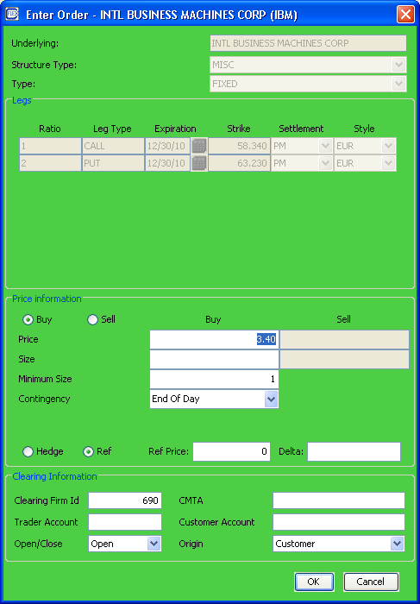

- New Cancel Order Panel. CancelRe is not supported.
- Implement new API.
- Order Status Screen.

10.5 SAGUI
- SA GUI Order Status and Order Cancel functionality.

10.6 CDB
- Changes to support SBT ORDER
- Add new columns to SBT_ORDER table in CDB for all SSXX_OWNER schemas:
  - Hedge Reference Indicator (1 for Hedge, 2 for Reference)
  - Hedge Reference Price
  - Pre-facilitation Hedge (If Pre-facilitation Hedge Indicator is chosen)
  - Delta value

- Modify SBT_ORDER_P package to replicate new columns.
- Modify EOD_PROCESS_BC.SBT_ORDER procedure to include new columns into Missing logic code.
- Regression testing Count Validation logic.

10.7 DWH/ARCHIVE
- Changes to support SBT ORDER in DWS
- Add new columns to SBT_JOBS.TEMP_SBT_ORDER table in DWS.

  - Hedge-Reference Indicator
  - Hedge-Reference Price
  - Pre-facilitation Hedge Price
  - Delta value

- Add new columns to SBT_ORDER, FUT_SBT_ ORDER, ONE_SBT_ ORDER, STK_SBT_ ORDER, OPT_FUT_ ORDER, FLEX_SBT_ORDER tables in DWS and ARCHP
  - Hedge-Reference Indicator
  - Hedge-Reference Price
  - Pre-facilitation Hedge Price
  - Delta value

- Modify TEMP_SBT_ ORDER _P, SBT_ ORDER _P, FUT_SBT_ ORDER _P, ONE_SBT_ ORDER _P, STK_SBT_ ORDER, OPT_FUT_SBT_ ORDER _P, FLEX_SBT_ORDER _P packages to replicate new columns
- Add new columns to SBT_ORDER_EXCPT_LOG table in DWS/ARCH
- Regression test DWS_REPL_P.EXCPT_TB_LOAD procedure

10.8 Billing
No changes

10.9 Market Replay
- Revise input selection criteria for orders to remove unnecessary criteria (e.g. subset of contingency codes, order origin, etc)
- Change Order list and Order Detail screens to include new order columns ( hedge Ind, Hedge Price, Ref Ind, Ref Price, Pre-fac Hedge Ind, Pre-Fac Hedge, Delta value). Change displays to show percentage premium price
- Add Hyperlink to Order detail if order related to auction (RFQ)
- Add new filter to input selection criteria to select orders with percentage products

10.10 Other Processes
No changes

11 Allocation for Trades
Please review the requirement document for this feature before reading through this section.

11.1 CBOEdirect Server
CBOEdirect has capabilities to configure different allocation strategies for different types of trade using Allocation Strategies trading properties. This should have been setup during the configuration for FLEX_MAIN. For FLEX Auction, need to define a new constant, see below.

All other changes to support CFlex are done in the Business Cluster. Slight difference on allocation for CFLEX auctions (FLEX or AIM).

AllocationStrategies are loaded when OrderBooks are created. See AllocationStrategyFactoryImpl.

11.1.1 Constants.idl adding new AllocationTradeType for FLEX Auction Allocation
FLEX_AUCTION_TRADE = 13;

11.1.2 Trade Service:
The following rules apply to all allocations, not just regular.
- FLEX Strategies cannot be traded with legs!! Only Strategy-Strategy trade is supported.
- Buy Write execution will print the stock leg in CBSX but will not check NBBO at CBSX. Buy Write prices on the flex option legs need to be defined later, but stock leg will have a price.
- Flex Option legs will not be priced during trade execution. These leg prices will be defined as in Pending Strategy Leg Price processing
- Flex trades cannot be reinstated. Trade Report reinstate flag will be set to false during trade creation.

11.1.3 Regular Order Allocation:
Regular Order allocation uses the trading property AllocationStrategies (Customer, PriceTime) to be allocated using AllocationStrategyImpl.

11.1.4 FLEX Auction - AuctionProcessorFlexAuctionImpl processAuctionExpire:
- Auction Initiator order if any takes all the quantity that is available. Trade Allocation is based on Customer then Price Time.
- Remaining responses can trade if crosses. Take one side then cross with the other side based on the same Customer the Price Time allocation already existed currently. See AllocationStrategyImpl.
- Product state goes to open.
- Publish Auction Expired with specific reason.

11.1.5 FLEX Auction - TradeService
- Additional logic and methods for processing FLEX trades.

11.1.6 AIM Auction - AuctionProcessorCFlexAIMAuctionImpl processAuctionExpire:
- Trade Allocation is: Customer, InternalGuaranteedFixedPercentage,PriceTime. See existing AIM and corresponding allocation strategies for auction type:AIM.

11.2 SAGUI
Support the new AllocationTradeType for FLEX_AUCTION to display AllocationStrategies trading property.

11.3 Other Processes
- No Changes.

12 Pending Trade – Fixed Strategy Trade
Please review the requirement document for this feature before reading through this section.

12.1 CMI/API

12.1.1 cmiConstants.idl new ReportType for Fill Report
- PENDING_LEG_PRICE
- PENDING_PRICE
- REVIEW_PRICE
- PENDING_PRICE_ON_HOLD
- PRICE_APPROVED

12.1.2 cmiTrade.idl new Struct for trade summary report to get trades
struct UserRelatedTradeReportStruct {
ExternalTradeReportStructSequence relatedTradeReports;
long parentReportIndex;
short status;
};

typedef sequence <UserRelatedTradeReportStruct> RelatedTradeReportStructSequence;

struct UserTradeReportSummaryStruct {
cmiUtil::CboeIdStruct tradeId;
cmiProduct::ProductKey productKey;
cmiSession::TradingSessionName session;
cmiUtil::DateTimeStruct timeTraded;
boolean active;
short status;
};

typedef sequence <UserTradeReportSummaryStruct> TradeReportSummaryStructSequence;

struct UserRelatedTradeReportSummaryStruct {
UserTradeReportSummaryStructSequence relatedTradeReports;
long parentReportIndex;
sequence<long> extraSearchReportIndexes;
};

12.1.3 cmiV10.idl to support query and accepting prices for pending trades
- acceptLegPricesForTrade(UserId, LegPricesAndPackagePrice, tradeId, pKey)
- UserSummaryTradeReportStructSequence getUserTradeReportSummaryByTime (DateTimeStruct starttime,, DateTimeStruct endtime, userId, sessionName, short status
- UserRelatedTradeReportStructSequence getUserRelatedTradeReport(userId, tradeId);

12.2 CBOEdirect Server
For Strategy Trade, even if it is fixed price trade, there is only package price initially. Leg prices will need to be updated by the initiator/AIM primary order userId/Maker side of the trade. Help Desk always has permission to update these prices.

12.2.1 IDL changes to support query and update trade prices/status (TradeMaintenanceService and TradeQueryService).
- Methods added for cmi need to be supported.
- updatePendingTradeStatus(userId, classKey, tradeId, status) to be added to TradeMaintenaceService
- Adding new struct RelatedTradeReportSummaryStructV2 to include status on top of RelatedTradeReportSummaryStruct.
- RelatedTradeReportSummaryStructV2Sequence getTradeReportSummaryV2ByTime(DateTimeStruct startTime, DateTimeStruct endTime, String sessionName, ClassKeysSequence classKeys, short status) // gui requested to be able to query trades based on status, or all status(0), or all classes(0) to be added to TradeQueryService
- new constants for trade status
  - PENDING_LEG_PRICE
  - PENDING_PRICE
  - REVIEW_PRICE
  - REVIEW_PRODUCT
  - ON_HOLD
  - PRICE_APPROVED
  - BUST

12.2.2 GLOBAL changes - TradingProperty
- TimerForPendingPriceReview

12.2.3 OHS changes – OrderHistory
- OrderHistory new entry types for each trade price update.
- OrderHistoryHomeImpl and impl for updates.

12.2.4 OHS changes – OrderHandlingService
- Support CMI/API method.
- Validation on prices and user.
- Send to Trade engine ORD service.

12.2.5 BC changes – TradeMaintenanceService
- Adding new column state in sbt_tradereport table.
- TradeReport, TradeReportEntry related Homes and Impls:
  - support additional field on pending price state and updates.
  - Trades without need of pending prices and trades for other trading sessions will be marked as approved by default.
  - NO last sale will be published for any trade price updates. Only during initial trade, we will publish it out.
- TradingClassPendingTradeCommand.java – will use class level lock and command instead of synchronize on trade or order as order sequence number will be updated during pending trade processing when publish fill reports.
- TradeServiceImpl
  - create pending trade command and use class level lock to process command. See above TradingClassPendingTradeCommand.
  - support update of pending prices requested by the user.
  - support query of trades that need pending price updates.
  - publishing of updated fill reports thru order that participated in the trade.
  - Not to publish trade report to CTMr until trade is marked as approved. This includes the changes for trades without any pending trade resolution such as fixed price trades.

- TradeValidationStrategyCFlex, a new impl for trade validations. Need to make sure only the initiator of FLEX_AUCTION, or Primary order of AIM auction, or MAKER of the trade is updating the trade price during pending trade price state. However, Help Desk users can always update the prices and the state of the trade.

12.2.6 BC changes – TradeQueryService
- Support new IDL methods to include status in the query result.

12.2.7 BC changes – OrderRoutingDesitination
- OrderRoutingDestination(ORD) impl needs to implement new methods and send to trade service.
- OrderValidationCFlexStrategy to validate trade engine specific rules.
- OrderHome and Order Impls to add changes for republishing fill reports with update status and price based on a trade report.

12.3 SAGUI
- Support the new AllocationTradeType to display AllocationStrategies trading property.
- Trading property, leg pricing overrides, pending trade query (class / federated), including subscriptions. All API changes exposed to SA, plus 'hold' functionality.

12.4 GUI
- Implement the trade reporting API.
- Get pending trades by class / user. Notification required to know if the user is the 'price specifier'.
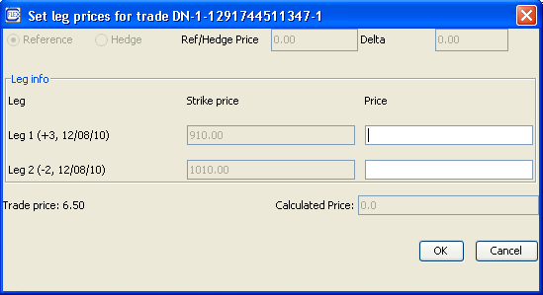

12.5 SACAS
API changes to be implemented, as described for sagui. Support subscribing for ticker/recap by session (not just by class)

12.6 CAS
API changes to be implemented, as described for gui. Also support subscribe for ticker/recap by session (not just by class)

12.7 FIX
Large changes required for FIX API to support the leg reporting / notification API.

12.8 CDB
Covered in Pending Trade – Percentage Simple Order Trade.

12.9 DWH
Covered in Pending Trade – Percentage Simple Order Trade.

12.10 Market Replay
- Change trade and trade detail screens to display trade status (e.g. pending trades) Also include raw_trade_price, Trade_price_ind columns
- Add new filter to input selection criteria for current trade status ( specify specific status)
- Add new filter to input selection criteria for historical trade status (specify specific status)
- Add new order history event type descriptions to support complex order leg price updates.

12.11 Other Processes
No changes

13 Pending Trade – Percentage Simple Order Trade
Please review the requirement document for this feature before reading through this section.

13.1 CMI/API

13.1.1 cmiV10.idl to support accepting prices for pending trade
- acceptPriceForTrade(OrderIdStruct, UnderlyingPrice, tradeId, pKey)
- Trade getPendingPriceTrades(userId, sessionName) Same as Fixed Strategy Leg Trade

13.2 CBOEdirect Server
Pending prices will need to be updated by the initiator/AIM primary order userId/Maker side of the trade. Help Desk users can always update the prices.

Most changes are captured within feature: Pending Trade – Fixed Strategy Trade. Changes here are only the different steps required to resolve strike price, premium price and product creation on new strike price.

13.2.1 IDL Changes to support product resolution and CMI/API new methods
- ProductMaintenanceService.idl - IDL interface method to support creation of product using underlying price to calculate the strike price.
  - createProductFromPercentagePriceProduct(currentPercentageProductKeysStruct, underlyingPriceForCalculation)
- ProductQueryService.idl - IDL interface method to query of related parent percentage product for given product derived during post trade completion processing.
  - getOriginatedProduct(cProductKeysStruct). Not found exception will be thrown if not found.

- OrderRoutingService.idl, TradeMaintenanceService.idl, OrderHandlingService.idl – to support new CMI methods above, userId is required for server interface, but not in CMI.

13.2.2 GlobalServer changes – ProductMaintenanceService and ProductQueryService
- New table product_relationship to capture which product was the original for the new product created.
- New domain impls for the new table.
- Product will be created when a percentage strike price product is resolved with price given by user/helpdesk during price resolution.
- Implement IDL interface methods in PMS to support creation of product using underlying price to calculate the strike price.
- Implement IDL interface method in PQS to support the query for related product.
- The strike price of the product to be created will be 1 penny better if the strike already existed as standard product.

13.2.3 OHS changes – OrderHistory
- New entry for order history when product is changed on the trade. New product Key will be used on history for the same tradeId, but not the order itself.
- New entry for each trade state update.

13.2.4 OHS changes – OrderHandlingService
- Support CMI/API method.
- Validation.
- Send to Trade engine ORD service.

13.2.5 BC changes – OrderRoutingDesitination
- OrderRoutingDestination(ORD) impl needs to implement new methods and send to trade service.
- OrderValidationCFlexStrategy to validate trade engine specific rules.

13.2.6 BC changes – TradeMaintenanceService
- TradeReport, TradeReportEntry related Homes and Impls:
  - Support the update of product key and prices.
- TradeServiceImpl
  - Support update of pending prices requested by the user using underlying price given by the user.
  - Call global to create product based on a new price calculated.

- TradeValidationStrategyCFlex, a new impl for trade validations. Need to make sure only the initiator of FLEX_AUCTION, or Primary order of AIM auction, or MAKER of the trade is updating the trade price during pending trade price state. However, Help Desk users can always update the prices and the state of the trade.

13.2.7 BC scripts

Trade Match Data recovery to be updated to only resend unacked reports on approved trades.

13.2.8 BC changes – StatusServer

Only publish unacked reports on final fill reports.

13.3 SAGUI
Trade price override, pending trade query (class / federated), including subscriptions. All API changes exposed to SA

13.4 GUI
Implement the trade reporting API. Get pending trades by class / user.

13.5 SACAS
API changes to be implemented, as described for SAGUI.

13.6 CAS
API changes to be implemented, as described for gui.

13.7 FIX
Large changes required for FIX API to support the price reporting / notification API.

13.8 CDB

- Changes to support SBT TRADE RPT
- Add new columns to SBT_TRADE_RPT table in CDB for all SSXX_OWNER schemas:
TRADE_STATUS valid values
  - PENDING_LEG_PRICE
  - PENDING_PRICE
  - REVIEW_PRICE
  - REVIEW_PRODUCT
  - ON_HOLD
  - PRICE_APPROVED
  - BUST

RAW_TRADE_PRICE
TRADE_PRICE_IND valid value “P”

- Modify SBT_TRADE_RPT_P package to replicate new columns.
- Modify EOD_PROCESS_BC.SBT_TRADE_RPT procedure to include new columns into Missing logic code

- Regression testing Count Validation Logic

- Changes to support SBT ORDER
1. Add new columns to SBT_ORDER table in CDB for all SSXX_OWNER schemas:

AUCTION INSTRUCTIONS
RAW_ORDER_PRICE

2. Add a new value to ORDER_PRICE_IND - “P ‘ – percentage

- Modify SBT_ORDER_P package to replicate new columns.
- Modify EOD_PROCESS_BC.SBT_ORDER procedure to include new columns into Missing logic code
- Regression testing Count Validation Logic

- Changes to support SBT ORDER HIST
- Add new columns to SBT_ORDER_HIST table in CDB for all SSXX_OWNER schemas:

UNDERLYING STOCK PRICE
RAW_ORDER_PRICE

- Add a new value to ORDER_PRICE_IND - “P ‘ – percentage
- Accept new event type related for simple and complex CFLEX orders related to price resolution

- Modify SBT_ORDER_HIST_P package to replicate new columns.

- Modify EOD_PROCESS_BC.SBT_ORDER_HIST procedure to include new columns into Missing logic code

- Regression testing Missing logic and Count Validation.

13.9 DWH/ARCHIVE
- Changes to support SBT TRADE RPT in DWS
1. Add new columns to SBT_JOBS.TEMP_SBT_TRADE_RPT table in DWS.

TRADE_STATUS
RAW_TRADE_PRICE
TRADE_PRICE_IND valid value “P”
2. Add new columns to SBT_TRADE_RPT, FUT_SBT_ TRADE_RPT, ONE_SBT_ TRADE_RPT , STK_SBT_ TRADE_RPT , OPT_FUT_ TRADE_RPT, FLEX_TRADE_RPT tables in DWS and ARCHP

TRADE_STATUS
RAW_TRADE_PRICE
TRADE_PRICE_IND valid value “P”

3. Modify TEMP_SBT_TRADE_RPT_P, SBT_ TRADE_RPT _P, FUT_SBT_ TRADE_RPT _P, ONE_SBT_ TRADE_RPT _P, STK_SBT_TRADE_RPT, OPT_FUT_SBT_ TRADE_RPT _P, FLEX_SBT_TRADE_RPT_P packages to replicate new columns.
4. Add new columns to SBT_TRADE_RPT_EXCPT_LOG table in DWS/ARCH
- Regression test DWS_REPL_P.EXCPT_TB_LOAD procedure

- Regression testing Archival jobs

- Changes to support SBT ORDER in DWS
- Add new columns to SBT_JOBS.TEMP_SBT_ORDER table in DWS.

HEDGE EXECUTION INSTRUCTIONS
RAW_ORDER_PRICE
- Add new columns to SBT_ORDER, FUT_SBT_ ORDER, ONE_SBT_ ORDER, STK_SBT_ ORDER, OPT_FUT_ ORDER , FLEX_SBT_ORDER tables in DWS and ARCHP

HEDGE EXECUTION INSTRUCTIONS
RAW_ORDER_PRICE

- Modify TEMP_SBT_TRADE_RPT_P, SBT_ TRADE_RPT _P, FUT_SBT_ TRADE_RPT _P, ONE_SBT_ TRADE_RPT _P, STK_SBT_TRADE_RPT, OPT_FUT_SBT_ TRADE_RPT _P, FLEX_SBT_TRADE_RPT_P packages to replicate new columns.
- Add new columns to SBT_ORDER_EXCPT_LOG table in DWS/ARCH
- Regression test DWS_REPL_P.EXCPT_TB_LOAD procedure
- Changes to support SBT ORDER HIST in DWS /ARCHP
- Add new columns to SBT_JOBS.TEMP_SBT_ORDER_HIST table in DWS.

UNDERLYING STOCK PRICE
RAW_ORDER_PRICE

- Add new columns to SBT_ORDER_HIST, FUT_SBT_ ORDER_HIST, ONE_SBT_ ORDER_HIST, STK_SBT_ ORDER_HIST, OPT_FUT_ ORDER_HIST, FLEX_SBT_ORDER tables in DWS and ARCHP

UNDERLYING STOCK PRICE
RAW_ORDER_PRICE

- Modify TEMP_SBT_ ORDER_HIST_P, SBT_ ORDER _P, FUT_SBT_ ORDER _HIST_P, ONE_SBT_ ORDER _HIST_P, STK_SBT_ ORDER_HIST_P, OPT_FUT_SBT_ ORDER _HIST_P, FLEX_SBT_ORDER_P packages to replicate new columns .
- Add new columns to SBT_ORDER_HIST_EXCPT_LOG table in DWS/ARCH
- Modify SBT_ORDER_HIST_EXCPT_Log_P to include new columns
- Regression testing Archival jobs

13.10 Billing

No changes

13.11 Market Replay
- Change trade and trade detail screens to display percentage strike and percentage price.
- Add new filter to input selection criteria to select trades with percentage products
- Add new order history event type descriptions and change order history screen to support multiple product display ( for changes to percent strike and fixed strike )
(Other design elements needed for this is included in Fixed Strategy Trade )

(No support for listing just percentage strike products to fixed strike products – e.g. display of prod_relation table)
(assumption - No “fixed product key” on sbt_order )

13.12 Other Processes
No changes

14 Pending Trade – Percentage Strategy Order Trade
Please review the requirement document for this feature before reading through this section.

14.1 CMI/API
Will be using same method for Percentage Simple Order Trade

14.2 SOSABridge (new CorpSys process)
- Configure a new process to connect to SOSA so OCC can have CFlex product intraday for real time clearing when CTMr sends the trade to OCC.
- Will listen to both product creation events and trade events.
- Disseminate CFlex Product to OCC SOSA only when a trade is final and product has not been sent (activation date is not set).
- Will update GlobalServer product activation date if there is a trade and activation date has not been set.
- In the interim when SOSA is not ready to accept the call, SOSABridge will create the file to be send to OCC using current format.

14.3 CBOEdirect Server
Percentage Strategy Order Trade resolution is done in two steps.
- For given trade, first is to resolve the package price and strike price on the legs of the percentage strategy trade.
- Then this becomes Pending Trade for Fixed Strategy Order Trade. See that feature section for changes.

14.3.1 OHS changes – OrderHistory
- New entry for order history when product is changed on the trade. New product Key will be used on history for the same tradeId of the strategy product as well as the leg products, but not the order itself.
- New entry for each trade state update.

14.3.2 OHS changes – OrderHandlingService
- Support CMI/API method if new method for Strategy is needed.
- Validation
- Send to Trade engine ORD service.

14.3.3 BC changes – OrderRoutingDesitination
- OrderRoutingDestination(ORD) impl needs to implement new methods and send to trade service.
- OrderValidationCFlexStrategy to validate trade engine specific rules.
- OrderImpl needs to make sure order histories are created for package and leg update.
- Fill reports can be published to users with leg prices even if it is not final (approved).

14.3.4 BC changes – TradeMaintenanceService
- TradeReport, TradeReportEntry related Homes and Impls:
  - Support status update of the trade.
  - Trade status will become Pending Leg Prices once new products are created based on the underlying prices specified by the user.
  - Processing then repeat same step as Pending Trade for Fixed Strategy Order Trade.
- TradeServiceImpl
  - Support update of pending prices requested by the user using underlying price given by the user for package price.
  - Call global to create product based on a new price calculated including leg products.

14.4 SAGUI
- Trade price override, pending trade query (class / federated), including subscriptions. All API changes exposed to SA

14.5 GUI
Implement the trade reporting API. Get pending trades by class / user.

14.6 SACAS
API changes to be implemented, as described for SAGUI.

14.7 CAS
API changes to be implemented, as described for GUI.

14.8 FIX
Large changes required for FIX API to support the price reporting / notification API.

14.9 CDB
- Changes to PROD_RELATION table
  - Create a new PROD_RELATION table to relate prod_id to prod_id (like prod_comp table) to be replicated to CDB for GC_OWNER schema
  - Create a new package PROD_RELAT to replicate new data
  - Regression testing Missing Logic and Count Validation logic.

- Changes to SBT_TRADE_RPT table in SSXX_OWNER schemas

  - New values to TRADE_STATUS column in SBT_TRADE_RPT table to indicate pending trade report

- Changes to SBT_ORDER_HIST table in SSXX_OWNER schemas

  - New Order history event types need to be replicated to support for package and leg updates

- Changes to MKT_DATA_HIST table to support % for TRADE price in SSXX_OWNER schemas

  - Add new columns to MKT_DATA_HIST

RAW_LAST_SALE_PRICE
LAST_SALE_PRICE_IND valid value “P”

2. Modify EOD_PROCESS_BC.MKT_DATA_HIST procedure to include new columns into Missing logic code
3. Regression testing Count Validation

14.10 DWH/ARCHIVE
- Changes to support PROD_RELATION table in DWS/ARCH
- New TEMP and PERM table to be support replication of new global table to DWS
  - We might need to de-normalize the product information.
- New temp and perm packages to be developed to replicate the table to DWS
TEMP_PROD_RELATION_P and PROD_RELATION_P
- New table to ARCHP to archive the data

- Changes to support SBT_TRADE_RPT and SBT_ORDER_HIST table in DWS

- Regression testing for new values in TRADE_STATUS field in FLEX_SBT_TRADE_RPT and FLEX_SBT_ORDER_HISTORY

- Changes to MKT_DATA_HIST table to support % for TRADE price in DWS/ARCH

  - Add new column to TEMP_ MKT_DATA_HIST and TEMP_CDB_MKT_DATA_HIST
RAW_LAST_SALE_PRICE
LAST_SALE_PRICE_IND valid value “P”

  - Add new columns to MKT_DATA_HIST, STK_MKT_DATA_HIST, FUT_MKT_DATA_HIST, ONE_MKT_DATA_HIST, OPT_FUT_MKT_DATA_HIST, FLEX_MKT_DATA_HIST to DWS/ARCH databases

RAW_LAST_SALE_PRICE
LAST_SALE_PRICE_IND valid value “P”
  - Modify the following packages MKT_DATA_HIST_P, STK_MKT_DATA_HIST_P, FUT_MKT_DATA_HIST_P, ONE_MKT_DATA_HIST_P, OPT_FUT_MKT_DATA_HIST_P, FLEX_MKT_DATA_HIST _P to replicate data to permanent tables
  - Add new columns to MKT_DATA_HIST_EXCPT_LOG table in DWS/ARCH
  - Regression test archival jobs.

14.11 Billing
No changes

14.12 Market Replay
(all changes denoted in fixed strategy and percentage simple order trade sections)

14.13 Other Processes
None

15 Block Trade
Please review the requirement document for this feature before reading through this section.

15.1 CBOEdirect Server

15.1.1 TradeMaintenanceService IDL
acceptExternalTradeForProduct(ExternalTradeEntryStructV2 externalTrade, LegOrderEntryStructV2Sequence legsInformation, ProductDefinition);

15.1.2 BC changes – TradeMaintenanceService
- Create product if not exist by calling global server ProductMaintenanceService.
- Support Strategy BLOCK trades. But block trade on buy/write is not supported
- Adjust the struct to make sure the legsInformation sequence and price is matched up with the product definition when returned from global as the product might get switched to a new sequence or buy/sell side changes.
- Validate CFLEX block trading rules such as only support fixed price trades, leg prices and premium price on strategy.
- Reinstate indicator will be false.
- Trade will be defaulted as APPROVED trade and considered final (approved) so will be published out to CTMr immediately.
- ALL Approved trade can be busted but cannot be updated.

15.2 SAGUI
- Implement new API.
- New Block Trade screen for FLEX Trades needs to include product creation functionality.
- Simple and Strategy Block trades will be supported.
- Multiple contras will be supported for FLEX block trades. Multiple contras will be allowed only on one side of the Block Trade. GUI creates and sends Atomic Trades to server, so it need to figure out each atomic trade from the multiple contra info entered by HD user.
- Trade Query screen needs to support new Trade Struct.

15.3 GUI
None

15.4 SACAS
None

15.5 CAS
None

15.6 FIX
None

15.7 CDB
None

15.8 DWH
None

15.9 Market Replay
Accept block trade for strategies

15.10 Other Processes
- No Changes.

16 Trade Bust
Please review the requirement document for this feature before reading through this section.

16.1 CBOEdirect Server

16.1.1 BC changes – TradeMaintenanceService
- Reinstate is not supported
- Pending trade being busted will not publish the bust to trade report channel for CTMr.

16.2 SAGUI
- Trade Query and Trade Bust screens need to display Trade State info – new Trade Struct.
- Trade Bust works on the atomic trade level. Existing functionality should work.

16.3 GUI
None

16.4 SACAS
None

16.5 CAS
None

16.6 FIX
None

16.7 CDB
- Changes to support SBT_TRADE_RPT
Add new value to TRADE STATUS field

16.8 DWH/ARCHIVE
- Changes to support SBT_TRADE_RPT in DWS
- Regression testing DWS and Archival jobs for new values in TRADE STATUS field

16.9 Billing

No changes

16.10 Market Replay
- Add new trade status (trade type/state?) value description for trade screen. If new column, change filter to select trade busts.

16.11 Other Processes
- No Changes.

17 Trade Match
Please review the requirement document for this feature before reading through this section.

17.1 CTMR
- Trade data will be stored in separate tables for CFlex.
- Will treat CFlex product the same as W_MAIN to CTMi and OCC interface.
- RTC backward-compatibility will require a CFLEX-enabled flag for firms in CTMr.

17.2 CTMi
- RTC will add product indicator using the spare byte.
- Firms can use existing login for Option or Flex products but can set filter on product.
- CTMi/CTMr interface will be changed to filter different types of product.

17.3 CDB
No changes

17.4 DWH/ARCHIVE

- CTMR – DWS interface change

- Create a new interface to CTMR system
- Create new interface tables CTM_FLEX_TRADES_Daily and CTM_FLEX_TRADE_ACTV_DAILY in CTMR database

- Create new tables FLEX in DWS and ARCHP databases

FLEX_TRADES_HIST_MAST
FLEX_TRADES_HIST_DTL
CTM_FLEX_TRADE_ACTV_HIST
CTM_FLEX_TRADES_HIST
CTM_FLEX_TRADES_EXCPT_LOG

- Create a new FLEX_TH load application to load FLEX trades from CTMR. The load should include a logic to segregate test trades from production trade

- Create a a new FLEX_TH_XREF process to connect FLEX trades with FLEX SBT ORDERS

- Create a new Archival Group FLEX_TH in ARCH_OWNER.ARCH_GROUP_CONFIG_T table in ARCHP database.

- Create configuration entries in ARCH_OWNER.ARCH_TABLE_CONFIG_T in ARCHP database to archive FLEX Trade history tables

- Create new archival Control_M jobs to replicate FLEX Trade history tables from DWS to ARCHP

17.5 Other Processes
No changes

18 Open Interest
Please review the requirement document for this feature before reading through this section.

18.1 CMI/API

18.1.1 cmiProduct and ProductQuery related IDL changes
- Move ProductStructV4 from product.idl to cmiProduct.idl
- Add method to getProductV4ByClass in cmi.

18.2 CBOEdirectServer

18.2.1 Global – ProductMaintenanceService
- updateProductOpenInterestData will be update to check if product class exist, create the product if not exist. Current process only support opening interest on existing product. We need to support new product for FLEX.
- Support to return open interest in extensions for product data query so GUI can display open interest along with product data.
- Extensions will be name value pair. When product is created today hence no open interest(not openinterest = 0), don’t populate the extensions.
- Script loadOpenInterest to support FLEX_MAIN should be part of FLEX_MAIN Trading Session feature changes.

18.3 SAGUI
- Existing SA GUI Open Interest Screen should work. No changes required.

18.4 GUI
- Provide Open Interest screen. Results should be displayed by Product Class. User should be able to create an order or start an auction from this screen using currently selected product.

18.5 SACAS
None

18.6 CAS
Change to support product v4 query in cmi.

18.7 FIX
See CAS changes

18.8 CDB
No changes

18.9 DWH/ARCHIVE
- Changes to support CFLEX Open interest data to be sent to CBOEdirect
  - Create DWS job which populates SBT_FLEX_OPEN_INT table from OCC sources and filters class symbols against PROD_CLASS data for FLEX products.

  - Create snapshot t on CBOEdirect GCB database for SBT_FLEX_OPEN_INT table.

18.10 Other Processes
- No Changes.

19 End of Session
Please review the requirement document for this feature before reading through this section.

19.1 CBOEdirectServer

19.1.1 BC changes – TradeMaintenanceService
- Implement TradingSessionListener.
- On trading session event PREPARE_END_OF_SESSION query pending trades. If there is any, will return false so trading session client will veto the action and End of Session cannot proceed until pending trades are resolved or busted by helpdesk.

19.2 Other Processes
- No Changes.

20 End of Day
Please review the requirement document for this feature before reading through this section.

20.1 CBOEdirectServer
All other scripts to support new FLEX_MAIN session should be already covered in New Trading Session feature.

20.1.1 Global - cleanupServer
Products need to be aged or deleted during end of day cleanup
- If no order history, no activation date set and no open interest, set inactivation date to be today, mark product state as obsolete
- If has order history entry, set inactivation date to next (n) days using infra CalendarService.
- If there is trade, set inactivation date to exp_date if is not already set.
- If there is openInterest, set inactivation date to exp_date if is not already set.
- Delete products that marked obsolete.

21 Reporting
Please review the requirement document for this feature before reading through this section.

21.1 CBOEdirectServer

21.1.1 Global Server – MarketDataReportingService
- Configure to support FLEX_MAIN.
- Reporting on Half Houly News Wire, WEB and OPRA will append FLEX to W_MAIN reports, not as separate reports. Currently it is generated by session only.
- updateSummary and related scripts should support FLEX_MAIN. This should already be part of work as described in FLEX_MAIN session feature.

21.2 CTMR
- Generate reports required in text format.

21.3 DWH
- Modify Web Market Statstic report to include Flex categories
  - Create a new application MKT_STATS_LOAD to include FLEX_MAIN data along with W_MAIN options. Make it configurable for C1 and C2.
  - Create a new temp table TEMP_MKT_STATS_HIST and a new permanent table MKT_STATS_HIST in DWS and ARCH databases.
  - Disable existing EEOD process.
  - Archive MKT_STATS_HIST table to ARCHP

- Corp Stats application
- Incorporate new FLEX feed into Corp Stats application
- Implement rollout flag for transaction from CFLEX 1.0 to CFLEX 2.0

21.4 Market Replay
- Required reports are already covered in specific features.

21.5 Other Processes
- No Changes.

22 Billing
Please review the requirement document for this feature before reading through this section.

22.1 Billing
- See corresponding Billing section in other features.

22.2 Other Processes
- No Changes.

23 Surveillance
Please review the requirement document for this feature before reading through this section.

Surveillance applications are using OCC data. No changes.
Market Action Database updates will not occur for CFLEX.

Rollout
Please review the requirement document for this feature before reading through this section.

CBOEdirect
It is important during coding and configuration to make sure not to introduce dependencies between tiers that will cause circular dependency.

Market Replay
(All changes required are listed in previous features)

Other Processes
- No Changes.

Appendix

Glossary
Term | Description
AIM | Automated Improvement Mechanism
API | An application programming interface (API) is an interface implemented by a software program to enable interaction with other software, similar to the way a user interface facilitates interaction between humans and computers
BC | Business Cluster
BDX | Book Depth Express Server
Buy Write Strategy | A trading strategy that consists of writing call options on an underlying position to generate income from option premiums. Because the options position is covered by the underlying position, the downside risk of writing the option is minimized.
CAS | Client Application Server
CBOEdirectTM | CBOE screen-based trading system.
CDServer | CBOEdirect Server
CDB | Real time database replication application
CFLEX | It is an internet-based, electronic system for trading FLEX options used by CBOE currently
Cmi/CMI | CBOE Market Interface
COB | Complex Order book or Strategy Order Book
COPP | CBOE OPRA Participant Processor- It sends quotes and last sales from CBOE to OPRA
CoppBridge | Bridging process between CBOEdirect Trade Server and COPP
CORBA | Common Object Request Broker Architecture
Cross Product | When a Strategy product is created with one leg as Option and other leg as Stock
CSM | CBOE Streaming Market
CTMi | Computerized Trade Match System Interface
CTMR | Computerized Trade Match System-Rewritten for Unix Platform
DWH | Data Warehouse
EOD | End of Day for trading
EOS | End of Trading Session
FE | Front End Proxy process
FIX | Financial Information 85xchange (FIX) protocol is an electronic communications protocol initiated in 1992 for international real-time exchange of information related to the securities transactions and markets.
FLEX | Flexible Options
GC | Global Cluster
GLOBAL | Global Server on Global Cluster
GUI | Graphical User Interface: The windowed information screens accessed by users of a system.
HEDGE_REF_PRICE | If security, what is the price of that security; if it’s a future, what is the price of the futures contract
HEDGE_REF_TYPE | Either a security or a futures contract, i.e. the underlying for the option – is the underlying a security or is it a future
PREFACILITATION_PRICE | CBOE’s prefacilitation hedge rule allows a hedge to be executed in advance of the options being executed – this column is asking for the price at which the prefacilitation hedge was executed.
Hybrid | Products that are traded electronically on CBOEdirectTM and on the exchange floor.
IDL | Interface Definition Language
IPD | Industry Product Database
Market Replay | It is an Internal Tool which is used by CBOE Brokers/Member Firms/Helpdesk to view their quotes/trades/orders on a next-to real time and historical basis.
MDH | Market Data History, contains all reported quotes and last sales in time sequence. It is an audit trail of trade engine transactions on CBOEdirectTM.
MDX | Market data service that provides a reliable source of market data from CBOE systems to independent software vendors and for certain functionality displays on Trader GUI.
MPP | Market Procedures and Performance
NBBO | National Best Bid Offer: The best bid offer across all national exchanges
OCC | Options Clearing Corporation
OHS | Order Handling Server in the Business Cluster
OPRA | Options Price Reporting Authority
ORD | Order Routing Destination Service in Business Cluster
PMS | Product Maintenance Service
PQS | Product Query Service
RTC | Real Time Communication
SACAS | System Administration Client Application Server
SAGUI | System Administration GUI.
SOSA | OCC’s Streamline Options Series Adds – processing series add.
SOSABridge | Bridging process between CBOEdirect and OCC SOSA.
TPS | Trading Permit System
XTP | eXtreme Ticker Plant

CFLEX Component Grid and Notes

See CFLEXComponentGridAndNotes.xls for more information.

