Design: CFLEX2.0 AIM Auction Creation and Pending Trade Query

Overview

Requirement:
- Flex User should able create an AIM Auction (Simple Auction or Strategy Auction) for an existing product as well as for new product using new Web-CAS.
- Flex Users should be able to create Pending Trade Query

Scope:
- AIM Auction and AIM AON Auction creation for FLEX_MAIN session
- Pending Trade Query

Implementation

IDL Changes

CMI IDL Modification
    - cmiOrder.idl

struct InternalizationAuctionResultStruct
{
InternalizationOrderResultStruct internalizationOrderResultStruct;
AuctionStruct internalizationAuctionStruct;
};
typedef sequence <InternalizationAuctionResultStruct> InternalizationAuctionResultStructSequence;

    - cmiUtil.idl

typedef short TradeStatus;
typedef sequence <cmiUtil::TradeStatus> TradeStatusSequence;

    - cmitrade.idl

New structs for user trade report summary to get trades
struct UserTradeReportSummaryStruct
{
cmiUtil::CboeIdStruct tradeId;cmiProduct::ProductKeysStruct
productKey cmiSession::TradingSessionName session;
cmiUtil::DateTimeStruct timeTraded;boolean active;
cmiOrder::OrderIdStruct orderId;cmiUtil::PriceStruct price;
string userId;long quantity;
cmiOrder::ContraPartyStructSequence contraParties;
cmiUtil::TradeStatus tradeStatus;
cmiUtil::KeyValueStruct extensions;
};
typedef sequence <UserTradeReportSummaryStruct>
UserTradeReportSummaryStructSequence;

struct UserRelatedTradeReportSummaryStruct
{
UserTradeReportSummaryStructSequence relatedTradeReports;
long parentReportIndex;sequence<long> extraSearchReportIndexes;
};
typedef sequence <UserRelatedTradeReportSummaryStruct> .
UserRelatedTradeReportSummaryStructSequence;

    - cmiV10.idl

interface FlexTradeService
{
...
// new method to get user trade report summary for a given time range and trade status.
cmiTrade::UserTradeReportSummaryStructSequence
getUserTradeReportSummaryByTime (in cmiUtil::DateTimeStruct startTime, in cmiUtil::DateTimeStruct endTime, in cmiProduct::ClassKeySequence classKeys, in cmiSession::TradingSessionName sessionName, in
cmiUtil::TradeStatusSequence tradeStatus)
raises(
exceptions::SystemException,
exceptions::CommunicationException,
exceptions::DataValidationException,
exceptions::NotFoundException,
exceptions::AuthorizationException
);
}

    - cmiConstants.idl

New report type constants for pending trades
interface ReportTypes
{
...
const cmiUtil::ReportType PENDING_LEG_PRICE = 110;
const cmiUtil::ReportType PENDING_PRICE = 111;
const cmiUtil::ReportType REVIEW_PRICE = 112;
const cmiUtil::ReportType PENDING_PRICE_ON_HOLD = 113;
const cmiUtil::ReportType PRICE_APPROVED = 114;
}

interface TradeStatus
{
const cmiUtil::TradeStatus PENDING_LEG_PRICE = 1;
const cmiUtil::TradeStatus PENDING_PRICE = 2;
const cmiUtil::TradeStatus REVIEW_PRICE = 3;
const cmiUtil::TradeStatus REVIEW_PRODUCT = 4;
const cmiUtil::TradeStatus PENDING_PRICE_ON_HOLD = 5;
const cmiUtil::TradeStatus PRICE_APPROVED = 6;
const cmiUtil::TradeStatus BUST = 7;

};

Other IDL Modification:
    - OrderHandlingService.idl

New methods to create products and initiate AIM auction
interface OrderHandlingService
{
...
cmiOrder:: InternalizationAuctionResultStruct
acceptInternalizationOrdersForProduct (in cmiProduct::ProductStruct
productStruct,in cmiOrder::OrderStruct primaryOrder, in
cmiOrder::OrderStruct matchOrder, in cmiOrder::MatchType matchType)
raises (
exceptions::SystemException,
exceptions::CommunicationException,
exceptions::AuthorizationException,
exceptions::DataValidationException,
exceptions::NotAcceptedException,
exceptions::TransactionFailedException
);

cmiOrder::InternalizationAuctionResultStruct
acceptInternalizationOrdersForStrategyProduct (in cmiProduct::ProductStruct strategyProduct, in cmiStrategy:: StrategyLegDefinitionStructSequence
legDefinitions , in cmiOrder::OrderStruct primaryOrder,
in cmiOrder::LegOrderEntryStructV2Sequence primaryOrderLegEntries,in cmiOrder::OrderStruct matchOrder,in cmiOrder::LegOrderEntryStructV2Sequence
matchOrderLegEntries, in cmiOrder::MatchType matchType)
raises(
exceptions::SystemException,
exceptions::CommunicationException,
exceptions::AuthorizationException,
exceptions::DataValidationException,
exceptions::NotAcceptedException,
exceptions::TransactionFailedException
);
}

    - TradeMaintenanceService.idl

New method to update pending trade status
interface TradeMaintenanceService
{
trade::RelatedTradeReportSummaryStructV2Sequence getTradeReportSummaryByTimeV2 (in cmiUtil::DateTimeStruct startTime, in cmiUtil::DateTimeStruct endTime, in cmiSession::TradingSessionName sessionName, in cmiProduct::ClassKeySequence classKeys, in cmiUtil::TradeStatusSequence tradeStatus)
raises (
exceptions::SystemException,
exceptions::CommunicationException,
exceptions::AuthorizationException,
exceptions::DataValidationException,
exceptions::NotFoundException
);

cmiTrade::UserTradeReportSummaryStructSequence getUserTradeReportSummaryByTime(in cmiUtil::DateTimeStruct startTime, in cmiUtil::DateTimeStruct endTime, in cmiProduct::ClassKeySequence classKeys, in cmiSession::TradingSessionName sessionName, in cmiUtil::TradeStatusSequence tradeStatus, in string userId)
raises(
exceptions::SystemException,
exceptions::CommunicationException,
exceptions::DataValidationException,
exceptions::NotFoundException,
exceptions::AuthorizationException
);

cmiTrade::UserRelatedTradeReportSummaryStructSequence getUserRelatedTradeReports(in cmiProduct::ClassKey classKey, in cmiSession::TradingSessionName sessionName, in cmiUtil::CboeIdStruct tradeId, in string userId)
raises(
exceptions::SystemException,
exceptions::CommunicationException,
exceptions::DataValidationException,
exceptions::NotFoundException,
exceptions::AuthorizationException
);
}

    - order.idl

struct InternalizationStrategyAuctionResultStruct
{
cmiOrder::InternalizationAuctionResultStruct internalizationResultStruct;
cmiStrategy::StrategyLegStructSequence legStructs;
};
typedef sequence <InternalizationStrategyAuctionResultStruct>
InternalizationStrategyAuctionResultStructSequence;

    - ohs.idl

interface OrderEntryService
{
...
cmiOrder:: InternalizationAuctionResultStruct
acceptInternalizationOrdersForProduct (in order::OrderRoutingParameterStruct
orderRoutingStruct,in cmiProduct::ProductStruct productStruct, in
cmiOrder::OrderStruct primaryOrder, in cmiOrder::OrderStruct matchOrder, in cmiOrder::MatchType matchType)
raises (
exceptions::SystemException,
exceptions::CommunicationException,
exceptions::AuthorizationException,
exceptions::DataValidationException,
exceptions::NotAcceptedException,
exceptions::TransactionFailedException
);

cmiOrder::InternalizationAuctionResultStruct
acceptInternalizationOrdersForStrategyProduct (in
order::OrderRoutingParameterStruct orderRoutingStruct,
in cmiProduct::ProductStruct strategyProduct, in cmiStrategy::
StrategyLegDefinitionStructSequence legDefinitions , in
cmiOrder::OrderStruct primaryOrder, in
cmiOrder::LegOrderEntryStructV2Sequence primaryOrderLegEntries,in
cmiOrder::OrderStruct matchOrder,in cmiOrder::LegOrderEntryStructV2Sequence
matchOrderLegEntries,in cmiOrder::MatchType matchType)
raises(
exceptions::SystemException,
exceptions::CommunicationException,
exceptions::AuthorizationException,
exceptions::DataValidationException,
exceptions::NotAcceptedException,
exceptions::TransactionFailedException
);
};

interface OrderRoutingDestination : OrderRoutingDestinationReports
{
...

cmiOrder:: InternalizationAuctionResultStruct acceptInternalizationOrdersForProduct (in order::OrderRoutingParameterStruct orderRoutingStruct,in cmiProduct::ProductStruct productStruct,
in order::OrderHandlingStruct primaryOrder, in order::OrderHandlingStruct
matchOrder, in cmiOrder::MatchType matchType)
raises(
exceptions::SystemException,
exceptions::CommunicationException,
exceptions::AuthorizationException,
exceptions::DataValidationException,
exceptions::NotAcceptedException,
exceptions::TransactionFailedException
);

order::InternalizationStrategyAuctionResultStruct
acceptInternalizationOrdersForStrategyProduct (in
order::OrderRoutingParameterStruct orderRoutingStruct,in
cmiProduct::ProductStruct strategyProduct,
in cmiStrategy:: StrategyLegDefinitionStructSequence legDefinitions , in order::OrderHandlingStruct primaryOrder,
in order::OrderHandlingStruct matchOrder, in cmiOrder::MatchType matchType)
raises(
exceptions::CommunicationException,
exceptions::AuthorizationException,
exceptions::DataValidationException,
exceptions::NotAcceptedException,
exceptions::TransactionFailedException
);

};

    - trade.idl

struct RelatedTradeReportSummaryStructV2
{
TradeReportSummaryStructV2Sequence tradeReportSummaryStructV2;
long parentReportIndex; sequence<long> extraSearchReportIndexes;
};
typedef sequence <RelatedTradeReportSummaryStructV2>
RelatedTradeReportSummaryStructV2Sequence;

Code Changes

Classes & Interfaces

Simple Internalization Order flow

OHS Flow:

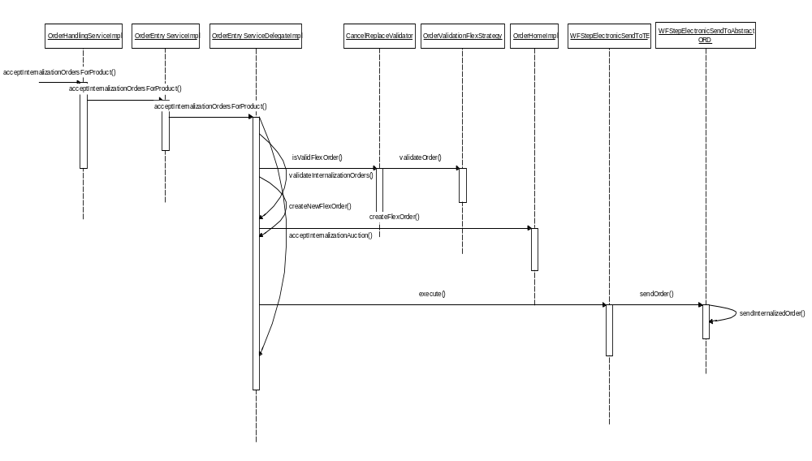

TE Flow:

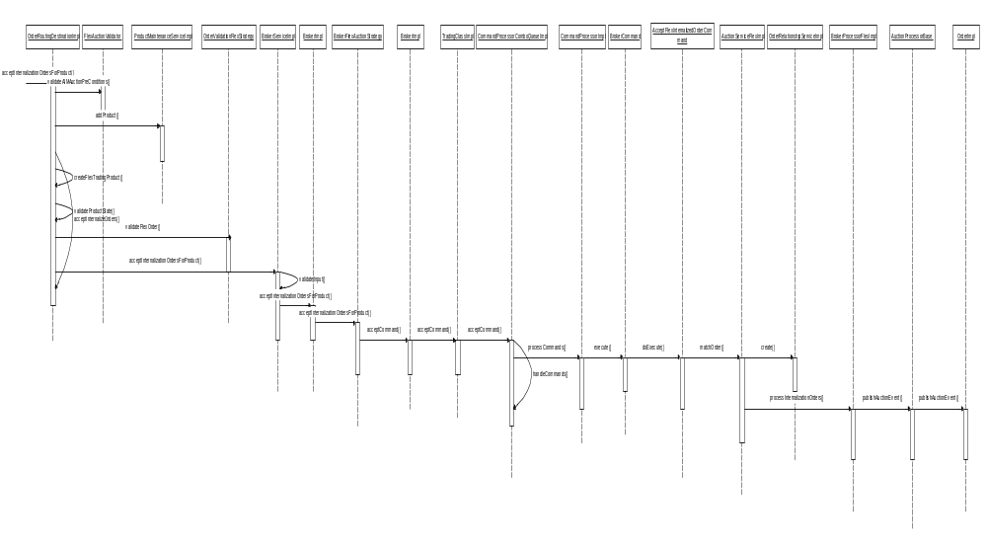

Simple Internalization Order code changes

OrderHandlingServiceImpl.java

Delegates incoming internalization order to OrderEntryServiceImpl.Java

OrderEntryServiceImpl.java

Delegates incoming internalization order to OrderEntryServiceDelegateImpl.java

OrderEntryServiceDelegateImpl.java

Generate orderID.

Validate incoming internalization order.

Persist Primary and secondary order in SBTORDER table.

Executes NewOrder_Electronic_Workflow and send incoming order to TE.

OrderRoutingDestinationImpl.java

Checks if the product exists and creates if it does not exists.

Validate incoming order and sent it to BrokerServiceImpl.java.

BrokerServiceimpl.java

Delegates incoming order to BrokerImpl.java

BrokerImpl.java

Delegates incoming order to BrokerFlexAuctionStrategy.java

BrokerFlexAuctionStrategy.java

Creates and execute AcceptFlexInternalizedOrderCommand.java

AcceptFlexInternalizedOrderCommand.java

Delegate call to AuctionServiceFlexImpl to match the internalized pair order.

AuctionServiceFlexImpl.java

Delegated call to InternalizedPairManager to create internalizationOrderPair.

Identifies auction starting price and starts the AIM Auction.

Strategy Internalization Order Flow

OHSFlow:

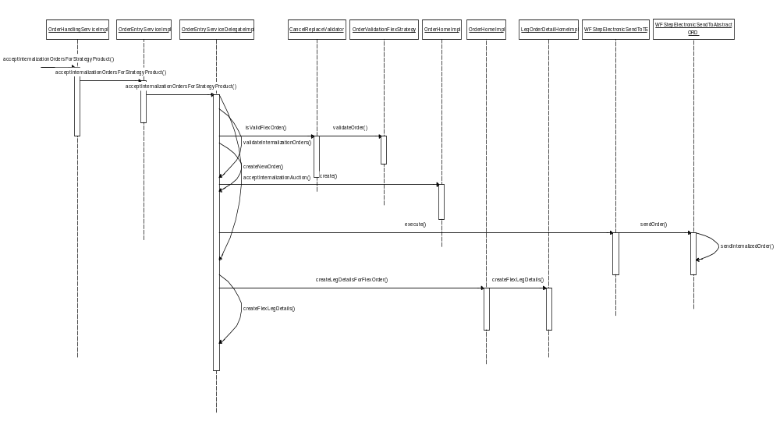

TE Flow:
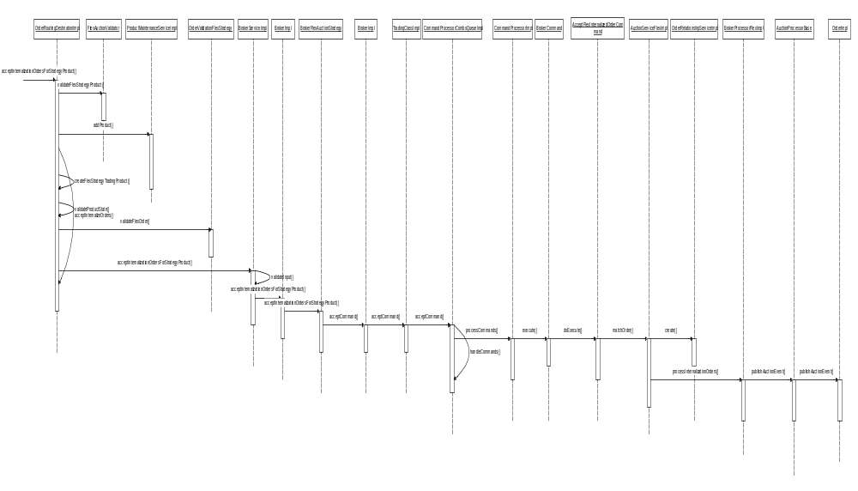

Strategy Internalization Order code changes

OrderHandlingServiceImpl.java

Delegates incoming internalization order to OrderEntryServiceImpl.Java

OrderEntryServiceImpl.java

Delegates incoming internalization order to OrderEntryServiceDelegateImpl.java

OrderEntryServiceDelegateImpl.java

Generate orderID.

Validate incoming internalization order.

Persist Primary and secondary order in SBTORDER table.

Executes NewOrder_Electronic_Workflow and send incoming order to TE.

Persists leg details using LegOrderDetailHomeImpl.java

OrderRoutingDestinationImpl.java

Checks if the product on which order is placed exists and creates if it does not exists.

Validate incoming order and sent it to BrokerServiceImpl.java.

BrokerServiceimpl.java

Delegates incoming order to BrokerImpl.java

BrokerImpl.java

Delegates incoming order to BrokerFlexAuctionStrategy.java

BrokerFlexAuctionStrategy.java

Creates and execute AcceptFlexInternalizedOrderCommand.java

AcceptFlexInternalizedOrderCommand.java

Delegate call to AuctionServiceFlexImpl to match the internalized pair order.

AuctionServiceFlexImpl.java

Delegated call to InternalizedPairManager to create internalizationOrderPair.

Identifies auction starting price and starts the AIM Auction.

Simple AIM Order Trade Flow

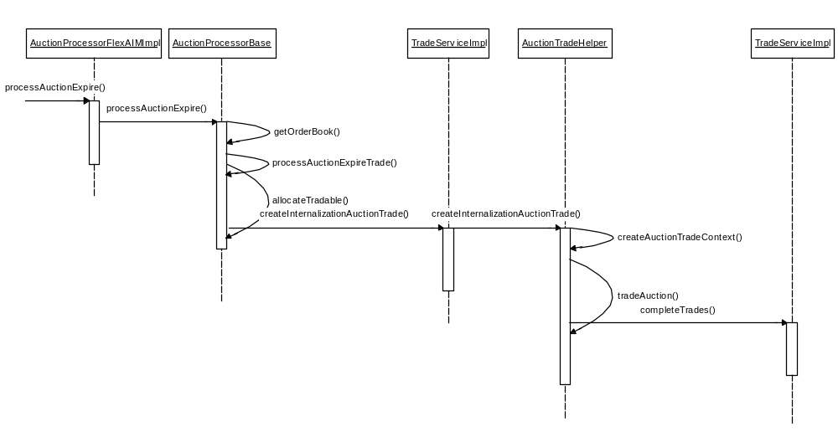

Simple Internalization Order trade Code Change

AuctionProcessorFlexAIMImpl.java

Delegate process auction expire processing request to AuctionProcessorBase.java.

Publish the auction end event using AuctionStatusPublisher.

AuctionProcessorBase.java

Delegates Internalization auction trade to TradeServiceImpl.java

TradeServiceImpl.java

Delegates call to AuctionTradeHelper.java for Internalization auction trade.

AuctionTradeHelper.java

Creates Internalization auction participants list and delegates Internalization auction participants list to TradeServiceImpl.jave to complete trade.

Pending Trade Query – Query by Time, Trade Status, User and Class.

Trade Query by time and trade status

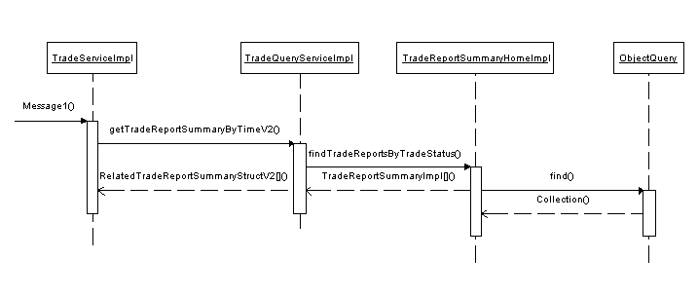

Trade Query by trade status and user

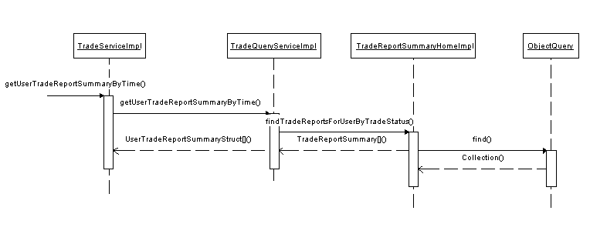

Trade Query by Trade Id and User

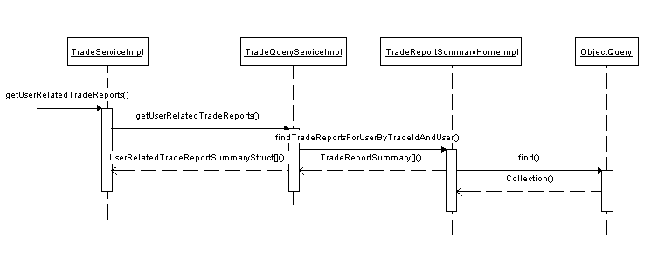

Pending Trade Query Changes

TradeServiceImpl.java

Implemented new method from TradeMaintenanceService for pending trade.

getTradeReportSummaryByTimeV2(DateTimeStruct startTime, DateTimeStruct endTime, String sessionName, int[] classkeys,short[] tradeStatus)

getUserTradeReportSummaryByTime(DateTimeStruct startTime, DateTimeStruct endTime, int[] classKeys, String sessionName, short[] tradeStatus, String userId)

getUserRelatedTradeReports(int classkey, String sessionName, com.cboe.idl.cmiUtil.CboeIdStruct tradeId, java.lang.String userId)

modified method tradeMatch() create pending trades.

TradeQueryService.java

Changes to implement method for pending trade query

getUserRelatedTradeReports(com.cboe.idl.cmiUtil.CboeIdStruct tradeId, java.lang.String userId)

getTradeReportSummaryByTimeV2(DateTimeStruct startTime, DateTimeStruct endTime, String sessionName, short[] tradeStatus)

getTradeReportSummaryByTimeV2(DateTimeStruct startTime, DateTimeStruct endTime, String sessionName, short[] tradeStatus)

TradeQueryServiceImpl.java

Changes to implement methods to query pending trades based on trade status and user id constraints

Changes to organize trade reports for strategy trades.

TradeReportSummaryHome.java

Changes to add new method for pending trade queries

findTradeReportsByTradeStatus(DateTimeStruct startTime, DateTimeStruct endDateTime, short[] tradeStatus

findTradeReportsForUserByTradeStatus(DateTimeStruct startTime, DateTimeStruct endDateTime, short[] tradeStatus, String userId, int[] classKeys)

findTradeReportsForUserByTradeIdAndUser(CboeIdStruct tradeId, String userId)

TradeReportSummaryHomeImpl.java

Changes to implement methods to query for pending trades based on criteria for trade status, trade id and user.

TradeReportEntrySummary.java

Changes to add methods to get user, session name, order id information from sbt_tradereportentry table

TradeReportSummary.java

Changes to fetch trade status data from sbt_tradereport table.

TradeReportHomeImpl.java

Added new method createPendingTrade() to set trade status code.

TradeReportImpl.java

Changes to include new field trade_stat_code

Scripts

Database Scripts

alter_sbt_tradereport_CFLEX2.sql

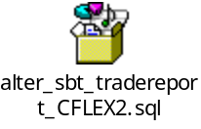

Database Changes:

SBT_TRADEREPORT

Changes to add following new column:

SetContext

None

XML/DTD

OrderValidationStrategy.xml

Changes to add new tag originTypesForFlexAimAuctionResponse to validate origin types for AIM responses.

List of Files

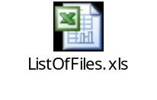

Client

CAS Changes

Classes & Interfaces

OrderEntryV10.java

New order entry interface with the FLEX Simple-AIM and Strategy-AIM Methods.

UserOrderEntryImpl.java

Added the two FLEX AIM methods:
public InternalizationAuctionResultStruct acceptInternalizationOrdersForStrategyProduct(ProductStruct strategyProduct,StrategyLegDefinitionStruct[] legDefinitions, OrderEntryStruct primaryOrder, LegOrderEntryStructV2[] primaryOrderLegEntries, OrderEntryStruct matchOrder,LegOrderEntryStructV2[] matchOrderLegEntries, short matchType)
throws SystemException, CommunicationException, AuthorizationException, DataValidationException, NotAcceptedException, TransactionFailedException

public InternalizationAuctionResultStruct acceptInternalizationOrdersForProduct(ProductStruct productStruct, OrderEntryStruct primaryOrder, OrderEntryStruct matchOrder, short matchType) throws SystemException, CommunicationException, AuthorizationException, DataValidationException, NotAcceptedException, TransactionFailedException

UserOrderServiceImpl.java

Implementation for the two new AIM methods. This call the OrderHandlingServiceRoutingProxy to send the orders to OHS.

OrderHandlingServiceClientRoutingProxy.java

Implemented the two AIM methods. This is the OHSRouting proxy which looks up the service route based on the Product key and session.

FlexTradeServiceImpl/UserFlexTradeServiceImpl/AuctionHandlingServiceClientRoutingProxy.

Implemented the 2 pending trade query methods:

public UserTradeReportSummaryStruct[] getUserTradeReportSummaryByTime(DateTimeStruct p_startTime, DateTimeStruct p_endTime, int[] p_classKeys, String p_sessionName, short[] p_tradeStatus) throws SystemException, CommunicationException, DataValidationException, NotFoundException, AuthorizationException

public UserRelatedTradeReportSummaryStruct getUserRelatedTradeReports(int p_classKey, CboeIdStruct p_tradeId, String p_sessionName) throws SystemException, CommunicationException, DataValidationException, NotFoundException, AuthorizationException

CAS Sequence Diagram

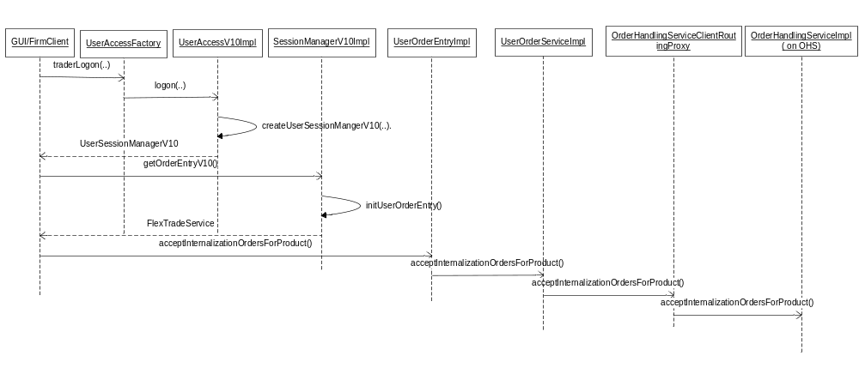

FIXCAS Changes

Classes & Interfaces

FlexPendingTradeQueryByTimeMessageDispatcher

New dispatcher to handle pending trade query by time.

FlexPendingTradeQueryByTradeIDMessageDispatcher

New dispatcher to handle pending trade query by trade id.

FlexOrderListMessageDispatcher

New dispatcher to handle AIM auction for simple Orders.

FlexSpreadOrderListMessageDispatcher

New dispatcher to handle AIM auction for Spread Orders.

InProcessFlexTradeServiceImpl

Added the two cmi methods for pending trade query.

public UserTradeReportSummaryStruct[] getUserTradeReportSummaryByTime(DateTimeStruct p_startTime, DateTimeStruct p_endTime, int[] p_classKeys, String p_sessionName, short[] p_tradeStatus) throws SystemException, CommunicationException, DataValidationException, NotFoundException, AuthorizationException

public UserRelatedTradeReportSummaryStruct getUserRelatedTradeReports(int p_classKey, CboeIdStruct p_tradeId, String p_sessionName) throws SystemException, CommunicationException, DataValidationException, NotFoundException, AuthorizationException

OrderEntryImpl

Added the two AIM cmi methods.
public InternalizationAuctionResultStruct acceptInternalizationOrdersForStrategyProduct(ProductStruct strategyProduct,StrategyLegDefinitionStruct[] legDefinitions, OrderEntryStruct primaryOrder, LegOrderEntryStructV2[] primaryOrderLegEntries, OrderEntryStruct matchOrder,LegOrderEntryStructV2[] matchOrderLegEntries, short matchType)
throws SystemException, CommunicationException, AuthorizationException, DataValidationException, NotAcceptedException, TransactionFailedException

public InternalizationAuctionResultStruct acceptInternalizationOrdersForProduct(ProductStruct productStruct, OrderEntryStruct primaryOrder, OrderEntryStruct matchOrder, short matchType) throws SystemException, CommunicationException, AuthorizationException, DataValidationException, NotAcceptedException, TransactionFailedException

New FIX Messages for Pending Trade Query
Pending Trade Query By Time ( InBoundMessage)
Message Type = U05
Tag | Field Name | Usage | Is New UDF For Flex
21024 | QueryReqId | Unique id for this Query. The response for the query  will have this id. ( Like market data request) | Yes
336 | Trading Session ID | This should be FLEX_MAIN | No
55 | Symbol | The Flex Option trading Symbol. Ex 1AAPL  Give a comma separated symbol List for  querying multiple classes.  Ex : 1AAPL,1IBM,1AA | No
167 | Security Type | FLEX' for flex options | NO
21011 | Flex Query Start Time | The start time for query criteria. Trades between Start time and End time will be fetched | Yes.( Reused in Flex Auction Query )
21012 | Flex Query End Time | The End Time for query criteria. Trades  between Start time and End time will be  fetched | Yes.( Reused in Flex Auction Query )
150 | ExecType | This is the trade Status. It could be one of  the following values:  PENDING_LEG_PRICE = 1;  PENDING_PRICE = 2;  REVIEW_PRICE = 3;  REVIEW_PRODUCT = 4;  PENDING_PRICE_ON_HOLD = 5;  PRICE_APPROVED = 6;  BUST = 7;  For, querying for multiple trade status, give  a comma separated list of values. | No
Pending Trade Query By Time ( OutBoundMessage)
Message Type = U07
Tag | Field Name | Usage | Is New UDF For Flex
21024 | QueryReqId | Unique id for this Query. This is copied from the query  request | Yes
336 | Trading Session ID | This should be FLEX_MAIN | No
48 | SecurityID | The CBOE Product key for the Flex Product | No
17 | ExecID | The CBOE Trade ID( highID  :LowId) | No
60 | Transact Time | Time of Trade | No
37 | OrderID | The CBOEOrder ID in the form highId:lowID | No
44 | OrderPrice
40 | OrdType | The OrderType: Will be of limit or percentage | No
9433 | Execution Information | User Id for the Trade | No
382 | NoContraBrokers | Number of different brokers on the other side of  this fill report | No
14 | CumQty | Total quantity traded | No
150 | ExecType | The Trade status of the trade | No
Begin Repeating Group for NoContraBrokers
375 | ContraBroker | FirmIdentifier of contraparty to trade. Currently not used for all orders. | No
337 | ContraTrader | Trader or broker acronym of contraparty to trade. Currently not used for all orders | No
437 | ContraTradeQty | Quantity traded with this contraparty | No

Pending Trade Query By User (InBound Message)
Message Type = U06
Tag | Field Name | Usage | Is New UDF For Flex
21024 | QueryReqId | Unique id for this Query. The response for the query  will have this id | Yes
336 | Trading Session ID | This should be FLEX_MAIN | No
55 | Symbol | The Flex Option trading Symbol. Ex 1AAPL | No
167 | Security Type | FLEX' for flex options | NO
17 | ExecID | The CBOE Trade ID( highID  :LowId) | No
Pending Trade Query By User ( OutBoundMessage)
Message Type = U07
Tag | Field Name | Usage | Is New UDF For Flex
21024 | QueryReqId | Unique id for this Query. This is copied from the query request | Yes
336 | Trading Session ID | This should be FLEX_MAIN | No
48 | SecurityID | The CBOE Product key for the Flex Product | No
17 | ExecID | The CBOE Trade ID( highID  :LowId) | No
60 | Transact Time | Time of Trade | No
37 | OrderID | The CBOEOrder ID in the form highId:lowID | No
44 | Price | This is the Trade Price | No
40 | OrdType | The OrderType: Will be of limit or percentage | No
9433 | Execution Information | User Id for the Trade | No
382 | NoContraBrokers | Number of different brokers on the other side of  this fill report | No
14 | CumQty | Total quantity traded | No
150 | ExecType | The Trade status of the trade | No
Begin Repeating Group for NoContraBrokers
375 | ContraBroker | FirmIdentifier of contraparty to trade. Currently not used for all orders. | No
337 | ContraTrader | Trader or broker acronym of contraparty to trade. Currently not used for all orders | No
437 | ContraTradeQty | Quantity traded with this contraparty | No

WebCAS Changes

Classes & Interfaces

WebCasAuctionRequestDispatcher.java

We need to add action id for creating an AIM Auction creation on simple and Strategy product.

WebCasInProcessFlexTradeService.java

We need to add below methods for creating an AIM auction on simple and strategy product.

InternalizationAuctionResultStruct acceptInternalizationOrdersForProduct(ProductStruct productStruct, OrderEntryStruct primaryOrder, OrderEntryStruct matchOrder, short matchType)

InternalizationAuctionResultStruct acceptInternalizationOrdersForStrategyProduct(ProductStruct strategyProduct, StrategyLegDefinitionStruct[] legDefinitions, OrderEntryStruct primaryOrder, OrderEntryStruct matchOrder, short matchType)

WebCasInProcessFlexTradeServiceImpl.java

We need to add implementation for the new methods added in WebCasInProcessFlexTradeService for AIM auction creation.

Sequence diagram:

Flow for simple AIM Auction Creation:

GUI

FlexGUI Changes

Changes for AIM Auction Creation
We need to create below mentioned files for AIM Auction creation.
- AIMAuctionModel.java
This would gather all the data from GUI required for starting an AIM Auction. If product details contain only one leg, we would be creating a ProductStruct, otherwise we would be creating an ProductStruct along with an array of StrategyLegDefinitionStruct.

- AIMAuctionPanel.java
This class would be having all the components required for AIM Auction creation, example, Primary order and Matched order details, etc.

- AuctionSelectorPanel.java
This panel would be having the FLEX Auction panel and AIM auction panel. Based on the radio button selection, we would be showing the appropriate panel to user.

- AuctionServiceAPI.java
We need to add implementation for creating an AIM auction on a simple and a strategy product.

Changes for Respond to AIM Auction
We need to create below mentioned files for AIM Auction creation.
- RespondToAIMAuctionFrame.java
We would create a new frame to show the Respond to AIM auction pop-up screen.

- RespondToAIMAuctionPanel.java
This class would be render all the components required to respond to AIM Auction creation, Product details, price and quantity, clearing information for that auction response.

Changes for All Event Screen
In All events screen, we would be using the last sale events to show the trade information of all trades happened during the day. It would be also listening on auction events. We would be adding separate row for each auction events like New Flex auction, T1 Ended, T2 ended.

We would be also adding the order events of logged-in user in this table. User won’t be able to see order events of other user.

We need to create below mentioned files to show my trades information.
- AllEventMessage.java
Define an interface which would define common methods for all the events.

- AllEventMessageImpl.java
We need to define the implementation for all events messages.

- AllEventsPanel.java
We need to create a panel which would render the all events table.

- AllEventTableConfig.java
We need to create a table configuration for all events table.

- AllEventTableModel.java
We would define a table model which would always append the events received on GUI.

- AllEventTableRow.java
We need to define the column headers and the initial ordering of these columns in the table.

Changes for Trades and My Trade
In Trades screen, we would be using the last sale events to show the trade information of all trades happened during the day.

In My Trades screen, we would be listening on order events. If an order is busted or filled, we would be adding the filled and bust event in my trades screen.

We need to create below mentioned files to show my trades information.
- BustReportCache.java
We would be creating a cache to store all the bust reports for the logged in user.

- FilledReportCache.java
We would be creating a cache to cache all the fill reports for the logged in user.

- MyTradePanel.java
We would create a new panel to render my trade table. Whenever user double clicks on any of the trade, we would be showing him the fill report screen with order and fill information. He can print or save this Jasper report.

- MyTradesTableModel.java
We need to create a table model which has all the fill reports.
- MyTradesTableRow.java
We need to define the set of columns headers and which column can be sorted
.
- ReportStructWrapper.java
We need to create a wrapper which provides all required fields for my trade and trades screen.

- TradesPanel.java
We would create a new panel to render trades table. This would be view only information. We won’t be providing any action on this table.

Changes for Current Market
We need to create below mentioned files to consume current market on Flex-GUI.
- CurrentMarketEventListener.java
We need to write a new CometD listener which would continuously listen on current market events. Whenever it receives an event for current market update, it will publish this event on IEC channel.

- CurrentMarketCache.java
We would be creating a cache which would subscribe on current market channel of IEC for updates. Whenever CurrentMarketEventListener publish a current market event, it will update its cache for the particular product.

- ProductInfoTableModel.java
The product information panel would be showing the current market for selected products. So we this model would also subscribe for current market updates on IEC channel. If CurrentMarketEventListener publishes a current market event for any of these products, we would be updating the current market value for received product.

Sequence Diagram:
  - AIM Auction Flow:

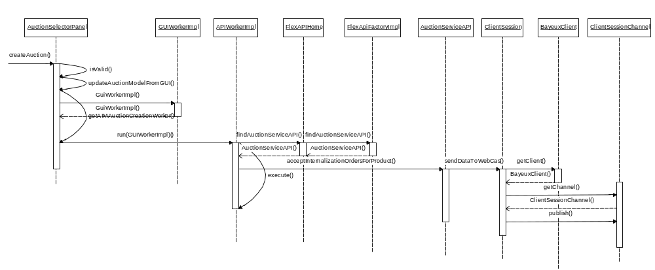

  - AIM Auction Response Flow:
