Design: CFLEX2.0 Flex Auction & Product Creation

Overview

Requirement:
Product creation through Flex Auction for both Flex option and strategy will be supported through both FIX and CMi interfaces. The objective of this feature is to accept the product description, create the product and publish an auction for the same. FLEX Auction can also be started on existing FLEX Products.

Scope:
Product Creation through Flex Auction

Implementation

2.1 IDL Changes

2.1.1 CMI IDL Modification
- cmiStrategy.idl

- New struct strategy Leg definition. This will be used in the StrategyAuctionRequestStruct to define the legs.

struct StrategyLegDefinitionStruct {
cmiProduct::ProductStruct legProduct;
long ratioQuantity;
cmiUtil::Side side;
};
typedef sequence < StrategyLegDefinitionStruct > StrategyLegDefinitionStructSequence;

- cmiOrder.idl

- Typedef for Hedge Reference Types:
typedef short HedgeReferenceType;

- New struct for HedgeInstructions for FLEX Auction

struct HedgeInstructionStruct{

string hedgeExecutionInstruction;
cmiOrder:: HedgeReferenceType hedgeReferenceType;
cmiUtil::PriceStruct hedgeReferencePrice;
cmiUtil::PriceStruct prefacilitationHedgePrice;
long deltaValue;

};
typedef sequence < HedgeInstructionStruct > HedgeInstructionStructSequence;

- New struct for FLEX Auction Request to create FLEX option product

struct AuctionRequestStruct{
cmiSession::TradingSessionName sessionName;
cmiOrder::AuctionType auctionType;
cmiProduct::ProductStruct product;
cmiOrder:: HedgeInstructionStruct hedgeInstruction;
CmiUtil::PriceStruct premiumPrice;
long quantity;
string extensions;

};
typedef sequence <AuctionRequestStruct> AuctionRequestStructSequence;

- New struct for FLEX Auction Request to create FLEX Strategy product

struct StrategyAuctionRequestStruct{
cmiProduct::ClassKey strategyClassKey;
cmiOrder::AuctionType auctionType;
cmiStrategy::StrategyLegDefinitionStructSequence strategyLegs;
cmiOrder :: HedgeInstructionStruct hedgeInstruction;
cmiUtil::PriceStruct premiumPrice;
long quantity;
string extensions;

};
typedef sequence < StrategyAuctionRequestStruct > StrategyAuctionRequestStructSequence;

- New struct for Order Hedge Instruction

struct OrderBookHedgeInstructionStruct{
cmiProduct::ProductKeysStruct productKey;
cmiSession::TradingSessionName sessionName;
string hedgeInstructions;
string extensions;
cmiUtil::PriceStruct price;
cmiUtil::Side side;
long volume;
cmiOrder::OriginType orderOriginType;
};
typedef sequence <OrderBookHedgeInstructionStruct> orderBookHedgeInstructionStructSequence;

- cmiV10.idl ( New)

- New Interface for FLEX

interface FlexTradeService
{

- For subscribing recap for all classes in FLEX_MAIN Session.

void subscribeRecapForAllClasses(
in cmiSession::TradingSessionName sessionName,
in cmiCallbackV4::CMIRecapConsumer clientListener,
in cmiUtil::QueueAction actionOnQueue)
raises(
exceptions::SystemException,
exceptions::CommunicationException,
exceptions::AuthorizationException,
exceptions::DataValidationException
);

- For unSubscribing recap for all classes in FLEX_MAIN Session.

void unsubscribeRecapForAllClasses(
in cmiSession::TradingSessionName sessionName,
in cmiCallbackV4::CMIRecapConsumer clientListener)
raises(
exceptions::SystemException,
exceptions::CommunicationException,
exceptions::AuthorizationException,
exceptions::DataValidationException
);

- For subscribing current market for all classes in FLEX_MAIN Session.

void subscribeCurrentMarketForAllClasses(
in cmiSession::TradingSessionName sessionName,
in cmiCallbackV4::CMICurrentMarketConsumer clientListener,
in cmiUtil::QueueAction actionOnQueue)
raises(
exceptions::SystemException,
exceptions::CommunicationException,
exceptions::AuthorizationException,
exceptions::DataValidationException

);

- For unSubscribing current Market for all classes in FLEX_MAIN Session.

void unsubscribeCurrentMarketForAllClasses(
in cmiSession::TradingSessionName sessionName,
in cmiCallbackV4::CMICurrentMarketConsumer clientListener)
raises(
exceptions::SystemException,
exceptions::CommunicationException,
exceptions::AuthorizationException,
exceptions::DataValidationException
);

- For subscribing ticker for all classes in FLEX_MAIN Session.

void subscribeTickerForAllClasses (
in cmiSession::TradingSessionName sessionName,
in cmiCallbackV4::CMITickerConsumer clientListener,
in cmiUtil::QueueAction actionOnQueue)
raises(
exceptions::SystemException,
exceptions::CommunicationException,
exceptions::AuthorizationException,
exceptions::DataValidationException
);

- For unSubscribing ticker for all classes in FLEX_MAIN Session.

void unsubscribeTickerForAllClasses (
in cmiSession::TradingSessionName sessionName,
in cmiCallbackV4::CMITickerConsumer clientListener)
raises(
exceptions::SystemException,
exceptions::CommunicationException,
exceptions::AuthorizationException,
exceptions::DataValidationException
);

- For subscribing Auction for all classes in FLEX_MAIN Session.

cmiOrder::AuctionSubscriptionResultStructSequence subscribeAuctionForAllClasses(
in cmiSession::TradingSessionName sessionName,
in cmiOrder::AuctionTypeSequence auctionTypes,
in cmiCallbackV3:: CMIAuctionStatusConsumer clientListener)
raises(
exceptions::SystemException,
exceptions::DataValidationException,
exceptions::CommunicationException,
exceptions::AuthorizationException
);

- For unSubscribing Auction for all classes in FLEX_MAIN Session.

cmiOrder::AuctionSubscriptionResultStructSequence unsubscribeAuctionForAllClasses (
in cmiSession::TradingSessionName sessionName,
in cmiOrder::AuctionTypeSequence auctionTypes,
in cmiCallbackV3::CMIAuctionStatusConsumer clientListener)
raises(
exceptions::SystemException,
exceptions::DataValidationException,
exceptions::CommunicationException,
exceptions::AuthorizationException
);

- For Querying the order book hedge instruction.

cmiOrder::OrderBookHedgeInstructionStructSequence getOrderBookHedgeInstructions(in cmiSession::TradingSessionName sessionName, in cmiProduct::ProductKey productKey, in cmiUtil::PriceStruct price) raises(
exceptions::SystemException,
exceptions::DataValidationException,
exceptions::CommunicationException,
exceptions::AuthorizationException
);

- FLEX Auction for a FLEX_OPTION product

cmiOrder::AuctionStruct requestForAuction(in cmiOrder::AuctionRequestStruct auctionRequestStruct, in cmiUtil::TimeStruct timeToRespond) raises(
exceptions::SystemException,
exceptions::DataValidationException,
exceptions::CommunicationException,
exceptions::AuthorizationException
);

- FLEX Auction for a FLEX strategy product

cmiOrder::AuctionStruct requestForStrategyAuction (in cmiOrder:: StrategyAuctionRequestStruct strategyAuctionRequestStruct, in cmiUtil::TimeStruct timeToRespond) raises(
exceptions::SystemException,
exceptions::DataValidationException,
exceptions::CommunicationException,
exceptions::AuthorizationException
);

- For request to withdraw a FLEX Auction for a FLEX product

void withdrawFromAuction(cmiProduct::ProductKey, cmiUtil::CboeIdStruct auctionId)
) raises(
exceptions::SystemException,
exceptions::DataValidationException,
exceptions::CommunicationException,
exceptions::AuthorizationException
);

- To get all auctions for the given classes.ClassKeySequence of length 0 will return auctions for all classes.

cmiOrder::AuctionStructSequence getAllAuctions(in cmiUtil::TimeStruct startTime, in cmiUtil::TimeStruct endTime, in cmiProduct::ClassKeySequence,
in cmiSession::TradingSessionName sessionName, in cmiOrder::AuctionState auctionState,
in cmiOrder::AuctionTypeSequence auctionTypes)
raises( exceptions::SystemException,
exceptions::DataValidationException,
exceptions::CommunicationException,
exceptions::AuthorizationException
);

- New UserSessionManager for FLEX.

interface UserSessionManagerV10 : cmiV9::UserSessionManagerV9
{
cmiV10::FlexTradeService getFlexTradeService()
raises(
exceptions::SystemException,
exceptions::CommunicationException,
exceptions::AuthorizationException,
exceptions::AuthenticationException,
exceptions::NotFoundException
);

};

interface UserAccessV10
{
UserSessionManagerV10 logon(
in cmiUser::UserLogonStruct logonStruct,
in cmiSession::LoginSessionType sessionType,
in cmiCallback::CMIUserSessionAdmin clientListener,
in boolean gmdTextMessaging )
raises(
exceptions::SystemException,
exceptions::CommunicationException,
exceptions::AuthorizationException,
exceptions::AuthenticationException,
exceptions::DataValidationException,
exceptions::NotFoundException
);

};

- cmiCallbackV10.idl ( New)

- To notify users of the auction related events.

interface CMIAuctionStatusConsumer {
void acceptAuctionStatus(
in cmiOrder::AuctionStruct auctionRequest, in cmiUtil:: AuctionStatus auctionStatus, in cmiUtil::TimeStruct statusTime);
};

- cmiUtil.idl

typedef short AuctionStatus;

- cmiConstants..idl

- Introduce new MarketDataHistoryEntryType for Auction
interface MarketDataHistoryEntryTypes

{
const cmiMarketData::MarketDataHistoryEntryType AUCTION_ENTRY = 8;
}

- New interface for Auction Terminate Reasons.

Interface AuctionStatus
{
const cmiUtil:: AuctionStatus UNSPECIFIED= 0;
const cmiUtil:: AuctionStatus NEW_AUCTION= 1; ;
const cmiUtil:: AuctionStatus AUCTION_EXPIRED= 2;
const cmiUtil:: AuctionStatus RESPONSE_TIMER_EXPIRED = 3;
const cmiUtil:: AuctionStatus RFA_CANCELLED = 4;

}

- Constants for HedgeReferenceTypes

interface HedgeReferenceTypes
{
const cmiOrder::HedgeReferenceType UNSPECIFIED = 0;
const cmiOrder::HedgeReferenceType HEDGE = 1;
const cmiOrder::HedgeReferenceType REFERENCE = 2;

}

- cmiErrorCodes.idl
interface NotAcceptedCodes
{
….
const exceptions::ErrorCode AUCTION_ALREADY_IN_PROGRESS = 8000;
};

2.1.2 Other IDL Modification:

- OrderBookService.idl

interface OrderBookService{

- For Querying the order book hedge instruction.

cmiOrder::OrderBookHedgeInstructionStructSequence getOrderBookHedgeInstructions(in cmiSession::TradingSessionName sessionName,in cmiProduct::ProductKey productKey, in cmiUtil::PriceStruct price) raises(
exceptions::SystemException,
exceptions::DataValidationException,
exceptions::CommunicationException,
exceptions::AuthorizationException
);
};

- AuctionService.idl (New)

Interface AuctionService{

- FLEX Auction for a FLEX_OPTION product

cmiOrder::AuctionStruct requestForAuction(in string userId ,in cmiOrder::AuctionRequestStruct auctionRequestStruct, in cmiUtil::TimeStruct timeToRespond) raises(
exceptions::SystemException,
exceptions::DataValidationException,
exceptions::CommunicationException,
exceptions::AuthorizationException
);

- FLEX Auction for a FLEX strategy product

cmiOrder::AuctionStruct requestForStrategyAuction (in string userId ,in cmiOrder:: StrategyAuctionRequestStruct strategyAuctionRequestStruct, in cmiUtil::TimeStruct timeToRespond) raises(
exceptions::SystemException,
exceptions::DataValidationException,
exceptions::CommunicationException,
exceptions::AuthorizationException
);

- For request to withdraw a FLEX Auction for a FLEX product

void withdrawFromAuction(string in userId , cmiProduct::ProductKey, cmiUtil::CboeIdStruct auctionId)
) raises(
exceptions::SystemException,
exceptions::DataValidationException,
exceptions::CommunicationException,
exceptions::AuthorizationException
);

- To get all auctions for the given classes.

cmiOrder:: AuctionStructSequence getAllAuctions(in cmiUtil::TimeStruct startTime, in cmiUtil::TimeStruct endTime, cmiProduct::ClassKeySequence, cmiSession::TradingSessionName sessionName,cmiOrder::AuctionState, in cmiOrder::AuctionTypeSequence auctionTypes) raises(
exceptions::SystemException,
exceptions::DataValidationException,
exceptions::CommunicationException,
exceptions::AuthorizationException
);

};

- Consumers.idl

- New consumer for Auction Status

interface AuctionStatusConsumer {
void acceptAuctionStatus(
in cmiOrder::AuctionStruct auctionRequest, in cmiUtil:: AuctionStatus auctionStatus, in cmiUtil::TimeStruct statusTime);

};

- TradingSessionService.idl

- New consumer for Auction Status
cmiStrategy::StrategyStruct acceptFlexStrategy(
in cmiStrategy::StrategyLegDefinitionStructSequence strategyLegs )
raises( exceptions::SystemException,
exceptions::CommunicationException,
exceptions::AuthorizationException,
exceptions::DataValidationException,
exceptions::AlreadyExistsException
);

Global Server

Product Creation

Flex Products – Simple

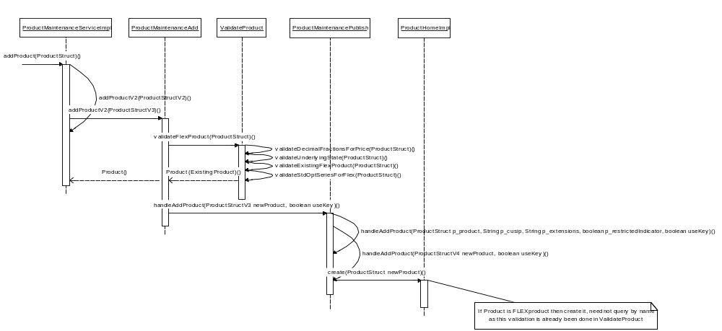

Description:

AuctionHandlingServiceImpl delegates the product creation request to ProuductMaintenanceService.

ProductMaintenanceAdd validates the request and creates the product if its not an existing product and publishes the product creation event

Code Changes
- ProductMaintenanceAdd.java
  - Changes to delegate request to ValidateProduct.java for validations
- ValidateProduct.java
  - Changes to validate Flex Products based on criteria like Strike price, Expiration date, option type, Exercise Style, Underlying State, Decimal Fraction and settlement type.
- FlexOptionEditor.java
  - New editor class created to update flex option products.
- PercentagePrice.java
  - Changes for new price type.
- PriceFactory.java
  - Added methods to create percentage price.

Flex Product – Strategy

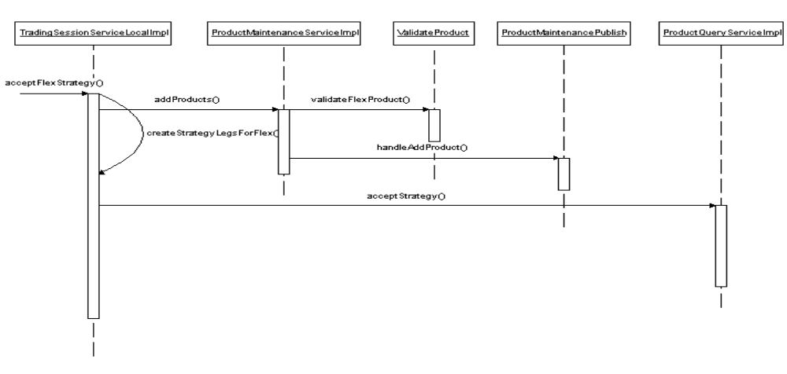

Description:

AuctionHandlingServiceImpl delegates the request to TradingSessionServiceLocal to create Flex Strategy Product.

TradingSessionServiceLocal delegates request to ProductMaintenanceService to create non existing legs.

ProductMaintenanceService validate and publish new product.

After successful creation of strategy legs request is delegated to ProductQueryService to create Flex Strategy Product.

Code Changes
- TradingSessionServiceLocalImpl
  - Changes to accept request from AuctionHandlingServiceImpl for strategy product creation
  - Changes to create legs from given strategy leg definitions
  - Changes to validate Flex Products based on criteria like Strike price, Expiration date, option type, Exercise Style, Underlying State, Decimal Fraction and settlement type.
  - Changes to delegate request to ProductQueryService for strategy product creation

BC Changes

Product Validation

Code Changes
- AuctionHandlingServiceImpl.java
  - Accept request from client for requestForStraregyAuction.
  - Delegate to FlexAuctionValidator for validations.
- FlexAuctionValidator.java
  - Validates strategy product creation request based on no. of legs, product state, and time to respond etc.

Flex Auction

Sequence diagram

Flex Auction – Simple Product

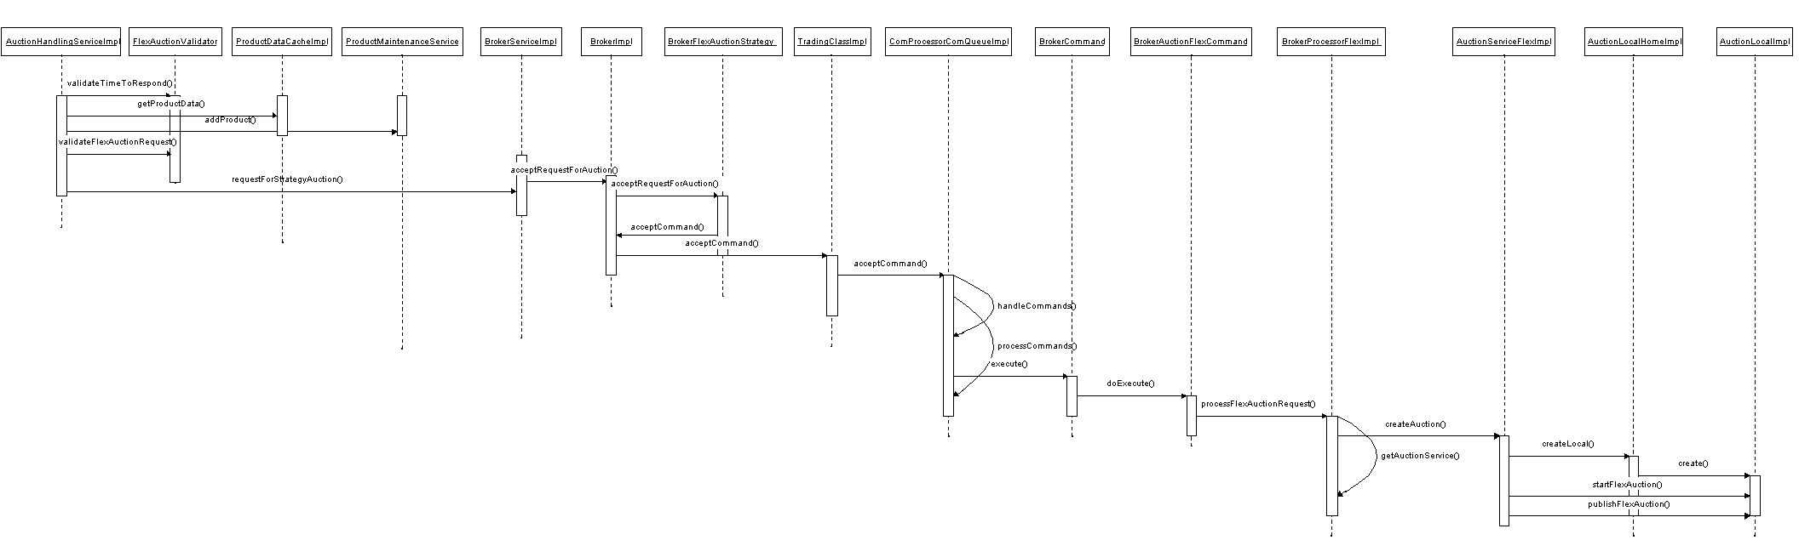

Flex Auction – Strategy Product

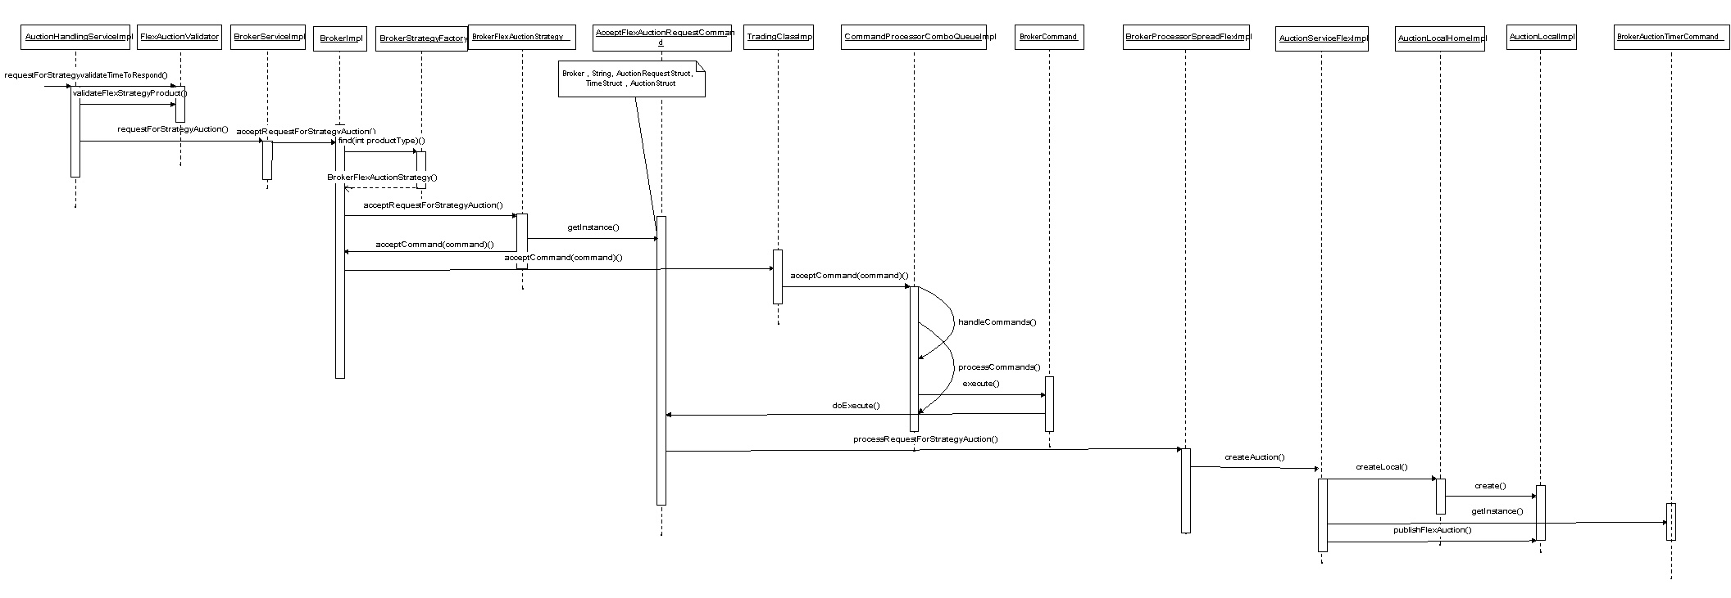
Description:

AuctionHandlingServiceImpl validates the auction request based on T1 timer

and product states for existing products.

Flex product is created if the request for auction is valid.

After successful creation of flex product the request is delegated to broker service and then broker to create new FlexAuctionRequest command.

BrokerProcessorFlexImpl (BrokerProcessorSpreadFlexImpl for Strategy flex auction)delegates request to AutionServiceFlexImpl to create and then to publish it on Auction event channel

Code Changes
- AuctionHandlingServiceImpl.java
  - New methods to accept request for flex auction on simple and strategy flex products.
  - Delegate request of simple and strategy flex auction to BrokerService
- BrokerFlexAuctionStrategy.java
  - New Strategy to create Flex Auction requests.
- AcceptFlexAuctionRequestCommand.java
  - New command to accept simple, strategy Flex Auction requests
- BrokerProcessorFlexImpl.java
  - New BrokerProcessor for simple flex products.
  - Delegates request to AuctionHandlingServiceImpl to create flex auction
- BrokerProcessorSpreadFlexImpl.java
  - New BrokerProcessor for strategy flex products.
  - Delegates request to AuctionHandlingServiceImpl to create flex auction.
- AuctionLocalImpl.java
  - Changes to persist hedge instruction details and flex auction information into database.
  - Publish Flex auction on auction event channel.

Market Data History Entry for an Auction

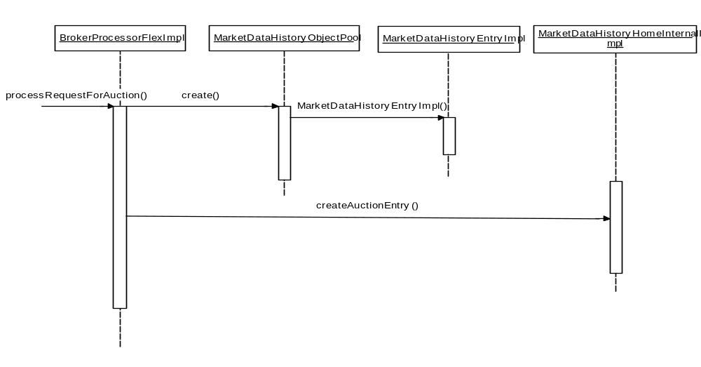
Description:

AcceptFlexAuctionRequestCommand request BrokerProcessorFlexImpl to process Auction.

MarketDataHistoryObjectPool receives request to create MarketDataHistoryEntryImpl.

MarketDataHistoryHomeInternalImpl receives request to create entry in MarketData pool.

Code Changes
- MarketDataHistoryEntryImpl.java
    - Map Auction ID with database.
- MarketDataHistoryHomeInternalImpl
    - Creates an Market Data History entry and populates Auction ID with entry type 8.
- SQLMarketDataHistoryInsert
    - Map Auction ID with database.

Withdraw Auction
Sequence diagram

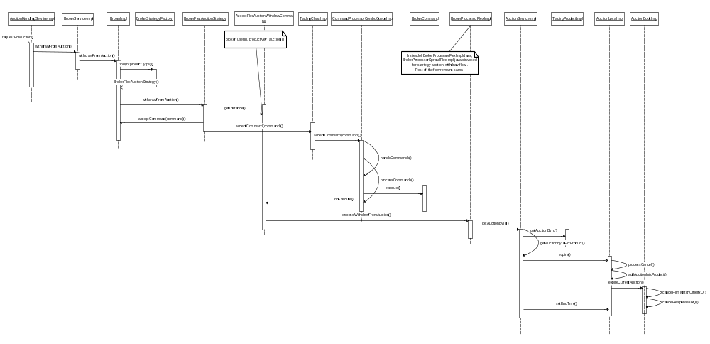
Description:

AuctionHandlingServiceImpl receives request to withdraw auction for given product.

AuctionHandlingServiceImpl validates (T1 timer validation) the request for withdraw auction and delegates the request to BrokerSerivce which in turn requests Broker to create new command to withdraw flex Auction.

AcceptFlexAuctionWithdrawCommand forwards the request to BrokerProcessorFlexImpl and AuctionService to withdraw the ongoing auction.

Code Changes
- AuctionHandlingServicexImpl
  - Validates the request for with draw auction against T1 timer i.e. user can’t withdraw interest from auction during T1 timer.
- AcceptFlexAuctionWithdrawCommand.java
  - New broker command to withdraw simple and strategy flex auction
- BrokerProcessorFlexImpl
  - Delegates request to AuctionService to withdraw from the auction.
- AuctionServiceImpl
  - Expires auction on given product with auction termination reason as RFA CANCELED.

Auction Query

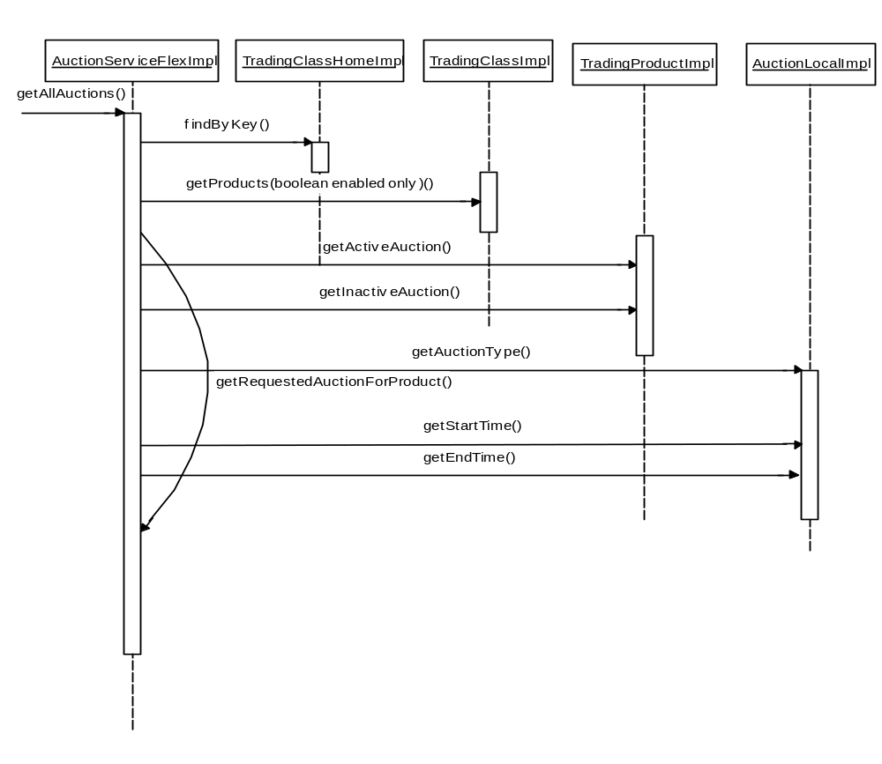
Description:

AuctionHandlingServiceImpl gets request for auction query. Based on the parameters i.e. AuctionType, AuctionState, start time , end time and given class keys the auction information is fetched for the trading product.

If class keys are not specified in the request then auction information for products in all the classes is fetched

Code Changes
- AuctionHandlingServiceImpl
  - New method get auction query request from user.
  - Queries for auction based on AuctionType, AuctionState, start time , end time and given class keys

Trading Property
Flex Auction Min Max Response Time

New files created:

- FlexAuctionMinMaxResponseTime.java
- FlexAuctionMinMaxResponseTimeGroup.java
- FlexAuctionMinMaxResponseTimeImpl.java
- FlexAuctionMinMaxResponseTimeImplBeanInfo.java

Files modified:

- TradingClass.java
- TradingPropertyFactoryImpl.java
- TradingPropertyTypeImpl.java
- TradingClassImpl.java
- TradingParameters.java
- PTPSAdminHelper.java
- PropertyTradingPropertyServiceImpl.java
- TradingPropertyDefinitions.csv

Product Opening
Files modified:

- BrokerHomeImpl
  - Modified to initialize product opening properties from Broker.xml
- BrokerImpl
  - Modified to disable publishing of Expected Opening Price.
- ProductStateServiceLocalImpl.java
  - Modified to prevent product state changes by underlying.

Scripts
- Database Scripts
- Alter script – SBTAUCTION
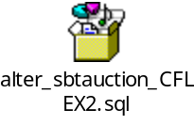
- Alter script – MKT_DATA_HISTORY
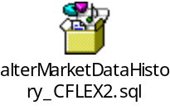

Database Changes:
- SBTAUCTION
- Changes to add following new columns:
TIME_TO_RESPOND_SEC_NBR
USER_ID
HEDGE_EXEC_INSTR_TEXT
HEDGE_REF_TYPE
HEDGE_REF_PRICE
PRFCLTN_PRICE
DELTA_VALUE_AMT
AUCTIONEDORDERID
STARTINGPRICE
AUCTIONTYPE
AUCTIONTERMINATEDREASON
USER_KEY
- Existing column AUCTIONEDORDERID to support null values.

- MKT_DATA_HIST
Changes to add new column AUCTION_ID and support new ENTRY_TYPE ‘8’ for flex auction.

SetContext
- None

XML/DTD
- AuctionStatusConsumer.xml
- New xml for AuctionStatusCosumer to hold consumer specific property values.
- AuctionStatusConsumer.dtd
- New dtd for AuctionStatusCosumer.xml
- CFLEXTradeServer.xml
- Changes to add BrokerProcessor entries for Flex auction
- Changes to add AuctionStatusConsumer entries.
- Changes to add new home implementation entry for Flex Auction i.e. AuctionHandlingServiceHomeImpl
- Broker.xml
- Added new property i.e publishExpectedOpeningTimer.
- TradingSessionService.xml
- Added entry in underlyingStateHaltTriggeredSessions property for FLEX_MAIN session.
- ProductStateService.xml
- New property for configure product state changes from underlying.

Client

CAS Changes

Sequence Diagram

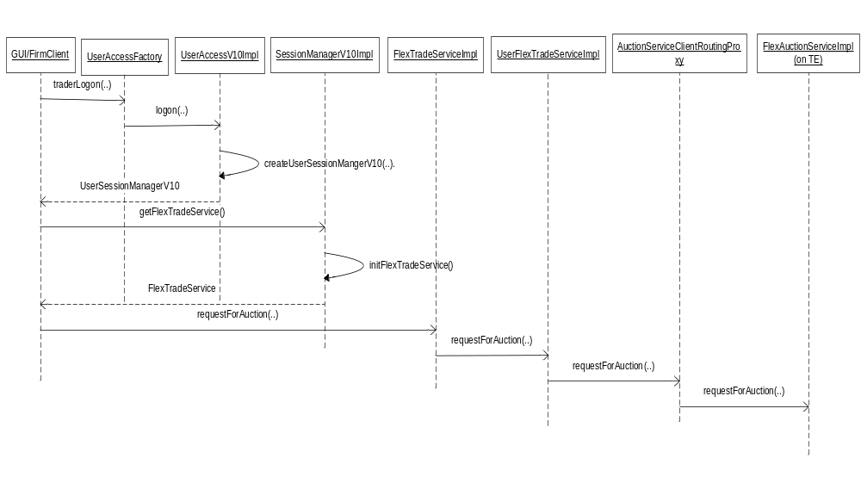

Code Changes

Below is a list of major code changes to implement the FLEX Auction feature. To view the list of all files changed, please refer to the attached xls sheet .

- To add a new UserSessionManager – UserSessionManagerV10 and UserAccess10
    - UserSessionManagerV10 – New UserSessionManager Interface
    - SessionManagerV10 - New Session Manager that extends UserSessionManagerV10 and SessionManagerV9
    - SessionManagerV10Home – Home interface for SessionMangerV10
    - SessionManagerV10HomeImpl - Impl for SessionManagerV10Home.Creates SessionManagerV10
    - SessionManagerV10Impl – Implementation of SessionManagerV10. This initializes the FlexTradeService.
    - UserAccessV10 – New UserAccess Interface
    - UserAccessV10Impl – Impl for UserAccessV10. Implements the new logon method that creates UserSessionManagerV10
    - UserAccessV10Home – Home Interface for the User Access.
    - UserAccessV10HomeImpl – Impl for UserAccessV10Home.Creates UserAccessV10
    - UserAccessV10Delegate – Delegate for UserAccessV10
    - UserSessionManagerV10Delegate – Delegate for UserSessionManager.

- To add the new FlexTradeService

    - FlexTradeService – New Interface for FlexTradeService. Extends the idl interface FlexTradeServiceOperations.
    - FlexTradeServiceImpl – Impl for the Flex TradeService. It implements the cmi methods of FlexTradeService.
    - FlexTradeServiceHome – Home interface for FlexTradeService.
    - FlexTradeServiceHomeImpl – Impl for FlexTradeServiceHome. Create and initializes the FlexTradeService for a given UserSessionManager.
    - FlexTradeServiceDelegate – Delegate for the FlexTradeService.

- Proxies for the AuctionService on TE

    - AuctionServiceClientRoutingProxy – Routing proxy for Auction Service on TE
    - AuctionServiceClientRoutingProxyHomeImpl – Creates the AuctionServiceClientRoutingProxy.

- New Consumer for Auction Status- AuctionStatusConsumer
    - AuctionStatusConsumer – New AuctionStatusConsumer Interface.. This is the consumer for all auction status messages on the Auction Event Channel.
    - AuctionStatusConsumerImpl – Imp for the new AuctionStatusConsumer Interface.
    - AuctionStatusContainer – container for Auction Status information which includes AuctionStruct, auctionStatus and statusTime.
    - AuctionStatusConsumerProxyHome – Home interface for AuctionStatusConsumerProxy.
    - AuctionStatusConsumerProxyHomeImpl – Impl for AuctionStatusConsumerProxyHome. Creates AuctionStatusConsumerProxy
    - AuctionStatusConsumerProxy – Proxy for Auction Status Consumer.

FIXCAS Changes

Sequence Diagram

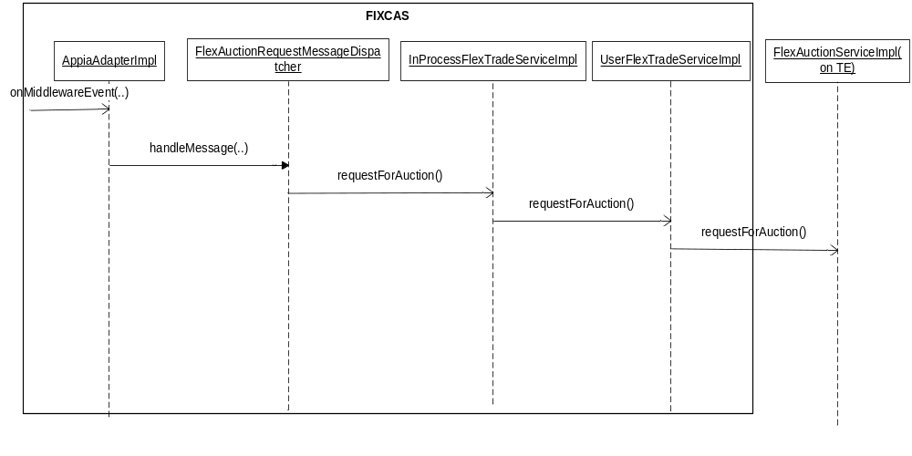
The diagram above shows the sequence for the requestForAuction() call in the FIXCAS. The sequence for requestForStrategyAuction() and withdrawFromAuction() will be similar except that the methods invoked will be different.

Code Changes
A new engine mode ‘FLEX’ will be added to fix CAS
Given below is the list of classes and interfaces changed

    - CasAppiaAdapterImpl – Initializes the dispatchers.Creates/Removes session.
    - FlexAuctionRequestMessageDispatcher – This is the common dispatcher handling all FLEX related request.
    - InProcessFlexTradeService – This is the flex interface on fix for all non cmi users.
    - UserFlexTradeService – This is the flex interface common to both cmi and fix. InProcessFlexTradeService will eventually call this intervace.

FIX Messages

Request For Auction Message
Request For Auction Message : 35 = a (Quote Status Request Message)
S.No | Fix Tag | Is  UDF? | New  UDF? | Mandatory | Tag usage
1 | 200 - Maturity Month Year | N | N | Y | Format: YYYYMM (e.g., 200209). Not Mandatory if tag 48(Security ID) is specified
2 | 205 – MaturityDay | N | N | Y | Specifies the maturity day of the product.  Not Mandatory if tag 48(Security ID) is specified
3 | 201 – Put Or Call | N | N | Y | Required for Option products. 0 = Put, 1 = Call  Not Mandatory if tag 48(Security ID) is specified
4 | 55 - Symbol | N | N | Y | Trading Symbol Ex : 1IBM, 1AAPL.
5 | 9383 - AuctionType | Y | N | Y | 9 = FLEX_AUCTION
6 | 167 – Security Type | N | N | Y | FLEX' for FLEX Options
7 | 9463- Subscription Request type | Y | N | Y | 502 = request for Auction
8 | 336 - TradingSessionID | N | N | Y | FLEX_MAIN' for CFLEX
9 | 202 - Strike Price | N | N | Y | Strike price for the product.  Not Mandatory if tag 48(Security ID) is specified
10 | 48 - Security Id | N | N | N | CBOEDirect Product Key. Mention this tag to start auction on an existing product.
11 | 21001 - Product price type | Y | Y | Y | Product type for the CFLEX Product  2 - FIXED  5 – PERCENTAGE.  Not mandatory if tag 48(Security id) is mentioned.
12 | 21002 - Premium Price | Y | Y | N | Price for the Auction
13 | 21003 - auction quantity | Y | Y | N | Quantity for the Auction
14 | 21004 - Auction Extension | Y | Y | N | Optional Fields
15 | 21005 - Hedge execution instruction | Y | Y | N | Hedge Execution Instruction
16 | 21006 - Hedge reference Type | Y | Y | N | Hedge Reference Type:  1 - HEDGE  2 - REFERENCE
17 | 21007 - Hedge Reference Price | Y | Y | N | Hedge Reference Price
18 | 21008 - Pre faciliation Price | Y | Y | N | Pre facilitation price
19 | 21009 - Hedge Delta Value | Y | Y | N | Hedge Delta
20 | 21010 - Time to respond for flex auction | Y | Y | Y | Time for the Auction. Responses will be accepted only within this time. Format : HH:MM:SS.fraction. Ex:1:30:30.30

Request For Strategy Auction Message
Request For Strategy Auction Message : 35 = a (Quote Status
Request Message)
S.No | Fix Tag | Is  UDF? | New  UDF? | Mandatory | Tag usage
1 | 55 - Symbol | N | N | Y | Trading Symbol Ex : 1IBM, 1AAPL
2 | 9383 - AuctionType | Y | N | Y | 9 = FLEX_AUCTION
3 | 48 - Security Id | N | N | N | Product key of the strategy product. Mention this to start auction on an existing product.
4 | 167 – Security Type | N | N | Y | ‘MLEG’ for strategy
5 | 9463- Subscription Request type | Y | N | Y | 503 = request for Strategy Auction
6 | 336 - TradingSessionID | N | N | Y | FLEX_MAIN' for CFLEX
7 | 21001 - Product price type | Y | Y | Y | Product type for the CFLEX Product  2 - FIXED  5 – PERCENTAGE. Not mandatory if tag 48( security id) is specified.
8 | 21002 - Premium Price | Y | Y | N | Price for the Auction
9 | 21003 - auction quantity | Y | Y | Y | Quantity for the Auction
10 | 21004 - Auction Extention | Y | Y | N | Optional Fields
11 | 21005 - Hedge execution instruction | Y | Y | N | Hedge Execution Instruction
12 | 21006 - Hedge reference Type | Y | Y | N | Hedge Reference Type:  1 - HEDGE  2 - REFERENCE
13 | 21007 - Hedge Reference Price | Y | Y | N | Hedge Reference Price
14 | 21008 - Pre faciliation Price | Y | Y | N | Pre facilitation price
15 | 21009 - Hedge Delta Value | Y | Y | N | Hedge Delta
16 | 21010 - Time to respond for flex auction | Y | Y | Y | Time for the Auction. Responses will be accepted  only within this time.Initiator can withdraw the  Auction only within this time . . Format : HH:MM:SS.fraction. Ex:1:30:30.30
17 | 555 - No Of legs | Y |  | Y | No of legs for the strategy. Not mandatory if security id of strategy(tag 48) is specified.
Begin Repeating Group for No of Legs
18 | 606 - LegSecurityType | Y | N | Y | This should be the first tag in the repeating group.  The other tags below can be in any order.Should be 'FLEX' for CFLEX.  Not mandatory if security id of strategy(tag 48) is specified
19 | 602 - LegSecurityID | Y | N | N | The leg product Key.  Not mandatory if security id of strategy(tag 48) is specified  Note : If this tag is specified, the tags below this are not mandatory.
20 | 600 – LegSymbol | Y | N | N | Leg Class Symbol. Ex. 1AA
20 | 611 - LegMaturityDate | Y | N | Y | Expiration date for the leg product.  Not mandatory if security id of strategy(tag 48) is specified
21 | 624 - LegSide | Y | N | Y | Side of the leg. Could be  1 = Buy  2 = Sell  5 = Sell_Short  6 = Sell_Short_Exempt  Not mandatory if security id of strategy(tag 48) is specified
22 | 612 - LegStrikePrice | Y | N | Y | Strike price for the leg.  Not mandatory if security id of strategy(tag 48) is specified
23 | 613 - LegOptAttribute | Y | N | Y | Call or Put. . 0 = Put, 1 = Call.  Not mandatory if security id of strategy(tag 48) is specified
24 | 623 - LegRatioQty | Y | N | Y | Ration Quantity.  Not mandatory if security id of strategy(tag 48) is specified

Get all auctions
Get All Auctions Message : 35 = a (Quote Status
Request Message)
S.No | Fix Tag | Is UDF? | New UDF? | Mandatory | Tag usage
1 | 55 - Symbol | N | N | Y | Trading Symbol Ex : 1IBM, 1AAPL. Give a Comma Separated list for multiple classes
2 | 9383 - AuctionType | Y | N | Y | 9 = FLEX_AUCTION. Give a comma separated auction type list to specify multiple auction types
3 | 167 – Security Type | N | N | Y | FLEX' for FLEX Options
4 | 9463- Subscription Request type | Y | N | Y | 505 = Get Auctions.
5 | 336 - TradingSessionID | N | N | Y | FLEX_MAIN' for CFLEX
6 | 21011 - Auction start time | Y | Y | Y | Auction start Time. . Format : HH:MM:SS.fraction. Ex:1:30:30.30
7 | 21012 - Auction End Time | Y | Y | Y | Auction End Time. Only auctions between the specified start and the end times will be fetched. . Format : HH:MM:SS.fraction. Ex:1:30:30.30
8 | 21013 - Auction State | Y | Y | Y | Auction State  STARTED = 1;  ENDED = 2;  PREMATURELY_ENDED = 3;  ABORTED = 4;

Withdraw from Auction
Request For Withdraw Auction Message : 35 = a (Quote Status
Request Message)
S.No | Fix Tag | Is  UDF? | New  UDF? | Mandatory | Tag usage
1 | 55 - Symbol | N | N | N | Trading Symbol Ex : 1IBM, 1AAPL.  Not Mandatory if tag 48(Security ID) is specified
3 | 9463- Subscription Request type | Y | N | Y | 504 = Withdraw from Auction
4 | 336 - TradingSessionID | N | N | Y | FLEX_MAIN' for CFLEX
5 | 48 - Security Id | N | N | Y | Product key for the product.
6 | 9385 - Auction Id | Y | N | Y | 9 = FLEX_AUCTION
5 | 167 – Security Type | N | N | N | FLEX' for FLEX Options

Subscribe Auction for all classes
Subscribe for all auctions : 35 = a (Quote Status Request Message)
S.No | Fix Tag | Is  UDF? | New  UDF? | Mand  atory | Tag usage
1 | 9383 - AuctionType | Y |  | Y | List of auctions separated by commans. For ex. 1,9  9 = FLEX_AUCTION
2 | 167 – Security Type | N |  | Y | FLEX' for FLEX Options
3 | 9463- Subscription Request type | Y |  | Y | 506 = Subscribe for all auctions.
4 | 336 - TradingSessionID | N |  | Y | FLEX_MAIN' for CFLEX

UnSubscribe Auction for all classes
Subscribe for all auctions : 35 = a (Quote Status Request Message)
S.No | Fix Tag | Is  UDF? | New  UDF? | Mand  atory | Tag usage
1 | 9383 - AuctionType | Y |  | Y | List of auctions separated by commans. For ex. 1,9  9 = FLEX_AUCTION
2 | 167 – Security Type | N |  | Y | FLEX' for FLEX Options
3 | 9463- Subscription Request type | Y |  | Y | 507 = Subscribe for all auctions.
4 | 336 - TradingSessionID | N |  | Y | FLEX_MAIN' for CFLEX

Auction Status Callback and Return message for auction request.
Auction Callback : 35 = R (Quote
Request Message)
S.No | Fix Tag | Is UDF? | New UDF? | Mandatory | Tag usage
1 | 55 - Symbol | N | N | Y | Trading Symbol Ex : 1IBM,
2 | 131- QuoteReqID | N | N | Y | This is the auction id of the auction.Firms will use this to send auction response.
3 | 48 - SecurityID | N | N | Y | Product key for the auction.
4 | 9383 - AuctionType | Y | N | Y | The type of auction the callback is for. FLEX_AUCTION=9
5 | 167 – Security Type | N | N | Y | FLEX' for FLEX Options
6 | 200 - MaturityMonthYear | N | N | N | MaturityMonthYear of the product
7 | 205 - MaturityDay | N | N | N | MaturityDay of the product
8 | 201 - PutOrCall | N | N | N | Put or Call
9 | 202- StrikePrice | N | N | N | Striker price of the product
10 | 336 - TradingSessionID | N | N | Y | Will beFLEX_MAIN
11 | 54 - Side | N | N | Y | The values to be used to solicit auction participation are: 1=Buy or 2=Sell
12 | 9743 - PIPManagementType | Y | N | Y | 1 = Solicitation to participate in an auction.  2 = Acknowledgement for Auction Request( Gives the product Key of the created product)  3 = Flex Auction status
13 | 21014 – Auction Status | Y | Y | Y | NEW_AUCTION = 12;  AUCTION_EXPIRED = 0;  RESPONSE_TIMER_EXPIRED = 51;  RFA_CANCELLED = 52;
14 | 21015 – Auction Status Time | Y | Y | Y | Time the auction status was sent

GUI

List of Files

Server Files Changed



CAS/FIXCAS Files Changed

