Design: CFLEX2.0 OrderEntry & Open Interest

Overview

Requirement:

Scope:
- Product Creation through Open Interest Data
- Order Entry
- Order Book Maintenance
- Flex Auction Trade

Implementation

IDL changes
    - cmiProduct.idl

Return struct for open interest query for flex products.

struct ProductExtensionsStruct
{
cmiProduct::ProductKeysStruct productKeys;
cmiUtil::KeyValueStructSequence keyValuePairs;
}

typedef sequence <ProductExtensionsStruct> ProductExtensionsStructSequence;

    - cmi.idl

New method to query products for open interest data.

interface ProductQuery {
...
cmiProduct::ProductExtensionsStructSequence getProductExtensionsByClasses(in cmiProduct::ClassKeySequence classKeys)
raises(
exceptions::SystemException,
exceptions::CommunicationException,
exceptions::AuthorizationException,
exceptions::DataValidationException,
exceptions::NotFoundException
);

    - cmiConstants.idl

interface ExtensionFields
{
...
// Constants for new fields in OrderEntryStruct extensions
const ExtensionField HEDGE_EXEC_INSTRUCTION = “hedgeExecInstr”;
const ExtensionField HEDGE_REFERENCE_TYPE = “hedgeRefType”;
const ExtensionField HEDGE_REFERENCE_PRICE = “hedgeRefPrice”;
const ExtensionField PREFACILITATIONPRICE = “prefactnprice”;
const ExtensionField DELTA = “delta”;
//Constant for Flex Auction time to respond.
const ExtensionField FLEX_AUCTION_TIME_TO_RESPOND = "timeToRespond";
//New constants for hedge instructions
const ExtensionField HEDGE_ORDER_TYPE = “hedgeOrdType”;
const ExtensionField HEDGE_MKT_ORDER_TYPE_VALUE = “MKT”;
const ExtensionField HEDGE_MOC_ORDER_TYPE_VALUE = “MOC”;
const ExtensionField HEDGE_VWAP_ORDER_TYPE_VALUE = “VWAP”;
const ExtensionField HEDGE_ORDER_PRICE = “hedgeOrderPrice”;
const ExtensionField HEDGE_EXP_DELTA = “hedgeExpDelta”;
const ExtensionField VWAP_TIME_HRS = “vwapTimeHrs”;
const ExtensionField VWAP_TIME_TILL_CLOSE_VALUE = “CLOSE”;
//New constants for open interest data
const ExtensionField OPEN_INTEREST_VALUE = “openInterest”;

}

    - constants.idl

New Allocation Trade Type for Flex Auction Allocation.

interface AllocationTradeTypes
{
const tradingProperty:: AllocationTradeType FLEX_AUCTION_TRADE = 13;
}

    - ProductQueryService.idl

Method to query Open Interest data for products.
cmiProduct::ProductExtensionsStructSequence getProductExtensionsByClasses(in cmiProduct::ClassKeySequence classKeys)
raises( exceptions::SystemException,
exceptions::CommunicationException,
exceptions::AuthorizationException,
exceptions::DataValidationException,
exceptions::NotFoundException
);

Code changes

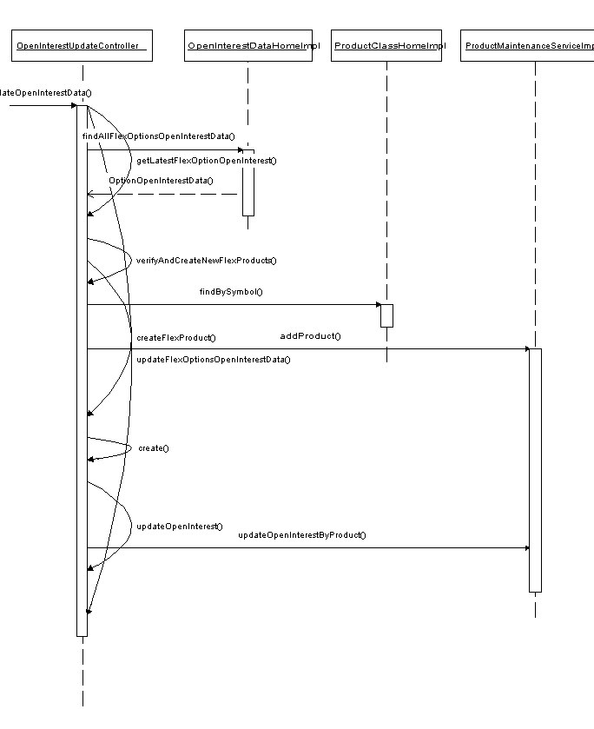

OPEN INTEREST Changes

OpenInterestUpdateController.java

Modified method updateOpenInterestData() to include open interest data for flex products

New method getLatestFlexOptionOpenInterest() to fetch open interest data from database

New method verifyAndCreateNewFlexProducts() to create new flex products from open interest data

OpenInterestDataHomeImpl.java

New method findAllFlexOptionsOpenInterestData() to query open interest data for flex products

FlexOptionOpenInterestDataImpl.java

New PersistentBObject implementation for flex products open interest data.

ProductQueryServiceImpl.java

New method getProductExtensionsByClasses(int[] classKeys) to query open interest data for given classkeys.

2.3 Order Entry

2.3.1 Regular Order

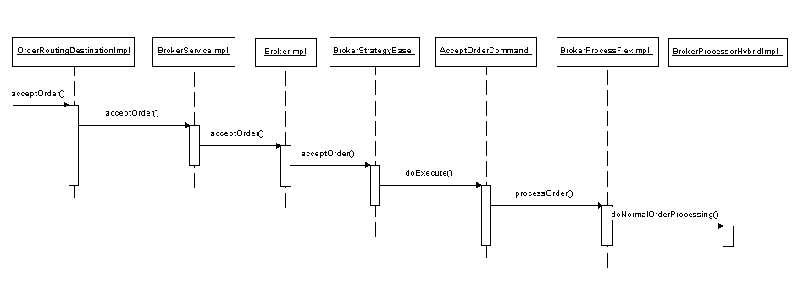

Auction Response 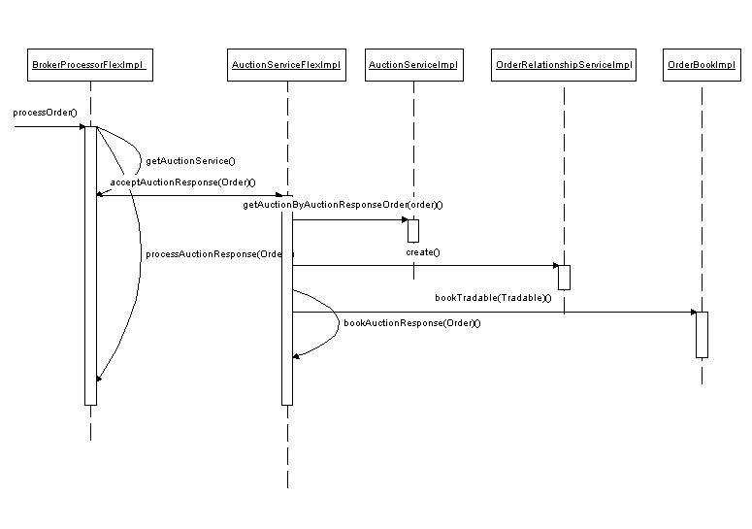

Order Entry Changes

SessionNamesEnum.java

Changes to add FLEX_MAIN session

BrokerProcessorFlexImpl.java

Changes to process Flex orders

OrderValidationFlexStrategy.java

Changes for TE specific validation for Flex orders

BrokerProcessorSpreadFlexImpl.java

Changes to process Flex orders

CancelReplaceValidator.java

Changes to get FLEX_MAIN session name for validation strategy

OrderValidationStrategy.java

Changes to add constant for FLEX_MAIN session name

BaseOrderImpl.java

New Fields added for persisting hedge instruction information for flex orders

ExtensionsFieldParser .java

Changes to parse extensions field to get hedge instructions.

2.3.4 Accept and Book Auction Response changes:

BrokerProcessorFlexImpl

Accepts flex auction response and delegates the request to AuctionServiceFlexImpl for processing.

AuctionServiceFlexImpl

Uses OrderRelationshipService to persist the auction response details in orderrelationship table.

Books the auction response in order book.

Order Book Hedge Instruction Query changes:

OrderBookServiceImpl

New method getOrderBookHedgeInstructions() to get hedge instruction data for a given product, at a given price.

2.3.5 Flex Auction Trading:
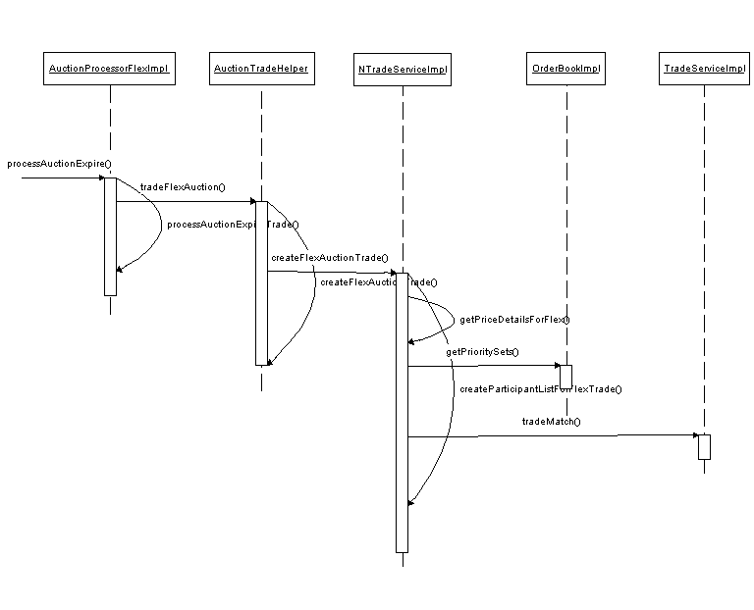

Files Changed:

AuctionProcessorFlexImpl.java

New method processAuctionExpire() ends the active flex auction

New method processAuctionExpireTrade() forwards the request to AuctionTradeHelper to create FlexAuctionTrade

Changes to cancel remaining auction responses after trading.

AuctionTradeHelper

New method tradeFlexAuction() to get trade price and trade quantity

New method createFlexAuctionTrade() delegates request to trade service for trade.

TradeServiceImpl

New method createFlexAuctionTrade() for trading flex auction responses and booked orders

New method getPriceDetailsForFlex() to take out tradables at price equal to or better than trade price.

New method createParticipantListForFlexTrade() gets priority sets of tradables from order book.

Scripts
- loadOpenInterest
Changes to load open interest for Flex Products for FLEX_MAIN session.

Database Changes:
- sbtorder
Changes to add new columns in table
HEDGE_EXEC_INSTR_TEXT VARCHAR2(256)
HEDGE_REF_TYPE NUMBER(1)
HEDGE_REF_PRICE VARCHAR2(12)
PRFCLTN_PRICE VARCHAR2(12)
DELTA_VALUE_AMT VARCHAR2(4)

SetContext
- None

XML/DTD
- ProductMaintenanceService.xml
New tag for FLEX_MAIN session.
- ProductMaintenanceService.dtd
Changes for new tag for FLEX_MAIN session

Client

CAS Changes

7.1.1 Open Interest

7.1.1.1 Sequence Diagram
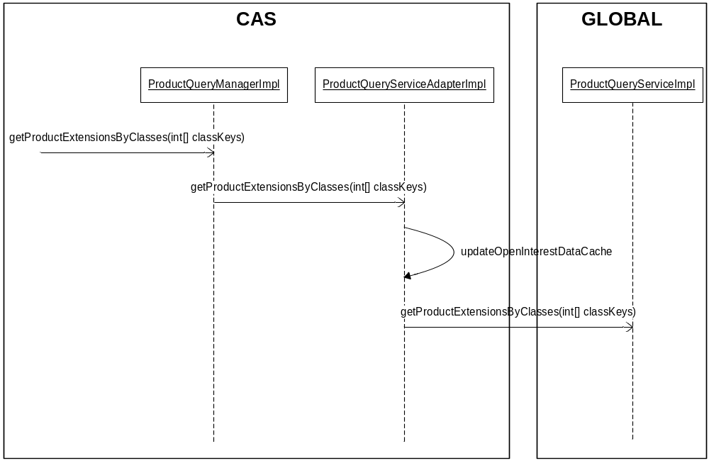

7.1.1.2 Code Changes

Below is the list of changes in cas for each of the features

For supporting Open Interest Query.

ProductQueryManagerImpl – Delgate to ProductQueryServiceAdapterImpl

ProductQueryServiceAdapterImpl – Query the Global to fetch the open interest data for products under the given list of classes and cache the same.

7.1.2 Market Data Subscription for All Classes

7.1.2.1 . Sequence Diagrams

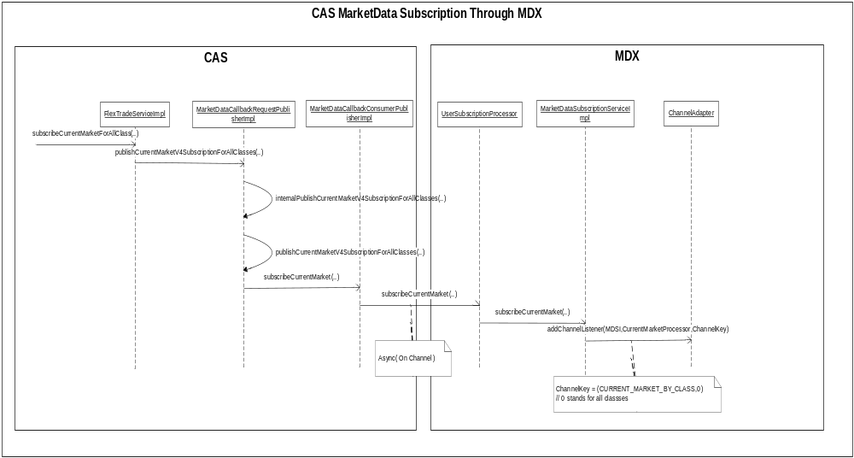

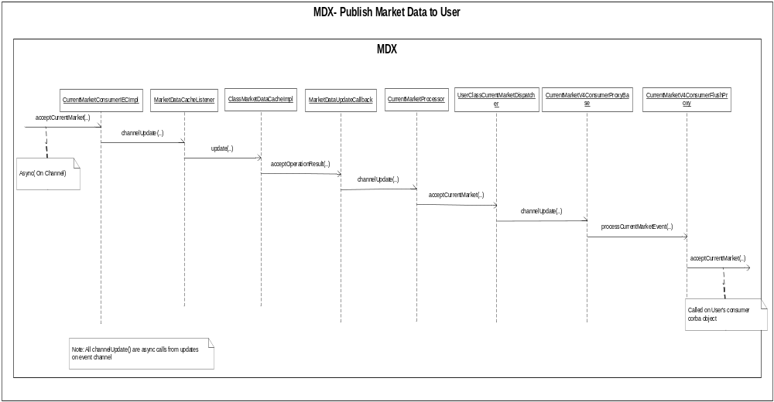

7.1.2.2 Code Changes

CAS :

Below are the list of major changes.For a complete list of changes, please refer to the attached xls file named Client_FilesChange.xls

      - MarketDataCallbackRequestPublisher: New Interface methods for subscribing for CurrentMarket,Ticker and Recap for all classes.
      - FlexTradeServiceImpl : Added Implementation for current market, recap and ticker subscription for all classes.

MDX

Below are the list of major changes.For a complete list of changes, please refer to the attached xls file named Client_FilesChange.xls

      - UserClassCurrentMarketDispatcher : Dispatch the current market event with classkey =0 . ClassKey =0 means all classes. Those who are subscribed for all classes will be listening on the channel with a classkey=0
      - UserClassRecapDispatcher: Dispatch the recap event with classkey =0 . ClassKey =0 means all classes
      - UserClassTickerDispatcher: Dispatch the ticker event with classkey =0 . ClassKey =0 means all classes
      - MarketDataSubsriptionServiceImpl : If the subscription request comes with a classekey =0, do not fetch the cached values. Classkey =0 stands for all classes.
      - MarketDataUpdateCallback : Publish the update event on the event channel with a classkey=0;
      - MarketDataListener : Publish the update event on the event channel with a classkey=0;
      - CurrentMarketV4ConsumerProxy: Publish the current market update if a subscription has been made for classkey =0;
      - RecapV4ConsumerProxy : Publish the Recap update if a subscription has been made for classkey =0;
      - TickerV4ConsumerProxy : Publish the Ticker update if a subscription has been made for classkey =0;
      - MiscConfigSetting : Read setContext variable SUBSCRIBE_FOR_ALL_MARKET_DATA

FIXCAS Changes

7.2.1 Open Interest Data Flow :

7.2.1.1 Sequence Diagram

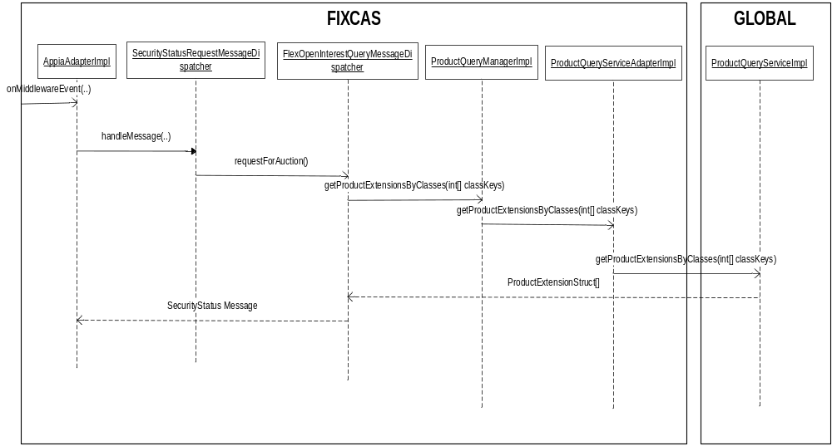

Code Changes

For supporting Open Interest Query.

SecurityStatusRequestMessageDispatcher –If the SubscriptionRequestType is OPEN_INTERST_QUERY, this dispatcher will delegate the request to the FlexOpenInterestQueryMessageDispatcher.

FlexOpenInterestQueryMessageDispatcher – This is the new dispatcher to handle the open interest query. This queries the ProductQueryServiceAdapter’s cache to fetch the data and sends the open interest data back to user in the SecurityStatus Message, one product at a time.

FIX Messages

a. InBound message to query for Open Interest.
Open Interest Query : 35 = e (Security Status Request Message)
S.No | Fix Tag | Is  UDF? | New  UDF? | Mandatory | Tag usage
1 | 55 - Symbol | N | N | Y | Trading Symbol Ex : 1IBM, 1AAPL.
2 | 9463- Subscription Request type | Y | N | Y | 508 = Flex Open Interest Wuery
3 | 324 - Security Status Req iD | N | N | Y | Must be a unique id.
4 | 336 - TradingSessionID | N | N | Y | FLEX_MAIN' for CFLEX
5 | 167 – Security Type | N | N | Y | FLEX' for FLEX Options

b. Outbound message to the user with the Open Interest Data.
Open Interest Query : 35 = f (Security Status Message)
S.No | Fix Tag | Is  UDF? | New  UDF? | Mandatory | Tag usage
1 | 55 - Symbol | N | N | Y | Trading Symbol Ex : 1IBM, 1AAPL.
2 | 48 - Security ID | N | N | Y | CBOE Direct Product Key
3 | 324 - Security Status Req iD | N | N | Y | The id with which request was made
4 | 336 - TradingSessionID | N | N | Y | FLEX_MAIN' for CFLEX
5 | 167 – Security Type | N | N | Y | FLEX' for FLEX Options
6 | 200 - MaturityMonthYear | N | N | Y | For Options or Futures to specify the  month and year of maturity. Format:  YYYYMM (e.g., 200204)
7 | 205 - Maturity Day | N | N | Y | Specifies the actual expiration day. For example, specifying “1” will mean the option expires on the first day of the month.  For Options or Futures and can be used in conjunction with MaturityMonthYear to  specify a particular maturity date.
8 | 201- PutOrCall | N | N | Y | 0 = Put, 1 = Call
9 | 202 - StriketPrice | N | N | Y | Strike price for the product
10 | 9314 - Open Interest | Y | N | Y | The Open interest quantity for this product

7.2.2 Market Data Flow for Fix

7.2.2.1 Sequence Diagrams

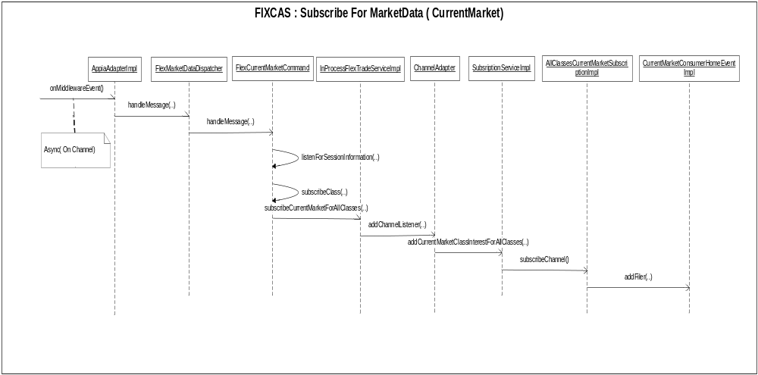

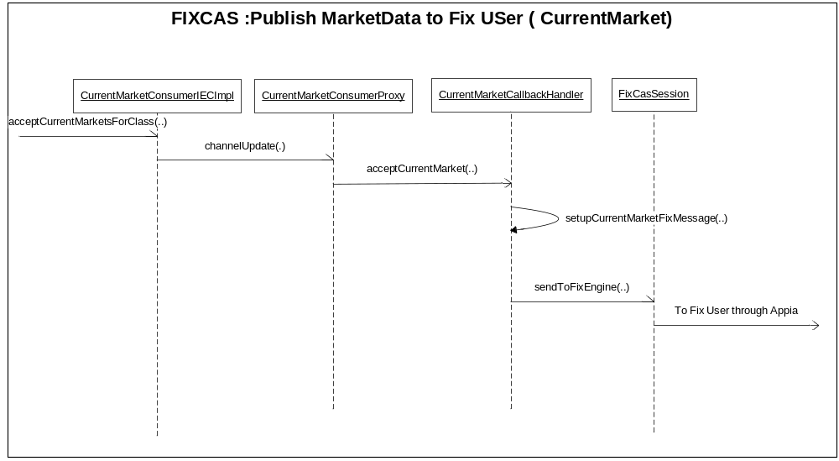

7.2.2.2 Code Changes for Fix Market Data:
Below are the list of major changes.For a complete list of changes, please refer to the attached xls file named Client_FilesChange.xls

      - CurrentMarketConsumerProxy – Added a check to allow publishing of current market if the channel key is CURRENT_MARKET_FOR_ALL_CLASSES
      - RecapConsumerProxy - Added a check to allow publishing of current market if the channel key is RECAP_FOR_ALL_CLASSES
      - TickerConsumerProxy - Added a check to allow publishing of current market if the channel key is TICKER_FOR_ALL_CLASSES
      - AllClassesCurrentMarketSubscriptionImp : New Subscription impl for handling subscription for current market for All classes
      - AllClassesRecapSubscriptionImpl : New Subscription impl for handling subscription for Recap for All classes
      - AllClassesTickerSubscriptionImpl : New Subscription impl for handling subscription for Ticker for All classes
      - SessionClassSubscriptionCollection : Interface methods to get subscription handlers for CurrentMarketForAllClasses,TickerForAllClasses and RecapForAllClasses
      - SubscriptionService : Interface methods for adding and removing Class interest for CurrentMarket,Recap and Ticker.
      - CurrentMarketConsumerHomeEventImpl : Add a new filter for current market subscription for all classes.
      - TickerConsumerHomeEventImpl : Add a new filter for ticker subscription for all classes.
      - Recap ConsumerHomeEventImpl : Add a new filter for Recap subscription for all classes.
      - CurrentMarketConsumerIECImpl : Publish current market for classkey =0
      - TickerConsumerIECImpl : Publish Ticker for classkey =0
      - RecapConsumerIECImpl : Publish Recap for classkey =0
      - MarketDataHelper : Hold the setcontext variable SUBSCRIBE_MARKETDATA_FOR_ALL_CLASSES ‘s value.
      - FlexMarketDataDispatcher: New dispatcher to handle flex market data messages
      - FlexTickerCommand : New command to handle flex ticker subscription request.
      - FlexCurrentMarketCommand : New command to handle flex current market subscription request.
      - FlexRecapCommand : New command to handle flex recap subscription request.
      - FlexTickerCallbackHandler : New Handler to process ticker callbacks

7.2.2.3 Fix Messages
      - Subscribe to Current Market : In the standard CBOE Market Data Request Message, send Symbol as “ _ALL_ “
      - Market Data Response : Same as today’s (Current) message.
      - Subscribe For Ticker : In the message as is today, send Symbol as “ _ALL_ “
      - Ticker Response : Same as Today’s(Current) message.
      - Recap Request : In the message as is today, send Symbol as “ _ALL_ “
      - Recap Response : Same as Today’s(Current) message

GUI

List of Files

Server Files Changed

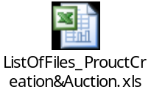

CAS/FIXCAS Files Changed

