Design: CFLEX2.0 Pending Trade

Overview

Requirement:
- Defined following information for different type of pending trades and sent to CTMR for trade matching.
    - Fixed Strategy trade—Leg Prices
    - Percentage Single Leg Trade- Strike Price
    - Percentage Strategy Trade- Strike/Premium Price and Leg Prices

Scope:
The term “Pending Trade” in FLEX refers to a trade that is done with incomplete information for clearing through OCC. Pending trades are not sent to CTMR until all the desired information is filled in. Till then they are stored in CBOEdirectTM. Once the required information is filled in, the trades are sent to CTMR for trade matching.
- Percentage Trades -
A percentage trade is a trade where the strike price denominated as percentage value rather than absolute value

- Strategy Trades
A strategy trade is done on the basis of net prices of legs. The individual leg trade prices should be filled in the trade report and sent to the CTMR for the trade matching

Implementation

IDL Changes

CMI IDL Modification
    - cmiStrategy.idl
struct LegTradePriceStruct
{
cmiProduct::ProductKey productKey;
cmiUtil::PriceStruct legTradePrice;
};
typedef sequence <LegTradePriceStruct> LegTradePriceStructSequence;

    - cmiConstants.idl

// New activity types for order history updates

interface ActivityTypes
{

const cmiTraderActivity::ActivityType NEW_PRODUCT = 21;
const cmiTraderActivity::ActivityType NEW_TRADE_PRICE = 22;
const cmiTraderActivity::ActivityType TRADE_PRICE_APPROVED = 23;
const cmiTraderActivity::ActivityType TRADE_PRICE_ON_HOLD = 24;
const cmiTraderActivity::ActivityType NEW_LEG_PRODUCT = 521;
const cmiTraderActivity::ActivityType NEW_LEG_TRADE_PRICE = 522;
const cmiTraderActivity::ActivityType LEG_TRADE_PRICE_APPROVED = 523;
const cmiTraderActivity::ActivityType LEG_TRADE_PRICE_ON_HOLD = 524;

}

    - cmiV10.idl

interface FlexTradeService
{
...
//new method to enter leg trade prices for pending trades
void acceptLegPricesForTrade (in cmiSession::TradingSessionName sessionName, in cmiProduct::ProductKey productKey,
in cmiUtil::CboeIdStruct tradeId, in cmiStartegy:: LegTradePriceStructSequence legPrices)
raises (
exceptions::SystemException,
exceptions::CommunicationException,
exceptions::AuthorizationException,
exceptions::DataValidationException,
exceptions::NotAcceptedException,
exceptions::TransactionFailedException,
exceptions::NotFoundException
);
//new method to enter trade price for percentage trades – simple and strategy products.
void setPriceForProduct(in cmiSession::TradingSessionName sessionName, in cmiProduct::ProductKey productKey, in cmiUtil::PriceStruct underlyingPrice, in cmiUtil::CboeIdStruct tradeId)
raises (
exceptions::SystemException,
exceptions::CommunicationException,
exceptions::AuthorizationException,
exceptions::DataValidationException,
exceptions::NotAcceptedException,
exceptions::TransactionFailedException,
exceptions::NotFoundException
);

}

Other IDL Modification:
    - TradeMaintenanceService.idl

New method to update trade status
boolean updatePendingTradeStatus(in cmiSession::TradingSessionName sessionName, in cmiProduct::ClassKey classKey, in cmiUtil::CboeIdStruct tradeId, in string userId, in cmiUtil::TradeStatus tradeStatus)
raises
(
exceptions::SystemException,
exceptions::CommunicationException,
exceptions::AuthorizationException,
exceptions::DataValidationException,
exceptions::NotAcceptedException,
exceptions::TransactionFailedException,
exceptions::NotFoundException
);

New method to enter leg trade prices for pending trades
void acceptLegPricesForTrade (in cmiSession::TradingSessionName tradingSessionName, in cmiProduct::ProductKey productKey,
in cmiUtil::CboeIdStruct tradeId, in string userId, in cmiStrategy:: LegTradePriceStructSequence legPrices)
raises (
exceptions::SystemException,
exceptions::CommunicationException,
exceptions::AuthorizationException,
exceptions::DataValidationException,
exceptions::NotAcceptedException,
exceptions::TransactionFailedException,
exceptions::NotFoundException
);

New method to enter trade price for percentage trades – simple and strategy products.
void setPriceForProduct(in cmiSession::TradingSessionName sessionName, in cmiProduct::ProductKey productKey, in cmiUtil::PriceStruct underlyingPrice, in cmiUtil::CboeIdStruct tradeId, in string userId)
raises (
exceptions::SystemException,
exceptions::CommunicationException,
exceptions::AuthorizationException,
exceptions::DataValidationException,
exceptions::NotAcceptedException,
exceptions::TransactionFailedException,
exceptions::NotFoundException
);

    - ProductMaintenanceService.idl

Method to create a fixed product from percentage product
cmiProduct::ProductStruct createProductFromPercentageProduct(in cmiProduct::ProductKeysStruct productKey, in cmiUtil::PriceStruct underlyingPrice)
raises (
exceptions::SystemException,
exceptions::CommunicationException,
exceptions::DataValidationException,
exceptions::TransactionFailedException,
exceptions::AuthorizationException,
exceptions::AlreadyExistsException
);

    - ohs.idl
interface OrderMaintenanceService
{
//New method to have order history with different activity Types
void acceptPendingFillReportStatusChange(
in order::OrderRoutingParameterStruct orderRoutingStruct,
in cmiOrder::OrderIdStruct orderId,
in cmiUtil::UpdateStatusReason statusChange,
in order::FillStructSequence fills,
in long transactionSequenceNumber,
in order::MarketDetailStructSequence marketDetailStruct,
in cmiTraderActivity::ActivityType activityType)
raises(
exceptions::SystemException,
exceptions::CommunicationException,
exceptions::DataValidationException,
exceptions::AuthorizationException,
exceptions::TransactionFailedException
);

    - ohsConsumers.idl

interface InternalOrderStatusConsumer {

// New method to have order history with different activity Types
void acceptPendingFillReportStatusChange(
in util::RoutingParameterStruct routingParameters,
in order::OrderRoutingParameterStruct orderRoutingStruct,
in cmiOrder::OrderIdStruct orderId,
in cmiUtil::UpdateStatusReason statusChange,
in order::FillStructSequence fills,
in long transactionSequenceNumber,
in order::MarketDetailStructSequence marketDetailStruct,
in cmiTraderActivity::ActivityType activityType);
};

Code Changes

Pending Trade Processing

Sequence diagram-

Fixed Strategy Pending Trades

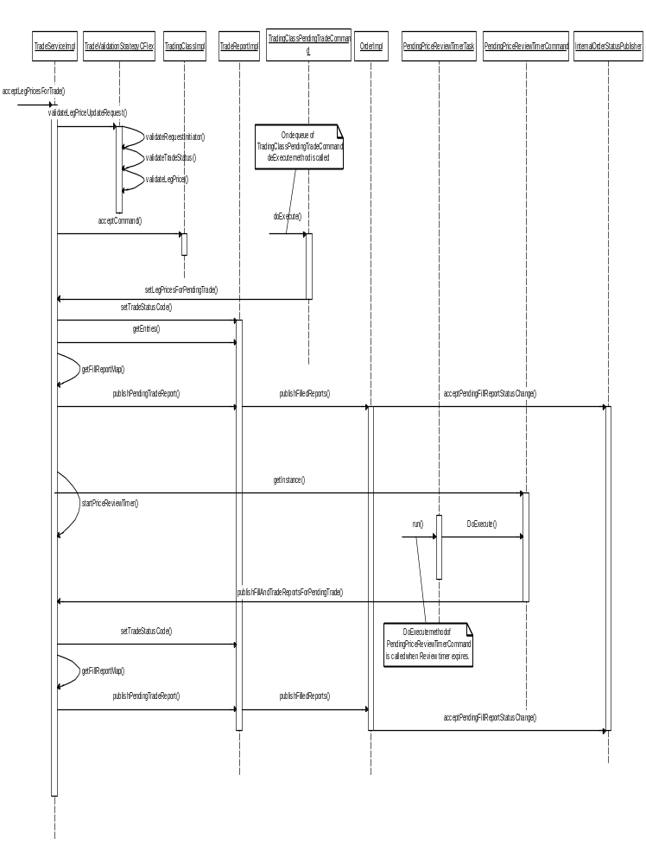

Fixed Strategy Pending Trades – Code Changes

TradeReportImpl.java

Modified method createPendingTrade() to set auctionId and initiatorBrokerUserId for pending trades.

ProductMaintenanceServiceImpl.java

New method createProductFromPercentageProduct() to create fixed product from original percentage product.

TradeServiceImpl.java

Modified method tradeMatch() to include a new method parameter which hold auctionId and initiatorBrokerUserId for pending trades.

Implement acceptLegPricesForTrade() method to define leg trade prices for pending trade.

Execute TradingClassPendingTradeCommand to hold class level lock.

Implements setLegPricesForPendingTrade() method to set leg prices and publish fill report with trade status as “REVIEW_LEG_PRICE”.

Implements setPriceForProduct() to set product price and trade price for percentage simple pending trades.

Implements startPriceReviewTimer() to start price review timer

Creates PendingPriceReviewTimerTask using PendingPriceReviewTimerCommand for duration set in “Pending Price Review Timer” TradingProperty.

Implements publishFillAndTradeReportsForPendingTrade() to approve price, publish fill report with trade status as “PRICE_APPROVED” and publish trade reports to CTMR.

Implemented method updatePendingTradeStatus() called by Helpdesk to update trade status of a pending trade.

TradeValidationStrategyCFlex.java

Validate User Id for trade

If trade status code is not Pending Leg Price, reject the request.

Validate request from Helpdesk user.

Validates summation of leg prices to be equal to strategy trade price.

If initiator order is present then summation is done with respect to the side of initiator i.e. initiator order is of Defined/ Opposite side.

If initiator does not place an order then summation is done according to the side of order which is placed first.

TradingClassPendingTradeCommand.java

Implementation to set leg prices for strategy products.

Implementation to create new product and calculate new trade price for percentage trades for simple products

PendingPriceReviewTimerTask .java

Implementation to execute PendingPriceReviewTimerCommand command

PendingPriceReviewTimerCommand.java

Implementation to call TradeServiceImpl to approve leg price, trade price and publish trade report to CTMR

OHSOrderEntryServiceImpl.java

Changes to implement new method acceptPendingFillReportStatusChange() to accept fill reports for pending trades.

OHSOrderEntryServiceDelegateImpl.java

Changes to publish pending trades fill reports for orders.

OrderImpl.java (OHS)

Modified method acceptFill() to update order history for given event type

OrderHistoryImpl.java

New method createHistoryForPendingTrades() to update order history for trade price and product updates for pending trades.

Scripts

None

Database Changes:

alter_sbtorderhistory_pendingTrades_CFLEX2.sql

New script to add under_sec_price column in sbtorderhistory

alter_sbt_tradereport_pendingTrades_CFLEX2.sql

New script to add auction_id and orig_product columns in sbt_tradereport

SetContext

XML/DTD

TradeValidationStrategy.xml

New strategy (TradeValidationStrategyCFlex.java) configured for FLEX_MAIN

List of Files

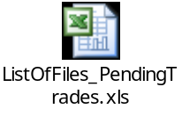

Client

CAS Changes

Classes and Interfaces

- FlexTradeService/FlexTradeServiceimpl/UserFlexTradeService/TradeMaintenanceServiceClientRoutingProxy/TradeMaintenanceServiceAdminClientRoutingProxy
Implemented the cmi methods to update leg price and strike price.

public void acceptLegPricesForTrade(String sessionName, int productKey, CboeIdStruct tradeId, LegTradePriceStruct[] legPrices) throws SystemException, CommunicationException, AuthorizationException, DataValidationException, NotAcceptedException, TransactionFailedException, NotFoundException

public void setPriceForProduct(String sessionName, int productKey, PriceStruct underlyingPrice, CboeIdStruct tradeId) throws SystemException, CommunicationException, AuthorizationException, DataValidationException, NotAcceptedException, TransactionFailedException, NotFoundException

FIXCAS Changes

Classes and Interfaces
- FlexLegPriceUpdateMessageDispatcher

Handles the fix message for leg price update

- FlexProductStrikePriceUpdateMessageDispatcher

Handles the fix message for product price update

- InProcessFlexTradeServiceImpl

Implemented the methods to update leg price and strike price.

public void acceptLegPricesForTrade(String sessionName, int productKey, CboeIdStruct tradeId, LegTradePriceStruct[] legPrices) throws SystemException, CommunicationException, AuthorizationException, DataValidationException, NotAcceptedException, TransactionFailedException, NotFoundException

public void setPriceForProduct(String sessionName, int productKey, PriceStruct underlyingPrice, CboeIdStruct tradeId) throws SystemException, CommunicationException, AuthorizationException, DataValidationException, NotAcceptedException, TransactionFailedException, NotFoundException
FIX Messages for Pending Trade Resolution

Accept Leg Prices For Trade ( InBoundMessage)
Message Type = U08
Tag | Field Name | Usage | Is New UDF For Flex
336 | Trading Session ID | This should be FLEX_MAIN | No
55 | Security ID | CBOEDirect Product Key | No
167 | Security Type | FLEX' for flex options | No
17 | ExecID | The CBOE Trade ID( highID  :LowId) | No
555 | No Of legs | Number of legs for which price needs to be resolved | No
Begin Repeating Group for No of Legs
606 | LegSecurityType | This should be the first tag in the repeating group.  It should be 'FLEX' for CFLEX | No
602 | Leg Security ID | CBOEDirect Product Key for the leg | No
566 | Leg Price | This is the trade price for the leg | No

Set Price For Product(InBound Message)
Message Type = U09
Tag | Field Name | Usage | Is New UDF For Flex
336 | Trading Session ID | This should be FLEX_MAIN | No
55 | Security ID | CBOEDirect Product Key | No
167 | Security Type | FLEX' for flex options | No
17 | ExecID | The CBOE Trade ID( highID  :LowId) | No
21024 | UnderLying Price | This is the price of the  underlying product  (Equity Or Index) | Yes

WebCAS Changes

GUI

