Design: CFLEX2.0 Product Class Creation

Overview

Requirement:
- CFLEX 2.0 Product Classes will be created through IPD. In addition to the existing fields, a CFLEX 2.0 Product Class will also have the exercise style.
- The SAGUI should also have a provision to create CFLEX2.0 Product Classes

Scope:
Product Class Creation for FLEX_MAIN session

Implementation

Sequence Diagram:

Server Design For Product class Creation using SA GUI:

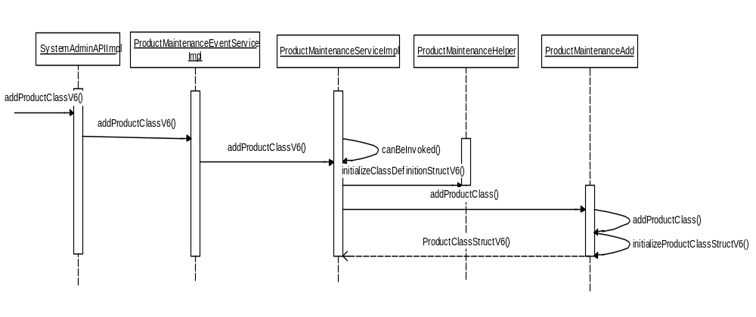

Server Design for Product Class Creation through IPD:

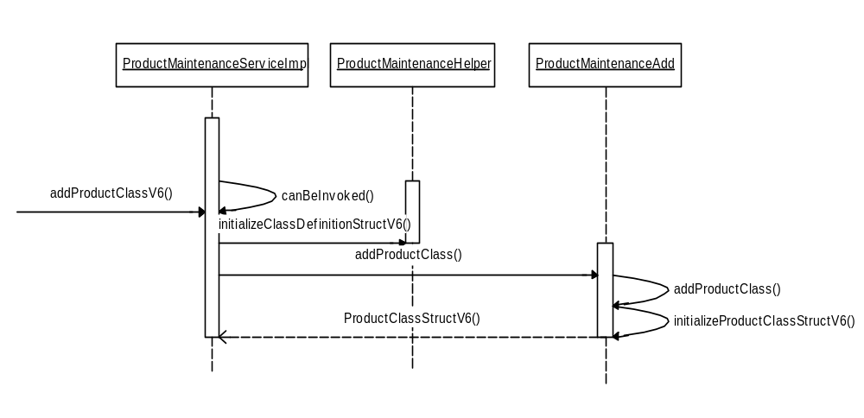

2.1 IDL Changes

2.1.1 CMI IDL Modification
  - Add a new product Type for CFLEX product

interface ProductTypes
{
...
const cmiProduct::ProductType FLEX_OPTION = 13;
}

  - Add a new constant for percentage price type.

interface PriceTypes
{
...
const cmiUtil::PriceType PERCENTAGE = 5;

}

  - New auction type for CFLEX

interface AuctionTypes
{
...
const cmiOrder::AuctionType FLEX_AUCTION = 9;
}

  - New constants for Exercise Style

typedef char ExerciseStyle;

interface ExerciseStyles
{
const ExerciseStyle None = 'N';
const ExerciseStyle American = 'A';
const ExerciseStyle European = 'E';
};

2.1.2 Other IDL Modification:
- product.idl

- New ClassDefinitionStruct with expirationStyle for CFLEX product

struct ClassDefinitionStructV6
{
ClassDefinitionStructV3 classDefinition;
cmiConstant::ExerciseStyle exerciseStyle;
};

struct ProductClassStructV6
{
product::ProductClassStructV3 prodClass;
cmiConstant::ExerciseStyle exerciseStyle
};
typedef sequence <ProductClassStructV6> ProductClassStructV6Sequence;

- ProductMaintenanceService.idl

- New method to add CFLEX product class

product::ProductClassStructV6 addProductClassWithKeyV6(in product::ClassDefinitionStructV6 updatedProductClass)
raises(
exceptions::SystemException,
exceptions::CommunicationException,
exceptions::DataValidationException,
exceptions::TransactionFailedException,
exceptions::AuthorizationException
exceptions::AlreadyExistsException
);

- New method to update CFLEX product class information

product::ProductClassStructV6 updateProductClassWithKeyV6(in product::ClassDefinitionStructV6 updatedProductClass)
raises(
exceptions::SystemException,
exceptions::CommunicationException,
exceptions::DataValidationException,
exceptions::TransactionFailedException,
exceptions::AuthorizationException
);

- New method to add CFLEX product class with session code

product::ProductClassStructV6 addProductClassV6(in product::ClassDefinitionStructV6 newClass)
raises(
exceptions::SystemException,
exceptions::CommunicationException,
exceptions::DataValidationException,
exceptions::TransactionFailedException,
exceptions::AuthorizationException,
exceptions::AlreadyExistsException
);

- New method to update CFLEX product class with session code

product::ProductClassStructV6 updateProductClassV6(in product::ClassDefinitionStructV6 updatedProductClass)
raises(
exceptions::SystemException,
exceptions::CommunicationException,
exceptions::DataValidationException,
exceptions::TransactionFailedException,
exceptions::AuthorizationException
);

- ProductQueryService.idl

  - New method to get product classes by class key

product::ProductClassStructV6Sequence
getProductClassesByKeyV6(in cmiProduct::ClassKeySequence productClassKeys, in boolean includeReportingClasses,
in boolean includeActiveOnly) raises(
exceptions::SystemException,
exceptions::CommunicationException,
exceptions::DataValidationException,
exceptions::AuthorizationException
);

  - New method to get product class by key

product::ProductClassStructV6
getProductClassByKeyV6(in cmiProduct::ClassKey productClassKey, in boolean includeReportingClasses,
in boolean includeProducts, in boolean includeActiveOnly) raises( exceptions::SystemException,
exceptions::CommunicationException,
exceptions::DataValidationException,
exceptions::NotFoundException,
exceptions::AuthorizationException
);

  - New method to get product classes by type

product::ProductClassStructV6Sequence
getProductClassesByTypeV6(in cmiProduct::ProductTypeSequence productTypes,
in boolean activeOnly, in boolean includeReportingClasses, in boolean includeProducts)
raises(
exceptions::SystemException,
exceptions::CommunicationException,
exceptions::DataValidationException,
exceptions::AuthorizationException
);

3. Global Server

3.1 Classes & Interfaces

  - ProductMaintenanceService:

Add new methods

- public ProductClassStructV6 addProductClassV6(ClassDefinitionStructV6 newClass)
Delegates the addition of product class to ProductMaintenanceAdd. This uses the session code and is called by the SAGUI.

- public ProductClassStructV6 updateProductClassV6 (ClassDefinitionStructV6 newClass)
Delegates the update of product class to ProductMaintenanceAdd. This uses the session code and is called by the SAGUI.

- public ProductClassStructV6 addProductClassWithKeyV6(ClassDefinitionStructV6 newClass)
Delegates the addition of product class to ProductMaintenanceAdd. This is called by the IPD.

- public ProductClassStructV6 updateProductClassWithKeyV6(ClassDefinitionStructV6 newClass)
Delegates the update of product class to ProductMaintenanceAdd. This is called by the IPD.

  - ProductMaintenanceAdd:

Add new methods

- public ProductClassStructV6 addProductClass (ClassDefinitionStructV6 newClass)
Persists the Product Class and publishes the creation of new product Class

  - ProductMaintenanceUpdate:

Add new methods

- public ProductClassStructV6 updateProductClassV6 (ClassDefinitionStructV6 newClass)
Persists the Product Class update and publishes the same

  - ProductQueryServiceImpl

Add new methods

- public ProductClassStructV6 getProductClassByKeyV6(int productClassKey,boolean includeReportingClasses,boolean includeProducts,boolean includeActiveOnly)
Returns the product class for the given classkey

- public ProductClassStructV6[] getProductClassesByKeyV6(int [] productClassKeys, boolean includeReportingClasses, boolean includeProducts, boolean includeActiveOnly)
Returns a list of product class structs for the given array of productclasskeys.

- public ProductClassStructV6[] getProductClassesByTypeV6(short[] productTypes, boolean activeOnly, boolean includeReportingClasses,boolean includeProducts)
Returns as list of product classes for the given product types.

  - ProductClass
Added getter and setter for the new field ExerciseStyle

  - ProductClassImpl
Added a new field ExerciseStyle ( corresponds to the new column) and the validation for the new Product Type.

3.2 Scripts
- None

3.3 Database Changes:
Addition of a new data field in table PROD_CLASS .This will store the Expiration Style as ‘European’ or ‘American‘ or ‘None’
Details for the column added:
- Field name: EXER_STYLE
- DDL: VARCHAR2 (1 BYTE)
- Java: String
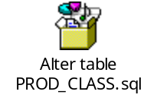

3.4 SetContext
- None

3.5 XML/DTD
- None

4. Client

4.1 SACAS Changes
  - ProductMaintenanceEventServiceImpl:

Add new methods

All the below methods perform delegates to the ProductMaintenanceService on Global Server
- public ProductClassStructV6 addProductClassV6(ClassDefinitionStructV6 newClass)

- public ProductClassStructV6 updateProductClassV6 (ClassDefinitionStructV6 newClass)

- public ProductClassStructV6 addProductClassWithKeyV6(ClassDefinitionStructV6 newClass)
- public ProductClassStructV6 updateProductClassWithKeyV6(ClassDefinitionStructV6 newClass)

  - ProductQueryServiceImpl

Add new methods

All the below methods perform delegates to the ProductQueryService on Global Server

- public ProductClassStructV6 getProductClassByKeyV6(int productClassKey,boolean includeReportingClasses,boolean includeProducts,boolean includeActiveOnly)

- public ProductClassStructV6[] getProductClassesByKeyV6(int [] productClassKeys, boolean includeReportingClasses, boolean includeProducts, boolean includeActiveOnly)

- public ProductClassStructV6[] getProductClassesByTypeV6(short[] productTypes, boolean activeOnly, boolean includeReportingClasses,boolean includeProducts)

5. GUI

5.1 SAGUI Changes

Changes for Navigation Panel in Product Definition Window
We don’t need a change for getting FLEX OPTION as a new product type on Product description window, as this screen is using ProductQuery to get all the active product types.

GUI is using getProductClassesByType() method of ProductQueryService to get the existing list of Product classes and same ProductClassStruct (which was returned from getProductClassesByType method) is used when user want to see the information of existing product class.

Below is the list of files which needs to be changed to get the existing product classes in FLEX_OTION.
1. ProductTypeTreeModel.java
When we are loading the Product Classes for a product type, we need to load ProductClassStructV6 to have the exercise style field available on GUI.
From getLoadProductClassesWorker() method, we need to give a call to getProductClassesByTypeV6 method of SystemAdminAPIImpl.

2. ProductClassDetailFactory
Add a method to create an instance of ProductClassDetailImpl using ProductClassStructV6

3. ProductClassModelFactory
Add a method to create an instance of ProductClassModelImpl using ProductClassStructV6

4. SystemAdminAPIImpl.java
Need to add a new method to get the list of all product classes for the FLEX OPTION.
ProductClassStructV6[] getProductClassesByTypeV6(short[], boolean, boolean, boolean){}

Sequence Diagram

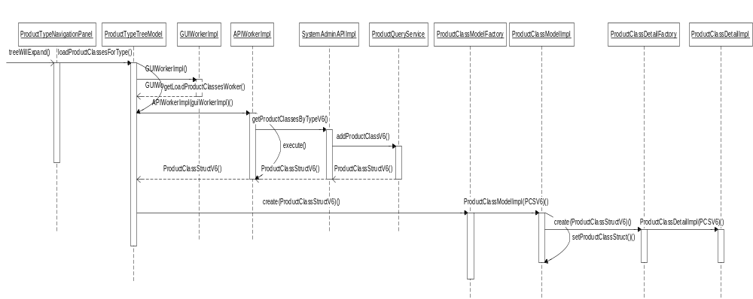

Changes for Product Class Creation panel in Product Definition Window
When user hit GUI Buttom “Add new option Class” in Product Definition window, it shows the EditProductClassPanel.java, which has all the fields needed for a new product class definition.
After filling up all the required fields, when user clicks on “save changes” button, actionlistener will give a call to saveChanges() method of EditProductClassPanel.java. As this is an API call which would hit SA-CAS, it uses APIWorker to call SystemAdminAPIImpl.java. This is the class which would finally gives a CMi call to ProductMaintenanceEventService in SA-CAS for product class creation using addProductClassV6 (ClassDefinitionStructV6) method.

Below are the list of files which needs to be changed for creating a new product class for FLEX_MAIN session using product definition window.
1. EditProductClassPanel.java
In this panel, we need to add a radio button for selecting the Exercise Style for the new class.

2. ProductClassModelImpl.java
Add a new constructor to set the ProductClassStructV6 parameters.

We also need to add a new method to create ClassDefinitionStructV6.
ClassDefinitionStructV6 getClassDefinitionStructV6(){}
This method would be internally calling to buildClassDefinitionStructV6 () of ProductStructBuilder for struct creation. After setting the values, we need to pass the same struct to SystemAdminAPIImpl for product class creation.

3. SystemAdminAPIImpl.java
Now the ClassDefinitionStructV5 would be sent to SA-CAS using the new method call mentioned below.
ProductClassStructV6 addProductClassV6 (ClassDefinitionStructV6){}
Also we need to add a method which would return the newly created class with reporting class struct
ProductClassStructV6 getProductClassByKeyV6(int, boolean, boolean, boolean){}

4. ProductTypes.java
Add FLEX_OPTION as a new product type.

5. ExcerciseStyles.java (New file)
Create a new formatter for exercise style.

6. ProductStructBuilder.java (from domain vob)
Add a new method buildClassDefinitionStructV6() for creating a new ClassDefinitionStructV6 struct.

7. ProductClassDetailImpl.java
Add a new constructor to set the ProductClassStructV6 parameters.

Sequence Diagram:

