

SYSTEMS DIVISION

Architecture Document

Flex GUI

Prepared by:
David Wegener
January 14, 2011

CBOE CONFIDENTIAL AND PROPRIETARY

Change History

Version | Date | Author | Description
1.0 | 1/14/11 | David Wegener | Created
1.1 | 3/30/11 | Pawan Wattamwar | Updated based in WS Security meetings. Key updates:  - Gateway to be DMZ  - IP address validation using Object Infrastructure Security Service

FLEX GUI Architecture Document

This document outlines the architecture for the new FLEX GUI. The basic architecture is a Java client connecting to a Web Service CAS. The Java Client will be a Web Start application that will be downloaded to the client PC. The Web Service CAS will be a CAS process with the addition of a Web Service front end. It will be similar to a FIX CAS. The Web Service will process SOAP requests from the client by translating the SOAP message structs into CMI structs and invoking CAS Application layer interface calls which contain CMI API constructs. Responses will be translated back into SOAP messages and sent to the client. The client will also need to run a Web Service to receive market data back from the server. The client and Web Service CAS will use WS-Security policies to protect the privacy and integrity of the data.
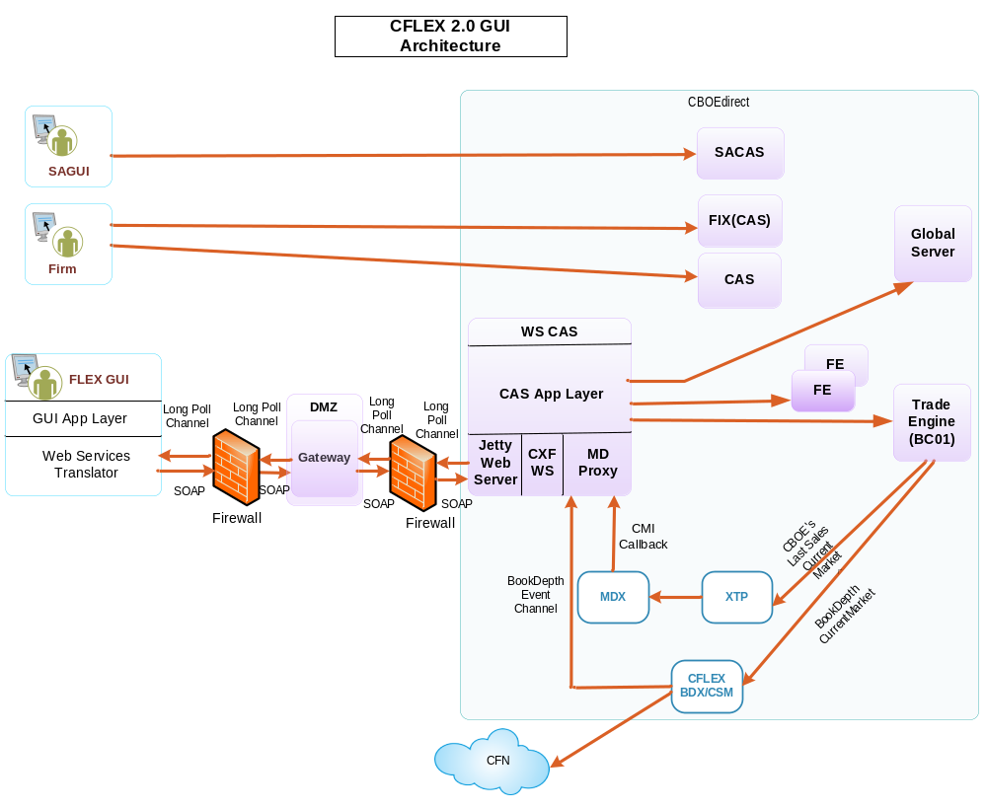

Java Client
The client will be a Web Start application. It will use code signed jar files to allow access to local resources on the host PC and to insure authenticity of the code. The client will register the market data end point reference with the Web Service CAS. The Web Service CAS will use the reference for returning market data. The application needs to be able to run on Windows XP, Vista, and Windows 7. The CBOE GUI frameworks and Trader GUI components are available copied into the new code base if applicable.

Web Service CAS
The Web Service CAS used for the gui will provide client access via a Web Service interface instead of the traditional CMI interface. This is similar to how the FIX CAS servers work. The Web Service interface will have methods and structs that parallel the CMI interface for all features needed for the client to support FLEX. The Web Service interface will act as an adapter to translate SOAP requests to and from CMI requests. The Web Service CAS will need to include both a Web Server (Jetty) and a Web Service runtime (CXF) to make the interfaces available to clients.

The Web Service CAS will also need to provide a Market Data Proxy. This proxy will need to maintain current market and book depth callback instances in order to provide market data back to the client. The current market data will be coming from MDX(Market Data Server), and Book Depth information form the CFLEX BDX server. The Web Services CAS will need to maintain the callbacks based on subscription requests from the client. It will need to invoke the appropriate client Web Service to deliver the data.

The Web Services will need to be developed using structs that correspond to CMI structs. An adapter framework will also need to be developed to translate back and forth between the Web Service structs and the CMI structs.

Keep alive/age sessions
The Web Service CAS will need to implement a mechanism to keep track of client sessions. The Web Service CAS will need the ability to monitor the sessions to identify when the client is no longer available. This will need to tie into the existing session management service provided by the CBOE Infrastructure. It will also need to interface with the Market Data Proxy to make sure that data subscriptions remain in sync with active clients.

Secure communications/Authentication
In order to protect the parties involved, communications between the client and the Web Service CAS will need to be secured. Security will require both encryption to prevent eavesdropping as well as signing to prevent message tampering. Both the client and the Web Service CAS should utilize HTTPS and WS-Security policies to secure the communications.

A procedure will need to be developed to insure that the proper security keys are generated and registered.
IP based validation and user authentication will be required using CBOEdirect Security services. The authentication would be done by Object Infrastructure Security Service running on gc2a. The authentication would be done two steps:
- User Authentication
- For user id marked as restricted, the IP address would be checked. There are 3 types of IP address validation supported:
  - Single IP Address
  - Subnet
  - IP Address Range
Table, SECURITYUSER, in infra GCD would be used for IP address validation

