Design: CFLEX2.0 Auction Creation

Overview

Requirement:
- Flex User should able create a FLEX Auction (Simple Auction or Strategy Auction) for an existing product as well as for new product using new Web-CAS.

Scope:
Simple Flex Auction and Strategy Flex Auction creation for FLEX_MAIN session

Implementation

2.1 IDL Changes

2.1.1 CMI IDL Modification
- None

Other IDL Modification:
- None

3. Global Server

3.1 Classes & Interfaces
- None

3.2 Scripts
- None

3.3 Database Changes
- None

3.4 SetContext
- None

3.5 XML/DTD
- None

4. Client

WebCAS Changes

4.1.1 Classes & Interfaces

ConfiguarationServlet.java

Added the new service FlexAuctionService for initialization and added the CBOEJSONConveter and register the convetors for converting CMI structs into lightweight POJO classes.

FlexAuctionService.java

This is the comed service which receives the request from client on Auction Creation channel and which dispatched the data to CAS services FlexTradeService for processing. After fetching the returned auctionStruct is delivered back to client.

WebCasAuctionRequestDispatcher.java

This receives request from service and calls the WebCasAdapter to fetch the session and after that the appropriate service i.e. FlexTradeService to put request for auction. Based on the actionID the further request is initialized i.e. Simple FLEX Auction creation or Strategy Auction Creation.

WebCasDispatcherFactory.java

This class initializes the WebCasAuctionRequestDispatcher based on actionID provided.

WebCasAdapter.java

This class is used to fetch the current user Session using method getSession method using sessionID.

WebCasSession.java

This class stores the session and fetched WebCasAccessManager using method getWebCasAccessManager().

WebCasAccessManager.java

This class holds the methods the to get references of existing CAS service. Added a new method getFlexTradeService() for fetching WebCasInProcessFlexTradeService. From where FlexTradeService is called and requestForAuction method returns the Struct AuctionStruct.

WebCasInProcessSessionManagerImpl.java

This is the class which provides session management methods and starts the required CAS services .Added a new method getWebCasInProcessFlexTradeService () to get the service WebCasInProcessFlexTradeService.

WebCasInProcessFlexTradeService.java

Added a new service in CAS for handing the trade requests like subscribe to CurrentMarket, ticker, Auction and unsubscribe .This is initialized with the session created by the FLEX user login.

WebCasInProcessFlexTradeServiceImpl.java

This class is the implementation of WebCasInProcessFlexTradeService.

WebCasInProcessFlexTradeServiceHome.java

This is the home Interface used to deploy this service in CAS.

WebCasInProcessFlexTradeServiceHomeImpl.java

This class is the implementation of WebCasInProcessFlexTradeServiceHome interface which creates the instance of WebCasInProcessFlexTradeServiceImpl.

CboeJSONPojoConverterFactory.java

This Class is wrapper over the JSON converter functionality which takes the object and initiates the respective object converter class.

CboeJSONPojoConverter.java

This class converts POJOs to JSON and vice versa.

Sequence diagram:

Flow for simple Flex Auction Creation:

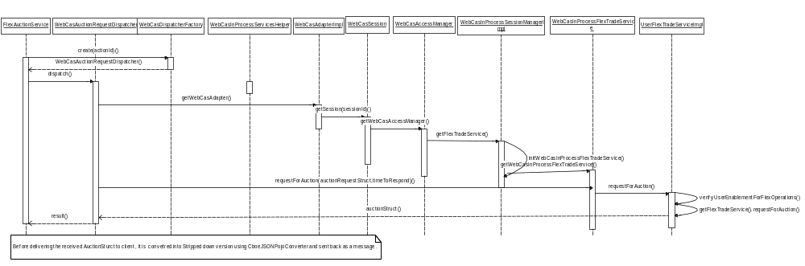

5. GUI

5.1 FlexGUI Changes

5.1.1 Changes for Auction Creation Screen
We need to create below mentioned files for giving a call to WCAS for logon.

- AuctionCreationFrame.java
Whenever user right clicks on any of the product class from product class tree and clicks on “Start Auction”, we would be launching a new frame which has the entire panel for Auction creation.

- AbstractButtonPanel.java
We would create an abstract panel which would contain only create auction and cancel button and initialize the listeners for these buttons.

- AuctionCreationPanel.java
This panel would be having the Product creation panel and auction selector panel to select the auction type, either FLEX Auction or AIM auction.

- ProductCreationPanel.java
This panel will show a drop down to select the underlying product classes, price type, and Settlement type and expiration style for the product. We would be using this information to find FLEX product class.

- ProductClassFinder.java
This class would return the Flex product class based on the Settlement type and expiration style selection.

- AuctionSelectorPanel.java
This panel would be having the FLEX Auction panel and AIM auction panel. Based on the radio button selection, we would be showing the appropriate panel to user.

- FlexAuctionModel.java
This would gather all the data from GUI required for starting an FLEX Auction. If product details contain only one leg, we would be creating an AuctionRequestStruct, otherwise we would be creating an StrategyAuctionRequestStruct.

- FlexAuctionPanel.java
This class would be having all the components required for FLEX-Auction creation, example, T1 timer, buy/sell side quantity, etc.

- HedgePanelForPercentage.java
If user selects the product’s price type as percentage, he can specify the instructions for delta hedging. This class would be having all the components required for hedge instructions.

- LegInformationPanel.java
In FLEX_OPTION, we can create a product with one or more legs. This class would have all the components required to define a leg. Ex. Side, ratio, option type, etc.

- AuctionServiceAPI.java

- FlexAPIFactory.java
Need to add a finder method which would return an instance of AuctionServiceAPI.

- FlexAPIFactoryImpl.java
We need to implement the finder method of AuctionServiceAPI for the FLEX GUI.

- DeltaHedgeInstructions.java
Create an enum which lists all the supported values for delta hedge instructions.

- ExpirationStyle.java
Create an enum which enlist all the expiration styles supported for FLEX_MAIN session.

- OptionType.java
Create an enum to list all the option types for a product.

- PriceType.java
Create an enum to have all the supporting price types for FLEX GUI.

- SettlementType.java
Create an enum which has all the supported settlement types for FLEX_MAIN session.

- Side.java
Create an enum which lists all the supported values of sides in FLEX_OPTION.

- SessionName.java
We would list FLEX session and sub-session name in this enum.

5.1.3 Sequence Diagram:
  - FLEX Auction Flow:

