Design: CFLEX2.0 User Logout

Overview

Requirement:
- Flex User should able to successfully logout from new WebCas.

Scope:
User logout for FLEX_MAIN session

Implementation

2.1 IDL Changes

2.1.1 CMI IDL Modification
- None

Other IDL Modification:
- None

3. Global Server

3.1 Classes & Interfaces
- None

3.2 Scripts
- None

3.3 Database Changes
- None

3.4 SetContext
- None

3.5 XML/DTD
- None

4. Client

WebCAS Changes

4.1.1 Classes & Interfaces

LogoutService.java

This is the comed service which receives the request from client on Logout channel and which dispatches the data to CAS services for processing. After proper logout , the result is delivered back to client.

WebCasLogoutDispatcher.java

This call receives request from service and calls the WebCasAdapter to fetch the session and after that call is placed to the sessionManager for logoff.

WebCasDispatcherFactory.java

This class provides the WebCasLogoutDispatcher based on actionID provided.

WebCasInProcessServicesHelper.java

Added a method in this class to get the WebCasAdapter .

WebCasAdapterImpl.java

This class is used to fetch the current user Session using method getSession method using sessionID.Added a new method removeSession which fetches the session stored using SessionID.

WebCasSession.java

This class stores the session and fetched WebCasAccessManager using method getWebCasAccessManager().Added a new mthod here stop() to initiate the CAS logoff on WebCasAccessManager.

WebCasAccessManager.java

This class holds the methods the to get references of existing CAS services. Added a new method initiateCasLogoff() which checkes for no pending logoff request and successful login before actually starting log off. This calls the SessionManager and invokes the logout method.

WebCasInProcessSessionManager.java

This class extends the sessionManagerImpl which has method logout to be invoked from WebCasAccessManager and publish the logout on channels.

Sequence diagram:
Webcas Logout flow:
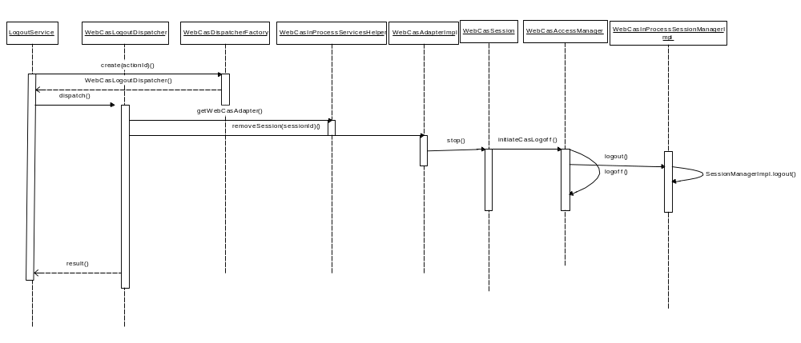

5. GUI

5.1 FlexGUI Changes

5.1.1 Changes for Logout
Below mentioned classes needs to be change to logout a user.

- MainWindow.java
When user clicks on close button, it would call cleanUpAndExit() method. If user is logged in, then we would give a call to method perfromLogout(). This would create a SwingEventThreadWorker to give a call to Web-CAS.

- LoginAPI.java
We would be writing one new method logout(), which would publish the data on logout channel of cometd.
The cometd listener would be listening to logout channel for force logout message. If GUI receives any force logout message, it would show a pop-up to user that you have been force logout by Help desk user and the GUI would close.

5.1.3 Sequence Diagram:
  - FLEX GUI Flow:

