Design: CFLEX2.0 Order Entry

Overview

Requirement:
- Flex User should able to enter order for the session FLEXMAIN on existing product.

Scope:
Order should be accepted from FLEX GUI for existing simple as well as Strategy Products.

Implementation

2.1 IDL Changes

2.1.1 CMI IDL Modification
- None

Other IDL Modification:
- None

3. Global Server

3.1 Classes & Interfaces
- None

3.2 Scripts
- None

3.3 Database Changes
- None

3.4 SetContext
- None

3.5 XML/DTD
- None

4.

Client

WebCAS Changes

Sequence Diagram

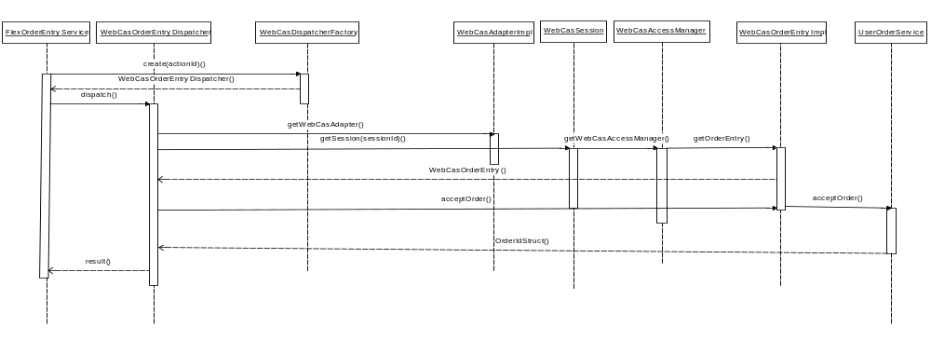

Classes and interfaces

OrderEntryService.java

This is the comed service which receives the request from client on OrderEntry channel and which dispatched the data to CAS services for accepting the new order. After creating the new order OrderIdStruct is delivered back to client.

WebCasOrderEntryDispatcher.java

This call receives request from service and calls the WebCasAdapter to fetch the session and after that the appropriate service i.e WebcasOrderEntry. Client send a the methodname to invoke on the fetched service ,so calls are palced according to the requested method from client and result struct is sent into a map back to client.

WebCasDispatcherFactory.java

This class initializes the WebCasOrderEntryDispatcher based on actionID provided.

WebCasAdapterImpl.java

This class is used to fetch the current user Session using method getSession method using sessionID.

WebCasSession.java

This class stores the session and fetched WebCasAccessManager using method getWebCasAccessManager().

WebCasAccessManager.java

This class holds the methods to get references of existing CAS service. Added a new method getOrderEntry() for fetching WebCasOrderEntry service ,from where using acceptOrder or acceptStrategyOrder method the new orders are entered.

WebCasConstants.Java

This class contains all the required constants to match up the client and Service calls.

WebCasOrderEntry.java

This is the new service Interface added to call the existing CAS service UserOrderService and call acceptOrder Method.

WebCasOrderEntryInterceptor.java

This is the Interceptor generated for WebCasOrderEntry service.

WebcasOrderEntryHome.java

Home interface for WebCasOrderEntry Service to add the Service into CAS.xml.

WebCasOrderEntryHomeImpl.java

This is the Implementation class for Home interface of WebcasOrderEntry Service which creates instance of WebCasOrderEntryImpl.

WebcasOrderEntryImpl.java

This is the implementation for WebcasOrderEntry Service.

5. GUI

5.1 For Auction Information Screen

We need to create below mentioned files to display auction information in a tabular view.
- AuctionEventMessage.java
Define an interface which defines the getter methods for each column of the table.

- AuctionEventMessageImpl.java
This would be the actual implementation of the AuctionEventMessage, where we would be specifying the values for each getter method.

- AuctionEventPanel.java
Define one panel which would consist of a table component for all the auction events. We would be removing all the expired auctions from the table.

- AuctionEventRowRenderer.java
We need to define a decorator which would specify color for each row depending upon the auction status.

- AuctionEventTableConfig.java
We need to define the table configuration like visible column names, their order of appearance, template row header and Table Model used by that table.

- AuctionEventTableModel.java
We would be creating a table model for the auction events. This model would listen on IEC channel for auction events. If an event is received, a row is inserted or updated based on the auction id of that event. If auction status is expired, then we would be removing that row from the model.

- EventMouseAdapter.java
We need to define a mouse adapter which would be implementing all mouse related events like right click on a table row, etc.

- EventTabbedPane.java
We would be creating a tabbed pane where all the screens like auction information, order status, etc would be rendered.

- EventTableConfig.java
We would be defining an abstract class, which would be extended by all the event tables.

- AuctionEventTableRow.java
We would define a class which would use AuctionEventMessage to create a table row.

- EventMessageListener.java
Define an interface, which consist of all the methods required to add, update or remove auction event message from table model.

- AuctionEventListener.java
Create a listener which would be continuously listening on CometD channel. If it receives an auction event on the channel, it would publish that event on IEC channel.
- ProductCache.java
We would be creating one product cache which would be built whenever user is selecting a product class in the product class tree. Whenever GUI receives an auction event on a new product which is not available in cache, it will query for product using the product key.

- ProductClassFinder.java
Need to add a finder method for a product class using class key.

- ProductImpl.java
Create a new class which would be implementing Product interface and we would be using this class to format product name.

- StrategyImpl.java
Create a new class which would be implementing Strategy interface and we would be using this class to format strategy name.

- StrategyLegImpl.java
Create a new class which would be implementing StrategyLeg interface and we would be using this class to format strategy leg name.

5.2 For Order entry, Auction Response and Execution screen
- AbstractSubmitCancelButtonPanel.java
Create an abstract panel, which consist of submit and cancel button and action for those buttons.

- AddNewOrderFrame.java
Create a new frame for entering an order.

- AddNewOrderPanel.java
Create a new panel which would have product information, price information and clearing information. This would be extending the abstract button panel and provide implementation for accept order.

- AddOrderBrokerDetailPanel.java
This panel would be showing all the clearing information needed during order entry.

- OrderEntryModel.java
We need to define a model which needs to be populated during order entry.

- PriceInformationPanel.java
This panel would show all the order specific entries like price, quantity, side and hedge instructions for auction.

- ProductInformationPanel.java
This panel would show the product information in view-only mode for auction response and order entry.

- RespondAndExecuteFlexAuctionFrame.java
Create a new frame for auction response.

- RespondAndExecuteFlexAuctionPanel.java
Create a new panel which extends abstract button panel and show product information, price information and clearing information for auction response.

- WithdrawFromFlexAuctionFrame.java
Create a new frame for auction withdrawal.

- WithdrawFromFlexAuctionPanel.java
This panel would be showing product information and takes user confirmation for auction withdrawal.
- OrderEntryService.java
Create an interface which has all the methods for order entry.

- SubscriptionListener.java
Create an interface which would be implemented by each and every class which needs to subscribe on any event channel.

- ContingencyType.java
Create an enum which has the entire list of supported Contingency for FLEX_MAIN session.

- OrderOriginType.java
Create an enum which has the entire list of supported order origin types for an order of FLEX_MAIN session.

- FlexAPIFactory.java
Need to add a finder method which would return an instance of OrderEntryServiceAPI.

- FlexAPIFactoryImpl.java
We need to implement the finder method of OrderEntryServiceAPI for the FLEX GUI.
This would get the client session object from ClientSession class and uses the same to publish the data.

- FlexAPIHome.java
Need to add a finder method which would return an instance of OrderEntryServiceAPI.

- AuctionServiceAPI.java
New web API for auction service needs to be defined which would actually implement the flex trade service methods required for FLEX GUI.

- OrderEntryServiceAPI.java
New web API for order entry service needs to be defined which would actually implement all the methods of order entry service.

5.3 For Open Interest and Product Information
- ProductOpenInterestPanel.java
Create a new panel to display list of products in table from product cache, which are having open interest as non-zero.

- ProductOpenInterestTableConfig.java
Create a table configuration for open interest table.

- ProductOpenInterestTableModel.java
Create a new table model for open interest table.

- ProductInformationAndStatusPanel.java
Create a new panel which would display all the products along with the product state and open interest on that product.

- ProductInfoMouseAdapter.java
Create a new adapter which would handle all the mouse events on the product information table. We would be creating a pop-up menu which would have option to enter a buy/sell order and to start flex auction on existing product.

- ProductInformation.java
Create an interface which would have all the methods required for product information and open interest.

- ProductInformationImpl.java
Create a new class which has all implementation for product information.

- ProductInfoTableConfig.java
Create a table configuration for product information table.

- ProductInfoTableModel.java
Create a table model for product information table.

- ProductInfoTableRow.java
Create a table row which has all the list of columns for both product information and open interest tables.

- ProductCache.java
Create a cache which would have all load all the products whenever user selects a product class. This cache would listen on IEC channel for product state updates and product/strategy updates.
- ProductStatusEventListener.java
Create a listener which would be listening on product status channel. Whenever a product state is updated, this would be publishing the updated product status on IEC channel.

5.4 For Order Status Window
We need to be created for getting order status in main window.
- OrderStatTableConfig.java
Create a table configuration for order status table.

- OrderStatusMessage.java
Create an interface which would have all the methods required for an order.

- OrderStatusMessageImpl.java
We would be implementing all the methods required to render order information in the order status table.

- OrderStatusMouseAdapter.java
We would create a mouse adapter which would handle all mouse events of order status table.

- OrderStatusPanel.java
We need to create a panel which would render the order status table and a refresh panel to filter the orders based on user selection.

- OrderStatusRefreshPanel.java
A refresh panel needs to be created which will have the product class and product drop down.

- OrderStatusTableModel.java
We need to create a table model for order status table which would render all the orders for the logged in user. This would be doing a query to order cache.

- OrderStatusTableRow.java
We need to create a class to define the list of columns which would be there in order status table.

- OrderQueryCache.java
We need to create a order cache which would built when user is logged in and it would listen on order event listener for further updates.
- OrderEventListener.java
We need to create a listener which would listen for order event from Web-CAS.

5.1.1 Sequence Diagram:

Auction Information Screen

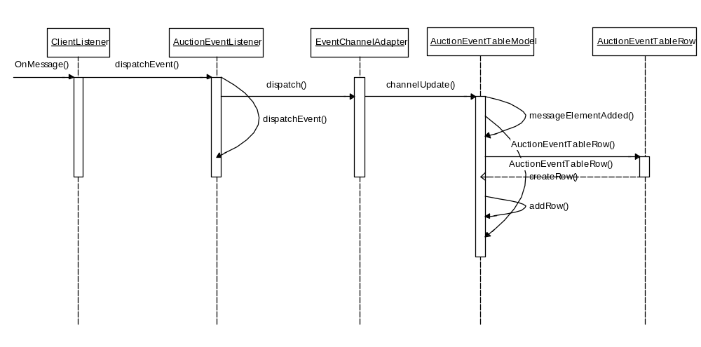

New Order entry

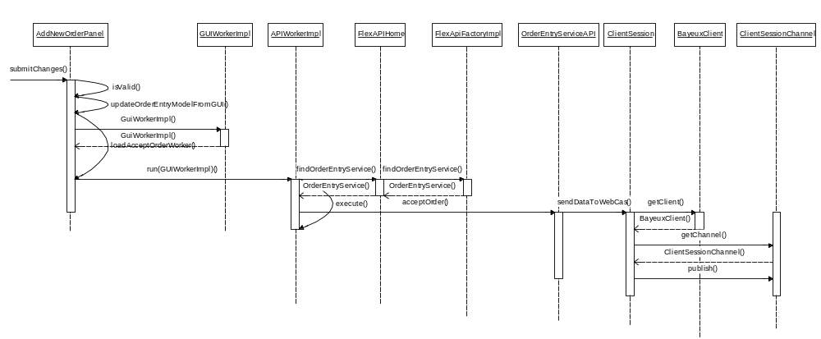

Auction Response

