Design: CFLEX2.0 Product Query

Overview

Requirement:
- Flex User should able to see the all product classes for the session FLEXMAIN.

Scope:
All the Product classes with product type 13 (i.e Session FLEXMAIN) should be fetched through Global Database and rendered on FLEXGUI.

Implementation

2.1 IDL Changes

2.1.1 CMI IDL Modification
- None

Other IDL Modification:
- None

3. Global Server

3.1 Classes & Interfaces
- None

3.2 Scripts
- None

3.3 Database Changes
- None

3.4 SetContext
- None

3.5 XML/DTD
- None

4. Client

WebCAS Changes

4.1.1 Classes & Interfaces

ProductQueryService.java

This is the comed service which receives the request from client on Productquery channel and which dispatched the data to CAS services for processing. After fetching the product classes the result is delivered back to client.

WebCasProductQueryDispatcher.java

This call receives request from service and calls the WebCasAdapter to fetch the session and after that the appropriate service i.e ProductQueryManager to get ProductClasses for input ProductType.

WebCasDispatcherFactory.java

This class initializes the WebCasProductQueryDispatcher based on actionID provided.

WebCasAdapter.java

This class is used to fetch the current user Session using method getSession method using sessionID.

WebCasSession.java

This class stores the session and fetched WebCasAccessManager using method getWebCasAccessManager().

WebCasAccessManager.java

This class holds the methods the to get references of existing CAS service. Added a new method getProductQuery() for fetching ProductQueryManager. From where using getProductClasses method the product classes are fetched as an array of CMI Struct ClassStuct.

CMItoFlexProductClassMapper.java

The returned CMI Struct need to be converted into the lightweight Flex structs. This class converts the corba ClassStruct into FlexClassStruct bean with getters setters as required by Cometd for data to respond. Now this converted FlexClassStruct is added into a hashmap, result and passed to service for delivering to client.

WebCasConstants.Java

This class contain all the required constants to match up the client and Service calls.

Sequence diagram:

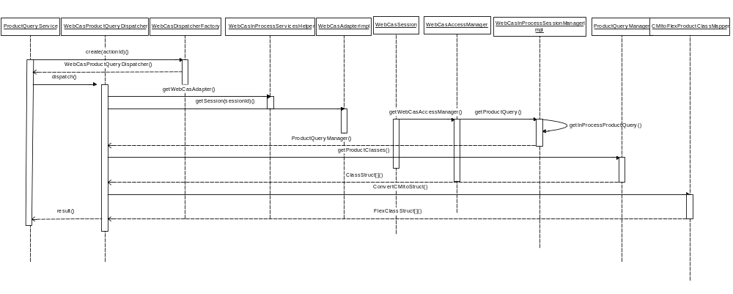

5. GUI

5.1 FlexGUI Changes

5.1.1 Changes for Product Selection
We would be doing product query by type for FLEX_OPTION product type and then categorize these classes based on the underlying product for the product class, either Equity or Index.
Whenever user does a right click on any of the class, a pop-up menu would be shown and user can create an auction by clicking “Start Auction”.

Below mentioned files would be changed to render all the product class in the tree and pop-up menu.

- MainWindow.java
We need to add the ProductSelectionPanel in the main window.

- ProductSelectionPanel.java
We would be creating a new panel to create a tree showing all the underlying classes under Equity and Index.

- ProductTreeModel.java
We need to create a new tree model for the product tree.

- ProductType.java
Need to define all the supporting product types for FLEX GUI.

- ProductClassModel.java
This class would cache all the underlying classes of Equity and Index along with the product classes defined for FLEX_OPTION.

- ProductCellRenderer.java
A new cell renderer needs to be defined to format the product class names in the product tree.

- ProductFormatter.java
We would be defining the styles in which a product class can be displayed in the tree.

- FlexProductQueryAPI.java
New web API for product query needs to be defined which would actually implement the product query methods required for FLEX GUI.
We would be doing a query for all the product classes created for FLEX_OPTION and then categorize them based on the underlying product (either Equity or Index).
Before sending request for product query, we would be creating a message Id for that request and store that in pending result hash map. Same message Id would be returned from the Web CAS, and used to return the result to appropriate request.

- FlexAPIFactory.java
Need to add a finder method which would return an instance of FlexProductQueryAPI.

- FlexAPIFactoryImpl.java
We need to implement the finder method of FlexProductQueryAPI for the FLEX GUI.
This would get the client session object from ClientSession class and uses the same to publish the data.

5.1.2 Sequence Diagram:
  - Product Selection Panel Flow:

