CBOEDirect Release Notes

CboeDirect x.x

Last updated: 3/27/2011

Authors: <>

Table of Contents
Overview of CD Server changes in this release 3
Work requests included in this release 3
WR 6708 : CFLEX 2.0 4
Goal 4
Summary of changes 4
New Routing, Trading and Firm properties 5
Bugfixes included in this release 6
Operator Procedure changes 7
Infra 14 Changes 8
Summary of changes 8
Branch Manifest 9
Appendix A - Database Changes 10
GC Database changes 10
BC Database changes 10
Appendix B – Installation order and pre-requisites 11
Installation order 12
Appendix C – GC Installation Procedures 13
GC2 A/B Trade engine Installation Procedures 13
QA Steps 13
Infra group steps after End of all Sessions 13
Server Group steps 13
Steps to configure FLEX Processes – 13
GC1A/B Trade Engine Installation procedures 14
QA steps 14
CD Server group steps after end of all sessions 14
Steps to configure FLEX Session and Processes – 14
Verification after GC Upgrade 15
Verifying MarketDataReportServer - for Last Sale and Recap processing 16
Verifying GC Installation for FLEX Session and Processes 16
Backout procedures GC1A/B 16
Failover procedures GC1A/B 16
MDGC1 A/B Trade engine Installation Procedures 17
QA Steps 17
Server Group steps 17
Verification (ONE_MAIN and W_MAIN) – XTP Underlying feed 17
Verification (ONE_MAIN and CFE_MAIN) – Bookdepth Feed 17
Backout procedures MDGC1A/B 18
Failover procedures MDGC1A/B 18
MDGC 2 A/B Trade engine Installation Procedures 19
QA Steps 19
Server Group steps 19
Verification 19
Backout procedures MDGC2A/B 19
Failover procedures MDGC2A/B 19
GC - Saturday verification after upgrade 20
Appendix D – BC Installation procedure 22
QA steps 22
Server group steps after end of all sessions 22
Steps to configure FLEX Processes – 22
Verification for FLEX Processes – 22
Verification 23
Final verification 25
Failover 25
Fallback 25
Saturday BC verification after upgrade 26
Appendix E - LC Installation procedures 28
QA steps 28
Server group steps 28
Verification 28
Appendix F – Details on how to execute various commands 29
Script to configure FLEX_MAIN - “configureTemplateAndSessionsFLEX” 29
Script to configure groups for FLEX -“configureClusterGroupsForFTS” 29
Appendix G - CAS & SA CAS Installation procedures 31
dix H - FIXCAS Installation Procedures 32
Appendix I - MDCAS Installation Procedures 33
Appendix J - CFIX Installation Procedures 34
Appendix K - MDX Instllation Procedures 35
Appendix L - Performance tests 36
Appendix M – Fast Failover GUI 37

Overview of CD Server changes in this release

Work requests included in this release
- 6708 – CFLEX 2.0

WR 6708 : CFLEX 2.0

Goal
The goal of this project is to move the CFLEX system to CBOEdirectTM while adding new auction capabilities and user interface. Following are the high level requirements for CFLEX2.0
- Provide the capability to create FLEX products
- Provide the ability to list, quote and trade FLEX options
- Add new features such as FLEX Auction to the auctions used by CBOEdirectTM
- Modify existing features such as AIM auction to support FLEX options
- Provide real time clearing of FLEX options
- Provide Buy Write strategies for FLEX options
- Provide electronic access to FLEX trading using CMI API and FIX Protocol
- Modify existing GUIs to make it FLEX Option compatible
- Make FLEX option information available over the Internet
- Provide a complete archive of FLEX trading in the Data Warehouse for surveillance, billing, reporting and statistical purposes.

Summary of changes
- Following areas of the system have been changed for CFLEX 2.0
For more details on this project please refer to the detailed requirement document as that explains the new functionality being added in detail.

New Routing, Trading and Firm properties

Flex Auction Min/Max Response Time – New trading property added to set min time to respond to flex auction. This is applicable for both simple/complex Flex and AIM auction,

Bugfixes included in this release

Nbr | Remedy PR # | (PITS) Ticket ID | Assigned To | Create Date | Problem Description

Operator Procedure changes

Infra 14 Changes

Summary of changes

Branch Manifest

Branch Name | Description

Appendix A - Database Changes

GC Database changes

- PROD_CLASS Table
Addition of a new data field in table PROD_CLASS .This will store the Expiration Style as ‘European’ or ‘American‘ or ‘None’
Details for the column added:
- Field name: EXER_STYLE
- DDL: VARCHAR2 (1 BYTE)
- SQL Script
alterProdClass_CFLEX2.sql

BC Database changes
- SBTAUCTION Table
- Addition of new data fields in SBTAUCTION.
TIME_TO_RESPOND_SEC_NBR NUMBER(10)
USER_ID VARCHAR2(15)
HEDGE_EXEC_INSTR_TEXT VARCHAR2(256)
HEDGE_REF_TYPE NUMBER(1)
HEDGE_REF_PRICE VARCHAR2(12)
PRFCLTN_PRICE VARCHAR2(12)
DELTA_VALUE_AMT VARCHAR2(4)
USER_KEY NUMBER(20)
- SQL Script
alter_sbtauction_CFLEX2.sql

- MKT_DATA_HIST Table
- Addition of new data field in MKT_DATA_HIST
AUCTION_ID NUMBER(20)
- SQL Script
alterMarketDataHistory_CFLEX2.sql

- SBTORDER Table
- Addition of new data fields in SBTORDER
HEDGE_EXEC_INSTR_TEXT VARCHAR2(256)
HEDGE_REF_TYPE NUMBER(1)
HEDGE_REF_PRICE VARCHAR2(12)
PRFCLTN_PRICE VARCHAR2(12)
DELTA_VALUE_AMT VARCHAR2(4)
- SQL Script
alter_sbtorder_CFLEX2.sql

- SBT_TRADEREPORT Table
- Addition of new data fields
TRADE_STAT_CODE NUMBER(3)
ORIG_TRADE_PRICE VARCHAR2(12)
INIT_BRKR_USER_ID VARCHAR2(15)
AUCTION_ID NUMBER(20)
ORIG_PRODUCT NUMBER(20)
- SQL Scripts
alter_sbt_tradereport_CFLEX2.sql
alter_sbt_tradereport_pendingTrades_CFLEX2.sql

- SBTORDERHISTORY Table
- Addition of new data fields
UNDER_SEC_PRICE VARCHAR2(12)
- SQL Script
alter_sbt_tradereport_pendingTrades_CFLEX2.sql

Appendix B – Installation order and pre-requisites

Installation order
To install the BC we need to ensure that memory on all the bc’s has been increased to handle the new memory requirement.
Also need to confirm we we can install both master and slave side bc on a weekend and backout the slave, this is to execute new-old and new – new failover with old and new style failover (so 3 failovers in total).
Day 0:
Day 1: Install new ACL.
Day 1:
Day 1:
Day 1: Install Master GC1, 2 and 3 (Saturday).
Day 1:

Day 2: Install GC1,2 and 3 Slave side.
Day 2:

Day 3: Install Master BC’s (2-3 weeks, starting one Saturday).
Day 3: Install SA CAS’s and SA GUI’s.
Day 3: Install SHM’s.

Day 4: Operator & Help desk training.
Day 4: Install Slave side BC’s, Can use new Failover procedure at this time.

Day 5:
Day 5: Install CAS’s (Internal & external) and FIX/Engines.
Day 5: Install GUI’s.

Day 6:

Day 7: Install MDGC’s
Day 7: Install LC’s

Day 8:

Appendix C – GC Installation Procedures

GC2 A/B Trade engine Installation Procedures

SAGUI Steps
Create Product Description :
CFLEX Equity – Base description should be ‘EQUITY’
CFLEX Index – Base description should be ‘INDEX’

SQL
- Run the SQL Scripts on GC Schema:
- alterProdClass_CFLEX2.sql

QA Steps
- At 3:15 have qa load the new software for release .

Infra group steps after End of all Sessions
- Load new ACL. (Need to load only once).
Copy ACL.csv from domain/release to $RUN_DIR/tmp
Go to $RUN_DIR and execute
updateRoles -P -R QAINFRA_CRIT_14.0.13 tmp/ACL.csv
- Open a extent map file existing at location $RUN_DIR/properties/xml
- For four BC environment - ExtentMap.infra.bc1_nonhybrid.xml
- For ALL_IN_ONEEnviornment - ExtentMap.server.bc_merged.xml
- Verify node entries for OHServerCFLEX and CFLEXTradeServer in extent map
- Run script $RUN_DIR/bin/refreshExtentMap.

Server Group steps
- Most of the steps here can be done at 3:15.
- Only if needed fix the setContext file in /sbt/prod/tradeeng directory. After you login, if the setContext version has changed then the setContext version nbr needs to change .
- Change run_dir links for previous release.
- Change the run_dir link in /sbt/prod/tradeeng to point to the new release.
- Logout and log back in as tradengp.
- Run script $RUN_DIR/bin/genWatchedProcessList. Verify that $RUN_DIR/properties/ WatchedProcessListServer.out is generated and that all processes are listed correctly in this file.
- Do a diff against the old and new WatchedProcessListServer.out file to ensure they are the same. DO NOT go any further is this does not work.
- Run script $RUN_DIR/bin/createProcessWatcherWatchList –C –L infra

GC1A/B Trade Engine Installation procedures

QA steps
- At 3:15 have qa load the new software using the QA setup steps.

CD Server group steps after end of all sessions
- Shutdown tradeengine on GC1.
- Change run_dir links to point to the new CBOEDirect release.
- Logout and log back in.
- Update setContext in home directory if needed.
- Start the GC processes.
- Master side only:
Load the Trading property “csv” file as explained (by running the command)
TradingPropertyServiceClient setPropertyDefinitions
$RUN_DIR/properties/TradingPropertyDefinitions.csv

- Execute initFlexAuctionTradingProperties script to initialize Flex Auction Min Max Response Time for all classes.

Steps to configure FLEX Session and Processes –
Note : Following scripts needs to be executed only if GlobalServer process is already running.
- Check the GlobalServer process by executing $RUN_DIR/chk
- Run script $RUN_DIR/configureTemplatesAndSessionsFLEX to create FLEX MAIN session and FLEX_MAIN Session templates as FLEX_MAIN.index and FLEX_MAIN.equity
- Run script $RUN_DIR/showSessionStatus It should display the FLEX_MAIN Session in it .
- Run script $RUN_DIR/configureClusterGroupsForFTS to create ProcessGroup and UnderlyingGroup for CFLEXTradeServer
- Run script $RUN_DIR/showGroupTree –a
It should display the CFLEXTradeServer and CFLEXTradeServer.underlyingProducts group under Global and Global. underlyingProducts group for each CFLEXTradeServer instance
- Run script $RUN_DIR/assignClassesToSession
- Run script $RUN_DIR/ showClasses -bySession FLEX_MAIN It should list all classes assigned to FLEX_MAIN Session
- Run script $RUN_DIR/assignClassesToGroup –update
- Run script $RUN_DIR/ showClasses -byGroup CFLEXTradeServer. It should display all groups created for CFLEXTreadServer along with classes assigned to this group.
- Run script $RUN_DIR/setTradingProperties FLEX_MAIN

Verification after GC Upgrade
If you are installing the Slave side box then perform a fail-over so that the upgraded box becomes Master and then continue on with the remainder of the plan.
- Check all files (.log, .debug, .out, .err) for errors, exception’s and high system alarms.
- Enable global external connections on the GC (globalExternalServices start).
- Start all sessions using the SA GUI
- Verify on prdgc01a/b that there are no products in NO_SESSION state.
- Use SAGUI to open test products on all the BC’s. You can get the list of test classes from operations (This list is taped to one of the monitors in the basement)
- Login to 2 trader GUI’s and bring up the market display window and status window) on each of the GUI’s. NOTE: Status Window is a scrolling display that shows status messages for orders and quotes as and when they occur. (This window can be used to verify that OrderStatus and QuoteStatus events are working).
- Do test trades using quotes/orders on atleast one BC for all sessions.
- Verify that CurrentMarket (Mkt Bid and Mkt ask) is showing up on the market display window. This tests out that current market events are working.
- Verify that the last sale price and quantity fields are showing up on the Market display window. This tests out that Last Sale and Recap events are working.
- Verify that Order Status messages (New Order, Order filled are showing up on the Status window screen)
- Check all files on prdgc01 (.log, .debug, .out, .err) for errors, exception’s and high system alarms.

Verifying MarketDataReportServer - for Last Sale and Recap processing
- Run script createHalfHourlyReport – nw W_MAIN.
- Verify that new report file is generated.
log/HalfHourly_NewsWireReport_latest.xml.log
- Review the XML to see if the total volume is updated correctly.
- Repeat above for –hvol.
- Do not run for –opra as there is no way just to create report and not send. –opra option can be verified on Saturday testing only.
- Run ar MarketDataReportServer1 showTickerConsumerStats and verify number messages received.
- Do test trade on any test class for W_MAIN.
- Run above ar command again and verify total number of events received increased.
- Open trader gui and open DSP (Display Series Price) screen and do query for any W_MAIN product. Recap information should be displayed properly.
- Open trader gui and open VOL screen and do query for any W_MAIN class. VOL information.
- End all the sessions.
- Test Complete, Notify operations.

Backout procedures GC1A/B
To backout code shutdown tradeengine and flip the run_dir to the old release that was installed.
To backout user role changes, flip the role of user PARWS to CLASS DISPLAY and then do a dummy update on all the users that were converted..

Failover procedures GC1A/B
Follow regular GC failover procedures.

MDGC1 A/B Trade engine Installation Procedures

QA Steps
- At 3:15 have qa load the new software for release .

Server Group steps
- Shutdown tradeengine processes
- Most of the steps here can be done at 3:15.
- Only if needed fix the setContext file in /sbt/prod/tradeeng directory. After you login, if the setContext version has changed then the setContext version nbr needs to change .
- Change run_dir links for previous release.
- Change the run_dir link in /sbt/prod/tradeeng to point to the new release.
- Logout and log back in as tradengp.
- Start Tradeengine processes.

Verification (ONE_MAIN and W_MAIN) – XTP Underlying feed
- Verify all .log, .err, .out, .debug for exceptions and alarms.
- Put all W_MAIN products in pre-open state (Be care full when doing this on a weekday).
- Start tips replay.
- Verify products are moving to opening rotation.
- Enter a quote on one real product , verify MDH has latest underlying data.

Verification (ONE_MAIN and CFE_MAIN) – Bookdepth Feed
- Verify all .log, .err, .out, .debug for exceptions and alarms.
- Put all Test classes for ONE_MAIN and CFE_MAIN products in pre-open
- Enter Quotes.
- Using ar command on CfnAdapter1 enable refresh of Bookdepth on all sessions.
- Using cfnAdmin monitor all the 12 Multicast lines (6 fro CFE primary and backup and 6 for ONE_MAIN primary and backup). Full refresh of bookdepth is done every few seconds, you will see your test classes having data in them.

Backout procedures MDGC1A/B
To backout code, shutdown tradeengine and flip the run_dir to the old release that was installed.

Failover procedures MDGC1A/B
Follow regular MDGC 1 failover procedures.

MDGC 2 A/B Trade engine Installation Procedures

QA Steps
- At 3:15 have qa load the new software for release .

Server Group steps
- Shutdown tradeengine processes
- Most of the steps here can be done at 3:15.
- Only if needed fix the setContext file in /sbt/prod/tradeeng directory. After you login, if the setContext version has changed then the setContext version nbr needs to change .
- Change run_dir links for previous release.
- Change the run_dir link in /sbt/prod/tradeeng to point to the new release.
- Logout and log back in as tradengp.
- Start Tradeengine processes.

Verification
- Verify all .log, .err, .out, .debug for exceptions and alarms.
- Open all test classes in W_MAIN session.
- Have operations bring up an RCN screen.
- Enter a quote on every single Test class.
- Verify on an RCN screen if quotes have been received on all test classes.
- If an RCN is not available you can use mdbAdmin to monitor the data that is broadcast on the broadcast udp ports. NOTE: data is broadcast on 2 networks, you should monitor both the networks. (Monitor some classes on one network and other classes classes on the 2nd network).

Backout procedures MDGC2A/B
To backout code, shutdown tradeengine and flip the run_dir to the old release that was installed.

Failover procedures MDGC2A/B
Follow regular MDGC 2 failover procedures.

GC - Saturday verification after upgrade
# | Description | PASS/FAIL
1 | loadOpenInterest test (performed by Ops at startup- requested at weekend test meeting)
2 | Product download test – CAS (performed by Ops at startup)
3 | Restart all CAS & Fix Engines. Verify CAS startup time. (performed by Ops at startup)
4 | Start all sessions using the SA-GUI (performed by Ops at startup)
5 | Verify all products are assigned to sessions and no product is in NO_STATE (Ops at startup)
6 | Run ITG Checkout scrpt on all BC’s (performed by Ops at startup)
7 | Transition all products for all sessions to PRE-OPEN state.
8 | Run the XTP replay, replaying the Friday 8:29-8:45 traffic at a 1.5 times rate. Verify that all W_MAIN classes transitioned to OPENING-ROTATION, verify ticker and recap on GUI, Verify underlying price in MDH. Verify broadcast to a PDS. Verifies Data from MDGC1.
9 | OPEN all products for all sessions.
10 | Kill a CAS to verify users are logged out - SMS test
11 | Enter Quote - Book Depth update (dynamic) - CFE/ONE_MAIN Verify that data goes ot of CfnAdapter1 on mdgc01 (3 outbound lines for CFE and 3 outbound lines for ONE).  ar cfnAdmin monitor raw CFE_MAIN C 1
12 | Generate and verify Half Hourly reports for News Wire and HVOL. Actually sending the file to OPRA can only be verified on the weekend. Only on the weekend can you use the –opra option.  * Verify hourly reports are generated every half an hour by Control-M  * Run script createHalfHourlyReport – nw W_MAIN.  * Verify that new report file is generated.  log/HalfHourly_NewsWireReport_latest.xml.log  * Repeat above for –hvol.
13 | Examine global log to verify open interest was loaded
14 | Using SA_GUI, spot check some open interest for some of the products. There should be non-zero values for most of the products. It is OK if a few of them have zero values because it might be a result of new series additions.
15 | Run ar MarketDataReportServer1 showStatistics and verify number messages received
16 | Do test trade on any production class for W_MAIN. Note : SATURDAY TESTING ONLY
17 | Repeat step 16 and verify total number of events received increased
18 | Repeat step 13 and verify the reported numbers have increased
19 | Pause XTP Replay.
20 | Perform four BCXX failovers with GC01a is master. Where XX is a single hybrid, CFE, ONE, and STOCK BC.
21 | Run ITG Checkout scripts on the failed over BCs (only). While running proceed to step 23.
22 | Verify that data CM , LS and Product states are going out to PDSs. The PDSs are verified as follows:  Verify the PDS Overhead is updating with values from the class being used. Quote and last sale information should change. This verifies the MDB broadcast. Depending on the type of display OPS has configured on their test PDS Overhead, the last sale might not show up. Have them switch screen types until they find the one that shows the last sale. Make sure XTP replay is NOT running during the ITG checkouts. XTP Replay can cause spooling and there would be a possibility of dropped quotes/trades which could cause the test to appear to fail.
23 | Failover MDGC01 and MDGC02 with new GC01a as master.
24 | Verify CFE/ONE_MAIN book depth data is being published by repeating step 12.
25 | FE failover test with GC01a as master. KILL FE03
26 | Restart CAS2011. Verify the cas reinitializes.  Run ITG Checkouts on any of the following BC/TE combinations that use FE03.  BC04/TS-4 (cas2011)  BC10/TS-3 (cas2011)  BC30/TS-2 (cas2011)  BC82/TS-1 (cas2011)  BC90/TS-3 (cas2011)  BC93/TS-4 (cas2011)  BC98/TS-1 (cas2011)
27 | Start XTP Replay (1.5 rate(. Open the Market Display For Underlying window and verify ticker and recap.
28 | Verify broadcast to a PDS. The PDSs are verified as follows:Verify the PDS Overhead is updating with values from the class being used. Quote and last sale information should change. This verifies the MDB broadcast. Depending on the type of display OPS has configured on their test PDS Overhead, the last sale might not show up. Have them switch screen types until they find the one that shows the last sale.
29 | GC01 Fail over (new to old)
30 | Pause XTP Replay.
31 | RUN CMi and FIX ITG Checkout scripts (all BCs) after the fail over.
32 | Verify Failover times to see how long it takes to do the complete failover (Stop + goMaster + Pre-open products)
33 | Close->PreOpen->Open all products in all sessions. Time the transition from Close to PreOpen
34 | Bounce a CAS to verify it “re-inits”
35 | Verify the CAS startup time against the previous morning startup time using the CAS Start Times script.
36 | Failover GC2.
37 | Run any special procedures provided by infra group on how to verify gc2 failover.

Appendix D – BC Installation procedure

QA steps
- At 3:15 have qa load the new software.

SQL
- Run the SQL Scripts on BC Schema:
- alter_sbtauction_CFLEX2.sql
- alterMarketDataHistory_CFLEX2.sql
- alter_sbtorder_CFLEX2.sql
- alter_sbt_tradereport_CFLEX2.sql
- alter_sbt_tradereport_pendingTrades_CFLEX2.sql
- alter_sbtorderhistory_pendingTrades_CFLEX2..sql

Server group steps after end of all sessions
- Verify that the BC table changes have been done as explained above (None identified so far).
- Verify that the default routing properties and trading properties have been set correctly as explained above.
- Shutdown tradeengine on the BC being installed (tradengp and tradengh login).
- Install new software CBOEDIR.xxx release, change run_dir links .
- Start the BC processes (tradengh first and then tradengp logins).
- Enable business external connections on the master bc.
- Start all sessions, do a quick quote and order test on one test class on the affected BC.

Steps to configure FLEX Processes –
- Only if needed fix the setContext file /sbt/prod/tradeeng directory. After you login, if the setContext version has changed then the setContext file needs to change for following-
  - SETCONTEXT_VERSION = ‘12’
  - Export FTS_INSTANCES="CFLEXTradeServer1 CFLEXTradeServer2 CFLEXTradeServer3 CFLEXTradeServer4"
  - Modify ALL_SERVER_NAMES to include OHServerCFLEX , CFLEXTradeServer1,CFLEXTradeServer2, CFLEXTradeServer3 and CFLEXTradeServer4 entry in it.

Verification for FLEX Processes –
- Check the processes running on the dev / BC01 for the four BC environment by executing $RUN_DIR/chk command . It should display the process named as CFLEXTradeServer1, CFLEXTradeServer2, CFLEXTradeServer3, CFLEXTradeServer4 and OHServerCFLEX .
- Check all files (.log, .debug, .out, .err) has been created for all instances of CFLEXTradeServer and OHServerCFLEX process at $RUN_DIR/log.
- Make sure all initialization is complete on these processes with following steps –
- cd $RUN_DIR/log
- vim CFLEXTradeServer1.log
- /All initialization is complete
Repeate the above steps for log file of each CFLEXTradeServer instance and OHServerCFLEX .

- Run createSbtEC

Verification
- Check all files (.log, .debug, .out, .err) for errors, exceptions and high system alarms.
- Make sure all initialization is complete on all processes.
- Open sessions associated with this bc pair and send a few test orders & quotes, fill one test order and leave a couple of orders in the book. All Test orders should be for customer origin.
- When installing master side box, please verify if the distributed caches are updated properly
At this point in time the Slave side caches have not yet been installed, so we can only check the distributed cache on the master side).
On Master TS run the following commands to verify the counts of different caches
  - ar HybridTradeServer1 distributedCache TradingProductCache
  - ar HybridTradeServer1 distributedCache GenericCache
  - ar HybridTradeServer1 distributedCache OrderCache
On Master OHS run the following commands to verify the counts of different caches
    - ar HybridTradeServer1 distributedCache GenericCache
  - ar HybridTradeServer1 distributedCache OrderCache
- When installing the slave side box please verify that the order caches are in synch by running the following commands
a) status –count (run this one either on master or slave)
The command above will display the order counts on all Trade Servers and the OH Servers on that bc for both master and slave side boxes. If the count of orders is the same on master and slave side we are ok, otherwise there is something wrong with the installation.
- On Master and slave TS’s run the following commands to verify the counts of different caches are in synch with each other
  - ar HybridTradeServer1 distributedCache TradingProductCache
  - ar HybridTradeServer1 distributedCache GenericCache

On Master & Slave OHS run the following commands to verify the counts of different
Caches are in synch with each other.
- ar OHServerHybrid distributedCache GenericCache
- If you are installing the Slave side box then perform a fail-over so that the upgraded box becomes Master and then continue on with the remainder of the plan.
We need to do the failover twice, Old Failover style and new Fast Failover before each failover we need to ensure that the caches are in synch while there are orders in the book.
- Run the command businessExternalServices check to make sure that remote connections are established for the adapters on that bc.
- Verify on prdgc01a/b that there are no products in NO_SESSION state.
- Use SAGUI to open test products associated with the affected BC’s . You can get the list of test classes from operations (This list is taped to one of the monitors in the basement)
- Login to 2 trader GUI’s and bring up the market display window and status window) on each of the GUI’s. NOTE: Status Window is a scrolling display that shows status messages for orders and quotes as and when they occur. (This window can be used to verify that OrderStatus and QuoteStatus events are working).
- Run the ITG checkout script on all affected bc’s only.
- Verify that last sale from affected bc’s are showing up on MDRS that runs on the global server.
- Check all files on the affected BC’s (.log, .debug, .out, .err) for errors, exceptions and high system alarms.
- Run the ar command hsAdmin –c stats –p HybridHistoryServer1 to verify if counts on the HybridHistoryServer are increasing.
- Run the ar command hsAdmin –c stats –p HybridTradeServer1 to verify that counts on the TradeServer are increasing (which means that the TradeServer is sending data to the history server).
Some times after end of session the external applications will not allow connections afer hours, so the only way to verify is by looking at the log file to make sure that the program’s are making an attempt to connect to the remote system on correct ip address and correct port nbrs.

Final verification
- Close all products in all sessions using the SA GUI (Pick the tab to close ALL the products).
- Verify memory usage for all processes on the BC and Garbage Collection activity by comparing with the OLD and NEW .out files.
- End all the sessions
- If you started this upgrade on the Slave side perform a fail-over so that the upgraded box becomes Slave now.
- Test Complete, Notify operations.

Failover
- See operator procedures on how to failover BC’s or list instructions specific to your release here.

Fallback
- Revert the run_dir link back to the old release and restart tradeengine processes to verify that the release has been backed out.

Saturday BC verification after upgrade

# | Description | PASS/FAIL
 | You will need 2 trader gui's and 1 sa gui - login thru all these guis before you start the test. XtpReplay data should be captured on a production day between 8:29-8:45. This applies only if installing on a W_MAIN or W_STOCK BC.
1 | Pre-requisites – Ops has brought up system and successfully ran checkouts
2 | Verify on prdgc01a/b that there are no products in NO_SESSION state.
3 | Ask Ops to verify the “checkout results” e-mail that is sent to the CCS e-mail group when checkouts complete. There should be 3 e-mails for CMI and 3 e-mails for FIX.
4 | Verify XTP Data is being received by the trade servers, Underlying recap (W_MAIN), BOTR exchange indicators (W_MAIN and W_STOCK using a production class)  - Verify using ar commands on the bc (on the Trade Servers)..
5 | Using a Trader GUI, do MDH Queries and verify NBBO and exchange indicators.
6 | Run the following commands to get counts. These commands will be run again after ITG checkouts. The counts should increase.  Run ar MarketDataReportServer1 showStatistics on the GC and note the number of messages received.  Run “hsAdmin –c stats –p HybridHistoryServer1” to get count  Run “hsAdmin –c stats –p HybridTradeServer1” to get count
7 | Run ITG checkouts for the BC being installed.
8 | WHILE ITG CHECKOUTS ARE RUNNING - Verify current market, last sale, trade reports, fill reports over all external connections. Enter a quote, order, and trade for a production class for the W_MAIN, W_STOCK, W_ONE, W_CFE sessions.  CTMr – verify there are no un-acked trade reports. This can be verified via the following command: (TO DO: Insert command here)  COPP – This is for W_MAIN. verify the COPP GUI shows a queue being build for the OPRA lines. This will be true if COPP was brought up without OPRA being live and without the OPRA simulator being up. These conditions result in no place for COPP to send the data and it will queue inside COPP.  FOPP-ONE – This is for ONE_MAIN. verify the FOPP-ONE GUI shows an increase in the number of messages that were sent out the outbound lines.  FOPP-CFE – This is for CFE_MAIN. verify the FOPP-CFE GUI shows an increase in the number of messages that were sent out the outbound lines.  STOPP – This is for W_STOCK. verify the STOPP GUI shows a queue being build for the outbound lines. This will be true if STOPP was brought up without STIC/NASDAQ being live and without the STOPP simulator being up. These conditions result in no place for STOPP to send the data and it will queue inside STOPP.  PDS - This instruction only applies if you are installing a W_MAIN BC. Verify the PDS Overhead is updating with values from the class being used. Quote and last sale information should change. This verifies the MDB broadcast. Depending on the type of display OPS has configured on their test PDS Overhead, the last sale might not show up. Have them switch screen types until they find the one that shows the last sale. Make sure XTP replay is NOT running during the ITG checkouts. XTP Replay can cause spooling and there would be a possibility of dropped quotes/trades which could cause the test to appear to fail.
9 | Run the following commands to get counts. The counts should have increased from the values obtained before the ITG Checkout  Run MDRS Admin Request on GC to show “last sale” count  Run “hsAdmin –c stats –p HybridHistoryServer1” to get count  Run “hsAdmin –c stats –p HybridTradeServer1” to get count
10 | If this is a BOB BC installation Operations or on site support staff need to enter a manual price report in for one of the products on the Trader GUI. The last sale column should be updated. Check, MDH, there should be an entry for this last sale.
11 | Verify Order Cache is in synch before failover (This requires master and slave to be upgraded with the same 8.6 release – If not done on Saturday then this step needs to be done on the day when the slave bc is installed)  Run the command ‘status –count’ once to display count of orders in the distributed cache on both master and slave side. Verify that the counts of orders are same on both master and slave bc’s.
12 | Verify all other Caches are in synch before failover (This requires master and slave to be upgraded with the same 8.6 release - If not done on Saturday then this step needs to be done on the day when the slave bc is installed)  On both master and slave bc’s run the following commands to compare the counts of individual caches  On TS’s run the following commands  - ar HybridTradeServer1 distributedCache TradingProductCache  b) ar HybridTradeServer1 distributedCache GenericCache  On OHS’s run the following commands  - ar OHServerHybrid distributedCache GenericCache
13 | BC Failover test, We need to repeat the section below for  a) New BC – Old BC : Old Style Failover  b) New BC – New BC: Old Style Failover (can be done when slave is installed)  c) New BC – New BC: New Style Failover (can be done when Slave is installed)
14 | For the BC being installed, use the procedures as listed in the operator procedures and have ops execute the BC failover over procedures.
15 | Time the fail over, it should take roughly 3 minutes for Old Failover & 200 Millis for Fast Failover.
16 | After the fail over run the ITG checkout script on all BC’s.
17 | Enter Manual Price Report – Verify Last Sale Update – Verify MDH entry
18 | If installing on a BOB BC: (otherwise, skip this step)  Enter Manual Quote – Verify Current Market Update  Enter Manual Price Report – Verify Last Sale Update – Verify MDH entry  Open DSP (Display Price Series) screen and check information displayed for product. The DSP screen is opened on the Trade GUI using a login that has a price reporting roll.
19 | Close the products, End the sessions and verfy that all the sessions have ended successfully.

Appendix E - LC Installation procedures

QA steps
- At 3:15 have qa load the new software.

Server group steps
- Notify help desk that LC will be upgraded and that next day they may need to remount the log directories on their CMC Viewer PC’s.
- Master or Slave side can be upgraded after 3:15. There is no need to wait for End Of Session.
- If installing the master side box shutdown tradeengine processes on the Slave Side first then shutdown tradeengine processes on the master side.
- If installing the slave side then Shutdown tradeengine processes on the Slave side.
- Change run_dir links to point to the new release.
- Only if needed fix the setContext file in /sbt/prod/tradeeng directory. After you login, if the setContext version has changed then the setContext is not run and you will not be able to start any process.
Delete orun_dir and move run_dir to orun_dir. Helpdesk needs “orun_dir” to look at old Linkage log files.
- Logout and log back in as tradengp.
- Have operations bring up tradeengine processes using PATROL
- If this is the slave box then failover and run thru the verification steps listed below.

Verification
- Check all files (.log, .debug, .out, .err) for errors, exceptions and high system alarms.
- Make sure all initialization is complete on all processes.
- If you are installing the slave side box then installation is complete. (Just make sure operations runs the slave box in master mode the next day).
- Verify memory usage for all processes on the LC’s and Garbage Collection activity by comparing with the OLD and NEW .out files.
- Just pick a test class and send the out bound Order, it will get cancelled in the “Fix Linkage Adapter” with a reason code of Away Exchange cancel (199).

Appendix F – Details on how to execute various commands
These commands are to be used during development installs only and not in production.

Script to configure FLEX_MAIN - “configureTemplateAndSessionsFLEX”
A script has been written to create FLEX_MAIN Sessions and templates for FLEX_MAIN session.

Usage:
configureTemplateAndSessionsFLEX

Sessions and Template created with it –
This script creates a FLEX_MAIN Session with autoStartFlag as ‘False’ and Session destination code as ‘1’ i.e. SBT .

Default start Session and end session time would be configured as 4.45AM and 18.00 PM
Two Session templates are created for FLEX_MAIN as FLEX_MAIN.equity and FLEX_MAIN.index with autoProductTime as false

Product level trading hours would be configured for these tempale as given below –
 | FLEX_MAIN.equity | FLEX_MAIN.index
PreOpenTime | 8.29.55 | 8.29.55
OpenTime | 8.30.00 | 8.30.00
ProductCloseTime | 15.02.00 | 15.15.00

Script to configure groups for FLEX -“configureClusterGroupsForFTS”

New script is added to create routing groups for FLEX trade servers .

configureClusterGroupsForFTS dev
Usage:
configureClusterGroupsForFTS <dev | test2[56789] | test30>
Argument 1 Enviornment for which the routing groups needs to be configured .
Example: configureClusterGroupsForFTS dev

Two groups are created with this as - CFLEXTradeServer1 and CFLEXTradeServer1.underlyingProduct.
Using this script groups can be created for Enviornment with four BC and ALL_IN _ONE configuration

Appendix G - CAS & SA CAS Installation procedures
- Follow CAS Production Installation and CAS Component configuration documents for standard installation.
- After installing 8.6 CAS, each user id must be configured with correct rate limits for their respective sessions otherwise user would be limited to the default limits which are too low for some sessions.
- CBOEDIR_CRIT_8.6.74 has a TTE fix for Federated query for cancelAllQuotes which causes huge outliers on BC.
- CBOEDIR_CRIT_8.6.115 has as FIX for PIT 70218.

dix H - FIXCAS Installation Procedures
- Follow CAS Production Installation and CAS Component configuration documents for standard installation.
- After installing 8.6 FIXCAS, each user id must be configured with correct rate limits for their respective sessions otherwise user would be limited to the default limits which are too low for some sessions.
- Change the setContext.v2fixcas01 under /sbt/test/infra/config/bin to make enginemode as flex.
ENGINE_MODE=FLEX

- Change to fixcas01.ini under /sbt/test/infra/config/properties :

[VALIDATION]
validate_fields = OFF
validate_bounds = OFF
validate_instances = OFF
validate_dates = OFF

- Add a new variable to setContext for FLEX fixcas only
export SUBSCRIBE_FOR_ALL_MARKET_DATA=true

Appendix I - MDCAS Installation Procedures
- Follow CAS Production Installation and CAS Component configuration documents for standard installation.

Appendix J - CFIX Installation Procedures
None. Manual installation is needed.

Appendix K - MDX Instllation Procedures
- Follow CAS Production Installation and CAS Component configuration documents for standard installation.

- Add a new variable to setContext for FLEX mdx only
export SUBSCRIBE_FOR_ALL_MARKET_DATA=true

Appendix L - Performance tests
Nbr | Test | Scenario
1 | Base line Test | Steady customer order/cancel with no synching
2 | Basic latency timing and failover | Steady customer order/cancel and failover
3 | Verify failover with huge nbr of orders | Send 1 million orders as fast as possible.
4 | Impact of slave bounce | 1 hour test , bounce slave in between to measure impact on master.
5 | Impact of slave hangs | 1 Hour test and ppstop slave for 5 minutes to measure impact of slave hangs.
6 | Single and double failover | 1 hour test with failover and then failover again to verify we can go back to original master.
7 | Controlled synching test | Submit 100,000 initially followed by order /cancel pair, stop test and verify order counts on OHS and TS.
8 | Verify master startup intraday | Submit 100,000 initially follwed by order /cancel pair, stop test , bounce master bc & verify order counts on OHS and TS.
9 | Verify slave startup before master works correctly | Bring up master, send 100,000 orders, kill the master, bring up slave,bring up master and verify order counts in OHS and TS on master and slave.
10 | Data Integrity verification | Restart Master while trafic is running
11 | Data Integrity verification | Custome test to print Master order count and kill with system.exit

Appendix M – Fast Failover GUI
In order to provide a more user-friendly failover experience the Global View GUI has been enhanced to provide visual feedback to the Fast Failover process. The Fast Failover Window is invoked by clicking on a cluser in the Global View Screen as follows:
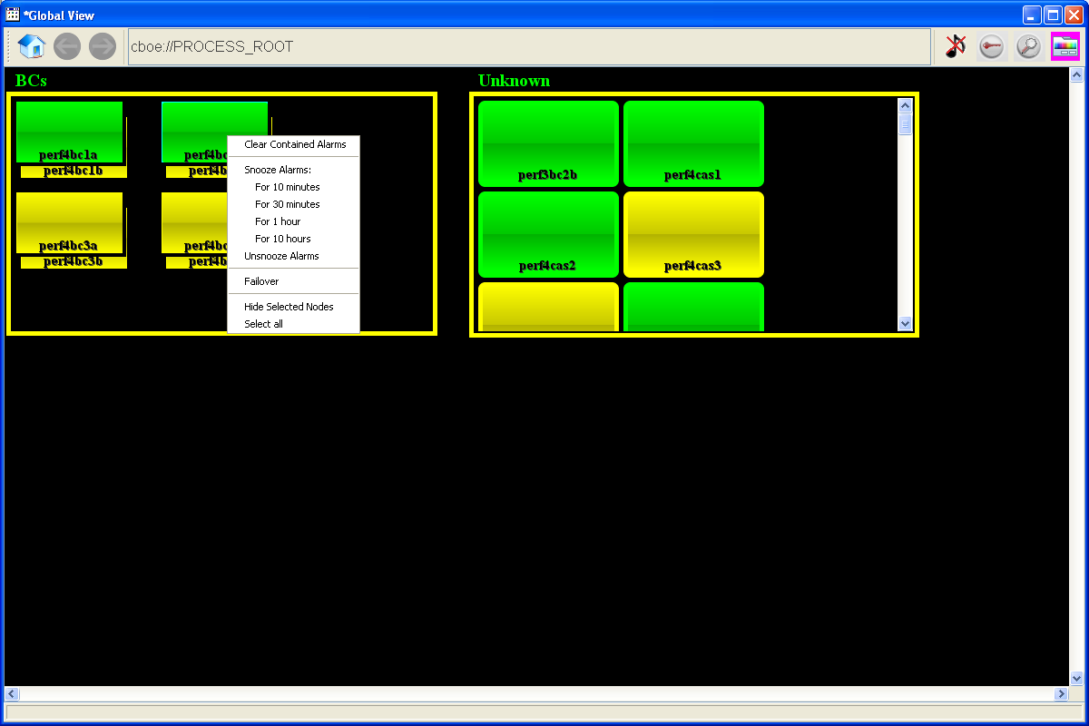

Choosing the Failover option the user will show the following Failover window:
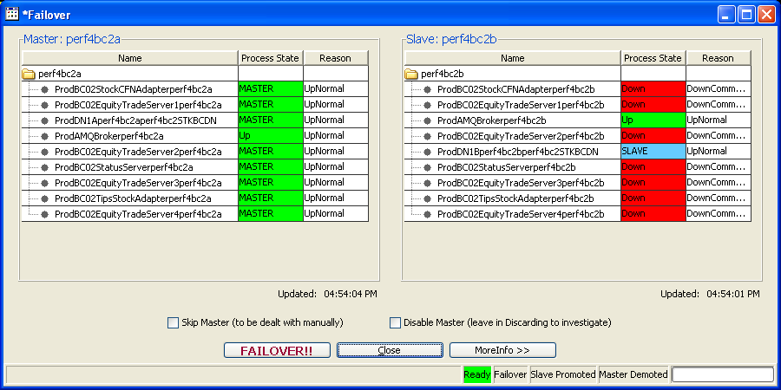
The GUI calls the same code that the command line version calls to do the Failover. This will autodetect which machine is master and display it on the left and the slave on the right. Clicking the “FAILOVER!!” button will start the failover process. The bottom status line follow the Failover status and highlight the Failover, Slave Promoted, and Master Demoted indicators as the failover progresses. It will also display the failover time in milliseconds. Also, the process states on both boxes are depicted just like they are in the System Health Monitor and will reflect process states as they are published by Process Watcher. This may not happen immediately and might take as long as 10 seconds to update.

In order to provide a safeguard to make sure that the user is attempting to failover the proper BC, they will have to type the BC name into the following warning dialog after initiating the failover:
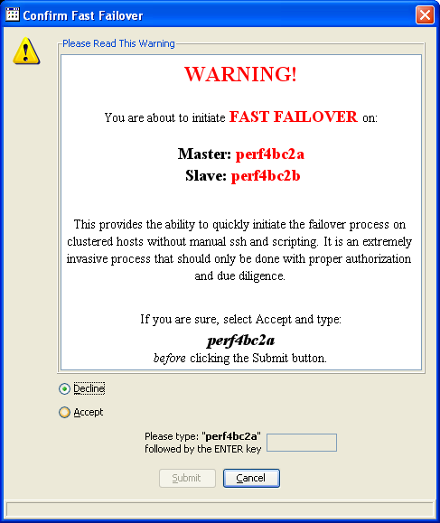
Full documentation of this new GUI window can be found in the System Health Monitor Users Manual.

