Complex Order Auction
Test Plan Document

Snezhana Ruseva

Table of Contents:

1. COA Project Overview 3
2. COA Project Feature List 3
3. Start Of New Auction Process (Feature 1) 3
4. Feature 1 Activity Diagram 4
5. Develop a Feature Model for Feature 1: Start Of New Complex Order Auction 6
1. Feature Decision Table based on the Activity diagram 6
6. Auction Starting Price 6
7. Auction Starting Price Activity Diagram 7
8. Develop a Feature Model for Auction Starting Price 8
1. Feature Decision table based on the Activity Diagram 8
9. Joining an Existing Auction 8
10. Premature End Of Auction 9
11. Joining Or Ending An Existing Auction Activity Diagrams 9
1. Auction started with limit order 9
2. Auction started with MKT order 11
12. Develop a Feature Model for Joining Or Ending Prematurely An Auction From Incoming Order 12
1. Test Case Identification for Joining Or Ending Prematurely an Auction From Incoming Same As the Auction Side Order; Auction Started With Limit Order 12
2. Test Case Identification for Ending Prematurely an Auction from Incoming Opposite of the Auction Side Order; Auction Started with Limit Order 12
3. Test Case Identification for Joining Or Ending Prematurely an Auction From Incoming Order; Auction Started With MKT Order 13
4. Test Case Identification for Ending Prematurely an Auction due to DQ movement/The Flow diagram for this outcome is reflected in the Allocation activity diagram 15
5. Test Case Identification for Ending Prematurely an Auction due to state change 15
13. RFP & RFP responses 15
14. Develop a Feature Model for RFP responses 16
1. Test Case Identification for RFP responses 16
15. Auction Order Cancel/Replace 16
16. RFP Order Cancel/Replace 16
17. Allocation 17
18. Allocation Activity Diagram 18
1. Normal End Allocation 18
2. Premature End Allocation 19

1. COA Project Overview

The goal of this project is to provide an automated auction process for complex order. The project also introduces 4 new handling instructions for complex orders: TSB request, Auto ex request, Book request, and Auction request.

2. COA Project Feature List

- Start Of Complex Order Auction (Feature 1)
  - Start A New Auction Process
  - Starting Auction Price
  - Join An Existing Auction Process
  - RFP & RFP Responses
  - Auction Order Cancel/Replace
  - RFP Order Cancel/Replace
- Premature End of Auction (Feature 2)
  - Due to incoming spread orders from opposite side
  - Due to incoming spread orders from the same side
  - Due to derived quote movement
  - Due to state change
- Allocation (Feature 3)
  - Normal end Of Auction Allocation
  - Premature end of Auction Allocation

3. Start Of New Auction Process (Feature 1)

- With each incoming strategy order from TPF, a handling instruction will be specified.
  - If the tag is “A” the system will auction the order.
  - If the tag is “B” the system will book the order
  - If the tag is “X”, the system will try to trade the order
    - If order does not trade, the system will return the order to TPF
    - If order trades partially, the system will book the remaining qty
  - If the tag is “T”, the order will perform a TSB (Top Of Spread Book) query and return it to TPF. This order will never execute, its only purpose to query the current spread market.

- Complex order Auction can be started either with limit or MKT spread order with “BD”, “C”, “MM”, and “F” origin types (more origin types could be added in the future). “I” orders cannot start an Auction.
- In order to start the auction the following conditions should be satisfied:
  - Spread Class should auction enabled
  - Min Numbers of Quoters >= a number which is configurable
  - Auction Qty has to be within the Min/Max size >= numbers which are configurable
  - Strategy product should be in trading state (Fast/Open)
  - If there is a Spread Quote trigger, the system should expire it
  - If there is an Existing Auction on the same spread product, the incoming order depending on the price will either expire, join the Auction, or will be booked /returned back to TPF
- If there is no existing auction on the product, the system will start the auction and send RFP

4. Feature 1 Activity Diagram

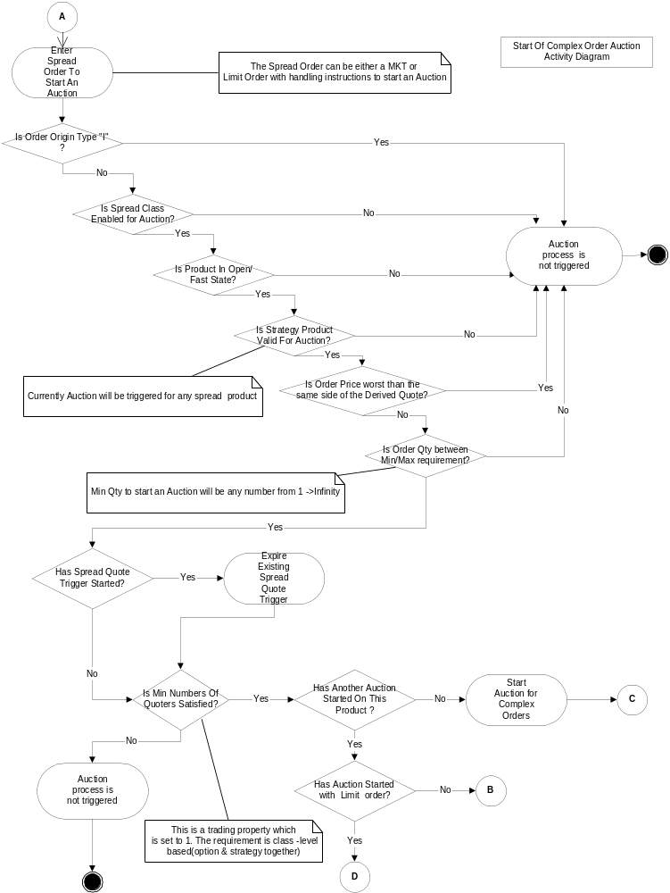

5. Develop a Feature Model for Feature 1: Start Of New Complex Order Auction

Feature Decision Table based on the Activity diagram

Decision Points |  |  |  |  |  |  |  |  | Outcomes
Is Order Origin Type “I”? | Is Spread Class Enabled For Auction | Is product in Open/Fast state? | Is strategy product Valid for Auction? | Is Order Price Worst than Same side of DQ? | Is Order Qty within Min/Max size? | Has Spread Quote trigger Been started? | Has Auction Been Started On the same product? | Is Min Number of Quoters Satisfied? | Start Of New Auction is Not Triggered | Start Of Auction Is Triggered
Y | Y | Y | Y | N | Y | Y | N | Y | √
Y | Y | Y | Y | N | Y | N | Y | Y | √
N | Y | Y | Y | N | Y | N | N | Y |  | √
N | Y | Y | Y | N | Y | N | N | N | √
N | Y | Y | Y | N | Y | N | Y | Y | √
N | Y | Y | Y | N | Y | Y | Y | Y | √
N | Y | Y | Y | N | Y | Y | N | Y |  | √
N | Y | Y | Y | N | N | N | N | Y | √
N | Y | Y | Y | Y | Y | N | N | Y | √
N | Y | Y | N | N | Y | N | N | Y | √
N | Y | N | Y | N | Y | N | N | Y | √
N | N | Y | Y | N | Y | N | N | Y | √

6. Auction Starting Price

- Auction Starting Price for limit order is best of
  - Execution price in the instruction if it is better than the order price and DSM
  - Order price (if it is a limit order) if it is better than execution price in instruction and DSM
  - DSM if order price (or execution price in instruction if any) is worst than the DQ on the other side
- Auction Starting Price for MKT order is best of
  - Execution price in the instruction if is better than DSM
  - X% DSM if the order is market order and there is no specified execution price
- The Maximum auction volume will be the less of
  - Maximum execution volume in the instruction
  - Order remaining qty

7. Auction Starting Price Activity Diagram

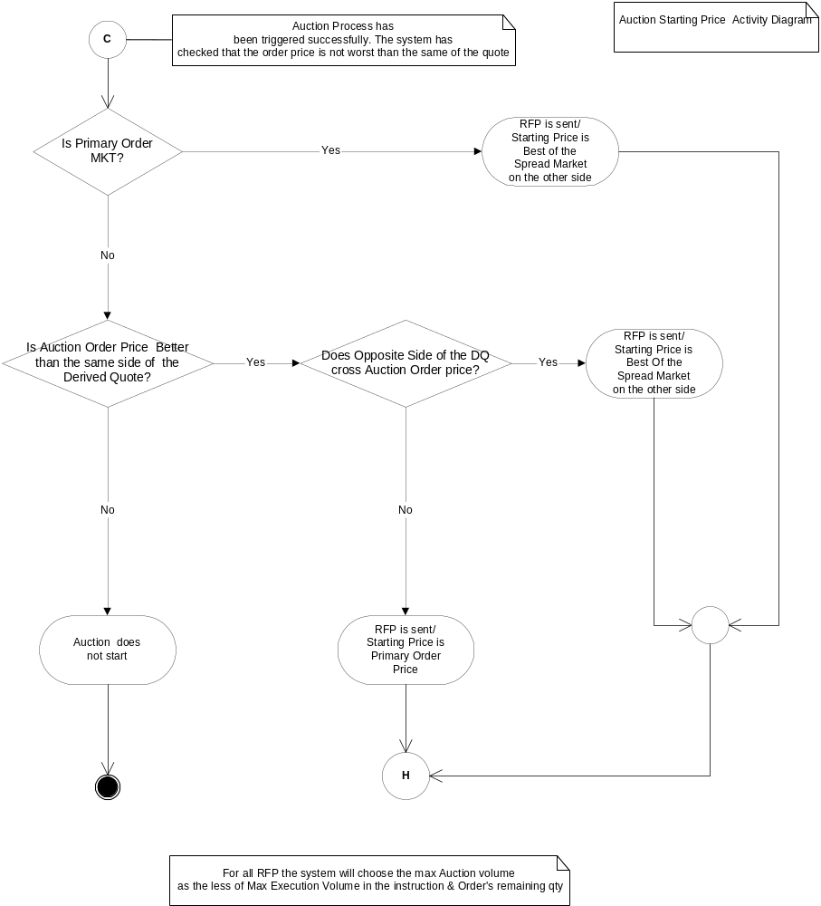

8. Develop a Feature Model for Auction Starting Price

Feature Decision table based on the Activity Diagram
  - Assuming Auction has started

Decision Points |  |  |  |  | Outcomes
Is Auction order MKT? | Is Execution price in instruction specified? | Is Execution price better than DSM (if MKT order) & Order price (if Limit order) and is within the DQ range? | Is Order price better than DSM & is within the DQ range? | Is Order price better than DSM, but outside the DQ range? | RFP is sent; Starting Auction price is best of the Spread market on the other side | RFP is sent; Starting Auction price is Auction Order Price | RFP is sent; Auction price is Execution price in instruction
Y | N | - | - |  | √
Y | Y | N | - |  | √
Y | Y | Y | - |  |  |  | √
N | Y | Y | Y | N |  |  | √
N | Y | Y | N | Y |  |  | √
N | Y | N | N | Y | √
N | Y | N | Y | N |  | √
N | N | - | Y | N |  | √
N | N | - | N | Y | √

9. Joining an Existing Auction

- If Auction started with limit order, any incoming non- Q limit order on the same side with any handling instruction (except “T”) will join the existing Auction
  - If incoming order price is equal to Auction Order price
  - If incoming order price is worst than Auction Order price, but better than Auction starting price
- If Auction started with MKT order, any incoming non - Q limit order on the same side with any handling instruction (except “T”) will join the existing Auction
  - If incoming order price is equal to Auction Starting Price
  - If incoming order price is better than Auction Order price
- If Auction started with MKT order, any incoming MKT order on the same side with any handling instruction (except “T”) will join always the existing Auction
- When another order joins an existing Auction and the new Auction qty is greater than 50% of original auction qty, the system should update the RFP to reflect the new combined qty

10. Premature End Of Auction

- Premature end of Auction from incoming Opposite order
  - Auction started with Limit order
    - Any incoming Opposite of the Auction MKT order will force the Auction to expire
    - Any incoming Opposite of the Auction non -Q Limit order with price better than Auction Starting Price will force the Auction to expire
  - Auction started with MKT order
    - Any incoming Opposite of the Auction MKT order will force the Auction to expire
    - Any incoming Opposite of the Auction non- Q Limit order with price better than Auction Starting Price will force the Auction to expire
- Premature end of Auction from incoming Same side order
  - Auction started with Limit order
    - Any incoming Same side MKT order will force the Auction to expire
    - Any incoming Same side Q or non- Q Limit order with price better than original Auction Order price will force the Auction to expire
    - Any incoming Same side Q Limit order with price worst than Auction order price but better than Auction Starting Price will force the Auction to expire
    - Any incoming Q or non –Q orders with worse price than Auction Starting Price will be booked. But if it crosses the other side of the spread book, the existing Auction will expire prematurely
  - Auction started with MKT order
    - Same side orders can’t force the Auction to expire. They either join or get booked except:
    - Any incoming Q or non –Q orders with worse price than Auction Starting Price will be booked. But if it crosses the other side of the spread book, the existing Auction will expire prematurely
- Premature end of Auction from Derived Quote movement
  - Same side derived quote movement:
    - Auction will end prematurely if Auction Starting Price is worst than same side of Derived Quote
    - Auction will end prematurely if same side of DQ is better than original auction order price
    - Auction will end prematurely if same side of DQ is between the original auctioned order price & Auction starting price
  - Opposite side DQ movement

- Premature end of Auction due to state change
  - If spread product goes to close state, the Auction will be forced to expire
  - For all other state changes, Auction will end normally

11. Joining Or Ending An Existing Auction Activity Diagrams

Auction started with limit order

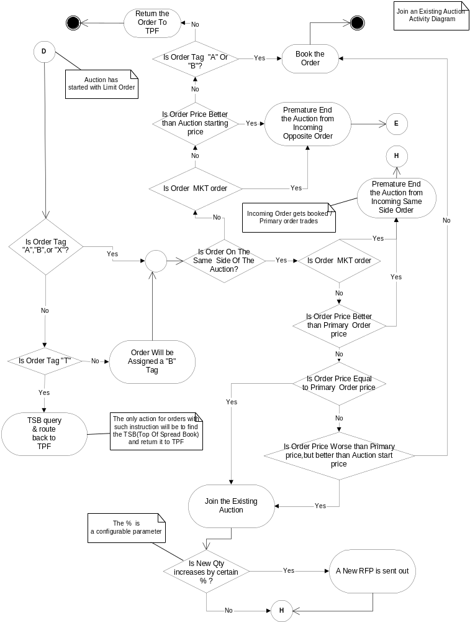

Auction started with MKT order

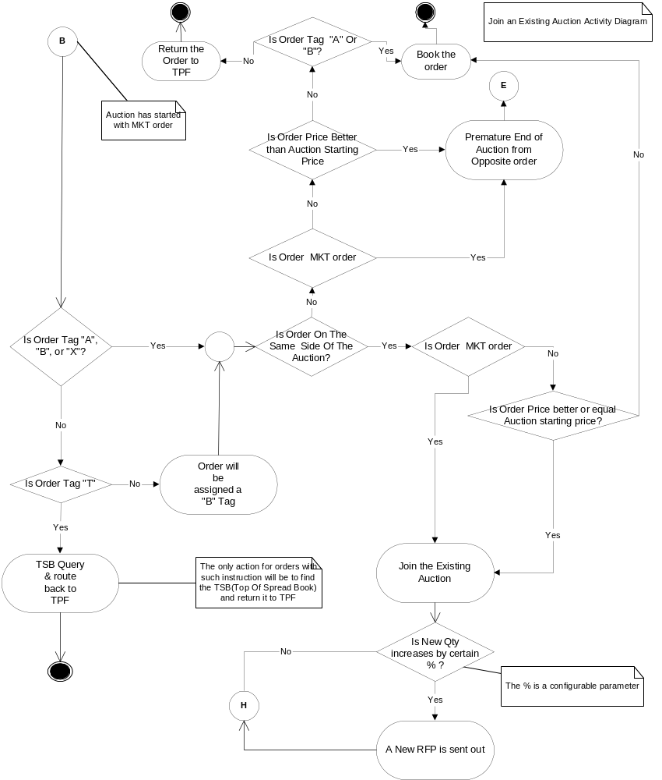

12. Develop a Feature Model for Joining Or Ending Prematurely An Auction From Incoming Order

Test Case Identification for Joining Or Ending Prematurely an Auction From Incoming Same As the Auction Side Order; Auction Started With Limit Order

Decision Points |  |  |  |  |  |  |  | Outcomes
Is order tag “A”, “B” or “X”? | Is Order tag “T”? | Is Incoming Order on the same side of the Auction? | Is Order MKT order? | Is Order Price > auction order price? | Is Order Price = auction order price? | Is Order price < Auction price, but > Auction Starting price? | Is new qty > 50 % of original auction qty? | Assign a “B” tag for limit orders & “X” for MKT orders | TSB query & return to TPF | Book the order | Join the Auction | Premature end the existing Auction | Send new RFP
N | N | Y | Y | - | - | - | - | √ |  |  |  | √
N | N | Y | N | Y | N | N | - | √ |  |  |  | √
N | N | Y | N | N | Y | N | N | √ |  |  | √
N | N | Y | N | N | Y | N | Y | √ |  |  | √ |  | √
N | N | Y | N | N | N | Y | N | √ |  |  | √
N | N | Y | N | N | N | Y | Y | √ |  |  | √ |  | √
N | N | Y | N | N | N | N | - | √ |  | √
N | Y | Y | - | - | - | - | - |  | √
Y | N | Y | Y | - | - | - | - |  |  |  |  | √
Y | N | Y | N | Y | N | N | - |  |  |  |  | √
Y | N | Y | N | N | Y | N | N |  |  |  | √
Y | N | Y | N | N | Y | N | Y |  |  |  | √ |  | √
Y | N | Y | N | N | N | Y | N |  |  |  | √
Y | N | Y | N | N | N | Y | Y |  |  |  | √ |  | √

Test Case Identification for Ending Prematurely an Auction from Incoming Opposite of the Auction Side Order; Auction Started with Limit Order

Decision Points |  |  |  |  |  |  | Outcomes
Is order tag “A”? | Is Order tag “B”? | Is Order Tag “X”? | Is Order tag “T”? | Is Incoming Order on the same side of the Auction? | Is Order MKT order? | Is Order Price > = auction starting price? | Assign a “B” or “X” tag | Book the order | Premature end the existing Auction | TSB query | Return to TPF
N | N | N | N | N | Y | - | √ |  | √
N | N | N | N | N | N | Y | √ |  | √
N | N | N | N | N | N | N | √ | √
N | N | N | Y | N | - | - |  |  |  | √ | √
N | N | Y | N | N | Y |  |  |  | √
N | Y | N | N | N | Y |  |  |  | √
Y | N | N | N | N | Y |  |  |  | √
Y | N | N | N | N | N | Y |  |  | √
Y | N | N | N | N | N | N |  | √
N | Y | N | N | N | N | Y |  |  | √
N | Y | N | N | N | N | N |  | √
N | N | Y | N | N | N | Y |  |  | √
N | N | Y | N | N | N | N |  |  |  |  | √

Test Case Identification for Joining Or Ending Prematurely an Auction From Incoming Order; Auction Started With MKT Order
Decision Points |  |  |  |  |  |  |  | Outcomes
Is order tag “A”? | Is Order tag “B”? | Is Order tag “X”? | Is Order tag “T”? | Is Incoming Order on the same side of the Auction? | Is Order MKT order? | Is Order Price > = auction starting price? | Is new qty > 50 % of original auction qty? | Assign a “B” tag to the order | TSB query | Book the order | Return to TPF | Join the Auction | End the Auction | Send new RFP
N | N | N | N | Y | Y | - | N | √ |  |  |  | √
N | N | N | N | Y | Y | - | Y | √ |  |  |  |  | √ | √
N | N | N | Y | Y | - | - | - |  | √ |  | √
N | N | Y | N | Y | Y | - | N |  |  |  |  | √
N | N | Y | N | Y | Y | - | Y |  |  |  |  | √ |  | √
N | Y | N | N | Y | Y | - | N |  |  |  |  | √
N | Y | N | N | Y | Y | - | Y |  |  |  |  | √ |  | √
Y | N | N | N | Y | Y | - | N |  |  |  |  | √
Y | N | N | N | Y | Y | - | Y |  |  |  |  | √ |  | √
Y | N | N | N | Y | N | Y | N |  |  |  |  | √
Y | N | N | N | Y | N | Y | Y |  |  |  |  | √ |  | √
Y | N | N | N | Y | N | N | - |  |  | √
N | Y | N | N | Y | N | Y | N |  |  |  |  | √
N | Y | N | N | Y | N | Y | Y |  |  |  |  | √ |  | √
N | Y | N | N | Y | N | N | - |  |  | √
N | N | Y | N | Y | N | Y | N |  |  |  |  | √
N | N | Y | N | Y | N | Y | Y |  |  |  |  | √ |  | √
N | N | Y | N | Y | N | N | - |  |  | √
N | N | N | N | N | Y | - | - | √ |  |  |  |  | √
N | N | N | Y | N | - | - | - |  | √ |  | √
N | N | Y | N | N | Y | - | - |  |  |  |  |  | √
N | Y | N | N | N | Y | - | - |  |  |  |  |  | √
Y | N | N | N | N | Y | - | - |  |  |  |  |  | √
Y | N | N | N | N | N | Y | - |  |  |  |  |  | √
Y | N | N | N | N | N | N | - |  |  | √
N | Y | N | N | N | N | Y | - |  |  |  |  |  | √
N | Y | N | N | N | N | N | - |  |  | √
N | N | Y | N | N | N | Y | - |  |  |  |  |  | √
N | N | Y | N | N | N | N | - |  |  |  | √
N | N | N | Y | N | - | - | - |  | √ |  | √
N | N | N | N | N | N | Y | - | √ |  |  |  |  | √
N | N | N | N | N | N | N | - |  |  | √

Test Case Identification for Ending Prematurely an Auction due to DQ movement/The Flow diagram for this outcome is reflected in the Allocation activity diagram

Decision Points |  |  | Outcomes
Is New DQ on the other side crossing the Auction Starting Price? | Is Auction starting price worst than DQ on the same side? | Is Auction Starting Price within the new DQ range? | Trigger End of Auction | Do not trigger End Of Auction
Y | N | N | √
N | Y | N | √
N | N | Y |  | √

Test Case Identification for Ending Prematurely an Auction due to state change

Decision Points |  |  |  |  | Outcomes
Is product state changed to closed? | Is product state changed to On Hold? | Is product state changed to Suspended? | Is product state changed to Halted? | Is product state changed to Fast? | Trigger End of Auction | Do not trigger End Of Auction
Y | N | N | N | N | √
N | Y | N | N | N |  | √
N | N | Y | N | N |  | √
N | N | N | Y | N |  | √
N | N | N | N | Y |  | √
N | N | N | N | N |  | √

13. RFP & RFP responses

- When Auction process starts, the system sends an RFP with Auction starting price and qty
- Market Makers will receive a RFP if both conditions are satisfied:
  - They should have at least one quote either on the option or spread market
  - They should be subscribed to receive RFP for strategies
- RFP response orders are accepted with any Origin types (except “I”)
- RFP response prices should be better or equal to Auction Starting Price in order to trade
  - RFP prices are based on penny thick.
- The system will not accept RFP response prices with worst prices than Auction starting Price
- Once the Auction expires, all RFP response orders that did not trade will be cancelled by the system

14. Develop a Feature Model for RFP responses

Test Case Identification for RFP responses

Decision Points |  |  |  | Outcomes
Is Auction active? | Is RFP order origin type “C”, “F”,”MM”, or “BD”? | Is RFP order price > or = Auction Starting Price? | Is RFP order for the Same Spread product as the Spread Auction? | Valid RFP order, the system accept the entry | Valid RFP, but wrong product | Invalid RFP order, the system rejects the entry
Y | Y | Y | Y | √
Y | Y | Y | N |  | √
Y | Y | N | Y |  |  | √
Y | N | Y | Y |  |  | √
N | Y | Y | Y |  |  | √

15. Auction Order Cancel/Replace

- During Auction period, user can cancel the Auction order, but the cancel request will be pending until auction expires and allocation is done
  - If there is a remaining qty on the Auction order after allocating against RFP orders, the qty will be cancelled
- During Auction period, user can cancel/replace the Auction order, but the cancel/replace request will be pending until auction expires and allocation is done
  - If there is a remaining qty on the Auction after allocating against the RFP orders, the qty will be cancelled and replaced with the new order

16. RFP Order Cancel/Replace

- During Auction period, user can cancel the RFP response order, but the cancel request will be pending until auction expires and allocation is done
  - If there is a remaining qty on the RFP order after allocating against the auction order, the qty will be cancelled
- During Auction period, user can cancel/replace the RFP response order, but the cancel/replace request will be pending until auction expires and allocation is done
  - If there is a remaining qty on the RFP order after allocating against the auction order, the qty will be cancelled and replaced with the new RFP order

17. Allocation

- Normal End Of Auction Allocation
  - Auction started with limit order: price time order allocation
    - The system will allocate against any RFP orders via CUMA in price order (“C” RFP orders have higher priority)
    - If there are resting opposite side spreads with price equal to Auction Starting Price, the system allocate first against them via UMA (resting “C” orders have priority, they are filled completely), then allocate against any RPF orders with same price via CUMA
    - After allocation is done for Auction order and there are still RFP orders/Resting spreads, the system will allocate them against any joining the Auction order in the same sequence. If there are still remaining RFP orders, the system will cancel the remaining qty.
    - If there is remaining qty on the Auction order, the system will book it
  - Auction started with MKT order: price time order allocation
    - Allocate first against better than Auction Starting Price RFP orders via CUMA in price order (“C” RFP orders have higher priority)
    - Allocate against legs via UMA in price time order (up to the X% protection price) when Auction Starting price is equal to the DQ on the other side)
    - Allocate against any resting spreads (“C” orders have priority, they are filled completely first) with price equal to Auction starting price
    - Allocate against any RFP orders with price equal to Auction starting price via CUMA (“C” RFP orders have higher priority)
    - After allocation is done for Auction order and there are still RFP orders/Resting spreads, the system will allocate them against any joining the Auction order in the same sequence. If there are still remaining RFP orders, the system will cancel the remaining qty.
    - If there is remaining qty on the Auction order, the system will be routed back to TPF

- Premature End Of Auction Allocation
  - From incoming Opposite side order: price time order allocation
    - Allocate first against the Opposite order if its price is better
    - Follow same allocation as the normal end
  - From incoming Same side order: price time order allocation
    - Follow same allocation as normal end: Auction order is allocated first
  - Derived quote movement allocation
    - If DQ crosses the Auction starting price but it is not equal, the system will allocate first against the legs via UMA in price time order
    - If Auction starting price is worst or equal to the DQ on the same side, allocation cannot be done & Auction order will be booked / returned to TPF
  - Product state change to closed
    - Follow normal end allocation

18. Allocation Activity Diagram

Normal End Allocation
  - This activity diagram covers the allocation path when Auction ends prematurely from incoming same as the Auction side order

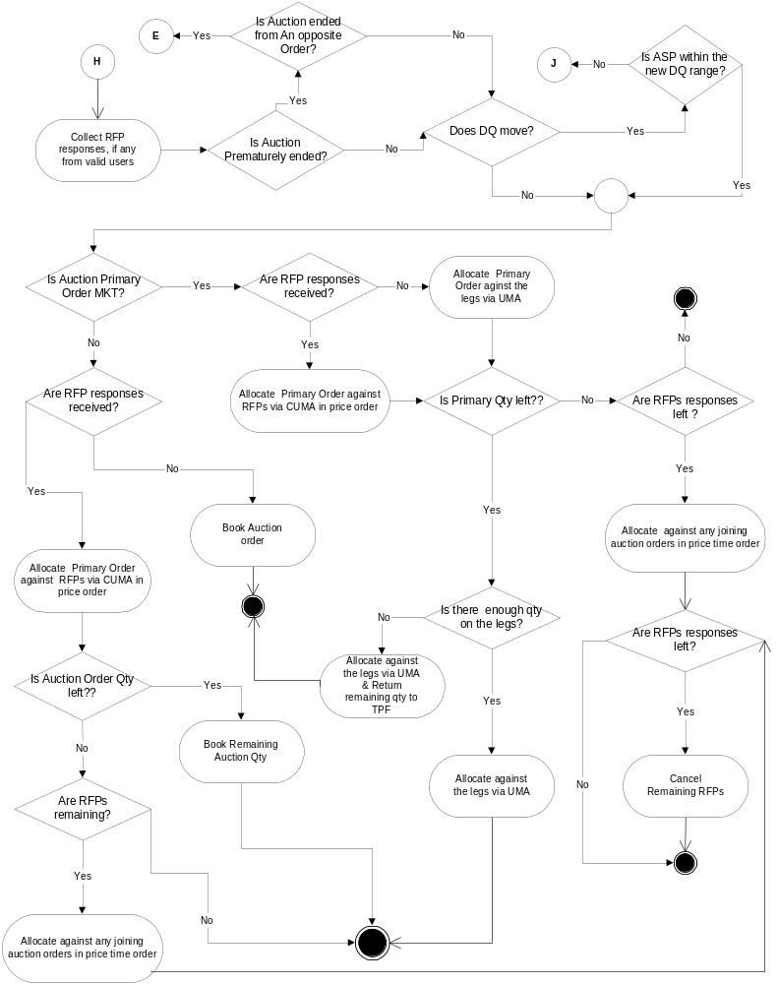

Premature End Allocation
  - From incoming Opposite of the Auction order

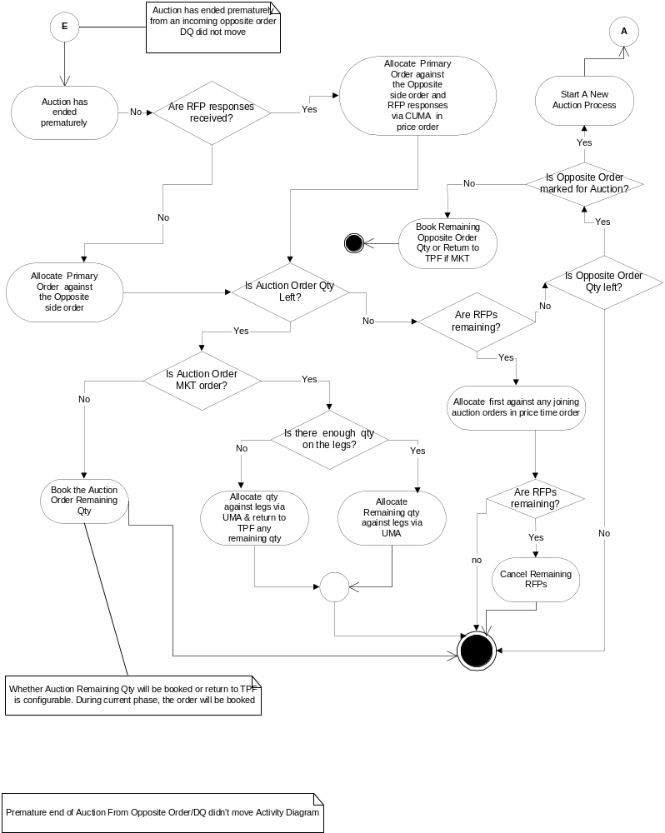

  - Derived Quote Movement

