Strategy Price Protection

High Level Design

Prepared By:

Table of Contents
Table of Contents 1
Strategy Price Protection 2
Limit Price Protection related changes 2
Market Complex Order Price Protection at Execution 7

Strategy Price Protection

Limit Price Protection related changes
Changes in OHS server
Limit orders that meet the criteria below will be rejected when received by OHS. Data validation reject code will be provided to users indicating the reject reason.
Criteria For Vertical Strategy:
CASE 1
Leg1 - Sell Call Aug $20.00
Leg2 - Buy Call Aug $30.00
This strategy should NOT result in Debit. Any -ve price on order will be rejected. Zero price is OK.

CASE 2
Leg1 - Buy Call Aug $20.00
Leg2 - Sell Call Aug $30.00
This strategy should NOT result in Credit. Any +ve price on order will be rejected. Zero price is OK.

CASE 3
Leg1 - Sell Put Aug $30.00
Leg2 - Buy Put Aug $20.00
This strategy should NOT result in Debit. Any -ve price on order will be rejected. Zero price is OK.

CASE 4
Leg1 - Buy Put Aug $30.00
Leg2 - Sell Put Aug $20.00
This strategy should NOT result in Credit. Any +ve price on order will be rejected. Zero price is OK.

Criteria For Strategy with three legs:
CASE 1(CALL)
CASE 1.1
Strategy Buy Call 20.00: Sell 2 Call 40 : Buy Call 60
Middle price($40.00) = average of outer prices(20+60/2)
Reject +ve(credit) prices. Debit or even is allowed.
CASE 1.2
Strategy Buy Call 20.00: Sell 2 Call 50 : Buy Call 60
Middle price > avg of Outer prices
Reject +ve(credit) prices.
CASE 1.3
Strategy Buy Call 20.00: Sell 2 Call 30 : Buy Call 60
Middle price < avg of Outer prices
NO validation. Allow all the prices.
CASE 2(CALL)
CASE 2.1
Strategy Sell Call 20.00: Buy 2 Call 40 : Sell Call 60
Middle price = avg of Outer prices
Reject -ve(debit) prices. Credit or even is allowed.
CASE 2.2
Strategy Sell Call 20.00: Buy 2 Call 50 : Sell Call 60
Middle price > avg of Outer prices
Reject -ve(debit) prices
CASE 2.3
Strategy Buy Call 20.00: Sell 2 Call 30 : Buy Call 60
Middle price < avg of Outer prices
NO validation. Allow all the prices.
CASE 3(PUT)
CASE 3.1
Strategy Buy Put 20.00: Sell 2 Put 40 : Buy Put 60
Middle price = average of outer prices
Reject +ve(credit) prices. Debit or even is allowed.
CASE 3.2
Strategy Buy Put 20.00: Sell 2 Put 30 : Buy Put 60
Middle price < avg of Outer prices
Reject +ve(credit) prices.
CASE 3.3
Strategy Buy Put 20.00: Sell 2 Put 50 : Buy Put 60
Middle price > avg of Outer prices
NO validation. Allow all the prices.
CASE 4(Put)
CASE 4.1
Strategy Sell Put 20.00: Buy 2 Put 40 : Sell Put 60
Middle price = avg of Outer prices
Reject -ve(debit) prices. Credit or even is allowed.
CASE 4.2
Strategy Sell Put 20.00: Buy 2 Put 30 : Sell Put 60
Middle price < avg of Outer prices
Reject -ve(debit) prices
CASE 4.3
Strategy Buy put 20.00: Sell 2 Put 50 : Buy Put 60
Middle price > avg of Outer prices
NO validation. Allow all the prices.

Code Changes:
1. A new integer variable would be added to ProductDataImpl. This integer value will indicate the sign for which orders will be rejected.
e.g. If value in the variable is debit then same side orders with –ve price will be rejected.
2. ProductDataCacheImpl will have the logic to calculate the sign. A new method calculatePriceProtectionForStrategy(ProductDataImpl product) is added to the class. This method will calculate and set the sign in ProductDataImpl. This value is calculated only for strategies.
3. This calculation will be done every time OHS server is started and whenever a new strategy is created.
4. Changes are made to ProductDataCacheBaseHomeImpl.find() method and ProductDataCacheImpl. updateProductStrategy(StrategyStruct p_updatedStrategy) method.
5. When ever a new strategy order is entered, order validation in OrderValidationOpenOutcryStrategy will call new validation validateStrategyPriceProtection in FieldsValidator.
6. validateStrategyPriceProtection method in FieldsValidator will use the sign from ProductDataImpl to validate the order against the defined rules. Order will be rejected with invalid price data validation if it doesn’t fit into the criteria.

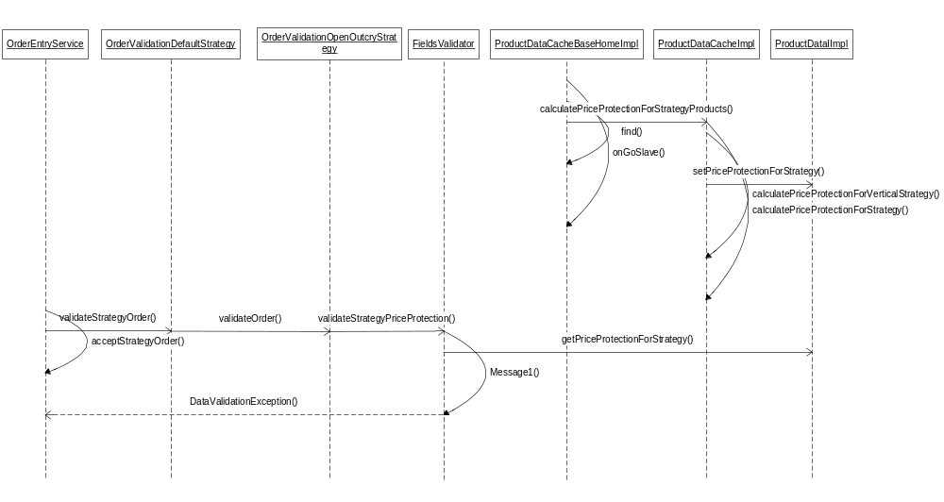
- OrderValidationOpenOutcryStrategy.java
Location: \ohs\integration\impls\com\cboe\ohs\receivers\validation
- Calls a new method validateStrategyPriceProtection(OrderStruct order, ProductData product) from the validateOrder(OrderStruct order, boolean allowZero) method.

- FieldsValidator.java
Location: \ohs\integration\impls\com\cboe\ohs\receivers\validation
- Define a new method protected void validateStrategyPriceProtection(OrderStruct order, ProductData product) throws DataValidationException. This method validates the order price against the rules.If users enter the order coming under the rule then they are rejected when received by OHS.

- ProductData.java
Location: \server\Java\interfaces\com\cboe\interfaces\productData
- Declares methods public abstract int getPriceProtectionForStrategy() and public abstract void setPriceProtectionForStrategy(int priceProtectionForStrategy) for getting and setting the value of priceProtection for strategy.

- ProductDataImpl.java
Location: \server\Java\common\com\cboe\server\util\productData
- Define methods public int getPriceProtectionForStrategy() and public void setPriceProtectionForStrategy(int priceProtectionForStrategy) for getting and setting the value of priceProtection for strategy.

- ProductDataCache.java
Location: \server\Java\interfaces\com\cboe\interfaces\productData
- This is an interface that declares new variables (Credit and debit).

- ProductDataCacheImpl.java
Location: \server\Java\common\com\cboe\server\util\productData
- Calls a new method calculatePriceProtectionForStrategy(ProductDataImpl product) from the updateProductStrategy(StrategyStruct p_updatedStrategy).This method verifies whether the strategy is vertical or the strategy contains three legs and further calls calculatePriceProtectionForVerticalStrategy(ProductDataImpl product) method or calculatePriceProtectionForThreeLegsStrategy(ProductDataImpl product)respectively.
- Define a new method public synchronized void calculatePriceProtectionForVerticalStrategy(ProductDataImpl product) which calculates the reasonable price for both the verticals (Call Call and Put Put).It calculates the price difference between exercise prices of two legs (sellSidePrice and buySidePrice) of vertical strategy.If difference is positive,it sets it to 1;if it is negative, sets it to -1 and if the difference is 0, sets it to 0.
- Define a new method public void calculatePriceProtectionForStrategyProducts() which iterates over the entire set of products stored in the hash map and calls calculatePriceProtectionForStrategy() method.
- Define a new method public synchronized void calculatePriceProtectionForThreeLegslStrategy(ProductDataImpl product) which calculates the reasonable price for the legs wherein the legs have summation of their ratio as 4, have the same expiration month and belong to Call Call Call or Put Put put group. If it belongs to Call Call Call group, calculatePriceDifferenceForCall(final ProductLegData firstLeg, final ProductLegData secondLeg, final ProductLegData thirdLeg, final Price middlePrice, Double averagePrice) method is called and if it belongs to Put Put Put group, calculatePriceDifferenceForPut(final ProductLegData firstLeg, final ProductLegData secondLeg, final ProductLegData thirdLeg, final Price middlePrice, Double averagePrice) method is called.
- Define a new method public synchronized int calculatePriceDifferenceForCall(final ProductLegData firstLeg, final ProductLegData secondLeg, final ProductLegData thirdLeg, final Price middlePrice, Double averagePrice) which calculates the price difference between legs of call group. Middle price (price of second leg) is compared with the average price of first
and third legs. If middle price is greater than average price, we check whether the three legs form Buy sell Buy group or Sell Buy Sell group. If it is Buy Sell Buy,+1 is returned and if it is Sell Buy Sell group, -1 is returned.
- Define a new method public synchronized int calculatePriceDifferenceForPut(final ProductLegData firstLeg, final ProductLegData secondLeg, final ProductLegData thirdLeg, final Price middlePrice, Double averagePrice) which calculates the price difference between legs of put group. Middle price (price of second leg) is compared with the average price of first
and third legs. If middle price is less than average price, we check whether the three legs form Buy sell Buy group or Sell Buy Sell group. If it is Buy Sell Buy,+1 is returned and if it is Sell Buy Sell group, -1 is returned.

- ProductDataCacheBaseHomeImpl.java
Location: \server\Java\common\com\cboe\server\util\productData
- Modify the method find() to call calculatePriceProtectionForStrategyProducts() method of ProductDataCacheImpl.java class. This method is called after downloading of products gets completed.
Changes in Hybrid Trade Server:
Code Changes:
1. A new integer variable would be added to TradingProductImpl. This integer value will indicate the sign for which orders will be rejected.
e.g. If value in the variable is debit then same side orders with –ve price will be rejected.
2. TradingProductImpl will have the logic to calculate the sign. A new method calculatePriceProtectionForStrategy(ProductDataImpl product) is added to the class. This method will calculate and set the sign in TradingProductImpl. This value is calculated only for strategies.
3. This calculation will be done every time Hybrid Trade server is started and whenever a new strategy is created.
4. Changes are made to TradingProductHomeImpl.completedBuildTradingProducts() method and
- TradingProduct.java
Location: \domain\Java\interfaces\com\cboe\interfaces\domain
- Declares the method public Price getExchangePrescribedWidthForStratergy(Price basePrice) that gets the EPW for strategy.
- Declares the method public int getPriceProtectionForStrategy().
- Declares the method public void calculatePriceProtectionForStrategy().

- TradingProductImpl.java
Location: \server\Java\impls\com\cboe\internalBusinessServices\productStateService
- Defines a new method public Price getExchangePrescribedWidthForStratergy(Price basePrice) that further calls getExchangePrescribedWidthForStratergy() method in TradingClassImpl.java. This method gets the exchange prescribed width for a price.
- Define a new method calculatePriceProtectionForStrategy().This method verifies whether the strategy is vertical or the strategy contains three legs and further calls calculatePriceProtectionForVerticalStrategy() method or calculatePriceProtectionForThreeLegsStrategy()respectively
- Define a new method public void calculatePriceProtectionForVerticalStrategy() which calculates the reasonable price for both the verticals (Call Call and Put Put).It calculates the price difference between exercise prices of two legs (sellSidePrice and buySidePrice) of vertical strategy.If difference is positive,it sets it to 1;if it is negative, sets it to -1 and if the difference is 0, sets it to 0.
- Define methods public int getPriceProtectionForStrategy() and public void setPriceProtectionForStrategy(int priceProtectionForStrategy) for getting and setting the value of priceProtection for strategy.
- Define a new method public synchronized void calculatePriceProtectionForThreeLegslStrategy() which calculates the reasonable price for the legs wherein the legs have summation of their ratio as 4, have the same expiration month and belong to Call Call Call or Put Put put group. If it belongs to Call Call Call group, calculatePriceDifferenceForCall(final TradingStrategyLeg firstLeg, final TradingStrategyLeg secondLeg, final TradingStrategyLeg thirdLeg, final Price middlePrice, Double averagePrice) method is called and if it belongs to Put Put Put group, calculatePriceDifferenceForPut(final TradingStrategyLeg firstLeg, final TradingStrategyLeg secondLeg, final TradingStrategyLeg thirdLeg, final Price middlePrice, Double averagePrice) method is called.
- Define a new method public synchronized int calculatePriceDifferenceForCall(final TradingStrategyLeg firstLeg, final TradingStrategyLeg secondLeg, final TradingStrategyLeg thirdLeg, final Price middlePrice, Double averagePrice) which calculates the price difference between legs of call group. Middle price (price of second leg) is compared with the average price of first and third legs. If middle price is greater than average price, we check whether the three legs form Buy sell Buy group or Sell Buy Sell group. If it is Buy Sell Buy, +1 is returned and if it is Sell Buy Sell group, -1 is returned.
- Define a new method public synchronized int calculatePriceDifferenceForPut(final TradingStrategyLeg firstLeg, final TradingStrategyLeg secondLeg, final TradingStrategyLeg thirdLeg, final Price middlePrice, Double averagePrice) which calculates the price difference between legs of put group. Middle price (price of second leg) is compared with the average price of first and third legs. If middle price is less than average price, we check whether the three legs form Buy sell Buy group or Sell Buy Sell group. If it is Buy Sell Buy, +1 is returned and if it is Sell Buy Sell group, -1 is returned.

- TradingClass.java
Location: \domain\Java\interfaces\com\cboe\interfaces\domain
- Declares the method public Price getExchangePrescribedWidthForStratergy(Price basePrice) that gets the EPW for strategy.

- TradingClassImpl.java
Location: \server\Java\impls\com\cboe\internalBusinessServices\productStateService
- Defines a new method public Price getExchangePrescribedWidthForStratergy(Price basePrice) that gets the exchange prescribed width for a price.
- OrderBookSpreadEditor.java
Location: \server\Java\impls\com\cboe\businessServices\orderBookService
- Modify the method public boolean crossesMarket(Side tradableSide, Price tradablePrice, Price exchangePrescribedWidth) to check whether bid-ask spread of the DSM is wider than the strategy EPW or not.

Market Complex Order Price Protection at Execution
Requirements
    - If market complex order’s trade price meets the criteria, as described in the above “limit price protection related changes”, at the time of execution, the order will not trade and will be routed to PAR.
    - A new trading property strategy EPW is created, which works similar to the leg EPW.
    - Market complex order will not trade and will be routed to PAR, if DSM width, which is the bid-ask spread of the DSM, is wider than the new trading property strategy EPW.

Changes in HybridTradeServer1
Complex order trade is composed of two parts – with resting complex order first, followed by with legs:
- for market complex order trading with resting complex order, at each trading price level, adds extra checking “if DSM width is less than or equal to the new trading property strategy EPW”; if it is not, the market complex order will not trade and will be routed to PAR with return reason NOT_TRADED_WIDE_MKT; if it is, trade is allowed.
- for market complex order trading with legs, at each trading price level, adds extra checking “if DSM width is less than or equal to the new trading property strategy EPW or the trade price violates the strategy product price protection rule”; if any of one these two conditions fails, the market order will not trade and will be routed to PAR, where with the first condition, it will be returned with reason NOT_TRADED_WIDE_MKT, and with the second condition, it will be returned with reason NOT_TRADE_PRICE_PROTECTION.

