Send Equity Legs to TRF (When PAR down / User logout / Product state change / Failover)

Overview

Current processing
Currently, when a CPS COA auction starts and responses arrive to trade with it, the Equity legs from both orders are sent to CBSX to execute the trade and generate the reports back to the spread trade server. Any validation relevant to Equity is executed in CBSX.

New requirement
- Disable functionality to use CBSX for printing the stock portion of cross product spreads.
- When a trade can be made based on two CPS that can trade with each other, i.e. a COA response, an order hits the COB or a CPS AIM, paired stock orders will be sent to a third party broker dealer who will be responsible for printing the trade and then sending back a fill report to CBOEdirect. CBOE direct will hold the fill on the CPS until it receives a trade confirmation from the third-party BD, however CBOEdirect will print the options trade immediately.
- New price edits will be added to increase the likelihood that spreads can fill against responses.:
  - A new parameter will be added to allow NBBO trade-throughs for the stock portion of the trade. The parameter will be in terms of number of ticks through the NBBO.

Design

    - Send Equity Legs to TRF instead to CBSX to generate the report
When two CPS orders trade with each other, the Equity portion of the trade will be sent directly from the STS server instead of HTS. The option part will be executed in HTS and the fill report for the Option section as the CPS will forwarded to STS. STS will piblis the options portion right away and will hold the CPS report until the fill from TRF is received.
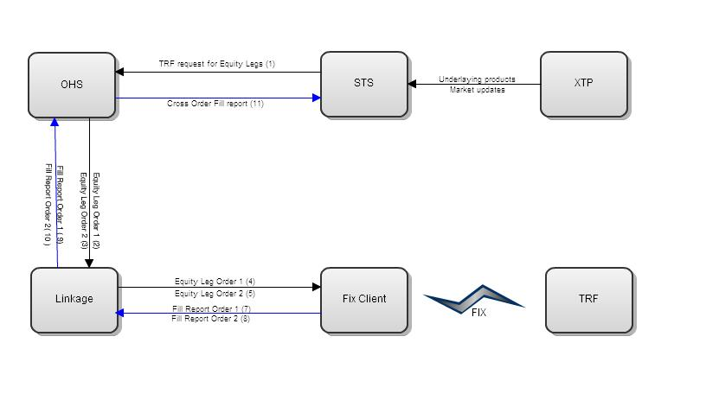
Figure 1. New handling for Spread Order’s Equity Legs
When a trade can be made based on two CPS that can trade with each other, i.e. a COA response, an order hits the COB or a CPS AIM, paired stock orders will be sent to OHS to generate derived orders to be sent via Linkage to a Trade Report Facility (TRF).

New Linkage Router for TRF

A new linkage router is defined for TRF called Millennium. The behavior of the OrderMapper and ExecutionReportMapper will similar to those of regular router mappers (CITI, WOLVERINE, etc) . 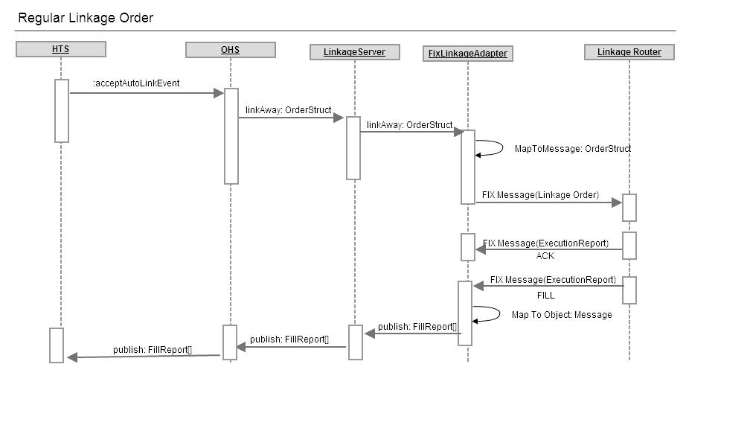
For CPS orders 2 orders will be sent two the router representing the equity legs to be traded. OHS will wait to get the reports for both legs before publishing a single trade report to STS.
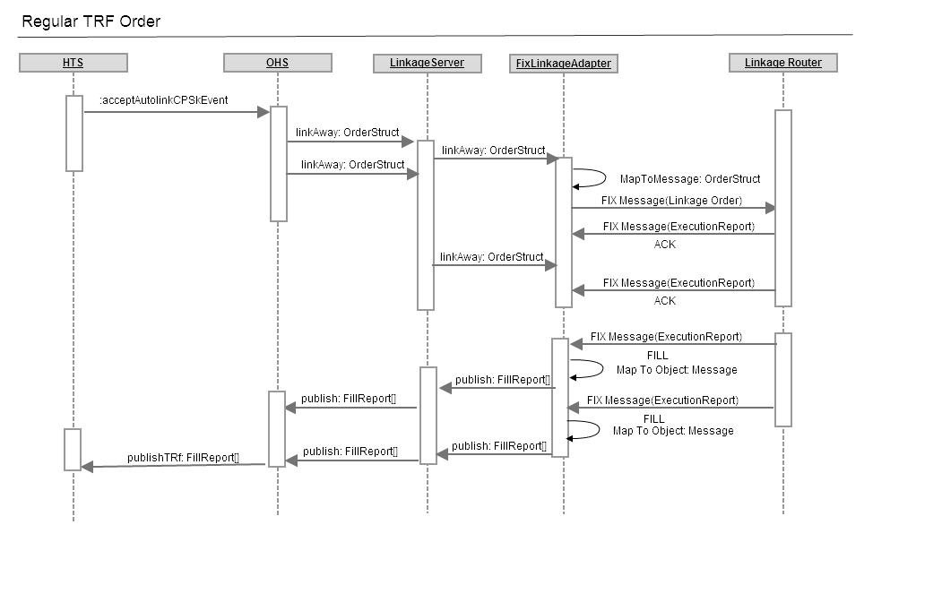
Millenium (TRF ) FIX Message

New order

BeginString 8=FIX.4.2
BodyLength 9=186
MsgType 35=D
SenderCompanyID 49=XXXX
TargetCompanyID 56=NYFIX
MsgSeqNum 34=1722
SendTime 52=20110405-16:01:55
SenderSubID 50=CST007
PossDupFlag 43=N
PossResend 97=N
ClOrdID 11=CST007-22970149
ClOrdLinkID 583=CST007-22970148
ClientID 109=GSCO
HandlInst 21=1
Symbol 55=CLF
Side 54=2
TrasactionTime 60=20110405-16:01:54.916
OrderQty 38=159
OrdType 40=2
Price 44=101.4
TimeInForce 59=0
CheckSum 10=023

Execution Report

BeginString 8=FIX.4.2
BodyLength 9=0312
MsgType 35=8
TargetSubID 57=CST007
PossResend 97=N
MsgSeqNum 34=3199
SenderCompanyID 49=NYFIX
TargetCompanyID 56=XXXX
PossDupFlag 43=N
SendTime 52=20110405-16:01:55
ClientID 109=PFTK
ClOrdID 11=CST007-22970148
CumQty 14=159
ExecType 150=2
LeavesQty 151=0
ExecID 17=12507269
ExecTransType 20=0
LastMkt 30=13
LastPx 31=101.400000
LastShares 32=159
OrderID 37=66885994
ComplianceID 376=CST007-22970148
OrdQty 38=159
OrdStatus 39=2
OrdType 40=2
Price 44=101.400000
Side 54=1
Symbol 55=CLF
ClOrdLinkID 583=CST007-22970149
TimeInForce 59=0
AvgPx 6=101.400000
TrasactionTime 60=20110405-16:01:55.663
SettlmntTyp 63=0
ExecBroker 76=NYFX
CheckSum 10=032

Implementation

OHS
- AutoLinkServiceDelegateImpl
  - acceptAutoLinkCPSEvent(getRoutingStruct(),
getOrderRoutingParameterStruct(),
getOrderId(),
pairedOrder.getOrderId(),
autoLinkStruct, marketStruct)
Accept order Incomming Cross order TRF call

Linkage
- New classes to handle new TRF router MILLENIUM:
  - OrderMapperMillenniumImpl
    - mapToMessageObject(businessServicesWrapper, routerId)
  - MillenniumOrderHandlerImpl
    - handleValidatedMessage(com.cboe.interfaces.integrationServices.message.Message message, ArgumentSet argumentSet) throws SystemException, DataValidationException
Modify the handling of Execution reports to hold the Execution report(fill) for a cross order until both sides are available.
  - ExecutionReportMapperMillenniumImpl
    - mapToCancelReportMessage(ExecutionReport executionReport)
Map ExecutionReport (Cancel) to message object to forwarded to linkage server
    - mapToFilledReportMessageByRouter(ExecutionReport executionReport, LinkageExtensionsWrapper filledReportStructExtensions)
Map ExecutionReport (Fill) to message object to forwarded to linkage server

IDL
- Create new OrderRelationshipTypes in domain/contants.idl:
  - TRF_SWEEP_ORDER = 10
  - TRF_CROSS_ORDER = 11

Trading Properties
NBBOTradeThroughTicks.- NBBO Trade trough ticks for Equity leg

Routing properties
- TRFRouteEnabled: Used to determine if a CPS equity trade will be sent to CBSX or to TRF. This property is also accessible to STS to determine the behavior it will also affect market order splits to be sent to TRF.

Scripts
- None

Database
- LINKAGEORDERRELATIONSHIP
  - New Type values:
    - 10 -> TRF_SWEEP_ORDER
    - 11 -> TRF_CROSS_ORDER

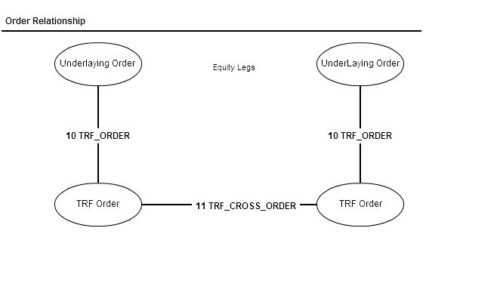
- SBTORDERHISTORY
  - New Event Types
    - 350 -> TRF_ROUTE_TO_AWAY_EXCHANGE
    - 351 -> TRF_ORDER_RELATIONSHIP
    - 352 -> EXECUTION_REPORT_ON_TRF_ORDER
    - 353 ->TRF_EXECUTION_REPORT_ROUTED
    - 354 -> TRF_EXECUTION_REPORT_FAILED_ROUTE

SetContext

XML/DTD
- AuolinkOrder_TRF_Workflow.xml to define the workflow for TRF orders.
- AutolinkOrder_TRF_FillReportWorkflow.xml to handle the fill reports from TRF
- Update WorkflowHome.xml to include the new workflows

Homes/Services
- .

PerformanceTestingProcedure
- .

TestingProcedure

OperatorProcedure
- .

Fallback/Failover

